
Applied Leadership and Management
Module Assignment Submission
Student Name: | Lyssa Muir
Student Number: | 1917752
Module No: | BMSK4009
Module Title: | Learning in the Digital Era

Statement of Confirmation of Authenticity
By the act of making this submission, the student declares that this is the work of the student named above. The work has not, in whole` or in part, been knowingly presented elsewhere for assessment, or where assessment has been built on a previous assessment, this has been identified. Where materials have been used from other sources it has been properly acknowledged. If this statement is untrue, the student acknowledges that an assessment offence has been committed.
Attention is drawn to the plagiarism and unfair practice policies of both the University and of ILM.

  - How can I prepare myself for Higher Education

Time Management
Time management is organising and prioritizing your time between different activities/ tasks in order of importance or to meet deadlines. There are many different things that can be used or done to help in effective time management, such as the use of a diary, making to do list in order of priorities, get into a routine, setting alarms etc. Effective time management whilst in higher education aids in handing in assignments on time, being punctual and present whilst attending lectures. Managing your time effectively is vital when preparing yourself for higher education. Managing your time effectively whilst in higher education sets you up and prepares you for when you start your career. Prioritising and managing time efficiently will have a positive impact and contribute to becoming successful in the things you are doing in all areas of life. Time management is one of my skills that I stick to quite well- I document tasks I have to complete in my diary, I set alarms and reminders and I often write a to do list weekly. I set things in order of priority and nearest deadlines.

Academic Writing
Academic writing is a formal way of writing used by colleges and universities. Students are expected to write their assignments, essays, dissertation papers and research study papers in an academic format. Academic writing is correctly sourced, well written and planned, clear, precise, well structured, correct use of punctuation, clear language and spelling, formal, and unbiased. The purpose of academic writing is to see the individuals/ authors knowledge on the subject their writing about, shows how they interpret information they have researched or have been given, to present their ideas and opinions and to show or to make the reader believe what you’re saying through your writing. It is important when writing academically that the information that is being written is clear and concise, this enables the reader/s to understand the context of the information you are trying to get across, also it will aid in achieving better grades when in higher education. It is important that academic papers and research have correct grammar and spelling, similarly to being clear and concise, it is so the audience can understand your message, also papers can be failed if the grammar and spelling are very poor and can detract from what could be a good piece of work and lastly with the use of correct grammar and spelling the work would be so much more easier to understand and have a naturally better flow to it. When talking about academic writing it is important that every single bit of information you have found is referenced correctly, whether it be information from a book, website a study etc. Referencing your research is vital as if it isn’t done or isn’t done correctly then the individual could be called up for plagiarising another individual’s piece of work. It is also important when finding information that the source is a reliable source with accurate information. Websites such as Wikipedia would be classed as an unreliable source of information as anyone can access the information and edit it at any time. Academic writing, not a strong point, is a skill that I am continuing to work on to get better so that it reflects in my academic work writing and my grades.

Transferrable Skills
Most individuals have transferrable skills which they’ve learned that can be transferred and applied to other areas of their life. Transferrable skills could have been learnt over time through day-to-day hobbies, different jobs, through educations etc. What is a transferrable skill? A transferrable skill could be leadership/ management, communication, time management, prioritization, listening, research skills, ability to work a part of a team or lone work, people skills/ customer service, problem solving skills, physical skills, and cultural awareness. The importance of transferrable skills in all aspects of live are essential. Transferrable skills show that you are adaptable and can take on different tasks with competence, they can lead to increased productivity and more successful outcomes in what you’re doing. I currently possess many transferrable skills that I could apply to other areas of my life. I efficient with time management, team working, communicating, listening and practical skills. Although generally I would say I can apply all transferrable skills mentioned above, there are a few that I am weaker at than others such as research skills, leadership etc.

Reflection
Reflection is the ability of thinking about and learning from past experiences. It involves questioning yourself in way such as- what did I do here? What could have gone better? What would I change if I were to do it again? Etc. Reflection is a powerful skill that is used in many areas whether it be personal, academically or in the workplace. Reflection is often used in problem solving or when a situation could have gone better. Using and utilizing the skill of reflection can have a huge benefit if you were to complete the same task again in the future to know what you would do differently. There are many tips to help incorporate reflection into your development, which include asking more questions, practice mindfulness, documenting, asking for help when needed. Reflection aids with development in all areas. Reflection is not one of my strong points. It is a skill I know how to do, but rarely incorporate it into my daily life, but it is a skill that I need to prioritize as it is hugely beneficial in achieving success in future goals and tasks. Reflections helps in learning and development, increases awareness, shows willingness to learn from mistakes etc. I have included below a well-known reflective cycle- Gibbs reflective model which clearly explains the process of reflection.

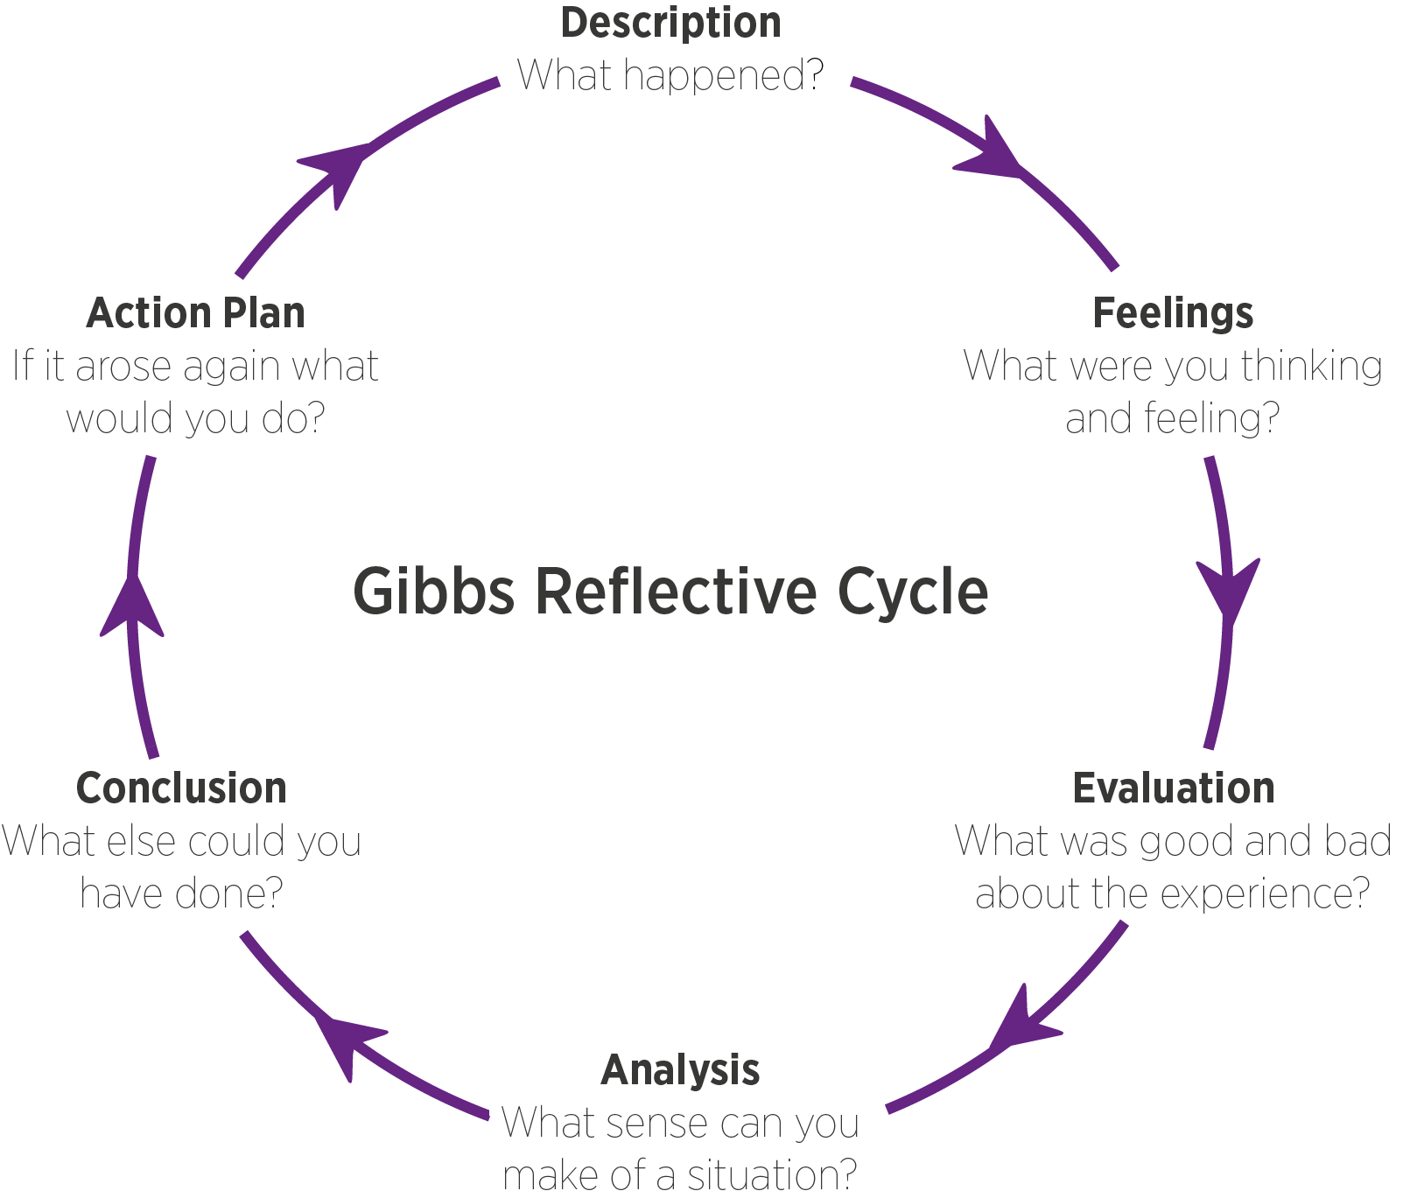
‘Gibbs 1988’

1.2 Skills Mind Map
I have created a mind map of the skills I currently possess and use day to day in my life, work and academically. I have also identified the skills I need. As you can see in the mind map many of these skills are transferrable between work, academically and day to day.

Skills

Skills I need
Skills I have

Time Management
Transferable
Academic Writing

Punctual, able to meet deadlines at work and academically.
Correctly referencing, using reliable sources.

Planning and organisational skills- use of a diary and to do list to keep up to date to meet work and academic deadlines and goals.
Digital/ IT Skills- Use of all Microsoft packages, email, phone, fax, video calls etc.
Digital Learning/ tools- The use of the online library for study research.

Study Skills- researching, planning, prioritising and the use of mind maps and other tools.
Effective Communication- Verbally, written and digitally.

Reflection- Analysis, Action plan etc.

  - Personal Development Plan to improve skills identified

What do I want to learn? | What do I have to do? | What support and resources will I need? | How will I measure success? | Target Date for Review
To use the online library effectively for research instead of using website. | Persevere and spend some time looking into it and how to use it properly. | Support from tutor on accessing it correctly and use of UWTSD HWB. | Using books from the online library as part of my research for future assignments. | 6-12 Months
Academic Writing- be clear and direct with what I’m writing and referencing correctly. | Take my time, maybe research, and read different study papers or articles where the academic writing is thorough and correct. Research into APA7 and other types of referencing. | Different books, academic papers/ articles. Look into APA7 referencing more. | Achieving higher grades in my academic assignments and better feedback | 6-12 Months
Time Management | Continue sticking to deadlines to the best of my ability, prioritise tasks work/ academic, set reminders/ alarms and continue to use a diary daily. | Diary to continue to keep track of tasks, alarm reminders to notify me of upcoming deadlines. | By continuing to manage my time well and not fall behind on tasks and deadlines. | 6- 12 Months
Effective Communication- Academic and workplace | Continue to ensure I communicate effectively with individuals in workplace and with tutor in higher education. | Verbally, via email, phone, Microsoft teams, text message etc. | Ensuring there is mutual understanding of things being discussed and things not going missed/ unnoticed. | 6-12 Months.
Transferrable Skills | Continue using my transferrable skills daily and apply them to all areas. Work on the ones I’m not as strong as to get better- i.e. research | Pier, colleague, tutor support. Continue to apply the skills daily to gain confidence in all skill areas. | Becoming more confident in the transferrable skills that I feel I’m not as strong/ confident in. | 6-12 Months.
Reflection | After each task where the outcome could have gone better reflect. | Take time and try to reflect on tasks that didn’t go to plan. I could use Gibbs reflective model as a template for my own reflection | Achieving better outcomes and results when completing future tasks as I would know what to do better next time. | 6-12 Months

References

- Time Management is about more than life hacks. Harvard Business Review. (2023, April 5). https://hbr.org/2020/01/time-management-is-about-more-than-life-hacks. Accessed- 29/9/23
- How to manage your time as a university student. Student. (2023, September 18). https://www.timeshighereducation.com/student/advice/how-manage-your-time-university-student. Accessed- 29/9/23
- What is academic writing?: DOS and don’ts for students. Scribbr. (n.d.). https://www.scribbr.com/category/academic-writing/. Accessed- 29/9/23
- Edlin, F. (2022, June 27). What are the four main purposes of academic writing?. Authors Cast. https://authorscast.com/what-are-the-four-main-purposes-of-academic-writing. Accessed on 30/9/23
- Cheary, M. (2023, September 4). What are transferable skills?. reed.co.uk. https://www.reed.co.uk/career-advice/what-are-transferable-skills/. Accessed- 30/9/23.
- Lennon, D. (2016, November 10). Why are transferable skills important?. JobMonkey. https://www.jobmonkey.com/why-transferable-skills-important/. Accessed- 1/10/23
- What is reflective learning and why is it important? - indeed. (n.d.). https://uk.indeed.com/career-advice/career-development/reflective-learning, Accessed- 1/10/23
- Kwaite. (2023, September 21). Reflective practice - the skill we all need. Leap Like A Salmon. https://www.leaplikeasalmon.com/reflection-is-it-a-skill. Accessed- 1/10/23

