Prashant Thapa (1806502)
1806502@student.uwtsd.ac.uk

Effective Team-working and communication

Executive Summary
The purpose of this report is to outline effective communication and team-working. This report also illustrates how Michelle can develop her team and have effective communication. Michelle business is growing and expanding but the team structure will not be effective when expanding her business for the demand of the job. This report will outline the problem Michelle toy store might face or is facing and will try to solve it.

Contents List
Table of Contents
Title 1
Executive Summary 1
Contents List 1
Terms of Reference 1
Findings 1
Communication 6
Modes of Communication 7
Shannon and Weaver (1949). 7
Berlo’s communication model. 8
Schramm’s model of communication (1954). 9
Conclusions 10
Recommendations 10
Appendices 11
Reference List 12

Terms of Reference
The report was requested by Lecturer Chris Felices and Mel Squire. The report was requested on the date 12 April 2019. The purpose of the report is to highlight Michelle’s toy store barriers in communication and help her set up the business with effective team members. The report was compiled by Prashant Thapa. The report was submitted in 12 April 2019.

Findings
Michelle is the owner of a Toy store in Swansea, currently most of the employees are part-timers who work variable hours and work in the stores opening hours from 8AM till 10PM. Of the 27 people she employs, 6 work in the stock room and some of the stock room staff only work nights where there are no managers. She employs 14 sales assistant and one of her sales assistants in on a long-term sickness. The workplace does not have a formal team who work on a regular basis and only have ad hoc who work when they are needed for a specific job. Her business does not look to have a clear structure which can cause breakdown in communication and therefore the communication not being effective. Michelle business currently operates more as a group then a team as the staff that work there are always changing and don’t have time to build trust within themselves which is vital to form a team.
Michelle can incorporate these steps into her workplace from Cardinal (2015) who insists that there are 5 steps in building an effective team.
Step 1: Establishing leadership by building trust through honesty and transparency.
Step 2: Establishing relationship with all her employees by knowing each of their strengths and weakness and use their knowledge to solve specific problems and tasks.
Step 3: Building relationship between her employees by examining how they work together and take steps to improve communication and trust between the team. If a conflict occurs the managers can act as the negotiator by listening to both sides of the stories.
Step 4: Once the relationship is built between the employees the managers need to motivate them to work effectively in a team, encouraging the employees to share any suggestion and concerns which can help the team.
Step 5: Finally, after the relationship is established Michelle can set the ground rules by keeping track of the team’s performance and individual performance. During teambuilding processes managers need to simplify and guide their team so that the trust is built between each other and they can work efficiently.
According to Abadi (2010) in the Tuckman model the life cycle of team involves four stages and at each stage the dynamic of the team changes drastically from a stage of inadequacy and awkwardness to very efficient team. The four stages are:
- Forming: This is where the team members are nervous and are uncertain about each other roles and look for guidance, support and direction.
- Storming: At this stage, the team start growing with confidence and don’t look for guidance from the outside source and fight against the demand of the job. This is where each team members express their individuality and there is power struggle in the team and can cause conflict. The team member needs to be expert and skilful at ensuring the team members listen and respect each other differences and ideas.
- Norming: At this stage, each team members express their own views and opinions about the team problems and are more open about it. They are more cooperative and want to be part of the team as they listen to one another and are more tolerant to one another’s views and opinions. They start to work as a team while setting up procedures to deal with the job by working together and ignoring each other’s differences. At this stage, the team leaders are not that much involved at decision making and problem solving as the team members are already focused on that. The team leader can lead their team and support the team if any difficult situation arises or the team members are in a dilemma.
- Performing: At this stage, as the team know, trust, and rely on each other they are focused in completing the job, each member of the team has a specific job role, the task is done following the procedures set up by the team and is fully accomplished. The team can solve problems as all the members have one common goal. They communicate well as a team and are more effective as a team. As Abadi (2010) states that not every team make it to this level of team growth as they stop at the norming stage. This team is highly motivated, and all the team members are interdependent. When a conflict arises the team, members work through it without intruding the task.
After analysing Michelle’s toy shop business, Michelle needs to form a team that can have clear communication between each other, where the team members are solving the problems as a group ,where there is assurance and commitment to the task by each of the member, and all team members are focused on one common goal. This can be done by using the Tuckman’s model. She needs to employ people on their problem solving, decision making and ability to work as part of the team. She needs to assemble a team and make the team go through the four stages of team development. But Miller (2010) mentions that the team must pass through their forming and storming development stages before they can proceed to norming and ultimately performing stages.
Michelle needs to change a group to a team to benefit her organisation so the team members can progress to the development phases of norming and performing. Moga (2017) states a group is a collective of equally independent individuals with different goals who are brought together by common interests and experience whereas a team is an interdependent group of individuals who share responsibility and are focused on a common goal.
Moga (2017) further states that if a group transforms from a group to a team the organisation is more likely to achieve success as there are more conversation between team members, the collaboration and synergy is better and as they are all focused on a common goal. Once the team is formed the team leader must give their team members feedback by listening, sharing ideas like brainstorming and setting up future steps.
Moodle (2019) states that that in Belbin’s team role theory an individual influence on a team can be measured by their qualities such as intelligence, dominance, extroversion / Introversion and stability / anxiety. Based on these characteristics of an individual there are eight team roles in a team.
- The Implementer: Slater (2019) states that the main contribution of the implementer is to turn ideas, concepts and general plans into a practical brief, and then execute them through that brief. The implanter is used for when the work needs to be done but he/she lacks flexibility and are resilient to change.
- The Coordinator: Establishes each team members roles to the individual’s abilities, makes clear goals and tough decision. Lacks creativity and is slightly scheming in achieving goals.
- The Shaper: The shapers are very motivated, have strong desire to achieve success and have strong work ethics. The shapers come across as arrogant, impatient and are impulsive.
- The Plant: They are often very distinctive, creative and are unorthodox. They come up with ideas and are very innovative in solving problems. But sometimes the plant can be unrealistic and are often sensitive to criticism and rejection of their ideas.
- Resource investigator: They are often described as people with enthusiasm, curiosity and are extrovert. Slater (2018) states that the main contribution of the Resource Investigator is to discover just what resources are available and to develop external contacts that may be useful to the team. They lack discipline and can lose track of the job.
- The monitor evaluator: They are concerned and are anxious to ensure the consequences of any decision are fully thought through. They analyse the ideas and the suggestion that come from the team. They are very vital to the team as their judgment hardly is ever wrong. They lack in ideas and can be over critical of the team’s ideas.
- Team worker: They are sociable, unassertive and are supportive of the members of the team in achieving and maintain team effectiveness. They struggle under pressure and are undecisive when making tough decision.
- Completer/ Finisher: They are careful, arranged, painstaking and have great attention to details. They make sure that every members of the team effort are to near perfection and don’t start any work that they can’t finish. They always have a sense of urgency which can put pressure on the team members and can overly focus on the details then the outcome of the job.
Michelle can identify each of the roles above and try to fit them in a team to help her toyshop. She needs Completer/ Finisher and shaper when there are orders with deadlines. She also needs to put Coordinators or Shapers in team leading roles as they are good at making decisions and when work needs to be done.

Communication
(Daly,2017) states that a person must have the skill to explain themselves evidently, to listen and to interact well to other people. Ahmed (2018) mentions that there are six requirements for a communication to be effective in a team.
- Listening carefully to the conversation is a must for communication to be effective. Team members cannot collaborate and work together if they do not listen to each other what they are trying to say. Mckenna (1998) mentions that listening ranks as one of the most valuable communication skills.
- Knowing the audience by knowing who they are speaking to. They need to alter their language, tone and the medium so that it's right for their audience.
- Being Concise, Complete and Correct by avoiding to repetition, unnecessary details from the communication. The message needs to be complete by including all the valuable, relevant facts, needs to be organised and easy to follow. Simon (2015) effective communicators often use shorter words in lieu of longer ones whenever possible.
- Incorporating feedback in the message by giving and receiving feedbacks. Constructive feedback is valuable in improving the team’s performance at work.
- Showing respect through the conversation by showing respect when having conversation as people will be more interested in having conversation.
- Not forgetting non-verbal communication as they are critical to effective communication. The hand gestures, the stance and the body language are helpful at interpreting the meaning of the words being used in communication.
With so many options available Michelle needs to pick the right and appropriate method for the conversation to be effective. Also, she needs to pick the best medium that suits the nature of the conversation to convey the messages.

Modes of Communication
According to Smith and Mounter (2005) the way communication flows around an organisation and equally the way the way it fails should be ones first and paramount concern.

Shannon and Weaver (1949).
Shannon and Weaver model deals with various concepts like Information source, transmitter, Noise, channel, message, receiver, channel, information destination, encode and decode. The model is effective between person to person rather than group. This model does not have a feedback and the conversation is only one way. The noise also affects the communication (Businesstopia, 2018).
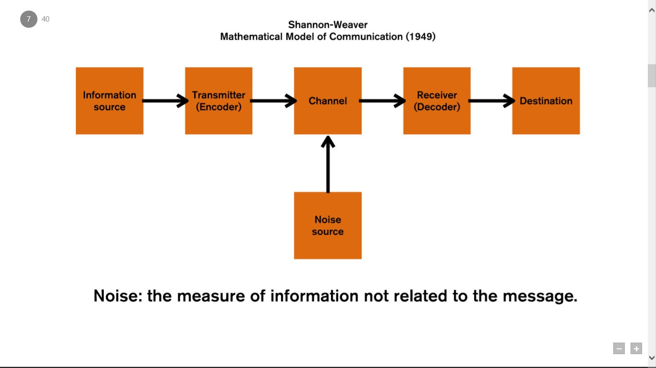
Figure1: Shannon and Weaver communication model.

Berlo’s communication model.
Also known as the SMCR model this model also doesn’t have a feedback, there is no concept of noise, it is a direct mode of communication and there is no two-way communication (Businesstopia, 2018).
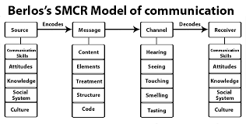
Figure 2: Berlo’s model of communication.

Schramm’s model of communication (1954).
This is a two-way communication model. There is feedback in this model, it shows why redundancy is an important part and there is no separate sender and receiver.
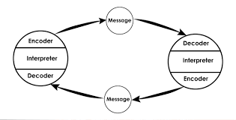
Figure 3: Schramm’s Model of Communication.
Michelle needs to incorporate Schramm’s model of communication as it is a two-way communication and is more effective. Two-way communication provides employees with a means to convey their complaints, attitudes, feelings, interests and opinion to their superiors. Afterwards, superiors can take necessary steps for well-being of the employees. As a result, job satisfaction of the employees increases.
According to Khullar (2016) two-way communication create democratic environment where team members can freely express their ideas and views. It is vey useful to overcome confusion and ambiguity regarding the messages as the receiver can they response. It creates friendly relationship the team members. There is a sense of mutual understanding. The communication is more effective and it increases efficiency.

Conclusions
Michelle business is growing fast, and she must focus on team development. There must not be too many barriers when communicating and the communication must have a feedback and be two way. She must also develop and invest in team structures and management for nights as some team need motivation from their superiors in order to complete the task.

Recommendations
Michelle needs to reshape her team structure and the way team communicates.
Recommendation | Who is responsible for actioning? | To be completed by (date) | Costs incurred?
Recommendation .1  Recruit skilful employees | Michelle, HR and the recruitment team. | 16/04/2019 | Labour cost
Recommendation .2  Build an effective team using the 4 stages of Tuckman team development. | Team managers and providing appropriate training. | 30/04/2019 | Training cost
Recommendation .3  Develop effective communication between the team. | Team managers and team members | 30/04/2019 | No cost.

Appendices
Figure1: Shannon and Weaver communication model.
Figure 2: Berlo’s model of communication.
Figure 3: Schramm’s Model of Communication.

Reference List
- Abudi, G. (2018). The Five Stages of Project Team Development. Available at: https://project-management.com/the-five-stages-of-project-team-development/ (Accessed 02/04/2019).
- Ahmed, A. (2018). Requirements for Effective Communication. Available at: https://bizfluent.com/info-8013804-requirements-effective-communication.html (Accessed:10 April 2019).
- Businesstopia. (2018). Berlo’s SMCR Model of Communication. Available at: https://www.businesstopia.net/communication/berlo-model-communication (Accessed: 11 April 2019).
- Businesstopia. (2018). Shannon and Weaver Model of Communication. Available at: https://www.businesstopia.net/communication/shannon-and-weaver-model-communication (Accessed: 10 April 2019).
- Cardinal, R. (2015). 5 steps to building an effective team. Available at: https://www.huffpost.com/entry/5-steps-to-building-an-effective-team_b_7132406 (Accessed 02/04/2019).
- Daly, L. (2017)10 employability skills that you need to learn. Available at: http://movingonmagazine.co.uk/10-employability-skills-that-you-need-to-succeed (Accessed:10 April 2019).
- Khullar, V. (2016). Available at: https://www.quora.com/Why-two-way-communication-is-important (Accessed:10 April 2019).
- Mckenna, C. (1998). Powerful Communication Skills: How to Communicate with Confidence. Career Press.
- Miller, B.C. (2010). Nice Teams Finish Last: The Secret to Unleashing Your Team's Maximum Potential. AMACOM.
- Moga, B. (2017). Group vs Team: Are Groups Really That Bad?. Available at: https://activecollab.com/blog/collaboration/group-vs-team (Accessed: 03/04/2019).
- Moodle. (2019). Effective Team-working and Communication. Available at: https://moodle.uwtsd.ac.uk/course/view.php?id=5703 (Accessed: 10 April 2019).
- Simon, P. (2015). Message Not Received: How New Technologies and Simpler Language Can Fix Your Business Communications. Canada: John Wiley & Sons.
- Smith, L. and Mounter, P. (2005). Effective internal communication. London and Philadelphia: Kogan Page.

