INDIVIDUAL BUSINESS MODEL CANVAS WITH ENTREPRENEURIAL REFLECTION
REWORK

The module title: Entrepreneurship
Module Level: 5
Module code: BMIH5001

Khalada Akther
2209626

Business Model Canvas for Sentimental Retreat in London:

The hospitality industry demands innovative business concepts to stand out in a competitive market. This report presents a proposal for a unique wellness retreat “sentimental retreat in London” using the Business Model Canvas (BMC). This business model canvas BMC (Appendix 1) will outline the key elements of the business plan, including the value proposition, customer segments, channels, revenue streams, key activities, resources, partnerships, cost structure, and entrepreneurial reflection. The proposal includes detailed discussions of each BMC section, justifications with contemporary examples, and comparisons (Appendix 1) with key competitors such as Sharpham Trust and Gaia House. Our retreat focuses on holistic wellness, integrating ecofriendly practices with comprehensive wellness services to create a unique value proposition. The Business Model Canvas (BMC) is a strategic tool that provides a structured approach to developing and presenting business concepts (Osterwalder & Pigneur, 2010).

Value Proposition. Our wellness retreat offers a unique blend of holistic wellness services and ecofriendly practices. The key elements of our value proposition include:
Holistic Wellness Programs: We provide a comprehensive range of wellness activities designed to improve both physical and mental wellbeing. Our offerings include yoga sessions, meditation practices, and nutritional workshops that are curated to promote a balanced lifestyle. These programs are led by experienced professionals (Smith & Puczkó, 2009). For example, our yoga sessions might incorporate various styles, such as Hatha, Vinyasa, and Yin yoga, to cater to different preferences and skill levels.

Eco-Friendly Practices: Sustainability is at the core of our operations. We implement a variety of ecofriendly practices, such as utilizing solar panels to harness renewable energy, sourcing organic food from local suppliers to reduce our carbon footprint and maintaining rigorous waste reduction programs to minimize environmental impact. (Bohdanowicz, 2006). For instance, we plan to collaborate with local organic farms like Daylesford Organic to ensure that our ingredients are fresh and sustainably sourced.

Personalized Experiences: Recognizing that each individual's wellness journey is unique, we offer personalized wellness programs tailored to the specific health assessments and goals of our clients (Conner et al., 2010). By leveraging advanced health assessment tools and regular consultations with wellness experts, we ensure that each client receives a tailored experience that maximizes their wellbeing.

Our competitors, such as Sharpham Trust and Gaia House, also emphasize wellness and ecofriendly practices. However, our unique combination of personalized wellness plans and advanced ecofriendly technology sets us apart (Sharpham Trust, 2024; Gaia House, 2024). Unlike our competitors, we integrate cutting-edge technology such as wearable fitness trackers and wellness apps to provide real-time feedback and personalized insights, further enhancing the client experience and ensuring measurable health improvements.

Customer Segments. Our target market includes. Health-Conscious Individuals: This segment comprises people who are actively seeking to enhance their physical and mental wellbeing through holistic practices. They are typically motivated by the desire to maintain a healthy lifestyle, manage stress, and achieve overall wellbeing (Schnell, 2011). For instance, we aim to attract clients similar to those frequenting wellness centres like The Life Centre, a popular yoga and Pilates studio in London known for its holistic approach.

Corporate Clients: Companies increasingly recognize the importance of employee wellbeing for productivity and morale. Our wellness retreat offers tailored wellness programs for corporate clients, focusing on improving employee health, reducing stress, and enhancing overall productivity (Cooper & Dewe, 2008). For example, partnering with firms such as PricewaterhouseCoopers (PwC), which has a strong focus on employee wellbeing programs, can be beneficial in reaching this segment.

Eco-Conscious Travelers: This group consists of individuals who prioritize sustainable travel and ecofriendly accommodations. They seek destinations that align with their environmental values and offer sustainable practices. Our retreat's commitment to ecofriendly infrastructure and practices appeals to this demographic, which is concerned about reducing their carbon footprint and supporting green initiatives (Budeanu, 2007). An example of this segment includes travelers who frequent Eco-stays in the UK, which offers sustainable lodging options and attracts ecology conscious guests.

Channels. We will employ a diverse range of channels to effectively reach and engage our target customers. Website and Online Booking: Our website will serve as a central hub for potential customers, offering comprehensive information about our services and seamless online booking capabilities (Chaffey & Ellis Chadwick, 2016). This platform will prioritize user-friendliness and accessibility, ensuring a smooth customer experience from browsing to booking.

Social media: Active engagement on prominent social media platforms such as Instagram, Facebook, and LinkedIn will be integral to our strategy (Kaplan & Haenlein, 2010). These channels will not only facilitate direct interaction with our audience but also serve as platforms to share valuable wellness related content, establishing our brand as a trusted authority in the wellness sector.

Partnerships: Collaborating with established entities such as travel agencies, health clubs, and corporate wellness programs will significantly expand our market reach (Varma et al., 2016). These partnerships will enable us to tap into existing customer bases and leverage their networks to promote our services, fostering mutually beneficial relationships within the industry.

Analytics and Optimization: Central to our digital strategy is the use of analytics tools like Similarweb to continuously monitor and optimize our online performance (Similarweb, 2024). By leveraging data driven insights, we will refine our marketing efforts, enhance user engagement, and maximize conversion rates across all digital channels.

Through these integrated channels, we aim to not only attract new customers but also nurture lasting relationships.

Customer Relationships. Building strong and lasting customer relationships is fundamental to our business strategy. We will focus on the following approaches to achieve this. Personalized Customer Service: We are committed to providing personalized support and recommendations tailored to the unique needs and preferences of each customer (Peppers & Rogers, 2016). By understanding and anticipating their individual requirements, we aim to enhance satisfaction and build trust, fostering a strong rapport with our clientele.

Loyalty Programs: Implementing robust loyalty programs will be a cornerstone of our customer retention strategy (Dowling & Uncles, 1997). These programs will reward repeat customers with exclusive discounts, special offers, and personalized perks, incentivizing continued patronage and reinforcing our commitment to customer appreciation.

Community Engagement: Creating a vibrant community around our brand is essential for nurturing long-term relationships (Putnam, 2000). We will organize regular events, workshops, and online forums where customers can interact, share experiences, and exchange insights related to wellness. This engagement not only strengthens bonds but also positions us as a supportive and valued member of their wellness journey.

By implementing these strategies, we aim to cultivate a loyal customer base characterized by high satisfaction levels and sustained engagement.

Revenue Streams. To ensure financial stability and facilitate sustainable growth, we will diversify our revenue streams by offering a range of services and products tailored to our customers' needs. Our revenue streams will include. Membership Fees: We will offer flexible membership options, including monthly or annual subscriptions, granting members access to a comprehensive suite of wellness programs and facilities (Kotler et al., 2016). These memberships will provide customers with ongoing benefits and incentives to maintain their commitment to their wellness journey.

Program Fees: In addition to membership access, we will generate revenue through charges for specific wellness programs and activities tailored to individual interests and goals (Hemmington, 2007). These may include yoga classes, meditation workshops, nutritional counseling sessions, and specialized wellness retreats, allowing customers to customize their experience based on their preferences.

Accommodation Fees: Revenue will be generated from ecofriendly lodging options available at our wellness retreat (Bohdanowicz, 2006). Our accommodation offerings will prioritize sustainability and comfort, providing guests with a tranquil environment conducive to relaxation and rejuvenation.

Retail Sales: We will offer a curated selection of wellness related products for sale, including organic food items, health supplements, and ecofriendly merchandise (Conner et al., 2010). These retail offerings will complement our services and align with our commitment to holistic wellness, providing customers with access to premium quality products that support their health and wellbeing.

Key Resources. The key resources required for our wellness retreat include. Qualified Staff: Experienced wellness professionals are crucial for delivering high-quality services. Our team will consist of yoga instructors, nutritionists, and mental health counsellors who have extensive expertise and training in their respective fields (Smith & Puczkó, 2009). For example, hiring experts like Chris James, a renowned yoga and detox specialist, and collaborating with Dr. Michael Dixon, a leading figure in holistic health, will enhance our credibility and attract clients seeking top-notch wellness programs.

Ecofriendly Facilities: Sustainable infrastructure is a cornerstone of our wellness retreat. Our facilities will include solar panels to generate renewable energy, organic gardens to provide fresh produce for our meals, and advanced waste management systems to minimize our environmental impact (Bohdanowicz, 2006). For instance, we will model our practices after successful ecofriendly retreats like Daylesford Organic, known for its sustainable farming and ecofriendly infrastructure, and Gaia House, which emphasizes environmental sustainability in its operations.

Technology: Advanced technology is essential for efficient operations and superior customer experience. We will utilize state-of-the-art booking and customer management systems to streamline reservations and client interactions. Additionally, we will employ analytics tools like Similarweb to monitor performance and customer behavior, allowing us to make data driven decisions to enhance our services and marketing strategies (Similarweb, 2024). Partnering with technology providers such as Mindbody, which offers comprehensive wellness service platforms, and utilizing Fitbit wearables for tracking fitness and wellness metrics, will help us stay at the forefront of innovation in the wellness industry.
These resources are essential to deliver high quality services and maintain our competitive edge in the wellness market.

Key Activities. Our key activities will focus on the following areas to ensure the success and sustainability of our wellness retreat. Program Development. By regularly assessing customer feedback and staying abreast of new wellness trends, we can introduce innovative programs that enhance the physical, mental, and emotional wellbeing of our guests. For instance, incorporating new practices such as sound healing or forest bathing could attract niche market segments looking for unique wellness experiences (Schnell, 2011). Additionally, leveraging technology to offer virtual wellness programs can expand our reach beyond the physical retreat location.

Marketing and Promotion: Effective marketing strategies are crucial to attracting and retaining customers. This includes both online and offline marketing efforts. Digital marketing will play a significant role, utilizing social media platforms, email marketing, and search engine optimization (SEO) to reach potential customers (Chaffey & Ellis Chadwick, 2016). Content marketing, through blogs and videos showcasing our wellness programs and ecofriendly practices, will help build our brand identity and engage our target audience. Offline strategies, such as partnerships with local businesses and participation in wellness fairs and events, will further enhance our visibility. Regular promotions and loyalty programs will also incentivize repeat visits and referrals.

Sustainability Practices: Sustainability is a core value of our wellness retreat, and we are committed to continuously improving our ecofriendly practices (Bohdanowicz, 2006). We will also source organic and locally produced food to reduce our carbon footprint and support local farmers. Additionally, ecofriendly building materials and green construction practices will be utilized for any expansions or renovations. By integrating sustainability into every aspect of our operations, we enhance our value proposition and appeal to coconscious travelers.

Regular Assessment and Optimization: To ensure operational excellence and customer satisfaction, regular assessments of our activities and programs are essential. This involves collecting and analysing Key performance indicators (KPIs) such as customer feedback, conducting internal audits, and benchmarking against industry standards. Continuous optimization of our programs, marketing strategies, and sustainability practices will help us maintain a high standard of service and adapt to changing market conditions.

By focusing on these key activities, we ensure that our wellness retreat not only meets but exceeds customer expectations, fostering loyalty and positive word-of-mouth while contributing to a sustainable future.

Key Partners. We will establish key partnerships with several strategic partners to enhance our service quality and expand our market reach. Local Suppliers: Partnering with local farmers and suppliers to source organic food and ecofriendly products will support the local economy and ensure sustainability. This commitment to local sourcing also resonates with the growing consumer preference for sustainable and locally sourced products (Budeanu, 2007). For example, we plan to collaborate with suppliers like Daylesford Organic, known for its commitment to sustainable farming practices, and Abel & Cole, which provides organic produce and ecofriendly products in London.

Health and Wellness Experts: Collaborating with renowned wellness experts, such as yoga instructors, nutritionists, and holistic therapists, will enhance our program offerings and credibility. These experts bring specialized knowledge and skills that can elevate the quality of our wellness programs (Smith & Puczkó, 2009). For instance, partnering with well-known figures such as Dr. Michael Dixon, a pioneer in holistic health, and Chris James, a leading expert in yoga and detox programs, can draw a dedicated clientele seeking expert guidance.

Corporate Clients: Partnering with companies to offer customized wellness programs for their employees can open new revenue streams and strengthen our market position (Cooper & Dewe, 2008). We will offer tailored wellness retreats and workshops designed to address specific corporate needs, such as stress management, teambuilding, and leadership development. Potential partners include large London based firms such as Unilever and PwC, which have robust employee wellness programs and a commitment to enhancing workplace wellbeing.

Technology Providers: Collaborating with technology providers to integrate innovative solutions such as wellness apps, virtual reality meditation sessions, and wearable fitness trackers will enhance the guest experience and provide personalized wellness insights. For instance, partnering with Mindbody, a platform that offers wellness services, and Fitbit, a leader in wearable fitness technology, can help us stay ahead of industry trends and offer cutting edge services that appeal to tech savvy customers.

Travel Agencies and Online Booking Platforms: Establishing partnerships with travel agencies and online booking platforms like TripAdvisor, Booking.com, and Secret Escapes will increase our visibility and accessibility to a broader audience. These platforms can help drive bookings and provide valuable customer reviews and feedback, which are essential for reputation management and continuous improvement.

Cost Structure. To ensure sustainable profitability and operational efficiency, our cost structure will encompass the following key components. Staff Salaries: We are committed to compensating our team of qualified wellness professionals and dedicated support staff competitively (Smith & Puczkó, 2009). Investing in skilled professionals is essential to delivering exceptional service and maintaining high standards of customer care throughout our retreat.

Facility Maintenance: Maintaining our ecofriendly facilities and infrastructure is a priority to uphold our commitment to sustainability (Bohdanowicz, 2006). Costs associated with regular upkeep, repairs, and ecofriendly initiatives will be budgeted to ensure our facilities remain conducive to relaxation and wellness for our guests.

Marketing Expenses: We will allocate a portion of our budget to comprehensive marketing efforts aimed at promoting our wellness retreat (Chaffey & Ellis Chadwick, 2016). This includes online strategies such as social media campaigns, SEO, and website optimization, as well as offline initiatives like print advertising and participation in wellness expos and events. These activities will enhance brand visibility, attract new customers, and reinforce our position in the competitive wellness market.

Technology Investments: Strategic investments in technology are crucial for enhancing operational efficiency and improving the guest experience (Similarweb, 2024). This includes implementing advanced booking systems, customer management software, and analytics tools to monitor performance metrics and optimize our service delivery. By leveraging technology, we aim to streamline processes, enhance data-driven decision making, and ultimately, elevate overall guest satisfaction.

In conclusion, our wellness retreat concept, articulated through the Business Model Canvas, represents a compelling fusion of holistic wellness services and ecofriendly principles. By focusing on health-conscious individuals, corporate clients seeking wellness initiatives, and eco-conscious travelers, we are poised to meet the increasing demand within these segments of the market.

Our business model is underpinned by a robust framework that integrates contemporary examples and thorough competitor analysis. This approach ensures a strong value proposition characterized by our commitment to exceptional service quality and sustainable practices.

The detailed justifications and explanations provided throughout this plan underscore the feasibility and uniqueness of our business concept. By leveraging our strengths in personalized customer service, diverse revenue streams, and strategic cost management, we are confident in our ability to achieve sustainable growth and establish a prominent presence in the competitive hospitality industry.

In conclusion, our wellness retreat is positioned for success, poised to deliver unparalleled experiences that promote holistic wellbeing while contributing positively to the environment and community. We look forward to realizing our vision and making a meaningful impact in the lives of our guests.

Reflection on Personal Entrepreneurial Characteristics:

In this reflective essay, I will employ the Gibbs reflective cycle to delve into my personal entrepreneurial and managerial test results, critically evaluate my motivations and characteristics. This essay also reflects on me in class entrepreneurial/managerial test results using the Gibbs reflective cycle. The results indicate that I am occasionally enterprising, scoring 76% on the GET 2 test. This suggests I have strengths in some enterprising characteristics and may be enterprising in specific situations.
Through the Gibbs reflective cycle, I assessed my entrepreneurial characteristics and motivations. The results indicated a strong inclination towards innovation, risk-taking, and a passion for creating a positive impact. This aligns with entrepreneurial theories such as the Effectuation theory, which emphasizes leveraging resources and taking calculated risks.

Understanding My Test Results:
What the Score Means. Getting 76% on the GET 2 (Appendix 2) test tells me that I have some entrepreneurial strengths, especially in certain situations.
How I Feel. This result makes me feel content with my current projects but curious about how I can become more enterprising in different contexts.
What I've Noticed. Realizing that I am enterprising in limited contexts, like employment or community projects, helps me understand where my strengths lie.
Ambitions and Opportunities. While I may be happy with my current projects, the suggestion that I can do more, especially with ambitions for an innovative growth business, motivates me to explore further.

Exploring My Entrepreneurial Side:
Recognizing Strengths. The test points out that I have strengths in certain entrepreneurial aspects like taking risks and being creative, but not consistently.
Connecting with Theories. These strengths align with the Effectuation theory, emphasizing the importance of using available resources and taking calculated risks.
Motivations Unveiled. My motivations are rooted in being content with my current projects and being open to exploring entrepreneurship in different ways, whether within employment or through community projects.
Bridging with Models. The Integrative Model of Entrepreneurial Intentions fits well with my test results, emphasizing the role of personal attitudes and perceptions in shaping entrepreneurial intentions.

Applying What I've Learned:
Taking a Closer Look. Understanding my results has motivated me to look closely at how I can become more entrepreneurial, especially if I want to explore innovative growth business ideas.
Emotional Journey. I feel a mix of contentment with my current situation and excitement about the prospect of trying new and more enterprising endeavours.
Seeking Opportunities. I'm actively looking for opportunities to use my entrepreneurial skills in different ways and take on projects that are more challenging and innovative.
What I've Realized. Through this journey, I've realized that even though I might be enterprising occasionally, there's potential for growth and a shift towards more ambitious entrepreneurial pursuits.

In conclusion, this reflective journey has provided valuable insights into my entrepreneurial characteristics and motivations. While I may be content with my current projects, the awareness of my enterprising strengths and the potential for growth has sparked a newfound ambition. Combining this self-awareness with established theories and models creates a roadmap for continuous entrepreneurial development, encouraging me to explore new and innovative opportunities.

References:

Abel & Cole. (n.d.). Retrieved from https://www.abelandcole.co.uk
Bohdanowicz, P. (2006). Environmental awareness and initiatives in the hotel industry. International Journal of Hospitality Management, 25(4), 662682.
Booking.com. (n.d.). Retrieved from https://www.booking.com
Budeanu, A. (2007). Sustainable tourist behaviour – a discussion of opportunities for change. International Journal of Consumer Studies, 31(5), 499508.
Chaffey, D., & Ellis-Chadwick, F. (2016). Digital Marketing: Strategy, Implementation and Practice. Pearson Education Limited.
Chris James Mind Body. (n.d.). Retrieved from https://chrisjamesmindbody.com
Conner, M., Norman, P., & Bell, R. (2010). The theory of planned behavior and healthy eating. Health Psychology, 29(3), 218227.
Conner, T. S., Brookie, K. L., Carr, A. C., Mainvil, L. A., & Vissers, M. C. (2010). Let them eat fruit! The effect of fruit and vegetable consumption on psychological well-being in young adults: A randomized controlled trial. PLOS ONE, 12(2), e0171206.
Cooper, C. L., & Dewe, P. (2008). Wellbeing—absenteeism, presenteeism, costs and challenges. Occupational Medicine, 58(8), 522524.
Daylesford Organic. (n.d.). Retrieved from https://www.daylesford.com
Dowling, G. R., & Uncles, M. (1997). Do customer loyalty programs really work? Sloan Management Review, 38(4), 71-82.
Dr. Michael Dixon. (n.d.). Retrieved from https://www.michaeldixon.org.uk
Ecostays. (n.d.). Retrieved from https://www.ecostays.co.uk
Fitbit. (n.d.). Retrieved from https://www.fitbit.com
Gaia House. (2024). Retrieved from https://gaiahouse.co.uk
Hemmington, N. (2007). From service to experience: Understanding and defining the hospitality business. The Service Industries Journal, 27(6), 747-755.
Kaplan, A. M., & Haenlein, M. (2010). Users of the world, unite! The challenges and opportunities of social media. Business Horizons, 53(1), 59-68.
Kotler, P., Bowen, J. T., & Makens, J. C. (2016). Marketing for Hospitality and Tourism. Pearson.
Mindbody. (n.d.). Retrieved from https://www.mindbodyonline.com
Osterwalder, A., & Pigneur, Y. (2010). Business Model Generation: A Handbook for Visionaries, Game Changers, and Challengers. John Wiley & Sons.
Peppers, D., & Rogers, M. (2016). Managing Customer Relationships: A Strategic Framework. John Wiley & Sons.
PricewaterhouseCoopers (PwC). (n.d.). Retrieved from https://www.pwc.co.uk
Putnam, R. D. (2000). Bowling Alone: The Collapse and Revival of American Community. Simon and Schuster.
PwC UK. (n.d.). Retrieved from https://www.pwc.co.uk
Schnell, T. (2011). Individual differences in meaning-making: Considering the variety of sources of meaning, their density and diversity. Personality and Individual Differences, 51(5), 667-673.
Secret Escapes. (n.d.). Retrieved from https://www.secretescapes.com
Sharpham Trust. (2024). Mindfulness retreats. Retrieved from Sharpham Trust.
Similarweb. (2024). Retrieved from https://www.similarweb.com
Smith, M., & Puczkó, L. (2009). Health and Wellness Tourism. Butterworth-Heinemann.
The Life Centre. (n.d.). Retrieved from https://www.thelifecentre.com
TripAdvisor. (n.d.). Retrieved from https://www.tripadvisor.co.uk
Unilever. (n.d.). Retrieved from https://www.unilever.com
Varma, V., Wadhwa, S., & Deshmukh, S. G. (2016). Evaluating petroleum supply chain performance. International Journal of Productivity and Performance Management, 65(6), 739-763.

Appendix 1

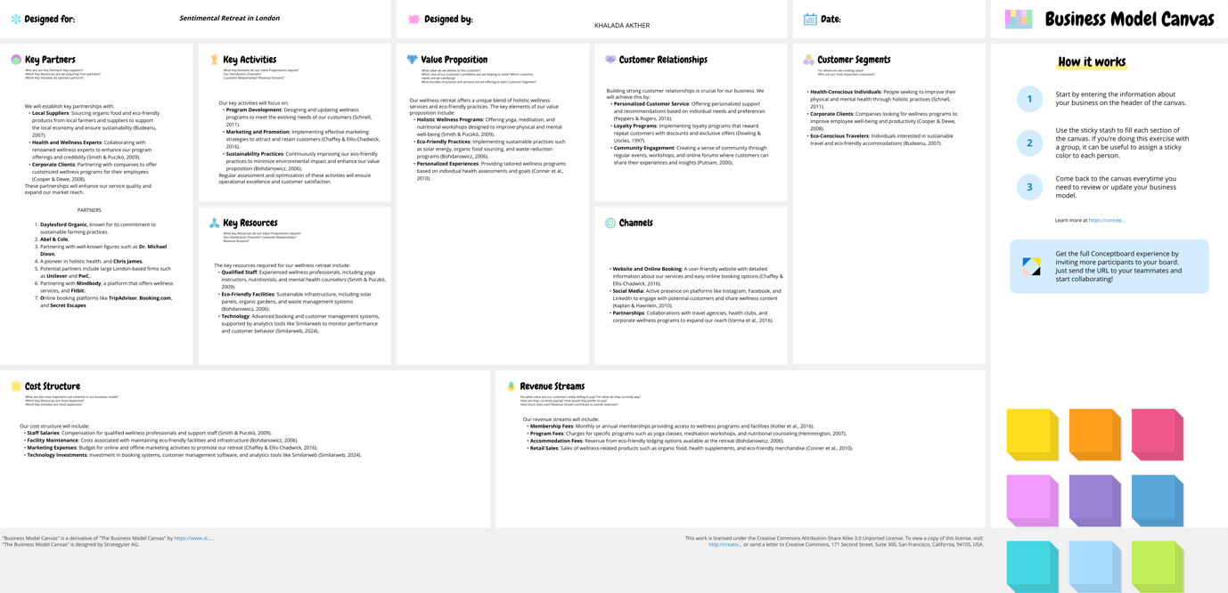

Similar web:
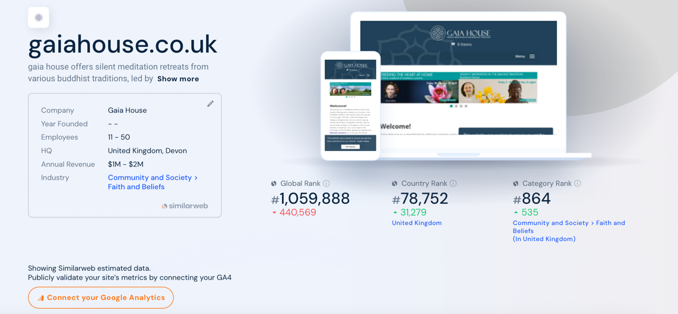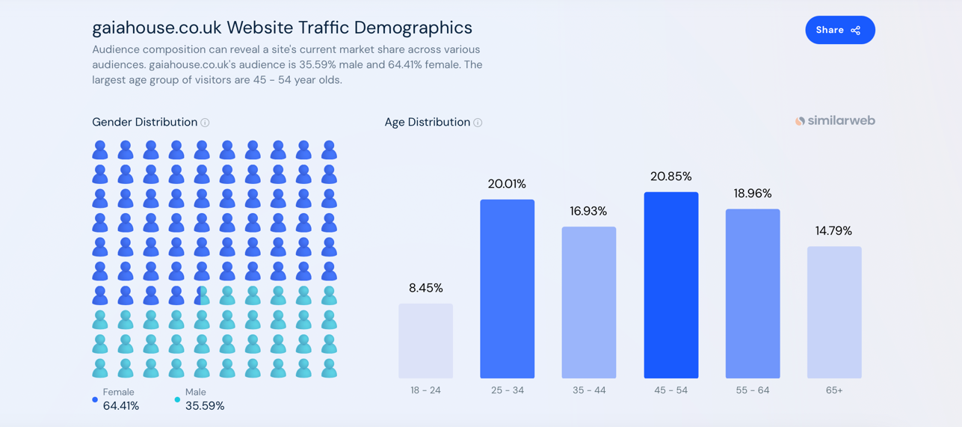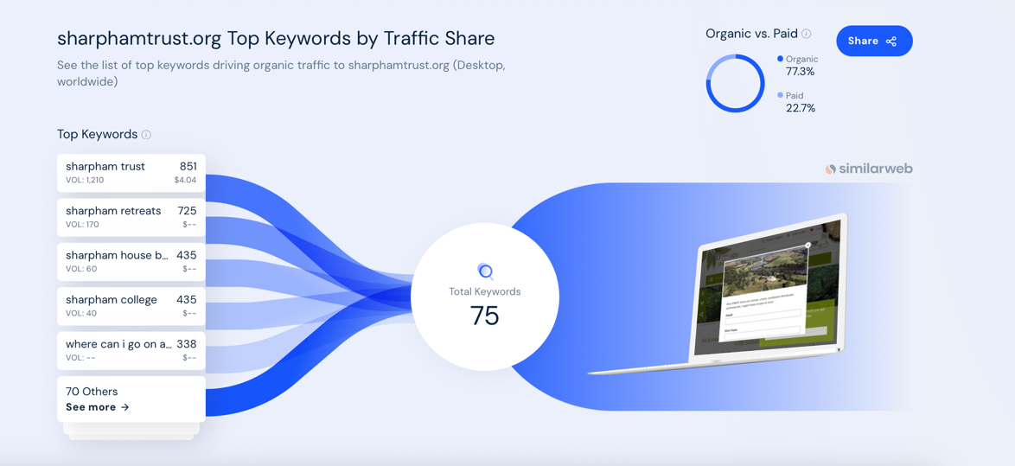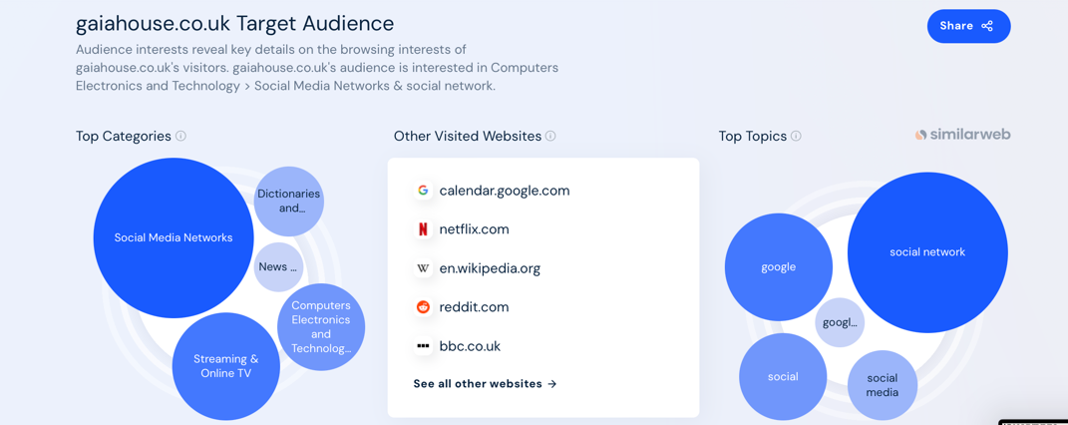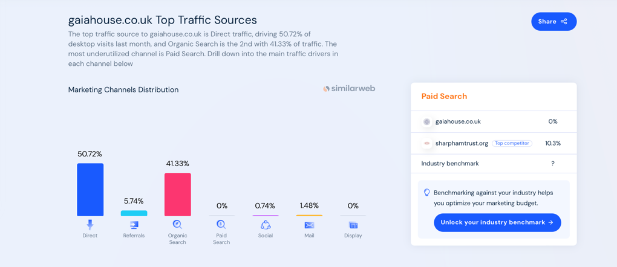

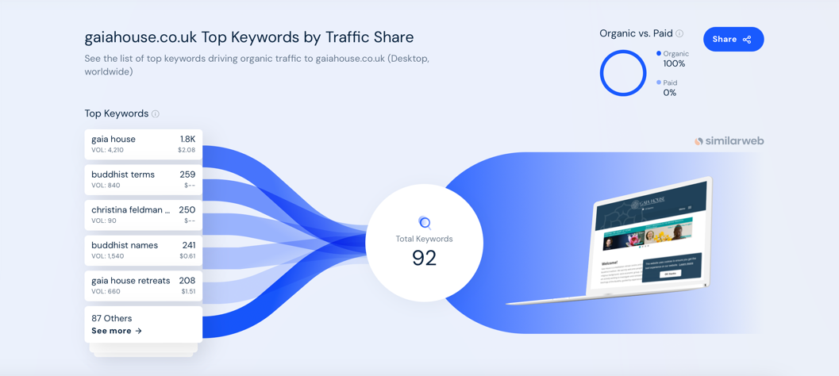

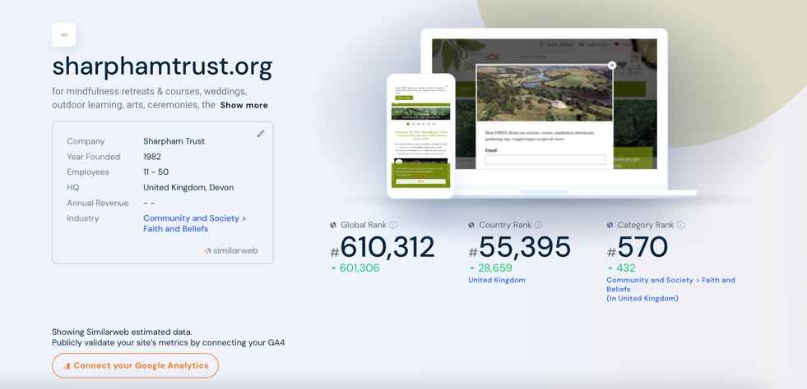
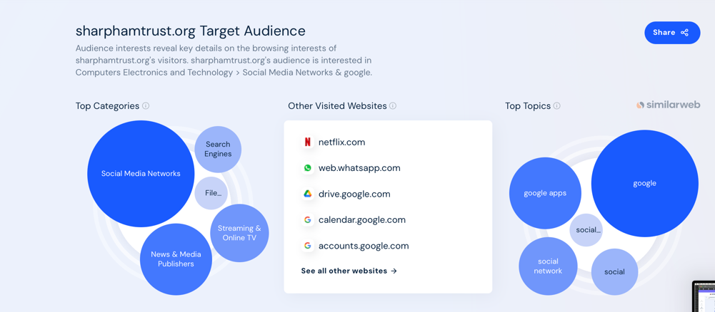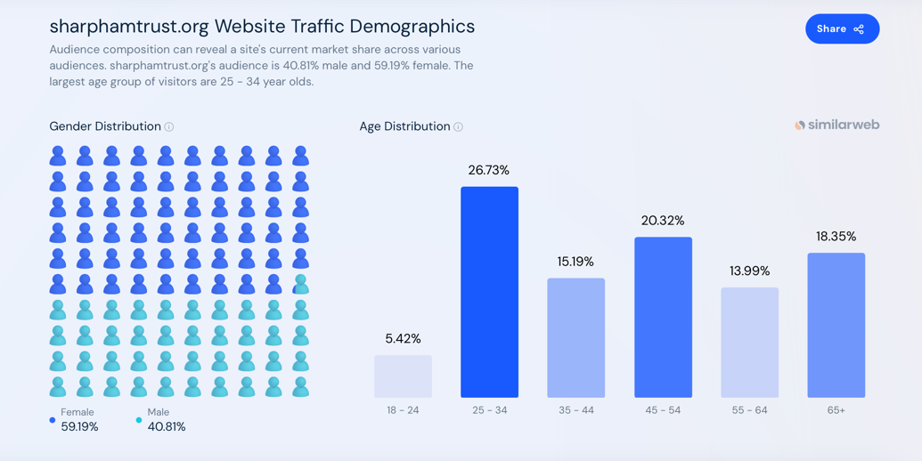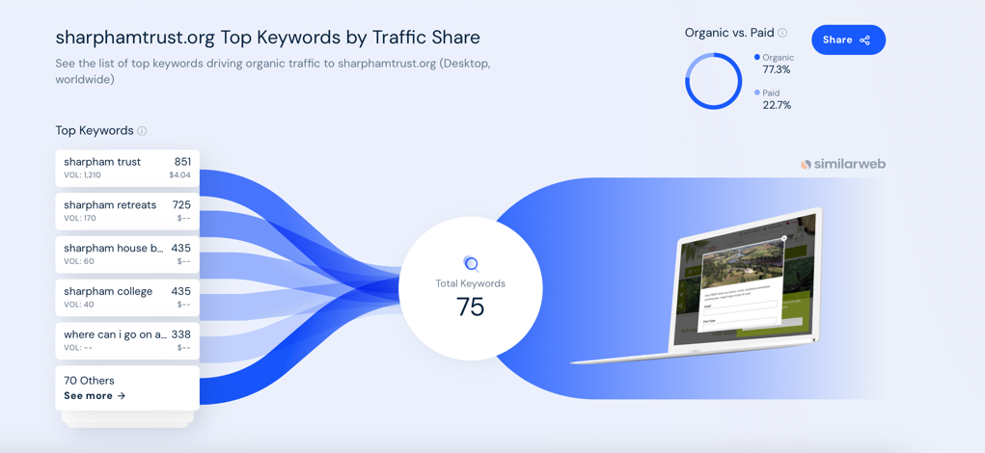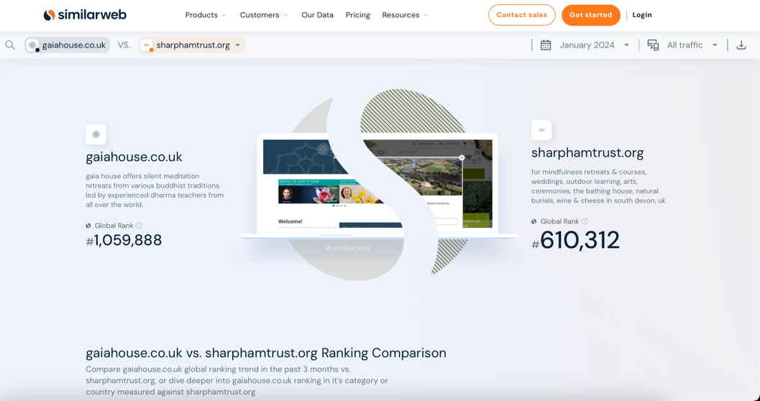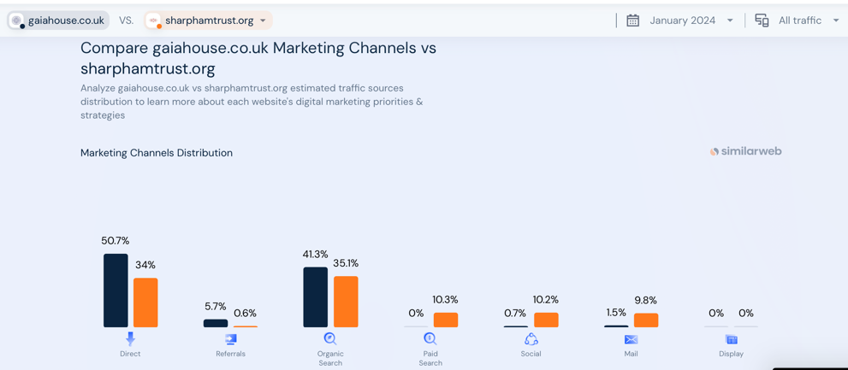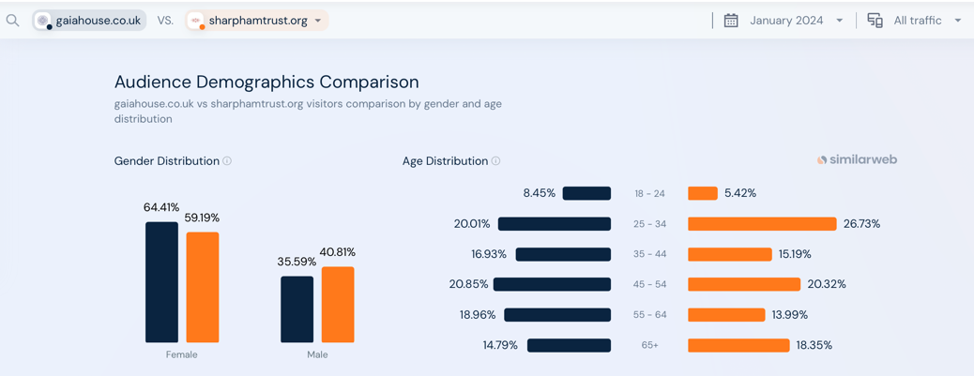
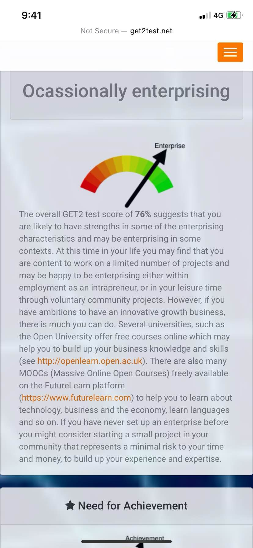
Appendix 2


