Maze Pathfinding Implementation

 C++

Table of Contents
Table of Figures 3
Introduction 4
Dijkstra’s Algorithm 4
A* Algorithm 5
Comparison of Dijkstra’s and A* 6
Development of the Implemented Algorithm 6
Strengths and weaknesses of the Algorithm 11
Additional Features 11
Conclusion 16
Bibliography 16

Table of Figures
Figure 1 - Dijkstra's Algorithm tries to find the cheapest route 4
Figure 2 - A Maze for Dijkstra's Algorithm 4
Figure 3 - A* Algorithm on a grid 5
Figure 4 - Maze to demonstrate that A* can make mistakes (Red Path - Where A* would likely want to go, Green Path - Fewest Moves to Target) 5
Figure 5 - Strengths and Weaknesses of Dijkstra's and A* 6
Figure 6 - A maze generated by the provided program 6
Figure 7 - A generated maze with the desired path drawn 7
Figure 8 - Programmer's Algorithm in Simplest form 7
Figure 9 - Algorithm's Variables 8
Figure 10 - Code to make the player move right when at the top of the maze 8
Figure 11 - The code to scan a wall for a gap 8
Figure 12 - The code to move the player towards the gap 9
Figure 13 - Code to move the player up and check whether the player has reached the target 9
Figure 14 - Gif of How the Algorithm moves through a maze 10
Figure 15 - Results of the Maze completion 10
Figure 16 - Added Subroutines 11
Figure 17 - Data generation and Subroutine callers 12
Figure 18 - Variables Created for Data Collection 12
Figure 19 - Alterations to Header File 13
Figure 20 - Global Variables found at the top of Grid.cpp 13
Figure 21 - Altered Results Subroutine 13
Figure 22 - Within Benchmarking mode, the program outputs a percentage of completion instead of the results of each maze 14
Figure 23 - The data collected within Benchmarking mode 14
Figure 24 - In Automatic mode, you now get the option to run Automatic mode again and whether to have the maze printed out with each move 15
Figure 25 - Mazes being printed out for each step 15

Introduction
In this document, Rhys the programmer will research into different maze searching algorithms and make comparisons and evaluations on them. Additionally, the programmer has been asked to code their own algorithm to navigate randomly generated mazes, challenged to make an algorithm that’s as efficient as they can possibly make it at travelling through the mazes.

Dijkstra’s Algorithm
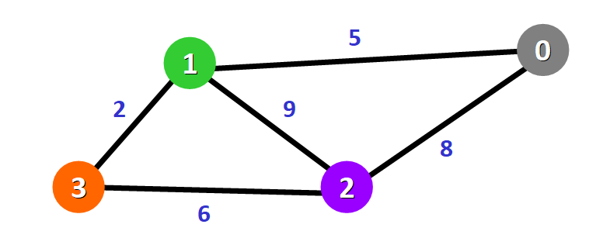
Figure 1 - Dijkstra's Algorithm tries to find the cheapest route
Dijkstra is an algorithm with a multitude of use cases. It can be used for networking, satnavs and map routing, maze searching and much more. It works by storing potential paths and their distances/costs in a queue and travelling the shortest route every time until it reaches the target location. Dijkstra’s algorithm can only be used in situations where there’s a distance or cost to move to the next location. [1]
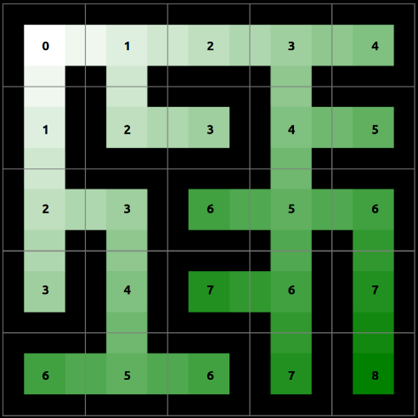
Figure 2 - A Maze for Dijkstra's Algorithm
In a maze scenario, each possible position would likely be assigned a cost of 1, as it is one move away from the last position. It would then scan the cheapest route at each intersection. If it meets a dead end, it will backtrack to the last intersection and try the next route stored in the queue. Once it has gotten to the end, it would have essentially found the cheapest route to the end as it prioritises the cheapest routes first. When that route has been found, the player can then navigate through that route to get to the end in the smallest possible number of moves. Although in a situation where a small amount of maze accesses is desired, Dijkstra’s algorithm could search down multiple paths before finding the right one, which could increase the number of maze accesses quite far.

A* Algorithm
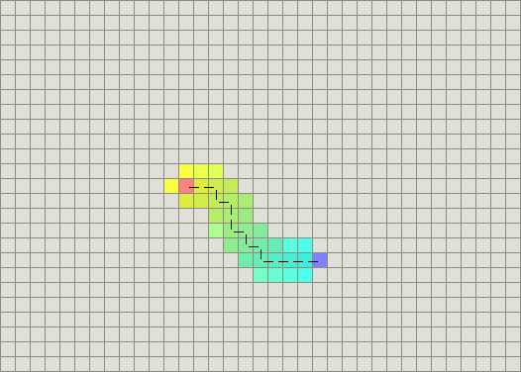
Figure 3 - A* Algorithm on a grid
The A* algorithm is near identical to the Dijkstra’s algorithm, whereby it will search the cheapest routes first. The A* algorithm is basically a variant of the Dijkstra’s algorithm, just a bit more complex. A* will prioritize routes which get it closer to the target, unlike Dijkstra’s which just picks the first route in the queue. This means that A* typically spends a lot less time searching for the route to the end of the maze. [2]
X | X | X | X | X | X | X | X | X | X | X | X | X
X |  |  |  | X |  |  | X |  |  |  |  | X
X |  | X |  | X | X |  | X |  |  |  |  | X
X |  | X |  | X | X |  | X |  | X |  |  | X
X |  | X |  | X |  | P |  |  | X |  |  | X
X |  | X |  | X | X |  | X |  | X |  |  | X
X |  | X |  | X | X |  | X |  | X |  |  | X
X |  | X |  |  |  |  | X |  | X |  |  | X
X |  | X | X | X | X | X | X |  | X |  |  | X
X |  |  |  |  |  | T |  |  |  |  |  | X
X | X | X | X | X | X | X | X | X | X | X | X | X
Figure 4 - Maze to demonstrate that A* can make mistakes (Red Path - Where A* would likely want to go, Green Path - Fewest Moves to Target)
A* can make mistakes. Figure 4 shows a maze, where a blank space is a movable position, an X is a wall, P is the player starting location and T is the target. Where the players spawns, it has the option to go up, left, down or right. The A* algorithm would likely prioritize moving down as it gets it closer to the target’s position. Moving down is actually a very long path, but it does get to the target, so A* would likely stop searching there. The green path in the maze is the fastest path to take, but A* would likely ignore the right route for the down route. In essence, A* doesn’t always take the most direct route to get to the end of the maze.

Comparison of Dijkstra’s and A*
With the Dijkstra’s and A* algorithms, they have a lot of similarities. That being said, they still have their advantages and disadvantages over each other when it comes to maze searching.
Algorithm | Dijkstra’s | A*
Strengths | - Always finds the best route eventually.  - Simpler than A* to implement. | - Can be faster on average than Dijkstra’s.  - Would likely scan the maze a lot less on average, which would result in it being more efficient.
Weaknesses | - Can be quite slow, especially compared to A*.  - Would typically scan the maze a lot, which would result in it accessing the maze a lot more on average than A*. | - Might not always take the least amount of moves to get to the end of the maze.  - More complex than Dijkstra’s.  - Can potentially be slower than Dijkstra’s if the conditions aren’t towards A*’s favour.
Figure 5 - Strengths and Weaknesses of Dijkstra's and A*

Development of the Implemented Algorithm
The programmer was given the task to code an algorithm which would find its way through a randomly generated maze. Due to the simplicity of the generated mazes, instead of utilising an already existing algorithm to navigate them, the programmer decided to make his own.
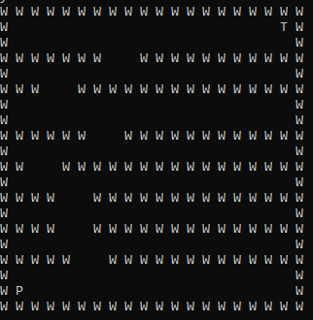
Figure 6 - A maze generated by the provided program
From looking at the generated mazes for the first time, the programmer was able to see a potential solution. The generated mazes were very basic, comprising of horizontal walls with two wide gaps randomly placed within them.
Figure 7 - A generated maze with the desired path drawn
The lack of vertical walls meant that there was an obvious path to take with every maze generation, whereby the player just has to prioritise going up to the highest point, then going right to get to the target. The programmer decided to create an algorithm which would move on this desired path.
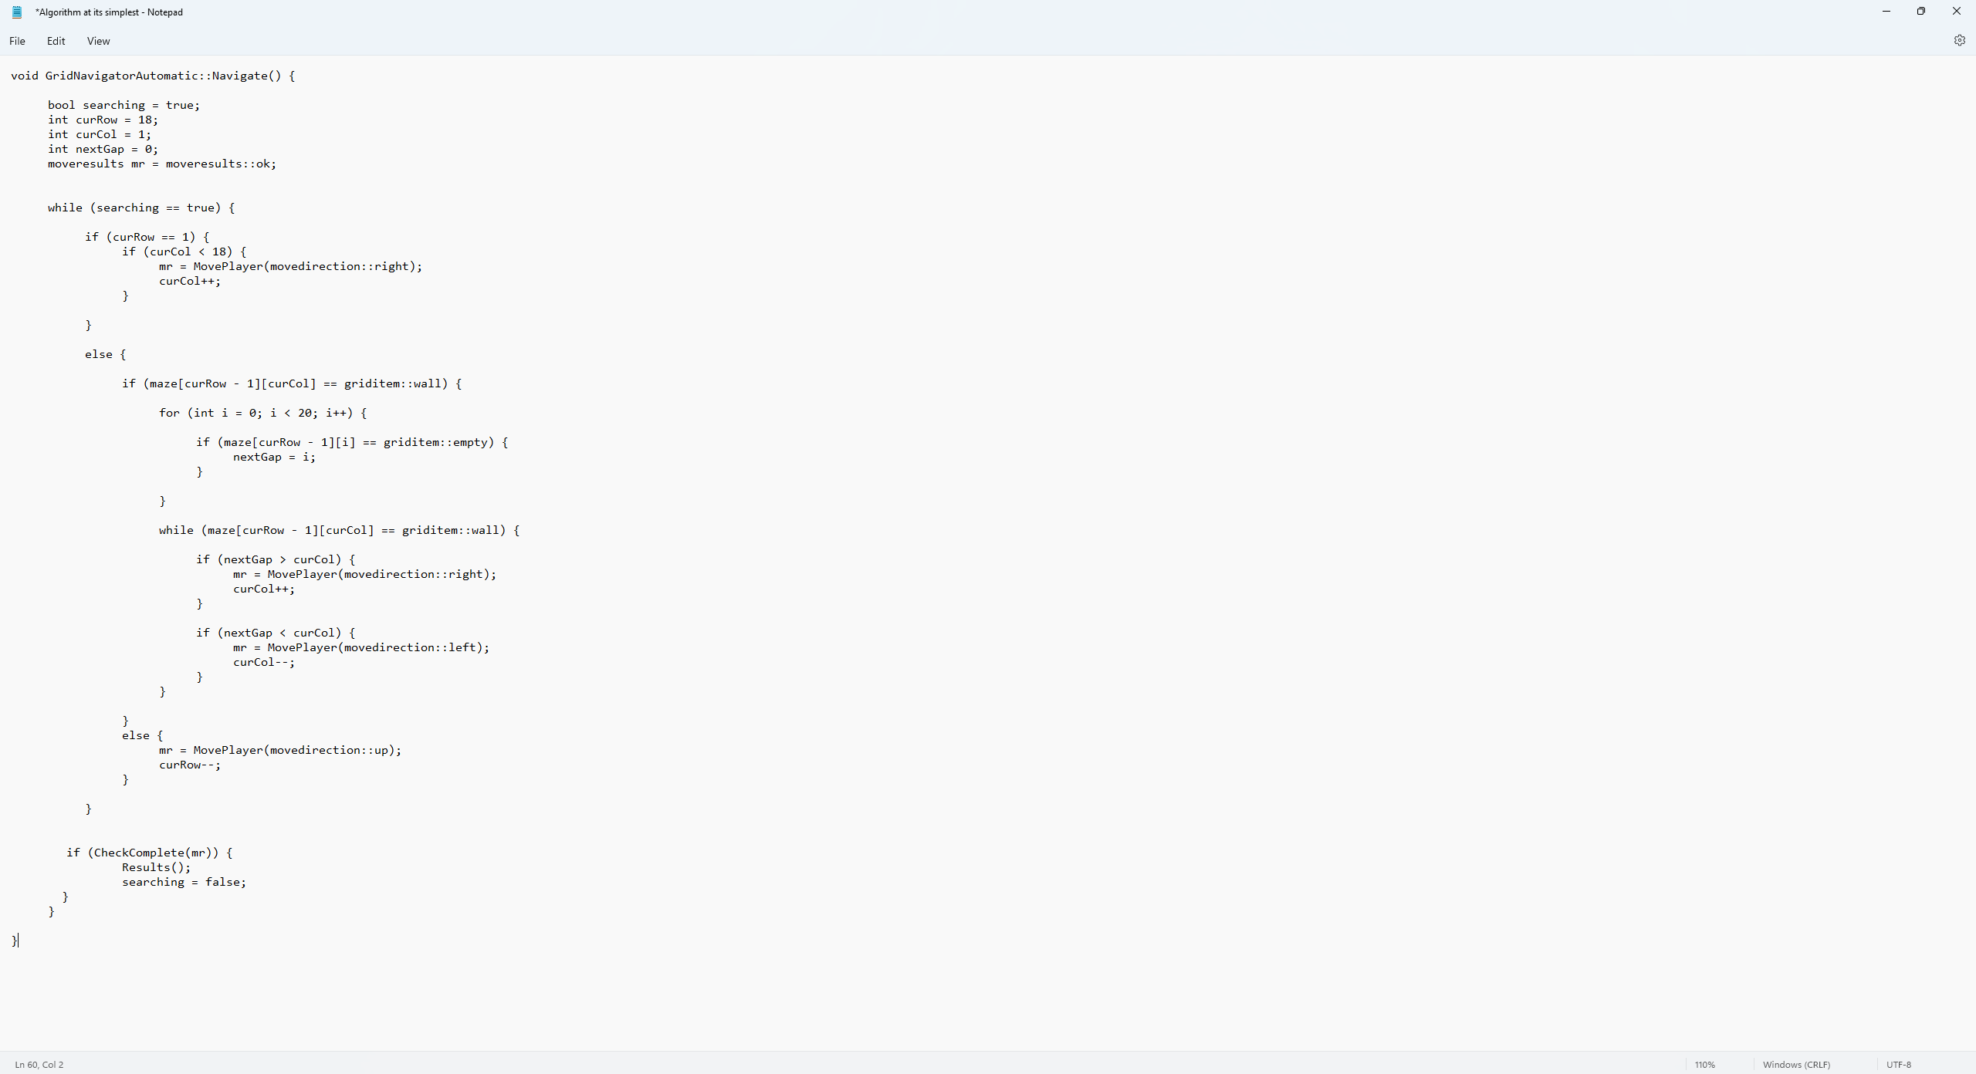
Figure 8 - Programmer's Algorithm in Simplest form
Figure 8 shows the created algorithm. This is the algorithm at its simplest working form, before comments were written and code was added to get it functional with running 10k times and collecting means, min and max values. It is actually a very simple solution; however, the programmer believes that a simple maze should have nothing but a simple solution.
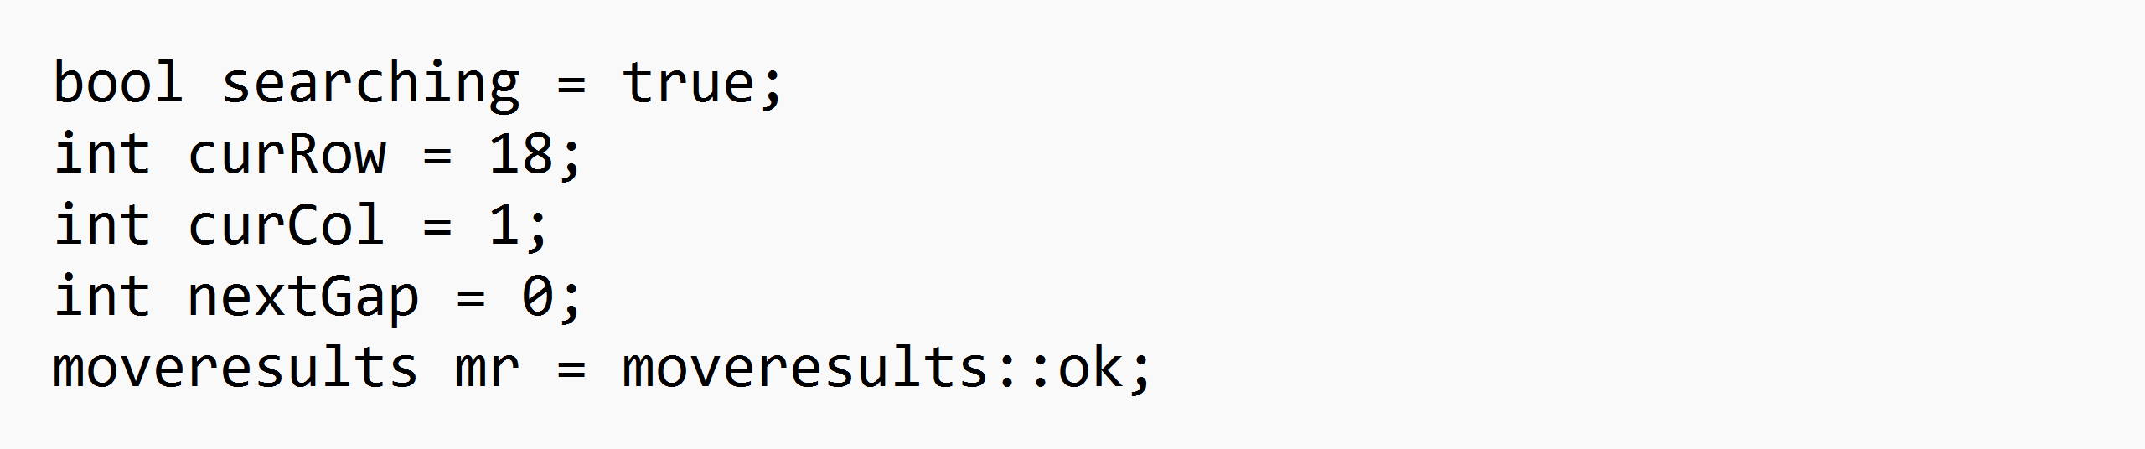
Figure 9 - Algorithm's Variables
There are 5 variables used to get the algorithm to work. The searching Boolean is used within the main loop of the algorithm to repeat the code until the target has been reach. The two integers called curRow and curCol are used to store the player’s current location within the maze and act like coordinates, initially set to the location where the player always begins within the maze. The nextGap integer is used to store the location of a gap in the wall when the player reaches a wall and mr is used to allow the player to move.
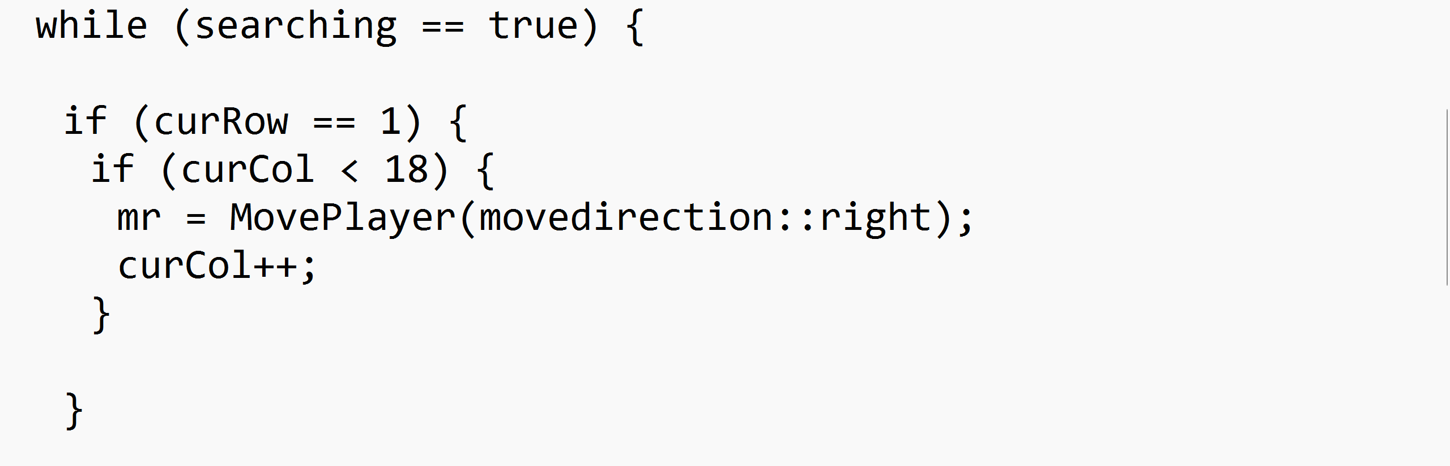
Figure 10 - Code to make the player move right when at the top of the maze
The first thing the algorithm does is check whether the player is at the very top of the maze. If it is, then it will move right until it reaches the target.
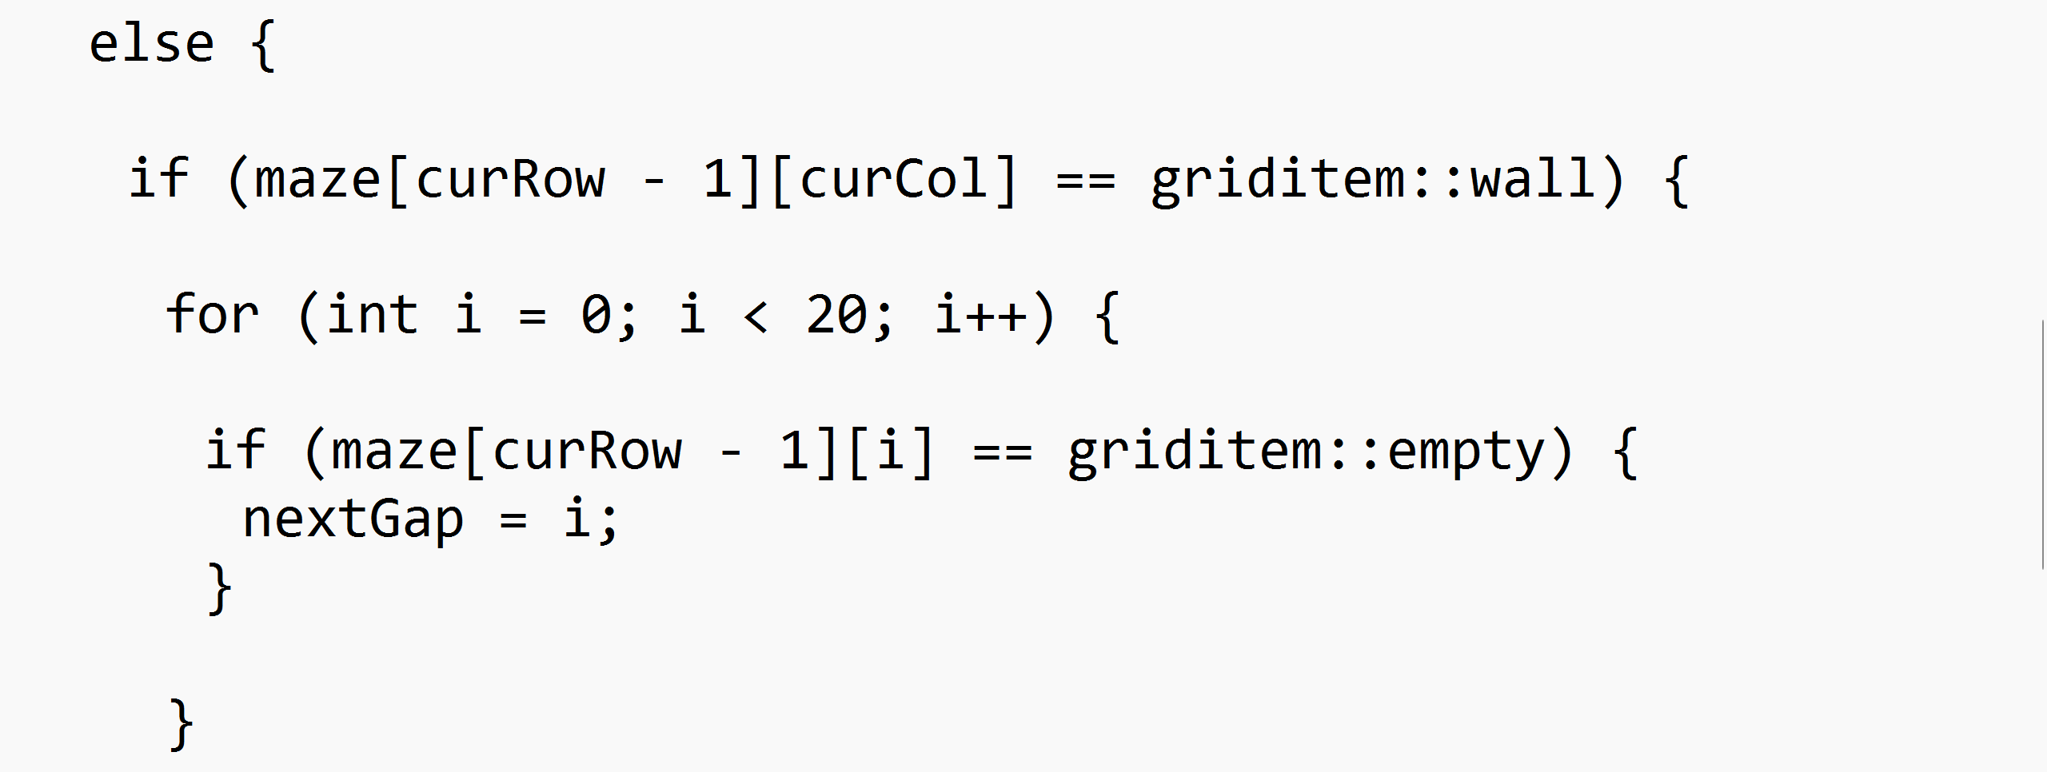
Figure 11 - The code to scan a wall for a gap
If the player isn’t at the top of the maze, then it will check if there’s a wall above the player. If there is, then the algorithm scans the wall above it for the gap in the wall, which is stored in the nextGap variable.
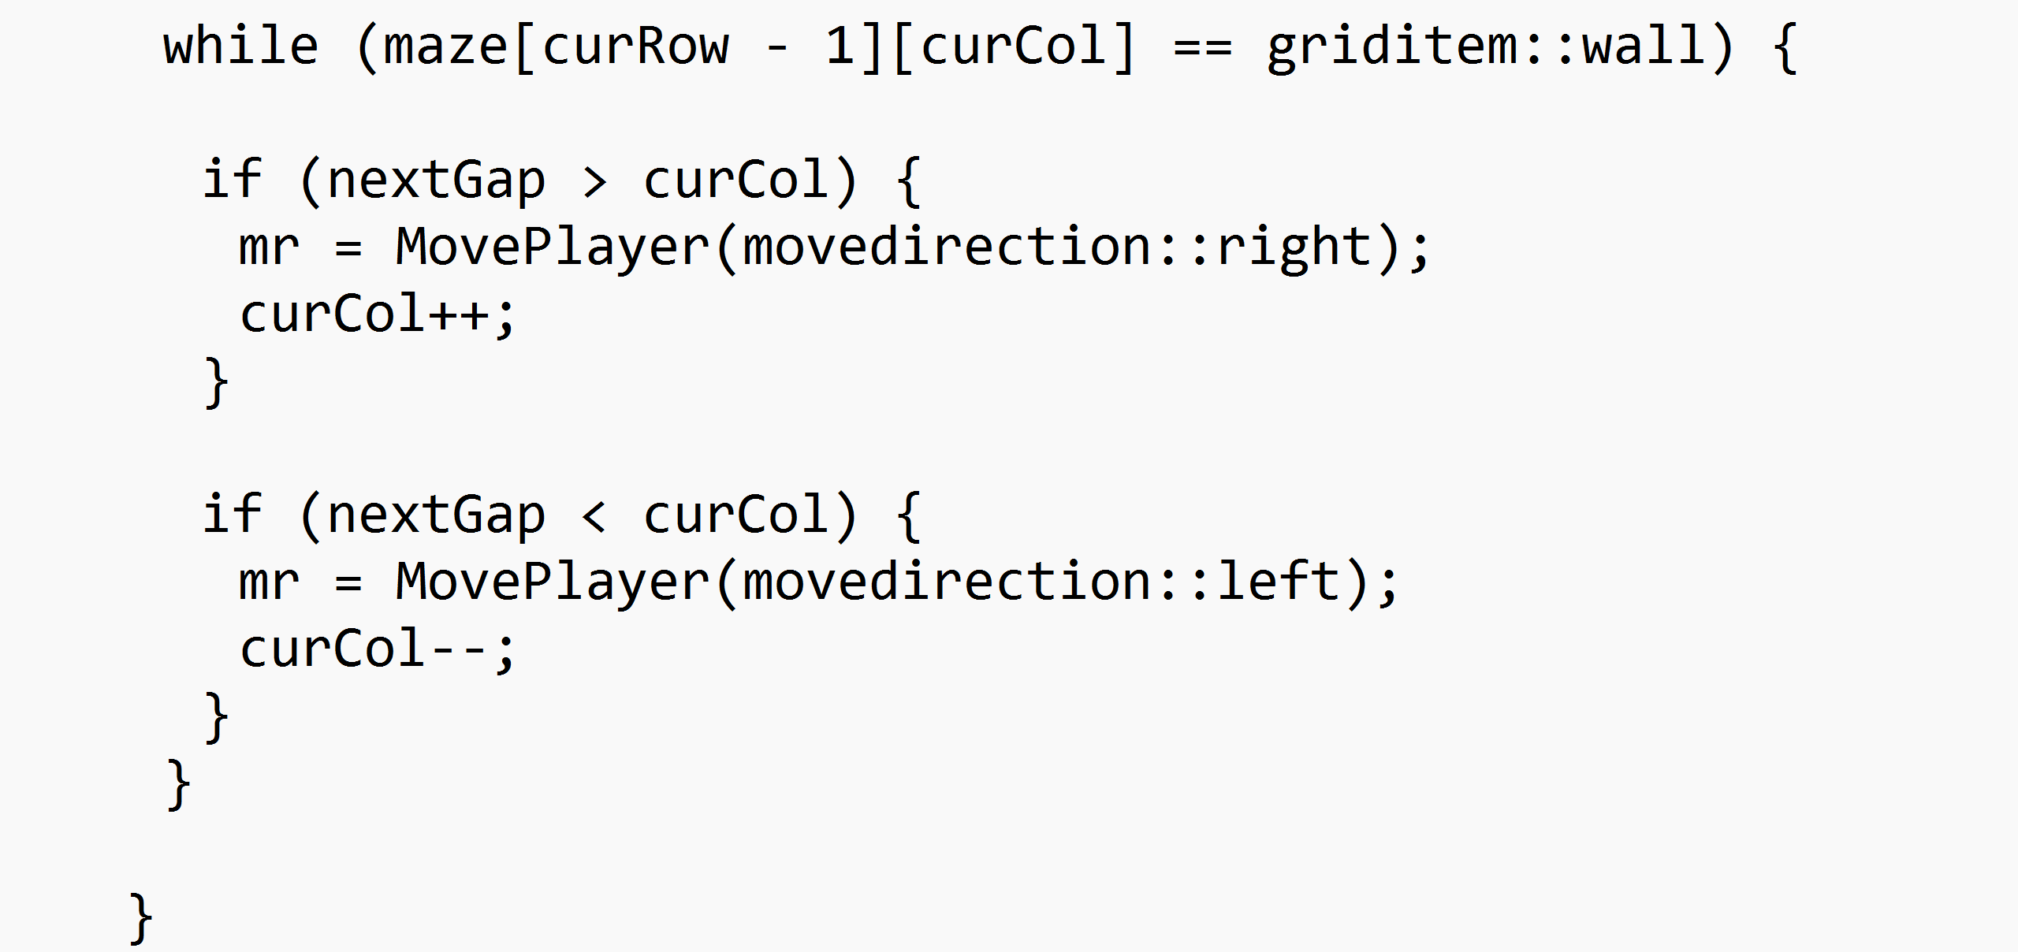
Figure 12 - The code to move the player towards the gap
While there’s a wall above the player, it will move towards the gap in the wall. If the gap is to the left of the player, it will move left, and it would move right if the gap is to the right.
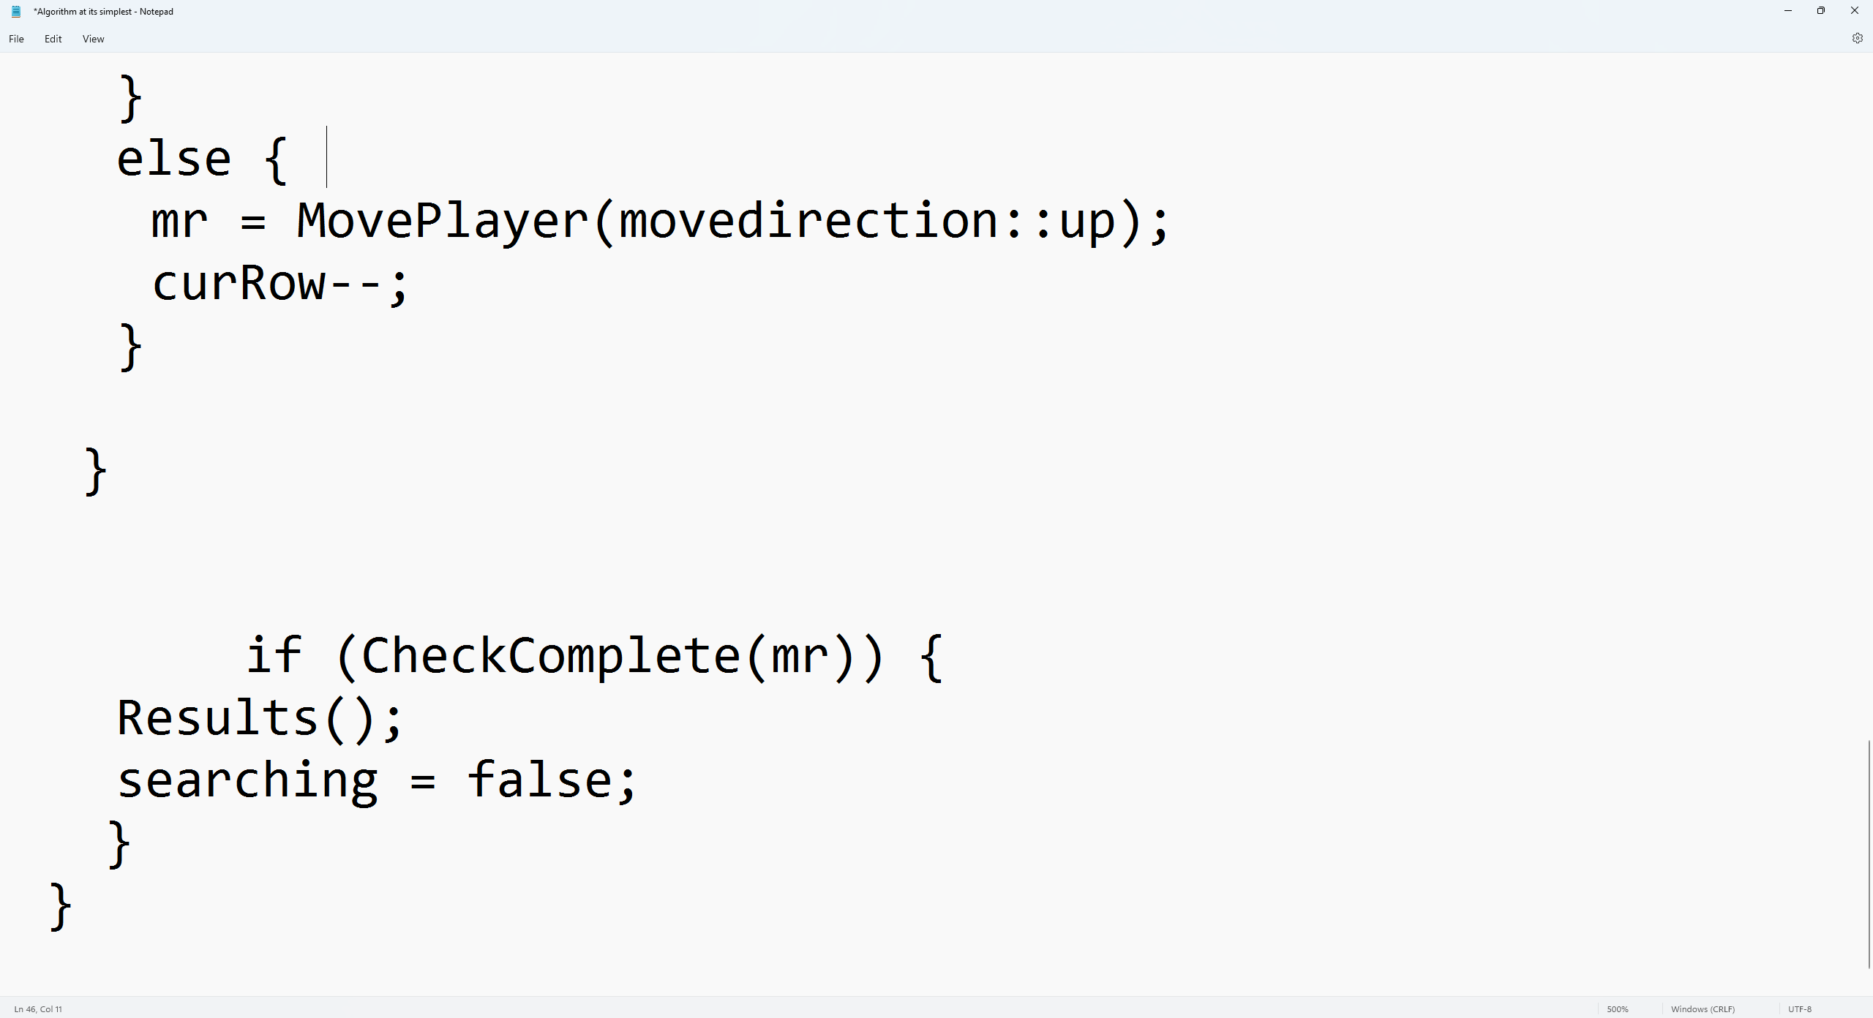
Figure 13 - Code to move the player up and check whether the player has reached the target
If there isn’t a wall above the player, then it just moves up. At the bottom of the loop, there is a check for whether the player has reached the target. if it has, then the results get printed and the loop closes.
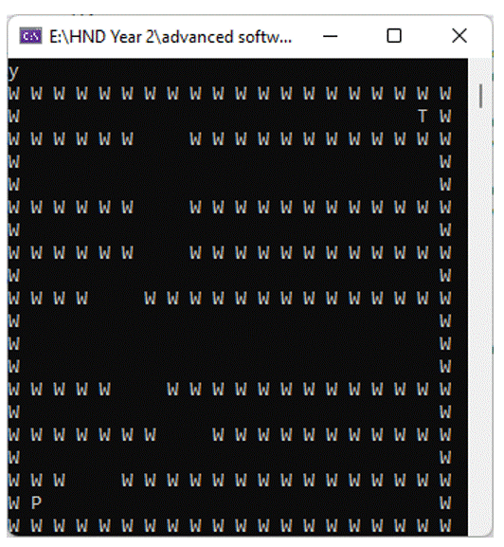
Figure 14 - Gif of How the Algorithm moves through a maze
So how does the algorithm travel through the maze? It always prioritises moving up unless either a wall is above the player, or the player is at the top of the maze. If it hits a wall, the player moves to the gap, if the player is at the top of the maze, it moves right until it reaches the target.
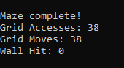
Figure 15 - Results of the Maze completion
As seen in figure 15, the algorithm doesn’t hit any walls and interestingly has as many grid accesses as moves with each maze search.

Strengths and weaknesses of the Algorithm

Strengths:
- The algorithm is incredibly simple.
- The algorithm didn’t take long to create, so other parts of the program could be focused on.
- The algorithm uses the fewest moves possible with each maze generation.
- The algorithm doesn’t hit any walls.
- The algorithm seems perfect for the generated mazes.
Weaknesses:
- The algorithm physically can’t move the player down, so if the maze generation was altered so that vertical walls could generate, the algorithm would likely get stuck and never be able to complete most mazes. Fixing this could potentially make the algorithm much more complicated.
- If it were possible for multiple gaps to generate in the horizontal walls, the algorithm would always prioritize the furthest gap to the right due to how it searches the wall for gaps from left to right. This could result in the Algorithm not going the most direct route to the end of the maze.
- The code could probably be tidied up more and made more efficient in a few ways, but efficiency doesn’t really matter here as the algorithm is so small anyway.

Additional Features
The programmer wasn’t just asked to create an algorithm for the maze, but additionally a benchmarking mode which would run the algorithm 10k times and calculate the min, max and average number of moves, accesses and walls hit.
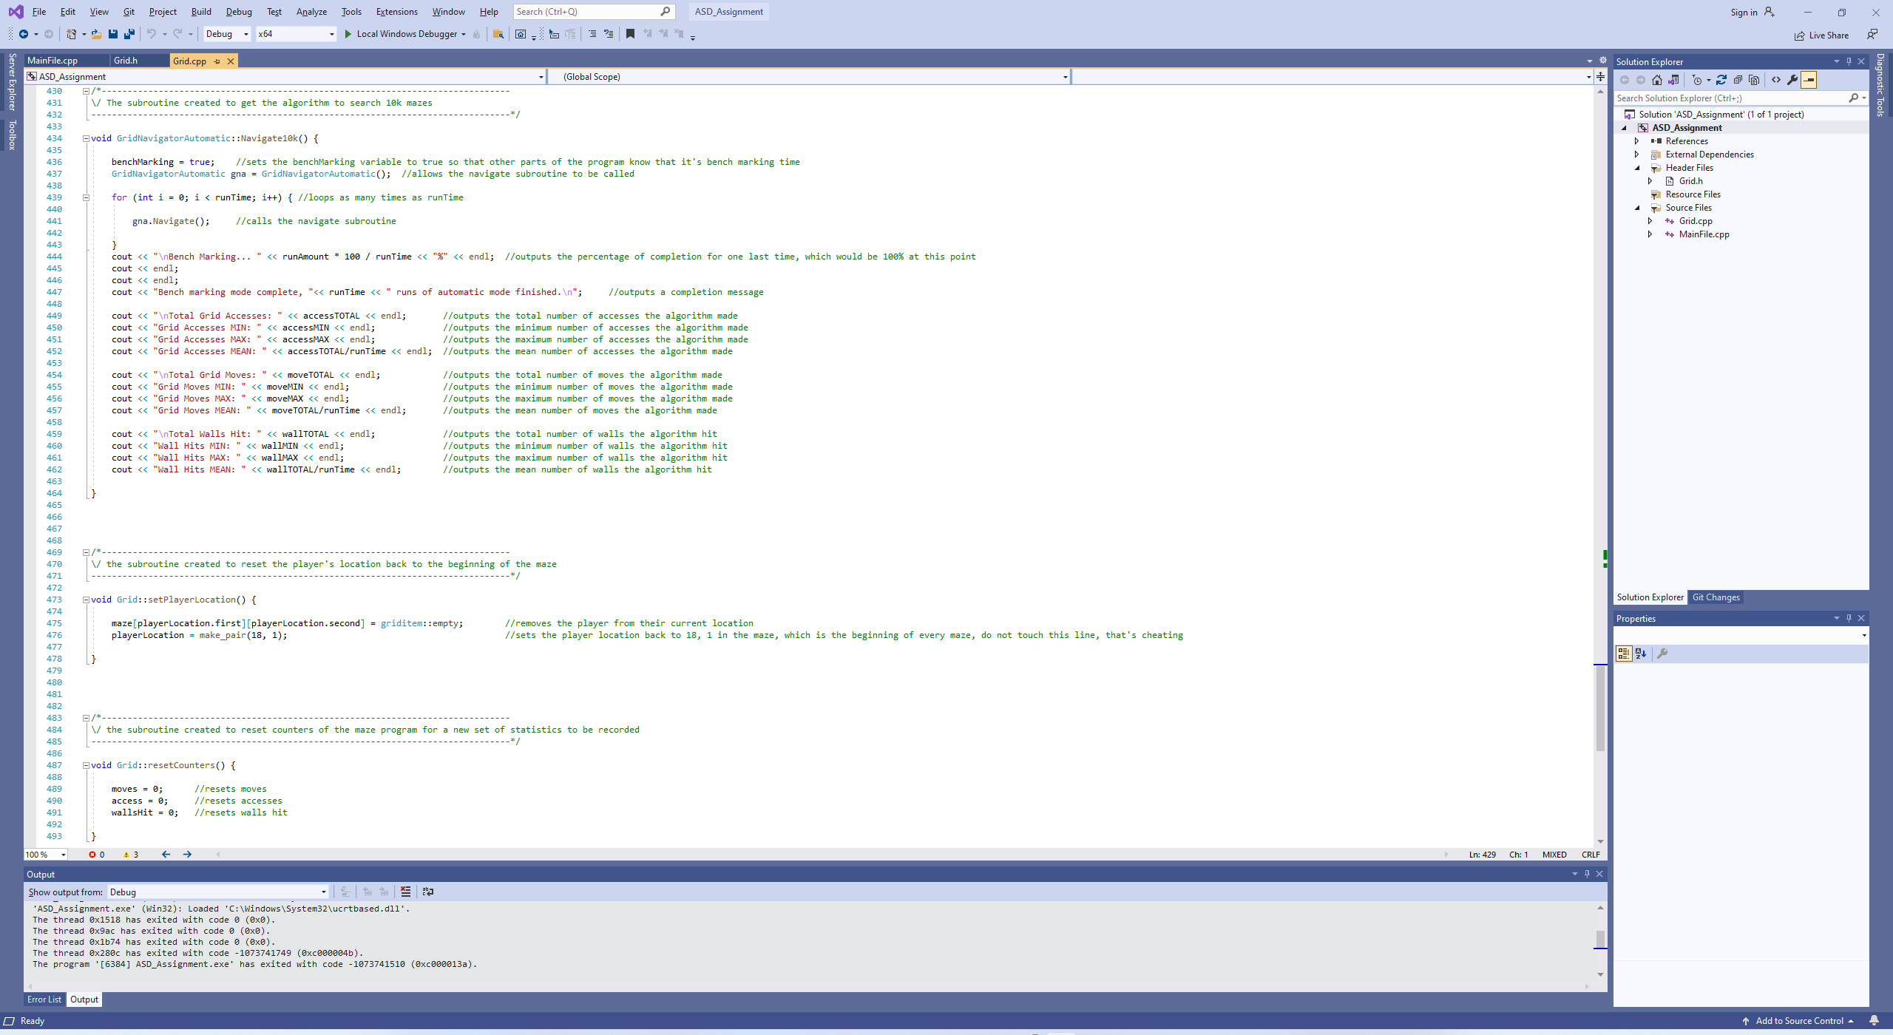
Figure 16 - Added Subroutines
Figure 16 shows the subroutine implemented to allow the algorithm to run 10k times, along with the subroutines to reset the counter and respawn the player at the start of the maze.
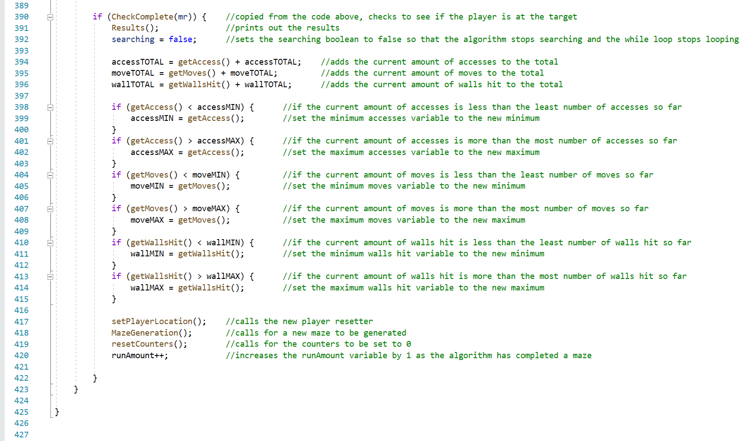
Figure 17 - Data generation and Subroutine callers
Figure 17 shows the changes that were made to the checkcomplete if statement within the algorithm to allow the program to record the results of each maze navigation. It then calls some subroutines to reset the maze for the next navigation (generates a new maze, resets the player and counters).
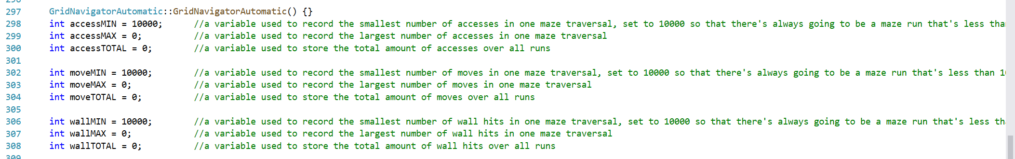
Figure 18 - Variables Created for Data Collection
Figure 18 shows the variables which were created to store information about the maze runs.
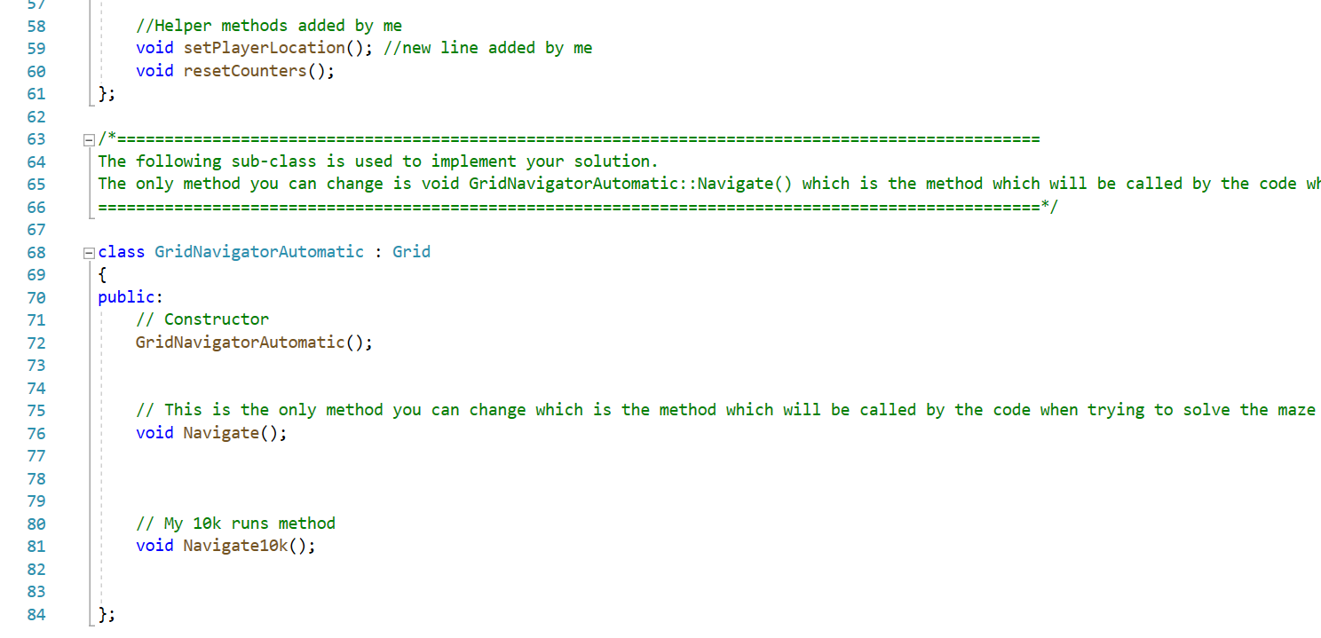
Figure 19 - Alterations to Header File
Figure 19 shows the alterations made to the header file.
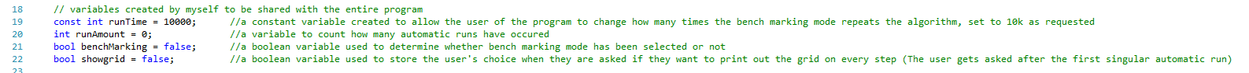
Figure 20 - Global Variables found at the top of Grid.cpp
Figure 20 shows the global variables which were created near the top of the Grid.cpp, including a constant integer to allow users to alter the amount of maze searches which occur in bench marking mode.
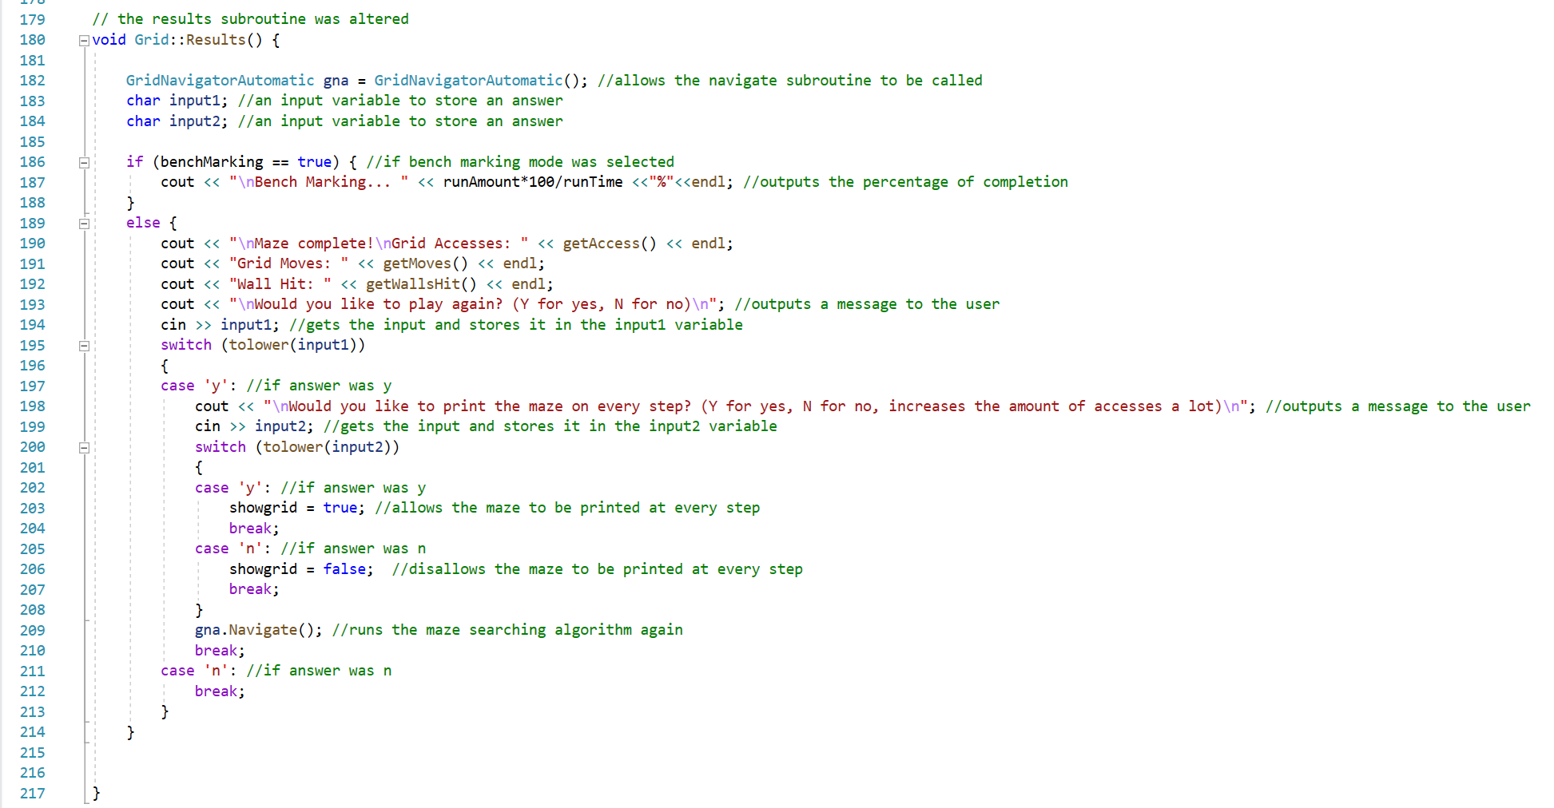
Figure 21 - Altered Results Subroutine
Figure shows the altered results subroutine, which was upgraded to allow users to see the progress within benchmarking mode and allows them to generate a new maze after a singular automatic maze search. The unique features added can be seen in the figures below.
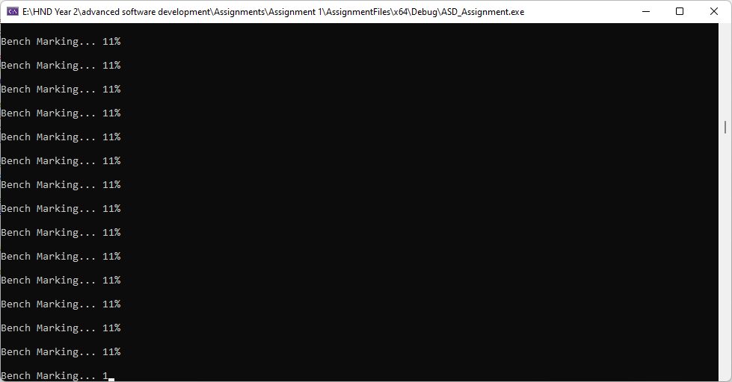
Figure 22 - Within Benchmarking mode, the program outputs a percentage of completion instead of the results of each maze
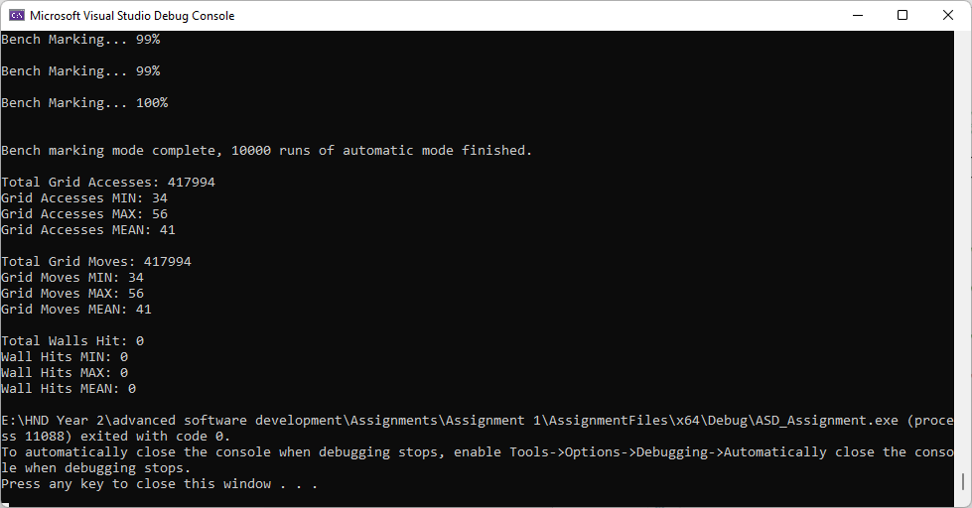
Figure 23 - The data collected within Benchmarking mode
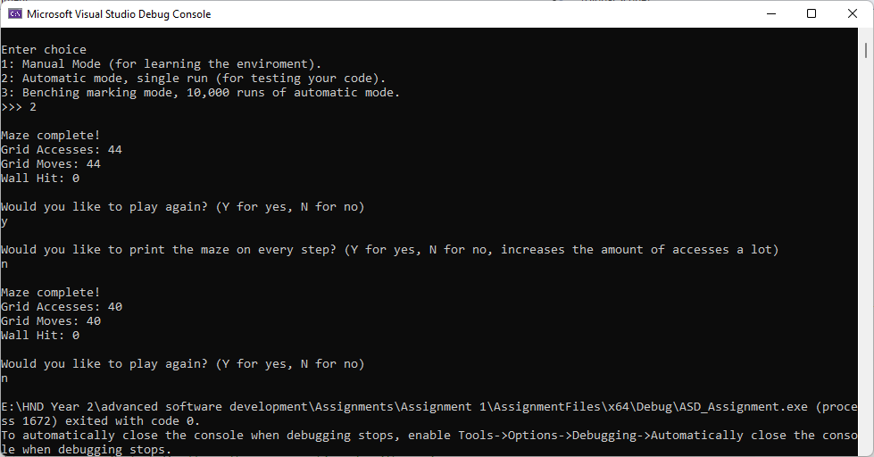
Figure 24 - In Automatic mode, you now get the option to run Automatic mode again and whether to have the maze printed out with each move
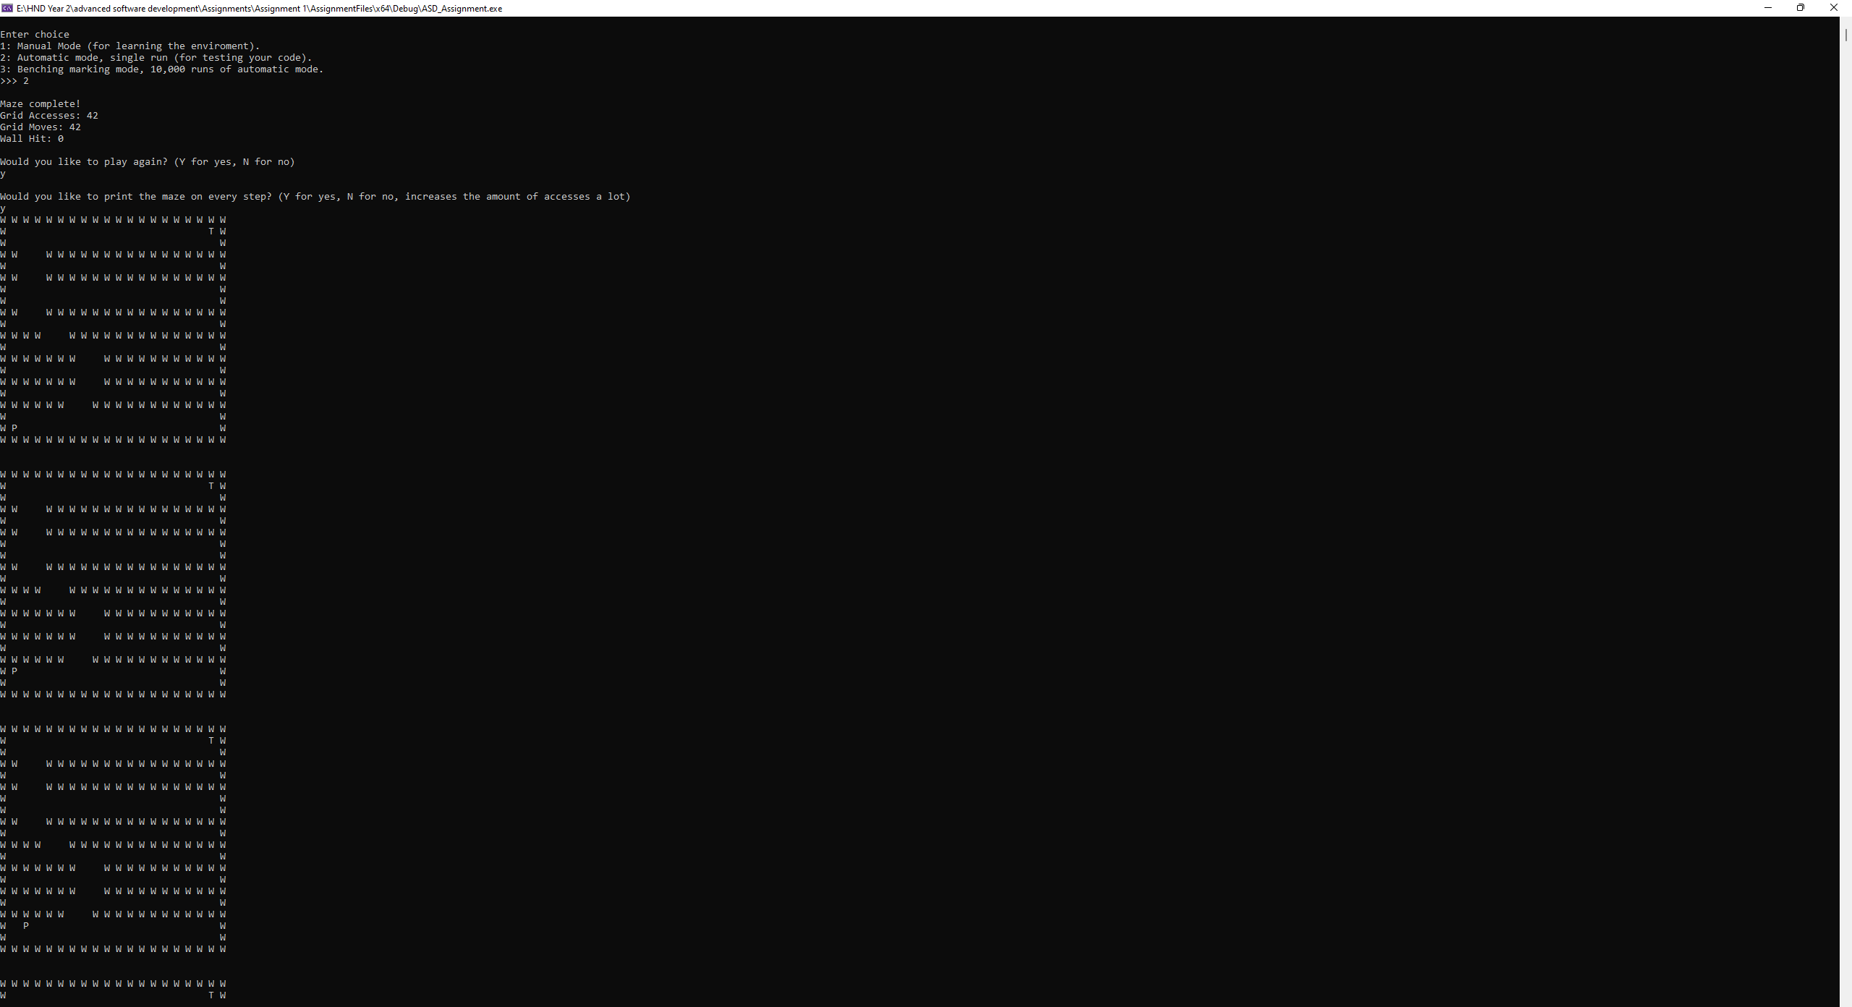
Figure 25 - Mazes being printed out for each step

Conclusion
In the end, the programmer is happy with his achievement. He was able to create his own algorithm to search the mazes without inspiration from other algorithms and class resources, he just sat down, looked at the mazes and started coding a solution from there. He was surprised that he was able to create an algorithm which could navigate the mazes perfectly. If the mazes were more complicated, he believes he would have tried using either the A* or Dijkstra’s algorithm, or even both to compare the two.

Bibliography

[1] | M. Jeulin-Lagarrigue, “Dijkstra,” 2020. [Online]. Available: https://hurna.io/academy/algorithms/maze_pathfinder/dijkstra.html.
[2] | A. Patel, “AStarComparison,” stanford, 1997-2022. [Online]. Available: http://theory.stanford.edu/~amitp/GameProgramming/AStarComparison.html.

