Value led culture and employee satisfaction.
-
A study and comparison of workplace culture in care and support agencies within the third and public sectors.
-
2105356
Laura Clarke
BA Business & Management
-
7774 words

DECLARATION
- This work has not previously been accepted in substance for any degree and is not being concurrently submitted in candidature for any degree.
- This Dissertation is being submitted in partial fulfilment of the requirements for the degree of BA Business Management.
- This Dissertation is the result of my own independent work/investigation, except where otherwise stated. Other sources are acknowledged by footnotes giving explicit references. A Bibliography is appended.
- I hereby give consent for my Dissertation, if accepted, to be deposited in the School Dissertation Library.
Name: ……Laura Clarke………………………………………..
Date of Submission: ……12/04/2024………………………………………..
Signature: ……………………………………………..

Acknowledgements
I would like to thank my family, especially my mum, for unwavering support, childcare to allow me to study, and the constant reassurance and the confidence they have shown in me, never doubting my decision to return to study while caring for two children, one of whom was a six-month-old.
I would also like to issue thanks to the third and public sector staff who kindly agreed to take part in the interviews, and willingly shared their views and experiences, in particular staff at a certain third sector agency who went above and beyond to assist me- you know who you are. (Subcultures – not only punks and mods!)
Thanks to the teaching staff on the BA Business & Management course, who provided engaging and thought-provoking content over the last three years, and to my peers/course mates who have been so welcoming and supportive, and made the entire course a pleasure to be a part of.

Abstract
This research project explores value led culture and value conflicts within the third sector and the public sector. Eight Interview candidates were selected based on their workplace and geographical area, the candidates cover a range of different roles and seniority levels, all candidates were asked a series of semi structured questions, leaving space for their views, paradigms and senses of self and identity to be identified and explored.
A qualitative approach was taken to the research, as the research question is not one that can be accurately explored through quantitative data.
Several key themes were identified following examining of the interview data, including that of public service motivation in all interview subjects.
Issues of entitlement and recognition were explored, as well as issues and differences in perception between employees of different positions within organisations.
This research provides useful information of cultural beliefs and differences within the select organisations and industries and could be expanded upon to provide contract between rural and urban employees, and to explore how workplace culture and public service motivation affects productivity and absence levels.

Contents

1.Introduction 5
1.1 Research aims and objectives. 6
2.Literature Review 7
2.1 The third sector, SDGs and well-being of future generations act. 8
2.2 The public Sector 10
2.3 Social identity theory 11
2.4 Organisational culture 11
2.5 Value led culture. 13
2.6 Motivation and Value conflicts 14
3. Methodology 17
3.1 Research Context 17
3.2 Approaches 17
3.3 Strategies 18
3.4 Techniques and procedures 18
3.5 Ethical considerations 19
3.6 Limitations, validity, and reliability 20
3.7 Methodology Overview 20
4. Findings 21
4.1. Qualitative Data. 21
5. Discussion and Analysis 22
5.1 Theme- Public Service Motivation 23
5.2 Theme- Differences in perception of the organisational culture. 26
5.3 Theme- Entitlement and Recognition. 27
5.4 Theme- Reasons for Retention. 28
6. Conclusion 31
List Of Figures 32
References 34

1.Introduction
Organisational culture and value conflicts have been studied extensively, with theorists such as Peter Drucker, known as the father of modern management theory saying that “culture—no matter how defined—is singularly persistent.” – this is often (and more famously) quoted as ‘culture eats strategy for breakfast’ (Hoffman, 1993.) - Edgar Schein proposed three layers of organisational culture, comprising of Artefacts, Espoused Values and underlying assumptions, and connected this to the importance of psychological safety and feelings of acceptance and worth within the workplace (Kilmann et al., 1986).
This research project aims to explore workplace culture and employee wellbeing within organisations engaged in providing care and support services, focusing on employees within the third sector and public sector, in the geographical area of ‘old Dyfed’ now known as the counties of Carmarthenshire, Ceredigion and Pembrokeshire. Despite being devolved to separate local authorities, the three counties share a health board, police force and other public and third sector organisations work ‘cross-border’ within the counties.
The three counties are rural, with high rates of disability and an aging population, with a population density of 67 residents per square kilometre, in contrast, Cardiff, the capital of Wales has a population density of 2571 people per square kilometre (Statistics Wales Demography Newsletter: August 2022 | GOV.WALES, 2022)

1.1 Research aims and objectives.
This study aims to draw contrasts and parallels between third sector and public sector staff working in help and support agencies across the geographical areas, as stated above, workplace culture and employee wellbeing and satisfaction has been studied extensively, and it was evident that public sector organisations place value on commissioning studies of their own workplace cultures and environments, in an effort to extrapolate data on employee productivity and wellbeing. There is significantly less data available on workplace culture within third sector organisations. Susan Bond, in her 2018 paper on workplace culture in third sector organisations in Scotland drew the conclusions that while the majority of third sector staff used a client focus approach, conflict could arise when this came up against a business centred approach, and that the continuing hybridity of third sector and public sector organisations means that these organisations, which may have viewed themselves as wholly separate agencies with differing priorities now find themselves competing for funding streams and contracts (Bond, 2018)
This study aims to expand on the research of Bond and other theorists, and explore the importance of vocationalism within the workplace, and what impact, if any this has on workplace culture and overall wellbeing of employees. the subject of pay, or financial renumeration will be raised with all interview candidates, with the aim of this question being to identify if emotional reward and recognition is more important that salary or status. An extensive literature review will be carried out, to provide contrast and background to the research project.

2.Literature Review
This literature review aims to examine the available literature and identify how it relates to the research question, in order provide context for this research. While there is a wealth of research dating back to at least the 1950s on employee engagement and workplace culture, when Elliot Jaques defined workplace culture as “"its customary and traditional way of thinking and doing of things, which is shared to a greater or lesser degree by all its members, and which new members must learn, and at least partially accept, to be accepted into service in the firm" (Alchian, 1950) there is much less available research and data on workplace culture and values within the third sector or other help and support agency sectors specifically. In drawing comparisons with the public sector and third sectors for the purpose of this research study, it became clear that there are gaps in the literature, this appears to be due to the fact that public sector organisations are generally larger scale organisations, with the ability or requirement to conduct regular employee surveys and with graduate schemes and bursary schemes which mean that research is more likely to be carried out on these specific organisations, in contract to third sector organisations which are usually smaller or more ‘self-sufficient’ – without the HR capabilities of the public sector. (NCVO, 2023.)

2.1 The third sector, SDGs and well-being of future generations act.
The third sector is an umbrella term for those organisations that are neither public nor private sector, and that are involved in creating social wealth and wellbeing, rather than organisational wealth. Third sector organisations include “registered charities and other organisations such as associations, self-help groups and community groups), social enterprises, mutuals and co-operatives” (National Audit Office (NAO), 2023) and the 1997 paper by Salamon and Anheier defines Third sector agencies as those that are “simultaneously; not profit distributing, independent from the state and benefiting from some level of voluntarism, usually donations, volunteering or by grant funding” (Kendall & Knapp, 2000).
Statistics compiled in 2022 show that 3% (1.1 million people) of employed individuals in the UK are employed within the third sector (Third Sector Trends 2022: First Report Released, 2022), this in contrast to private sector organisations, which holds 82% of the workforce (Statista, 2023) and statistically 75% of employees within the 3rd sector are women, and 50% of CEOs are women (paydata.co.uk 2023) this is in marked contrast to the fact that only “11 firms in the FTSE 250 are led by women” (Murray, 2023). Pay in the third sector is traditionally lower than that in the private and public sectors and Cunningham (2014) states that “Despite reports of a willingness among workers to trade off lower wages and conditions for the chance to ‘do good’, part of the reasons for recruitment and retention problems are because of the twenty – fifty percent gap in wages paid to those in the sector compared with similar roles in the government sector” (Cunningham et al., 2014)
Research by Benz (2005) suggests that third sector employees are motivated by intrinsic motivation and orientation, rather than solely monetary rewards, and by holding shared values with the organisation they become part of a psychological contract, which hinges on a mutual respect of beliefs and values (Frey & Osterloh, 2002) and that this psychological contract can ‘crumble’ if the employees perceive the actions of the management to be unfair, unjust, or against the mutual principles that the psychological contact is formed of (Fehr et al., 2002) despite the key factor in distinctiveness of the paid workforce in the third sector is that it is based on characteristics ‘of altruism, a commitment to a particular group or cause, a desire to care and related political and ideological beliefs’ (Cunningham 2010).
The United Nations Sustainable Development Goals are a set of 17 interlinked goals, which combined aim to tackle poverty, end deprivation and improve health and wellbeing and economic growth, the goals were implemented by all member states in 2015 (THE 17 GOALS | Sustainable Development) and in order to achieve these goals by 2030 collaboration between the third, private and public sectors is crucial. Implementation of the goals has caused funding to be funnelled into the third sector, in a ‘semi-hybridisation’ move that came around as there are some services that third sector organisations are better able to provide due to their innate flexibility (Bond, 2018)
The SDG also triggered the Wellbeing of Future Generations act, published in Wales in 2015 (Well-being of Future Generations (Wales) Act 2015 – the Future Generations Commissioner for Wales, 2015) in which it requires public bodies and organisations to consider the “long-term impact of their decisions, to work better with people, communities and each other, and to prevent persistent problems such as poverty, health inequalities and climate change.” Wales is and remains the only country worldwide where the requirement to protect the social and environmental world is written into law, and recommendation has been made for other governments to follow Wales’ lead in implementing the act. Concerns have been raised about the lack of clarity in the act, and a review in 2020 found that the Welsh Government have been ‘too slow’ in implementing policies supporting the act (Delivering for Future Generations: What Are the Barriers to Implementing the World’s First Well-being of Future Generations Act?, 2020)
The Act caused the Welsh Government to implement a STEEPLE test, (How STEEPLE Analysis Informs Strategy, 2023) looking at potential, possible or probable changes in Social, Technological, Economic, Environmental, Political, Legal and Ethical issues, and take action (or make recommendations) to deal with these issues, The actions and recommendations meant that Welsh government funding was channelled towards third sector and public sector organisations, in the aim that the changes to wellbeing required in the policies supporting the WFG Act could be implemented and supported by ‘on the ground’ organisations and agencies, with funds “targeted towards Welsh government priorities” (“Third Sector Scheme” 2014)

2.2 The public Sector
The Public sector can be defined as being any business that is funded by tax payers and/or run by the government, the Public Sector includes organisations such as the NHS, The Police and Fire service, public schools, Local Authorities, the Civil Service and other organisations who are designed to provide goods and services to the benefit of the community. Approximately 15% of employed individuals within the UK work within the public sector (Public Sector Personnel - Office for National Statistics, n.d.).
Following the second world war, the Labour government, headed by Atlee (PM 1945-1951) expanded the public sector (or government owned business and industry) rapidly, with many industries being taken into public ownership in an effort to regulate goods and services and provide a level of equality, as well as improving health and wellbeing for communities, industries under public ownership included the railways, steel industry, gas, electricity, telecoms and water, as well as the Postal Service under Royal mail (Cribb et al., 2014)
The Atlee Government followed a Keynesian approach to economics (Rabanal & Rubio-Ramı́Rez, 2005) The Keynesian approach follows the theory that “Demand is influenced by public and private economic decisions. Prices and wages respond slowly to changes in supply and demand. Changes in demand have the strongest short-term impact on output and employment” the theory justifies “government intervention through public policies that aim to achieve full employment and price stability.” (Brown & Lauder, 2001) and the expansion of the public sector created a large number of ‘secure’ jobs, which did not have the ‘risk factors’ associated with employment by a privately owned business.
Following the prolonged economic crisis of the 1970s, the Conservative government commissioned a report, known as the Ridley Report, which (amongst other recommendations) recommended the ‘breaking up’ of the public sector in order to realise capital for the government and reduce wage and pension responsibility. Over the course of the 1980s and the early 1990s the government broke up and sold off a large part of the public sector, including telecommunications and oil and gas industries as well as “British Steel, British Petroleum, Rolls Royce, British Airways, water and electricity” (Seymour, 2017) – This Conservate government were followers of the economic theories of Friedrich Hayek, who believed that “private investment in the public markets was a better road to wealth and economic co-ordination in Britain than government spending programs” (Steele, 1993)
The public sector is now greatly reduced, with public sector organisations themselves now having to largely operate within a competitive framework, with reduced funding, competitive bidding and tendering and outcome-based funding being common (Grand, 2007),

2.3 Social identity theory
Social identity theory is a concept first suggested by British psychologist Henri Tajfel in the 1970s (Luhtanen & Crocker, 1992) Social identity theory attempts to explain that individuals behave the way they do due to their self-perception of which social ‘group’ they belong to, perhaps subconsciously trying to please the group and retain status as a member by mirroring behaviour. The stages of social identity theory are presented as ‘social categorization, social identification, and social comparison’ (Vinney, 2019)
It is important to note that individuals can belong to more than one ‘group’- a group could be a siloed team at work, a family unit, a social group such as supporters of a football club or all of these. Individuals are likely to display slightly different behaviour when a part of diverse groups. For the purposes of this study social identity theory is relevant as the sense of belonging or exclusion an individual may feel as part of a workplace will go a long way towards how they perceive workplace culture. The social identity of a group or silo in the workplace could be described as one of the artefacts of the workplace culture, having an unspoken set of rules around behaviour and what is expected of the individual (Clair et al., 2005)

2.4 Organisational culture
Organisational culture is presented and manifested as “the way we do things around here” (Williams et al., 1993) and evidenced as deeply rooted beliefs and values as shared, consciously, or unconsciously by individuals in an organisation.
Charles Handy proposed that there are four distinct cultures, which are created over time by the management styles within an organisation, Handys’ four cultures are Power culture, Task Culture, Person Culture and Role culture, and it is notable that certain industries are more likely to manifest certain cultures, due to the required behaviours and motivations of the industry, for example the NHS could be described as having a Role Culture, with each individual having clearly defined tasks and responsibilities, while a third sector organisation may be an example of Task Culture, where expertise and problem solving are valued (MindTools)
The cultural Web, developed by Johnson and Scholes in 1992 provides a visual reminder of how organisational culture works and impacts productivity, values and environment.
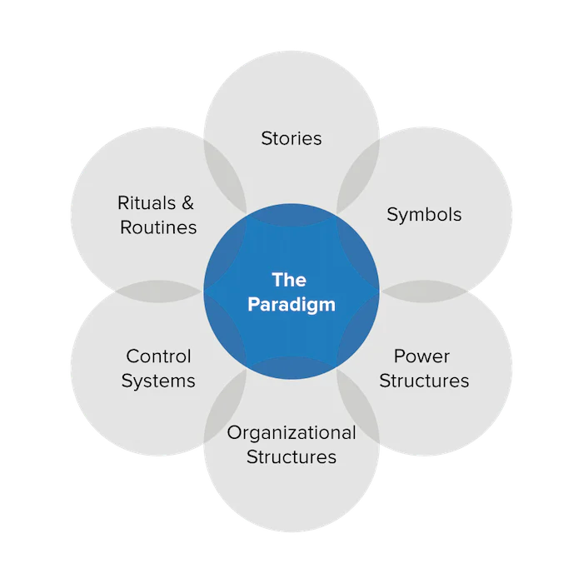
www.mindtools.com
The cultural web shows that the ‘Paradigm’, or cultural reality of working within an organisation is complex and is made up of six interlinked elements, new starters or others who do not agree with the presentation of the elements, which are often deeply embedded within a culture may quickly leave the organisation due to lack of ‘fit’ (the MIT Sloan Management Review carried out a survey in 2022 and found that “toxic workplace culture is 10.4 times more likely (than low pay) to contribute to an employee quitting” (Sull, 2022) and UK based HR company Breathe state that from surveyed individuals, 34% had chosen to leave a job in the first year due to toxic culture (The Impact of Company Culture, Knight Frank, 2023) ) and it can be therefore very difficult to make a lasting change to the culture or subculture of an organisation.
Culture is not always ‘top down’, and there is likely to be a difference in the presented culture, perceived culture and in the actual lived culture of an organisation (Sözen & Basım, 2022) although positive and supportive cultures, and those with shared values or ‘vocationalism’ are more likely to attract and retain staff and be more successful (Schein, 2010) Schein also suggested that workplace culture is “A pattern of shared basic assumptions that a group learns as it solves its problems of external adaptation and internal integration, that has worked well enough to be considered valid and, therefore, to be taught to new members as the correct way to perceive, think and feel in relation to those problems.” (Schein, 1985)
There is an argument to be made, in that positive workplace cultures are more likely in smaller organisations, in which employees are more likely to be known to each other and have personal relationships within the workplace, Drucker (1999) suggests this, and that “hierarchical levels should be as few as possible. Too many levels bring difficulties in understanding and communicating objectives both up and down the hierarchy.” Senior and Et Al. (2020).
In the case of third sector organisations, there are likely to be issues of sectoral permeability, or that the sector is insulated from others, thus real organisational change is not likely to come from without, employees within the third sector are likely to move around within the sector, and be of a certain ‘type’, as “People choose organizations as much as organizations choose people. Those working in organizations are more likely to remain in organizations whose structures, with their particular degrees of centralization, formalization, specialization and traditionalism, suit their individual and group preferences and needs.” (Senior & Et Al., 2020) meaning that while institutional isomorphism and mimetic behaviour are likely to occur between networks of similar organisations, there may be culture clashes when the semi-hybridity caused by rigid funding channels and ‘joint priorities’ invite new employee ‘types’ to work within third sector organisations.
In the public sector, there would traditionally be a strict hierarchy or divisional structure, with a ‘top down’ approach, more levels of structure and less contact and communication between levels. Barbara Senior described the public sector as “A rigid bureaucratic maze typified structural formation (within many such organizations) with the majority of members having narrowly defined and highly specialized jobs and being protected from making decisions through their constant deference to authority and reference to their rule books.” (Senior, 2020)

2.5 Value led culture.
In 1984 Geer Hofstede defined organisational culture as “the collective programming of the mind which distinguishes the members of one human group from another” (Wasieleski et al., 2020) but acknowledged that there are at least four different areas of ‘work related value difference’ and that individuals within the same organisation can have different issues and sub-values, He catalogued these differences as his Cultural Dimensions theory, comprising of ‘power distance; uncertainty avoidance; individualism/collectivism and masculinity/femininity’.
It could be said that the Cultural Dimensions theory, although used widely be theorists and management consultants, is outdated and guilty of applying stereotypes, although considering the area of this research paper, and that we have already established that 75% of staff within third sector organisations are women, this chimes with Hofstedes’ masculinity/femininity dimension which examines “the degree a society values assertiveness and materialism versus feelings, relationships, and quality of life” (FutureLearn, 2022), it could be stated that an organisation that makes its business in providing care, support and improving the quality of lives, as well as statistically lower wages, is likely to have a higher proportion of female employees, based on the traits applied to ‘femininity’ in the cultural dimensions theory.
In exploring values, and value led culture it is important to identify the deeply held values and beliefs of members at the very centre of the organisation’s sub-cultures and the overall culture.
For some members of an organisation, these values and beliefs will be so deeply held and part of their innate personalities that they would not be able to change at all and would struggle to manage under new management regimes or if the overall culture of the organisation is threatened with change.
While all workplaces have a culture, not all cultures are value based. Mazlows’ Hierarchy of Needs shows us that core needs must be fulfilled before those of self esteem and self-actualisation, therefore many people may work within roles that do not provide them with ‘experience purpose’ or increased self-esteem, but that fulfil the core psychological and safety needs. Value based work is work that fills all parts of Mazlows’ Pyramid, and it is said that “Work based on core values gives sense and meaning to it and aligns with the individual and the values that drive people’s lives. These values are not only ethical and moral, but also social and cultural” (Žydžiūnaitė, 2018)
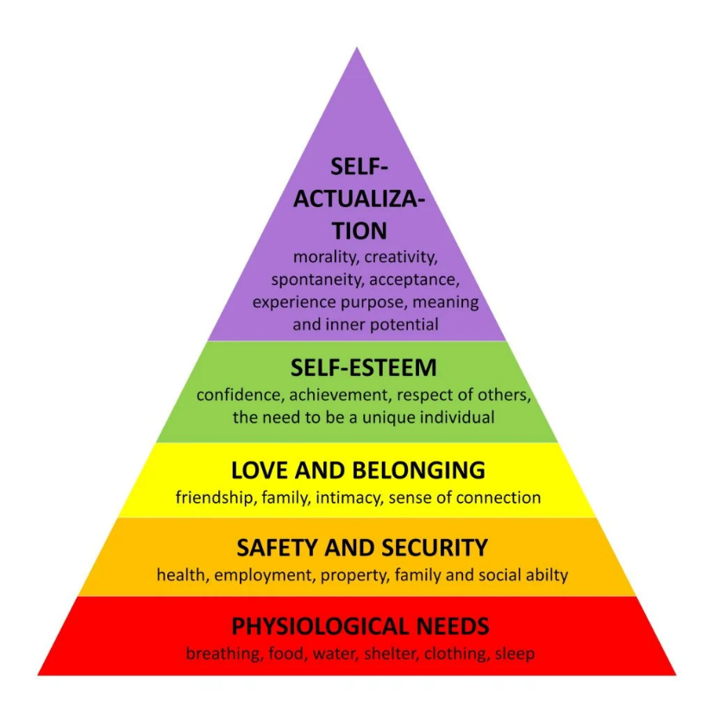
Mazlows’ hierarchy of needs

2.6 Motivation and Value conflicts
Motivation is a large part of ensuring that a work force is fulfilled, carrying out their work to the best of their ability and building good relationships with their colleagues or peers. Without motivation workplace culture is likely to suffer and conflicts are liable to appear. John Child, in his 1988 book ‘organization: a guide to problems and practice’ examined the consequences of deficient or malfunctioning organisational structures, and how the organisational structure, and management style can impact motivation, morale and culture. Childs ‘consequences’ are reproduced in the below image.
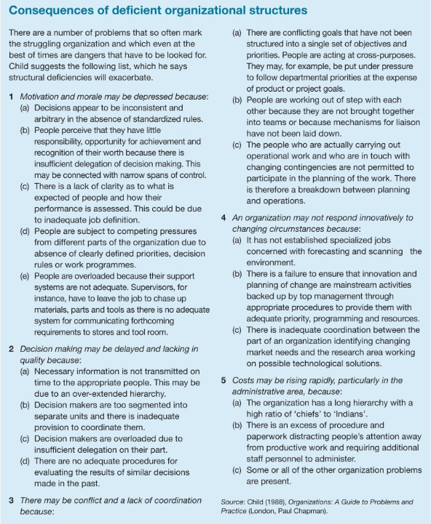
Motivation is defined as “all the factors that encourage individuals to be committed to and interested in doing something over time” (Hubbell & Chory‐Assad, 2005)
Public service motivation (PSM), “which refers to the motivation to serve others and improve the well-being of society at large” (Perry & Wise, 1990) and has been shown to improve performance and relationships within organisations, is a factor that may influence employees in the third sector and Public sector (health), and Wright and Pandey (2010) state that “emphasis on mission may make transformational leadership particularly useful in public and nonprofit organizations given the service and community oriented nature of their missions.”- This leads us to understand that while employees at all levels of the hierarchical chain believe that there is a common goal, motivation or shared vision, specifically if transformational leadership is in place, providing inspiration and motivation (Bass & Steidlmeier, 1999) there is likely to be less value conflict, and while personal conflict may arise, it is easier to set this aside and focus on the shared vision or mission.
Clashes in value-based systems can lead to impact on individuals and organisations, a study of conflict in Nordic organisations led Enehaug to design her conflict development model, which demonstrates the impact that unaddressed conflict can have on organisations (Enehaug et al., 2016).
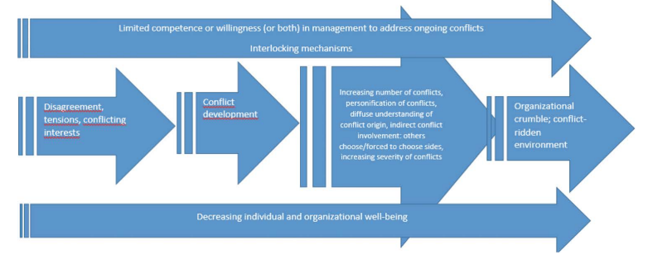
Conflict Development Model
Transformational leadership can help address value conflicts and culture clashes within organisations and assist in avoiding impact on organisational and individual wellbeing. Transformational leadership is a style of managing and leading that “inspires positive changes in those led and is invested in the success of every single member involved in the process” (Ugochukwu, 2024) Transformational leadership is said to identify strengths and weaknesses within each individual team member, and to nurture and encourage the individuals for the greater good of the team or organisation. It could be argued that transformational leadership can only really be affected in smaller organisations, as the larger the organisation becomes the more difficult it will be for individuals to truly build relationships with more senior colleagues or other teams. This issue also arises where there are multiple levels of rigid hierarchy within an organisation, and Drucker (1999) suggests that these should be as few as possible. Too many levels bring difficulties in understanding and communicating objectives both up and down the hierarchy.

3. Methodology

3.1 Research Context
The context of this research project must be defined by its objectives, these being to capture data from a number of interview subjects, based and working within the geographical area of Old Dyfed, this now being known as the 3 counties of Ceredigion, Pembrokeshire and Carmarthenshire. The geographical area selected covers an approximate 5765.75km₂ with a population of 375,200.
All research subjects are in paid employment, working within the ‘advice and support’ and health sectors within this geographical area, with a roughly even split between third sector employees and public sector employees. The selection of interview candidates that work in the same area or type of sector should allow the research to draw clear similarities, differences, and themes in the data.

3.2 Approaches
This research will take a phenomenological and Epistemological approach (Dovetail, 2023) to qualitative research in order to capture the essence of employees’ experience of working in the advice and support and health sectors. A phenomenological approach allows the researcher to capture information on the ‘social reality’ of the interview subjects, including an understanding of their attitudes, motivation and beliefs, and a epistemological constructivism approach allows us to understand that individuals perceptions and beliefs about the world around them may not be accurate, but are true to the individual and part of their belief systems (Hurst, 2023) Interpretivism will be used to analyse events through the perspective of the individuals who participate in and view them (Interpretivism (Interpretivist) Research Philosophy).
An ethnomethodological approach was considered for this research project, Ethnomethodology was described by Ritzer as “‘the study of ordinary members of society in the everyday situations in which they find themselves and the ways in which they use commonsense knowledge, procedures, and considerations to gain an understanding of, navigate in, and act on those situations.” (Ritzer, 2002) and this approach focuses on the sense of ‘artful practice’ that is contained within micro and macro structures of individuals daily lives (Scambler, 2021) This approach was considered on the basis that the individuals interviewed, while working in the health, and help and support sectors may find that they are dealing with daily situations that become routine, while these situations would be unusual or out of the ordinary for employees in other sectors.

3.3 Strategies
A Qualitative approach to the data will be taken in undertaking this study, as this approach will allow for a greater level of nuance and understanding of the interview subjects’ feelings, beliefs and perceptions, and semi structured interviews will allow for additional depth of clarity and avoid generalisations when analysing the data. As this research project aims to investigate values and value conflict within organisations a quantitative data collection method would not be appropriate, as a level of control over interview subjects needs to be maintained, to ensure that the subjects are from the appropriate employment background and the data is not unintentionally polluted by subjects that do not meet the selection criteria. As this study looks at an area that is not heavily researched and covers a relatively small group of subjects within a small geographical area, interviews and qualitative data collection appear to be the most appropriate method, allowing for the holistic perspective of the interview subjects to be considered.

3.4 Techniques and procedures
Due to the limited time available to complete this research project, Cross-sectional or ‘snapshot’ data (Wang & Cheng, 2020) will be captured from the interview subjects, with interviews to be carried out using Microsoft teams or in person, during the Months of January and February 2024
Saunders et al. (2007 )writes: “Sampling techniques provide a range of methods that enable you to reduce the amount of data you need to collect by considering only data from a subgroup rather than all possible cases or elements” as such, the researcher must consider that it will not be possible or time effective to interview all possible interview subjects within the geographical area, and the data would be skewed by the larger subject group of ‘non third sector’ individuals. Therefore, a representative sample of the geographical population was selected using purposive sampling (Ames et al., 2019) on the basis that they meet the required characteristics for the study; working for a business involved in the ‘help and support’ or health sector. These interview subjects should be able to provide rich data for the purposes of this research report. As there are only limited subjects who work within the help and support sector (3rd sector) the sampling could also be considered homogeneous (Purposive Sampling | Lærd.), although there will be some variation in level within the organisations, for example, managers, ‘front line’ workers and ‘back office’ or non-client facing staff will be interviewed.
All interview subjects are to be formally invited to interview and given an explanation of the purpose of the interview and of its anonymous nature, participants are to be informed that data will be promptly anonymised, and their records stored on secure cloud-based servers with a coded identifier. Contact details of the researcher to be given to all subjects for any follow up queries, and all subjects to be informed that they may withdraw from the study at any time.
Interviews are to be carried out via Microsoft teams or in person, to the interview subjects’ preference, and recorded for transcribing.
Semi structured interviews to be carried out, with questions to be asked focusing on personal values, motivation, job satisfaction and recognition, as well as questions focusing on value conflicts, both between personal values and organisational values, and value clashes between staff members.
The semi structured interviews will use a set of core questions, reproduced below, which will invite and encourage further discussion with the interview candidates.
Q1. Can you tell me a little about your role within the organisation?
Q2. What motivated you to join this organization, and how do your personal values align with the mission and goals of the organization?
Q3. How do you perceive the value of the work you do in contributing to the organization's mission?
Q4. Have you ever encountered situations where your personal values conflicted with the values of the organization? Could you share an example?
Q5. How accessible do you find management in terms of addressing concerns or seeking guidance?
Q6. Do you feel that management (or you yourself) may have to make choices that may not align with their personal values, or the organisational values, to secure the future of the organisation?
Q7. How do you perceive the differences in work culture and job satisfaction between the third sector and other sectors?
Q8. do you think silo-working, sub-cultures or a lack of growth mindset / ‘nostalgia’ is an issue within this organisation, or your sector in general.
Q9. Have you ever considered transitioning to a different sector for higher pay, and what factors influenced your decision to stay?

3.5 Ethical considerations
Prior to commencing data collection an ethics form was completed and submitted to the university for approval, all participants have been informed of the purposes of research and why they been asked to take part and have given informed consent to participate.
No interview subject is under the age of 18, and all have full mental capacity. Standards of good practice and respect as expected by the university have been adhered to at all times, and consideration has been given to any ethical issue that may arise from this research project, including reputational damage to individuals, organisations or the university. As such, interview subjects to be given the option to decline to answer any questions that they do not feel appropriate.

3.6 Limitations, validity, and reliability
The researcher must consider the limitations of the research, as well as the validity and reliability of the data gathered.
The Limitations include the fact that the sample size is relatively small, and that a longer research period would allow for a larger number of interview subjects, the narrow time span allowed for data collection limits the number of subjects it is possible to interview. The study is also limited by the geographical area, 3rd sector organisations and organisations working in the help and support sector within this geographical area are likely to deal with several of the same customers or clients and may be known to each other or share networks or report similar issues. If this study was broader, and able to compare, for example inner city support agencies with rural support agencies it may provide more and different data.
The study also needs to consider the risk of bias from the researcher, this can be partially avoided by selecting the interview participants randomly from the pool of available subjects, rather than by approaching individual subjects who may be known to the researcher. The risk of Bias in favour of third sector vs private sector remains, and this can be partially avoided by using thematic analysis of the anonymised data.
A validity and reliability issue is that the study is likely to be unverifiable due to not being able to be truly replicated, as even if the same interview subjects were re-interviewed, their views, beliefs, attitudes or employment may have changed, therefore delivering different results (Theofanidis & Fountouki, 2022). The problem of dishonesty, under or over exaggeration from interview candidates remains a risk.

3.7 Methodology Overview
Using a phenomenological and Epistemological approach, semi structured interviews will be carried out with a pool of 8-10 interview subjects, all based and working within the assigned geographical area and having the required characteristics for sampling, the selected approach aims to identify the beliefs, feelings and philosophies of the individuals interviewed in relation to the research objective, that being to identify common themes of motivation and values within the help and support and health sectors, and how value conflicts are dealt with by organisations and individuals.

4. Findings
4.1. Qualitative Data.
This study set out to examine workplace culture and value conflicts within the workplace, specifically focusing on third sector organisations and public sector organisations engaged in providing help, advice and support to customers. As stated in the methodology chapter, a qualitative method was chosen, with semi structured interviews carried out with a number of employees working within the third sector and the public sector. Candidates were an even split of third sector and public sector employees, and were employed in a range of roles, from CO/senior management to minimum wage employees on fixed term contracts.
Interviews were carried out either in person or via Microsoft teams, with interview candidates encouraged to expand on the questions and share their feelings and beliefs on how their organisation is managed, how they perceive their workplace culture and if they believe that shared values are a key part of their organisation.
The ideas of belonging and value led culture were discussed with all participants, and the interviews were transcribed and broken down into a thematic chart, as well as plotted on a heat matric, where positive and negative experiences within their organisation are assigned a traffic light coding, With Green representing a positive experience, Amber a varying experience and Red a negative experience.
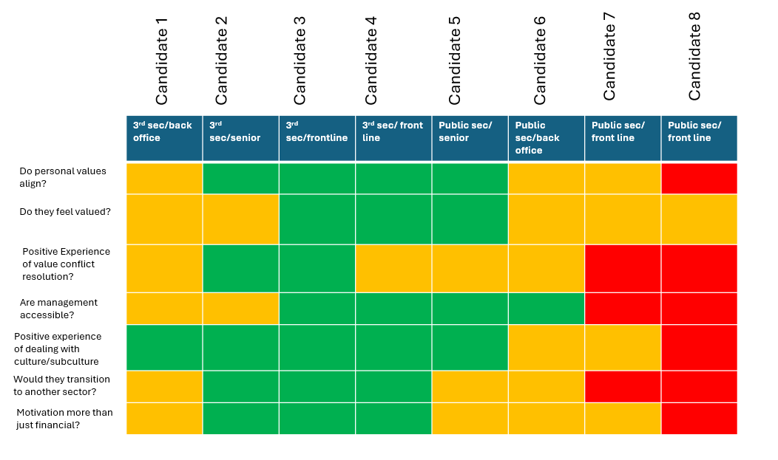
Heat/data matrix- Clarke.

5. Discussion and Analysis
The creation of the heat/data matrix allows us to examine a visual representation of the overall perception that the interview candidates hold about themselves and the organisations they work within. It is interesting to note that while the third sector interview candidates largely hold an overwhelmingly positive view of their workplace culture and embodied values, this is skewed by the interviewing of a senior staff member, who reports issues with their managers, and that they do not feel valued for their contribution, and that of a back office staff member who acknowledges that their values are not fully in line with the ‘organisational mission’ and that their motivation for remaining is mainly financial.
Of the public sector employees interviewed, the opposite appears to be true, with the senior and back-office staff reporting higher levels of satisfaction and feelings of value that the front-line candidates interviewed.

Several clear themes were identified in the course of the study, and these are discussed in greater depth in the below section.

5.1 Theme- Public Service Motivation
An overarching theme that emerged in the course of this research, and the interviews carried out is that of Public Service Motivation, of the ten candidates interviewed, only one showed motivation not related to carrying out service/making a difference, despite the interview candidates being a mix of third sector and public sector employees (although all engaged in providing care, support and advice in some capacity)
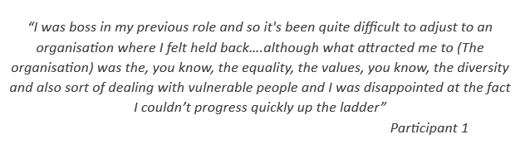

The other participants expressed that values such as integrity, honesty, and a commitment to serving others are important to them, and this is evident in the attitudes and actions of the individuals interviewed. They appear to prioritise the needs of their clients or patients and strive to deliver high-quality service despite various challenges. The below statement from a participant shows the strength of feeling of some employees who are engaged in ‘making a difference’ through their work.
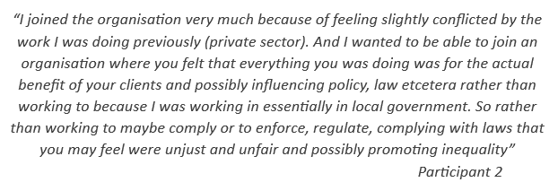
Other participants raised concerns about low and limited pay, within the third sector as a whole and the lower bands of the public sector, with the caveat that it was then an active choice by the individual to carry out lower paid work, as the work fulfils them and allows them to honour their own beliefs, ethics and feel they are making a difference.

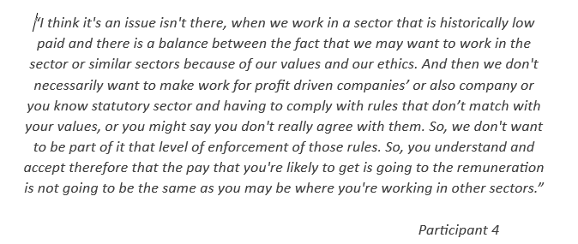
Concerns were also raised by participants that although a large amount of investment is made in recruitment and training, the statistically lower levels of pay may mean that retention of staff is limited to those who are in a position to be able to work for lower wages, meaning that highly skilled individuals may have to make the choice to work in a different sector, due to financial limitations.
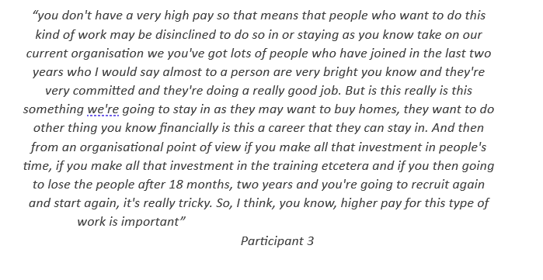
This potential financial constraint or limitation can also skew the demographic, particularly in the third sector, where the staff are likely to fall into an older age range, this may mean that enforcing cultural change within the organisations may be more difficult, with one member of a management team stating-
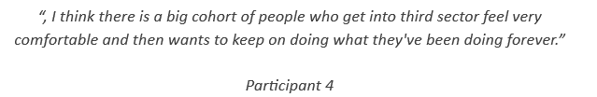
And a manager in the public sector expressed concerns that-
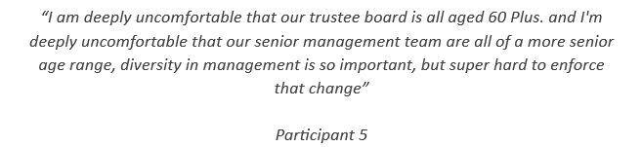

The analysis of this theme leads us to believe that public service motivation and vocationalism is the key factor in what draws individuals to work within the help and support sectors, although this cannot be the only factor, and it appears to be often younger, or less financially secure people who are not able to work in a lower paid industry, or remain working long term in an industry that matches their personal values, of the candidates interviewed, it was a defining factor that the age range of the third sector staff was predominantly higher than the public sector candidates. This may be evidence that while public service motivation is the key factor for all candidates, and perhaps the industries examined as a whole, this cannot be the only factor that individuals take into account, unless they already find themselves in a more financially secure position.

5.2 Theme- Differences in perception of the organisational culture.
The second clear theme to emerge was that of differences in perception of workplace culture and ‘how things are run’ between senior and junior colleagues, and differences in perception between ‘time served’ employees and those that are more recent arrivals to their sector, as well as a difference in perception of the customer/client or Consumer by the staff. The Interviews participants were an even mix of senior and junior staff members and there were clear differences in how they perceive their organisation, the organisational culture and their worth to the organisation and the subsequent reward and recognition. An interview candidate who has a history of working in the public sector and has transitioned to the third sector stated;
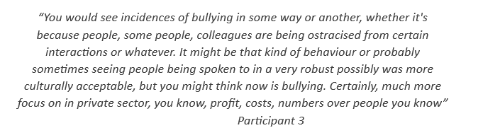
A participant who is currently employed within the public sector expressed concern about the culture of their workplace, stating;
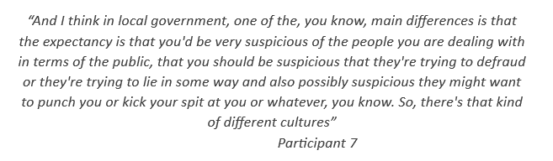
A public sector staff member who is engaged in ‘back office’ work, working closely with more senior figures as well as front line staff expressed the
view that
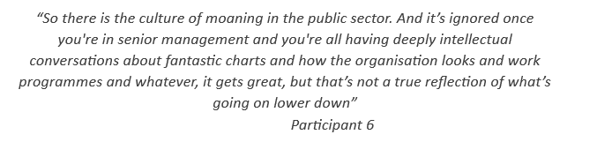

Overall, it became apparent over the course of the interviews that while third sector employees usually find their managers approachable and feel valued in their work, as well as feeling that generally the organisation is united and problems being resolved quickly, this is not echoed in the public sector. Within the public sector it appears that senior managers are ‘out of touch’ with the reality of their workplace culture, with emphasis on policies, slogans and the publicly presented ethos of the organisation, while this varies drastically from the ‘real world’ experience of the staff, particularly those on a lower pay scale and client facing, who overwhelmingly feel undervalued and pulled in different directions by demands of clients or customers and that which is expected of them according to organisational policy. The majority of public sector workers interviewed felt that management are not approachable and that they are not valued in their work, which appears to add to their overall disenchantment with their work and lack of engagement.

5.3 Theme- Entitlement and Recognition.
In the course of the interviews a number of candidates expressed views that the personal and team recognition they gain from their work, and the difference that they feel they are making to wider society is of greater importance to them than the financial renumeration that comes from work, however front line staff within the public sector expressed the views that senior management do not lead effectively and that staff are not recognised and rewarded to the level that they feel they should be;
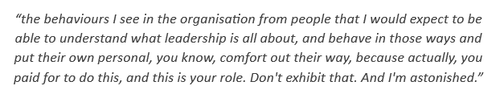
As well as expressing concern that the ‘on paper’ values of their organisation are not echoed by the reality of their workplace culture.
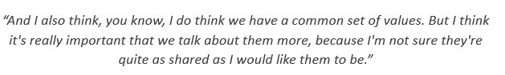
A third sector manager expressed that they have been treated very badly by board members, and feel that they have been placed in an uncomfortable position, where they must defend the organisational values as well as the rights of less senior staff, the staff member generally feels supported by frontline and back office staff, with the only conflict arising from senior managers, as their motivation may be more strategic and finance based than that of the ‘on the ground’ team.
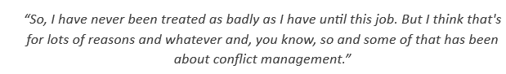
Staff within the public sector shared that their workplace culture is not positive or supportive, and that they feel there is a ‘culture of entitlement’ with staff often looking for progression and pay increases rather than supporting their colleagues. Statements included;
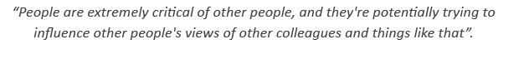
It was also expressed that the public sector does not have a very dynamic or organic culture, with a lack of cultural change and cases of staff members that don’t ‘fit’ the cultural paradigm leaving their roles shortly after joining.


5.4 Theme- Reasons for Retention.
When asked to discuss reasons for employee retention and long-term goals, the interview candidates expressed a variety of motivations, within the public sector this included guarantee promotion/salary increase through the banding system, as well as enhanced sickness and maternity leave, and generous pension schemes. There was the implication that work would become less arduous as one progressed up through the ranks and that the ‘long game’ was worth playing for job security, even if individuals feel less supported. This detracts from the vocationalism that we assigned to all individuals interviewed at the beginning of this study.
A manager within the public sector is quoted as saying;
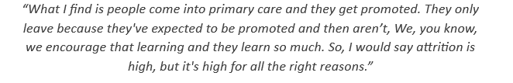
Another public sector employee shared that the role they are employed in is convenient to them, but they do not feel loyalty towards the organisation and do not respect the organisation, due to the disjointed and siloed ways of working they have observed.
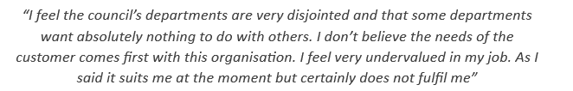
Another front-line public-sector worker summed up their work-life and their experiences by stating
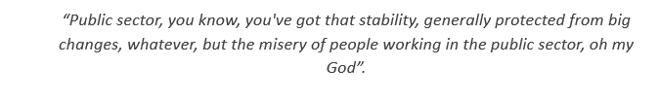

Referring back to the data/heat matrix (fig) it is notable that the interview candidate within the third sector organisation that felt least valued was the senior manager, who stated that;
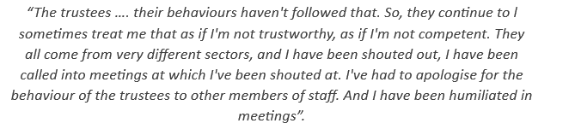
the interview candidate followed this up with a statement that expressed that the values they see, and try to nurture within their team go some way towards combating the treatment they have received;
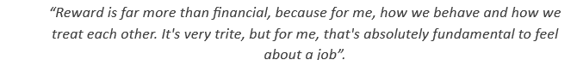

A front-line worker within the third sector, who has a history of working in a variety of sectors stated that their reasons for staying included a mutually respectful and supportive environment;
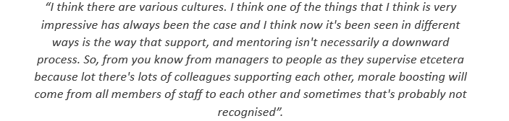
While another interview candidate from the third sector raised the case that presenteeism is not an issue within their organisation, with employees being valued for the contributions that they make and not penalised for illness, absence or personal issues, and that while this is a reason for their retention, it would also be a barrier to them leaving to pursue higher pay, as they would not expect the same respectful treatment in another sector;
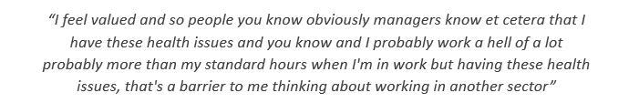
A sentiment echoed by the majority of third sector employees, was notable by its absence in public sector employees.
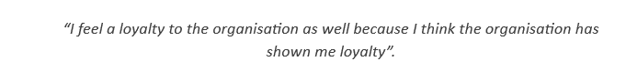

6. Conclusion
The subject of employee wellbeing and workplace culture is arguably one of the most studied areas of business administration/human resources, however there is little data available on the working environments of third sector employees.
This study has aimed to explore the contrasts between public sector and third sector employees and had identified some clear areas of difference in the perception of individual employees. Within this research project we were unable to expand our research question to encompass asking if employee wellbeing increases productivity, and this could be expanded upon in a future paper.
Key findings of this study are that (taking into consideration influencing factors such as small sample size and geographical area, which may impact the results) overwhelmingly, third sector employees are more supported, feel more valued and are more satisfied with their lot than their equivalents in the public sector. In regard to salary/pay, no individual disclosed their salary/rate of pay, but the published average salaries for the industries shows a marked difference between sectors.
In the majority of cases within the third sector, financial renumeration is of less importance than the vocationalism of the employees, and the opposite is shown within the public sector, with emphasis on ‘pay equals value of employee’ being a recuring factor. Public service motivation, as exhibited by the majority of interview candidates can be seen as fulfilling the need for eudaimonia, which is a crucial part of Self-determination theory. Both Eudaimonia and self-determination rely on the individual being in a position where self-actualization, personal expressiveness and autonomy are valued, however the views expressed by the interview candidates working in the public sector demonstrate that this self-actualisation is not being truly fulfilled, while they are working in a more rigid, hierarchical organisation.
Another factor that became apparent is that there is a ‘disconnect’ between senior and junior figures within the public sector, senior figures within the public sector appear to hold the world view that their organisations have a positive workplace culture through all levels of the hierarchy, and that their organisational manifesto or ethos is successfully manifested by the staff throughout the organisation, this view is not reinforced by front line staff within the organisations who present the views that they are undervalued and that management are unapproachable, with value conflicts becoming apparent as front line staff look to prioritise customer or patient wellbeing. This disconnect echoes the social identity theory issue of ‘us vs. them’.
All participants interviewed from the third sector organisations felt that there was no link between being in a position of privilege or financially secure and being able to carry out the work that they do, alternatively the public sector employees felt that you must have a level of financial security in order to work within the third sector, for perhaps less pay but more reward. The age range of the interview candidates shows that the third sector predominantly has employees of an older age range, including individuals who may have passed retirement age and returned to the workplace which could lead us to believe that despite the candidates not agreeing with the hypothesis, there is a higher likelihood that employees within the third sector are more financially comfortable or established in careers than those who may work in the public sector (specifically front line or low grade roles).

List Of Figures
Cultural Web | Johnson & Scholes | P11
Hierarchy of Needs | Mazlow | P14
Consequences of deficient organisational structures | Child | P15
Conflict Development model | Erehaug | P16
Interview Questions | Clarke | P19
Heat/Data Matrix | Clarke | P22

References
Admin. (2021, July 7). Sociological Theorists: Harold Garfinkel. Graham Scambler. https://www.grahamscambler.com/sociological-theorists-harold-garfinkel/
Alchian, A. A. (1950). Uncertainty, evolution, and economic theory. Journal of Political Economy, 58(3), 211–221. https://doi.org/10.1086/256940
Alfred, R. (2013, December 10). Values-led businesses care about behaviours not buzz words. The Guardian. https://www.theguardian.com/sustainable-business/values-led-business-behaviour-buzz-words
Ames, H., Glenton, C., & Lewin, S. (2019). Purposive sampling in a qualitative evidence synthesis: a worked example from a synthesis on parental perceptions of vaccination communication. BMC Medical Research Methodology, 19(1). https://doi.org/10.1186/s12874-019-0665-4
Baarspul, H. C., & Wilderom, C. P. (2011). Do employees behave differently in public- vs Private-Sector organizations? Public Management Review, 13(7), 967–1002. https://doi.org/10.1080/14719037.2011.589614
Barrett, R. (2013). The Values-Driven organization: Unleashing Human Potential for Performance and Profit. Routledge.
Bass, B. M., & Steidlmeier, P. (1999). Ethics, character, and authentic transformational leadership behavior. The Leadership Quarterly, 10(2), 181–217. https://doi.org/10.1016/s1048-9843(99)00016-8
Bond, S. (n.d.). Managing Value Conflicts: An Examination of Values and Value Conflicts in Third Sector Organisations in Scotland. In https://www.ros.hw.ac.uk/bitstream/handle/10399/3472/BondSM_0418_soss.pdf?sequence=1&isAllowed=y.
Brown, P., & Lauder, H. (2001). Capitalism and social progress. In Palgrave Macmillan UK eBooks. https://doi.org/10.1057/9780333985380
Chang, S. M., Budhwar, P., & Crawshaw, J. R. (2021). The Emergence of Value-Based Leadership Behavior at the frontline of Management: A Role Theory Perspective and Future Research agenda. Frontiers in Psychology, 12. https://doi.org/10.3389/fpsyg.2021.635106
Child, J. S. (1984). Organization: A guide to Problems and practice. https://doi.org/10.4135/9781446280348
Clair, J. A., Beatty, J. E., & MacLean, T. L. (2005). Out of sight but not out of mind: managing invisible social identities in the workplace. the Academy of Management Review, 30(1), 78–95. https://doi.org/10.5465/amr.2005.15281431
Contreras, F., Baykal, E., & Abid, G. (2020). E-Leadership and teleworking in times of COVID-19 and Beyond: What we know and where do we go. Frontiers in Psychology, 11. https://doi.org/10.3389/fpsyg.2020.590271
Corporate Values, workplace decisions and ethical standards of employees on JSTOR. (n.d.). www.jstor.org. https://doi.org/10.2307/40604595
Cribb, J., Disney, R., & Sibieta, L. (2014). The public sector workforce: past, present and future. https://doi.org/10.1920/bn.ifs.2014.00145
Cunningham, I., Baines, D., & Charlesworth, S. (2014). GOVERNMENT FUNDING, EMPLOYMENT CONDITIONS, AND WORK ORGANIZATION IN NON‐PROFIT COMMUNITY SERVICES: a COMPARATIVE STUDY. Public Administration, 92(3), 582–598. https://doi.org/10.1111/padm.12060
Dawkins, S., Tian, A. W., Newman, A., & Martin, A. (2015). Psychological ownership: A review and research agenda. Journal of Organizational Behavior, 38(2), 163–183. https://doi.org/10.1002/job.2057
De Graaf, G., Huberts, L., & Smulders, R. (2016). Coping with public value conflicts. Administration & Society, 48(9), 1101–1127. https://doi.org/10.1177/0095399714532273
Delivering for future generations: what are the barriers to implementing the world’s first Well-being of Future Generations Act? (n.d.). https://research.senedd.wales/research-articles/delivering-for-future-generations-what-are-the-barriers-to-implementing-the-world-s-first-well-being-of-future-generations-act/
DiMaggio, P., & Powell, W. W. (1983). The Iron Cage revisited: institutional isomorphism and collective rationality in organizational fields. American Sociological Review, 48(2), 147. https://doi.org/10.2307/2095101
Dovetail Editorial Team. (2023, February 7). What is Phenomenology in Qualitative Research? https://dovetail.com/research/phenomenology-qualitative-research/
Enehaug, H., Helmersen, M., & Mamelund, S. (2016). Individual and Organizational Well-being when Workplace Conflicts are on the Agenda: A Mixed-methods Study. Nordic Journal of Working Life Studies, 6(1), 83. https://doi.org/10.19154/njwls.v6i1.4911
Feather, D. (n.d.). How to write a research methodology for an undergraduate dissertation. CORE. https://core.ac.uk/display/5224057?source=2
Fehr, E., Fischbacher, U., & Gächter, S. (2002). Strong reciprocity, human cooperation, and the enforcement of social norms. Human Nature, 13(1), 1–25. https://doi.org/10.1007/s12110-002-1012-7
Frey, B. S., & Osterloh, M. (2002). Successful management by motivation : balancing intrinsic and extrinsic incentives. In Springer eBooks. http://ci.nii.ac.jp/ncid/BA5885367X
FutureLearn. (2022, October 25). Updates, Insights, and News from FutureLearn | Online Learning for You. FutureLearn. https://www.futurelearn.com/info/courses/managing-company-culture/0/steps/216758
Grand, J. L. (2007). The politics of choice and competition in public services. The Political Quarterly, 78(2), 207–213. https://doi.org/10.1111/j.1467-923x.2007.00848.x
Hoffman, A. J. (1993). The importance of fit between individual values and organisational culture in the greening of industry. Business Strategy and the Environment, 2(4), 10–18. https://doi.org/10.1002/bse.3280020402
Hogan, R. C., Curphy, G. J., & Hogan, J. (1994). What we know about leadership: Effectiveness and personality. American Psychologist, 49(6), 493–504. https://doi.org/10.1037/0003-066x.49.6.493
How many voluntary organisations are there? (n.d.). NCVO. https://www.ncvo.org.uk/news-and-insights/news-index/uk-civil-society-almanac-2023/profile/how-many-voluntary-organisations-are-there/
How STEEPLE Analysis informs design Strategy. (2023, October 5). Delve. https://www.delve.com/insights/how-steeple-analysis-informs-design-strategy
Hubbell, A. P., & Chory‐Assad, R. M. (2005). Motivating factors: perceptions of justice and their relationship with managerial and organizational trust. Communication Studies, 56(1), 47–70. https://doi.org/10.1080/0008957042000332241
Hurst, A. (2023, March 21). Chapter 3. A short chapter on epistemology (How do we know what we know?). Pressbooks. https://open.oregonstate.education/qualresearchmethods/chapter/ch-3-epistemologies/#:~:text=An%20epistemological%20perspective%20where%20meaning,outside%20the%20object%20of%20study.
Interpretivism (interpretivist) Research Philosophy. (n.d.). Research-Methodology. https://research-methodology.net/research-philosophy/interpretivism/
Jehn, K. A. (1994). ENHANCING EFFECTIVENESS: AN INVESTIGATION OF ADVANTAGES AND DISADVANTAGES OF VALUE‐BASED INTRAGROUP CONFLICT. International Journal of Conflict Management, 5(3), 223–238. https://doi.org/10.1108/eb022744
Kendall, J., & Knapp, M. (2000). The third sector and welfare state modernisation: inputs, activities and comparative performance. LSE Research Online Documents on Economics. https://ideas.repec.org/p/ehl/lserod/29055.html
Khan, H. S. U. D., Rehmat, M., Butt, T. H., Farooqi, S., & Asim, J. (2020). Impact of transformational leadership on work performance, burnout and social loafing: a mediation model. Future Business Journal, 6(1). https://doi.org/10.1186/s43093-020-00043-8
Kilmann, R. H., Saxton, M. J., & Serpa, R. (1986). Issues in understanding and changing culture. California Management Review, 28(2), 87–94. https://doi.org/10.2307/41165186
Kotzé, K., & Roodt, G. (2005). Factors that affect the retention of managerial and specialist staff: An exploratory study of an employee commitment model. SA Journal of Human Resource Management, 3(3). https://doi.org/10.4102/sajhrm.v3i2.65
Luhtanen, R., & Crocker, J. (1992). A collective Self-Esteem scale: Self-Evaluation of one’s social identity. Personality & Social Psychology Bulletin, 18(3), 302–318. https://doi.org/10.1177/0146167292183006
MindTools | Home. (n.d.). https://www.mindtools.com/ass7geb/handys-four-types-of-culture
Money matters: A Keynesian approach to monetary economics. (1983). Journal of Macroeconomics, 5(1), 138. https://doi.org/10.1016/0164-0704(83)90020-4
Murray, C. (2023, September 22). The FTSE gender gap: why do so few women lead the nation’s top&nbsp;plcs? Raconteur. https://www.raconteur.net/leadership/ftse-100-gender-gap
Our strategy. (n.d.). Citizens Advice. https://www.citizensadvice.org.uk/about-us/about-us1/future-of-advice-our-strategic-framework-2019-22/
Public sector personnel - Office for National Statistics. (n.d.). https://www.ons.gov.uk/employmentandlabourmarket/peopleinwork/publicsectorpersonnel
Purposive sampling | Lærd Dissertation. (n.d.). https://dissertation.laerd.com/purposive-sampling.php#:~:text=Homogeneous%20sampling%20is%20a%20purposive,%2C%20occupation%2C%20etc.).
Rabanal, P., & Rubio-Ramı́Rez, J. F. (2005). Comparing New Keynesian models of the business cycle: A Bayesian approach. Journal of Monetary Economics (Print), 52(6), 1151–1166. https://doi.org/10.1016/j.jmoneco.2005.08.008
Ritz, A., Brewer, G. A., & Neumann, O. (2016). Public Service Motivation: A Systematic Literature Review and Outlook. Public Administration Review, 76(3), 414–426. https://doi.org/10.1111/puar.12505
Ritzer, G. (2002). Contemporary sociological theory and its classical roots: the basics. https://openlibrary.org/books/OL7303134M/Contemporary_Sociological_Theory_and_Its_Classical_Roots
Schein, E. H. (2010). Organizational culture and leadership. John Wiley & Sons.
ScienceDirect.com | Science, health and medical journals, full text articles and books. (n.d.). Authentic Leadership and Organizational Culture as Drivers of Employees’ Job Satisfaction Garazi Azanzaa *, Juan Antonio Morianob Y Fernando Molerob. https://pdf.sciencedirectassets.com/287298/1-s2.0-S1576596213X70021/1-s2.0-S1576596213700070/main.pdf?X-Amz-Security-Token=IQoJb3JpZ2luX2VjEPn%2F%2F%2F%2F%2F%2F%2F%2F%2F%2FwEaCXVzLWVhc3QtMSJHMEUCIQDpB6K0AGIu9M6WZw5vKVVaUONbXZbNJpsOnIZjV5oLNQIgJ54EwisRGRR6u2q78DCKSAyznGIym4jN0tMCJ6ybXTIqsgUIERAFGgwwNTkwMDM1NDY4NjUiDHKi6thkk3Viv9PlHCqPBYkijIqAqSwSoeL0%2B%2Fa5AlkbdFjazStnbNeRxVhTI20EPH4B%2FZyUrbJMHBcbSgC%2F%2Bh%2BMc4WybGLk1Oe5Jwi4TkAKU1BYhlntolTDOH6LfnioXzjwaKLZ7Hytr3FMH3%2Fp%2Fcy4hPOJVYVtmOqUXUTO22OEOY4PC9UpO%2FbQsCioII4q%2FpR40a9HDUqM1oaTybPZT7uIaJqx1n3hosXAGvmjNzNZFvCae4MU3uaaT2X3axQH0nJEq1XWDNIqbHooHe%2BioNtmLzbcKQMC9uRIrlgZxmk6hQS2jnNUMKUJ9Fz6IL4TiflU%2Fw4ug6dhfQr3Lp1B7EhQ%2FPw2DrMcR%2FbjNAha97xd9O5IlK2g%2Fz4Tm3mP83QKLEvYwZUNgrGRFAIJ2aAAZVeQsqlb%2F63rgCgyBZd%2Fv18drwnKP1vV51TFw2%2Fiz6Rh5zPmDg6MRyr7Z88Hw3COx6wfM1oa92lAsa35QlrizGpeGEzcxcUqsnszLNHN%2F6CgtWgRs3Oquh26RqP98GM36kh%2Ffh92444Zb3uQ%2FbZ01%2FlQaKkZycwhmnRB0zPkd9%2FNg5Uop89WlYVHEdCrHG%2BCm4rbSveK0k1bCn4yAimF25%2FMzfkowtv%2B2GSsUdXQZjyzrYBLEAxux9Sd8xqJX
Senior, B. (2020). Organizational Change. Pearson Education.
Senior, B., & Et Al. (2020). Organizational change (6th ed.). Pearson Education.
seo@i3media.net. (2023, May 15). Salary Expectations - private public & third sector. Paydata. https://www.paydata.co.uk/hr-hub/blogs/setting-salary-expectations-for-private-public-and-third-sector-companies/
Seymour, R. (2017, September 20). A short history of privatisation in the UK: 1979-2012. The Guardian. https://www.theguardian.com/commentisfree/2012/mar/29/short-history-of-privatisation
Shah, J. (2015). Organizational culture and job satisfaction: An Empirical Study of R & D Organization.
Sözen, H. C., & Basım, H. N. (2022). The dark side of organizational behavior: Examining Undesirable Aspects of Organizational Life. Taylor & Francis.
Statista. (2023, December 12). Number of private sector employees in the UK 1999-2023. https://www.statista.com/statistics/676734/private-sector-workforce-uk/#:~:text=In%20the%20second%20quarter%20of,percent%20of%20the%20UK%20workforce.
Statistics Wales Demography newsletter: August 2022 | GOV.WALES. (2022, September 6). GOV.WALES. https://www.gov.wales/statistics-wales-demography-newsletter-august-2022-html#:~:text=On%20average%20there%20were%20150,434%20residents%20per%20square%20kilometre).
Steele, G. R. (1993). The Economics of Friedrich Hayek. https://doi.org/10.1057/9780230379497
Steijn, B., & Giauque, D. (2021). Public sector Employee Well-Being. In Oxford University Press eBooks (pp. 221–238). https://doi.org/10.1093/oso/9780192893420.003.0012
Strategic organizational diagnosis and design: Developing theory for application. (1996a). Long Range Planning, 29(5), 745. https://doi.org/10.1016/s0024-6301(96)90311-8
Strategic organizational diagnosis and design: Developing theory for application. (1996b). Long Range Planning, 29(5), 745. https://doi.org/10.1016/s0024-6301(96)90311-8
Successful commissioning toolkit What are third sector organisations and their benefits for commissioners? - National Audit Office (NAO). (2023, May 4). National Audit Office (NAO). https://www.nao.org.uk/successful-commissioning/introduction/what-are-civil-society-organisations-and-their-benefits-for-commissioners/
Sull, D. (2022, January 11). Toxic culture is driving the great resignation. MIT Sloan Management Review. https://sloanreview.mit.edu/article/toxic-culture-is-driving-the-great-resignation/
THE 17 GOALS | Sustainable Development. (n.d.). https://sdgs.un.org/goals
The Impact of Company Culture: Positive examples and negative signs | Knight Frank. (n.d.). https://www.knightfrank.co.uk/office-space/insights/culture-and-space/fix-bad-company-culture/
Theofanidis, D., & Fountouki, A. (2022). LIMITATIONS AND DELIMITATIONS IN THE RESEARCH PROCESS. Perioperative Nursing, 155–163. https://doi.org/10.5281/zenodo.2552022
Third sector scheme 2014. (2014). Welsh Government Publications. https://www.gov.wales/sites/default/files/publications/2019-01/third-sector-scheme-2014.pdf
Third Sector Trends 2022: first report released. (2022, December 2). Birmingham Voluntary Service Council. https://www.bvsc.org/news/third-sector-trends-2022-first-report-released#:~:text=The%20sector%20employs%20about%201.1,per%20cent%20of%20national%20employment.
Tsai, Y. (2011). Relationship between Organizational Culture, Leadership Behavior and Job Satisfaction. BMC Health Services Research, 11(1). https://doi.org/10.1186/1472-6963-11-98
Ugochukwu, C. (2024). Transformational Leadership Style: How to inspire and Motivate. Simply Psychology. https://www.simplypsychology.org/what-is-transformational-leadership.html
Vinney, C. (2019, July 22). Understanding social identity Theory and its impact on behavior. ThoughtCo. https://www.thoughtco.com/social-identity-theory-4174315#:~:text=Social%20identity%20theory%20is%20built,that%20of%20relevant%20out%2Dgroups.
Wang, X., & Cheng, Z. (2020). Cross-Sectional studies. Chest, 158(1), S65–S71. https://doi.org/10.1016/j.chest.2020.03.012
Wasieleski, D. M., Waddock, S., & Shrivastava, P. (2020). Management and the sustainability paradox: Reconnecting the Human Chain. Routledge.
Well-being of Future Generations (Wales) Act 2015 – the Future Generations Commissioner for Wales. (n.d.). https://www.futuregenerations.wales/about-us/future-generations-act/
Westall. (2009). Value and the third sector Working paper on ideas for future research. http://epapers.bham.ac.uk/798/1/WP25_Value_and_the_third_sector_-_Westall_Dec_09.pdf
What is the importance of research context in relation to research design and data analysis? | ResearchGate. (n.d.). ResearchGate. https://www.researchgate.net/post/What_is_the_importance_of_research_context_in_relation_to_research_design_and_data_analysis#:~:text=Research%20context%20provides%20the%20lenses,%2C%20historical%2C%20cultural%20or%20topical.
Williams, A., Dobson, P., & Walters, M. (1993). Changing culture: New Organizational Approaches. Hyperion Books.
Žydžiūnaitė, V. (2018). Leadership Values and Values Based Leadership: What is the Main Focus? Applied Research in Health and Social Sciences, 15(1), 43–58. https://doi.org/10.2478/arhss-2018-0005

