Practices of Community Engagement in FedEx Corporation

Prepared for
University of Wales, Trinity Saint David
Module Community Engagement
Assignment 1

Prepared By
Student Rosca Ana Diana

Introduction
Community engagement is the active participation of individuals, businesses and community groups in the decisions that affect their lives.
The term ‘community engagement’ is used to describe the way people learn, contribute and collaborate with others, and adding value to existing network partners. (Community engament-class notes, 2021)
This report focuses on the corporate responsibility activities, at FedEx Express Ltd. The purpose of this report is to provide an insight into the best practices of community engagement and on their stakeholder’s participation.
FedEx Express is a global company, and its main activity is delivery, courier and shipping services. Their motto, “Connecting people”, integrates community engagement into their core strategies. For more than 35 years in Europe they have been connecting people with goods, services and offering customers access to the world largest air express network. Their fleet across Europe has over 25,000 vans, 6500 trucks and approximately 70 aircrafts. There are connecting over 220 countries and territories and serve 78 airports worldwide. (FedEx Express, 2021).
The topics that will be discussed in this essay are the standards, measurements of best practices, of their community engagement program, they principles they adhere by and their consequences. Their focus is on four main ideas:
- Multiplying opportunities for the economy, people and the environment.
- Supporting small and diverse businesses.
- People by multiplying potential.
- Environment by multiplying efficiencies.

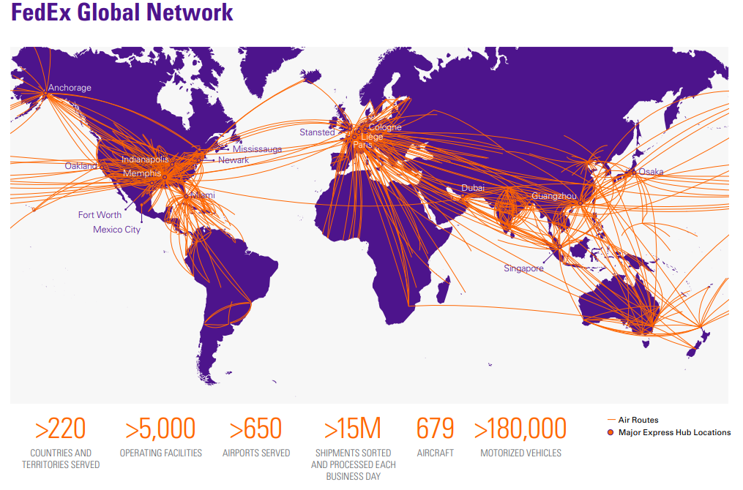

Analysis of the company’s best practices of community engagement
FedEx Express adheres to the standards of community engagement. Taken together these standards form an extensive and comprehensive list for their level of community engagement.
Analyzing the information presented to us on the company’s website we can conclude that FedEx Corporation includes eight FedEx companies: FedEx Express, FedEx Ground, FedEx Freight, FedEx Office, FedEx Custom Critical, FedEx Trade Networks, FedEx Services and FedEx SupplyChain. The social responsibility areas they focus on, are:
- Economy area by connecting businesses and communities through a growing portfolio of services and tools they enable economic growth and make it easier for the customers to access new markets, improving the quality of life and the life standards.
- People- they have 475,000 team members providing them with workplaces and career development opportunities.
- Environment- they work continuously in order to minimize their environmental footprint through their Reduce, Replace, Revolutionize approach and their Environmental policy that guides the companies in managing environmental performance. (FedEx Express, 2020)

According to their 2020, Global Citizenship Report, one of their main social responsibility strategy is ‘Materiality- focusing on what matters most’ (FedEx Express, 2020). In the process of assessing the evolving factors of the global business environment or the potential challenges they take into the account not only the business perspective but also the perspective of their stakeholders.

FedEx Stakeholders
Customers | Shareowners | Team Members
Government | Local communities | Media
Non-governmental organizations | Regulators | Suppliers
Supply Chain Workers

In the 2020 materiality assessment, the input included both internal and external stakeholders’ engagement. The internal engagement comprised interviews with the senior management and online surveys to employees around the world. The external stakeholders engagement was done by phone interviews with representatives from academia, customers industry associations, media, suppliers, as well as an online survey. (FedEx Express, 2020)

Diversity and Inclusion
We live in a world where corporations, businesses, play an instrumental role in meeting the communities needs through their employees, and through their financial contributions.
One of the strengths that FedEx is constantly developing is the expenditure and involvement in the community by strategically integrating community engagement into their business strategies. There is research that supports the fact that community programs led by the employer positively impacts employee engagement.
FedEx actively invests in recruitment and in maintaining a diverse workforce that reflects the communities they serve. They also offer over 170 summer intern positions each year and various programs like the ’Boardroom Experience’ in an effort to diversify internship and entry level talents. (FedEx Express, 2020)
FedEx learns about their community; they promote against discrimination of any kind and their workforce is always diverse and reflecting of their community. In FedEx D&I Enterprise overview, it is mentioned that:” In FY19, 29% of our workforce was Black/African American and 16% was Hispanic/Latin. FedEx management was 37% people of color in the U.S. The FedEx Board of Directors includes 13 directors, four of whom are women and three of whom are ethnically diverse.” (FexEx, 2020)
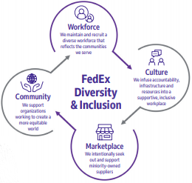

Their commitment to diversity extends beyond their business. They invest in nonprofit organizations and in community empowerment organizations in order to provide greater access to educational and empowerment opportunities. Some of their partners are NAACP, The 800 Initiative, Vital Voices or National Urban League.

Involvement and recruitment
FedEx advocates for the fact that continued investment in its people is the main point for the company’s success. The central point when it comes to its employees is “safety above all”. They invest in up-to-date equipment, FedEx Express, Freight and Ground use video event data recorders, forward collision mitigation systems and technology to improve safety for their drivers. (FedEx Express, 2020)
Each year, their employees receive additional training, relevant to the up to date equipment and they provide to tuition assistance in order to provide their employees with further education.
FedEx Offices offer their new employees with a more consistent experience in term of training. They provide the Core New Employee Orientation Program. After the implementation of this orientation program, the message consistency increased from 27% to 84%. The orientation program is normally 2 days longs and it involves 11 modules including social responsibility, safety, information security among others. (FedEx Express, 2021)
Also in 2019, the company launched close to 40 new courses for team members, covering topics related to electrical safety, hazardous materials or dynamic route optimization.
FedEx offers multiple unique leadership or career development tools like Global Leadership course for four months for full employees. Excel Drive is another development program they offer that benefits people and the community, along with internships and mentoring through the FedEx services ”College Connections”

Responsibility and communication
Responsibility is our duty to make the decisions we take or do not take, the measures we take or do not take as well as the resulting consequences.
FedEx advocates for responsible engagement not only for the success of their business but also in the benefit of the millions of stakeholders by creating income and new opportunities. Their strategies in engaging their community include dialogue and power sharing. They share the necessary information through all available networks, giving their stakeholders the power trough participation and consultation.
They maintain a constant contact with their stakeholders through making information available to them on all platforms available. They also do it through ongoing engagement efforts like programs that allow them to discuss the business strategy, operations and sustainability. These programs allow them to gather feedback and offer a better understanding to their needs and concerns.
To make sure that all their stakeholders are informed and can find any information they require at any time, they use a streamline approach to share all their environmental, social and governance performance. They use recognized external platforms like CDP, Eco Vadis, and Responsible Business Alliance as well as their own platforms to publish documents like FedEx Annual Report, Proxy Statement or the Global Citizenship Report. (FedEx Express, 2020)

Planning
They strive to achieve the highest service excellence and maximize both efficiency as well as profitability. Regularly, they communicate extensively with their stakeholders through online surveys, interviews so that according to the global business trending they plan the strategy to adopt for the next year or for the years to come. At the end of each year, they also present an annual report with the challenges they faced and what has been accomplished.
They are clear about their purposes and goals with the community they are engaging with presenting their purposes using the SMART technique, the ‘who’, ‘how’, ‘why’, ‘can’, and ‘how’ being clearly described and the timescales are realistic. (FedEx Express, 2020)

Working together
Their focus these last years has been directed to E-Commerce. Because is has become a fundamental part of retailing, extending their network on the online direction has become increasingly important for FedEx. Whether a purchase is perishable foods or luxury goods, where and how a customer receive their package is becoming more and more important.
The recently added E-commerce center, along with FedEx Small Business Center provides personalized guidance and tips specifically designed for selling online.
By creating this center, they help owners of small and medium business and they empower them, giving them the chance to meet the shopper’s expectations. By putting this platform to use for small businesses, they allow them to make connections, giving them a better opportunity for a healthier community, creating jobs and putting in work economic engines that are so important to development.
Along with this Center for E-Commerce they launched the app FedEx Delivery Manager, a tool to help both businesses as well as their customers to take control and to give them access to information at all times.
Through the app they allow customers to make changes and customize delivery dates or even delivery locations. The client gets notifications with a link to a secure portal where they can choose from a multitude of delivery options like deliver to another address, leave with a neighbor, deliver in a different day or to leave the package in a safe place. (FedEx Delivery manager , 2019)
The interface is designed in an easy manner, allowing both business owner and the customer an easy and pleasant experience, no extra skills being required except for using a mobile device with an internet connection.

Impact and sustainability
The corporation, with its planning and engineering program is continuously looking for ways to reduce and revolutionize their emissions footprint. More than 180,000 vehicles are owned and contracted on road and not their own and those are not all the time according to the latest standards.
The fuel used to power the fleet represent 92% of their emissions footprint in 2019 and almost 6% of the operating costs. (Susteinability FedEx, 2019) This means they always seek ways to reduce the greenhouse gas emissions and to improve efficiency. The steps taken in this direction include:
Using more efficient purchased and not contracted transportation by modernizing the aircraft and vehicle fleet
Engaging team members and customers in energy efficiency initiatives
Using cutting edge technologies

According to Smith. F., Chairman and CEO at FedEx Corp, FedEx has the “responsibility to take bold actions in addressing climate changes “ (Susteinability FedEx, 2019). The corporation’s target is to have carbon neutrality by 2040.
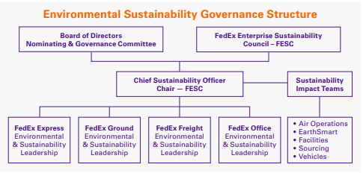

Conclusion
FedEx Strategy when it comes to community engagement is a well-planned one, delivered in a concise way so that its purpose is clear and easy to comprehend. They support activities that create opportunities for growth and prosperity in the community and they encourage inclusive engagement.
They recognize, respect and take steps in supporting the diversity and inclusion of the community which helps in identifying and mobilizing the assets of that community. They respect their employees and take steps in making sure their safety is always assured.
The methods they are using are ensured to be fit for the purpose and easy to work with, and they are adapted in response to the feedback received from the community.
Taking into consideration their sustainability plan, if more of the fleet was owned by them or if they choose to involve a clause that allows to contract work with FedEx only if the vehicles have low or no emissions, than their emissions footprint would reduce considerably as well.
They have a good communication system with the stakeholders, clearly and regularly. The are transparent when sharing the necessary information and present it in an easy to understand way and they value their community members feedback.
Another important thing is that they pay attention to monitoring and evaluating. They pay attention to global trends; they map the community and use those strong points not just to their advantage but also to the community’s benefit. They are showing us that there is better strength in collaborating, in working together so that we can all develop and benefit.
They learn from their past and they always weight the impact of what they have achieved, setting the scope for the future by observing the past-gathering relevant information, recording evidence and logging the learned lessons.

References
Community engament-class notes (2021) University of Wales Trinity Saint David.
FedEx Delivery manager , 2019. FedEx Delivery Manager. [Online]
Available at: https://www.fedex.com/en-gb/shipping-tools/deliverymanager.html
[Accessed 30 May 2021].
FedEx Express, 2020. FedEx 2020 Global Citizenship report. [Online]
Available at: https://sustainability.fedex.com/FedEx_2020_Global_Citizenship_Report.pdf
[Accessed 25 May 2021].
FedEx Express, 2021. FedEx Express. [Online]
Available at: https://www.fedex.com/en-gb/about/company-info.html
[Accessed 25 May 2021].
FexEx, 2020. FexExCares. [Online]
Available at: https://fedexcares.com/sites/default/files/2020-07/FINAL%20-%20FedEx%20D%26I%20Enterprise%20Overview.pdf
[Accessed 25 May 2021].
Susteinability FedEx, 2019. Susteinability FedEx. [Online]
Available at: https://sustainability.fedex.com/
[Accessed 30 May 2021].

