
OBESITY IN A HEALTHCARE CENTRE
Module: Introduction to Research

student name : ROXANA-ANDREEA TIRIS
STUDENT ID : 1912306
mODULE CODE: BMHP5005
LECTURER’S NAME: DR. TAYO KOREDE
DEADLINE DATE : 19.11.2021
Table of Contents

Question : How does the consumption of high-fat foods in healthcare contribute to residents’ obesity?

  - Background…………………………………………. 2
  - Methodology and Methods………………………… 3
  - Importance…………………………………………...4
  - Literature Review……………………………………5
    - Fast food and Trans Fat…………………………. 5
    - Physical Inactivity…………………………………7
    - Portion distortion, doft drinks and fructose……. 9
    - Health initiatives to prevent obesity………………11
    - Food labelling………………………………………11
    - Findings and discussions…………………………...12
  - Conclusion…………………………………………….. 13
  - Recommendations……………………………………. 14
  - References………………………………………………16

Obesity in a Healthcare Centre
Question:
How does the consumption of high-fat foods in healthcare contribute to residents' obesity?
1.1 Background:
Obesity is more common than you think. In fact, it’s so common that experts now believe one out of every two Americans is obese. That means you are very likely already walking around with a significant amount of unnecessary fat if your BMI is above 25 kg/m2. Obesity is one of the biggest health problems facing our country, and it's getting worse. If current trends continue, by 2030, more than half (51%) of all Americans will be obese. That's almost 100 million people. Today, almost one-third of all U.S. children are either overweight or obese. That's scary when you consider the long-term consequences of childhood obesity. Research shows obese children are 30% more likely to become obese adults.5,6 Furthermore, they are at least 60% more likely to have health problems such as diabetes, heart disease and high blood pressure.
Numerous co-occurring health conditions are associated with obesity, including type 2 diabetes, high blood pressure, high cholesterol, high triglycerides, and non-alcoholic fatty liver disease. As a direct result of these comorbidities, the medical costs directly related to being overweight or obese are difficult to determine, but a conservative estimate would place the healthcare burden for overweight and obese people in the United States at approximately $150 billion per year.4–6 The increase in mortality among overweight and obese individuals is related to comorbid conditions, rather than overweight and obesity per se; because of their various overweight and obese-associated conditions, overweight and obese patients present challenging and complex issues in medical and surgical intensive care units. The role that obesity plays with regard to the economic and health consequences in the United States is so huge, any healthcare reform proposal that ignores or minimizes it is not only unrealistic, it is financially unsustainable. Obesity is a serious health problem that is increasing at an alarming rate in the U.S. and around the world. In this article, the author will provide an overview of the current status of the problem, describe how it is defined, and discuss the impact of public health and environmental factors associated with the recent rise in obesity.
1.2 Methodology and Methods:
Being overweight or obese is a serious disease that affects millions of people worldwide. It's important to understand how your lifestyle choices affect your health and well-being. Obesity is linked to a number of illnesses and diseases. It increases the risk of developing heart disease, stroke, diabetes, cancer, and arthritis. It also causes an increase in chronic low-level inflammation, which has been shown to be detrimental to health in several ways. Adipose tissue secretes a variety of proteins that help regulate metabolism in other tissues in the body. Inflammation of the adipose tissue (usually caused by an excessive intake of fatty acids) results in the secretion of cytokines by the infiltrating macrophages. People with Alzheimer’s often experience severe memory loss and often become disoriented and confused. These symptoms are caused by the destruction of neurons in the brain by beta-amyloid plaques and neurofibrillary tangles, which are formed as a result of faulty gene expression or protein synthesis. High-fat diets over long periods of time lead to inflammation in the brain and the body, and to leptin resistance in the hypothalamus. These three factors are closely connected. Stress activates the Hypothalamus, Adrenal Glands, Liver, and many other organs in the body. This causes the release of catecholamines, cortisol, and other hormones that prepares the body to deal with an “emergency.” The brain needs to know what's happening outside of itself so it can respond appropriately. Microglia are the resident immune cells of the brain. Their primary function is to maintain CNS homeostasis, and they do this by phagocytosing cellular debris and toxic molecules, as well as releasing anti-inflammatory cytokines and neurotrophic factors. They are activated in response to CNS insults and participate in repair processes. Rats fed with a high-fat diet showed signs of glial activation (microglia and astrocytes) as early as three days after the start of the diet. Increased ghrelin secretion may occur as a result of central ghrelin resistance. This is a theory that suggests that when we get older our brains become less responsive to the hormone ghrelin. This theory is consistent with the observation that in aged rats, increased ghrelin secretion does not stimulate food intake. Rather, it appears to produce a state of hunger similar to that observed in younger, healthier animals.
1.3 Importance:
In this study, we investigated the effects of a high-fat diet on the neuroinflammatory profile of the glial cells (microglia and astrocytes) from the cortex, striatum, hippocampus, and cerebellum of C57BL/6 mice. Our findings suggest that a high-fat diet elicits a neuroinflammatory response in all brain regions analysed, but is predominantly mediated by resident microglia. Astrocytes do not seem to be involved in the inflammatory process, as evidenced by the lack of changes in their morphology and gene expression. These results indicate that a high-fat diet is capable of inducing an inflammatory response in the brain, which might contribute to the cognitive dysfunction associated with obesity. Our analyses reveal a specific reaction of hypothalamic microglia to eating high-fat food. That means that when you eat a high-fat meal, your brain literally "lights up" in a particular way that can be detected by an MRI machine. Inflammation is the body’s immune response to something that causes harm. When we talk about inflammation in the brain, it is referred to as neuroinflammation. Through the use of bone marrow chimeras, we were able to demonstrate that endogenous microglia mediate the hypothalamic response to a high-fat diet in the absence of infiltrating monocytes. The healthiest people are often the ones who are at their ideal weight or even have a bit of a weight problem.
1.4 Literature Review:
It is well known that diets high in fat (HFD) causes an immune response in the body as well as the central nervous system. Peripheral adipose tissue is not just an energy storage depot; it is also an important immune tissue. Macrophages are the primary immune cells in this tissue, and they play a key role in the resolution of inflammation. Similarly, the microglia in the brains of animals that are obese have been shown to be over-activated which results in them secreting an excessive amount of cortisol (the stress hormone). Cortisol inhibits the growth of new nerve cells in the hippocampus, a region of the brain associated with memory and learning.
1.4.1 Fast Food and Trans Fat:
It's no coincidence that as the obesity epidemic has spread across the globe, so has the consumption of junk food. Eating more fast food during the teenage years was associated with an increased weight gain later in life. Increased fast food consumption over a four-year period was also associated with a significant increase in insulin resistance in all ethnic/gender groups. Several other cross-sectional studies have shown similar associations between eating fast food and being overweight or obese. Those studies showed that children who frequently ate fast food were more likely to be overweight or obese than those who rarely eat fast food. There is one specific aspect of fast-food consumption that almost guarantees you will get fat and develop insulin resistance, and that is the portion size. Reduce portion sizes dramatically and watch the results improve. Fast food, when compared to home-cooked meals, is very high in caloric density. That means it has a lot of calories for its size. And often, it has a lot of fat and sugar as well. It's likely that these are the primary reasons why people who eat a lot of fast food are at an increased risk for obesity and diabetes. It is true that fast food has a very high caloric density (energy content per unit of food weight) and that it contains significant amounts, but the total caloric content of a typical American fast-food meal only exceeds that of an average meal by 55%. This is mainly due to the fact that most fast-food meals are made up of more than one food item, which dilutes the caloric density of the meal as a whole. Fast food consumption by children is associated with childhood obesity, and it is most prevalent among poor and/or minority children.
It is also prevalent among many overweight / obese children and adolescents. In a recent study, 75% of obese children and adolescents reported eating fast food at least once a week. The link between fast food and childhood obesity is strong and undeniable. This is one of the reasons the American Academy of Paediatrics recommends limiting screen time for children and restricting their access to junk food. As Dr. Robert Kushner points out in his book, Fast Food Nation, in the United States today, "more than half of all children 6 to 11 years old are either obese or overweight." He goes on to say, "And it is not just children who are affected. The average American woman cannot remember a time when she was not overweight or obese.
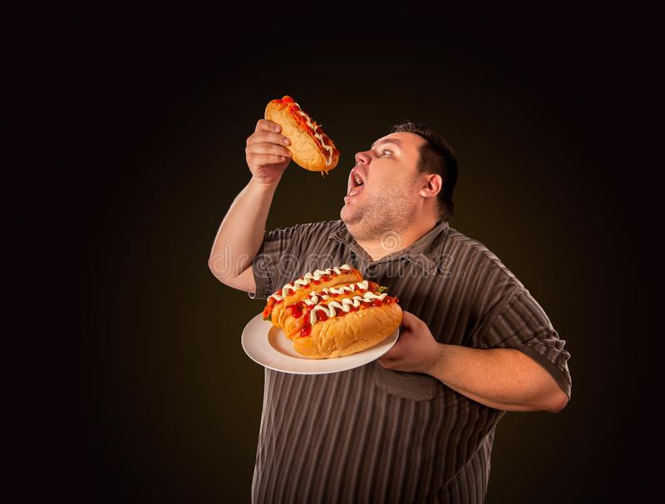
1.4.2 Physical Inactivity:
Figure 1 Fast Food and Trans Fat:
It’s not just a matter of “suggestion.” Physical activity (any type) is an essential requirement for weight loss. If you want to burn calories and reduce your risk of obesity and being overweight, you have to do something (regardless of your starting point). hose who reported being more physically active and less sedentary (high PA vs. low PA) lost significantly more weight over a ten-year period than those who reported being less physically active and more sedentary (low PA vs. high PA). Those who gained the most weight during the year had the greatest increase in their total cholesterol level. They also had the most to gain in terms of their bad cholesterol level. This is an interesting prospective study about the relationship between baseline physical activity and subsequent weight gain. Individuals who are low in physical activity at baseline and then become overweight during the study period were not more or less likely than those with higher baseline physical activity to subsequently regain their previous body weight. However, this study did show that the amount of weight gain was significantly correlated with the amount of physical activity performed while overweight. Adolescent obesity has more than doubled over the last 20 years and is the subject of considerable debate. There are many possible causes for this trend but one factor often overlooked is the growing popularity of part-time work among teenagers. One of the reasons people don’t get as much exercise as they should is the time they spend sitting in front of the tube or sitting in their car commuting. A recent study looked at the effect of increased television viewing on all-cause and cardiovascular mortality. A total of 8,800 adults followed for a median of 6.6 years were evaluated for various risk factors. The results showed that there was an increased risk of death for every hour per day of television viewing, even when controlled for other risk factors. This includes both network and cable programs. Even after adjusting for age, sex, weight, and exercise, the longer people watched TV, the greater their chances of dying from a heart attack or stroke. People who watch more than three hours of TV per day are 50% more likely to die from a heart attack or stroke than those who do not watch any TV at all. After dieting and losing a significant amount of weight, the most important thing for an individual with obesity is to maintain a high level of physical activity. This is because it promotes the preservation of lean body mass as fat mass is lost and reduces the risk of recidivism.

1.4.3 Portion Distortion, Soft Drinks, and Fructose:
Figure 2 Physical Inactivity:
Being obese increases your risk for heart disease, diabetes, cancer, arthritis, stroke, and many other health problems. That's why it's so important that you take control of your weight by choosing foods that will help you achieve and maintain a healthy weight. Studies show the portion sizes of many foods have greatly increased in the last 30 years. This has led to a significant increase in energy intake by the population. Many fast-food companies have increased portion sizes by as much as 500% since the introduction of their products 50 years ago.
Consumption of soft drinks has been linked with metabolic syndrome and cardiovascular risk based on the Framingham study. Consuming more than 2 cans (12 oz) of regular soda per day was associated with an 80% increased risk for cardiovascular disease and a 69% increased risk for diabetes. Caloric intake from sweetened beverages is a major contributor to the obesity epidemic in the United States. In a nationally representative sample of US adults, 68% of the obese population exceeded the recommended limits for sugared beverage consumption.
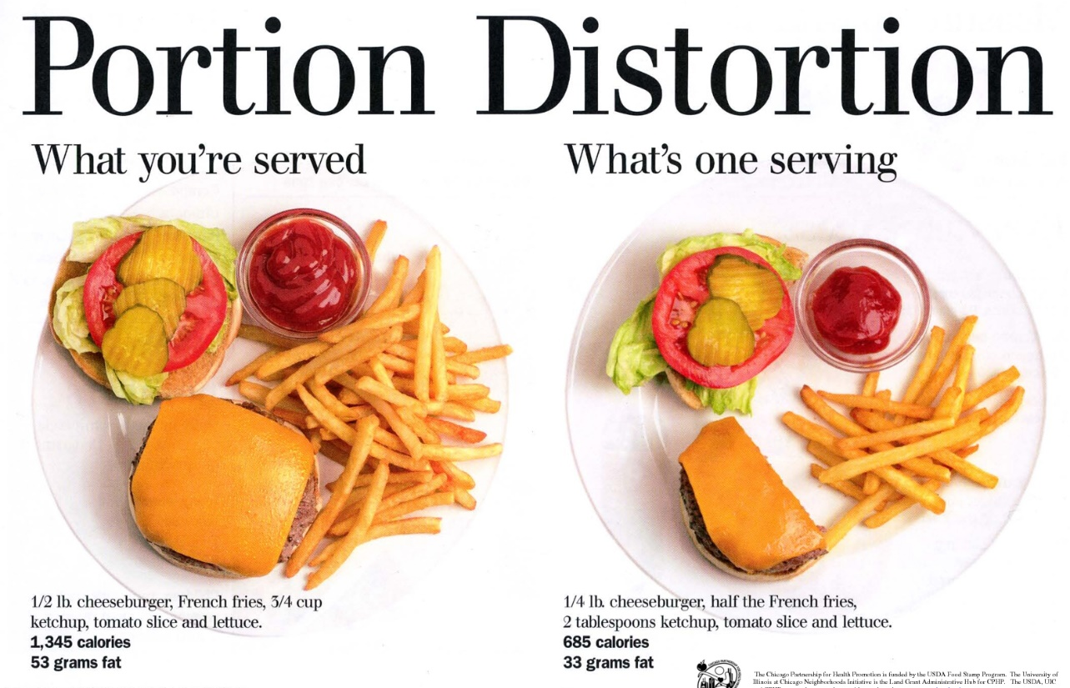
Sugared beverages are a top source of calories for children and adolescents, accounting for approximately one-quarter of their daily calories. Soft drink consumption is highest among low income and ethnic minority groups. High-fructose corn syrup is sometimes blamed for causing obesity. Fructose comes from three main sources: sugar, HFCS, and fruit. Sugar comes from natural foods such as fruits, milk and honey. It is found only in small amounts in most foods. HFCS is a corn product that has been processed to create a thick, sweetener. It is used in many foods and beverages to enhance their flavour. Some studies suggest that HFCS may increase the absorption of calories and contribute to weight gain in humans. High-fructose corn syrup (HFCS) is very different from table sugar or granulated sugar.
Figure 3 Portion Distortion, Soft Drinks, and Fructose:
1.4.4 Health Initiatives to Prevent Obesity:
It’s no longer a question of whether or not obesity is going to be a major epidemic in this country. That being said, many experts believe obesity is already here and has been for some time. n fact, it's estimated that if current trends continue, by 2020 more people will die from being overweight or obese than from smoking. Obesity initiatives should now be developed to help people who are obese achieve and maintain a healthy weight. These initiatives should include everything from helping people develop a healthier relationship with food, to developing new drugs, to conducting innovative research and providing education. Smoking and obesity are similar in that both are preventable and both are major contributors to the U.S. health care crisis. However, while smoking is totally avoidable, there are some people who simply will continue to gain weight, no matter what they eat. These are the rare exceptions. For the rest of us, adequate nutrition is an essential component of good health, and thus, we should all try to achieve a healthy body weight, whether we smoke or not. Often, the public doesn't understand what constitutes good nutrition versus bad nutrition. They simply don't have the facts. It explains what nutrition is, why it's important, how to achieve it, and how to tell whether or not they are getting the right kinds of nutrition for their needs. As changes are made to the US health care system, it is important to offer options that directly and aggressively target obesity through health initiatives and prevention programs.
1.4.5 Food Labelling:
Little data exist that show food product labelling improves eating habits. However, it is reasonable to assume that when people know exactly what they are eating, they are more likely to choose healthier options. The study showed that when specific nutrient information was provided on food packages, students at all three schools significantly increased their purchases of low-fat/low-saturated fat foods and decreased their purchases of high-fat/high-saturated fat foods. However, students at one of the schools decreased their purchases of lower carbohydrate foods when general nutrition information was provided on the packages instead of specific nutrient information.
1.4.6 Findings and Discussions:
Obesity is a character flaw in some cultures. It is also the result of overeating. When people say “you look fine to me,” what they mean is that from their perspective, you do not appear to be grossly overweight. The fat character in ancient Greek comedy was always a glutton and a figure of ridicule. No matter what century or what culture, humans have had a difficult time accepting someone who is overweight as worthy of respect. Obesity is unattractive in modern Western cultures, and being fat is often associated with negative stereotypes. That's why it's important to understand the true reasons people overeat - usually because they're trying to cope with a difficult emotional situation in their lives. People of all ages can be targets of bullies or shamed by their peers. In many ways, American society has become extremely concerned with the so-called “ideal” body weight for women and men.
These concerns have been fuelled by popular media such as magazine articles, television shows, and movies. However, there are some important differences between what is considered a healthy body weight for women and men. Overweight and obese adults are more likely to develop numerous health conditions, including heart disease, type 2 diabetes and some cancers. There are different classifications of obesity. In some cases, it’s just a matter of opinion as to what classification best fits the situation. In other cases, there may be different scientific reasons for different classifications. In any case, it’s helpful to know the facts so you can better understand what your doctor is trying to tell you and what decisions you need to make for your own health. The earlier you address your weight problems, the better off you will be. If you are not sure if you are overweight or obese, find out your body mass index (BMI). Your doctor can also tell you if there are other factors that may put you at an increased risk for heart disease and diabetes. Kids are getting fatter and fatter. That’s no mystery. It's what they eat. But, there's another factor at work, and it has less to do with what we (as parents) feed them and more to do with what we don't feed them. You see, fat kids are often rejected by their peers and often suffer psychological problems as a result.
1.5. Conclusions:
Obesity is the next major public health challenge facing the United States. It is a complex problem that requires a multi-faceted and comprehensive approach if we are going to effectively combat it. Obesity is a serious health problem in the U.S. It is linked to many other health problems, including heart disease, diabetes, and some types of cancer. Obesity is linked to diabetes, high blood pressure, high cholesterol, heart disease, stroke, and cancer. That’s why it’s important to know what to eat and what to avoid if you have a weight problem. Artificial trans fats should be completely banned. They should be taxed and restricted in the same way that they are in Denmark and New York City.
Also, there should be more access to healthy food and less access to vending machines in schools. Children are suffering from an obesity epidemic. This situation is made worse by the fact that many schools no longer teach students how to properly care for their bodies. A renewed emphasis on physical activity in the school curriculum may help to prevent children from becoming overweight or obese. Obesity is impacting every doctor in some way. Some specialists will be impacted more than others, but all doctors will be affected in some way. Especially as far as obesity-related gastrointestinal disorders are concerned. There are several emerging treatments that require endoscopic therapies which will greatly impact these physicians. As well as the greater complexity of patient management in general. Obesity must be fought using a wide variety of strategies. Focusing on just one aspect of the problem at a time has been shown to be ineffective. Combating this epidemic requires a multi-pronged approach.
1.6. Recommendations:
These recommendations are a good place to start in your battle against childhood obesity. But, to truly prevent childhood obesity, you must also make sure your child is getting enough of the other nutrients needed to grow healthy and strong. That’s why it’s important to work with a paediatrician or another health care provider who can help you create an individualized plan to meet your family’s unique nutritional needs.
Paediatricians and primary care providers play a crucial role in helping children and teens develop and maintain a healthy weight. By routinely measuring body mass index and offering appropriate advice and guidance, paediatricians and primary care providers can make a tremendous difference in a child’s or teen’s life. It's not enough for prenatal providers just to give a woman healthy "cues." They must also give her specific, practical instructions on how to put those cues into action. And, they must do this without judgment or criticism. Every provider of health care should work to avoid bias and discrimination against people who are overweight or obese.
There is no single or simple solution to the obesity epidemic. However, over the past 30 years there has been a 350% increase in the amount of food we are offered to purchase as compared to a 150% increase in our income. It's a very complex problem, and there has to be a multifaceted approach. We live in an unhealthy society. Policy makers, state and local organizations, businesses and community leaders, schools, childcare and healthcare professionals, and individuals must work together to create an environment that promotes a healthy lifestyle.

  - References
Chen, S. E., Florax, R. J., & Snyder, S. D. (2012). Obesity and fast food in urban markets: A new approach using geo-referenced micro data. Health Economics, 22(7), 835–856. https://doi.org/10.1002/hec.2863
CORE center report university of colorado at denver and health sciences center: Obesity in medical school curriculum. (2006). Obesity Management, 2(6), 235. https://doi.org/10.1089/obe.2006.2.235
Cotet, A. M., & Rotthoff, K. W. (2013). Economic growth and obesity: Findings of an obesity kuznets curve. SSRN Electronic Journal. Published. https://doi.org/10.2139/ssrn.2375523
Foundation funding to prevent obesity. (2013). Health Affairs, 32(6), 1165–1167. https://doi.org/10.1377/hlthaff.2013.0413
Hayes, A., Chevalier, A., D’Souza, M., Baur, L., Wen, L. M., & Simpson, J. (2016). Early childhood obesity: Association with healthcare expenditure in australia. Obesity, 24(8), 1752–1758. https://doi.org/10.1002/oby.21544
Kopelman, P. (1999). Conclusions. International Journal of Obesity, 23(S7), S23–S24. https://doi.org/10.1038/sj.ijo.0800958
le Roux, C. W., Chubb, B., Nørtoft, E., & Borglykke, A. (2018). Obesity and healthcare resource utilization: Results from clinical practice research database (CPRD). Obesity Science & Practice, 4(5), 409–416. https://doi.org/10.1002/osp4.291
Lobstein, T., & Brownell, K. D. (2021). Endocrine‐disrupting chemicals and obesity risk: A review of recommendations for obesity prevention policies. Obesity Reviews, 22(11). https://doi.org/10.1111/obr.13332

New york obesity research center: St. Luke’s-Roosevelt hospital Center/Columbia University/Albert einstein college of medicine. (2009). Obesity Management, 5(2), 72–73. https://doi.org/10.1089/obe.2009.0207
Nørtoft, E., Chubb, B., & Borglykke, A. (2017). Obesity and healthcare resource utilization: Comparative results from the UK and the USA. Obesity Science & Practice, 4(1), 41–45. https://doi.org/10.1002/osp4.148
O’Dowd, A. (2015). Health committee backs sugar tax on soft drinks in fight against child obesity. BMJ, h6453. https://doi.org/10.1136/bmj.h6453
Rasera, I., Luque, A., Junqueira, S. M., Brasil, N. C., & Andrade, P. C. (2016). Effectiveness and safety of bariatric surgery in the public healthcare system in brazil: Real-World evidence from a High-Volume obesity surgery center. Obesity Surgery, 27(2), 536–540. https://doi.org/10.1007/s11695-016-2439-y
Salkhayeva, B., Nurbayeva, G., Zhumakarimov, M., & Amanov, S. (2020). Health risk management: A literature review. Journal of Health Development, 1(35), 24–29. https://doi.org/10.32921/2225-9929-2020-1-35-24-29
Wu, F., Li, L., Zhao, G., & Li, Z. (2021). Influence of sports intervention based on K-Center algorithm on adolescent obesity metabolism and bone quality. Journal of Healthcare Engineering, 2021, 1–6. https://doi.org/10.1155/2021/9236369

