
MASTER OF BUSINESS ADMINISTRATION
ASSESSMENT COMPONENT 2
TOPIC NAME = MARKETING PORTFOLIO
COMPANY NAME= APOTHECA BY LUSH

Student Name: MAHIPALSINH RANVIRSINH GOHIL
Student ID: 2510635
Word count: 2700
Module Name: Marketing Management
Module Code: LCMB7024
Lecturer’s Name: DR JAYALAKSHMI GOPALKRISHNAN

Table of Contents:

Element 1: Segmentation, Differentiation, Targeting and Positioning (STDP) Analysis for Apotheca by Lush 3
Introduction of the company 3
Segmentation, Targeting, Differentiation, and Positioning (STDP) analysis for the new brand concept 3
Element 2: Marketing mix utilising the 7Ps Framework 6
7Ps marketing mix that supports the overall brand strategy 6
Place 6
People 8
Process 8
Element 3: Marketing Strategy Pitch 10
Element 4: Reflection 15
Reference List 17

Element 1: Segmentation, Differentiation, Targeting and Positioning (STDP) Analysis for Apotheca by Lush

Introduction of the company
Lush cosmetics is an ethical skin care company that has been running around since 1995 in the UK (Lush, 2025b). Vegan cosmetics brand, Lush is not like other beauty brands because it values being caring for the earth, open, and doing the right thing by people. Lush Fresh Vegan Cosmetics are making things by hand, being eco-friendly, not testing on animals, and not using animal products. In this context, the new brand of Lush, named Apotheca, is aimed to shape and address customer concerns about allergies, chemicals, and the flexibility of making natural cleaning and cosmetics products just the way they like to have. This brand specialises in herbal, dermatologically consulted, vegan skincare products, expanding Lush's ideology (Lush, 2025a). Apotheca, led by Lush, is planned to be a well-known beauty and wellness center that will offer natural skin care products, high-quality, personalised herbal medicines, along with cosmetic treatments done in-store.
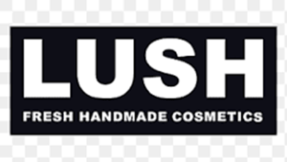

Figure 1: Logo of Lush Cosmetics
(Source: Lush Fresh Handmade Cosmetics, 2025)

Segmentation, Targeting, Differentiation, and Positioning (STDP) analysis for the new brand concept
The Lush Apotheca concept comes from market shifts. According to Alnuqaydan (2024), over 62% of skincare consumers worry about chemical compounds' long-term consequences. Market demand for vegan cosmetics in the regions of UK is quickly increasing, thanks to people who care about the sustainable environment and want goods that are not tested on animals specifically (GlobeNewswire News Room, 2024). There are people looking for natural medicines, safe cosmetics, along with goods made from plants. Lush’s products are all natural, made to order, and based on scientific research methods. They were developed with the help of dermatologists and herbalists. People are putting more and more value on real, health-promoting items. This makes perfect the combination of professional advice and most importantly natural therapies quite attractive. New branding is meant to attract those who prefer products that are therapeutic hygiene over regular ones. As mentioned by Sears (2024), there are a majority of people who prefer selecting products that are made just for them, taking into account things like skin sensitivity, allergies, and shaping the lifestyle. Apotheca by Lush knows how important it is to provide proper and mild, yet effective remedies for those with allergies, or chemical sensitivity. The provision of product customisation, a tranquil in-store environment characterised by floral design elements, and the availability of expert assistance collectively cultivate a distinctive purchasing experience, thereby promoting customer trust and enduring loyalty.
The demographic, behavioural, psychographic and geographical major market categories for Apotheca by Lush are determined. Since, the UK women aged 16–40 use the most skincare and cosmetic goods, this group is the main focus. As per Varshney and Ahmed (2023), this group is socially conscious, health-sensitive, ethical and values sustainable and safe beauty. Behaviourally, the brand will target frequent skincare shoppers, sensitive skin sufferers, who desire tailored solutions or professional guidance before buying. Urban areas like London, Birmingham, Manchester, and Glasgow, where consumers’ interest in premium and vegan products is great, remain the main focus.
Apotheca by Lush will target young and middle-aged women who embrace organic products, holistic wellness, and ethical production. It is estimated for this group to be active online, follow beauty influencers, and is aware of mainstream cosmetic production's environmental impact (Ünalmış et al., 2024). They want brands that promote their sustainable lifestyle. Products promising lower long-term costs are also popular with this audience. Apotheca by Lush's tailored formulas for individual skin issues are projected to reduce ineffective product purchases, justifying financial investment and long-term loyalty. As per Grech et al., (2024), a new brand must differentiate itself to succeed in the clean beauty market. Customisation, expert collaboration, and sensory experience distinguish Apotheca from standard cosmetic businesses and its custom formulas based on dermatological and botanical examinations distinguish the brand from generic natural skincare. Secondly, the brand's scientific reputation is raised by its work with doctors and its participation in training programs for plant medicine.
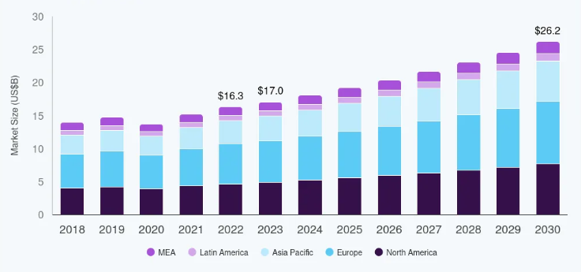

Figure 2: The Vegan Cosmetics Market (Between 2018-2030)
(Source: Grandview research, 2025)
The worldwide vegan beauty product industry was worth $15.17 billion in 2021. In the mid of 2030, core market might be developed worth around $26.16 billion (Grandview research, 2025). As shown in figure 2, this increasing trend is expected to continue at a CAGR of around 6.1% in between 2022 and 2030. The global requirement of vegan products has been growing the vegan business market. This trend is driven by customers' refusal to use cosmetics with animal products. This inclination arises from customers' inherent aversion to animal pain. A large number of people consider the consequences of their actions on themselves, the environment, and other species. Plant-based beauty products and Vegan beauty products have become more popular in recent years. Ojaniemi mentioned that in 2024, Lush's Apotheca aimed to become a prominent vegan botanical cosmetics company. This brand has efficiently addressed skin issues via the proper use of natural remedies, along with the advanced technological implication (Lush, 2025a). The company specifically attract health-conscious consumers and holding its own against the core natural competitors by providing and leading safe, interesting in-store experiences, cleaning solutions that is highly customised, and chemical-free, inclusion of the plant-based ingredients.

Element 2: Marketing mix utilising the 7Ps Framework

7Ps marketing mix that supports the overall brand strategy
Since Apotheca by Lush is proposed to offer products and services like tailored treatments and consultation, the 7Ps marketing mix framework will best describe the strategy:
Product
Apotheca by Lush is expected to have many cruelty-free, dermatologically-approved herbal skincare items and vegan. Clinical skin examinations create serums, balms, masks, cleansers and therapy oils. Products will be tailored to skin issues such dryness, acne, pigmentation or sensitivity. Professional skin analysis with 98% accuracy and expert advice are offered in-store by the brand (TOLOMEO, 2021). Hybrid products made with responsibly sourced natural ingredients from over twenty supplier nations make Apotheca distinctive. The distinctiveness makes it stand out and appealing.
Price
prices of Lush's new segment, Apotheca, will be value-based. Although natural and customised items cost more to make, the brand seeks to keep them affordable for most UK consumers and the small tailored goods cost $10, whereas luxury treatments cost up to $80 depending on formulation complexity (George, 2024). This cost matches customer desire to invest in natural and clinically proven skincare, since UK consumers spend £450 on skincare yearly. Transparent pricing promotes ethical branding, whereas seasonal discounts keep customers.
Place
Handcrafted beauty, hair care, and skincare products are produced and sold by the company Lush. The company is well-known for its philosophy of not testing products on animals. Young people still constitute a substantial proportion of Lush's consumer base in the UK, despite the fact that the company's shopper profile encompasses a diverse variety of demographics and in 2024, the majority of the money that the ethical cosmetics and beauty brand Lush made came from its business operations in the UK (Statista, 2025). This was then followed by the retail activities of the brand in the US, Canada, and Japan, where the total number of Lush stores is virtually on par with the number of outlets in the UK. Lush's Apotheca distribution approach will combine digital channels, physical retail and subscription delivery. Also, the selection of flagship across Lush locations will have apothecary-inspired décor to promote relaxation. According to Dube and Dube (2023), to extend beyond cities, the brand offers online consulting and home delivery. Distribution credibility is enhanced via dermatology clinic and fitness studio partnerships. In depth expansion into the certain UK Market, Lush reflects and garnered to promote brand awareness along with customer confidence boosting.
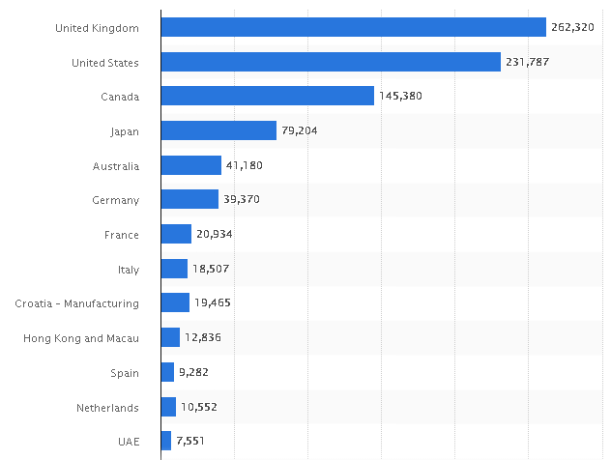

Figure 3: figures indicating revenue of Lush Cosmetics globally for the year 2024, by country
(Source: Statista, 2025)
Promotion
Apotheca by Lush will make use of influencer involvement, digital storytelling and community-driven initiatives for promotion. Thereby, the herbal skincare and chemical reduction education are expected to be promoted (Dube and Dube, 2023). It may be found out what goes on behind the scenes, ways to help animals without hurting them, and professional advice on social networking platforms. Younger people want to hear about skin care professionals who do not consume meat and are educated in dermatology. Experiential marketing including sampling, in-store demos and personalised consultations improve brand recall.
People
The primary demographic of Lush's UK customers comprises ethically-minded consumers, socially conscious, predominantly students, young adults (ages 18–35), and professionals who are in search of self-care, prefer cruelty-free, vegan and fresh products. These are produced with minimal waste, and are drawn to peer reviews, in-store experiences, and the company's robust ethical position (Nikolova, 2022). These customers typically possess higher education and disposable income. Rather than being influenced by traditional advertisements, they are more motivated by their principles, enjoyment, and the shopping experience. Apotheca by Lush's marketing mix will focus on skin-conscious people because the brand relies on consultations. It demonstrates that the dermatologists, store assistants, herbal advisors and wellness trainers provide precise assessments and personalised product solutions. Every member of staff receives extensive training on the brand's guiding principles, components, and scientific basis. Employees who work directly with clients are taught emotional intelligence so that they may provide individualized and compassionate service (Frantzeskos, 2022).
Process
Lush Cosmetics promotes using deception, customer content, and in-store experiences. The brand promotes its products via micro-influencers, ethics, community involvement, and trustworthy information (Jiang, 2025). By appealing to consumers' shared values like animal and environmental care, it will market its new services at an affordable price. The process dimension guarantees smooth interactions from guidance to product purchase. Skin assessment, ingredient recommendation, sample testing, product customisation, and purchase comprise the five-step process. Digital data logs record skin profiles for recurrent visits, boosting loyalty and ease and the process efficiency reduces wait time and improves branch consistency (Rane et al., 2023).
Physical Proof
Apotheca by Lush's authenticity and luxury are to be reinforced by physical evidence. As of October 8, 2025, the UK is home to a total of 113 Lush outlets (ScrapeHero, 2025). England has the greatest number of Lush sites inside the UK, with a total of 99 stores, which is around 80% of all Lush stores in the UK (Karchin and Horvath, 2023). The Apotheca stores will display calm consulting rooms, and scent-infused furnishings that will altogether simulate a natural clinic. Every product will have precise ingredient mapping on recyclable glass and biodegradable packaging. Physical proof lends credence to clinical knowledge, natural wellness, and environmental responsibility.
Product | - cruelty-free  - dermatologically-approved herbal skincare items  - hybrid products made with responsibly sourced ingredients
Price | - prices are value-based  - cost match with consumer desire to invest in natural and clinically proven skincare  - transparent pricing
Place | - hybrid model with the combination to digital platforms, physical retail and subscription delivery  - brand offers home-delivery services and online consultation
Promotion | - Integration of influencer engagement, digital storytelling and community-driven campaigns  - Social media campaigns
People | - People are central  - Trained staffs
Process | - Seamless interactions ranging from the consultation to that of the product purchase.  - Usage of digital data logs
Physical Proof | - Reinforces the authenticity and premium experience of Apotheca  - Packaging with the usage of recyclable glass and also the biodegradable materials

Table 1: Highlights from the Lush 7P’s Framework
(Source: Self- Developed)

Element 3: Marketing Strategy Pitch
The cosmetics world involves significant usage of chemicals, and it has the ability to deteriorate the skin condition of the customer (Kaushik et al., 2023). Moreover, many consumers are sensitive to certain cosmetic items due to allergic reactions. Hence, it is prudent to design effective cosmetic ranges that help these consumers sustain. To prevent excessive usage of chemical ingredients, it is imperative to use some natural solutions. Moreover, the cosmetics industry tends to test items on animals, which can harm them (Srinivasulu et al., 2022). Hence, to enhance the overall outcome, the utilisation of natural ingredients with zero cruelty towards animals can help Lush to help its consumers.
The Solution: Apotheca by Lush
To assist consumers, Lush has come up with natural vegan products (Lush, 2025a). With a changing lifestyle, veganism is gaining momentum, and many consumers are refusing to use products which are made from animal derivatives (Kaushik et al., 2023). Hence, Apotheca by Lush is developing herbal remedies for different skincare problems. In this regard, it tied up with dermatologists and herbal medicine trainers to offer in-depth consultation with consumers, as it can help them to get personalised product formulation (Saraiva, 2021). Besides, a serene clinical in-store ambience with aesthetic treatments can rejuvenate consumers’ beauty experience.
Target Market and Pricing
Target consumers are socially conscious teenagers, young and middle-aged women in the UK, mostly in the age group of 16-40 years old females. Reduction of expenses in daily cosmetics with personalised product formulation and aesthetic treatment can attract them. Since the brand is making products from natural ingredients, it is costlier than normal cosmetic products found in drugstores. However, it is affordable for a larger consumer section where items vary between the price ranges starting from $10.
Future Recommendations
- The company should invest more in the research and development sector for diversified sustainable cosmetics products.
- It can offer reward points and occasional discounts to attract consumers.

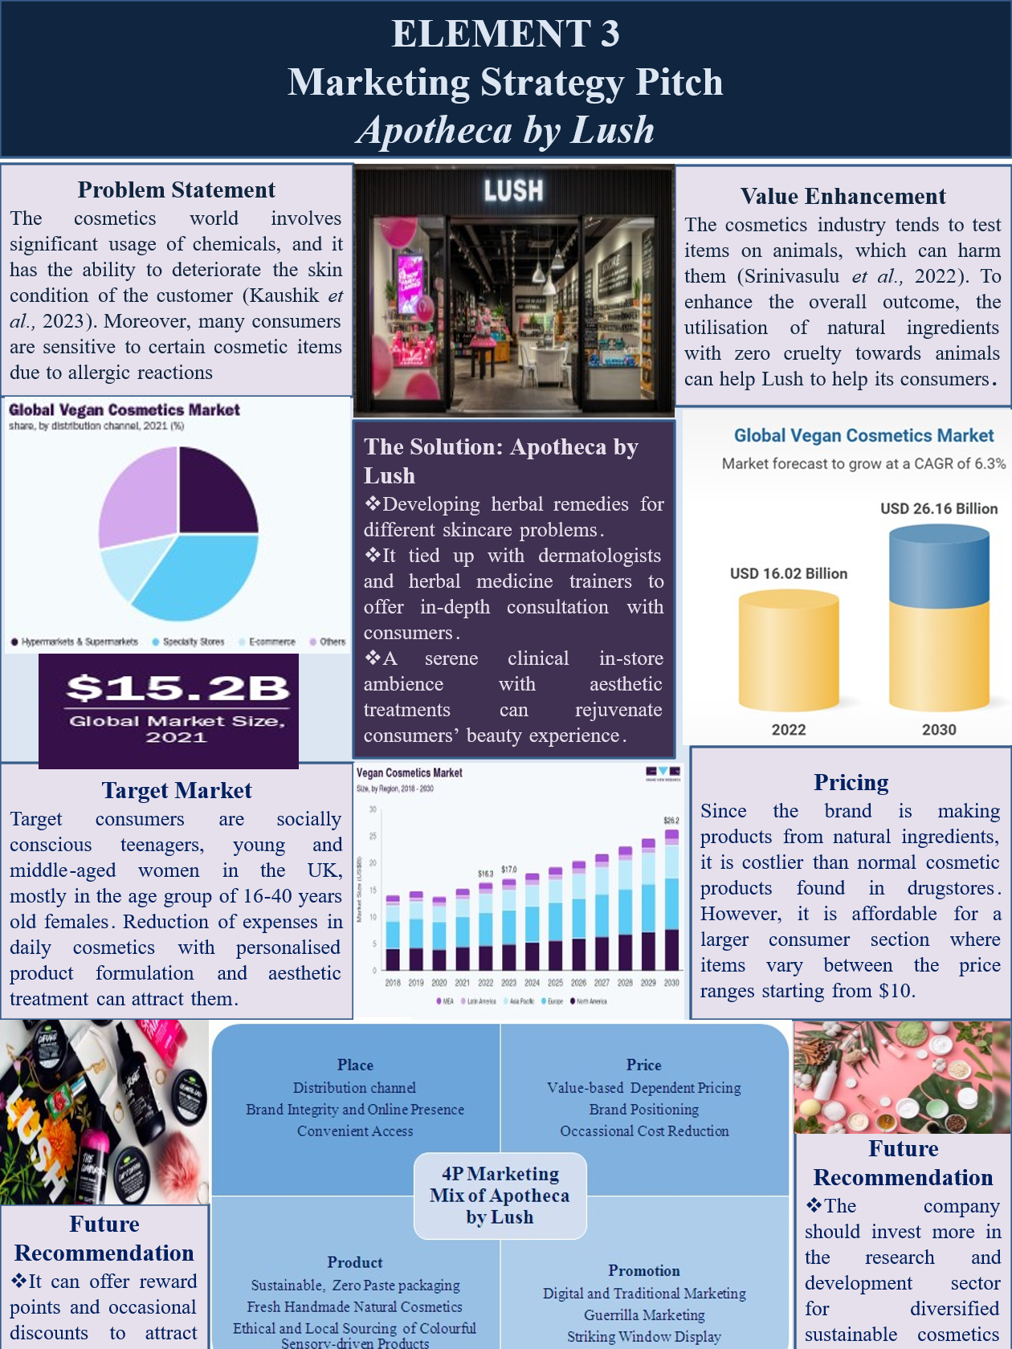
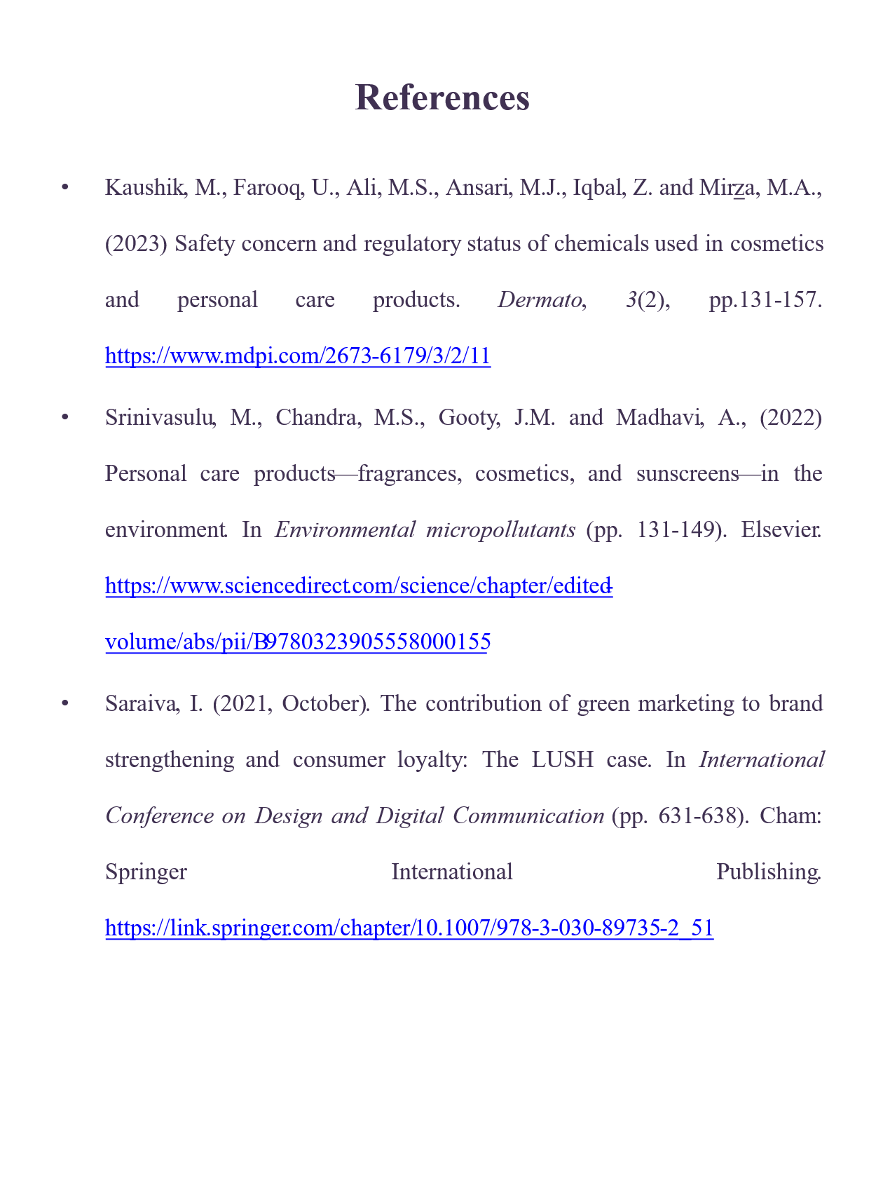

Element 4: Reflection
It identified that building the Apotheca by Lush brand concept and marketing plan was educational. The initial problem was creating a new brand that fit Lush's ideology while introducing a separate identity. This requires a deep grasp of Lush's ethics, consumer attitudes, and skincare market gaps. Throughout this process, I learned that current beauty consumers seek personalised solutions backed by expertise rather than generic items. After developing the STDP study, I learned how to define precise market categories and create a target buyer persona. This research helped me learn more about how demographic and psychographic factors affect how people buy makeup, especially in markets that are always changing. As a result of learning more about competitive difference and brand strategy, I can now stand out in a market that is already full. Understanding how things like naturalness, veggie certification, and skin proof affect customer trust helped me come up with strong value propositions.
Preparing the marketing mix improved my strategic thinking. I learned that the 7Ps framework must be integrated to complement the brand identity. This work improved my abilities to create realistic distribution plans, rationalise price and create true promotional activities. Delivering the marketing strategy pitch helped me grow. My presentation skills improved, especially in explaining complicated ideas clearly and persuasively. Crafting a pitch poster from extensive research required imagination, clarity, and confidence. I had to think visually and tactically about brand value in limited space. Overall, this portfolio improved my analytical, communication, and branding skills. It stressed the need of research-driven marketing decision-making and adaptation to consumer trends. I want to employ customer surveys and expert interviews more in future projects to improve market insights. I would also improve my time management to better assess rival strategies and consumer expectations. This work helped me grasp strategic brand building and gain marketing abilities for future roles.
In overall, I was able to obtain a more thorough comprehension of how strategic thinking, creativity, and analytical judgement must all work in tandem when constructing a new brand identity for a company as a result of developing the concept of the Lush Apotheca. Enhancing the marketing strategy has demonstrated the significance of maintaining a consistent and engaging brand narrative throughout all components, from the STDP to the Marketing Mix. This method demonstrated the significance of market data in the process of making decisions. This is necessary due to a number of issues faced by consumers, including sustainability, vegetarianism, and ethical sourcing. It is necessary to possess eloquence, self-confidence, and the ability to express intricate concepts in order to become proficient in the accent. I found out that reception is influenced by the tone, presenting style, and images. My research skills were developed as a result of this experience, my ability to synthesize information was better, and my reflective thinking abilities were improved. In the future, I will strive to enhance my analytical abilities, better my time management skills, and include more practical benchmarks in order to improve my marketing initiatives.

Reference List
Alnuqaydan, A.M., (2024). The dark side of beauty: an in-depth analysis of the health hazards and toxicological impact of synthetic cosmetics and personal care products. Frontiers in public health, 12, p.1439027. https://www.frontiersin.org/journals/public-health/articles/10.3389/fpubh.2024.1439027/pdf
Dube, M. and Dube, S., (2023). Towards sustainable color cosmetics packaging. Cosmetics, 10(5), p.139. https://www.mdpi.com/2079-9284/10/5/139
Frantzeskos, O., (2022). Beauty and the Beast: Plastic Pollution in the Personal Care and Cosmetics Industry. https://research.library.fordham.edu/cgi/viewcontent.cgi?article=1134&context=environ_2015
George, A.S., (2024). Unsubscribe From Anxiety: The Psychological Costs of Subscription Service Overload. Partners Universal International Innovation Journal, 2(3), pp.115-131. http://www.puiij.com/index.php/research/article/download/141/112
GlobeNewswire News Room (2024) Vegan cosmetics and personal care ingredients industry research 2024-2034: Rising demand for transparency in ingredient sourcing and product formulations and awareness of cruelty-free products. Available at: https://www.globenewswire.com/news-release/2024/09/09/2942635/28124/en/Vegan-Cosmetics-and-Personal-Care-Ingredients-Industry-research-2024-2034-Rising-Demand-for-Transparency-in-Ingredient-Sourcing-and-Product-Formulations-and-Awareness-of-Cruelty-Fr.html (Accessed: 08 December 2025).
Grandview research (2025) Global Vegan Cosmetics Market Size Report, 2030. Available at: https://www.grandviewresearch.com/industry-analysis/vegan-cosmetics-market (Accessed: 01 December 2025).
Grech, V.S., Kefala, V. and Rallis, E., (2024). Cosmetology in the era of artificial intelligence. Cosmetics, 11(4), p.135. https://www.mdpi.com/2079-9284/11/4/135
Jiang, Z., (2025). The Rise of Nano-Influencers: Case Studies of Daniel Wellington, CeraVe, and Lush Cosmetics in Digital Marketing. Academic Journal of Business & Management, 7(1), pp.173-180. https://francis-press.com/uploads/papers/xKQXCcCIi0MyLQeazKLXMSIMvaXO7MbiQv4optQO.pdf
Karchin, L. and Horvath, D., (2023). Cosmetics marketing: strategy and innovation in the beauty industry. Bloomsbury Publishing. https://books.google.com/books?hl=en&lr=&id=pQq9EAAAQBAJ&oi=fnd&pg=PP1&dq=England+has+the+greatest+number+of+Lush+cosmetics+sites+inside+the+UK,+with+a+total+of+99+stores,+which+is+around+80%25+percent+of+all+Lush+stores+in+the+UK&ots=s5b2uRBQfW&sig=Bzy77Ms85LsdTmnny3Dq1lMVEeY
Lush. (2025a). Lush Fresh Handmade Cosmetics | Vegetarian & Cruelty Free | Lush. Available at: https://www.lush.com/uk/en (Accessed: 01 December 2025).
Lush. (2025b). Hello gorgeous… welcome to the wonderful world of Lush. Available at: https://weare.lush.com/lush-life/our-company/who-we-are/ (Accessed: 03 December 2025).
Nikolova, A., (2022). Sustainability in the beauty and personal care industry: Trends, best practices, and opportunities. Best Practices, and Opportunities (August 15, 2022). https://papers.ssrn.com/sol3/papers.cfm?abstract_id=4190097
Ojaniemi, H., (2024). Developing consumer claims in cosmetic industry: regulatory considerations and market insights through case study analysis. https://www.theseus.fi/bitstream/handle/10024/863005/Ojaniemi_Hanna.pdf?sequence=3
Rane, N., Choudhary, S. and Rane, J., (2023). Hyper-personalization for enhancing customer loyalty and satisfaction in Customer Relationship Management (CRM) systems. Available at SSRN 4641044. https://papers.ssrn.com/sol3/papers.cfm?abstract_id=4641044
ScrapeHero (2025) Number of lush locations in the UK in 2025. Available at: https://www.scrapehero.com/location-reports/Lush-UK/ (Accessed: 08 December 2025).
Sears, C.E., (2024). Botanical Bar Craft: A Guide to the Art of Apothecary Cocktails and Herbal Tonic Elixirs. Chelsea Green Publishing. https://books.google.com/books?hl=en&lr=&id=_cxSEQAAQBAJ&oi=fnd&pg=PT10&dq=Apotheca+by+Lush+understands+that+people+with+eczema,+allergies+or+chemical+intolerance+need+gentle,+effective+products&ots=xqPjgxGP88&sig=6xfQpIe2V95U73OJylUeYcYClBo
Statista (2025) Lush Cosmetics: Revenue by country 2024, Statista. Available at: https://www.statista.com/statistics/892454/lush-cosmetics-limited-revenue-by-country/#:~:text=Ethical%20cosmetics%20and%20beauty%20company%20Lush%20generated,operations%20in%20the%20United%20Kingdom%20in%202024 (Accessed: 08 December 2025).
TOLOMEO, A., (2021). Il business model. Il modello canvas applicato al caso Lush Fresh Handmade Cosmetics. Available at: https://tesi.univpm.it/bitstream/20.500.12075/11662/2/TESI%20FINALE%20.pdf (Accessed: 05 December 2025).
Ünalmış, E., Dirsehan, T. and Erdoğmuş, İ.E., (2024). Consequences of influencer-created content on influencers’ authenticity in the beauty and personal care industry. Journal of Marketing Communications, pp.1-27. https://www.tandfonline.com/doi/abs/10.1080/13527266.2024.2371833
Varshney, D. and Ahmed, Y.A.M., (2023). Walking the talk of sustainability practices: The case of Lush Retail Ltd. Rutgers Business Review, 8(1), pp.95-110. https://www.researchgate.net/profile/Deepanjana-Varshney/publication/371110279_Walking_the_Talk_of_Sustainability_Practices_The_Case_of_Lush_Retail_Ltd/links/66cd9bcf2d7c8b264eca60f4/Walking-the-Talk-of-Sustainability-Practices-The-Case-of-Lush-Retail-Ltd.pdf

