

BA (Hons) Leadership and Management Skills in the Workplace
Student Name: | Natasha Mitchell
Student Number: | 2116387
Module No: | BMSK5010
Module Title: | Developing the Learning Organisation

Statement of Confirmation of Authenticity
By the act of making this submission, the student declares that this is the work of the student named above. The work has not, in whole or in part, been knowingly presented elsewhere for assessment, or where assessment has been built on a previous assessment, this has been identified. Where materials have been used from other sources it has been properly acknowledged. If this statement is untrue, the student acknowledges that an assessment offence has been committed.
Attention is drawn to the plagiarism and unfair practice policies of both the University and of ILM.

Contents
Critically assess the potential benefits to the organisation of developing individuals in the workplace. 3
Critically evaluate development vehicles available to an organisation appropriate to the development needs of the individual. 4
Generate a detailed plan to meet the identified development needs of an individual in the workplace and evaluate how this would be used to manage performance. Manage an individual’s expectations in respect of personal development. 7
References 9

Critically assess the potential benefits to the organisation of developing individuals in the workplace.

The potential benefits to and organisation and individual are vast, there are also some negatives to this as well this will be explained. Potential benefits to the individual are employees learning new skills, improves the employee knowledge, prepares them for high positions or more responsibility. This also shows employees that they are valued within the organisation. Employee development refers to activities leading to the achievement of knowledge or skills for the purpose of growing. Organizations provide employees with development programmes in order to enhance their capabilities. (hameed, 2011). Organizations need to invest in continuous employee development in order to maintain employees and organisational success (nadeem, 2013).
Employee training according to the CIPD professional report found that 98% of practitioners wanted to achieve a positive culture fir learning but only 36% had achieved this. So why is this? The CIPD believe that the key to cultural learning. Is to support individuals and allow this knowledge to shape and become their process. Encourage teams within your organization to learn and reflect on the outcomes and process willingness to change.
They recommend three types of learning, organisational learning this is where businesses need structure and systems in place to work with leaders and communicate vision for learning and transformation. Evaluate current systems in place that the organisation has for developing employees and see how it can be improved if needed. Team learning this is where teams within the organisation can help the line managers understand their key roles, they play in supporting learning. Encourage mangers to be role model and implement learning into their role. Individual learning this would take place un a supportive environment that allows employees to implement their knowledge. Also, to provide different types of leaning to suit the individual. (CIPD, 2020)
Benefits to the organisation when implementing a development program for employees is that this can save costs, depending on the organization if its reproduction of materials or parts the way these are made could cut costs for the company there for they would be able to pay staff more or show staff they are valued bonuses etc. this would also avoid mistakes being made continuously this can be across all organisation practice where it would cost the company hundreds to rectify For example, within my current employment we deal will pallet collections and ship worldwide. One of our drivers labelled a pallet incorrectly due to that the two pallets in question ended in two different parts of the world this cost our division £1050 +VAT to rectify.
Other benefits are your staff feel valued the maintain their loyalty to the company by feeling they have job security for it becomes a safe space. It also will increase their willingness to learn and grow and potentially advance in their career within that organisation, become a mentor for other employees and spread their knowledge.

Critically evaluate development vehicles available to an organisation appropriate to the development needs of the individual.
  - What is a development vehicle?
A development vehicle is ways an individual can be developed within a workplace, some of the methods used to accomplish this are: appraisals, key performance reviews, on the job training, 360-degree performance reviews, workshops, mentoring and coaching, also task and job rotation. Employees and employers have various ways of putting their development skills into practice. The main goal is to strength the individual and to meet their full potential weather that be communicational, creative or becoming a strong leader.
  - Training
This approach combines lectures, practical exercises, videos, podcasts, simulations, and individual and group tasks to build employee abilities. It encompasses both formal (classroom-based, instructor-led, eLearning courses) and informal (self-study, YouTube videos, reading blogs and posts on educational topics on peer-group platforms like LinkedIn). Each choice will be tailored to the requirements of the organisation and the current issue. For instance, a hands-on, instructor-led course may be the best way to teach a specific skill or technique, such as how to prepare a restaurant's speciality dish or navigate a complex manufacturing process. While YouTube or online research may be enough for teaching more basic subjects like construction codes or IT support concerns, these incredibly specialised activities cannot be taught in this way. Workers must actively participate in training.
  - Task and job rotation
To put some of those new abilities to use, employees could volunteer to switch responsibilities with others on a shift or team. Employers can also promote job rotation as a way for workers who have expressed a desire for hands-on experience to gain new skills. Rotating jobs and positions are intended to provide opportunities to develop new skills or put newly acquired knowledge into practise. Stretch objectives: By engaging with staff members to determine their areas of improvement, management may then find tasks that will help staff members hone those talents. The assignments will typically push the limits of an employee's current function or duty, expanding its scope to include extra abilities that need to be developed.
  - Coaching
We cannot overstate how crucial it is to support employees in honing their abilities through coaching when discussing various employee development approaches and their advantages. Senior employees generally work one-on-one with less experienced staff members as part of this technique of skill development. This can speed up an employee's understanding of a variety of topics, but it can also take up the time of experienced or valuable staff and produce clone-like knowledge of the subject, as opposed to an employee learning the subject their own way or through feedback from a wide range of coworkers and mentors. Depending on the coaching's emphasis, this could be a quick approach to pick up extremely particular leadership and team management abilities. Additionally, it could concentrate on specific organisational abilities.

An excellent way to enhance abilities like technical and analytical skills is through coaching, which often takes a highly hands-on approach. Employees could learn crucial interpersonal and conflict resolution skills at coaching camps funded by their employers. (Andreev, 2023)
  - Mentoring
With this approach, management or senior leaders take on junior staff members to help them learn critical abilities that they may be lacking. Less formal arrangements may be utilised with younger management, while more formal mentoring programmes are often employed for senior executive/leadership jobs. Be aware of the time investment and even smaller funnel of a one-on-one teaching paradigm, just as you would with coaching. Mentoring is frequently utilised to build high-level abilities including leadership, strategic management, communication, critical thinking, and long-term vision articulation because it necessitates senior leadership commitment. In order to build the abilities needed at lower levels of the organisational structure, such as shop floor assistant or accounting supervisor, mentoring isn't particularly successful. At those levels, coaching might be a more effective strategy for skill development. Less seasoned, younger employees can learn from more seasoned ones; thus, mentoring isn't just for management. It is suitable for developing communication, leadership, and organisational abilities and may be done at any professional level. Additionally, it can be used to educate creativity or something new. (Andreev, 2023)
  - Workshops/working groups.
Employers can communicate with peers and colleagues both inside and outside the company using these techniques. The advantage in this situation is having rich access to both internal and external (dissimilar) colleagues. This wide-ranging input and knowledge can help with problem-solving, developing new insights, and fostering dialogue about best practises. This may be used for anything else and is excellent for collaboration and communication skills. Workshops are excellent for enhancing a variety of soft skills, including leadership, networking, teamwork, presentation, and public speaking. Additionally, it can be utilised to enhance research and analytical abilities. (Andreev, 2023)

  - Stimulations
Due of how interesting and useful they have become; these are growing in popularity. In its most basic form, a simulation could be acting out a customer service contact, for instance, learning how to calm down a combative and upset client in person, or reacting to an emergency crisis, such as simulating first aid situations. At their most advanced, simulations can take place entirely in a virtual environment, such as in-flight training or fire rescue, where staff members can gain the necessary skills in an unimportant environment. This is very helpful in bringing theoretical or textbook knowledge to the actual world, giving the employee the know-how, exposure, and comfortability to handle such jobs. (Andreev, 2023)
  - On the job training
On-the-job training is frequently a fantastic way for employees who have already received some basic training in a technical ability to polish it (whether it be in operating a new machine or learning new financial analysis methods). This essentially involves learning by doing, which is usually done immediately following the training. The fundamental objective of on-the-job training is to give the employee everything they need for self-study while they are at work. When employees finish the tasks, they are given, they either learn how to use something or apply the techniques. This is a highly common method of employee development because businesses often don't have the time to train each employee individually on every skill, especially if that talent doesn't call for specialised or advanced knowledge. (Andreev, 2023)

  - Self-study
There are various ways to do this, including reading, research, taking classes after work, etc. The topic is often something fresh that the organisation thinks will boost their performance rather than the abilities that they need. Even though self-study time isn't directly rewarded, if an employee buys a course that will boost his performance, the employer should reimburse him by footing the bill. The advantage is that the person can autonomously choose what interests them and pursue it. On the other hand, it might be challenging to inspire employees to invest their free time in work-related activities. (Andreev, 2023)
  - 360-degree performance reviews
This approach entails gathering feedback on a worker from a variety of peers, subordinates, supervisors, and outside suppliers, and then finding possibilities for skill development based on those inputs. Consider reading this post on performance appraisals for more details on this kind of criticism. (Andreev, 2023)

Generate a detailed plan to meet the identified development needs of an individual in the workplace and evaluate how this would be used to manage performance. Manage an individual’s expectations in respect of personal development.

The performance review I will be writing about is based on an employee within my current Organization. This was a formal meeting held by senior members of the pallet network. This took place due this member of staff falling behind on deliveries and not following the correct procedure we have in place. Here you will see two performance reviews the first was the plan that was set out after the first review the second is the results that followed these were discussed in a follow up meeting 3-4 weeks after the first. (robinson, 2023)
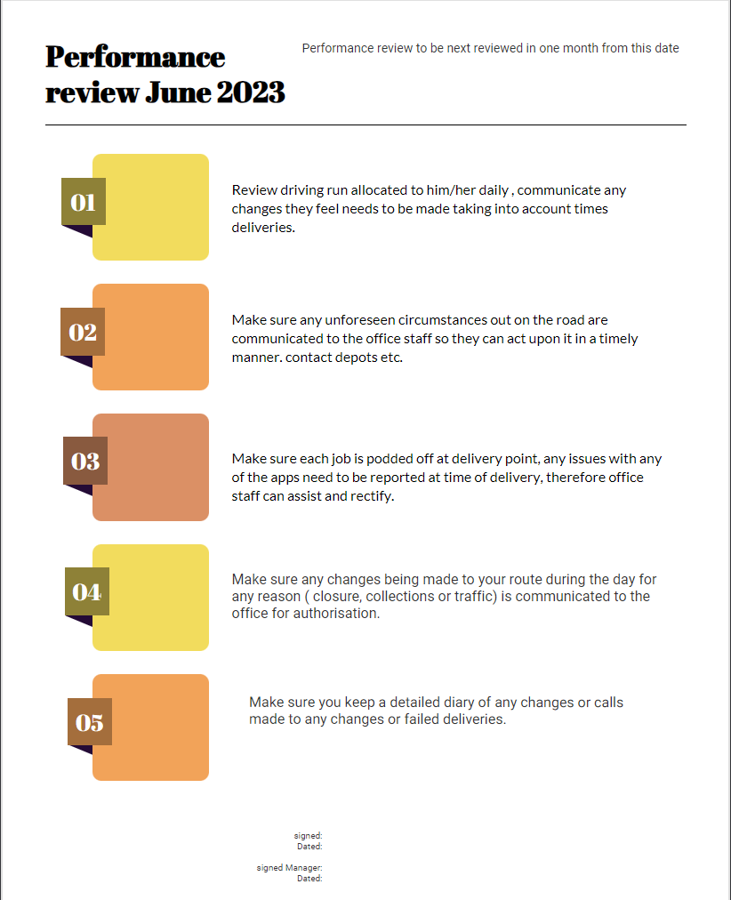

(infograph, 2023)

These targets for this individual are achievable and improvement is set to be seen within the next four weeks, not only are these targets are set out to improve the organisations standards, but they also teach the individual the importance, or timings, plannings and allows them to have their own input into their working day.
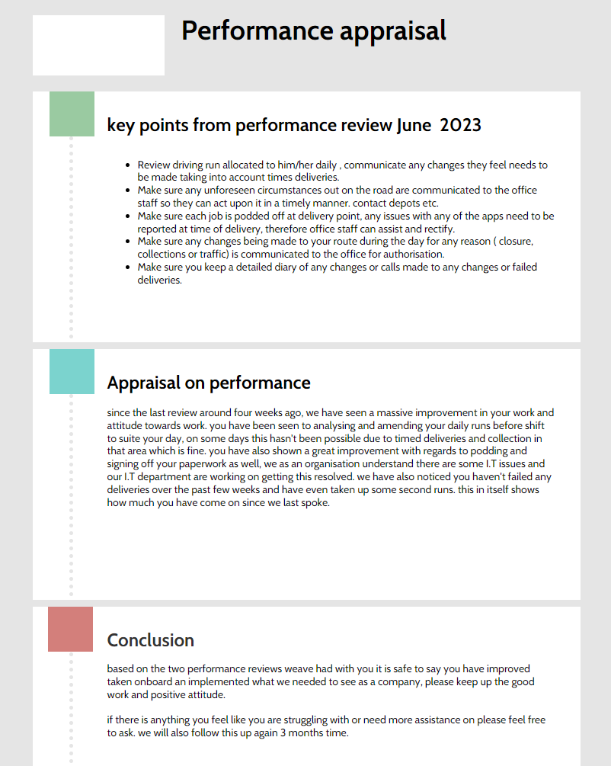

References

Bibliography
Andreev, I. (2023). Employee Development Methods.
CIPD. (2020). creaing learning cultures.
hameed, a. (2011). empolyee development and its affects. international journal of businesss, 91.
infograph. (2023). Retrieved from https://infograph.venngage.com/edit/b7363181-0c6a-480c-9056-b0b51a1ab0d7
nadeem, k. &. (2013). training and development program and its benefits.
robinson, w. (2023, june). performance meeting.

