Driving Your Development – BMHR7018

Helen Golaszewski

Portfolio Word Count - 4391
PDP Word Count - 545

Link to Canva - https://www.canva.com/design/DAFYB-J7qYQ/17tzqRgHtSWjzDoVueQj9A/edit?utm_content=DAFYB-J7qYQ&utm_campaign=designshare&utm_medium=link2&utm_source=sharebutton

Summary

Having worked in my current position as a HR Advisor with South Wales Police for 5 years, I have embarked on a journey of professional and personal development with the aim of achieving the next milestone in my career which is to achieve a promotion to HR Business Partner.
To analyse progression within the field of HR, it is important to measure my performance against a recognised standard of excellence, for HR professionals this is the CIPD Profession Map (CIPD, 2023 i). This portfolio will demonstrate how I have sought to embody the 8 core behaviours (CIPD, 2023 b) within the profession map by utilising a reflective model.
I have decided to use Gibb’s Reflective Cycle as a guide when reflecting and analysing each workplace scenario.
The 6 steps of the model begin with a description which establishes basic facts such what, who, where, why, when and how. This method is commonly known as 5W1H and is often used as a starting point when looking at gathering information for analysis to make improvements (Mahalik,2010).
Step 2 is to explore your feelings throughout the situation and how you feel about the situation now after time for reflection. The ability to self-reflect can not only help you learn from a particular situation, it can also assist in developing strong leadership skills in the workplace (Waters, 2022).
Step 3 and 4 are Evaluation and Analysis, these steps are often grouped together as this looks at both the positives and negatives of the situation and questions whether there could have been anything that would have improved the outcome further (The University of Edinburgh, 2020). It will be at this stage that research and models of best practice will be utilised to compare performance and highlight improvements.

Step 5 is the conclusion which aims to summarise the main learning points that have been discovered because of the reflections made in previous steps (Richardson,2017), this will then allow you to come up with any action plans which is the final step of the cycle.
Learning from this portfolio will form my Professional Development Plan.
Advantages of this model are that it is simple to follow, it allows you to explore how you felt but also allow you to reflect on what could have been done differently and if there is anything to be learned (Denis,2019; Mind Tools, 2022). In addition to this, the Gibbs model is also referenced as good practice within College of Policing guidance (College of Policing, 2023).
A limitation of this model is that it does not require you to think from different perspectives and is solely centred on an individual’s experience and assumptions (Smith,2021), as this is a portfolio designed on personal development, I feel that this limitation will have a reduced impact on the overall aim.
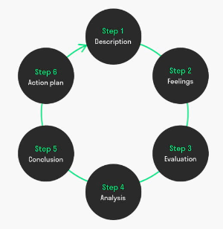

Graham Gibbs Reflective Cycle (Mulder, 2023)

Contents:

- “Every day is a school day” – Passion for Learning and Valuing People
- “Creating policy and building working relationships” – Commercial Drive and Situational Decision Making
- “Taking care of the SWP Family” - Working inclusively and Insights Focussed
- “Not Everyone likes change” - Ethical practice and Professional Courage and Influence
- Next Steps – Professional Development Plan.

“Every day is a school day”

Description

Our line manager informed us that she wished for us to take time on team continuous professional development, therefore I volunteered to organise the first HR Advisor (HRA) “CPD day”.
I organised a date that was suitable for everyone and booked a South Wales Police venue which central for the team to reduce the need for some to travel longer distances. This demonstrates my ability under “Valuing People” as I was considering the wellbeing of my colleagues (CIPD, 2023 j). The venue was not the normal office to reduce the likelihood of distractions, something which can be conducive to learning (Sanders, 2018).
Although I had volunteered to organise the day, I wanted to ensure that the team had a say in what the agenda was going to contain, therefore enabling them to have a voice on their own development which is an example of the “Valuing People” (CIPD, 2023 j) standards and is also assists with the engagement and retention of staff (Vijayaraghavan, 2022).
I sent out a request to my colleagues for ideas on what they would like on the agenda. Following very little feedback from the team, I developed an agenda which I felt would engage the whole team and allow for productive outcomes which could be fed back to our line manager.

The agenda for the day was as follows:
- Discussion regarding key outcomes from the HR Operations Team Away Day which had been arranged for the day before – the aim of this was to look at how wider team activities are impacting the work of the HRA’s and whether there were any changes required to our own processes which will ensure that we are aligned to HR strategy and objectives. This can be matched CIPD “Passion for Learning” core behaviour which requires professionals to look at wider factors and the impact that this could have (CIPD, 2023 f)
- Visit by the newly appointed Shared Services Manager who was about to implement a new Shared Service model within his admin team, this was an opportunity to meet a new member of the HR team to “build A sense of team spirit” a core behaviour under “Valuing People” (CIPD, 2023 j) and gain feedback from him regarding how he thought the HRA’s could work effectively alongside his team. Seeking feedback is also another standard under “Passion for Learning” (CIPD,2023 f)
- Project update – an opportunity for the team to discuss their ongoing project work with the aim of sharing knowledge.
- Team Skills Gap Analysis – the information from this would be used to form the agenda for future CPD Days.

On the day one on my colleagues had to attend online due to Covid, I was also informed at very late notice that two of my colleagues were not going to be able to stay for the duration of the day due to meetings and having to leave early. Despite this, all the agenda items were achieved apart from the team project updates as I felt the need to prioritise the other agenda items. Following the day, I wrote a report for my line manager to summarise what had been achieved and booked in a meeting with her to feedback on how it went.

Feelings
I felt positive about spending time with colleague’s face to face whilst getting the opportunity to focus on our development, however I found it challenging when my colleagues did not engage with me to develop the agenda and not all of them could stay for the day which shows that some of team may not consider CPD days as a priority. Overall, I was pleased that I had been the first person to volunteer and organise a day with some productive outcomes.

Evaluation/Analysis

The decision to have a face-to-face meeting after working remotely was a good opportunity to catch up with colleagues and share information which is viewed as a key component of team learning (Decuyper, 2010). In addition, the skills gap analysis exercise allowed the team and I to identify our strengths and weaknesses which was aligned to the HRA role responsibilities, this provided us with areas to focus on in future CPD days.

The main challenges that I faced was the lack of engagement and participation that I had from my colleagues and not being able to achieve all aspects of the planned agenda.

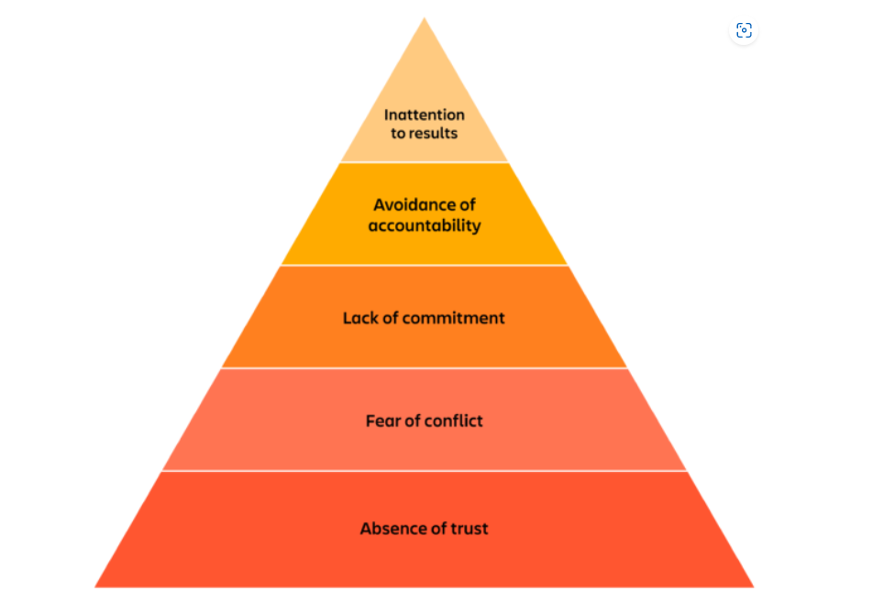
The Lencioni Model can be used to identify potential reasons lack of engagement from the team and can highlight areas for improvement (Mind Tools, 2023) If by using this model it can identify a gap in the HRA team function, it is something that then can be addressed to ensure that we are working more effectively as a team.

Lencioni Model (Boogaard, 2023)
Achieving Results
The Honey and Mumford Learning Style theory highlights the different approaches to learning that individuals find beneficial for them (Watson, 2019). The lack of engagement from colleagues could have been due to the format of the day as the agenda was heavily focussed on conversation rather than a mix of activities. Whilst this is important to consider, research also suggests that learning in accordance with preferred style does not have significant impact on performance outcomes (Wilkinson, 2014).

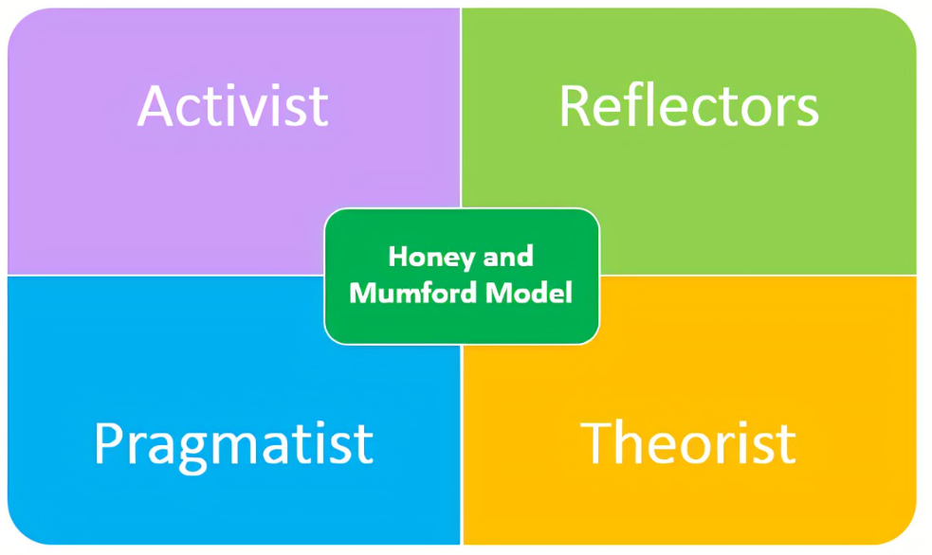

(The Peak Performance Centre, 2023)

Building Trust
Understanding the natural behavioural “roles” that team members present in the workplace according to Dr Beblin can help teams understand each other’s strength and weaknesses and develop better communication skills (Belbin, 2023). As the team have spent a considerable amount of time working from home since 2020, an exercise of this nature may be beneficial so that we can better understand each other which in turn could improve trust (Molnau, 2013).

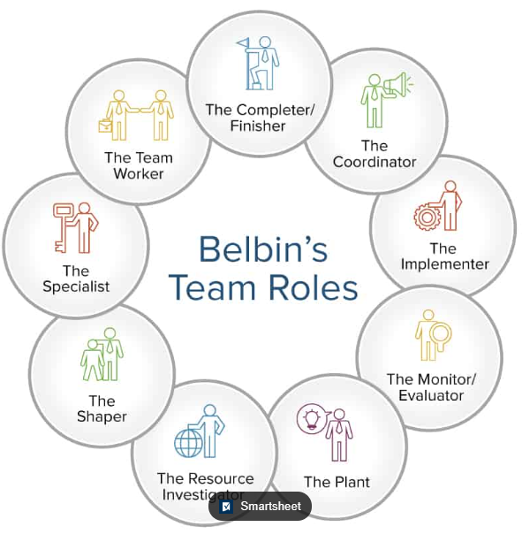

(Simon, 2017)

Conclusion

The organisation of the day demonstrated some of the core behaviours of Valuing People and Passion for Learning, however upon reflection, there are improvements that I could make to my approach going forward when trying to achieve results as part of a team.

“Creating policy and building working relationships”

Description

The SWP Special Constabulary Chief Officer requested assistance from HR to develop policies specific to the Special Constabulary.

To understand what is required and the expectations of the Chief Officer, I organised an initial meeting with the Special Inspector, as a result of this meeting there were several areas identified which would benefit from the development of a specific policy, however we agreed that a probation policy would be the priority to develop as this enabled to effective manage probation periods and provides a clear framework to be followed if there was any underperformance or a requirement for an extension.
Engaging with the “customer” to understand their needs and focussing on areas that impact on business performance demonstrates “Commercial Drive” (CIPD, 2023 a)

At the beginning of the project, I gathered information from various sources including the current internal policy for regular officers, police regulations and other forces. By conducting this exercise, I was able to determine what our options were for the design of the policy and present them along with advantages and disadvantages which demonstrates my “Situational decision making” (CIPD, 2023 h).

For continuity, the decision was to create a policy that followed a similar format to the Police Officer policy but making relevant changes to suit the Special Constabulary, for example making the mandatory notice of a meeting 14 days rather than 7 due to Special Constables being volunteers who often have employment in other organisations. Following the design of the policy, a consultation session with key stakeholders such as the Police Federation and the Special Sergeants allowed for feedback to ensure that the policy was going to be practicable as it would impact the way that they managed their probationers going forward. Understanding the impact of choices and actions on the wider performance of the business also demonstrates “Situational decision making” (CIPD, 2022 h).

Once the policy had been written, it became apparent that there would need to be a secure way of holding data that would be collated throughout probation and that Special Constables did not all have access to a laptop like the regular Police Officers. We therefore met with the data protection officer to determine a way to store documents which were not in breach of GDPR, however this developed into a much larger discussion than expected which delayed the implementation of the policy.

Feelings

I felt that I had managed the project well and created a product which will improve the management of Special Constables in their probation whilst building a strong working relationship with the Special Inspector.

Evaluation/Analysis

Upon reflection, the use of a Co-Manager approach (Wysocki, 2019) throughout the project meant that decisions were made collaboratively utilising both my specialist knowledge in HR and also the Special Inspectors knowledge of the Special Constabulary.
Conducting the benchmarking process, undertaking research and consulting with unions and staff when designing the policy was advantageous as we ensured that we created a policy that is consistent with existing policies and practices and aligned with SWP values and ethics, practice which is recommended when introducing new policy (George, 2022).

The main challenge faced was the setback caused following a meeting with the GDPR officer regarding storage of documents. Whilst this was a setback towards the end of the project when the policy was ready to publish, the risk of breaching GDPR regulations could have significant financial and reputational implications for the organisation (ICO, 2023).
To have potentially forecast the GDPR considerations at an earlier stage, a model which could have been utilised is Mendelow’s Stakeholder Matrix (Cuofano, 2023) this may have highlighted the influence that GDPR considerations would have had on the project. This however would have been reliant on stakeholders being correctly categorised and understanding the influence of each stakeholder from the beginning. (Martin, 2019).

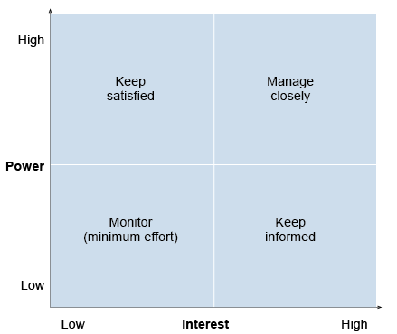

(The Open University, 2023)

Conclusion

Overall, I felt that this project was a success, and the policy has laid the foundations for further pieces of work that can be undertaken to assist the Special Constabulary in South Wales Police, the project allowed me to make decisions and also anticipate the impact on the management of probationary Special Constables. A learning point from this project would be to look at wider stakeholders who could potentially influence the progress of any future pieces of work at an earlier stage so that any setbacks could be dealt with.

“Taking care of the SWP Family”

Description

Recent changes to allowances had promoted the need for a review of the maternity/ adoption booklets for employees which I was tasked with completing. In addition to making the changes to the allowances, it was also an opportunity to review how useful our employees found the existing documents and establish whether any improvements were required.
I decided to use a “deign thinking” approach to the project which is a method that is “customer focused” (Mckinsey & Company, 2023). There are 5 stages to this approach which are as follows:
- Empathise – Gain feedback from your stakeholders.
- Define – Analyse the feedback to define areas for improvement.
- Ideate – Look to create solutions to address identified areas of improvement.
- Protype – Create a first draft of the new document.
- Test – Send the draft to stakeholders for final feedback. (Dam, 2022).

For the empathise stage, I decided to do some research by asking employees who had been on maternity/adoption leave within the last three years to complete a survey to capture what information they felt they needed during their pregnancy, maternity or adoption journey and whether our current information provided them with the support that they needed.
From the results of the survey, I was able to define the areas for improvement as follows:

- Whilst maternity/adoption leave is the same in terms of allowances, it was clear from feedback from someone who had been through the adoption process that the journeys are very different and that it was sometimes frustrating to have to read through pregnancy and maternity information and pick out elements that were relevant to them.
- There was very little information for those who wanted to know about leave entitlements for partners.
- Whilst the booklet referred to actions the line manager is responsible for throughout the existing guidance, employees fed back that line managers often weren’t aware of their responsibilities such as conducting a pre maternity/adoption support plan therefore this also highlighted a knowledge gap for line managers.

By asking questions to identify areas required for improvement, this demonstrates my ability to be “Insights Focussed” (CIPD, 2023 e).

Following the feedback, I also held discussions with the SWP Gender Equality Network to gain further insight into some of the issues that are highlighted to them regarding maternity/adoption leave which demonstrates “working inclusively” as I had looked to collaborate with colleagues and build working relationships which would benefit the organisation (CIPD, 2023 l) I was also further demonstrating being “Insights focused” by gathering evidence from multiple sources. (CIPD, 2023 e).

With the information gathered, I decided on the following solutions:

- A separate booklet was required for maternity and adoption so that this prevented colleagues having to look for information that was relevant to them.
- A further booklet was then required for partners so that they could see what their entitlements were for leave and support that is available to them.
- Due to the gap highlighted in the survey around line manager knowledge, there needed to be a line manager specific guide created so that they can understand their responsibilities they have when an employee asks about maternity/adoption/paternity leave.

Following my discussions with the GEN network, I also wanted to ensure that the guidance was inclusive and representative of all types of families, therefore the pictures used in the guidance would not be as heavily focussed on pregnancy and would include a diverse range of images. I was also conscious of the use of gender-neutral language throughout to ensure that the booklets were inclusive. I feel this further this demonstrates my passion for “working inclusively” and ensuring that this is reflected in the literature that is produced by HR (CIPD, 2023 l).

Whilst my ideas aimed to improve the gaps that had been identified, it was clear at this point that this project was going to be larger than first anticipated and with my daily workload still to complete, I had to ensure that I kept the project progressing. Without an official deadline for the project completion, this meant that the project was often reprioritised, and it therefore took several months to get a completed draft of the three booklets and a toolkit for line managers.

Once the drafts were complete, I wanted to ensure that other HR Professionals were able to review the documents as they would be responsible for promoting them once they were published. In addition to this, the drafts were sent to some of the employees that had completed the initial survey and the GEN Network representative as I felt it was important to keep stakeholders informed of progress something which is recommended when managing stakeholders (Bennett, 2022). This further developed my ability to “work inclusively” by sharing knowledge with my colleagues (CIPD, 2023 l).

Once the final comments were received, there were final amendments before the documents were ready to be published on our staff intranet.

Feelings

Whilst the project resulted in a much larger piece of work, I felt that it was important to address the concerns raised in the feedback to be able to provide further support to our colleagues going through maternity and adoption. As I am not a parent myself, I found the experience extremely informative, especially in terms of the long process that parents must go through to adopt a child, something which is now explained in the guidance for line managers so that they can also have an understanding and be able to support their employees more appropriately.

Evaluation/Analysis

When considering what went well in this project, I feel that whilst the overall product at the end was a success, the project allowed me to gain an insight into an area that I had no personal experience of previously and it provided me with the ability to empathise with others and enable me to think of better ways to provide guidance and support. Developing emotional intelligence is an important skill for HR professionals to have and it will assist me when working on future projects and during my future career development (Dixit, 2020; Drigas and Papoutsi, 2019).

When looking at what could be improved, the main challenge that I found is the time it took to complete the project from start to finish which in total was over 6 months.
As previously mentioned, as I was doing this task in addition to my normal workload there was not a fixed deadline for the completion of the review, however once it had been decided that the separate booklets and toolkit were to be developed, a clear project plan with milestones may have assisted in completing the work sooner. A Gantt chart is a tool which can be utilised for future projects and will also be a visual aid to monitor progress and delegate tasks to specific people involved (Hakoune, 2023). Whilst this may have helped the project meet deadlines sooner, it may not have been possible to eliminate all the time delays due to other work taking a higher priority.

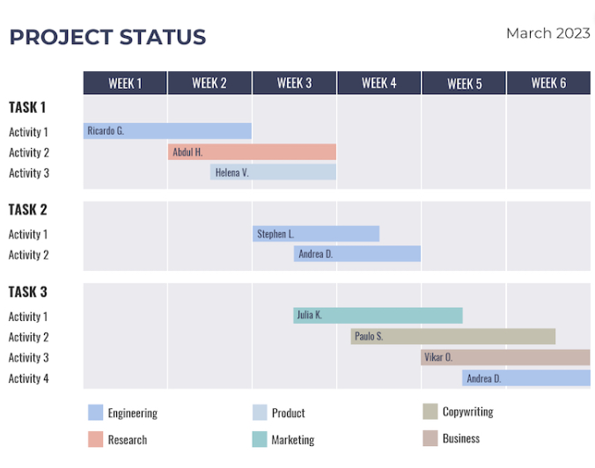

Gantt Chart Example (Keinapple, 2023)

Conclusion

This is an example of a piece of work which developed in to a large piece of work, however the outcome has led to a product which not only assists employees better when they are on their maternity/adoption journeys but also allowed HR to provide assistance for line managers to enable them to support colleagues more effectively which contributes to the wider objectives of HR and the Chief Constable’s Delivery Plan which is to “develop people” and prioritise employee wellbeing (SWP, 2021).

“Not Everyone likes change”

An Inspector within the Safeguarding Team made contact to discuss how he could align the rotas between two teams who provide a service to the Mid Glamorgan area as current work patterns meant that there were gaps in coverage, impacting on organisational delivery. The Inspector proposed that he aligned his South Team to the North Team pattern with some minimal changes and provided a business rationale for the proposal. I therefore advised that to conduct the change in work pattern a consultation process was needed as per employment regulations which is in line with CIPD ethical practice standards (CIPD, 2023 c).

- In addition to the proposed changes and the Business rationale, the Inspector would also need to produce an Equality Impact Assessment (EIA). An EIA is conducted to prevent any policies or decisions being discriminatory against any employees with a protected characteristic as per the Equality Act 2010 (Pyper, 2020).
- As there were staff and officers that were going to be impacted by this change, both the Police Federation and Trade Unions would need to be briefed prior to starting formal consultation, I also advised the Inspector that due to Police Staff having more favourable terms and conditions in terms of notice periods, that it would be more ethical to provide the Police Officers with the same notice period.

Prior to commencing the consultation, I highlighted that it was close to the Christmas break and that staff leave during the time of consultation could prevent some employees from engaging with the process, however the Inspector had made the decision to proceed. Whilst I accepted the decision, I informed him that an extension to the consultation period may be required if the Christmas break causes disruptions for employees which was agreed. I feel this is an example of how I considered the impact of decisions under “Ethical Practice” under the CIPD standards (CIPD, 2023 c).

During the main consultation meeting, it became clear that there was some resistance to the change particularly in the South Team as this was where there was the most change was going to happen, we were also challenged on why a timeline had been provided with dates in the consultation pack as it appeared that the changes were a “done deal” and that consultation was a tick box exercise. Whilst the dates had been provided with the intention of giving employees as much information as possible, to gain the trust of the employees and reassure them that we were conducting a meaningful consultation, I agreed to take the dates out of the timeline and encouraged employees to attend a one-to-one session where we would be able to discuss any of their concerns. I feel this demonstrates accountability and my ability to manage stakeholder relationships under the “Professional Courage and Influence standards” (CIPD,2023 g).

During the consultation, there were several alternative suggestions raised to the original proposal of which only one would achieve the business objectives, therefore, to be transparent I advised that employees should be given the chance to vote on their preference. This was conducted with all votes coming to myself so that the vote remained confidential to the Inspector, and the outcome was that overall employees preferred the original proposal. At the end of the consultation, whilst some employees were still not satisfied with the result, a decision was made to proceed with providing formal written notice and implement to achieve the business objectives.

Feelings

Whilst the business objective was ultimately achieved, I felt that the consultation was challenging at times due to the resistance that some of the employees had to the change. Whilst this caused delays, I felt that they were necessary to allow employees to feel properly consulted.

Evaluation and Analysis

When looking at what went well during the consultation, the work that was invested in getting the Police Federation and Trade Unions on board assisted in helping to get to implementation stage as they felt reassured that the organisation was following a fair and consistent process, something which can assist with maintaining a psychologically safe environment for employees (CIPD, 2023 m).

When looking at what I could have improved, I felt that the process was delayed due to a minority of employees which took a lot of attention and focus away from the overall objective. When reflecting on the approach that I took to the conflict, my preference was to achieve a collaboration style solution which is beneficial for all parties (Andreev, 2023), however the disadvantage was that this took time, the consultation period was extended, and a decision was made to implement the original proposal following a majority vote which did not achieve a full collaboration outcome. The delay in streamlining the Mid Glamorgan service could also have created reputational risk for SWP if service provided was not to standard.

To assist me in the future, I could use a change management model such as Kotter’s Change Model (Mind Tools, 2023). To get employees onboard, rather than focussing on the organisational need only, the benefits of the change for employees can also be included.

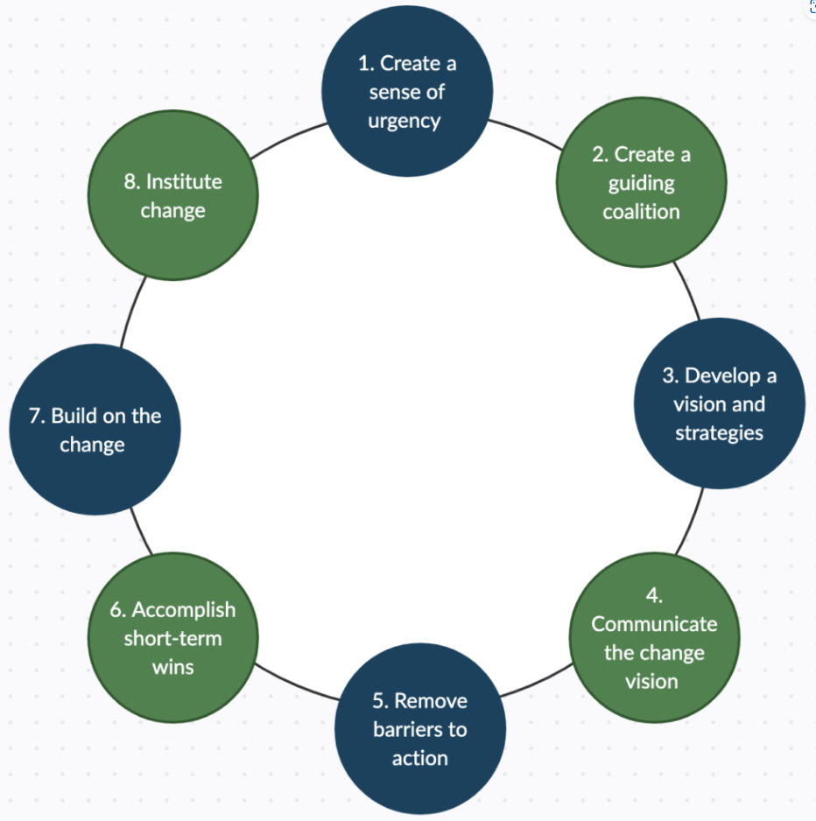

(Martinengo, 2021)

Conclusion

Whilst this change project came with some unexpected challenges, I felt that having achieved the objective of aligning the rotas in accordance with procedures and overcoming the helped me to identify areas in which I can improve for future projects. The ability to lead change is a key part of being a people professional (George, 2023), therefore this experience will also assist in my ambition to become a Business Partner.

Professional Development Plan

Objectives | Actions to be taken | Resources required | Target date for completion
To achieve the role of HR Business Partner (HRBP), one of the requirements is to gain the appropriate professional qualification. | To become a HRBP within South Wales Police (SWP), it is an essential criteria as per the SWP role profile (SWP, 2023) to hold a CIPD Level 7 qualification. | I am currently undertaking a Post Graduate Diploma in Strategic Human Resources Management at University of Wales, Trinity St David which will qualify me for a CIPD Level 7 qualification upon completion. | Completion of qualification expected June 2023.  I would like to achieve the role of HRBP by June 2024.
Following my experience in terms of lack of engagement from colleagues when organising the team CPD Day, I feel that understanding my strengths and weaknesses and how these translate into the role in my current team can assist in working more effectively (Murphy, 2020) | I feel that completing a Belbin questionnaire would be a useful exercise for my own self development and to understand my team (Belbin, 2023). | Belbin questionnaire which can be obtained via SWP Learning and Development Team. | Completion of the questionnaire by July 2023 to identify further development which can be implemented within my PDP over the next 12 months.
Following the learning I experienced when conducting the maternity/adoption guidance review, I feel that to expand on my knowledge as a HR Generalist, I need to learn about all elements of the employee lifecycle (CIPD, 2023 k). I therefore feel that I would benefit from gaining exposure to the Employee Relations side of HR, something which will also be part of my role as a HRBP in the future. | SWP has a dedicated Case Management Team that deals with “complex” grievances, misconduct and sickness cases, however there is an element of casework which is undertaken by the HRBPs, therefore I feel that the opportunity to assist a HRBP with a case will allow me to gain experience and also understand how policies and procedures aswell as legal considerations are put into practice (Suff, 2023). | HRBP to shadow whilst conducting a grievance, misconduct or complex sickness case. | December 2023.  Following the completion of my qualification, I will be looking to gain further knowledge and experience over the next 12 months to be able to achieve my overall objective of gaining promotion to HRBP.
A theme from all the situations mentioned in my portfolio was the need to improve my project management skills, whether this is in relation to time management, leading change and managing unexpected challenges. | Utilising technology such as One Note or MS Teams to create deadlines and share progress with other team members or line management will be something that I can develop myself when undertaking future project work (Pandey, 2023; Cruz, 2021)  To develop this further, I could also look at attend a project management course provided by SWP Learning and Development Team. | SWP already has MS Teams and One Note established.  To undertake a project management course, I would require up to 5 days to complete. | I can begin to utilise MS Teams and One Note as part of my everyday processes immediately.  I would aim to complete some more formal training by March 2024.

References

Andreev, I. (2023) Conflict Management Styles. Available at: https://www.valamis.com/hub/conflict-management-styles (Accessed: 14 May 2023)

Belbin. (2023) The Nine Belbin Team Roles. Available at: https://www.belbin.com/about/belbin-team-roles (Accessed: 30 January 2023)

Belbin. (2023) The Nine Belbin Team Roles. Available at: https://www.belbin.com/about/belbin-team-roles (Accessed: 14 May 2023)

Bennett, C. (2022) Your Simple Guide to Keeping Stakeholders Informed. Available at: https://www.consultationmanager.com/your-simple-guide-to-keeping-stakeholders-informed (Accessed: 14 May 2023)

Boogaard, K. (2022) What strong teamwork looks like: 7 proven models. Available at: https://www.atlassian.com/blog/teamwork/what-strong-teamwork-looks-like (Accessed: 15 May 2023)

CIPD. (2023 a) Commercial Drive. Available at: https://www.cipd.org/uk/the-people-profession/the-profession-map/explore-the-profession-map/core-behaviours/commercial-drive/ (Accessed: 02 February 2023)

CIPD. (2023 b) Core Behaviours. Available at: https://peopleprofession.cipd.org/profession-map/core-behaviours/ (Accessed: 21 January 2023)

CIPD. (2023 c) Ethical practice. Available at: https://www.cipd.org/uk/the-people-profession/the-profession-map/explore-the-profession-map/core-behaviours/ethical-practice (Accessed: 14 May 2023)

CIPD. (2023 d) HR Business Partner Roles. Available at: https://www.cipd.org/uk/the-people-profession/careers/roles/hr-business-partner (Accessed: 14 May 2023)

CIPD. (2023 e) Insights focused. Available at: https://www.cipd.org/uk/the-people-profession/the-profession-map/explore-the-profession-map/core-behaviours/insights-focused (Accessed: 14 May 2023)

CIPD. (2023 f) Passion for learning. Available at: https://www.cipd.org/uk/the-people-profession/the-profession-map/explore-the-profession-map/core-behaviours/passion-for-learning/ (Accessed: 29 January 2023)

CIPD. (2023 g) Professional courage and influence. Available at: https://www.cipd.org/uk/the-people-profession/the-profession-map/explore-the-profession-map/core-behaviours/professional-courage-influence (Accessed: 14 May 2023)

CIPD. (2023 h) Situational Decision Making. Available at: https://www.cipd.org/uk/the-people-profession/the-profession-map/explore-the-profession-map/core-behaviours/situational-decision-making/ (Accessed: 02 February 2023)

CIPD. (2023 i) The Profession Map. Available at: https://peopleprofession.cipd.org/profession-map (Accessed: 21 January 2023)

CIPD. (2023 j) Valuing People standards. Available at: https://www.cipd.org/uk/the-people-profession/the-profession-map/explore-the-profession-map/core-behaviours/valuing-people/ (Accessed: 28 January 2023)

CIPD. (2023 k) What do HR generalists do? Available at: https://www.cipd.org/uk/the-people-profession/careers/roles/hr (Accessed: 15 May 2023)

CIPD. (2023 l) Working inclusively. Available at: https://www.cipd.org/uk/the-people-profession/the-profession-map/explore-the-profession-map/core-behaviours/working-inclusively (Accessed: 14 May 2023)

CIPD. (2023 m) Working with trade unions. Available at: https://www.cipd.org/uk/knowledge/guides/working-trade-unions (Accessed: 14 May 2023)

College of Policing. (2023) About us. Available at: https://www.college.police.uk/about (Accessed: 21 January 2023)

College of Policing. (2023) Resources for reflective practice. Available at: https://assets.college.police.uk/s3fs-public/2020-11/Resources_for_reflective_practice_v1_0.pdf (Accessed: 21 January 2023)

Cruz, L. (2021) Ultimate Guide to Microsoft Teams Project Management (2023). Available at: https://clickup.com/blog/microsoft-teams-project-management (Accessed: 15 May 2023)

Cuofano, G. (2023) Mendelow Stakeholder Matrix. Available at: https://fourweekmba.com/mendelow-stakeholder-matrix (Accessed: 06 February 2023)

Dam, R. (2022) The 5 Stages in the Design Thinking Process. Available at: https://www.interaction-design.org/literature/article/5-stages-in-the-design-thinking-process (Accessed: 13 May 2023)

Decuyper, S. et al (2010) ‘Grasping the dynamic complexity of team learning: An integrative model for effective team learning in organisations’ Educational Research Review. 5 (2), pp111-113. Available at: https://www-sciencedirect-com.ezproxy.uwtsd.ac.uk/science/article/pii/S1747938X10000217 (Accessed: 29 January 2023)

Denis, G. (2023) Gibbs’ Reflective Cycle. Available at: https://expertprogrammanagement.com/2019/05/gibbs-reflective-cycle (Accessed: 21 January 2023)

Dixit, N. (2020) Emotional Intelligence in HR is crucial to your business - Learn Why! Available at: https://www.linkedin.com/pulse/emotional-intelligence-hr-crucial-your-business-learn-negi-dixit (Accessed: 14 May 2023)

Drigas, A. and Papoutsi, C. (2019) ‘Emotional Intelligence as an Important Asset for HR in Organizations: Leaders and Employees”. International journal of advanced corporate learning. 12 (1) pp.58, Available at: https://www.proquest.com/docview/2272188350?pq-origsite=primo (Accessed: 13 May 2023)

George, S. (2021) Change management. Available at: https://www.cipd.org/uk/knowledge/factsheets/change-management-factsheet/#managingchange (Accessed: 15 May 2023)

George, S. (2022) HR Policies. Available at: https://www.cipd.co.uk/knowledge/fundamentals/people/hr/policies-factsheet#7732 (Accessed: 05 February 2023)

Hakoune, R. (2023) What is a Gantt chart? Available at: https://monday.com/blog/project-management/everything-you-want-to-know-about-gantt-charts (Accessed: 14 May 2023)

ICO. (2023) Penalties. Available at: https://ico.org.uk/for-organisations/guide-to-data-protection/guide-to-le-processing/penalties/ (Accessed: 06 February 2023)

Kienapple, B. (2023) 11 Gantt Chart Examples For Project Management. Available at: https://venngage.com/blog/gantt-chart-example (Accessed: 14 May 2023)

Linkedin. (2022) What is Employee Development: Benefits, Key Areas and Planning. Available at: https://www.linkedin.com/pulse/what-employee-development-benefits-key-areas-planning (Accessed: 15 May 2023)

Mahlick, P. (2010) Using the Five W’s and One H Approach to Six Sigma. Available at: https://www.isixsigma.com/basics/using-five-ws-and-one-h-approach-six-sigma (Accessed: 28 January 2023)

Martin, E. (2019) 10 common problems with stakeholder management. Available at: https://sanzubusinesstraining.com/10-common-problems-with-stakeholder-management/ (Accessed: 06 February 2023)

Martinengo, G. (2021) Change Leadership: John Kotter’s 8-Step Model. Available at: https://giuseppemartinengo.org/change-leadership-john-kotters-8-step-model (Accessed: 14 May 2023)

McKinsey. (2023) What is design thinking? Available at: https://www.mckinsey.com/featured-insights/mckinsey-explainers/what-is-design-thinking (Accessed: 13 May 2023)

Mind Tools (2023) Gibbs' Reflective Cycle. Available at: https://www.mindtools.com/ano9qiu/gibbs-reflective-cycle (Accessed: 21 January 2023)

Mind Tools (2023) Lencioni's Five Dysfunctions of a Team. Available at: https://www.mindtools.com/a6ooqev/lencionis-five-dysfunctions-of-a-team - 02.02.2022 (Accessed: 02 February 2023)

Mind tools. (2023) Kotter's 8-Step Change Model. Available at: https://www.mindtools.com/a8nu5v5/kotters-8-step-change-model (Accessed: 14 May 2023)

Molnau, D. (2013) High-performance Teams: Understanding Team Cohesiveness. Available at: https://www.isixsigma.com/teams/high-performance-teams-understanding-team-cohesiveness/ (Accessed: 31 January 2023)

Mulder, P. (2018) Gibbs Reflective Cycle. Available at: https://www.toolshero.com/management/gibbs-reflective-cycle-graham-gibbs/ (Accessed: 28 January 2023)

Murphy, K (2020) Understanding your Team’s strengths and weaknesses. Available at: https://www.linkedin.com/pulse/understanding-your-teams-strengths-weaknesses-kieran-murphy (Accessed: 15 May 2023)

Nixon, L. et al. (2007) ‘Pedagogy and the intuitive appeal of learning styles in post-compulsory education in England. Journal of vocational education training. 59 (1) pp39-51. Available at: https://www-tandfonline-com.ezproxy.uwtsd.ac.uk/doi/full/10.1080/13636820601144088 (Accessed: 30 January 2023)

Pandey, S. (2023) How to Use OneNote for Project Management. Available at: https://www.brightwork.com/blog/6-easy-ways-to-use-onenote-for-project-management (Accessed: 15 May 2023)

Pyper, D. (2020) The Public Sector Equality Duty and Equality Impact Assessments. Available at: https://commonslibrary.parliament.uk/research-briefings/sn06591/ (Accessed: 14 May 2023)

Richardson, B. (2017) What Should the Conclusion Do in a Reflective Essay? Available at: https://classroom.synonym.com/should-conclusion-reflective-essay-19551.html (Accessed: 28 January 2023)

Sanders, I. (2018) How to organise a corporate away day that delivers. Available at: https://www.peoplemanagement.co.uk/article/1741710/organise-corporate-awaydays (Accessed: 28 January 2023)

Simon, B. (2017) How to Use Teamwork Roles to Build Winning Teams. Available at: https://www.smartsheet.com/how-to-use-team-roles-to-boost-performance (Accessed: 30 January 2023)

Smith, C. (2021) Gibbs Reflective Cycle: Feel the Benefit of Experiential Learning. Available at: https://www.makingbusinessmatter.co.uk/gibbs-reflective-cycle/ (Accessed: 21 January 2023)

South Wales Police. (2021) Chief Constable’s Delivery Plan, South Wales Police. Unpublished. (Accessed: 15 May 2023)

South Wales Police. (2023) HR Business Partner role profile. South Wales Police. Unpublished. (Accessed: 15 May 2023)

Suff, R. (2022) Employee relations: an introduction. Available at: https://www.cipd.org/uk/knowledge/factsheets/relations-employees-factsheet (Accessed: 14 May 2023)

The Open University (2023) Power versus interest. Available at: https://www.open.edu/openlearn/digital-computing/successful-it-systems/content-section-4.4 (Accessed: 06 February 2023)

The Peak Performance Center (2023) Honey Mumford Model. Available at: https://thepeakperformancecenter.com/educational-learning/learning/preferences/learning-styles/honey-mumford/ (Accessed: 30 January 2023)

The University of Edinburgh. (2020) Gibbs' Reflective Cycle. Available at: https://www.ed.ac.uk/reflection/reflectors-toolkit/reflecting-on-experience/gibbs-reflective-cycle (Accessed: 21 January 2023)

Vijayaraghavan, P. (2021) Employee Voice. Available at: https://www.linkedin.com/pulse/employee-voice-dr-parthiban-vijayaraghavan-h-c- (Accessed: 15 May 2023)

Waters, S. (2022) Self-awareness in leadership: How it will make you a better boss. Available at: https://www.betterup.com/blog/self-awareness-in-leadership (Accessed: 28 January 2023)

Watson, E. (2019) Honey & Mumford Learning Style Theory. Available at: https://www.theclassroom.com/global-vs-analytical-learning-styles-8572440.html (Accessed: 30 January 2023)

Wilkinson, T. et al (2014) ‘Does learning style influence academic performance in different forms of assessment?’ Journal of anatomy. 224 (3), pp304-308. Available at: Available at: https://onlinelibrary-wiley-com.ezproxy.uwtsd.ac.uk/doi/full/10.1111/joa.12126 (Accessed: 30 January 2023)

Wysocki, R.K. (2019) What Is a Collaborative Project Team? Available at: https://onlinelibrary.wiley.com/doi/epdf/10.1002/9781119562757.ch4 (Accessed: 02 February 2023)

