BY FARUK UDDIN-1805275
HOST ORGANISATION: UWTSD
PUBLISHED: 5 APRIL 2019
A Report on communication within the worklpace

PUBLISHED: 5 APRIL 2019

A Report on Communication Within the Workplace

Executive Summary

Through this report, the findings are that no organisation can survive without considering communication as a key element of a day to day running of the business.
There are many types of workplace communication to think about, from movements of mouth to movements of body to the writings on the paper or digital and electronic, it all comes under one banner.
How we run modern day businesses with effectiveness and accuracy and way we maximise full potential of the workforce through communication evaluation and analysis is some feat.
This report has delved into the types of communication methods, its pros and cons and what functions best suit dependant on the situation arising. It further explores into workgroups and team formation and discusses the positives and outcomes of it.

Table of Contents

Page Number
Executive Summary 1
1.0| Terms of Reference 3
2.0| Procedure 3
3.0| Findings:
3.1| Importance of Communication in a Workplace 3
3.1.1| Communication: Functions and Directions 4
3.1.2| Communication (Schramm’s) Model 4
3.2| Verbal Communication - Meaning, Types, Merits and Drawbacks 5
3.3| Non-Verbal Communication – Meaning, Types, Merits and Drawbacks 6
3.4| Two – Way Communication in a Workplace 7
3.5| Building Teams and Teambuilding in the Workplace 9
4.0| Conclusion 11
5.0| Recommendations/ Action Plan 11
6.0| Acknowledgements 11
7.0| Reference List 12

1.0| Terms of Reference
On the 21st of February, Jessica Shore, the Head of Business Communications at UWTSD made a request to submit a report on Communication Within the Workplace. This report aims to explore the different types of effective communication, levels and methods of communication skills that can be implemented in an organisation. It will also contain applications of group and team building theories and leadership skills.

2.0| Procedure
2.1| Books
2.2| Websites
2.2| Journals

3.0| Findings
3.1| Importance of Communication in a Workplace
To send information or ideas through the medium of speech, visual, written, electronic and other modes all fall under the communication banner. The model has to have a sender who sends the message and a receiver to obtain the message. A process is taking place during this time between the two parties, either it can fall in a category of ‘one way’ where all the information is sent to a receiver to decode and should be presented properly for them to understand because here there is no response or feedback. A ‘two way’ process is like a loop, information is transferred back and forth, where both parties are senders and receivers, here they can interact both ways and any misunderstandings and ambiguity can be clarified. A published article considers that successful work communication, looking into makeup of work groups to measure satisfaction in work life. (Deiuliis, D. 2016; p.3)
There are four functions of communications as follows: - (Martin, J. 2005; p.674)
1] Information processing. Data has to be collected and turned into information with meaning and purpose. In order to take decisions and undertake planning, information has to be created and shared out to trigger activity.
2] Co-ordination. It helps to unify the organisation to function as one body, which reduces losses and sudden crises events.
3] Visioning. When thoughts and ideas develop to “convey the vision, mission and strategies to employees”. (2005; p.674).
4] Personal expression. Management have to understand that individuals will have their own views and opinions about the products and services, management, employers, on the way business is run and about non-work issues as well. They have to engage them in a mutual understanding and respect and shape attitudes and feelings through an internal company communication.

3.1.1| Communication: Functions and Directions
In Stephen Robbins (2008) book, he states that “communication serves four major functions within a group or organization: control, motivation, emotional expression, and information”. (pp.158-9).
Every organisation has guidelines that requires observing, where there are different authority hierarchies, the need for compliance with rules and policies and following the job description. Good communication harnesses better motivation and increases productivity. People will know what’s to be done, how well its being done, and how there can be improvements. A study revealed that “communication as one the most dominant and important activity in the organization and it could be able to motivate employees”. (Ramadanty and Martinus. 01/01/16; pp.77-86).
A large extent of time is spent in the workplace; hence a primary source of social interaction takes place between members where they express their feelings and show emotions and frustrations. Information provides decision making to identify and evaluate situations.
There are three types of communication direction identified by Robbins (2008), the “downward communication” – this is usually flowed from higher ranking employees (e.g. group leaders and managers) or bosses to instruct jobs, policies and procedures, give feedback etc.
“Upward communication” flows to higher level where reports and progress are sent and employee feelings about their work, co-workers, any such disputes and grievances are raised. “Lateral communication” takes place amongst the same work group in any horizontal level. (pp. 160-1)

3.1.2| Communication (Schramm’s) Model

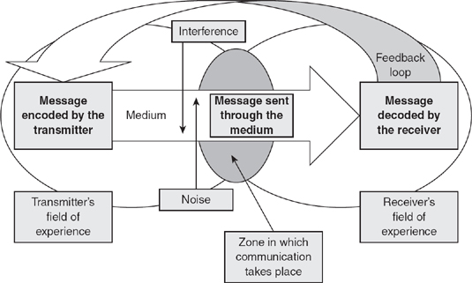
http://sk.sagepub.com/images/key-concepts-in-marketing/9781847874993-p178-1.jpg

i) Transmitter (Source)/ Receiver. The process always starts off with the Sender (Transmitter) encoding an idea into a message and sent via various channels and is directed to the Receiver. (Hunsaker, L. 2005; p.62)
ii) Encoding. The method and articulation of ideas put into writings or spoken out first must be conveyed precisely with meaning and sensitivity as the Receiver might judge it differently. (Martin, J. 2005; p.676).
iii) Transmission Channel. This is the choice of medium opted by the Sender to convey the message which comes in variety of channels which will be discussed later on.
iv) Decoding. The Receiver’s job is to interpret the information and understand its meaning. Here the meaning might not always be perceived as what was intended by the Sender.
v) Noise. This refers to interferences, background distractions and distortions that result in confusion.
vi) Feedback. In order to find out how the original message was interpreted; the Receiver becomes the Sender to give back a response.

3.2| Verbal Communication – Meaning, Types, Merits and Drawbacks

Meaning: “Verbal communication can be either oral, using spoken language in forms such as face-to-face talks, telephone conversations, tape recordings, and the like, or written, in forms, such as memos, letters, order blanks, and electronic mail, to name just a few”. (Greenberg and Baron. 1995; p.334). Oral communication includes sounds, words, language and speech, it happens most frequently in a work setting and can be classed into two bands. One is a spontaneous and sporadic type; hence it is an informal medium, and the other can be more formal and planned such as meetings, conferences etc., in this version less emotions is attached unlike the first one. Written communication involves any type of message that is written down, and is most effective and important method of communication in a business environment.
Both modes of communication (oral/written) are used in daily operations internally (e.g. employees, managers and owners), and externally (e.g. clients, customers, suppliers and lenders).

Types: Oral Written (Manker, A. Study.com)
* Face-to-face * Memos * Emails
* Presentations * Reports * Instant messages
* Meetings * Bulletins * Letters
* Group discussions * Job descriptions * Faxes
* Interviews * Employee manuals * Contracts
* Telephones/ Radiophones * Internet websites * Brochures
* Video conferencing * Advertisements * News releases
* Social Media

Merits of Oral Communication Drawbacks of Oral Communication
- Times saving * Emotion
- Quick feedback * No legal validity
- Powerful Means of Persuasion and Control * Risk of leak of secret
- Saving money * Problem for distance people
- Flexibility * Absence of Permanent Records
- Personal contact * Confused Speech
- Persuasive * Lack of Accountability
- Useful in all kinds of audiences * Greater scope for Errors
- Maintaining secrecy * Easily Forgotten
- Motivation * Greater chance of Misunderstanding
- More reliable * Distortion of Meaning
- Easiness * Inaccuracy

3.3| Non-Verbal Communication – Meaning, Types, Merits and Drawbacks

Meaning: It is stated that “communication is not confined to what is spoken; it includes non-verbal communication such as body language. Some have even suggested that 90 per cent of the way humans communicate is non-verbal”. (Watson and Reissner. 2014; p.275). It’s also referred to as ‘interpersonal communication’ where apart from body language, many other factors play a part.
A research revealed that ‘interpersonal communication’ skill is a vital tool for new employees and for more experienced workers seeking promotion, but knowledge of these skills and how they may be taught is limited. (Dekay, S.H 2012; pp.449-452).

Types:
- Body language (Kinesics)- Gesture, touch, posture, facial expression, eye contact, physical appearance, dress, etc.
- Paralanguage- Voice quality (pitch, range, resonance, etc.), vocal characteristics (whispering, groaning, coughing, etc.), vocal qualifiers (variations in volume or pitch) and vocal segregates (pauses, interruptions such as ‘ah’, ‘um’, etc.).
- Proxemics- Physical distance maintained, seating arrangements, etc.
- Environment- Room design, facilities, location, etc.
- Temporal- The use of time to create effect and influence.

Merits of Non-Verbal Communication
- Compliments and aids the message by adding meaning.
- Using visual, audio-visual and props makes presentation easier, more informative and attractive.
- Signs and symbols used sends messages quicker.
- Sign language through movements of hands and fingers communicates with deaf people.
- Speeds up communication by reaching the receiver fast.
- Helpful for illiterate people.
- Can be used as a substitute in areas blocked by noise, interruption, long distance, etc.

Drawbacks of Non-Verbal Communication
- Encoding and decoding in different ways by different people; hence distortion can take place.
- Costly in some instances, e.g. in presentation, computer instruments, projectors, props, etc.
- Problem in feedback
- Lack of formality as it does not follow any structures and rules. Most of the time it’s performed unconsciously and habitually.
- Cannot be understood by all since it requires repetitive use of gestures, facial expressions, eye contact, etc.
- Its not possible to stop non-verbal cues as its continuously performed even when verbal message ends.
- Differences in meaning across cultures.

3.4| Two - Way Communication in a Workplace
Businesses rely on two-way communication system to send and receive information with one another. It is essential that flow of information between employers, employees, customers, and other stakeholders is constantly maintained in order for the business to run smoothly and efficiently; for this to happen feedback is critical so as to know it was received and understood. There are various tools and interfaces that can be used to carry out these tasks such as verbal, written or electronic, some may be faster than others depending on the urgency and severity of the tasks at hand. Some jobs may need quicker action so an appropriate method have to be selected to suit the nature, while others require more sophistication and planning so a different method is available.

Following are two models of Two-Way Communication relevant to the Toy Store: -

Horizontal/ Vertical pattern of two-way communication
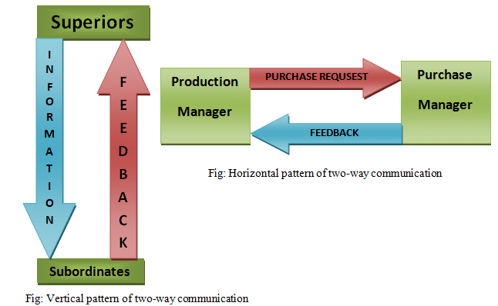
Staffs
Managers and Owner

Owner

Managers

Most effective methods of communication for Toy Store
It is recommended to use the following methods to communicate with store members, managers, and owner:
1) Face-to-face__ In everyday situations between all members of staff, managers on duty and with the owner. This will develop workplace relationship and team cohesiveness, also share ideas, and contribute to running of the business. The interaction is more personal which builds bonds, and managers and the owner speaking directly can build stronger relationships with the workforce and enhance trust. It is also easier to quickly report matters, resolve customer queries and complaints. Members can raise their grievances and opinions on any matter straightaway and can be addressed before becoming a big issue. This method definitely is best for better engagement, decision-making, accountability, inspiration, and focus. “In fact, 8 out of 10 people prefer face-to-face meetings over other methods”. (Fusion, J. Chron.com)
2) Meetings__ Should take place beginning of each week to allow staff to network, share ideas and inform management of issues, new employee introduction, addressing problems. Managers can separately liaise with the owner to talk about company’s needs and requirements, stocks and orders performance, sales and profits, etc.
3) Radiophones/ Transceivers__ This is the easiest way to keep in touch during the shift amongst members on shop floor and also is cheap to run and highly effective when you need to get staffs attention or instructing them a job.
4) Emails__ This can be used when a fast response isn’t needed. Managers can communicate with the Owner and vice versa. They can also contact suppliers, customers and employees regarding more professional matters
5) Telephone__ A phone call is the best way to get a response, you can take care of business on the spot. This is a real-time two-way conversation which you can make when you need to deal with specific person or is an urgent case when they aren’t in the location.
6) Instant Messages__ Almost everyone is accustomed to mobile phone messaging that can be sent as a short text and is very popular. Employees and Managers can share information on work routines, timetables, shift patterns, sickness and absenteeism, etc.

3.5| Building Teams and Teamworking in the Workplace
It is imperative that the Owner formulates a plan and puts it into implementation in order for the success, growth and sustainability of the business. She has to invest in her employees and managers, by showing them vision and giving them motivation to improve and advance the business.
Each individual “has their own values, attitudes, personality, talent, motivation, perception and ability to learn”. (Management Extra. 2005; p.7). All these attributes of individuals have to be harnessed by seeing them as an asset and combining these differences into a unified goal.
Because the business is growing in size and rapidly expanding its workforce, now is the time to put some structures in place into managing its workforce efficiently and coherently. Although there are three Managers, they will be working in different shifts to cover throughout the opening hours and will be busy planning, directing, controlling, monitoring and making sure everyone is complying with standards and target for the job. Even though Managers and Owner will have leadership qualities, they will be too busy with the administrative and organisational side.
In order to drive the workforce and get the maximum out of them, they need to be task driven, so a shake up must happen. As it is stated, at any one time a maximum of 8 workers are working in the store, formal teams need to be created, with each team a team leader assigned who can lead the team and report to a shift manager.
To build a team, a manageable size must be agreed, which in this case about 7 is ideal (the 8th person is the manager). Smaller teams are manageable and more coherent and less cause for dissent. (Belbin, R. M. 2010; p.110).
Developing Teams: To develop teams, first the management must nominate a team leader from the existing workforce for each team, and choose wisely the best candidate with some of these following qualities: - (Northouse, P. G.2012; p.232)
- Trustworthiness - honest, reliable, courage to do right, doesn’t deceive, cheat, steal and builds a good reputation.
- Respect - tolerant, good manners, considerate of others and works out disagreements.
- Responsibility - does the job, persevere, thinks before acting, considers the consequences and is accountable for the choices.
- Fairness - plays by the rules, open-minded, doesn’t take advantage and doesn’t blame others.
- Caring - kind, compassionate, forgives others, and help others in need.
To turn ‘groups’ into ‘teams’ they must perform the four stages of team development created by BW Tuckman, known as the ‘Tuckman’s Theory’ as follows: - (Management Extra. 2005. p. 73-4).
1) Forming - confusion, uncertainty, assess situation, testing ground rules, defining goals, get acquainted, establish rules, questions and answers and guidance from the leader.
2) Storming - disagreements over priorities, tension, hostility, battle with feelings and proving value to the team to the leader.
3) Norming - roles and relationship established, co-operation, consensus, and leadership accepted.
4) Performing - successful performance, openness, helpfulness, leader and team members give their best.
Team roles
The participating individuals who are now in teams could adopt the nine clusters of behaviour known as the ‘Belbin Team Roles’. By taking an analysis test, using the Belbin Interplace computer system to process the results of the Belbin Self Perception Inventory, Observer Assessments and Job Assessments, they could fall into the following characteristics role: - (Brooks, I. 2009; p.130).
- Plant (PL)
- Resource Investigator (RI)
- Co-ordinator (CO)
- Shaper (SH)
- Monitor Evaluator (ME)
- Implementer (IMP)
- Teamworker (TW)
- Completer-Finisher (CF)
- Specialist (SP)
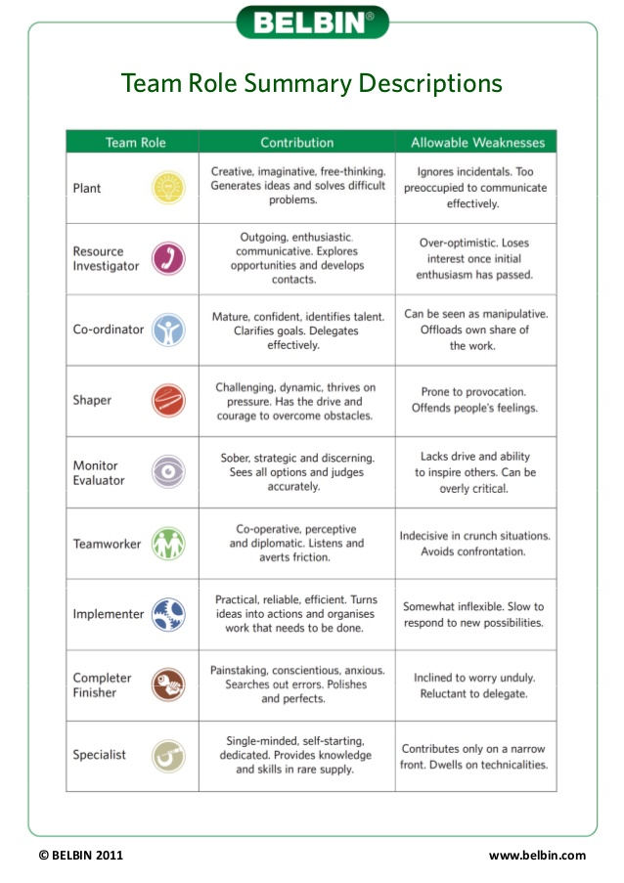
4.0| Conclusion
It has come to better light, after careful study, analysis, and research into communication theories how they can be put into practical use in the workplace. This has obvious benefits and financial rewards as well as making run businesses and organisations in a disciplined and orchestrated manner. Employees and Employers roles are clearly defined and through various mediums of communication skills levels and through formation of work teams, it is evident that individuals then can thrive and work for better success for themselves and the for the organisation.

5.0| Recommendations/ Action Plan
We can see, communication has many facets and channels, the direction and functionality are tremendous. Studies reveal that organisational communication is structured and organised and its language use is disciplined. It teaches better disciplines and skills that compliment and increases standards.
1] Store Work Shifts Pattern
Owner The owner, Michelle Sullivan’s relationship with employees and especially the three managers has to be strong and close. This will foster greater motivation, productivity, quality, profitability, more loyalty, and lesser safety risks, and disharmony in work. She will have to coordinate work and assign work shifts and timetables. She will have to be available in place of when a manager is unavailable for whatever reason such as holidays and sickness etc.
2] Shift Allocation
3 Managers The three Managers will have to split the shifts equally and rotate on a weekly or fortnightly basis so no shifts are unaccompanied. In any given time, one must be on duty on shift. During opening hours, the working hours must be split into two shifts and as current arrangement stands, that has to change where a Manager has to do night shift duty with stock room staffs in order that supervision and monitoring happen.
3] Formation of Teams and Team Leader
To bring newer recruits and existing members together the Owner has to sit together with the three Managers and staffs and propose a plan to instil and implement teams and choose through candidates by merits, democratically giving them voice to participate. This will make the workforce more task driven, motivated and feel less monotonous. Obviously, she will have to introduce some sort of incentives such as bonuses, discounts in store, participate in teambuilding and social events, etc., and should apply different margins for different hierarchies.

6.0| Acknowledgements
My sincere thanks and gratitude are sent to UWTSD Swansea Business Campus library for their invaluable resources of books and online materials of journals etc. I would also show appreciation for using research materials on the internet and thank the various organisations I had borrowed information from. And importantly my class lecturer, Jessica Shore, for her valued teaching!

7.0| Reference List

> Belbin, R. M. (2013) Management Teams- Why they succeed or fail (3rd ed). Oxon, UK: Routledge. p. 110.
> Brooks, I. (2009) Organisational Behaviour- Individuals, Groups and Organisation. (4th ed). Essex, UK: Pearson. p.130.
> Deiuliis, D (2016) Workplace Communication. Communication Research Trends. Vol: 35(1). p.3.
> Dekay, S. H (2012) Interpersonal Communication in the Workplace: A Largely Unexplored Region. Business Communication Quarterly. Vol: 75(4). pp. 449-452.
> Fusion, J. Face-to-Face Communication in Business. Accessed 30/3/2019. https://smallbusiness.chron.com/face-to-face-communication-business-2832.html
> Greenberg, J. and Baron, R. A (1995) Behavior in Organizations- Understanding and Managing the Human Side of Work (5th ed). New Jersey, USA: Simon& Schuster. p. 334.
> Hunsaker, P. L. (2005) Management- A Skills Approach. (2nd ed). New Jersey, USA: Pearson. p. 62.
> Management Extra (2005) Leading Teams. Oxford, UK: ELSEVIER. p. 7, 73-4.
> Manker, A (Study.com) Accessed 30/3/2019. https://study.com/academy/lesson/what-is-written-communication-in-business-definition-types-examples.html
> Martin, J (2005) Organizational Behaviour and Management (3rd ed). London: THOMSON. pp. 674, 676.
> Northouse, P. G. (2012) Introduction to Leadership- Concepts and Practice (2nd ed). London: SAGE. p.232.
> Ramadanty, S. and Martinus, H (01 January 2016) Organizational Communication: Communication and Motivation in the Workplace. Humaniora. Vol.7(1). pp. 77-86.
> Robbins, S. P. and Judge, T. A (2008) Essentials of Organizational Behavior. New Jersey, USA: PEARSON. pp. 158-9, 160-1.
> Watson, G. and Reissner, S (2014) Developing Skills for Business Leadership (2nd ed). London: CIPD. p. 275.

