Why are we drawn to images which challenge our sensibilities or make for uncomfortable viewing?
P150291
BA Photojournalism and Documentary Photography
Word count: 2,278
Paul Duerinckx & John Hill
Antonia Osuji

In this essay I will discussing why images which depict ‘socially unacceptable’ imagery and behaviours and should make for such uncomfortable viewing, are often the most visually interesting. The main body of this essay will make heavy reference to two documentary photographers, who I think demonstrate the two characteristics which I think draw us in and keep us interested such images; namely, curiosity and aesthetics.
Two of these photographers, Eddie Adams and his image of the Saigon execution, Sally Mann and her images of her children have received critical acclaim and significant media exposure as a result of their images, the associated public opinion and the discourse they provoked. I’ll summarise my argument in the conclusion using the references and points I will make.
I would like to start the main body of this essay with a quote from Susan Sontag book On Photography (Susan, 1978).
“The flâneur is not attracted to the city’s official realities, but to its dark seamy corners, the neglected populations - an official reality behind the façade of bourgeois life that the photographer ‘apprehends,’ as a detective apprehends a criminal”. (Susan, 1978)
Sontag speaks of two kinds of observers, the photographer and the flâneur; the flâneur being someone who walks around observing their environment. She does not directly label the photographer as a flâneur but hints that they have similar qualities, such as seeking out “voluptuous extremes” and “dark seamy corners”. This is relevant to both of my photographers which I will be discussing in the main body of this essay, as they both photograph the ‘alternative’ and socially challenging realities of life.
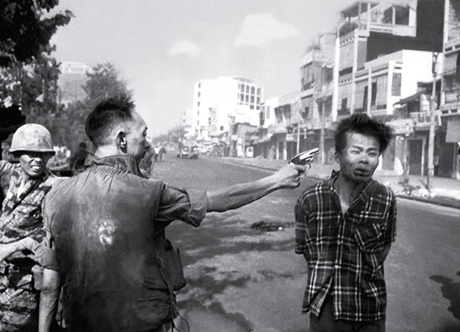
The first of the images for discussion depicts Brigadier General Nguyen Ngoc Loan, chief of the national police, standing alongside Nguyen Van Lem, the captain of a terrorist squad who had killed the family of one of Loan’s friends. Eddie Adams took this image simultaneous to the bullet entering Nguyen Van Lem’s head. The moment of the bullet’s impact is captured in the image and this specific moment seems to lend this image its critical value. In photographic terms, this is Adams’ ‘decisive moment’ and is a fine example of an image which keeps the viewer captivated. It does this by evoking a strong initial emotional response, which in turn prompts the viewer to ask and try to answer a number of questions about the image. Almost all visual stimuli will provoke in the viewer some sort of cognitive or emotional response, with degrees of variation depending on the stimulus and the individual. This reaction however, is almost an instant response as we decipher what is going on in the photograph. Adams has depicted a sense of imminence in this image. The image is charged with potential catastrophe, but is also hauntingly still. Seemingly calm but also tense. With moving images also depicting this event, much less is left to the imagination of the viewer; this particular image keeps us in a constant and unchanging state of suspense. Like a rubber band just before the tension is released and the band is let free. This ‘tension’ is never satisfied and is left with the audience throughout the entirety of the experience.
In terms of the image above, when broken down and the main focal points of the image are explored, my point becomes clearer. The background is desolate, there is no life there. In the first ‘third’ of the image, the dramatics come from the soldier’s his gritted teeth. Finally, the foreground which contains the most information and activity is clearly the forefront of the image. The anonymity of the man standing with his back to us and the tension in his arm, leads the eye over to the face of this man stood amongst the serene backdrop. By no means is this a pleasant image, but it keeps our attention perhaps because it satisfies an inner morbid curiosity about the potentially catastrophic outcome of the events captured.

In the absence of any other information, the viewer will make inferences about the image, formulating and attributing a bespoke and personal narrative to the image. The extent to which we achieve success in our attempt to explain the imagery and resolve the narrative, Deepens or satisfying our curiosity regarding the image. Our relative satisfaction with our ‘narrative’ impacts on our ability sustain said curiosity. The point at which our attributed ‘narrative’ satisfactorily explains the image, our curiosity wanes. It is at this point that we start to make appreciative judgements about the merits of the image based on a whole range of personal, socio-cultural, political and other references that the individual brings to the image. Paulo Freire, a Brazilian philosopher, gave a lecture at the Institute of Education where he touched on “epistemological curiosity”. This is the desire to gather new knowledge which is expected to stimulate intellectual interest. In this lecture, he says that “as human beings, like any other animal, we are curious by nature...It is through this kind of curiosity that we can approach the world, and ourselves.” (Paulo, 1995)

As small children we have an abundance of this said curiosity. It fuels our desire to learn about the world around us, which we have little, to no knowledge of. This a natural want to know the ‘ins-and-outs’ of things, to take things apart to see why they do what they do. As we grow older, we learn and we become more “civilised/cultured” and experienced and we tend to lose interest in exploring things as meticulously as before. So perhaps images such as Adams’ would need a combination of these aspects to stimulate curiosity and thought.

In terms of morbid curiosity and an epistemological curiosity, this image is initially interesting because its content deviates from ‘normal’ day-to-day images, and the second crucial thing is that the image has some vague familiarity about it. To merit further attention beyond the initial exploration, it must immediately resonate or have some recognisable relevance for the audience, otherwise there is no motivation to pursue or explore a fuller narrative, or appreciation for the fuller image. The pictures initial resonance would, or must leave sufficient scope for ‘exploration’ and be beyond what the audience initially imagined. The image needs just enough curiosity value for the audience to want to invest further time in it.

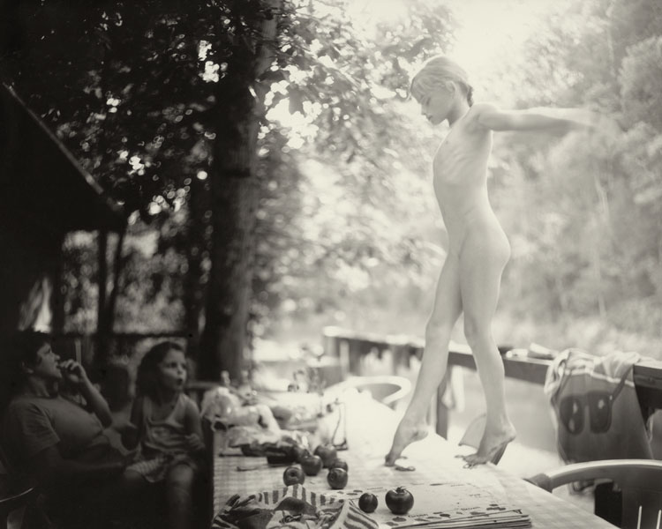
We make an instant opinion of anything which is visual the first time we see it. In looking, we attach our own personal connotations of what is visually appealing to us as individuals. In applying our own personal beliefs and morals to the stimulus, we may often neglect the original concept, using our own imagination and judgment to imbue the image with ‘value’, potentially replacing the artists conceptual ideas of what the image represents, with our own. This is especially true with images of taboo subjects, particularly when viewed outside the cultural environment where these taboos apply, or are more strongly upheld. This occurs as the viewer is free to attach their own opinions to the image and make a judgment of it applying ‘out of context’ value judgments. Stuart Hall writes something similar in his book on Representation, “Things don’t mean: we construct meaning, using representational systems…” (Stuart, 2013). The thing or image doesn’t hold the meaning; we do. In so doing, we are likely to strip away any context given, or not given to the image by the artist and this allows meaning, concepts and aesthetic criteria of appreciation to be culturally determined by its audience. I feel Sally Mann’s work, as depicted above is an example that demonstrates this.
As stated above, these images of her children are looked at very differently by different groups of people. Unlike Adam’s image, her work can make some viewers feel uncomfortable for several reasons. A group of people could be drawn to these images because they find them visually appealing, or they could be drawn to them because of their social taboo. These factors will be discussed in reference to Mann’s work.
In an article Sally Mann wrote for The New York Times Magazine she talked about the controversy around her body of work called Immediate Family, which was exhibited in November of 2007 in the Houk Friedman Gallery, New York. She wrote that she hadn’t considered that these images would be taken so far out of context from what she had intended for them ; “In my arrogance and certitude that everyone must see the work as I did…” (Sally, 2016). She hadn’t considered that people conditioned to alternative cultural lives would see the images and compare them to their own lives, in which the vast majority of children in, say, New York did not explore the ‘wilds’ of the city wearing no clothes, as children did on a secluded farm in Virginia. The kick back from the public really began when Richard B. Woodward, an art critic based in New York, wrote an article about her work for The New York Times Magazine challenging her on the ethics of her images. A small section of this article is rich in questions which are owed some sort of explanation. He writes that “If it is her solemn responsibility, as she says, “to protect my children from all harm,” has she knowingly put them at risk by releasing these pictures into a world where paedophilia exists?” (Richard, 2015). This comment is then virtually made redundant by a later observation in the same paragraph where he asks if “…these sensual images emerge from the behaviour of her subjects, or are they shaped by the taste and fantasies of the photographer for an affluent audience?” (Richard, 2015). Again, we tend to uphold any values we are brought up with, whether they are taught by the leading influences in our life, or they are self-taught. So through no fault of our own, we, again attach our own beliefs and values to images. If Woodward subscribes to the view that these images are “sensual” but attributes this to a particular societal audience, why does he himself describe them as such, unless he also thinks this? It can be argued that as a male, he doesn’t understand the view of a female on the images, or more importantly a mother’s view of them. It may not have been her intention with this set of images to reflect the same ‘value imbued imagery’, but in a documentary about her work called What Remains: The Life and Work of Sally Mann she says “I like to make people a little uncomfortable. It encourages them to examine who they are and why they think the way they do.” (Steven, 2006) This could be argued in favour of those who disagree with the ethic of the images because she ‘intentionally’ wanted to make the audience feel uncomfortable. Another interesting comment made by Woodward was “…And apart from legal and epistomologic matters, is the work any good?” (Richard, 2015) In answer to this, from an artist’s point of view, or from someone who sees the images as they were ‘intended’, they are “good” images. In an article for Vogue in June of 2015, Rebecca Bengal reminisces of her time as a child exploring the wild with her friends and wrote, ”It didn’t matter what we were wearing, or if we were wearing anything at all, because we had escaped the reach of our parents; there was no one to see us. Lords of the flies, we were free.” (Rebecca, 2015) Mann’s images not only draw from people their aesthetic or controversy judgements, they trigger a strong personal recognition of value. So perhaps the value of her images isn’t quite appreciated due to particular judgments made by people who are conditioned to only see their own beliefs and values in an image.
To conclude, I believe that the examples I have offered demonstrate that although an image, for whatever reason, is difficult to look at, some aspect draws us to examine it with a sense of curiosity and/or wonder. Both images I have referenced in this essay in terms of; aesthetics and subject matter are different in many ways. However, they overlap in the fact that Adams entertains the audience’s curiosity and encourages the viewer to ask questions about the context of the image, but also about the future beyond the captured moment. Mann on the other hand, arguably captures the curiosity of her children onto which the audience applies an aesthetic and value judgments. It is acknowledged that the above images may not resonate for every viewer as we are not all drawn to images of this kind because on some level we do not resonate with the images. Without this resonation, we have no motivation to further question the image and lose interest because the subject is too far from anything we can imagine ourselves being associated with. This is the basis of individualised artistic appreciation of ‘art’.

Bibliography
Sally, M. (1984 – 1991). Immediate Family (Family Album)
Eddie, A. (1968). Saigon Execution .
Paulo, F. (1995). Paulo Freire at the Institute . Southerland on Sea, Essex: Formara Limited.
Rebecca, B. (2015, June 26). After Sally Mann’s Memoir, a New Look at Her Most Famous Photographs. Retrieved from Vogue: https://www.vogue.com/article/sally-mann-immediate-family-reissue-memoir-hold-still
Richard, W. B. (2015, April 16). The Disturbing Photography of Sally Mann. Retrieved from The New York Times Magazine: https://www.nytimes.com/2015/04/19/magazine/the-disturbing-photography-of-sally-mann.html
Sally, M. (2016, April 16). Sally Mann's Exposure. Retrieved from The New York Times Magazine: https://www.nytimes.com/2015/04/19/magazine/the-cost-of-sally-manns-exposure.html
Steven, C. (Director). (2006). What Remains: The Life and Work of Sally Mann [Motion Picture].
Stuart, H. (2013). Representation. London: Sage.

+

