Type 2 Diabetes Mellitus: Long-Term Condition Management in the UK
Nazia Ali
2208450



Table of contents

- Introduction
- Epidemiology
- Pathophysiology
- Physical, Psychological, and Social Impact
- Treatment and Management
- Theoretical Frameworks and Models
- Policy and Legislative Context
- Recommendations for Person-Centred Care
- References

Introduction
Type 2 Diabetes Mellitus (T2DM) is a long-term metabolic disorder that develops when the body becomes resistant to insulin or when the pancreas is unable to produce enough insulin to maintain normal blood glucose levels (Davies et al., 2022). It is a growing public health concern both globally and in the United Kingdom (UK), contributing to high rates of illness, early mortality, and rising healthcare costs.
This booklet explores the impact of T2DM on individuals and families, reviews current evidence-based management strategies in the UK, considers theoretical approaches that support person-centred care, examines national policies and guidelines that shape diabetes care, and offers recommendations for improving outcomes and reducing health inequalities.

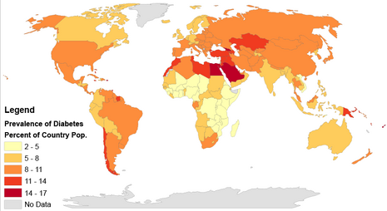

Epidemiology
T2DM affects millions of people globally and in the UK. The International Diabetes Federation (IDF, 2021) estimates that around 537 million adults worldwide are living with diabetes, with approximately 90% of these cases being Type 2. In the UK, Diabetes UK (2022) reports that over 4.9 million people have been diagnosed with diabetes, with the vast majority affected by T2DM.The condition is most common among older adults, people with obesity, and those living in deprived areas. It is also more prevalent among South Asian, African, and Caribbean communities, reflecting a combination of genetic factors and social determinants such as diet, income, and lifestyle (Young et al., 2023).
Key risk factors include obesity, physical inactivity, poor diet, ageing, and genetic predisposition (Dyson et al., 2018; Misra et al., 2023). Wider environmental influences, such as limited access to healthy food and fewer opportunities for physical activity, also play a role in shaping health inequalities (Lean et al., 2018). Globally, the prevalence of T2DM continues to rise due to ageing populations, urbanisation, and increasing obesity rates (IDF, 2021). Low- and middle-income regions are experiencing the fastest growth because of changing lifestyles and dietary patterns (Misra et al., 2023).
In the UK, social and economic inequalities influence patterns of T2DM. Older adults and people from minority ethnic backgrounds face a higher risk, and those from deprived communities are often diagnosed earlier and experience more complications due to barriers in accessing healthcare and limited health literacy (Young et al., 2023). The economic cost is substantial, with diabetes-related treatment and complications estimated to cost the NHS around £10 billion each year (Diabetes UK, 2022). Preventing T2DM and its complications relies on early detection, lifestyle modification, and public health strategies that address social and environmental determinants. Understanding the epidemiology of T2DM is essential for developing effective prevention and management strategies and reducing long-term health inequalities.
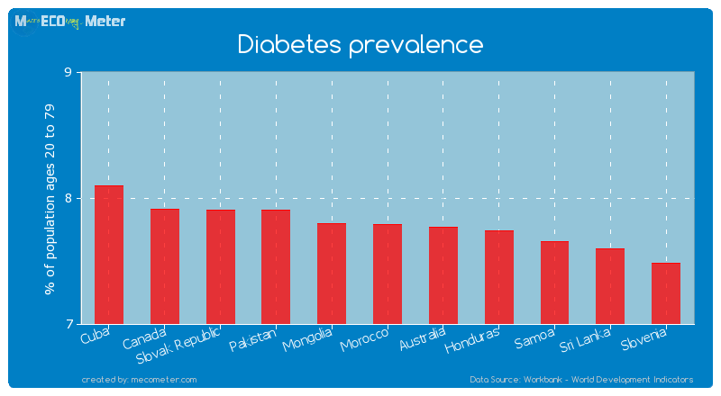
Pathophysiology
Type 2 Diabetes Mellitus (T2DM) develops because of a gradual decline in insulin sensitivity combined with progressive dysfunction of the pancreatic beta cells. Insulin resistance limits the body’s ability to utilise glucose effectively, particularly within skeletal muscle and adipose tissue, leading to elevated blood glucose levels (Davies et al., 2022). Prolonged hyperglycaemia contributes to a cycle of glucotoxicity that further impairs beta-cell function and promotes systemic low-grade inflammation. This inflammatory process plays a major role in the development of vascular complications such as atherosclerosis, hypertension, and endothelial dysfunction, which together contribute to the high rates of cardiovascular disease observed among people living with T2DM (Zinman et al., 2015). Chronic hyperglycaemia also disrupts lipid metabolism, leading to abnormal cholesterol and triglyceride levels that increase the risk of cardiovascular morbidity and mortality.
Obesity is one of the most significant contributors to insulin resistance. Excess adipose tissue increases the release of free fatty acids and alters adipokine secretion, typically raising leptin and lowering adiponectin levels (Dyson et al., 2018). Central or visceral obesity is particularly harmful because it triggers inflammatory and oxidative stress pathways that interfere with insulin signalling in muscle and liver tissues. Dysfunctional fat storage also causes fat to accumulate in organs such as the liver and pancreas, worsening insulin resistance and placing additional strain on beta cells.
Genetic factors influence how susceptible an individual is to be developing T2DM. Variations in genes involved in insulin secretion, receptor activity, and glucose metabolism partly explain why some people develop diabetes earlier or progress more rapidly than others (Misra et al., 2023). However, these genetic influences are closely linked to environmental and behavioural factors. Poor diet, limited physical activity, and socioeconomic disadvantage increase the likelihood of disease development and accelerate its progression.
Overall, T2DM arises from a complex interaction between genetic, metabolic, and environmental influences. Understanding these mechanisms is essential for identifying at-risk groups, improving prevention programmes, and designing personalised treatment strategies that address the root causes of insulin resistance and beta-cell dysfunction.

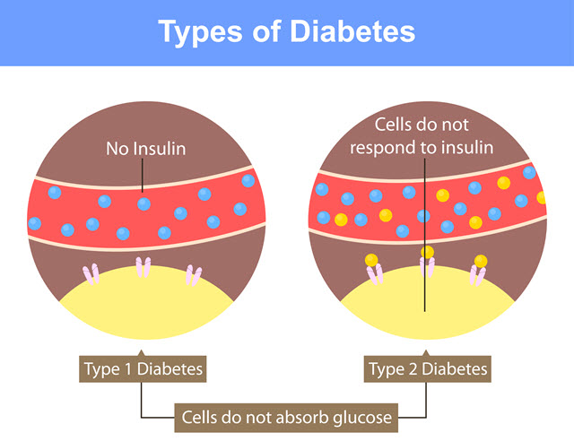
Physical, Psychological, and Social Impact
Type 2 Diabetes Mellitus (T2DM) affects people in many ways, with physical, psychological, and social consequences that can make everyday life more challenging. Physically, the condition increases the risk of heart disease, kidney problems, nerve damage, and eye complications (Marso et al., 2016). These health issues can limit mobility, reduce energy, and lower quality of life. Many people with T2DM also experience other health conditions such as obesity, high blood pressure, and high cholesterol, which together make management more complex (Zhou et al., 2018). Treatment often involves several types of medication or insulin therapy, which can cause side effects like weight gain, digestive discomfort, and low blood sugar episodes. Older adults may find managing diabetes particularly difficult, as age-related changes such as frailty or memory problems can make it harder to follow treatment plans and monitor blood glucose regularly (Sinclair et al., 2015).
The psychological effects of living with T2DM can be just as significant as the physical ones. Many individuals experience stress, anxiety, or depression linked to the ongoing demands of managing the condition (Egan et al., 2020). Constant attention to diet, medication, and blood sugar levels can lead to frustration or burnout. People may also feel guilty or fearful if their blood glucose levels fluctuate, worrying about possible long-term complications. Family members often share this burden, as they help with daily routines, meal planning, or emotional support, which can sometimes create tension or exhaustion within the household (van der Ven et al., 2019). Stigma around diabetes, especially the belief that it results only from poor lifestyle choices, can lead to embarrassment or reluctance to seek help (Fisher et al., 2014). Over time, these emotional pressures can affect confidence and engagement in self-care.
The social impact of T2DM is also considerable. People from lower-income backgrounds are more likely to develop the condition and face greater barriers to managing it effectively (McGovern et al., 2018). Limited income, food insecurity, and lack of access to safe places for physical activity can make it harder to maintain a healthy lifestyle. Time off work for medical appointments or the effects of fatigue can also affect job performance and income stability. Cultural and language barriers can prevent some individuals, particularly from minority ethnic groups, from fully accessing or understanding healthcare advice (Nam et al., 2011). These factors highlight the importance of healthcare approaches that are inclusive, culturally aware, and accessible to everyone.
Overall, the physical, psychological, and social challenges of T2DM show the need for holistic and person-centred care. Managing diabetes effectively requires more than controlling blood sugar levels; it involves supporting the emotional wellbeing of patients, involving families, and addressing wider social inequalities that influence health outcomes.
Treatment and Management
The management of Type 2 Diabetes Mellitus (T2DM) in the UK follows guidance from the National Institute for Health and Care Excellence (NICE, NG28, 2022), which emphasises a combination of lifestyle modification, pharmacological treatment, and structured education. First-line management focuses on improving diet, increasing physical activity, and initiating metformin therapy. When glycaemic targets are not met, additional medications such as SGLT2 inhibitors, GLP-1 receptor agonists, or DPP-4 inhibitors may be introduced. Treatment is tailored to individual needs, considering comorbidities, patient preferences, and overall cardiovascular and renal risk (Young et al., 2023). Management is dynamic, requiring regular review and adjustment to maintain optimal glycaemic control and minimise side effects, while adapting to changes in lifestyle or health status.
Structured education programmes, including DESMOND (Diabetes Education and Self-Management for Ongoing and Newly Diagnosed), play a key role in enabling individuals to manage their condition effectively (Sturt et al., 2015). These programmes provide patients with the knowledge and skills necessary for self-monitoring, encourage adherence to lifestyle recommendations, and offer psychological support to reduce the emotional burden associated with chronic illness. Non-pharmacological interventions have also shown promising outcomes. For example, the Diabetes Remission Clinical Trial (DiRECT) demonstrated that intensive dietary interventions could lead to remission in a significant proportion of participants, highlighting the potential of lifestyle-based strategies to alter disease progression (Lean et al., 2018).
Effective T2DM management relies on a multidisciplinary approach, involving general practitioners, diabetes specialist nurses, dietitians, podiatrists, and psychologists. Regular monitoring of HbA1c, blood pressure, lipid profiles, renal function, and retinal health is essential to prevent complications and enable early intervention (NICE, 2022). Increasingly, digital health tools, including telemedicine, mobile applications, and remote monitoring platforms, are being integrated into routine care (Greenhalgh et al., 2020). These technologies facilitate personalised feedback, support behavioural change, and ensure continuity of care, particularly for individuals in underserved areas. By combining traditional medical management with innovative digital solutions, healthcare teams can improve patient engagement, detect early signs of deterioration, and optimise long-term outcomes.
Theoretical Frameworks and Models
Effective management of Type 2 Diabetes Mellitus (T2DM) relies not only on clinical interventions but also on robust theoretical frameworks that guide care delivery. The Chronic Care Model (CCM) offers a structured approach to improving the management of long-term conditions, emphasising informed patients, prepared healthcare teams, and integrated systems of care (Wagner et al., 2001). The CCM shifts the focus from reactive treatment of acute episodes to proactive, planned, and patient-centred care. Its key elements include self-management support, delivery system design, decision support, clinical information systems, organisational support, and use of community resources. In practice, this framework ensures that patients receive coordinated care tailored to their individual needs, while healthcare teams are equipped with the skills and tools necessary to implement evidence-based interventions.
In addition, the House of Care Model complements the CCM by emphasising collaboration between patients, healthcare professionals, and wider organisational systems. It encourages proactive engagement, personalised care planning, and shared decision-making, ensuring that patients are central to all aspects of their care. This model reinforces the principles of coordinated, holistic care by integrating clinical, psychological, and social support structures within routine management (NHS England, 2019; Danhieux et al., 2023; Tahir et al., 2025).
Within the UK, the CCM underpins local diabetes service planning and delivery. NHS initiatives such as structured diabetes education programmes, integrated care pathways, and risk stratification tools reflect CCM principles by enabling early intervention, consistent monitoring, and collaborative goal setting (Bower et al., 2023). The model promotes active patient participation, recognising that informed and motivated individuals are more likely to engage in lifestyle modifications, adhere to medication regimens, and perform effective self-monitoring. By supporting collaboration across primary, secondary, and community care services, the CCM contributes to reduced hospital admissions, improved glycaemic control, and enhanced quality of life for people living with T2DM.
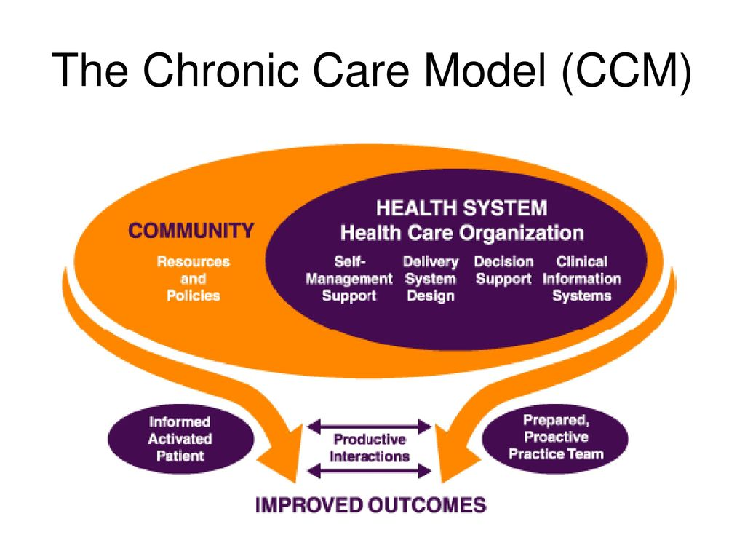

Policy and Legislative Context
The management of Type 2 Diabetes Mellitus (T2DM) in the UK is supported by a comprehensive policy framework developed by the government and the National Health Service (NHS). This framework reflects the growing prevalence of T2DM and its significant impact on public health. The NHS Long Term Plan (2019) is central to this approach, emphasising prevention, early diagnosis, and integrated care for individuals with long-term conditions. The plan prioritises proactive interventions, structured education, and personalised care pathways aimed at reducing complications and improving health outcomes. It also highlights the importance of digital health solutions, community-based programmes, and multidisciplinary collaboration to meet the complex needs of people living with T2DM.
The National Institute for Health and Care Excellence (NICE) guidelines (NG28, 2022) provide evidence-based recommendations for the clinical management of T2DM, covering pharmacotherapy, lifestyle interventions, and structured self-management education. These guidelines help ensure consistent standards of care across the UK and support clinicians in delivering patient-centred treatment. Complementing national frameworks, local initiatives such as the NHS Diabetes Prevention Programme focus on identifying high-risk individuals and providing targeted interventions to prevent or delay disease onset. These programmes address modifiable risk factors including obesity, poor diet, and physical inactivity, contributing to reduced incidence and narrower health inequalities (Brunton et al., 2023).
Policy implementation is reinforced through audits, quality standards, and financial incentives. The Quality and Outcomes Framework (QOF) rewards primary care practices for achieving key clinical targets, including HbA1c control, blood pressure monitoring, and cardiovascular risk assessment. These mechanisms promote adherence to best practice, improve patient monitoring, and encourage consistent, high-quality care. The National Diabetes Audit (NDA) complements this by providing detailed data on service provision and outcomes, identifying gaps in care and informing local and national strategy development.
Despite these measures, significant challenges remain. Disparities in care delivery persist, particularly among socioeconomically disadvantaged groups and ethnic minority populations (McGovern et al., 2018). Individuals from lower-income backgrounds may experience delayed diagnosis, limited access to structured education programmes, and higher rates of complications. Cultural and language barriers can also limit engagement with healthcare services, emphasising the need for tailored, accessible interventions. Regional variations in service provision further contribute to inconsistencies in care quality, highlighting the importance of integrated and equitable policies that prioritise vulnerable populations.
Preventive measures and public health initiatives are increasingly central to the policy landscape. Programmes promoting healthier diets, regular physical activity, and early screening are embedded within community and primary care settings, reducing the overall burden of T2DM and supporting wider population health goals, including the prevention of obesity and cardiovascular disease. Policy development is informed by ongoing research, national audits, and international best practice, ensuring that interventions remain evidence-based and responsive to changing population needs.

Recommendations for Person-Centred Care
Improving care for individuals with Type 2 Diabetes Mellitus (T2DM) requires a holistic, patient-focused approach that addresses medical, psychological, and social needs. The following recommendations highlight key strategies to enhance person-centred care:
Strengthening self-management support: Structured education programmes, such as DESMOND, alongside digital tools like mobile applications and telehealth platforms, can increase patient engagement and promote adherence to treatment plans. These resources empower individuals to manage diet, physical activity, and medication effectively, fostering greater autonomy in daily diabetes management (Sturt et al., 2015; Fadhil & Wang, 2019).
Integrating psychosocial care: Psychological distress, depression, and anxiety are common among people with T2DM and can negatively affect treatment adherence and glycaemic control. Incorporating mental health support, counselling, and caregiver resources into routine care is essential for addressing these challenges and reducing the overall burden of the condition (Egan et al., 2020; van der Ven et al., 2019).
Cultural and socioeconomic tailoring: Interventions should account for patients’ cultural, linguistic, and socioeconomic backgrounds to reduce health inequalities and improve accessibility. Community engagement translated educational materials, and culturally sensitive dietary guidance can enhance participation and ensure that interventions are relevant and effective (McGovern et al., 2018).
Expanding multidisciplinary collaboration: Coordinated care involving general practitioners, diabetes specialist nurses, dietitians, podiatrists, psychologists, and community support workers ensures that medical, psychological, and social needs are addressed simultaneously. Multidisciplinary teams improve continuity of care and enhance overall quality of management (Bower et al., 2023).
Supporting weight management and remission programmes: Intensive lifestyle interventions and structured weight management programmes, such as DiRECT, should be made widely available to eligible patients. These programmes have been shown to induce remission, reduce complications, and lower long-term healthcare costs (Lean et al., 2018).
End-of-life care planning: For patients with advanced complications, integrating palliative care principles alongside standard diabetes management ensures dignity, symptom control, and quality of life. Early discussions regarding preferences and personalised care plans are essential to meet individual needs (Sinclair et al., 2021).
Leveraging digital health and telemedicine: Telemonitoring, virtual consultations, and wearable technologies provide real-time feedback, enhance patient engagement, and reduce access barriers, particularly for those living in rural or underserved areas. These tools complement traditional care and support proactive self-management.
Implementing these strategies can empower patients, improve adherence to treatment, reduce complications, and address health inequalities. A person-centred approach ensures that care is effective, equitable, and responsive to the diverse needs of individuals living with T2DM.

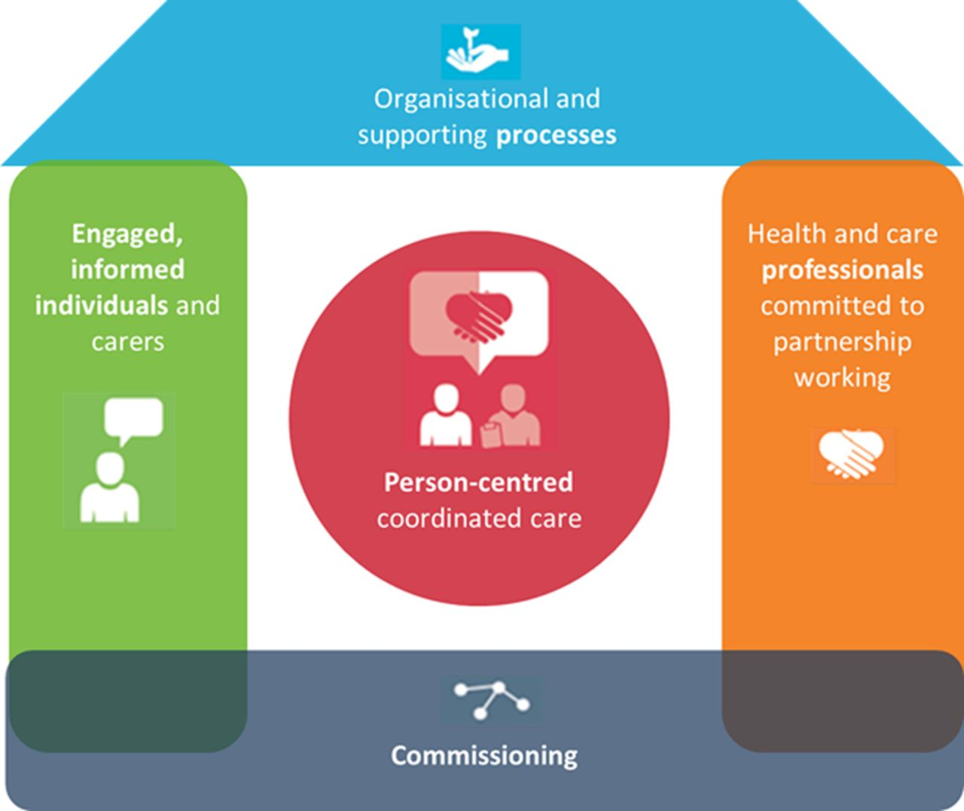
References
Agarwal, D.K. & Bertsimas, D.J., 2024. Interpretable AI-driven guidelines for type 2 diabetes treatment from observational data. Journal of Biomedical Informatics, 155, 104632.
Barron, E. et al., 2022. The cost of diabetes to the NHS: analysis of national spending. Diabetic Medicine, 39(8), e14710.
Bower, P. et al., 2023. Diabetes prevention at scale: findings from the DIPLOMA evaluation. BMJ Open Diabetes Research & Care, 11(1), e003028.
Brunton, L. et al., 2023. Evaluation of the national rollout of the NHS Diabetes Prevention Programme. BMJ Open Diabetes Research & Care, 11(2), e003210.
Buse, J.B. et al., 2020. 2019 Update to: Management of Hyperglycemia in Type 2 Diabetes. Diabetes Care, 43(2), pp.487–493.
Danhieux, K. et al., 2023. Scaling up chronic care model-based programmes for type 2 diabetes in primary care. BMC Health Services Research, 23, Article 1103.
Davies, M.J. et al., 2022. Management of hyperglycaemia in type 2 diabetes, 2022. Diabetologia, 65(12), pp.1925–1966. Available at: https://pubmed.ncbi.nlm.nih.gov/36151309/
Diabetes UK, 2022. Diabetes in the UK 2022: Key statistics on diabetes. London: Diabetes UK.
Dolezalova, N. et al., 2021. Development of a dynamic type 2 diabetes risk prediction tool: a UK Biobank study. Diabetes Therapy, 12(4), pp.1123–1133.
Dyson, P.A. et al., 2018. Diabetes UK evidence-based nutrition guidelines for the prevention and management of type 2 diabetes. Diabetic Medicine, 35(5), pp.541–547.
Egan, A.M. et al., 2020. Psychological impact of type 2 diabetes: a narrative review. Diabetology International, 11, pp.1–8.
Fadhil, A. & Wang, Y., 2019. Health behaviour change techniques in diabetes management applications: a systematic review. JMIR Diabetes, 4(2), e12297.
Fisher, L. et al., 2014. The impact of stigma on diabetes self-care and health outcomes. Diabetes Spectrum, 27(2), pp.121–128.
Greenhalgh, T. et al., 2020. Telehealth for people with chronic conditions during the COVID-19 pandemic. BMJ, 371, m4511.
Holt, R.I.G. et al., 2021. Diabetes and mental health: The hidden burden. Diabetic Medicine, 38(7), e14526.
International Diabetes Federation (IDF), 2021. IDF Diabetes Atlas, 10th ed. Brussels: IDF.
Khunti, K. et al., 2021. Multifactorial intervention in type 2 diabetes management. BMJ, 373, n1064.
Kumar, A. et al., 2024. Review of IDF Diabetes Atlas, 10th Edition: Global and regional burden. Diabetes Research and Clinical Practice, 205(1), 110937.
Lean, M.E.J. et al., 2018. Primary care-led weight management for remission of type 2 diabetes (DiRECT). The Lancet, 391(10120), pp.541–551.
Lean, M.E.J. et al., 2024. Five-year follow-up of the randomised Diabetes Remission Clinical Trial (DiRECT). Lancet Diabetes & Endocrinology, 12(3), pp.180–190.
Marso, S.P. et al., 2016. Liraglutide and cardiovascular outcomes in type 2 diabetes. NEJM, 375(4), pp.311–322.
McGovern, A. et al., 2018. Type 2 diabetes management and health inequalities in the UK. Diabetic Medicine, 35(7), pp.927–935.
Misra, S. et al., 2023. Precision subclassification of type 2 diabetes: a systematic review. Communications Medicine, 3, Article 138.
Nam, S. et al., 2011. Barriers to diabetes management: cultural and linguistic factors. Diabetes Educator, 37(4), pp.545–551.
NICE, 2022. Type 2 diabetes in adults: management (NG28). London: NICE.
NHS England, 2019. The NHS Long Term Plan. London: NHS England.
Sinclair, A.J. et al., 2015. Diabetes in ageing communities: challenges and management. Diabetic Medicine, 32(8), pp.1036–1045.
Sinclair, A.J. et al., 2021. End-of-life care in diabetes. Diabetic Medicine, 38(7), e14533.
Sturt, J. et al., 2015. The DESMOND programme: self-management education for people newly diagnosed with type 2 diabetes. Patient Education and Counseling, 98(5), pp.622–628.
Tahir, W. et al., 2025. Expert consensus to improve implementation of NICE type 2 diabetes guideline (NG28). Practical Diabetes, 42(2), pp.55–63.
van der Ven, N.C. et al., 2019. Family-based interventions for adults with type 2 diabetes: a systematic review. Diabetes Care, 42(8), pp.1595–1603.
Wagner, E.H., Austin, B.T. & Von Korff, M., 2001. Organising care for patients with chronic illness. Milbank Quarterly, 75(4), pp.579–612.
Young, K.G. et al., 2023. Recent UK type 2 diabetes treatment guidance and implications for SGLT2-inhibitor therapy. Practical Diabetes, 40(3), pp.85–90.
Zinman, B. et al., 2015. Empagliflozin, cardiovascular outcomes, and mortality in type 2 diabetes. NEJM, 373(22), pp.2117–2128.
Zhou, B. et al., 2018. Comorbidities and physical strain in type 2 diabetes. Diabetes Care, 41(10), pp.2035–2043.
NHS England, 2019. The House of Care: A framework for long-term condition management. London: NHS England.
Wagner, E.H., Austin, B.T. & Von Korff, M., 2001. Organising care for patients with chronic illness. Milbank Quarterly, 75(4), pp.579–612.
Bower, P. et al., 2023. Diabetes prevention at scale: findings from the DIPLOMA evaluation. BMJ Open Diabetes Research & Care, 11(1), e003028.

Prepared by: Nazia Ali

