University of Wales Trinity Saint David
Wales Institute of Science



Electrical Control Systems
ACHA4010

Reuben Pearson-Warder
2304115
06/04/2025
Contents
1 Task 3 1
1.1 Scope Time Division Calculations (3) 1
1.2 Function Generator output square wave (3) 1
1.3 Capacitor charge and discharge wave marked at correct points. (3) 2
1.4 Basic Capacitor Calculations (3) 2
1.5 Capacitor discharge table (2) 2
1.6 Plot log(V) Gradient (2) 3
1.7 Gradient Calculations and Compare(4) 3
1.7.1 Gradient Calculations 3
1.7.2 Comparison table 3
1.8 Capacitor Uses (5) 3
1.9 Inaccuracies Question (4) 4
2 References 5

Task 3

Scope Time Division Calculations (3)
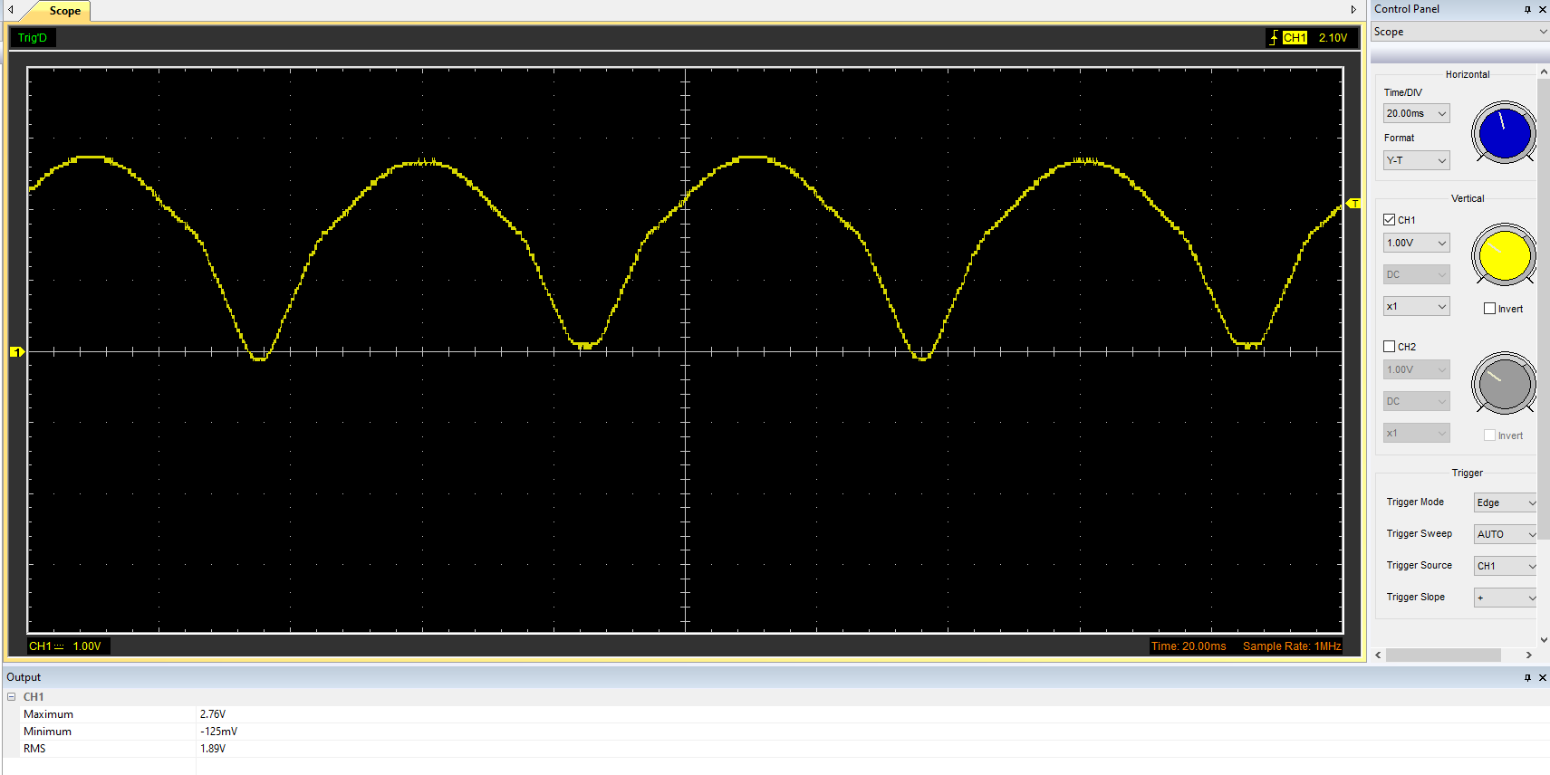

Function Generator output square wave (3)
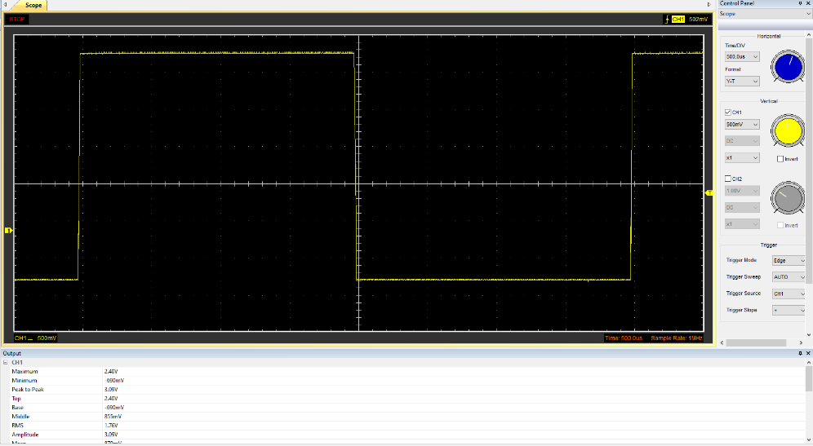

Capacitor charge and discharge wave marked at correct points. (3)
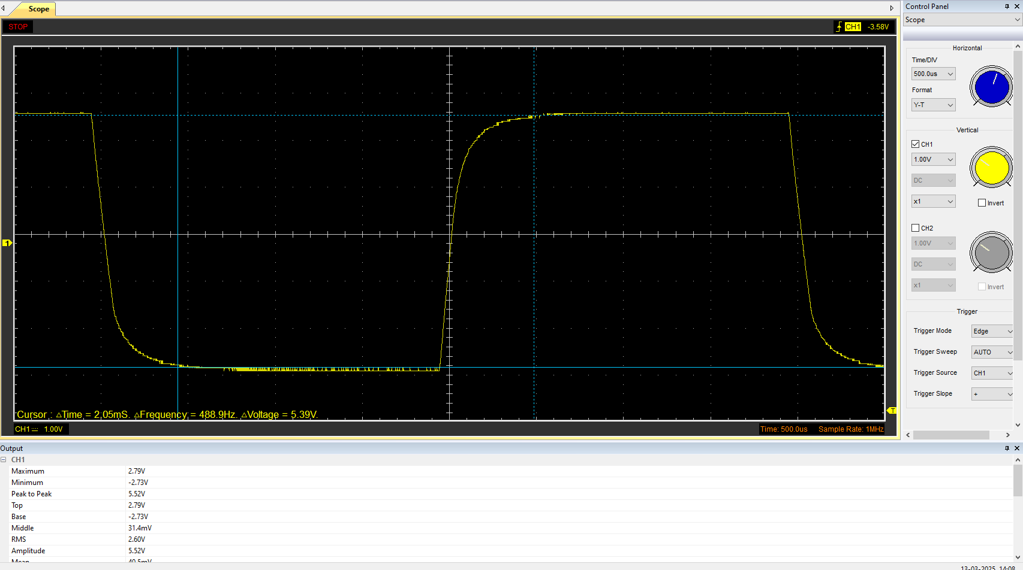

Basic Capacitor Calculations (3)
Time constant=2.05x10^-3 seconds
Resistance =320K Ohms
T=RC
C=T/R
C=2.05x10^-3/320x10^3
C=6.41x10-9F

Capacitor discharge table (2)
Time (s) | Voltage (V) | ln (V) | dy = y2 – y1  dy = ln(V)2-ln(V)1 | dx = x2- x1  dx = Time2 – Time1 | dy/dx
2x10-4 | 5.52 | 1.71 | x | x | x
4x10-4 | 5.52 | 1.71
6x10-4 | 5.52 | 1.71
8x10-4 | 5.52 | 1.71
1x10-3 | 3.58 | 1.28
1.2x10-3 | 0.84 | -0.17
1.4x10-3 | 0.53 | -0.63
1.6x10-3 | 0.32 | -1.14
1.8x10-3 | 0.21 | -1.56
2.0x10-3 | 0.00

Plot log(V) Gradient (2)

Gradient Calculations and Compare(4)

Gradient Calculations
Gradient = -1.703.125

Comparison table
 | Capacitance | Delta | Percentage difference
Actual | 1 µF | x | X
Marker Calculation
Gradient Calculation

Capacitor Uses (5)
Uses in electrical:
- Fridge -Helps start the cooling motor and stabilise voltage.
- In washing machines, they control the motor providing variations in speed.
- They are used in air conditioners to efficiently use energy.
- They are used in microwaves to help generate high voltages to help with heating.
(Where Are Capacitors Used in Everyday Life? - ZXcompo, 2023)
Uses in automotive:
- Cars use capacitors in the ignition system, lights and electronic aids such as ABS.
- Hybrid vehicles rely on capacitors for energy storage.
- Electric bikes use capacitors for smooth power delivery

Uses in Motorcycles:
- Used in the ignition systems
- Electronic aids
- CDI ignition
(Sample Application of Capacitor Use on Motorcycle — Steemit)

Inaccuracies Question (4)

References
(Format to Harvard style as per handbook)
Sample application of capacitor use on motorcycle — Steemit. (n.d.). Retrieved April 2, 2025, from https://steemit.com/technology/@batak/sample-application-of-capacitor-use-on-motorcycle-8709b671152be
Where are capacitors used in everyday life? - ZXcompo. (n.d.). Retrieved April 2, 2025, from https://www.zxcompo.com/where-are-capacitors-used-in-everyday-life/

