Research in Context Essay By Haoming Huang

Student Name: HAOMING HUANG
Student Number: 2205249
Programme of Study: BA Graphic Design
Module: ADAD5003 Research in Context
World count: 2200
Tutor: Donna Williams

Can Graphic Design really save your life?
Introduction to Graphic Design
Graphic design has evolved over a long period of time, from cave murals in 38,000 B.C. to today's widely used graphic design works with modern computers and tools, the evolution of graphic design in the long history is not yet over, and human beings are still exploring more possibilities of graphic design (Ellis and Ellis, 2018). During the development of graphic design, a variety of attributes such as warning, education, business, communication, healthcare, and art have been derived. However, with the rapid development of the times, it has also triggered many controversies, and this paper will focus on the question "Can graphic design really save lives?" This question will be broken down into two aspects, warning and education, to explore why graphic design can save lives. The article will focus on finding out the answer in areas such as traffic signs, food labelling and quality of teaching.

Road signs

Although road signs were widely used around the 1960s, they were still very immature at the time, according to a 1961 research paper by graphic designer Herbert Spencer, who decided to show British road signs from the early 1960s by photographing the signs he encountered on his drive from central London to Heathrow Airport, which had just opened at the time. In the article he shows that road signs were designed by different organisations resulting in different fonts, symbols, colours and styles for each sign, and in the article he demonstrates how confusing road signs in the UK must have been for motorists at the time (see fig1), and why it was so urgent for the road system at the time to have a road sign system that could be used by the public. It also demonstrates why there was an urgent need for a coherent and easily recognisable system of road signs for the road system of the time (Q, no date).
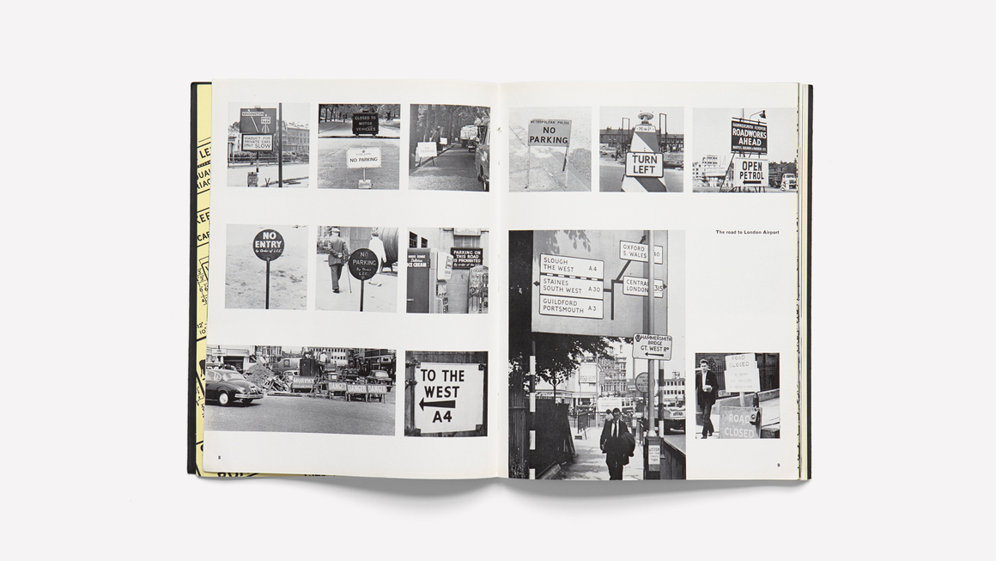
Fig. 1: Herbert Spencer. “Mile-A-Minute Typography?” From Typographica No. 4 (New Series), 1961. Edited by Herbert Spencer, published by Lund Humphries.
Road Safety Order is a major part of the road safety regulations and is largely responsible for the safety of drivers and pedestrians on the road, so the British Government took a different approach to the development of a new road sign system by commissioning Jock Kinneir and his assistant Margaret Calvert to design a new and rigorous system of road signs for new motorways and all other roads built in Britain at the time. They designed a new and rigorous road marking system for the new motorways and all other roads in the UK at the time, and through trial and error they came up with a road marking system with coordinated symbols, words, colours and shapes. The design was judged over time to be one of the greatest British design projects of all time, and elements of the design are still used today in countless ways （Q, no date).

Fonts
Jock Kinneir and Margaret Calvert's design contrasted with the confusing and varied road signs that existed at the time, and the initial typeface designed for road signs, 'Transport' sans-serif (see fig2), was characterised by being a more rounded typeface than was commonly used at the time, with distinctive 'a', 't' and 'l' endings and sans-serif scores, all of which contributed to improved legibility (Transport typeface). The "a", "t" and "l" endings and sans-serif scores all contribute to legibility (Transport (typeface) - Alchetron, The Free Social Encyclopedia, 2023b). 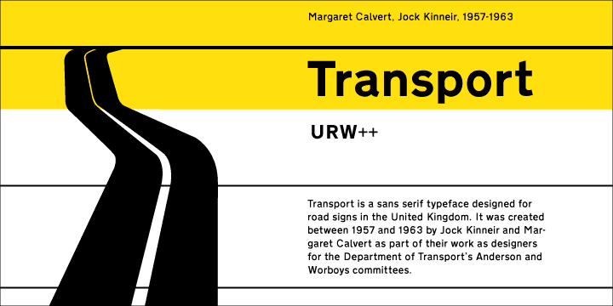
Fig. 2: (Transport (typeface) - Alchetron, The Free Social Encyclopedia, 2023)

Then in 2005 a major technological innovation came to motorway signage in the UK, a reflective pigment that when illuminated reflects back to where the light is emitted, making the typeface contrast with the normal blue background pigment, which makes the typeface easier to read, but they found that a medium thickness typeface was ideal for this as the reflected light tends to create a halo that makes the text appear slightly thicker, but the white background of less important road signs has the opposite effect and the reflection tends to migrate onto the black letters making them difficult to read. However, they found that medium thickness fonts were perfect for this situation, as the reflected light tended to create a halo that made the text appear slightly thicker, but the white background of the less important road signs had the opposite effect, and the reflections tended to be removed from the black letters making them difficult to read, so they realised that they needed a thicker typeface, and so 'Transport Heavy' was born! (see fig3)（Q, no date).
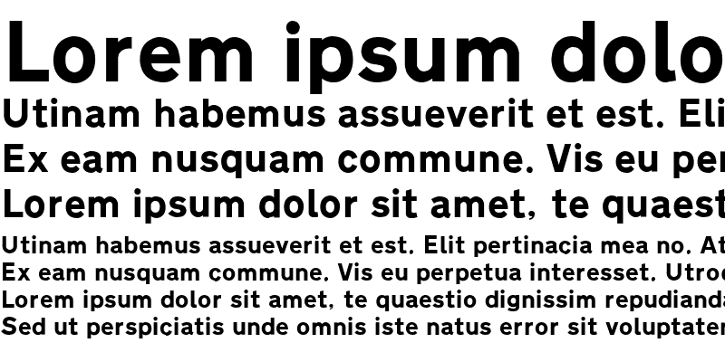
Fig. 3: (Roadgeek 2005 Transport Heavy Font : Download for free, view sample text, rating and more on Fontsgeek.Com, no date)
Therefore they designed their road signs with only 2 fonts and a mixture of large and small fonts in all the road signs they designed at the time, in order to help people to read according to their usual reading habits rather than using only capital letters, which makes it possible for people to recognise the words on the road signs more efficiently（Q, no date).

Shapes
The road signs designed by Jock Kinneir and Margaret Calvert are divided into three shapes in order to make them easy to understand and the three different shapes represent the three types of road signs, circles for signs that give commands, triangles for signs that warn you about something and rectangles for signs that provide information to people. By using these distinct and simple shapes they help people to recognise and react to road information more quickly (see fig4, fig5, fig6).
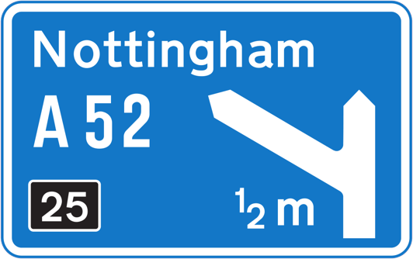

Fig. 4: Blue rectangular sign，All, 2023

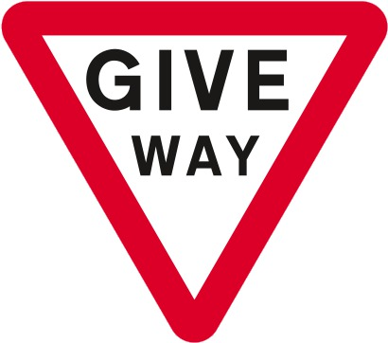

Fig. 5: The Give Way sign, All, 2023

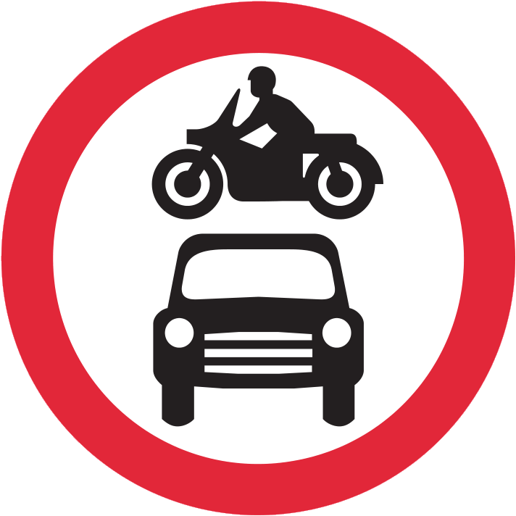

Fig. 6: Red circle road sign, All, 2023
Colours

Humans are sensitive to different colours differently according to (Dzulkifli, Mustafar, and Department of Psychology, International Islamic University Malaysia, 2013) research shows that compared to cool colours such as brown and grey, warm colours such as yellow, red and Warm colours such as yellow, red and orange have a greater effect on attention than cool colours such as brown and grey. In real life people don't usually notice this factor, but because Jock Kinneir and Margaret Calvert used it in their design and added it to their new road sign design, they have rated the importance of the sign from important road warning signs using highly saturated and contrasting colours such as red, reflective white, to less important road signs using more saturated and contrasting colours such as red, white and white. In contrast less important signs are orange, green, blue, grey, so that the importance of the sign is matched with the colour to attract attention and create visual order (Road sign colours, 2021)

Summary of the paragraph
Based on the above research it is clear that the work of graphic designers can have a significant impact on the safety of traffic movement in our lives, according to (Road accidents - Hansard - UK Parliament, 1961) there were 6,322 deaths due to road accidents in 1960 compared to 1,695 deaths in 2022 following the widespread use of new road signage systems Reported road casualties Great Britain, provisional results: 2022, 2023) Reported the number of people killed in road accidents in 2022 was only 1,695, as mentioned in the article, a rational and co-ordinated graphic design of road markings has contributed so much to the safety of road traffic and people's lives in the UK today.

Health

Graphic Design Helps Stop the Spread of Disease：
Graphic design is now a natural part of people's lives and plays an indispensable role in many areas, not only in providing convenience in our lives, but also as a life-saving tool in unexpected and dangerous situations. In 2019 the new coronavirus appeared in people's lives, when scientists from various countries found it, it means that it has already spread in the population, then the government and news stations (such as bbc, sky news, cnn, and other media) need to use a tool and a way to spread the news to the people, graphic design is that tool. Take sky news for example, they analysed the data to create an easy-to-understand real-time motion picture of the distribution of the virus and published posters on how to prevent the new coronavirus to remind people to stay at home and wear masks when going out (see fig7 and fig8).
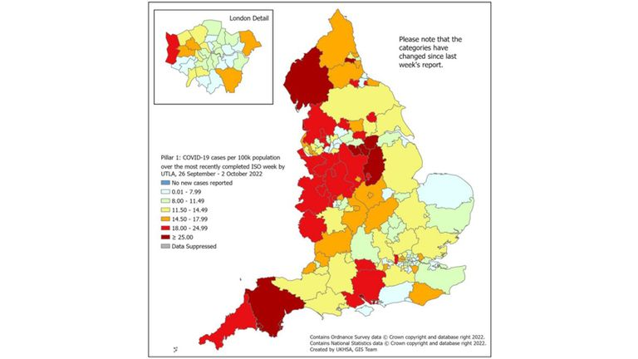
Fig. 7: Coronavirus distribution map (Allegretti, 2021)

The graphic designers at Sky news have created a map of the UK by blocking out areas so that people can see the number of people infected with the virus in their own area. The designers have used highly saturated colours for the more heavily infected areas and less saturated colours such as cyan and blue for the less infected areas through the use of colours and the whole map has been shown to help people stay away from areas at risk. Showing the distribution of the severity of the virus helps people to stay away from some dangerous areas, and this design conveys more information to people in a shorter period of time than the long time of broadcasting and news to express the information orally.
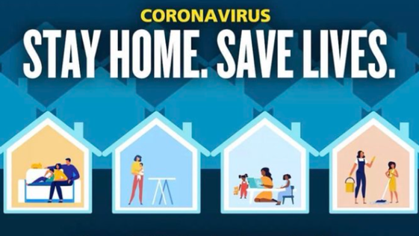
Fig. 8: Stay at Home Poster (Sky News, 2022)

According to (Hussain, 2021) the effect of colours on people's moods indicates that colours affect people's moods to a certain extent, for example, moderately saturated warm colours can make people's moods more stable such as light orange, light green ,lake blue, while high saturation can make people's moods tense, such as crimson red and dark blue.
Sky news' graphic designer designed a poster that uses the contrast and excess of warm colours inside the house and cool colours outside to convey that the home is safe and welcoming. The dark blue colour reveals a sense of danger outside, thus conveying that being at home does not restrict freedom but protects them. In the choice of text colour, the designer has designed the coronary virus as a yellow colour that is not easy to be ignored and the contrast between staying at home and saving lives is strong, and the white font is bigger than the smaller yellow font to give people a sense of the important message in white. The choice of fonts is also slightly rounded but similar to the warning symbols appearing in the font, the combination of these two styles of fonts is very good to convey to people than the danger outside the warmth of the home. The characters in the house can be seen doing a lot of activities and entertainment that can be done at home such as watching films, spending time with the children, cleaning, because staying at home all the time people will inevitably feel bored and depressed, the characters in these posters are a good reminder of the fact that there are a lot of things that can be done at home that are not so depressing as they might think, thus bringing some positive emotions to people and preventing them from suffering from psychiatric disorders during their stay at home.

Summary of the paragraph
In summary, graphic design in the field of health as a visual communication media tools quickly and concisely to convey more effective information to people, such as the mentioned virus distribution map, prevention posters, which is not only to allow people to prevent the danger but also to a certain extent to help people encountered at the time of the situation, for example, long term depression at home build up, the designers are optimistic through the design of the information conveyed to the people to help them mood, thus not only preventing physical illnesses but also psychological illnesses, so as to prevent physical illnesses. The designers use optimistic designs to convey messages to people that help them feel better, thus preventing not only physical illnesses but also psychological illnesses.

Conclusions
Designers have made a lot of efforts for people's (physical and psychological) safety, for example, the new traffic road signs designed with a more coordinated use of graphic design colours, fonts, shapes, and typography to help people identify the signs faster and more directly to react to avoid accidents, and to protect people's safety on the road. The coronavirus maps designed by the designers at sky news helped people to get real-time news about the spread of the virus in a short period of time so that they could avoid those areas and go out, as well as through the dissemination of posters to convey the message of staying at home and saving lives, and posters with colours, fonts, and characters that conveyed optimistic ideas to people to improve their moods at that time in the situation to avoid depression that could lead to mental illnesses. This sums up the evidence that the work of graphic designers often plays an invisible role in our lives, helping to save us from dangerous things.

Reference list

Allegretti, A. (2021) 'COVID-19: Government scraps coronavirus ad after sexism complaints,' Sky News, 28 January. https://news.sky.com/story/covid-19-government-scraps-coronavirus-ad-after-sexism-complaints-12201390.
Dzulkifli, M.A., Mustafar, M.F., and Department of Psychology, International Islamic University Malaysia (2013) The Influence of colour on memory Performance: a review, Malays J Med Sci. journal-article, pp. 3–9. https://www.ncbi.nlm.nih.gov/pmc/articles/PMC3743993/pdf/mjms-20-2-003.pdf.
Hussain, A.R. (2021) 'Colour Psychology in Art: How colour impacts mood,' Art And Design Review, 09(04), pp. 301–308. https://doi.org/10.4236/adr.2021.94025.
Q, F.& (no date) Jock Kinneir and Margaret Calvert. https://designmuseum.org/designers/jock-kinneir-and-margaret-calvert.

Road sign colours (2021). https://www.roads.org.uk/road-signs/road-sign-colours.

Road accidents - Hansard - UK Parliament (1961). https://hansard.parliament.uk/Commons/1961-03-29/debates/4d9a6e91-e091-40f8-9b99-c6f82d4c7ede/RoadAccidents.

Reported road casualties Great Britain, provisional results: 2022 (2023). https://www.gov.uk/government/statistics/reported-road-casualties-great-britain-provisional-results-2022/reported-road-casualties-great-britain-provisional-results-2022.
Sky News (2022) 'COVID-19: 'Concerning' increases in COVID hospitalisations - with 250% rise in one region,' Sky News, 7 October. https://news.sky.com/story/covid-19-concerning-increases-in-hospitalisations-with-250-rise-in-the-south-west-12713712.
Transport (typeface) - Alchetron, The Free Social Encyclopedia (2023a). https://alchetron.com/Transport-(typeface)#transport-typeface-fd9f8cd8-3507-44d7-8e8f-7470f8ffeb1-resize-750.png.

List of figures
Fig. 1: Fig. 1: Herbert Spencer. “Mile-A-Minute Typography?” From Typographica No. 4 (New Series), 1961. Edited by Herbert Spencer, published by Lund Humphries.
https://www.maharam.com/stories/rawsthorn_typographica#stories-carousel.

Fig. 2: Transport (typeface) - Alchetron, The Free Social Encyclopedia (2023c). https://alchetron.com/Transport-(typeface)#transport-typeface-fd9f8cd8-3507-44d7-8e8f-7470f8ffeb1-resize-750.png.

Fig. 3: Roadgeek 2005 Transport Heavy Font : Download for free, view sample text, rating and more on Fontsgeek.Com (no date b). https://fontsgeek.com/roadgeek-2005-transport-heavy-font.
Fig. 4: Blue rectangular sign，All, 2023.
https://www.drivingtheory4all.co.uk/uk-road-signs-and-meanings.

Fig. 5: The Give Way sign, All, 2023.
https://www.drivingtheory4all.co.uk/uk-road-signs-and-meanings.

Fig. 6: Red circle road sign, All, 2023.
https://www.drivingtheory4all.co.uk/uk-road-signs-and-meanings.
Fig. 7: Coronavirus distribution map, Sky News (2022b) 'COVID-19: 'Concerning' increases in COVID hospitalisations - with 250% rise in one region,' Sky News, 7 October. https://news.sky.com/story/covid-19-concerning-increases-in-hospitalisations-with-250-rise-in-the-south-west-12713712.

Fig. 8: Stay at Home Poster, Allegretti, A. (2021b) 'COVID-19: Government scraps coronavirus ad after sexism complaints,' Sky News, 28 January. https://news.sky.com/story/covid-19-government-scraps-coronavirus-ad-after-sexism-complaints-12201390

