Islam does not permit the representation of human figures’ is this statement true? Discuss the following statement in reference to examples of Islamic art you have studied

The representation of human figures with for the most part is strictly prohibited in Islam as it practices aniconism however contrasting to that statement representation of human figures including the prophet Mohammed do exist. Despite the belief that Islam does not allow the representation of human figures, human figures throughout the Islamic world were produced as this essay will show. This in part was done by the early Muslims to prevent the idea of idol worship, that God or a messenger of God of a depiction of them should be worshipped and carried around as opposed to the actual being themselves. And many quotes from historical figures further show this. However, as this essay will show there are indeed numerous examples which depict not only humans but also the prophet Mohammed.
Figure 1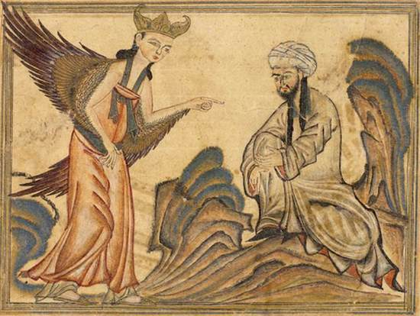
Figure one depicts an angel visiting Mohammed and revealing the Quran to him, this is one instance that counters the question posed ‘Islam does not permit the representation of human figures’ as we can clearly see the prophet Mohammed represented here. Perhaps the notion of human representation is not so much the issue as there are depicts that have survived form the Islamic age that I will show throughout this essay clearly depicting humans. but more the issue with Idol worship. If there are no depictions of a prophet or god then each time someone hears of them through prayer, scripture or whatever means it maybe they will have their own idea of what that person or God would look like. And interestingly many of the images that do depict Mohammed have since been defaced like figure 4 by various means or in some later renditions of artwork Mohammed is shown by having a veiled face such as figure 2 shows

Figure 2 (Nakkas Osman, 1595.)
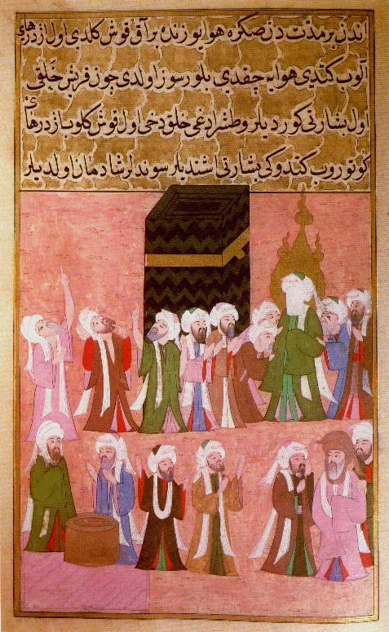
Thus, also perpetuating the belief that God made humans in his image and given the abundance of humans and how unique we all are form each other also spreads the idea of how powerful God by creating each human in his image. Therefore, it would also be wrong to make depictions of God in this instance as one can never truly perceive what he looks like. The same can be said for the depiction of Prophets and other human figures, as technology advances so do the methods by which we draw and articulate. By this each time an image is reproduced it is altered something changed or something is lost in some way. And in by doing this, we lose the importance of what the image shows and depicts and place greater value on the image itself which by this time present us with an artificial view of the work.
This may have a greater meaning now in the modern day where almost anyone can reproduce or create an image thanks to modern day technology but initially or the start of early Islam it would have had in some respects a simpler purpose rather than this. By its foundation, Islam was a new religion and it had to compete with older religions such as Christianity and Judaism

Figure 3
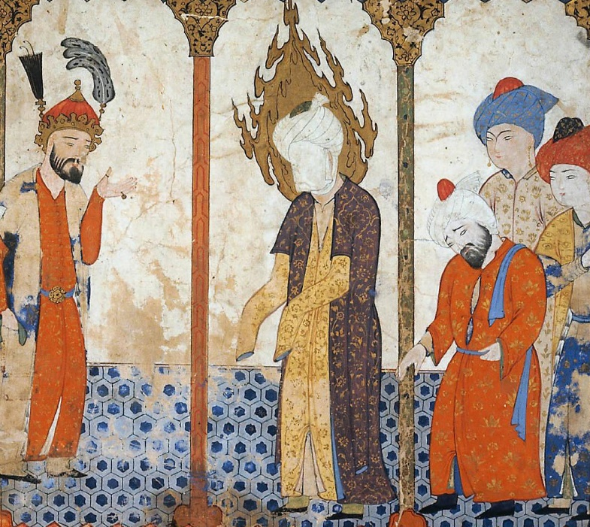
Furthermore, it was believed that any sculptor or painter creating the human image as Thomas Arnold wrote “was placing themselves as equal to God” thus by doing so was taking the role of God which for obvious reasons was blasphemy. The words of creator and sculptor in the Quran are both terms that are used to describe God therefore anyone else being referred to as a sculptor etc would already have some sense of Divination. However, there are clear examples which contradict this, for instance, it is theorized that the issues were the connotations associated with the images, not necessarily the images themselves.
Correspondingly, Arnold writes that once Mecca was conquered and Mohammed had the idols and depictions of Mecca destroyed he allowed a painting of Jesus and Mary to be kept intact which brings me to the next point. After the Hadiths came into circulation, and what were more readily available this also boosted the idea of Aniconism as it stemmed from Mohammed as the source for the idea this would also have helped to propagate the belief as followers of Islam would embrace this change and want to attempt to replicate how Mohammed acted as he was not only a prophet of God but the last prophet.
Therefore, setting the example effectively as to how Muslims should act. Thus ln the modern day leading to the assumption that it does not allow the depiction of human figures. The above images are also from two different time periods and regions. This is significant to the essay as it shows the prophet depicted in both field (figure 2) and unveiled (figure 1) figure 3 however shows Mohammed in a different setting while still veiled though and like the figure 2 he is shown with having his hands with additionally his face covered.
because of this we can see that the Islamic world was depicting Mohammed for a time without being censored or outright defaced through the passage of time. In Islamic literature it is also written how idols are destroyed by Muslims, for example in the book of idols written by Ibn al-kaliba it details how Mohammed orders the destruction of another Gods idol who is mentioned in the Quran around 630 BC upon which he does and in doing so the goddess in question appears and fight the Muslim champion Khalid she later defeated and the remaining icons were destroyed so that no one would worship her again. By doing this in literature it shows the readers that the icons of a religion in this case it was the al-uzza shows people that the icons are what eventually become what is worshipped rather than what they are representing to the people who are following that religion. And that this deity was only defeated by the will of the superior God that Khalid followed.
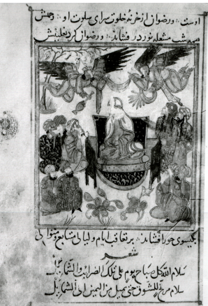
figure 4
This is useful to us examining the question as we can see the spread of the Aniconism practise taking place the first image was produced during the rule of the Abbasid Caliph in Iran and the second was also produced during this period the first was created roughly during reform within the Caliphs when the mamluks took control in Egypt near enough the time of the Mongol invasion the second image however was created post Mongol invasion. The censored image of Mohammed could have also been done in post to stop the Mongols and the practise of aniconism as a whole while it did not start out as this being the reason by not having a clear image of a prophet or other religious deity or symbol it meant that the invading forces had no pictorial or iconographical representation to deface as other regions in the middle east were extensively ravenged by the Mongols as they tore apart cities.
However, the Mongols who founded the Timurid dynasty and followed the practice of Islam did begin to depict the prophet Mohmmed and even wrote poems about him. With the most notable being the creation of the mi’raj in 1436 located at Herat which was the capital of the Khursan which depicts Mohammed in various scenes showing influences of Chinese art styles. But due to the Mongol’s being new to the religion it meant that perhaps they were to familiar with Aniconism, whatever the cause there are indeed surviving interpretations and art works form this dynasty that do clearly depict Mohammed and other human figures.
Figure 4 shows the prophet Mohammed enthroned with two angels overhead and other sat around them. All of their faces however have clearly been removed post construction thus showing that at one point human figures were created much like figure 1 and 5 that were not censored at one point in history. However unlike the other examples shown this image created in 1299 has had all of the humans defaced in some way, the clearest example of this is the eyes have been scratched out. In this instance it would appear that the statement is true and that Islam does not prohibit human representation and that things such as the scripture are more prevalent in the creation of Islamic art work.

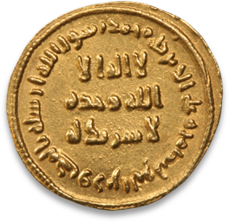
Figure 5
One specific example of the change in Islamic art from human depiction to that of the more geometric designs and patterns came in with the coinage that was being used.
The coin reforms, which under Abdul Al Malik were seemingly done in a manner of competition against the Byzantine rulers who refused to accept the new founded Umayyad coinage, subsequently led to war with the Byzantines. This measure of changing the coinage it meant that the practice of aniconism was then spread and interwoven into peoples’ daily lives, as they interacted and also traded with other regions.
The message on the coinage is simple “no god but God, unique, He has no associate” . This message was reproduced on each coin and after this those who did not submit older byzantine coins to be reminted and were found in possession of them were put to death. This shows the lengths to which Abdul al Malik was wiling to go to propagate the importance of aniconism. This change in currency may not seem as radical as the other methods of destruction of icons. It was the first time a specific currency had been created within the Islamic world and it was concurrent with the general move to aniconism replacing all human imagery with that of scripture, which would then become the primary conveyer of art in the Islamic world. From pottery to monuments, scripture was used as a means of decoration.
The statement “Islam does not permit the representation of human figure” is to an extent false. There are indeed existing images of humans within the Islamic world that depict not only humans but also the prophet Mohammed. These representations continued to appear through time, as the hadiths spread, or new influences occurred, such as the Mongols coming in and bringing Chinese art styles with them. The statement however is less to do with what the image symbolises and more to do with the image of Mohammed and his representation being prohibited to prevent that object from being worshipped. It leads to images of the Prophet being censored in some instances, as in figures 2 and 3. In other art works the prophet has been defaced and erased from the art. The reformation of the coinage under the Umayyad Caliph Abdul al Malik and the practice of Aniconism being put into and enforced in daily life caused the rival nations of this time to go to war again with the Muslims for the reformation.

Bibliography
Arnold, Thomas. 1928. Symbolism and Islam. The Burlington Magazine for Connoisseurs, Vol. 53, No. 307., pp. 154-156, 155.
Behiery, V., 2013. Bans on Muslim facial veiling in Europe and Canada: a cultural history of vision perspective. Social Identities, 19(6), pp.775-793.
BOLDRICK, S., BRUBAKER, L., & CLAY, R. (2013). Striking images, iconoclasms past and present.
http://www.telegraph.co.uk/news/worldnews/europe/france/11341599/Prophet-Muhammad-cartoons-controversy-timeline.html- y Our Foreign Staff
10:11AM BST 04 May 2015

SHAYKH MUHAMMAD HISHAM KABBAN http://www.islamicsupremecouncil.org/understanding-islam/legal-rulings/44-what-is-a-fatwa.html
Figure 1: https://www.dailykos.com/stories/2015/1/10/1356695/-Images-of-Muhammad-in-Islam 13th century illuminated manuscript from Tabriz (now in Iran) which depicts the Angel Jibril revealing the Qur’an to Muhammad DOA:20/1/18
Figure 3
https://historiamolim6000.wordpress.com/tag/islam/page/2/
Peter Parshall, “The Art of Memory and the Passion,” The Art Bulletin 81, 3 (September 1999): 456–72
Miles, George C. “The Iconography of Umayyad Coinage.” Ars Orientalis, vol. 3, 1959, pp. 207–213.
Figure 4
The Prophet Muhammad enthroned, from Saʿd al-Din al-Varavini’s Marzubānnāma (Book of the Margrave), Baghdad, 698 (1299). Archaeological Museum Library, Istanbul, Ms. 216, fol. 2v.
Figure 5
https://www.davidmus.dk/en/collections/islamic/dynasties/umayyads/coins/c257?show=faq DOA: 9.2.18
Ali W 2001 The development of the prophets portrayal from 13th century ilkhanid miniatures to 17th century ottoman art international proceedings of Turkish art

GRUBER 2009:229
13th century illuminated manuscript from Tabriz (now in Iran) which depicts the Angel Jibril revealing the Qur’an to Muhammad
Gruber:231
Parshall 1999:456-72
Turkish, 16th Century, painting on paper
Arnold 1928: 56
Arnold 1928: 56
Arnold 1965:8
Boldrick 2013:147
Boldrick 2023:147
Boldrick 2013:148
M-R seaguy the miraculous journey, plates
C 257
Sura 9 (al-Tawba), v. 33

