1) Unit 1 on Moodle and Written summary below:

In recent years, education has established itself as one of the topics with greatest public importance according to the requirements of dynamic globalization and the challenges of a highly competitive labor market. Knowledge involves two different components: content and skills. For the successful realization on the labor market it is important to be developed soft skills, such as problem solving, project work, teamwork, information skills, presentation of information. These can be considered as part of the ICT skills. Their development in school can be achieved with the help of modern learning, and the teacher is mostly a partner of the students in solving of more complex problems.
The skills required in a knowledge society include the following:
- Communication skills: alongside with reading, speaking and writing coherently and clearly, we need to add social media.



- The ability to learn independently: this means working out what you need to know, and where to find that knowledge.
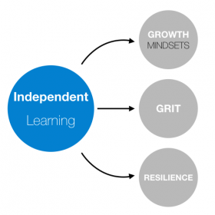
- Ethics and responsibility: this is required to build trust in informal social networks.

- Teamwork and flexibility: although workers work independently they depend heavily on collaboration and the sharing of knowledge with others in related but independent organizations.

- Thinking skills: critical thinking, problem-solving, creativity, originality, strategizing are some of the most important.
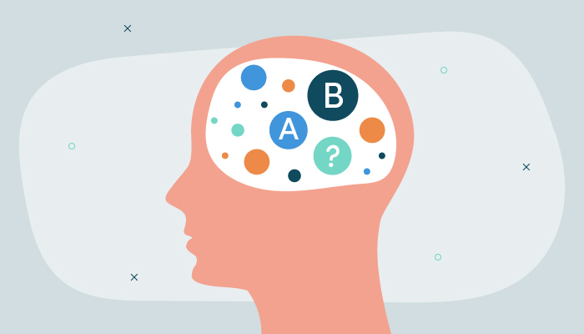
- Digital skills: most knowledge-based activities depend on the use of technology.

- Knowledge management: this is perhaps the most over-arching of the skills.
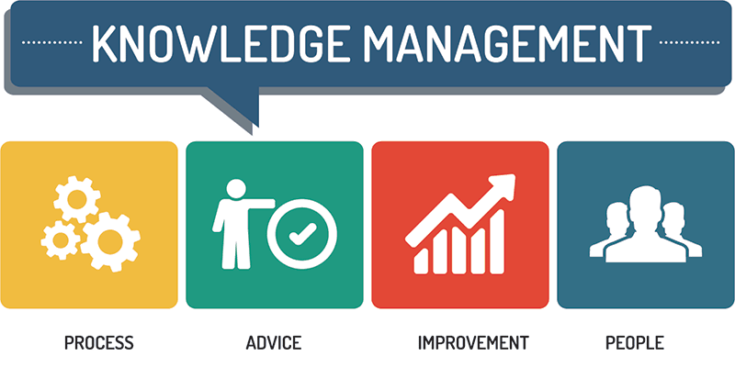
It will give more chances to find better job and communicating on academic level.

