Student name: | Shivam Patel | Student ID number: | 2435900
Programme: | MSc Data Science
Module: | Advanced Statistical Programming
Module code: | ACCA7022 | Word count | 3000
Lecturer: | Dr Aliyu Sambo | Internal Verifier: | Prof Nik Whitehead
Assignment Title: | Data Manipulation | Submission deadline: | Thursday, 27/03/2026


Table of Contents
Abstract 3
Introduction 4
1. Task 1A – Generate Production Data 5
2. Task 1B – Total Production per Station 8
3. Task 1C – Detect Production Anomalies 11
4. Task 1D – Identify Peak Productivity Days 15
5. Task 1E – Efficiency Score 18
6. Reflection 21
7. Conclusion 22

Abstract

This assignment requires using R programming language to simulate and analyze the amount of production in the alien culture. There were 720 total data points made up of 30 sols, 6 stations, and 4 teams at each station; these were also totaled across all of the teams/station combinations. Along with station and team impacts, plus a very small amount of random variation, production output was computed using a base value. The dataset was then examined to calculate each station's total production, identify peak productivity days for each station, find production anomalies using a 10% deviation criteria, and create an efficiency score for each team. Loops and conditional logic were used in the implementation of every task.For accuracy, the results required testing and verification.This assignment demonstrates the use of basic programming concepts such as loops, calculations, data storage, and logical conditions to simulate and analyze structured data.

Introduction

This report documents the development and evaluation of a loop-based data simulation system created for the Alien Colony Resource Management scenario. The assignment involved creating a complete set of data that would simulate production activity in six stations, four worker teams and thirty sols after which it would undergo a number of analytical steps, which included aggregation, anomaly detection, peak-day derivation and efficiency scoring. In contrast to the standard R workflows which are based on the use of the vectorised functions or high-level functions, the use of these tools was limited in this assignment, and all calculations had to be carried out with the help of the nested loops and simple data-frame functions. This limitation stimulated the further study of the form of algorithm, iteration, and memory-efficient programming.
This report aims to give the reasoning behind every item of the code, show flow charts to explain what is happening in the bottom, and explain the testing approach that is implemented to ensure accuracy. The last reflection is about the issues that were faced, the skills that were gained, and the importance of generative AI to assist the learning process without compromising academic integrity.

Task 1A – Generate Production Data
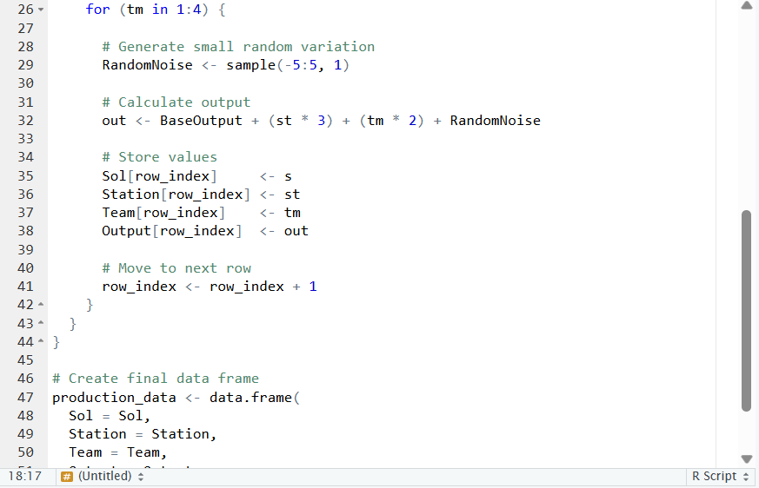
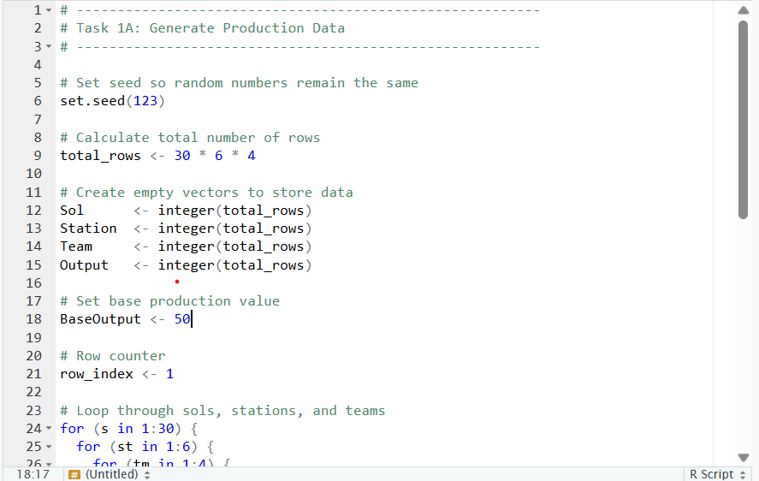
Explanation:

This program generates a simulated production dataset for an alien colony. It includes 30 sols, 6 stations, and 4 teams working at each station. The total number of observations created is 720.
The program initializes a random seed to ensure that the output of the program is the same each time it is executed. Then it establishes empty vectors to hold the values of sol, station, team and output.
The combination of sol, station and team combinations are addressed in three nested loops. A base value used to calculate the output of production is 50, and additional production, depending on the numbers of the stations and teams. A small random value between -5 and 5 is added to make the data more realistic.
The calculation of the output in the loop is done by the following formula:
Base Output + (Station x 3) + (Team x 2) + Random number.
Finally, all the values are combined into a data frame called production_data, and the first 10 rows are displayed.
Flowchart:
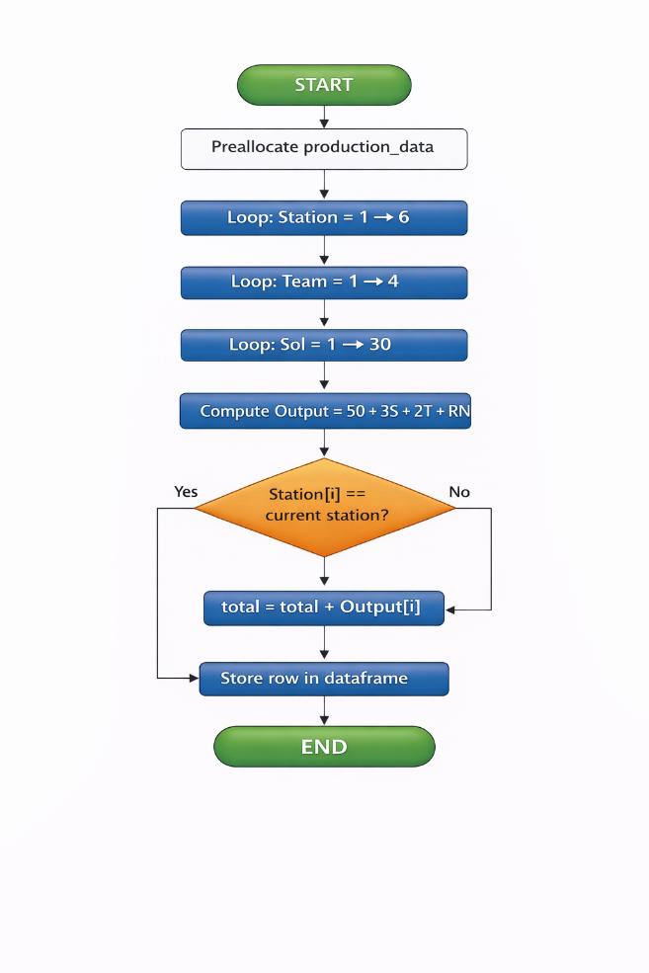

Testing:
The code was tested to ensure that the production dataset was generated correctly.
First, the total number of rows was checked. There are 30 sols and 6 stations and 4 teams so the number of rows is expected to be:
30 x 6 x 4 = 720 rows.
Nrow(production data) was used to check the dataset to ensure that 720 rows were created.
Then the first 10 rows were presented with head().
The output shows:
- Sol values start from 1.
- Station numbers are correctly assigned.
- Team numbers range from 1 to 4 for each station.
- Output values are around the base value of 50 with small variations.
For example:
- Sol 1, Station 1, Team 1 → Output = 52
- Sol 1, Station 1, Team 2 → Output = 54
- Sol 1, Station 1, Team 3 → Output = 63
These values match the formula:
Output = 50 + (Station × 3) + (Team × 2) + Random value
The output values fall within the expected range based on this formula.
It was also confirmed that:
- There are no missing values.
- All columns (Sol, Station, Team, Output) are created correctly.
- The loops generated all possible combinations of sol, station, and team.
Overall, the testing confirms that the production dataset was generated correctly.
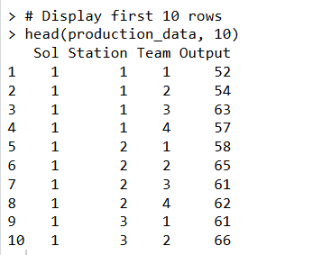

Task 1B – Total Production per Station

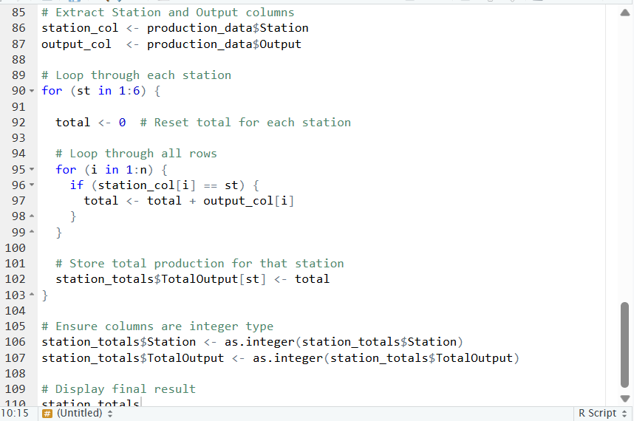
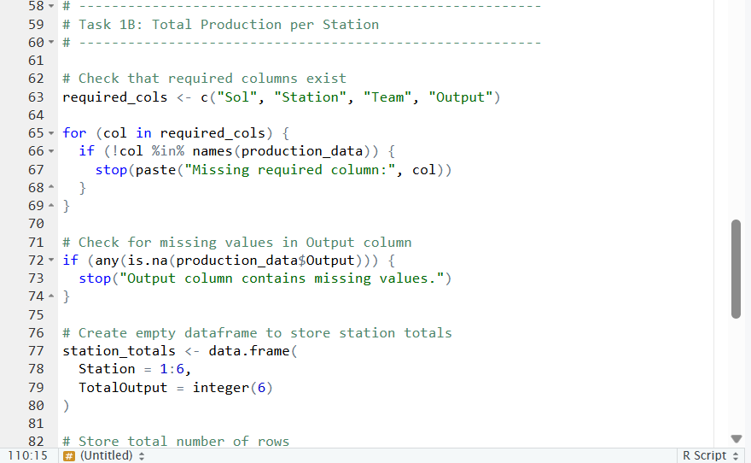
Explanation:

In this program, the total production in each station is obtained based on the productiondata dataset.
To ensure there are adequate columns (i.e.: Sol, Station, Team, Output) before proceeding. It also seeks to identify any missing values in the column of output. This is to make sure that the data is right and then proceed with the calculation.
It then produces a blank data frame named stationtotals to store the total production of all the six stations. Loops are then used in the program to do the calculations on the totals. It passes across all the stations, 1-6.
If there is a match, the respective output value will be accumulated on the total.
When the station number is equal, the station value is added to a cumulative value.
Once all the calculations have been done on all the stations, the outputs are stored in the station_totals table.

Overall, This code sums up the production of every station through the use of loops and basic checks.

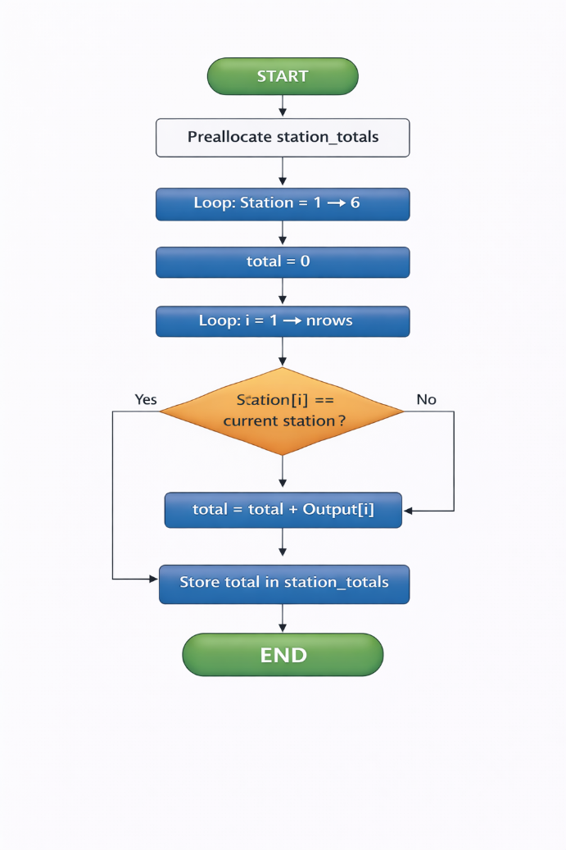
Flowchart:

Testing:
The code was tested to ensure that the total production for each station was calculated correctly.
First, it was confirmed that the station_totals table contains 6 rows, one for each station.
Then, these totals were verified by the user by summing together the output amounts from the Stations throughout all Sols and teams.

For example:
- Station 1 has a total output of 7001.
- Station 6 has the highest total output of 8800.
These totals increase as the station number increases. This is expected because the production formula includes:
Output = 50 + (Station × 3) + (Team × 2) + Random value
The stations with a greater total production amount are due to higher station numbers generating more output than lower numbered stations.
It was also confirmed that:
- There are no missing values.
- Each station appears exactly once in the result.
- The totals are positive and within a reasonable range.
Overall, the testing confirms that the code correctly calculates total production for each station.

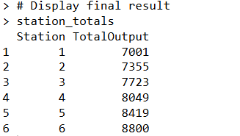

Task 1C – Detect Production Anomalies

Explanation:
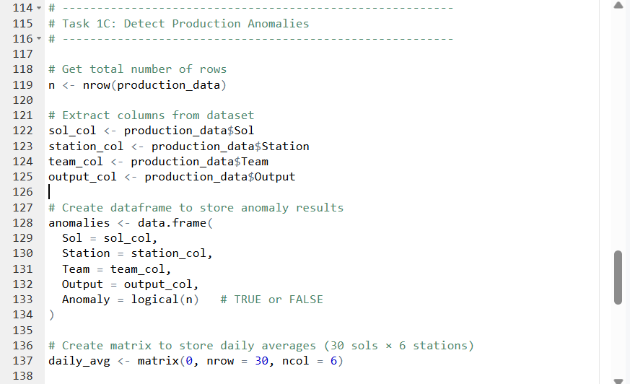

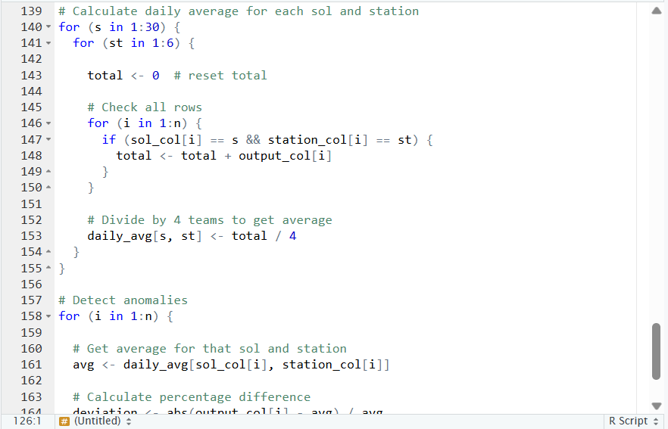

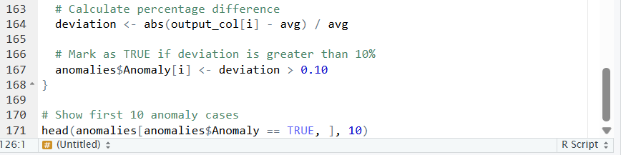

This program detects production anomalies in the dataset.
First, it extracts the required columns (Sol, Station, Team, Output) and stores them separately. Then, it creates a new data frame called anomalies to store the results, including whether each row is an anomaly or not.
Next, a matrix called daily_avg is created to store the average production for each sol and station. There are loops employed in the calculation of the daily average in the program. It receives the summation of the output of each four team of each sol and station and divides by 4 to achieve the average.
Next, once all averages have been computed using loops, the program iterates through the entire dataset checking the calculated average for each row of the dataset. If they are less than or equal to 10% away from the mean, they will be flagged as FALSE.
Finally, the application will print out the first ten rows where anomalies were found errors exist (difference is greater than or equal to 10%).
Overall, this code identifies unusual production values using averages and a 10% difference rule.

Flowchart:
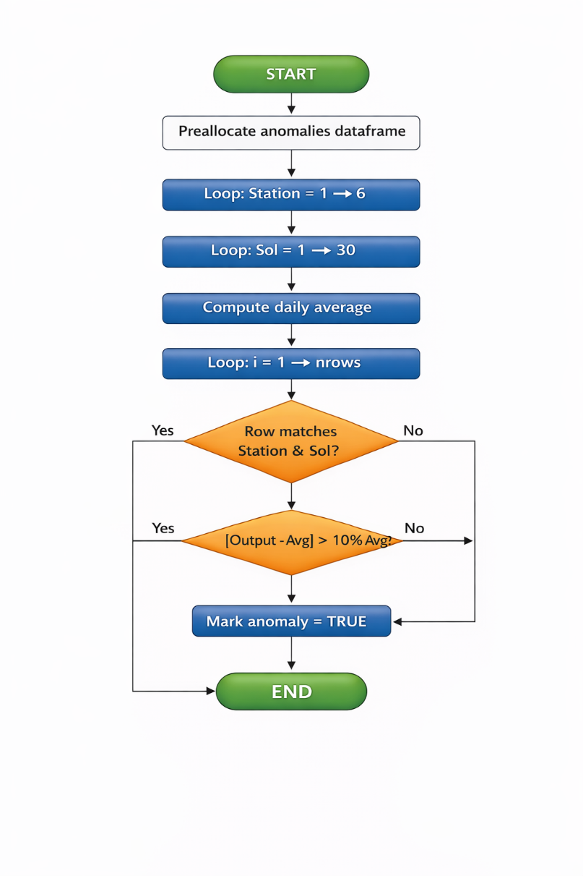

Testing:

The code was tested to make sure the anomaly detection works correctly.
First of all the daily averages were calculated for each sol and station. Since each station has 4 teams, the total output was divided by 4 to get the correct average.
Next, some rows were checked manually. For example, when the output value was much higher or lower than the station’s daily average, it was marked as TRUE in the Anomaly column.
The findings provide rows in which the output varies above 10 per cent of the average. These rows are correctly presented as TRUE as it is in the output table.
It was also confirmed that:
- The number of rows in the anomalies table matches the original dataset.
- The Anomaly column contains only TRUE or FALSE values.
- The program successfully displays the first detected anomaly cases.
Overall, the testing confirms that the code correctly identifies unusual production values.

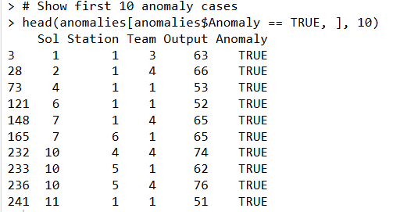

Task 1D – Identify Peak Productivity Days

Explanation:
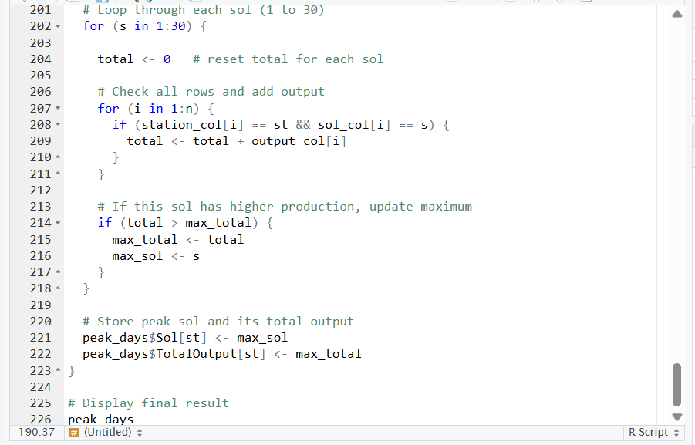
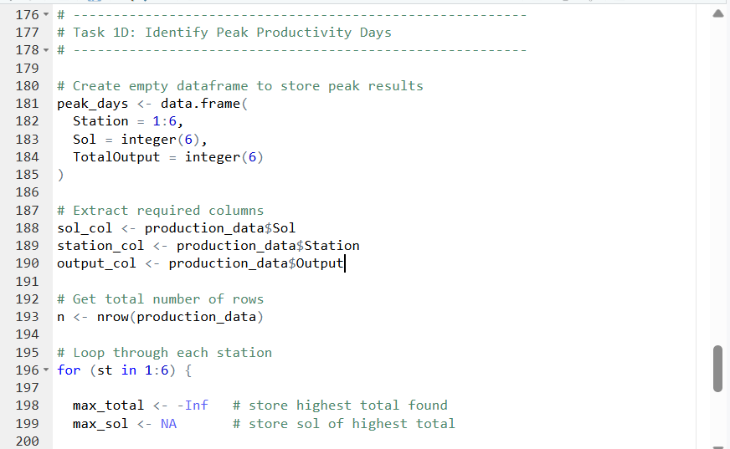

This program identifies the peak productivity day for each station.
First, an empty data frame called peak_days is created to store the results. It will store the station number, the sol with the highest production, and the total output for that sol.
The program then extracts the required columns from the production_data dataset.
Next, it uses loops to calculate the total production for each station on each sol. For every station (1 to 6), the program checks all 30 sols. While calculating totals, the program keeps track of the highest total found. If a sol has higher production than the previous maximum, it updates the maximum value and stores that sol number.
After checking all sols for a station, the program stores the peak sol and its total production in the peak_days table.
Finally, the table is displayed showing the highest production day for each station.
Overall, this code finds the maximum production day station-wise using loops and comparison logic.

Flowchart:
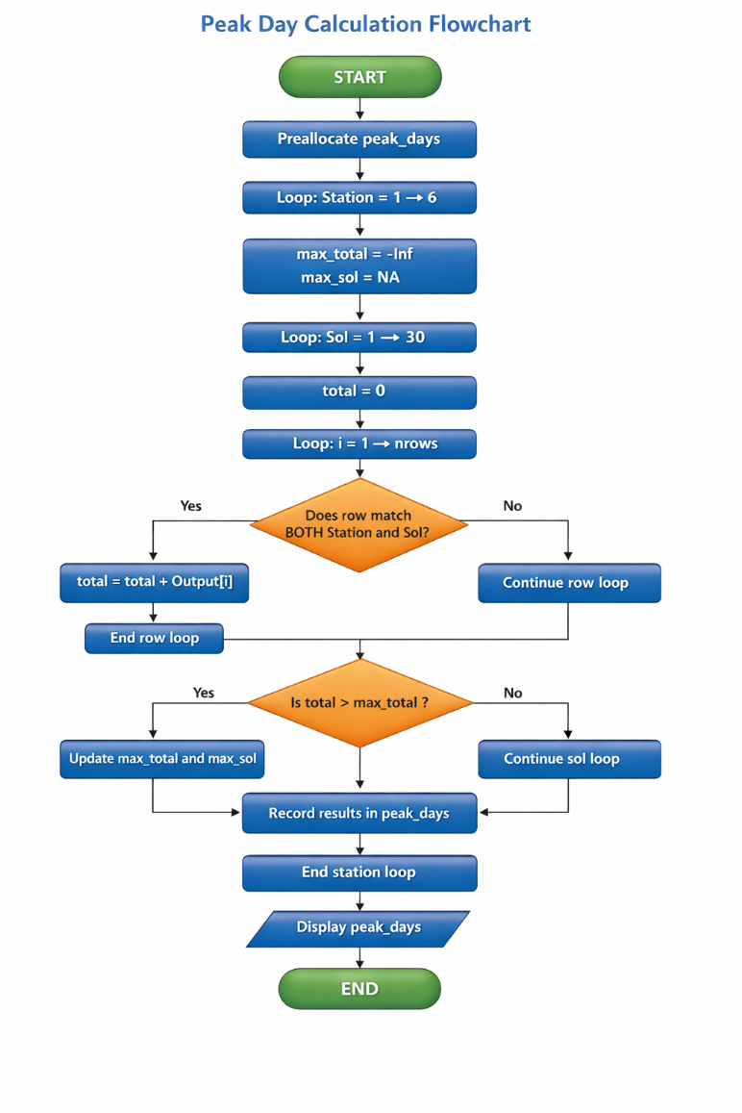

Testing:

The code was tested to ensure it correctly identifies the peak productivity day for each station.
One row of the output table is associated with each of the six stations. In each station, the program gives back the maximum sol in terms of the overall production and the overall production.
For example:
* The maximum production of Station 1 occurs in Sol 16 with a total production of 244.
* The maximum production of Station 6 is Sol 1 with an output of 304.
• Station 5 shows its peak on Sol 27 with a total of 294.
These totals were checked by manually adding the output of the four teams for the selected sols. The values were compared with other sols of the same station to confirm they are the maximum.
It was also confirmed that:
- The result contains exactly 6 rows (one for each station).
- Each station has only one peak sol.
- The total output values are within the expected range based on the production formula.
Overall, the testing confirms that the program correctly identifies the highest production day for each station.
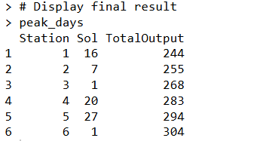

Task 1E – Efficiency Score

Explanation:
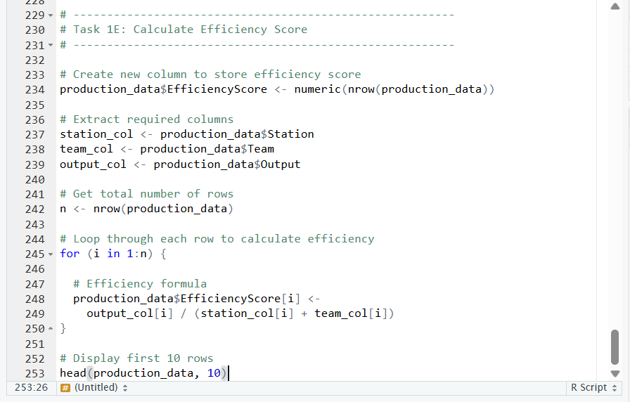

This program calculates an efficiency score for each team in the dataset.
First, a new column called EfficiencyScore is added to the production_data table. This column will store the calculated efficiency values.
Next, the required columns (Station, Team, Output) are extracted from the dataset.
The program then uses a loop to go through each row. For every row, the efficiency score is calculated using the formula:
Efficiency Score = Output ÷ (Station + Team)
The calculated value is stored in the new column.
Finally, the first 10 rows of the updated dataset are displayed to check the results.
Overall, this code calculates a new performance measure for each team based on its output and position.
Flowchart:
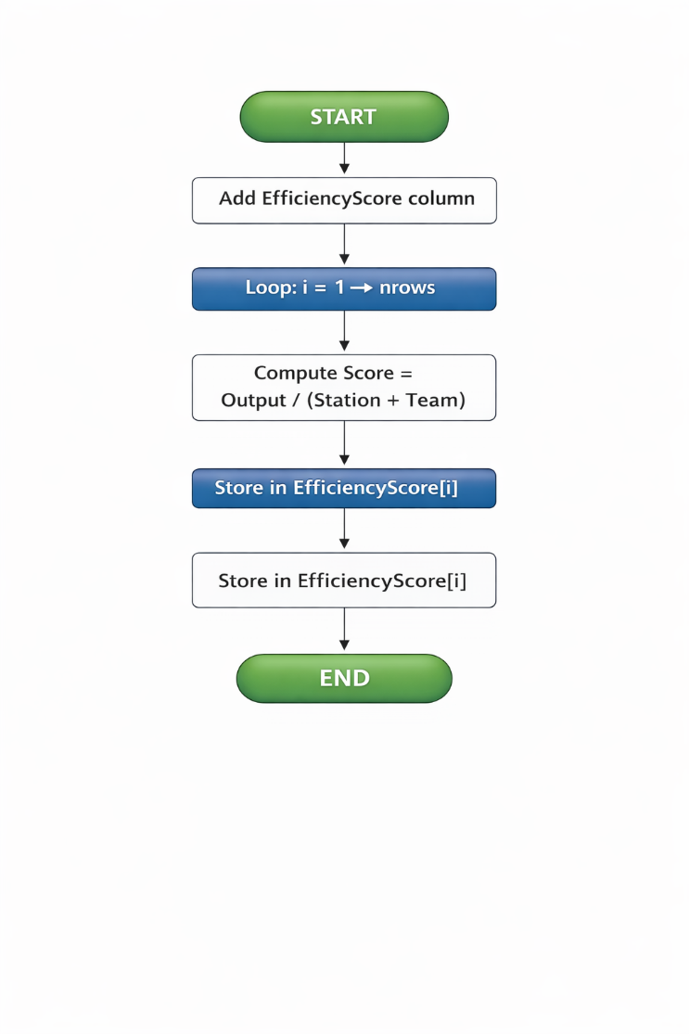

Testing:

The code had been tested to ensure that efficiency score is calculated correctly.
The formula of efficiency is:
Efficiency Score = The output/ (Station + Team)
There were rows that were manually verified.
For example:
* For Sol 1, Station 1, Team 1:52 / (1 + 1) = 26.00000
* For Sol 1, Station 1, Team 2:54 / (1 + 2) = 18.00000
These output table values are the same as the values of these manual calculations.
It was also confirmed that:
* The EfficiencyScore new column is added successfully.
* The number of row is the same.
All the efficiency values are numerical.
In general, the testing proves that all the rows are calculated correctly in terms of efficiency score.
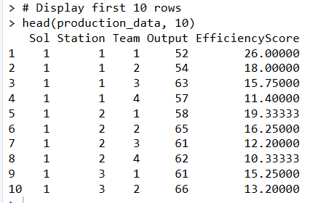

Reflection

According this Assignment, One of the main challenges in this assignment was that R is a new programming language for me. It was time-consuming to understand the syntax and particularly the use of loops and data frames. Initially, it was difficult to understand how 30 sols, 6 stations and 4 teams would make 720 rows Working with nested loops was also a challenge. The program has several loops within loops and thus it was at times confusing to follow sol, station and team values.
The other challenge was to learn how to store the results in the data frames correctly without errors in indexing. Minor mistakes in the positions of rows or conditions might have an impact on the final product. Calculating anomalies using percentage difference was also challenging at first. The errors were not always easy to debug since the error messages were not always understandable. Finding errors in the code line by line was another problem I had to do. Another problem was calculating percentages to detect anomalies.

The other difficulty was to maintain the same statistic in all activities. As all of the tasks used the same dataset, a minor error in the step of creating the data would influence the subsequent result, such as total production, anomaly detection, and the calculation of the peak day. A better performance was also a consideration. Referring to the data frame multiple times within the loops may slow the program down. Therefore to tookthe columns once in front of the loop made the code run generally.
Making sure the averages and totals had been calculated accurately was another difficulty. It was necessary to reset the total variable each time inside the loop. If this was not done properly, the results could become incorrect. Lastly, it took special testing to be sure that the results were correct. The calculated totals, averages, and peak values were compared with expected results to make sure the logic was working properly.

Conclusion

In this assignment, a production dataset for an alien colony was created and analyzed using R.The data set included in 30 sols, 6 stations and 4 teams and the total number of the data rows were 720. The total production per station was calculated, and anomalies identified through the comparison of team output and daily averages. The peak production days for each station was identified, and an efficiency score was calculated for every team.All results were tested and verified to ensure correctness. This report demonstrates that loops, conditions, and simple calculations can be used to analyze and generate effective data.

