Dissertation
LCBB6000
BA (Hons) Business Management
University of Wales Trinity Saint David (London Campus)

Exploring high costs of energy bills on electric consumers

Alexandru Ionut Stefaroi – 1914985

  - Declaration

I declare that I carried out this research and it was supervised by a team of lecturers, also I declare that this study has not been submitted to any other university for a degree.

  - Abstract

Exploring the high cost of energy bills on electrical consumers is a topic that is heavily discussed in nowadays society, therefore it’s important to analyse those aspects from different perspectives and drawn key ideas that can help the people in the future. The objective of this research is identify the causes of the risen electrical bills, to provide solution to the electrical consumers to reduce their bills, also make recommendation to the governments on how to develop new strategies regarding the electricity bills.
In order to achieve these objectives the study developed a questionnaire formed of ten questions to be able to collect the up to date data to be used in analysing the possible issues regarding the rising costs of electricity bills. The results indicated that the participants of the study have knowledge of rising cost and what was the cause of this, such as the war from eastern Europe and the inflation. Also, the results shown that the respondents believe that the solution to reduce the bills is to start using the green energy, and the government should provide long-term solution to reduce the cost of bills, instead of offering short term schemes to help them throughout this energy crisis. The study also highlighted several solutions that the authorities can address. This research paper helps the future studies to understand the people needs and how they can be helped in managing the electricity costs.

  - ACKNOWLEDGMENTS

I would like to thank to my supervisor that helped and guided me to the process of writing this research paper that was focusing on exploring the high cost of energy bills on electrical consumers. His assistance and support throughout the whole process, helped me to go through the difficult times and finally being able to accomplish all my objectives.
I wish to thank to my family also, as they were always very supportive and encouraging while I carry out this research.
I wish to show my appreciation to the participants of this study for taking their time to answer the questions in an honest manner and helping the research to provide real time data, which was a great value.

Table of Contents

Declaration ………………………………………………………………………………….2
Abstract ……………………………………………………………………………………. 3
Acknowledgements …………………………………………………………………………4
Chapter 1 Introduction …………………………………………………………………….7
  - Introduction ………………………………………………………………………………7
  - Background of the study …………………………………………………………………7
  - Problem Statement ……………………………………………………………………….8
  - Research Aim …………………………………………………………………………….8
  - Methodology ……………………………………………………………………………...9
  - Structure of the Dissertation ………………………………………………………………9
  - Summary …………………………………………………………………………………10
Chapter 2 Literature Review ……………………………………………………………….11
2.1 Introduction ………………………………………………………………………………11
2.2 The Energy Bills increased and its effects in the society…………………………………11
2.3 Previous studies and lessons learnt ……………………………………………………….12
2.4 Gaps identified …………………………………………………………………………...12
2.5 Summary …………………………………………………………………………………13
Chapter 3 Research Methods and Methodologies ………………………………………..14
3.1 Introduction ………………………………………………………………………………14
3.2 Philosophy of the study …………………………………………………………………..14
3.3 Paradigms of the study …………………………………………………………………..14
3.4 Research Approach ………………………………………………………………………15
3.5 Research Strategy ………………………………………………………………………..15
3.6 Research sample and population …………………………………………………………15
3.7 Data collection and Data analysis ………………………………………………………15
3.8 Ethical consideration of the Research …………………………………………………….16
3.9 Summary …………………………………………………………………………………16
Chapter 4 Data Analysis and Discussion …………………………………………………..17
4.1 Introduction ………………………………………………………………………………17
4.2 Analysis of Data ………………………………………………………………………….17
4.3 Discussion of the Data …………………………………………………………………..23
4.4 Summary ………………………………………………………………………………..24
Chapter 5 Conclusion, Limitations and Recommendations …………………………….25
5.1 Introduction ………………………………………………………………………………25
5.2 Conclusion of the Research ………………………………………………………………25
5.3 Limitations of the Research ………………………………………………………………26
5.4 Recommendations ………………………………………………………………………..26
5.5 Summary …………………………………………………………………………………26
Reference List ……………………………………………………………………………….27
Appendix …………………………………………………………………………………….30

  - Chapter 1 – Introduction

1.1 Introduction
Energy represents for the society one of the most important basic need that helps the people to live. Always has been a high interest in developing new ways of developing the energy consumptions and people have been using the newest technology to develop the system of using the energy. Over the years, there were different ways of improving energy supply to the society and many researchers have focused their studies to help the governments to develop better policies that aims to improve the use of energy supply in the most efficient ways. As energy supply represents an important aspect in the society, there are many sectors that are interested in this area, therefore there are many discussions that aims to improve the ways of energy supply to the population. Additionally, the energy plays a crucial role into worldwide economy as it helps the countries to develop and improve the life condition of people. The increased demand of energy has been impacted by the effects of urbanisation, modernisation, and the growth of population around the globe (Muneer, 2007). One of the main energy supplies used by people is the electricity and represents the most important ways of developing the economy of a country.
Over the years, the electricity sources were coming from gas, fossil fuels and coal, however these sources have proven that affects the environment by causing pollution, therefore people have tried other sources, such as renewable energy (Islam et al, 2014). The electricity supply has always been a challenge for the governments, especially the source of it also in the most recent years, the pollution caused by the sources, therefore different alternatives have attempted to be used by the society (Owusu et al, 2016). However, these alternatives, such as renewable energy has been difficult to implement on a long-term run, thus the society still faces issues in finding the most efficient ways to provide electricity to the population.

1.2 Background of the study
In nowadays electricity supply has brough attention to many agencies, such as the environmental ones, governments, private sectors, and scholars, therefore, many studies have been caried out that aimed to establish what will be the best way of finding the energy source that will be less polluted and less costly for the whole society(Owusu et al, 2016). However, the most recent studies have demonstrated that is crucial to use the electricity from a renewable source as it will have a positive effect on the globe. Additionally, the recent situation worldwide, and mainly in United Kingdom, which is referring to post-Covid, war between Ukraine and Russia and Brexit, it was highlighted by the society that there was a huge impact on the costs of electricity supply (Lorusso, 2022).
This impact of electricity costs has brought attention across the whole society; therefore, the governments has started to act against the high costs, the companies has changed their business strategies to be able to adapt to the new cost of electricity, also the researchers have developed new studies that aims to explore the causes and effects of the rising of electricity supply costs.

1.3 Problem Statement
Taking in consideration the high interest in analysing the electricity prices, this research project is aiming to explore the high costs of energy bills on electrical consumers. Currently the society requires a deep understanding of the rapidly increased electricity bills and how these effects will contribute to the future wellbeing of the population. Developing research studies that aims to explore the causes and consequences of the high cost of electricity bills, it will help the society to develop better long-term strategies that will help people to have a high level of living standards, also to sustain the growth of country’s economy.

1.4 Research Aim
The aim of this research is to explore the high costs of energy bills on electrical consumers.
Therefore, this research objectives to support the aim are:
- Attempt to identify the causes of the rapid increase of energy bills, especially on electrical consumers
- study is to provide suggested solutions to consumer’s in resolving the high costs of their electrical bills.
- To make suggestions to the government and other organisation so that they to develop policies that are aiming to help people to use their electricity efficiently at a reasonable cost.
Currently the energy bills, especially on electrical consumers, represents an essential aspect for the people, thus this research aims to answer several questions that will be able to provide solutions for the society in solving the high cost of electrical bills.
The main questions that the research will attempt to answer are:
- To understand why there was a rise of the energy bills and what caused it
- How people were affected by the soaring cost of the energy bills, especially the electrical consumers
- How this current issue can be resolved and provide solutions for new policies developed by the government

By answering these questions, the research will identify specific problems that can be analysed and explored in order to provide a better understanding of the high costs of electrical bills, therefore it will provide efficient solutions perhaps to reduce the costs of maintains at the same level for the near future, also on a long run term for the future generations.

1.5 Methodology
This research study aims to achieve it objectives by collecting data from the people randomly chosen that will be able to provide their viewing regarding the electrical bills. The methodology used in this research was to develop a questionnaire that aimed to collect quantitative data from the society afterwards the data will be analysed to obtain the most accurate information from the respondents. Following the data analysis, the study will be able to draw essential information that will help the society to developed better solutions in resolving the high cost of electrical bills. Gathering relevant information regarding the electrical bills and the most up to date data, it will help the research to provide the most accurate details regarding this field of study.

1.6 Structure of the Dissertation
This research is formed of five chapters that will target several aspects of the study. Chapter one is aiming to provide an introductory overview of the energy bills and their importance in the society and some background information regarding the study, also it is highlighting the objectives and importance of the research in this specific field of energy bills, same as the methodology used to collect data. Chapter two is exploring the theories and concepts of how the study is developed and how it can be compered to the other studies in this field and what is the input of this research in this specific area of study.
Chapter three is seeking to analyse the methodologies, theories, and paradigms of this research, also highlighting the method used to collect data and the tools used to analyse the information obtain. Additionally, chapter four will provide an in-depth analysis of the data found that will help the research to draw the essential information to achieve its objectives. Finally, chapter five will provide the conclusions of this study, also it will provide recommendations for the filed that was analysed and share the limitations faced in this research that will help other future studies to take in considerations.

1.7 Summary
Electrical energy has an important role in the society; therefore, people need to analyse all the aspects of this area, especially during difficult times when the soaring cost of electrical bills have a negative impact of the people wellbeing. Thus, this study aims to provide an overview of the electrical cost, also provide essential information regarding the current trends of the energy bills. Overall, this chapter provided background information of the study, also highlighting the objectives of this research and the methodology used to gather the data.

  - Chapter 2 – Literature Review

2.1 Introduction
This chapter is aiming to analyse the concept of the energy bills and its effects in the society, also explore the other similar studies that aimed to provide relevant information regarding the energy bills. Also, the lessons learnt from the previous studies is another aspect that will be discussed, same as the gaps identified while the research has been carried out.

2.2 The energy bills increased and its effect in the society
Electricity represents an important aspect in the society; therefore, the academics have focused their interest in analysing the effects of the high cost to electrical bills and how the consumers are affected. Many researchers developed surveys that aimed to analyse the electrical influences on the energy market. In the recent years this area of studying regarding the electricity have increase and this is due the major effects that are produced in the society and affected the people lifestyles (Citizen advise, 2018).
Exploring the high costs of energy bills on electric consumers represents the idea of analysing the rise of the energy bills, especially on electrical consumers and how this increase affected the people. The increase of the bills has happened in a short period of time; therefore, the society was financially affected which created challenging times for the electrical customers (Evans, 2022). The soaring energy bills have been characterised by the economical and sociological situation that happened around the world. As an example, it’s the war of Russia and Ukraine, which caused shortage of fuel, therefore the electrical demand has increased same as the prices causing inflation in many countries in Europe (Evans, 2022).
The importance of analysing the increased electrical bills represents a way of understanding the whole concept of electricity in the society, also the people need to have a better knowledge regarding the usage of the electricity. Furthermore, the importance of this subject has brought the interest of other research to develop similar studies that aimed to understand the customer behaviour towards electrical bills (Albatayneh et al, 2022). All the surveys focus their interest in analysing the energy process and how the consumers behaviour is affected, therefore different models of research were identified while compered the other surveys. Reproducing similar models of studies which aimed to identify the effects of the high costs of electrical bills helps the society to develop better strategies in the near future, but also on a long-term plan (Lesic et al, 2018).
By analysing the similar surveys caried out by the scholars, it could be identified different theories that are found to be the ground ideas of understanding the rise of the electrical energy bills and the major effects found in the countries’ economies, which disequilibrate the wellbeing of a nation.

2.3 Previous studies and lesson learnt
This research of exploring the high-cost energy bills on electric consumers has the advantage of the time, as is conducted during the most challenging period, referring to the post-Covid and during a war, therefore offers essential data of this difficult era (Battistini et al, 2022). Compared to the other studies this research brings the most up to date opinions of the electrical consumers, especially of the rapid increased energy bills, which other surveys cannot offer as the results will be completely different than what it was a year ago (Statista, 2022). On the other hand, a disadvantage of this survey will be subjectivity of the participants, as currently all the society is shocked the high prices of the energy bills and it may tend to exaggerate their response toward this increase. Another disadvantage of this study it may be the lack of knowledge that the consumers have regarding the usage of the electrics in their households and may understand differently the idea of the increased bills.

2.4 Gaps identified
The purpose of this research is to identify the challenges faced by the electrical consumers and the society itself, therefore identifying the possible gaps between research studies and people understanding this concept is crucial. While the research is attempting to obtain the most accurate data, also comparing to what studies are currently developed by the scholars, there are still gaps that can be identified while carried out this research.
As mentioned in the other studies where strategies of analysing the rise of electrical usage were efficient and helped the policy makers to develop better plans to help the society. There are still gaps identified that was not covered by the researchers, therefore it is important to highlight those gaps and attempt to address them in future (Muller-Bloch et al, 2015). While other researches have focused on the way how electrical supply has been used by the society and what advantages and disadvantages had, there are still required information’s that aims to understand the people knowledge regarding electrical usage, also how this knowledge can be used to developed better plans in the near future, Additionally, the rise of the electrical bills was the most recent challenges faced by the electrical consumers, therefore the most up to data is essential, in order to understand the issues face by the population and how this can be address in the near future, also to create new strategies that can help the future generations.

2.5 Summary
This chapter sought to analyse the effects of electrical bills and its effects on the people wellbeing. Additionally, an analysis of the similar studies and literature developed around this area of study has been evaluated and discussed with the purpose to identify possible key ideas that will help future studies in similar areas. Also, the lessons learnt while developing this research are crucial for the report as it will provide a better understanding in the future studies. The gaps identified in this are of study is essential, as the report is aiming to fill those gaps by proving the most current data collected which will provide vital information that can be used to reproduce more efficient ways of dealing with the risen cost of electrical bills.

Chapter 3 – Research Methods and Methodologies

  - Introduction
This chapter analyse the methods and methodologies used to explore the topic of high energy bills on electrical consumers. Thus the methodologies of this study will be explored by analysing the philosophies and paradigms used to develop this research. While the methods are focusing on the applied strategies to obtain the data. The chapter will also cover the research approach of this study.

  - Philosophy of the study
As this study aims to obtain data of the current situation of the high-cost energy bills and its effects on electrical consumers, the philosophy used will be realism and this is due the real and criticism characteristics found in this philosophy. This idea of realism will help the study to analyse the data as found, therefore by exploring the rise of electrical bills will be able to obtain an accurate information from the current society welfare. By using the realism philosophy will help the research to acknowledge relevant information’s that will help the study to be situated in a relevant timeframe due to the period of carrying out the research (Novikov et, 2013). Additionally, this philosophy will enable the research to identify the data obtained from the participates, while addressing their personal views and using the direct realism which is focusing on ideology of ‘’you get what you see’’ (Saunders et al, 2012). This idea of obtaining real time data helps the study to be original and play an essential role in this area of study.

3.3 Paradigms of the study
In regards of the paradigms that will be used in this study, it will be the positivism and critical realism. In the study will be found the positivism that will enable to obtain data that will focus on the effects of high costs of energy bills on the electrical consumers and what makes this cost to rise. Also, the critical realism will be able to highlight solutions of tackling the risen cost of the bills and offer options to the policy makers to reduce the negative effects of these cost in the society (Wahyuni, 2012).

3.4 Research Approach
The main approach of this research will be the induction, as the data will be collected, and theories will develop. This approach will be the most suitable for the study as the data that will be collected will be unique, due the high cost of the bills that the society didn’t face until now, therefore new ideas and strategies will be introduced in this area of study. The research approach used in the report will enable to obtain data that will help the research to get the best outcome and provide essential information regarding this are of study (Azungah, 2018). The induction approach will allow the study to analyse the data obtain and carry out an analysis that can develop new policies in targeting the root causes and effects of risen electrical bills on its consumers (Saunders et al, 2012).

3.5 Research Strategy
The research strategy used to develop this study has a target to obtain the data from the participants and then to be analysed in order to understand the problems that the society is facing and what can be done to solve those issues. The strategy used was to develop questions that are able to offer the relevant answers to enable the research to answer its questions. Another strategy that was used to develop this research was the way of obtaining the data, using the quantitative approach as will be able to provide information’s that can be used to highlight the necessary steps to be taken to solve the matter of risen bills on electrical consumers (Goddard et al, 2004).

3.6 Research Sample and Population
The research aimed to target random people that will be able to share their personal situation regarding the effects of risen electrical bills and how affected they were. The selection of the participants was made randomly using the social media platforms where they had to answer several questions. The aim of using this method of selection was to provide a mixed data as it will be able to obtain a wider range of information that will be used to create relevant strategies in addressing the risen effects of electrical bills.

  - Data collection and Data analysis
The data was collected by developing a questionnaire formed of ten questions that targeted several areas regarding the electrical usage in their lives. The questionnaire was developed using Google Forms as it was able to provide the accurate data collected from the respondents. The primary data collected using the questionnaire helps the research to obtain the most relevant information in an accessible way, therefore facilitating the researcher the way of collecting essential data to be used in the research (Apuke, 2017). This process used in collecting the data will facilitate the analysis of it, as the researcher will be able to draw the conclusion from the data obtained. Is essential to develop an efficient way of designing and collecting the relevant information as it will provide to the study the accurate data, so the research can withdraw vital information and creating the new strategies of explain and developing the risen electrical bills on the consumers.
The analysis of the data will be facilitated by the result of questionnaire which will be found in charts and tables, and this information will help the researcher to identify the relevant data and draw the conclusion. The data obtain from these charts will facilitate the researcher to understand the problem of the risen bills and how can be addressed in the future.

  - Ethical consideration of the Research
For research, the ethical issues are carefully taken in consideration by the researcher, as is vital to develop a study that respect and follows the participants life principles. The ethical consideration of this research was mainly based on explaining to the participants what the scope of this study is and that their rights are respected at any time during the study. Also, it was vital to highlight to the respondents that they can withdraw at any time without any risk taken, therefore offered to the participant the freedom to respond to the questions without any fears (Cacciattolo, 2015).

  - Summary
To conclude, this chapter highlighted the grounds of developing this study which was mainly discussing the theories and paradigms used to be able to obtain the appropriate data for the research. Additionally, it was discussed the research methodologies used to collect the data, analysing it and the ethical consideration that were the foundation of this research to be able to gain the most accurate data in an efficient and respectful way.

Chapter 4 – Data Analysis and Discussion

4.1 Introduction
This chapter intends to provide an analysis of the data collected that will be able to provide relevant information to enable in achieving the purpose of this study. The aim of this chapter is to highlight the data obtain and discuss it, then following these conclusions can be drawn. The purpose of the study is to obtain the most up to date data regarding the causes and effects of the risen bills on electrical consumers, therefore this part of the study will be able to highlight this relevant data that will help the study to accomplish its scope. Firstly, this chapter will analyse the data collected from the participants focusing on the results, and secondly it will provide a discussion of the outcomes which will provide key ideas in developing new strategies to address the risen bills on electrical consumers.

4.2 Analysis of Data

The study has designed a questionnaire formed of ten questions that aimed to gather the relevant data from a wider range of population to be able to explore the cause of the rising bills and develop several strategies to help the society to pass through the difficult times, especially regarding the risen bills.
The questionnaire was created using Google Forms, as this website provided the appropriate format in obtain the data, also the charts that can show the results of the questionnaire will allow to carry out the analysis of the results.
The results of the questionnaire shown that there were twelve respondents, where 58.3 percent were aged between 30 and 40 years old, also 16.7 percent of the participants were aged between 25 and 30 years old, and the same percentage was the 40 plus category of age, while only 8.3 percent was aged between 18 to 25 years. Please see below the chart regarding the age of participants.

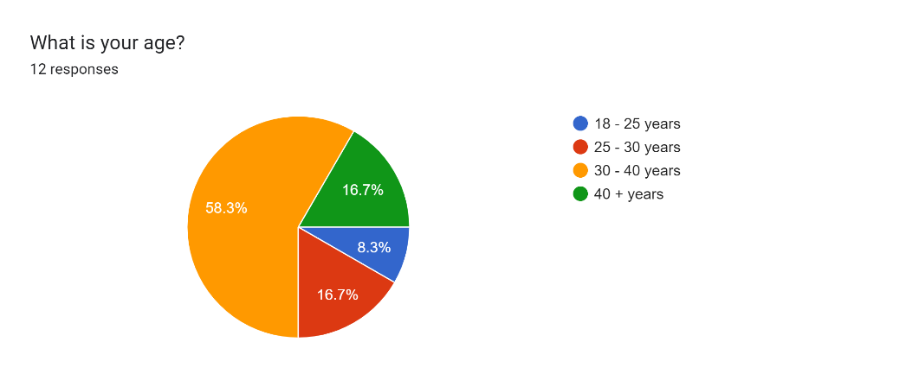
Figure 1
In regards of the participants employment status, it was revealed that 83.3 percent were employed, while 16.7 percent were self-employed. The results had shown that most of the participants have a guaranteed source of income while being employed, while the rest of the participants are liable to be exposed to a certain risk of their income.
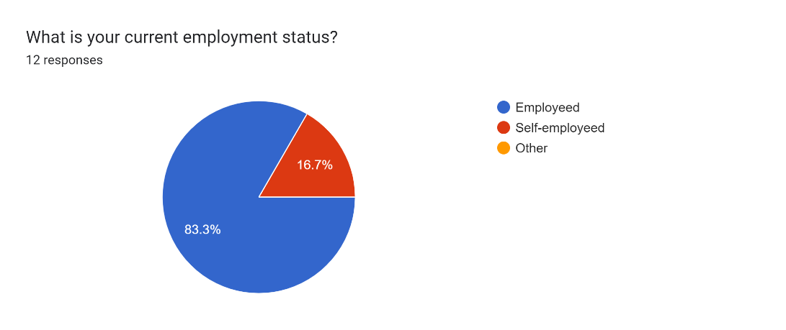
Figure 2
The results regarding annual earnings highlighted that 58.3 percent earn between £20.000 to £30.000 annually and this represent the UK medium average of annual salary and more then half of the respondents being in this category. Also, there is a 25 percent of participants that earn between £10.000 and £20.000 annual income, which highlights that are earning the minimum wage and puts them on the low-income sector in the society. Additionally, the results had shown that 8.4 percent are earning between £30.000 to £40.000 which reveals that these people are categorised as middle-class individuals in the UK. Finally, 8.3 percent of respondents are earning over £40.000 which highlights that this category of people are situate on a higher class of the UK average class salary.
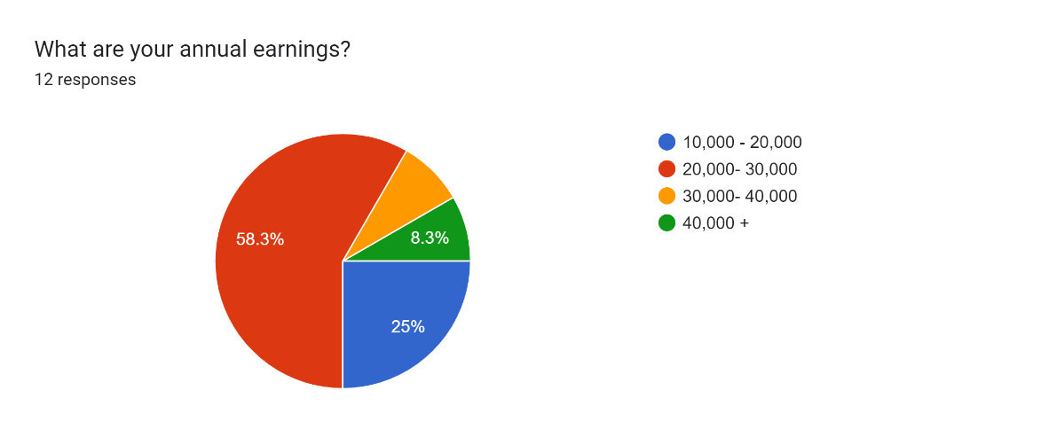
Figure 3

Going forward, regarding the energy supply that the respondents use, it shown that the majority of them, representing 83.3 percent are using electric and gas in their households, while 8.3 percent are using only electrics. This result highlights that most the respondents are using a mixed form of energy.
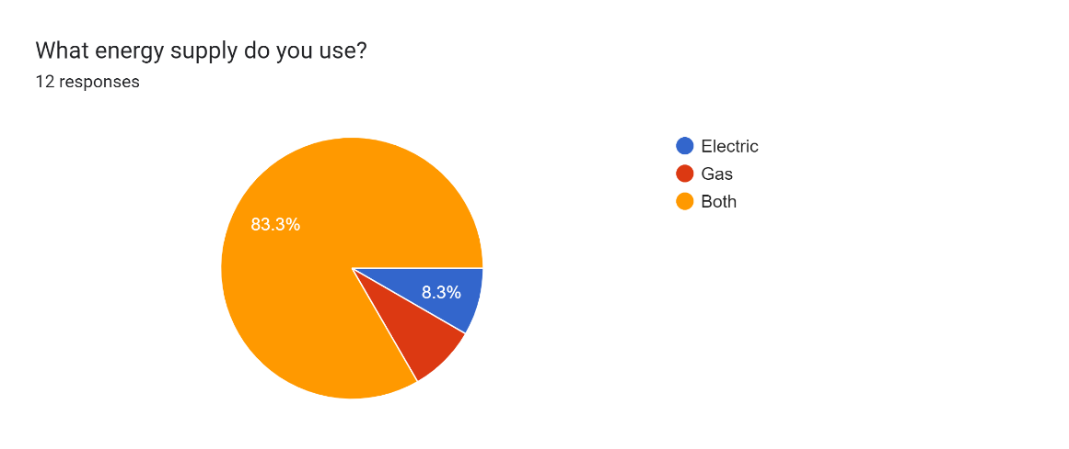
Figure 4

The rise of energy bills is the scope of this study to address and understand the cause, therefore the results of the questionnaire highlighted that 66.7 percent of the respondents were affected by the high cost of energy bills. Also, 16.7 percent disclosed that they were less affected by the rising cost of the bills, while the other category of 16.7 of participants were the most affected by high cost of bills.
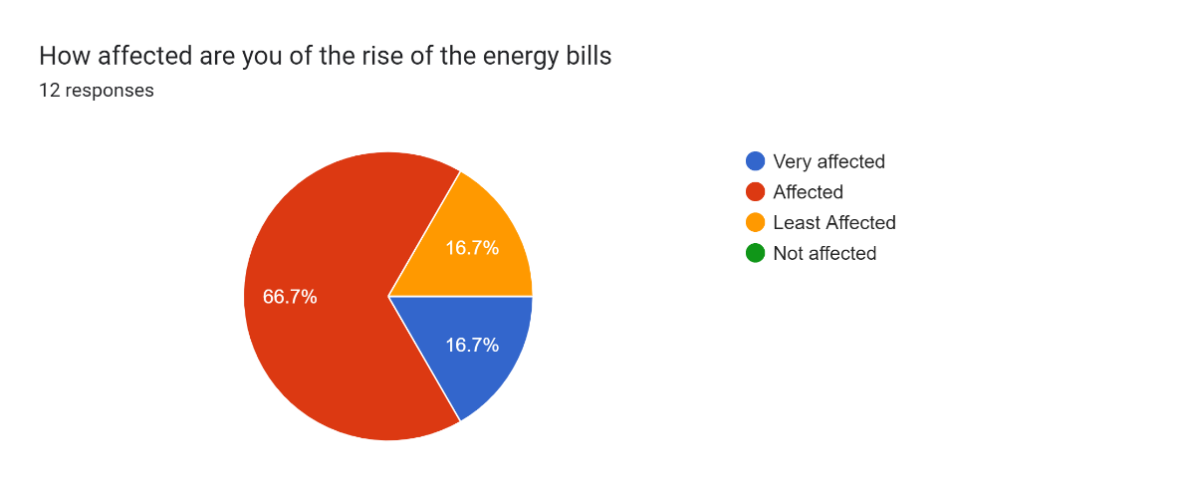
Figure 5

In regards of the question that aimed to identify how much the electrical bills did have increased in the last six months, 50 percent of the respondents have answer that the bills increased with more then 20 percent, while 41.7 percent responded that the increase was between 5 to 10 percent and 8.3 percent reported that the increase was between 10 to 20 percent.

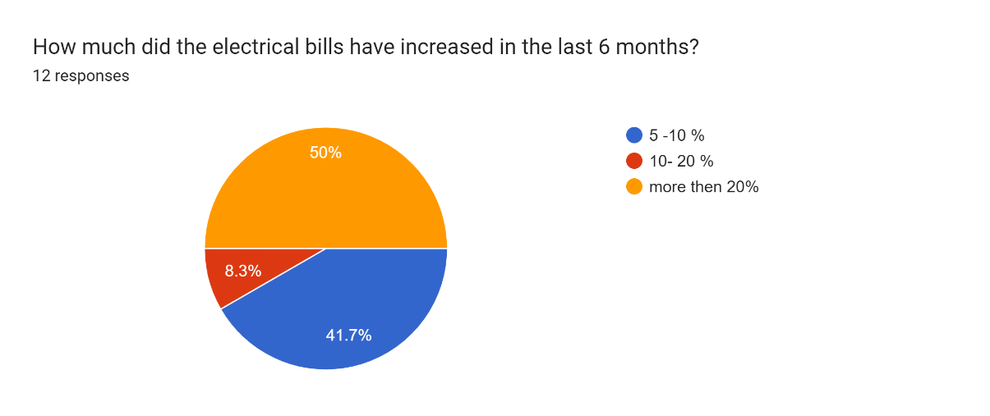
Figure 6
Furthermore, 50 percent of the respondents believe that inflation is the main reason of the increased bills, while the other 50 percent have reported that the war between Ukraine and Russia was the main reason. The figure below shows that the opinions are equally split, and the respondents believe that there are different causes of the rise of bills.
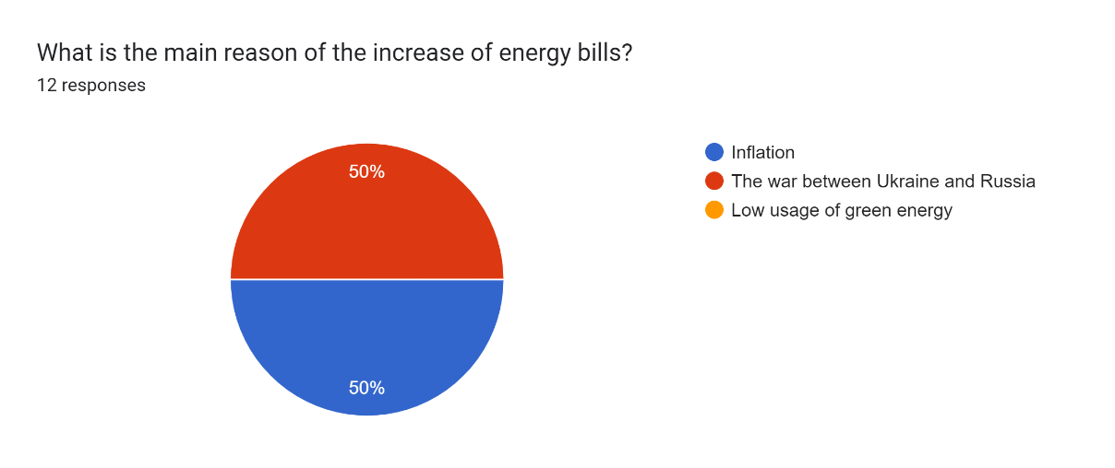
Figure 7

The question that was addressing the future trends of electrical bills in the future, 75 percent of the respondents have responded that the bills will increase even more than what is now, while 16.7 percent believes that it will be at the same price that is now, and the rest of 8.3 percent it will reduce. This results shows that most of the respondents think that the bills will still increase and shows a negative attitude towards any future changes.

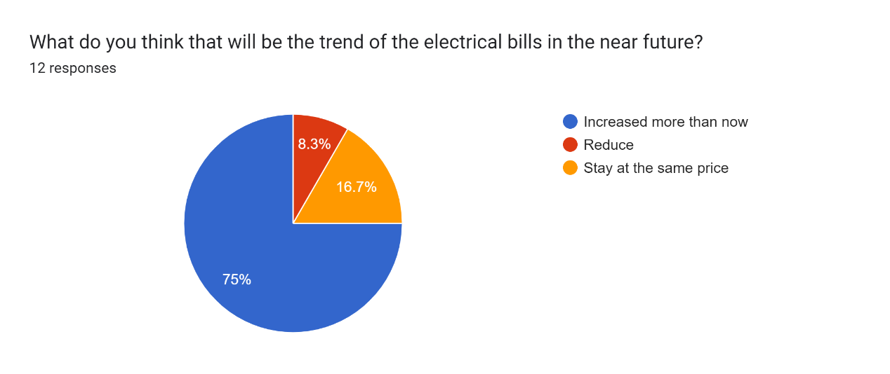
Figure 8

The question that referred to the efficiency of the Government scheme of helping the people paying the bills, the results shown that 33.3 percent were neutral to this solution offered by the authorities, while 16.7 percent believed that was the most efficient programme, while the same percentage of 16.7 percent believed that was just efficient, and then the other 16.7 percent though that was not really effective and the other 16.7 percent believed that was not efficient at all. It can be observed from the results that there is mixed opinion regarding this scheme.
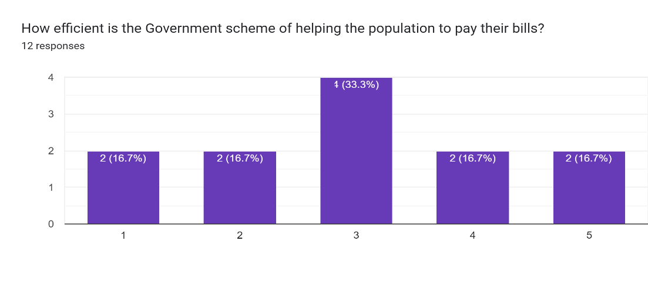
Figure 9
The final question that was referring to the future strategies that people think that will be suitable to address the rising cost of energy bills, the results shown that there were 83.3 percent of respondents that considered starting using the green energy is the best option, while 16.7 percent believes on reducing the energy consumption.
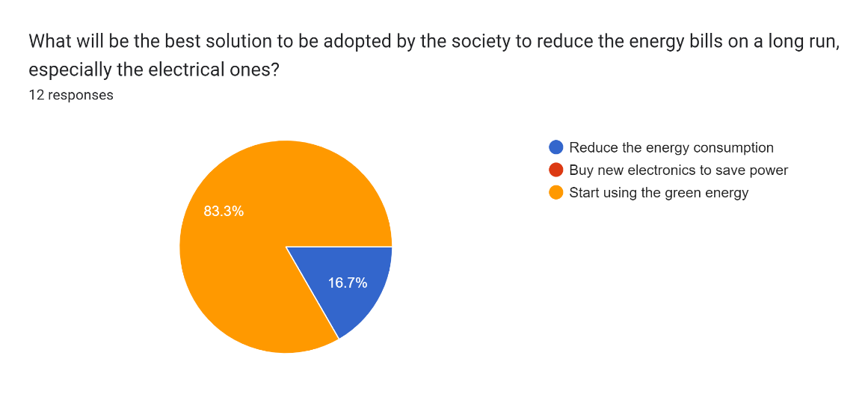
Figure 10

4.3 Discussion of the Data

Exploring the costs of the rising energy bills on electrical consumers is a subject that brough a lot of attention from society in the last year, therefore understanding the causes, effects and future plans for addressing is matter is highly important, also obtaining the real data from the people is another aspect that can help the society (Albers, 2017). The aims of this study was to understand the rising cost of electrical bills, therefore the questionnaire created helped the research to obtain the data required. The information obtain will be able to accomplish the objectives of this study, also provide essential information for the future policy makers and other studies.
As an overall view of the questionnaire results, it can be observed that there is a mixed ideas regarding the high cost of energy bills, also people believed that there was a huge impact on their life the rising cost of the bills.
Looking at why people think is the cause of the high energy bills it can be observed that there are two categories, half of them believe that the war between Russia and Ukraine while on the other half they believe that inflation is the main cause. It can be understood that both of these reasons together had a devastating impact on people’s life.
As discussed further in the questionnaire the people are not convinced by the government help scheme, in the future this leading to people might start to look for green energy option. The use of green energy is the most likely to be used option by the people as 83 percent of the people question agreed to this idea. Governments are expected to implement green energy solutions for the people especially with a low income, as seen from the questionnaire they were the most affected (Raybould et al, 2019).
Moreover, it can be observed that the most affected by the high rise of the energy bills were the people with an income between 20.000 and 30.000 pounds per year. The government help scheme resulted to be effective for only 16 percent of the participants as they rated it with the maximum number of efficiencies leaving the majority of 33.3 percent rating it on the number 3 as efficient, meaning that the scheme might be a solution for only certain people. Concluding that government’s scheme is just temporary solution and further option need to be taken in order to reduce bills price impact on people’s life.
Furthermore, there is 75 percent of the people questioned that believe the energy prices will continue to go up, as per this result people are aware of the energy impact and they are expected to look for alternatives such as green technologies, answer which is also found in the questionnaire with 83% of them stating that they will chose as a future option the green energy. Looking at government further action on this current situation, is expected from it to bring in new perspectives that are focusing on the green energy use, as the people are looking more into using it. As a first action from the government it has to be the spread of awareness between people on how important is the use of green energy in order to reduce the electricity consumption. Likewise, governments should implement policies in order to help the people buy and install new technologies that provide green energy and also provide help for the big manufacturing companies (Bounocore et al, 2019). Then the manufacturing companies can rethink their strategy and start using more green energy and also to produce equipment and devices with less energy consumption. All this together can help people and companies fight the inflation and the high energy prices by opting for more less energy consuming devices and using more sustainable sources of energy.

4.4 Summary
Overall, this chapter highlighted the results of this research that aims to provide a better understanding of the ring cost of energy bills on electrical consumers. The results of the questionnaire shown that there was a mixed opinions regarding the bills, also what is the cause of this high cost and same as the future strategies that should be developed regarding the electrical supply. Additionally, this chapter, provided a discussion of the data collected that helps the study to achieve its objective and answer the questions that the research proposed to answer. To conclude the results of this research shown that participants are aware of the main reason of the high cost of the bills, also have knowledge what will be the future regarding the electricity, therefore the society needs to quickly adapt the energy changes.

Chapter 5 – Conclusion, Limitations and Recommendations

5.1 Introduction
This chapter intends to conclude the research and provide an overall overview of the study, also whether the results have provided enough information to accomplish the objectives and answer the questions of this research paper. Additionally, this chapter will highlight the limitations of this study and provide recommending for the future research.

5.2 Conclusion of the research
Exploring the high of cost of electrical bills is a topic that brought much attention in nowadays society, as it’s cause an economic disequilibrium in people lives, therefore it’s important to examine this issues from all the perspectives. This research aimed to understand the causes that people think that reached to rising cost of electrical bills, also provide solutions to the people in managing those high cost and recommend new strategies to the authorities to develop better plans that aims to target those issues.
The questionnaire developed aimed to collect up to date data from the participants in order to understand their thoughts and what strategies can be implemented to address the issue of the electrical bills. The study used the data obtained and evaluate the results to be able to identify the key ideas of the research topic and these results can influence the society and policy makers to adopt new plans in addressing this matter. Thus, the results had shown that people understand why the bills on electrics are so high, also the participants have shown that are aware of the possible solution in resolving the electricity crisis. This concludes that the research reached its aims, also provides new ideologies that can be developed around this study, especially referring to the understanding of people that the future plans is to use the green energy for the electricity. This makes easier for the society to introduce the sustainable energy as people are willing to change their electricity usage towards the new technology (Zaki et al, 2022).
Furthermore, the results shown that the government temporary help scheme was an ideal solution for the low income people, however this does not address the actual problem of the society. The government should choose a long-term solution for the electricity bills, such as offering programmes that help the people to use the green energy, as this it will be a permanent option in reducing the electricity bills.
Overall, the study explored the high cost of electricity bills by gaining real time data from the society and then analysing these data to obtain the relevant information, thus the research was able to achieve its objectives and answered the questions addressed.

5.3 Limitations of the research
In regards of the limitations that the research faced, it can be said that the limited number of participants was one of the weaknesses of the study as it may not provide data from a wider range of people. Another limitation of this study was the subjectivity of people regarding this issue, especially that this topic is heavily discussed on media their answers may be influenced by it, as people may not further research the causes of risen bills or what are the future trends regarding electricity supply.

5.4 Recommendations
As future recommendations for the researches regarding the electricity bills, it would be interesting to analyse the data obtain from the electrical consumers that are using the green energy. This study will provide a better understand of costs and efficiency of green energy and how can influence the electricity supply.
Another future study would be recommended to analyse the aspect of electricity bills when those costs of bills are balanced and whether is still influencing their social welfare.

5.5 Summary
In conclusion this chapter summarised the results of this study and established that the objectives of the researched were achieved. Also highlighted the limitations encountered during the study and provide recommendation for the future studies.

Reference List

- Albaytaneh, A., Juaidi, A., Abdallah, R., Fernandes, A. and Aglugliaro, G. (2022) ‘Effect of subsidised electrical energy tariff on the residential energy consumption in Jordan’, Energy Reports, 8, pp. 893- 903.
- Albers, M. (2017) ‘Quantitative Data Analysis in the Graduate Curriculum’, Journal of Technical Writing and Communication, 47(2).
- Al-Marri, W., Al-Habaibeh, A. and Abdo, H. (2017) ‘Exploring the Relationship between Energy Cost and Peoples Consumption Behaviour’, Energy Procedia, 105, pp. 3464-3470.
- Apuke, o. (2017) ‘Quantitative Research Methods: A Synopsis Approach’, Arabian Journal of Business and Management Review, 6(11), pp. 40-47.
- Azungah, T. (2018), "Qualitative research: deductive and inductive approaches to data analysis’, Qualitative Research Journal, 18(4), pp. 383-400.
- Bhardwaj, P. (2019) ‘Types of Sampling in Research’s, Statistics, Review Article, 5, pp. 157-63.
- Battistini, N., Nino, V., Dosshe, M. and Kolndrekaj, A. (2022) ‘Energy price and private consumption: what are the channels?’, ECB Economic Bulletin, 3.
- Bounocore, J., Hughes, E., Michanowicz, D., Heo, J., Allen, J. and William, A. (2019) ‘Climate and health Benefits of increasing renewable energy deployment in the United States’, Environmental Research Letter, 14.
- Cacciattolo, M. (2015). Ethical Considerations in Research. In: Vicars, M., Steinberg, S., McKenna, T., Cacciattolo, M. (eds) The Praxis of English Language Teaching and Learning (PELT). Critical New Literacies. SensePublishers, Rotterdam. https://doi.org/10.1007/978-94-6300-112-0_4
- Citizens Advise (2018) ‘ Vulnerable customers and high energy prices’, Available at: Vulnerable consumers and high energy prices.pdf (citizensadvice.org.uk) (Accessed date: 30.08,2022).
- Evans, S. (2022) ‘Analysis: Why UK energy bills are soaring to high records- and how to cut them’, Carbon Brief. Available at: Analysis: Why UK energy bills are soaring to record highs – and how to cut them - Carbon Brief (Accessed date: 25.08.2022).
- Goddard, W. & Melville, S. (2004) “Research Methodology: An Introduction” 2nd edition, Blackwell Publishing.
- Gielen et al, (2019) ‘The role of renewable energy in the global energy transformation’, Energy Strategy Reviews, 24, pp. 38-50.
- Lesic, V., Bruine de Bruin, W., Davis, M., Krishnamurti, T. and ML, I. (2018) ‘Consumers perception on energy use and energy savings: A literature review’, Environmental Research Letters, 13.
- Lorusso, M. (2022) ‘The effect of high energy prices on UK consumers’, Available at: The Effects of High Energy Prices on UK Consumers (ncl.ac.uk) (Accessed date 12.11.2022).
- Muller-Bloch, C. and Kranz, J. (2015) ‘A Framework for Rigorously Identifying Research Gaps in Qualitative Literature Review’, Thirty Sixth International Conference on Information System.
- Muneer, T. and Asif, M. (2007) ’Energy supply, its demand and security issues for developed and emerging economies’, Renewable and Sustainable Energy Reviews, 11(7), pp. 1388-1413.
- Novikov, A.M. and Novikov, D.A. (2013) “Research Methodology: From Philosophy of Science to Research Design” CRC Press
- Islam, M., Nasanuzzaman, M., Rahim, N., Nahar, N. and Hosenuzzaman, M. (2014) ‘Global Renewable Energy – Based electricity Generation and Smart Grid System for Energy, Security’, Scientific World Journal, doi: 10.1155/2014/197136
- Owusu, P. and Sarcodie, S. (2016) ‘A review of renewable energy sources, sustainability issues and climate change mitigation’, CIVIL & ENVIRONMENTAL ENGINEERING | REVIEW ARTICLE, 3.
- Raybould, B., Cheung, W., Connor, C. and Butcher, R. (2019) ‘An investigation into UK Government policy and legislation to renewable energy and greenhouse gas reduction commitments’, Clean Technologies and Environmental Policy, 22, pp. 371-387.
- Saunders, M., Lewis, P. & Thornhill, A. (2012) “Research Methods for Business Students” 6th edition, Pearson Education Limited
- Statista (2022) ‘Monthly average electricity prices based on day-ahead baseload contracts in Great Britain from January 2015 to March 2022’, Available at: • GB: monthly electricity prices 2015-2022 | Statista (28.08.2022).
- Zaki, D. and Hamdy, M. (2022) ‘A Review of Electricity Tariffs and Enabling Solutions for Optimal Energy Management’, Energy, 15, pp.1-17.
- Wahyuni, D. (2012) The Research Design Maze: Understanding Paradigms, Cases, Methods and Methodologies. JAMAR. 10(1).

Appendix

Questionnaire

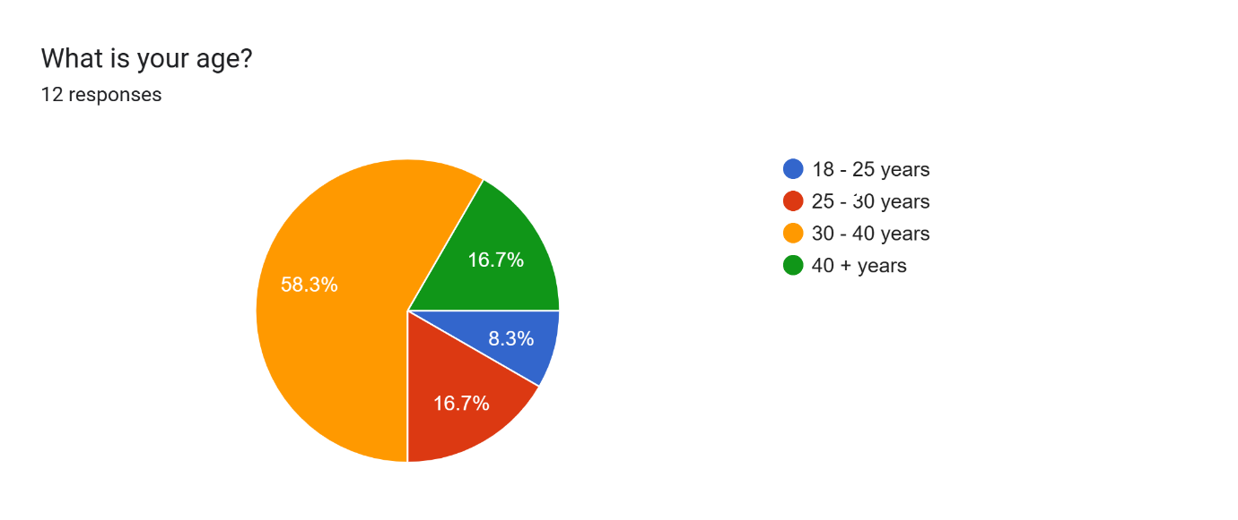
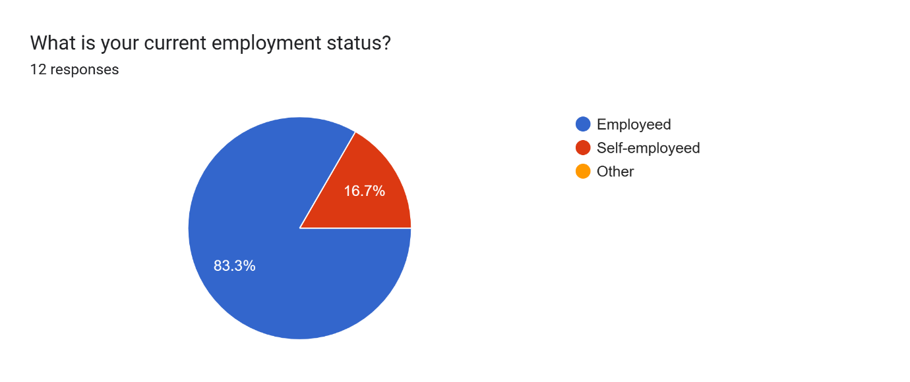
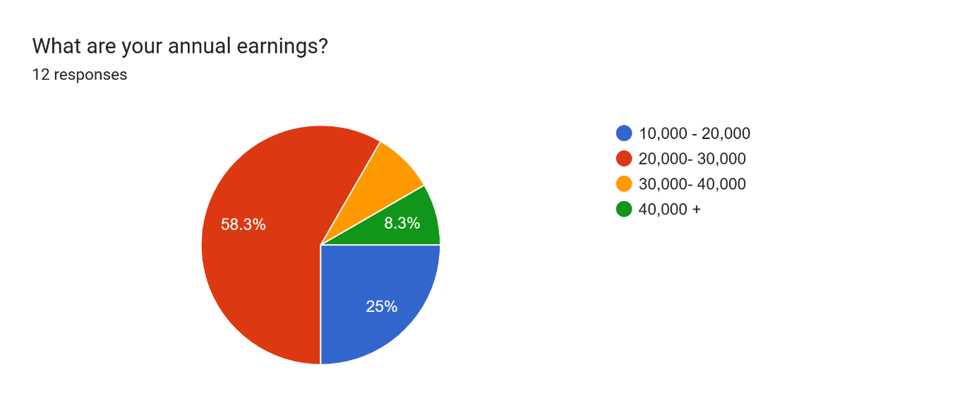
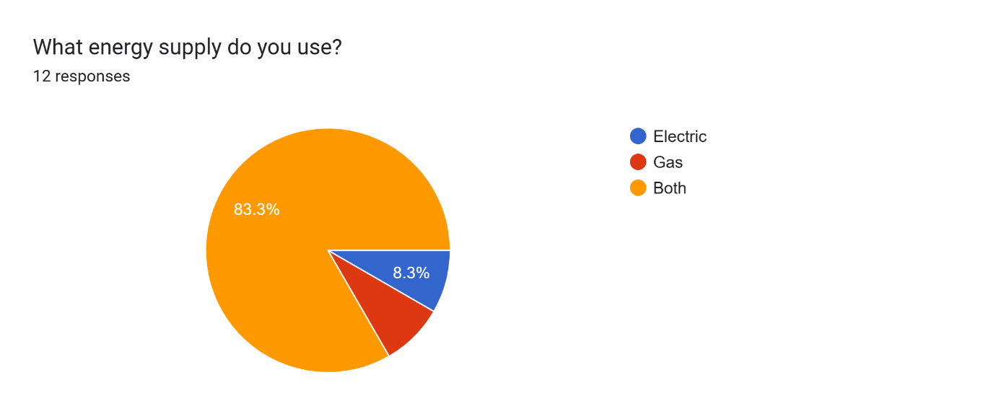
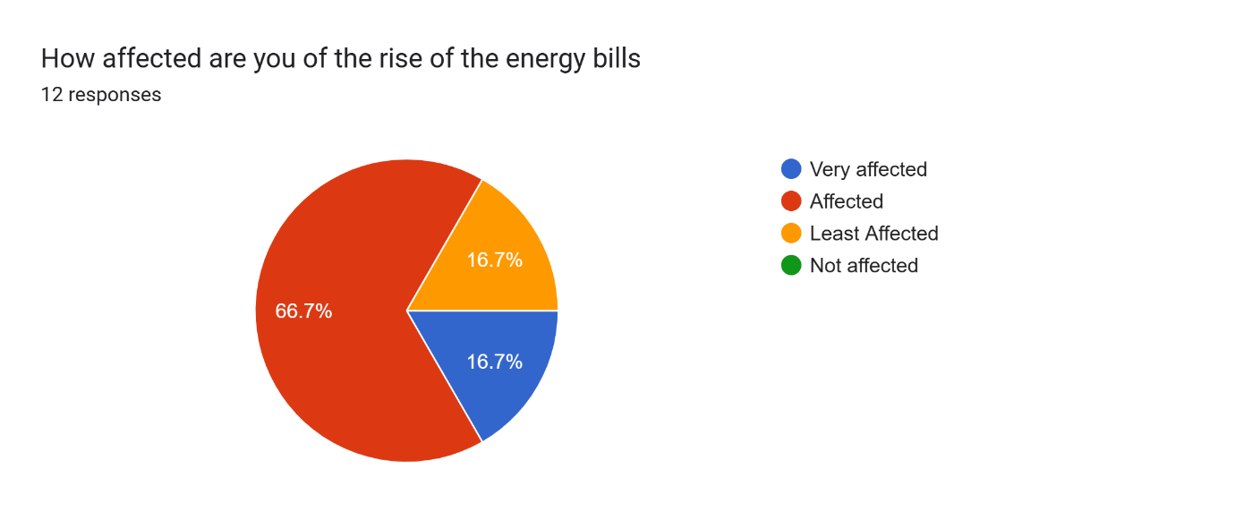
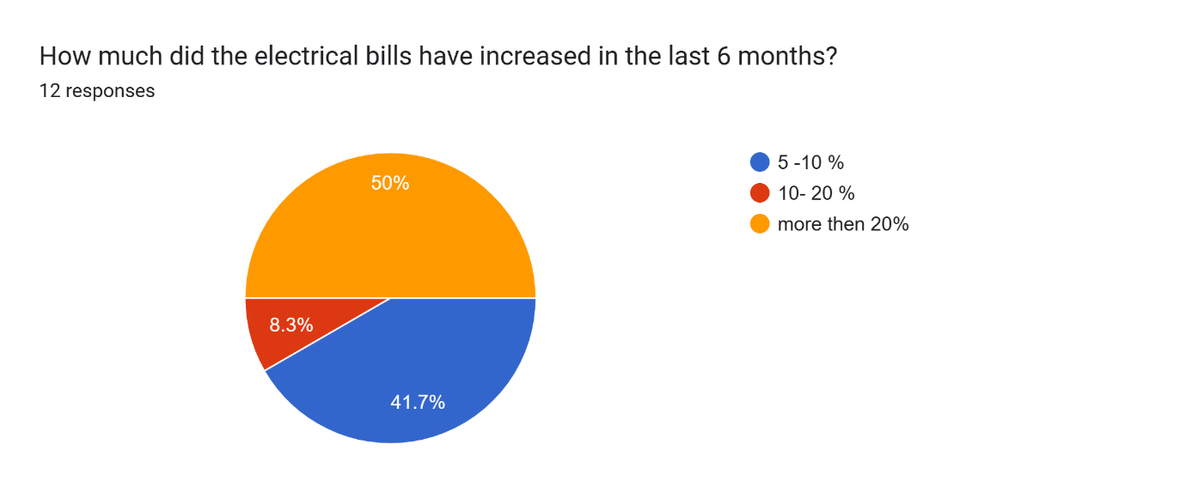
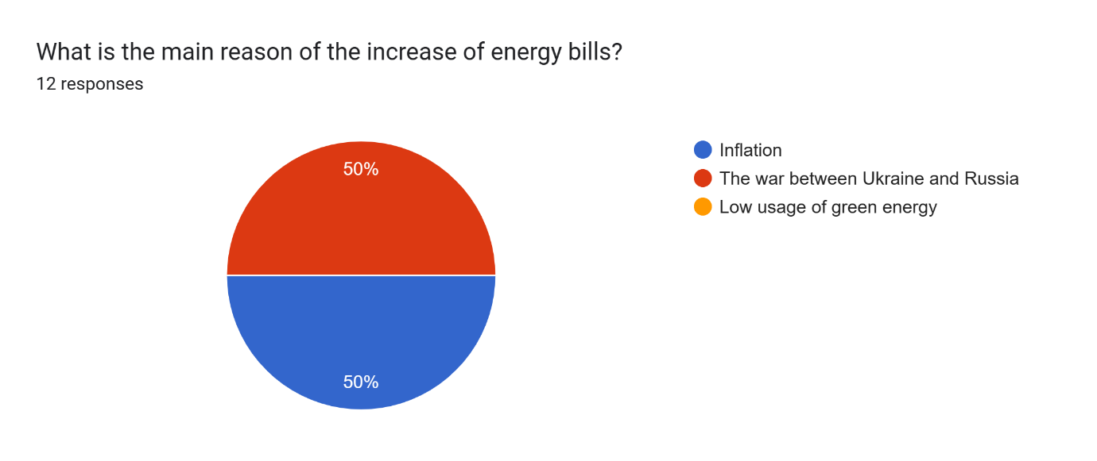
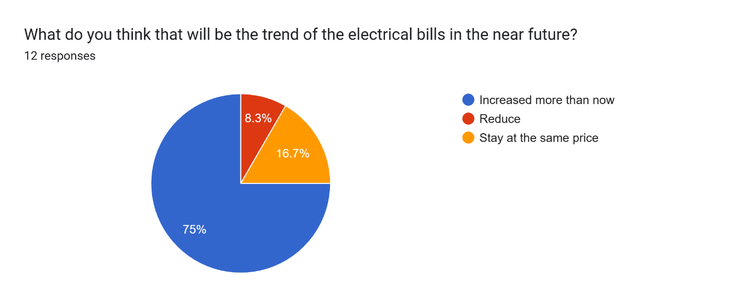
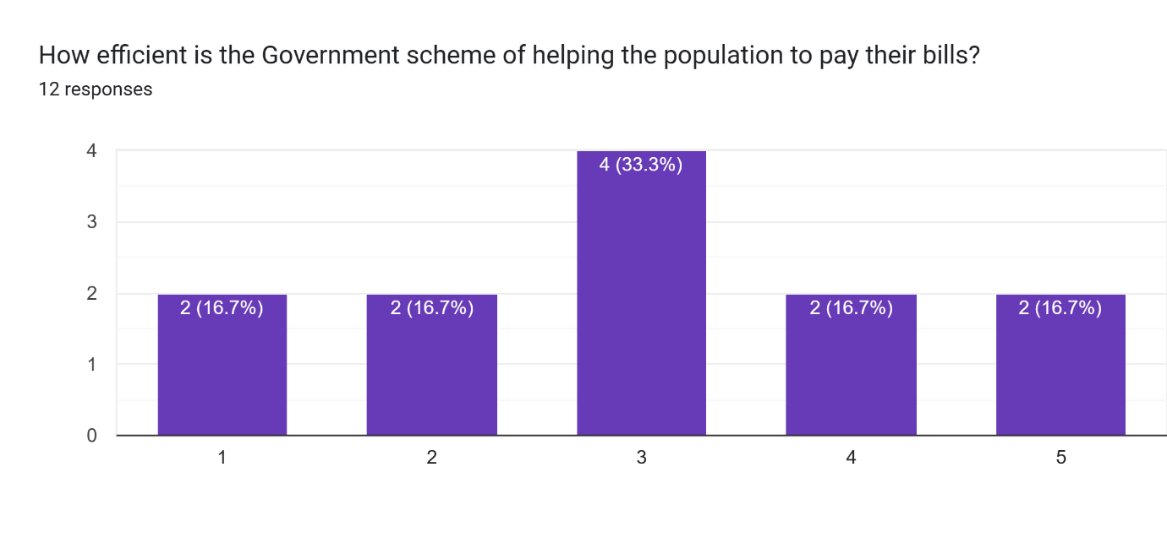
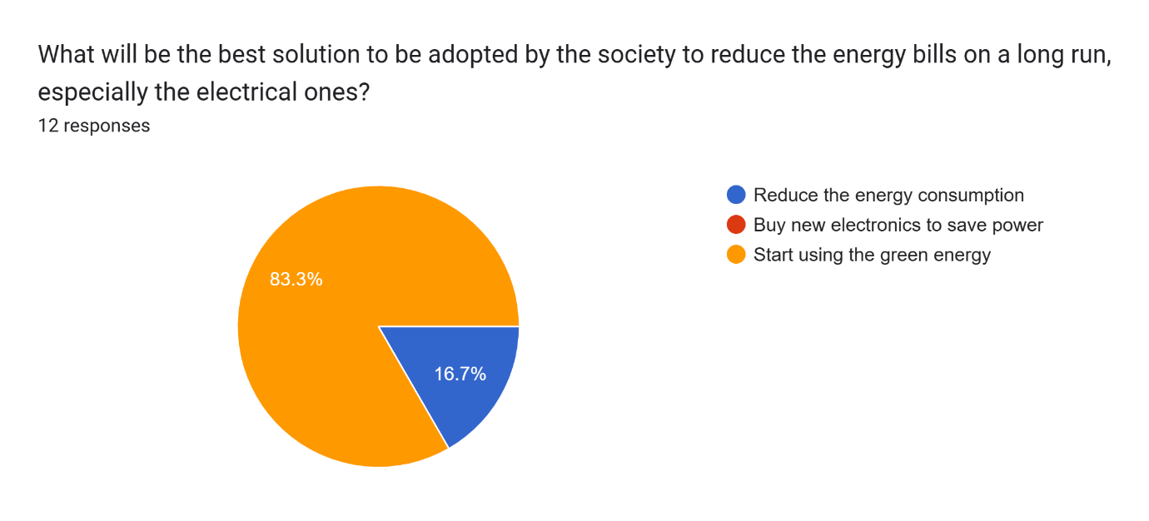

Participant Information Sheet
University of Wales Trinity Saint David (London Campus)
Winchester House
11 Cranmer Road
London – SW9 6EJ
Tel: +442075667600
Email: info.london@tsd.ac.uk
londonstudentservice@tsd.ac.uk


Rhif Adnabod Cyfranogwr:
Participant Identification Number:
FFURFLEN GANIATÂD CYFRANOGIAD | SAMPLE PARTICIPANT INFORMATION SHEET
Teitl Y Prosiect: / Project Title: Exploring the high cost of energy bills on electrical consumers

Dear Sir/Madam,

My name is Alexandru Ionut Stefaroi, and I am a business and management student in the School of Business, Finance and Management (London Campus), Faculty of Business and Management in University of Wales Trinity Saint David, United Kingdom. At present, I am conducting a research on Exploring the high cost of energy bills on electrical consumers. The purpose of this research is to identify the causes of the high cost of electrical bills and identifying possible solutions of reducing the bills in the future.

I would like to invite you to participate in my research project by answering the attached short questions developed by the researchers. Those questions will assess your opinions, experiences, knowledge, suggestions and views. Through your participation in the interviews, I hope to ascertain my research purpose to get the best opinion from you. I believe your opinion will be extremely helpful to me to carry out this research.

All questions will be kept strictly confidential to the researchers involved and at NO time will individual questions will be released to the general public. This gives you a chance to express your views on your programme a confidential and anonymous forum and still be able to make a difference. Your participation in this study is completely voluntary so you can withdraw from the questionnaire at any stage.

Please note, questionnaire should take no more than 30 minutes to complete but however, there is no time constraint. There are also no right or wrong answers. Attached to this letter along with the questionnaire there is a consent form where you will better understand researchers intension As this is a new project, your feedback is also important to me and I would be much obliged if you could also complete the feedback sheet along with the questionnaire. I understand that your time is at a premium, but your opinions are very valuable to me.
After careful and precise analysis of the data obtained from this questionnaires/interviews, I will be happy to provide you with a copy of the findings at your request. The results of this questionnaire will hopefully enhance my understanding of current level of knowledge and future findings. The results of the research will be feedback to Director of Studies, Supervisor, University and British Library.

I thank you in advance for your time and participation. If any questions do arise, feel free to contact me at your convenience.

NAME & ADDRESS OF RESEARCHER

University of Wales Trinity Saint David (London Campus)
Winchester House
11 Cranmer Road
London – SW9 6EJ
Tel: +442075667600
Email: info.london@tsd.ac.uk
londonstudentservice@tsd.ac.uk

Participation Consent Form
University of Wales Trinity Saint David (London Campus)
Winchester House
11 Cranmer Road
London – SW9 6EJ
Tel: +442075667600
Email: info.london@uwtsd.ac.uk
londonstudentservice@uwtsd.ac.uk



Rhif Adnabod Cyfranogwr:
Participant Identification Number:
FFURFLEN GANIATÂD CYFRANOGIAD | PARTICIPATION CONSENT FORM
Teitl Y Prosiect: / Project Title: Exploring high cost of energy bills on electrical consumers
Enw'r Ymchwilydd / Name of Researcher: Alexandru Ionut Stefaroi

1 | I confirm that I have read and understand the information sheet dated 10/11/2022 for the above study. I have had the opportunity to consider the information, ask questions and have had these answered satisfactorily.
2 | I understand that my participation is voluntary and that I am free to withdraw at any time, without giving any reason.
3 | I understand that any information given by me may be used in future reports, articles or presentations by the research team.
4 | I understand that my name will not appear in any reports, articles or presentations.
5 | I agree to take part in the above study.
Name of Participant |  | D.S., R.R. | Signature
Researcher |  | Alexandru Ionut Stefaroi | Signature

You may decline to participate in this study. You may end your participation in this study at any time. If you decide to remain anonymous, maintaining your anonymity will be a priority and every practical precaution will be taken to disguise your identity. If you prefer anonymity, there will not be any identifying information on audiotapes or transcripts of this or any interview. No one will hear any audiotapes or see any transcripts without your prior consent. All materials generated from this or any interview will remain confidential.
When completed please return in the envelope provided. One copy will be given to you and the original to be kept on the file of the research team at:

NAME & ADDRESS OF RESEARCHER

University of Wales Trinity Saint David (London Campus)
Winchester House
11 Cranmer Road
London – SW9 6EJ
Tel: +442075667600
Email: info.london@uwtsd.ac.uk
: londonstudentservice@uwtsd.ac.uk

APPLICATION FOR ETHICAL APPROVAL

In order for research to result in benefit and minimise risk of harm, it must be conducted ethically. A researcher may not be covered by the University’s insurance if ethical approval has not been obtained prior to commencement.

The University follows the OECD Frascati manual definition of research activity: “creative work undertaken on a systematic basis in order to increase the stock of knowledge, including knowledge of man, culture and society, and the use of this stock of knowledge to devise new applications”. As such this covers activities undertaken by members of staff, postgraduate research students, and both taught postgraduate and undergraduate students working on dissertations/projects.

The individual undertaking the research activity is known as the “principal researcher”.

Ethical approval is not required for routine audits, performance reviews, quality assurance studies, testing within normal educational requirements, and literary or artistic criticism.

Please read the notes for guidance before completing ALL sections of the form.

This form must be completed and approved prior to undertaking any research activity. Please see Checklist for details of process for different categories of application.

SECTION A: About You (Principal Researcher)
1 | Full Name: |  | Alexandru Ionut Stefaroi
2 | Tick all boxes that apply: |  | Member of staff: | ☐ | Honorary research fellow: | ☐
 | Undergraduate Student | ☒ | Taught Postgraduate Student | ☐ | Postgraduate Research Student | ☐

3 | Institute/Academic Discipline/Centre: | University of Wales Trinity Saint Davis
4 | Campus: | London
5 | E-mail address:
6 | Contact Telephone Number:
 | For students:
7 | Student Number: | 1914985
8 | Programme of Study: | Bachelor of Arts: Business Management
9 | Director of Studies/Supervisor: | Dr Anupam/ Dr Ofori

SECTION B: Approval for Research Activity
1 | Has the research activity received approval in principle?  (please check the Guidance Notes as to the appropriate approval process for different levels of research by different categories of individual) |  | YES | ☒ | NO | ☐
 |  |  |  |  | Date
2 | If Yes, please indicate source of approval (and date where known): Approval in principle must be obtained from the relevant source prior to seeking ethical approval | Research Degrees Committee |  | ☐
2 |  | Institute Research Committee |  | ☐
2 |  | Other (write in)  Approved by an assigned Dissertation support lecturer |  | ☒ | 10/07/2022

SECTION C: Internal and External Ethical Guidance Materials
 | Please list the core ethical guidance documents that have been referred to during the completion of this form (including any discipline-specific codes of research ethics, location-specific codes of research ethics, and also any specific ethical guidance relating to the proposed methodology). Please tick to confirm that your research proposal adheres to these codes and guidelines. You may add rows to this table if needed.
1 | UWTSD Research Ethics & Integrity Code of Practice | ☒
2 | UWTSD Research Data Management Policy | ☒
3 | [List any other relevant documents here] | ☐

SECTION D: External Collaborative Research Activity
If there are external collaborators then you should gain consent from the contact persons to share their personal data with the university. If there are no external collaborators then leave this section blank and continue to section E.
1 | Institution
2 | Contact person name
3 | Contact person e-mail address
4 | Is your research externally funded? |  | YES | ☐ | NO |  | ☐
5 | Are you in receipt of a KESS scholarship? |  | YES | ☐ | NO |  | ☐
6 | Are you specifically employed to undertake this research in either a paid or voluntary capacity? | Voluntary | YES | ☐ | NO | ☐
7 |  | Employed | YES | ☐ | NO | ☐
8 | Is the research being undertaken within an existing UWTSD Athrofa Professional Learning Partnership (APLP)? | If YES then the permission question below does not need to be answered. | YES | ☐ | NO |  | ☐
9 | Has permission to undertake the research has been provided by the partner organisation? | (If YES attach copy)  If NO the application cannot continue | YES | ☐ | NO |  | ☐

Where research activity is carried out in collaboration with an external organisation
10 | Does this organisation have its own ethics approval system? | YES | ☒ | NO | ☐
 | If Yes, please attach a copy of any final approval (or interim approval) from the organisation (this may be a copy of an email if appropriate).

SECTION E: Details of Research Activity
1 | Indicative title:
2 | Proposed start date: |  | Proposed end date:
Introduction to the Research (maximum 300 words per section)
Ensure that you write for a Non-Specialist Audience when outlining your response to the points below:
Purpose of Research Activity
Proposed Research Question
Aims of Research Activity
Objectives of Research Activity
Demonstrate, briefly, how Existing Research has informed the proposed activity and explain
What the research activity will add to the body of knowledge
How it addresses an area of importance.
3 | Purpose of Research Activity  (this box should expand as you type)
4 | Research Question  (this box should expand as you type)
5 | Aims of Research Activity  (this box should expand as you type)
6 | Objectives of Research Activity  (this box should expand as you type)
Proposed methods (maximum 600 words)
Provide a brief summary of all the methods that may be used in the research activity, making it clear what specific techniques may be used. If methods other than those listed in this section are deemed appropriate later, additional ethical approval for those methods will be needed. You do not need to justify the methods here, but should instead describe how you intend to collect the data necessary for you to complete your project.
7 | (this box should expand as you type)
Location of research activity
Identify all locations where research activity will take place.
8 | (this box should expand as you type)
Research activity outside of the UK
If research activity will take place overseas, you are responsible for ensuring that local ethical considerations are complied with and that the relevant permissions are sought. Specify any local guidelines (e.g. from local professional associations/learned societies/universities) that exist and whether these involve any ethical stipulations beyond those usual in the UK (provide details of any licenses or permissions required). Also specify whether there are any specific ethical issues raised by the local context in which the research activity is taking place, for example, particular cultural and/or legal sensitivities or vulnerabilities of participants. If you live in the country where you will do the research then please state this.
9 | (this box should expand as you type)

10 | Use of documentation not in the public domain: Are any documents NOT publicly available? | NO | ☒
10 |  | YES | ☐
11 | If Yes, please provide details here of how you will gain access to specific documentation that is not in the public domain and that this is in accordance with the current data protection law of the country in question and that of England and Wales.  (this box should expand as you type)

 | Does your research relate to one or more of the seven aims of the Well-being of Future Generations (Wales) Act 2015? | YES | NO
12 | A prosperous Wales | ☐ | ☒
13 | A resilient Wales | ☐ | ☒
14 | A healthier Wales | ☐ | ☒
15 | A more equal Wales | ☐ | ☒
16 | A Wales of cohesive communities | ☐ | ☒
17 | A Wales of vibrant culture and thriving Welsh language | ☐ | ☒
18 | A globally responsible Wales | ☐ | ☒
19 | If YES to any of the above, please give details:
 | (this box should expand as you type)

SECTION F: Scope of Research Activity
 | Will the research activity include: | YES | NO
1 | Use of a questionnaire or similar research instrument? | ☒ | ☐
2 | Use of interviews? | ☐ | ☒
3 | Use of focus groups? | ☐ | ☒
4 | Use of participant diaries? | ☐ | ☒
5 | Use of video or audio recording? | ☐ | ☒
6 | Use of computer-generated log files? | ☐ | ☒
7 | Participant observation with their knowledge? | ☐ | ☒
8 | Participant observation without their knowledge? | ☐ | ☒
9 | Access to personal or confidential information without the participants’ specific consent? | ☐ | ☒
10 | Administration of any questions, test stimuli, presentation that may be experienced as physically, mentally or emotionally harmful / offensive? | ☐ | ☒
11 | Performance of any acts which may cause embarrassment or affect self-esteem? | ☐ | ☒
12 | Investigation of participants involved in illegal activities? | ☐ | ☒
13 | Use of procedures that involve deception? | ☐ | ☒
14 | Administration of any substance, agent or placebo? | ☐ | ☒
15 | Working with live vertebrate animals? | ☐ | ☒
16 | Procedures that may have a negative impact on the environment? | ☐ | ☒
17 | Other primary data collection methods. Please indicate the type of data collection method(s) below. | ☐ | ☒
 | Details of any other primary data collection method:  (this box should expand as you type) | ☐ | ☒
If NO to every question, then the research activity is (ethically) low risk and may be exempt from some of the following sections (please refer to Guidance Notes).

If YES to any question, then no research activity should be undertaken until full ethical approval has been obtained.

SECTION G: Intended Participants
If there are no participants then do not complete this section, but go directly to section H.

 | Who are the intended participants: | YES | NO
1 | Students or staff at the University? | ☒ | ☐
2 | Adults (over the age of 18 and competent to give consent)? | ☒ | ☐
3 | Vulnerable adults? | ☐ | ☒
4 | Children and Young People under the age of 18? (Consent from Parent, Carer or Guardian will be required) | ☐ | ☒
5 | Prisoners? | ☐ | ☒
6 | Young offenders? | ☐ | ☒
7 | Those who could be considered to have a particularly dependent relationship with the investigator or a gatekeeper? | ☐ | ☒
8 | People engaged in illegal activities? | ☐ | ☒
9 | Others. Please indicate the participants below, and specifically any group who may be unable to give consent. | ☐ | ☒
 | Details of any other participant groups:  (this box should expand as you type) | ☐ | ☒

Participant numbers and source
Provide an estimate of the expected number of participants. How will you identify participants and how will they be recruited?
10 | How many participants are expected? | 20
11 | Who will the participants be? | Students and friends from social media  (this box should expand as you type)
12 | How will you identify the participants? | n/a  (this box should expand as you type)

 | Information for participants: | YES | NO | N/A
13 | Will you describe the main research procedures to participants in advance, so that they are informed about what to expect? | ☒ | ☐ | ☐
14 | Will you tell participants that their participation is voluntary? | ☒ | ☐ | ☐
15 | Will you obtain written consent for participation? | ☐ | ☐ | ☒
16 | Will you explain to participants that refusal to participate in the research will not affect their treatment or education (if relevant)? | ☒ | ☐ | ☐
17 | If the research is observational, will you ask participants for their consent to being observed? | ☐ | ☐ | ☒
18 | Will you tell participants that they may withdraw from the research at any time and for any reason? | ☒ | ☐ | ☐
19 | With questionnaires, will you give participants the option of omitting questions they do not want to answer? | ☒ | ☐ | ☐
20 | Will you tell participants that their data will be treated with full confidentiality and that, if published, it will not be identifiable as theirs? | ☒ | ☐ | ☐
21 | Will you debrief participants at the end of their participation, in a way appropriate to the type of research undertaken? | ☐ | ☐ | ☒
22 | If NO to any of above questions, please give an explanation
 | (this box should expand as you type)

 | Information for participants: | YES | NO | N/A
24 | Will participants be paid? | ☐ | ☒ | ☐
25 | Is specialist electrical or other equipment to be used with participants? | ☐ | ☒ | ☐
26 | Are there any financial or other interests to the investigator or University arising from this study? | ☐ | ☒ | ☐
27 | Will the research activity involve deliberately misleading participants in any way, or the partial or full concealment of the specific study aims? | ☐ | ☒ | ☐
28 | If YES to any question, please provide full details
 | (this box should expand as you type)

SECTION H: Anticipated Risks

Outline any anticipated risks that may adversely affect any of the participants, the researchers and/or the University, and the steps that will be taken to address them.

If you have completed a full risk assessment (for example as required by a laboratory, or external research collaborator) you may append that to this form.
1 | Full risk assessment completed and appended? |  | Yes | ☐
1 |  |  | No | ☒
2 | Risks to participants  For example: sector-specific health & safety, emotional distress, financial disclosure, physical harm, transfer of personal data, sensitive organisational information
 | Risk to participants:  (this box should expand as you type) | How you will mitigate the risk to participants:  (this box should expand as you type)
3 | If research activity may include sensitive, embarrassing or upsetting topics (e.g. sexual activity, drug use) or issues likely to disclose information requiring further action (e.g. criminal activity), give details of the procedures to deal with these issues, including any support/advice (e.g. helpline numbers) to be offered to participants. Note that where applicable, consent procedures should make it clear that if something potentially or actually illegal is discovered in the course of a project, it may need to be disclosed to the proper authorities
 | (this box should expand as you type)
4 | Risks to the investigator  For example: personal health & safety, physical harm, emotional distress, risk of accusation of harm/impropriety, conflict of interest
 | Risk to the investigator:  (this box should expand as you type) | How you will mitigate the risk to the investigator:  (this box should expand as you type)
5 | University/institutional risks  For example: adverse publicity, financial loss, data protection
 | Risk to the University:  (this box should expand as you type) | How you will mitigate the risk to the University:  (this box should expand as you type)
6 | Environmental risks  For example: accidental spillage of pollutants, damage to local ecosystems
 | Risk to the environment:  (this box should expand as you type) | How you will mitigate the risk to environment:  (this box should expand as you type)

 | Disclosure and Barring Service
 | If the research activity involves children or vulnerable adults, a Disclosure and Barring Service (DBS) certificate must be obtained before any contact with such participants. | YES | NO | N/A
7 | Does your research require you to hold a current DBS Certificate? | ☐ | ☐ | ☐
8 | If YES, please give the certificate number. If the certificate number is not available please write “Pending”; in this case any ethical approval will be subject to providing the appropriate certificate number.

SECTION I: Feedback, Consent and Confidentiality

1 | Feedback  What de-briefing and feedback will be provided to participants, how will this be done and when?
 | (this box should expand as you type)
2 | Informed consent  Describe the arrangements to inform potential participants, before providing consent, of what is involved in participating. Describe the arrangements for participants to provide full consent before data collection begins. If gaining consent in this way is inappropriate, explain how consent will be obtained and recorded in accordance with prevailing data protection legislation.
 | (this box should expand as you type)
3 | Confidentiality / Anonymity  Set out how anonymity of participants and confidentiality will be ensured in any outputs. If anonymity is not being offered, explain why this is the case.
 | (this box should expand as you type)

SECTION J: Data Protection and Storage

 | Does the research activity involve personal data (as defined by the General Data Protection Regulation 2016 “GDPR” and the Data Protection Act 2018 “DPA”)? | YES | NO
1 | “Personal data” means any information relating to an identified or identifiable natural person (‘data subject’). An identifiable natural person is one who can be identified, directly or indirectly, in particular by reference to an identifier such as a name, an identification number, location data, an online identifier or to one or more factors specific to the physical, physiological, genetic, mental, economic, cultural or social identity of that natural person. Any video or audio recordings of participants is considered to be personal data. | ☐ | ☐x
 | If YES, provide a description of the data and explain why this data needs to be collected:
2 | (this box should expand as you type)
 | Does it involve special category data (as defined by the GDPR)? | YES | NO
3 | “Special category data” means sensitive personal data consisting of information as to the data subjects’ –  (a) racial or ethnic origin,  (b) political opinions,  (c ) religious beliefs or other beliefs of a similar nature,  (d) membership of a trade union (within the meaning of the Trade Union and Labour Relations (Consolidation) Act 1992),  (e) physical or mental health or condition,  (f) sexual life,  (g) genetics,  (h) biometric data (as used for ID purposes), | ☐ | ☐x
 | If YES, provide a description of the special category data and explain why this data needs to be collected:
4 | (this box should expand as you type)

 | Will data from the research activity (collected data, drafts of the thesis, or materials for publication) be stored in any of the following ways? | YES | NO
5 | Manual files (i.e. in paper form)? | ☐ | ☐
6 | University computers? | ☐ | ☐
7 | Private company computers? | ☐ | ☐
8 | Home or other personal computers? | ☐ | ☐
9 | Laptop computers/ CDs/ Portable disk-drives/ memory sticks? | ☐ | ☐
10 | “Cloud” storage or websites? | ☐ | ☐
11 | Other – specify: | ☐ | ☐
12 | For all stored data, explain the measures in place to ensure the security of the data collected, data confidentiality, including details of backup procedures, password protection, encryption, anonymisation and pseudonymisation:
 | (this box should expand as you type)

 | Data Protection
 | Will the research activity involve any of the following activities: | YES | NO
13 | Electronic transfer of data in any form? | ☐ | ☐
14 | Sharing of data with others at the University outside of the immediate research team? | ☐ | ☐
15 | Sharing of data with other organisations? | ☐ | ☐
16 | Export of data outside the UK or importing of data from outside the UK? | ☐ | ☐
17 | Use of personal addresses, postcodes, faxes, emails or telephone numbers? | ☐ | ☐
18 | Publication of data that might allow identification of individuals? | ☐ | ☐
19 | Use of data management system? | ☐ | ☐
20 | Data archiving? | ☐ | ☐
21 | If YES to any question, please provide full details, explaining how this will be conducted in accordance with the GDPR and Data Protection Act (2018) (and any international equivalents, where appropriate):
 | (this box should expand as you type)
22 | List all who will have access to the data generated by the research activity:
 | (this box should expand as you type)
23 | List who will have control of, and act as custodian(s) for, data generated by the research activity:
 | (this box should expand as you type)
24 | Give details of data storage arrangements, including security measures in place to protect the data, where data will be stored, how long for, and in what form. Will data be archived – if so how and if not why not.
 | (this box should expand as you type)
25 | Please indicate if your data will be stored in the UWTSD Research Data Repository (see https://researchdata.uwtsd.ac.uk/ ). If so please explain. (Most relevant to academic staff)
 | (this box should expand as you type)
26 | Confirm that you have read the UWTSD guidance on data management (see https://www.uwtsd.ac.uk/library/research-data-management/) | YES | ☐
27 | Confirm that you are aware that you need to keep all data until after your research has completed or the end of your funding | YES | ☐

SECTION K: Declaration
The information which I have provided is correct and complete to the best of my knowledge. I have attempted to identify any risks and issues related to the research activity and acknowledge my obligations and the rights of the participants.

In submitting this application I hereby confirm that I undertake to ensure that the above named research activity will meet the University’s Research Ethics and Integrity Code of Practice which is published on the website: https://www.uwtsd.ac.uk/research/research-ethics/
1 | Signature of applicant: |  | Date: 13.01.2023

For STUDENT Submissions:
2 | Director of Studies/Supervisor: | Dr Anumpams Mazumdar/ Dr Dudley Ofori | Date:
3 | Signature: |  | Date:

For STAFF Submissions:
4 | Academic Director/ Assistant Dean: |  | Date:
5 | Signature: |  | Date:

Checklist: Please complete the checklist below to ensure that you have completed the form according to the guidelines and attached any required documentation:
☒ | I have read the guidance notes supplied before completing the form.
☒ | I have completed ALL RELEVANT sections of the form in full.
☒ | I confirm that the research activity has received approval in principle
☐ | I have attached a copy of final/interim approval from external organisation (where appropriate)
☐ | I have attached a full risk assessment (where appropriate) ONLY TICK IF YOU HAVE ATTACHED A FULL RISK ASSESSMENT
☒ | I understand that it is my responsibility to ensure that the above named research activity will meet the University’s Research Ethics and Integrity Code of Practice.
☒ | I understand that before commencing data collection all documents aimed at respondents (including information sheets, consent forms, questionnaires, interview schedules etc.) must be confirmed by the DoS/Supervisor, module tutor or Academic Director.

RESEARCH STUDENTS AND STAFF ONLY
All communications relating to this application during its processing must be in writing and emailed to pgresearch@uwtsd.ac.uk , with the title ‘Ethical Approval’ followed by your name.
You will be informed of the outcome of your claim by email; therefore it is important that you check your University and personal email accounts regularly.
STUDENTS ON UNDERGRADUATE OR TAUGHT MASTERS PROGRAMMES should submit this form (and receive the outcome) via systems explained to you by the supervisor/module leader.

This form is available electronically from the Academic Office web pages: https://www.uwtsd.ac.uk/academic-office/appendices-and-forms/

