Student: Camelia Ungureanu 1816236

COACHING and MENTORING
SKILLS FOR THE WORKPLACE
Executive Summary
Coaching, as well as mentoring, is an important process of teaching students with particular knowledge of subjects in a respective manner. Both two entities of coaching and mentoring are entitled to several learning interrogations as per organizational fields of context similarly. Critical evaluation of mentoring and steps of coaching is observed and differentiated as per merits and demerits respectively. Whereas, theories of Clutter-back styles related to four motives of helping in nature under coaching objectives are also used to demonstrate the character as well its purposes. However, tangible as well as non-tangible coaching benefits related to employer and also employee mentoring are taken into consideration to make the processes more sustainable. Thus, effective change type of management and its resilience is also established in this report after the Clutter-back rule with a perfect term briefing and evaluation is entitled. Gibb's reflection type of cycle is used as a framework based on which the whole scenario depends. The different types of skills needed for mentoring and tutoring are also discussed in the particular report which results in a positive outcome in the coming future and promotes the usage in a potentially advanced manner. Thus, the respective positive results will help every new person to get reliable and safe experiences easily for mentoring and coaching guidance respectively.

Table of Contents
Introduction 4
Main Findings 4
References 15

Introduction
Here, in this report, mentorship and tutoring, as well as coaching skills are used as a topic to be a focus in several manners considering the future of the students in development structure as well. The Gibbs model is also used for creating an effective method of learning structure in demand by the customer similarly. The standards, ethics, work criteria, and other factors also change a tutor to a perfect coach in a specific manner. Students gain perfect knowledge from a good teacher having experience gathered from teaching in international schools similarly (Turner and Hawkins, 2018). There is various effectiveness in all findings observed similarly and thus creates a major event with relation to organizational context simultaneously. An increase in mentoring methods, among workplaces, is empanelled when the other similar structures are impacted thoroughly as per heavy methods effectively applied in the particular workplace. This in turn increases the growth and development as per the critical findings that occurred in the whole era similarly. The tutors are termed as coaches and increase their knowledge easily and respectively taught the person easy ways of memorizing things as well. Thus, mentors and coaches are not the same people in a particular field similarly. Both are reserving and teaching a person with new techniques to survive but not serving in a similar manner.

Main Findings
Coaching is an important skill or structure of a particular entity with the help of which the detailed intervention regarding learning is entertained in a major manner. The coaching is defined in a very easy manner consisting of the ways and a development type of form with the help of which any person who was already experienced is termed as a coach similarly. In addition to this, the coach itself supports a leader who may become a learner in gathering or achieving the professional type of goal along with specific types of personnel are learned by the guidance in form of training similarly (Hamilton, et al. 2020). Various types of models of coaching are fond art performance, success type of coaching, and leadership type of coaching development differently. For example, Education coaching is freely practiced in a major way to improve the education and knowledge level of students in simple ways.
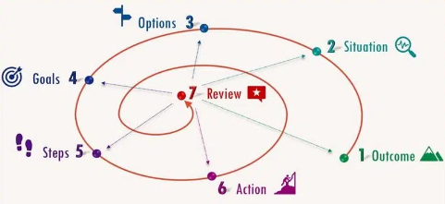
Figure 1: Steps of coaching levels
(Source: Jia, et al. 2020)
The above figure has the observations of several seven stages or steps related to coaching illustrated properly in a simultaneous manner. The steps are also termed as the first one is the outcome of any knowledge should be good and situation handling should be taught respectively in major ways. Various options of knowledge areas selection to be given or to be chosen by the students for effective usage should be enhanced easily. The fourth stage is also termed as goals which need to be set out easily and the coach should also force every player to fix their own goals in mind structure and never get missed whatever happens during the game as well (Julia, et al. 2020). Coaching also uses a technique in making a person ready to meet competitive exams as well as its effective strategies in a respective manner. There is leadership maintains seven stages of coaching are as follows: outcome, goals, situational, reviews, steps, the type spiral, and Action similarly.
Mentoring is also an important factor in knowledge gain and potential development in a similar manner. In addition to this, mentoring itself is a type of relationship that is protected in nature and barely supports experimentation as well as learning and on other hand helped several individuals with the potential factors to develop easily. In this process, both mentors, as well as mentees, have a vital need for their type of development (Ryder, and Downs, 2022). However, successful mentoring is observed in confidentiality as well as trust in similar ways. For example, mentoring is doing an individual job in a specific shadow in a respective manner.
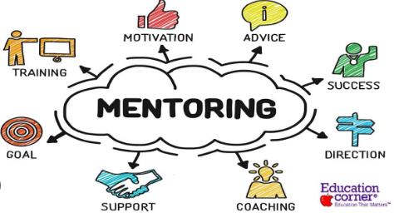
Figure 2: Mentoring process in Organizations
(Source: Cooper, et al. 2019)
There are keys available differences in coaching as well as mentoring similarly are:
- Coaching is a type of expert help to an individual trainee as a matter of performance improvement, whereas, mentoring creates a specific activity where a single person itself guides a second person in a similar method of usage.
- Whereas coaching is situated as a task-oriented concern but mentoring has a process of driving or making relationships in a major manner.
- Coaching continues for a time frame in shorter periods and on the other hand, mentoring carries up to longer time frames as well.
- Mentoring is not a well-structured teaching process whereas coaching is a well-structured and properly planned process of teaching steps (Loft-house, 2019).
- Coach always trains as a coach and on the other side mentor is termed as the mentoring process of teaching similarly.
- Coaching only focuses on building the improvement of individual performance and on the other hand, Mentoring provides career development with the full and overall growth of the whole employee simultaneously.
Tangible benefits occurring in terms of coaching and mentoring are related to cash vouchers, merchandise benefits, and gift vouchers as well but the intangible benefits are concerning employee management in stress, and employee engagement program involvement (Julia, et al. 2020).
Line managers are also schematic structural mannered staff in the respective managerial level higher than the working staff. The various works Performa by managers are inclusive of the below-mentioned activities:
- Dealing daily with customers as well as clients.
- Daily management of per day wages of people is necessary to be managed.
- Technical presence for super expertise activities will also need to perform ethical terms in advance.
- Quality checks are performed and work-level monitoring is also done accordingly.
- Rotational work schemes and allocated work environments will make the work values interesting respectively.
- Operational costs should be manageable in a similar manner.
The benefits of line managers are also important in terms of making the effects linearly. The manner of line managers for operation is creating vast effects in the technological manner of bonding as well (Bachkirova, et al. 2021). Line managers' involvement will enhance the stress level improvement in the team level of work performed as well. Their whole-time support to their respective team will make the team work efficiently without any tension respectively as line managers are termed as gatekeepers for all lower stages of staff problems in major ways.
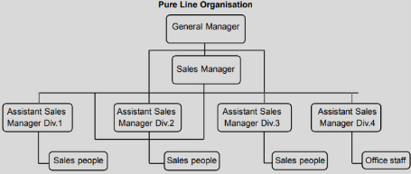
Figure 3: Line manager process in Organization
(Source: Burgess, et al. 2018)
The above figure shows the line managers' series and table of confrontation in an easy manner. Different numbers of assistant managers are taken into consideration under these line managers respectively. There are various types of drawbacks under the line action of an organization having a lack of Coordination type of techniques, excess types of advertisements, lack of specific specialization concerning services as well, lack of individual initiative, and unstable performances as well which need to be measured and minimized (Sekerin, et al. 2018). Various skills such as efforts on particular abilities are emphasized, feedback as per the front and back movement as considered and empanelled, always help together with a method of maintaining time and its management structures in a similar manner. Feedback should be followed and accomplishments taken should be based on celebration respectively under practices of coaching as well as mentoring processes (Burgess, et al. 2018).
Resilience type of coaching, as well as mentoring, is a similar matter of focus on the motive of building assets for the personal manner of usage respectively. Thus, resilience skills can be built with a growth process as a growth structure that needs to be made abundant in nature. The coaching process under the method of resilience is a form of ability for adapting and reacting as per life challenges and then easily turn into the momentum of front areas with a motive to achieve goals achievement (Waldren, et al. 2021). In addition to this, resilience is made up of five factors in major ways Self-caring, Particular purposes, Mindfulness as well as Self-aware, and relationship in a positive manner.
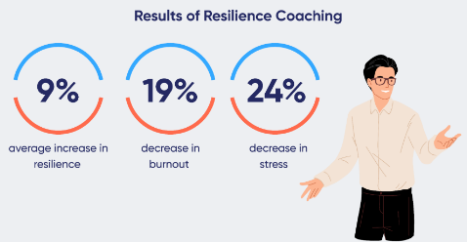
Figure 4: Role and results of resilience in the workforce
(Source: Chen, et al. 2018)
Change management is also a major event in making coaching a successful method of potential advancement. In coaching, this management is also named as change coaching in leadership manner which helps to manage and cope with strengths and weaknesses of the leader and then apply new chances of changing the environment of workforce changes in respect to place as well.
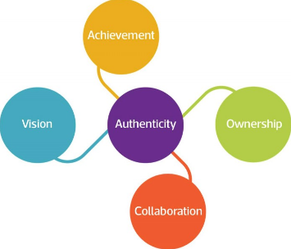
Figure 5: Role of mentoring during change management
There are different types, as well as five types of change management techniques evolved for adaptive and evaluation techniques, which are technologies, social work culture, environment structure, technologies and political influences, and economical phenomenon. The existing drivers in the force of the marketplace for work are taken into consideration are social and technological factors similarly. The emerging factors in the growth structure are political and economic techniques in a major manner (Hund, et al. 2018). This makes the environment happy and coaching as well as mentoring will become more after and easier in manner. The poor type of workforce management is taken into consideration to make effective decisions and similarly make values. Hence, the impact on the respective workforce is reduced in the terms of usage to demands of regular ethics and ethnicity as well. Various impacts are occurring during the start of the mentoring and coaching process but after the change management is used the impacts have been reduced to a greater extent nowadays (Sterk, et al. 2022).
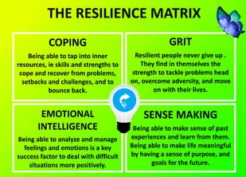
Figure 6: Resilience building during change management
(Source: Baker, et al. 2021)
Building resilience is an important structure of the workforce in several ways but the main effects are observed effectively in the methods of change management concerning workforce potential advancement as a coaching objective. In addition to this, resilience increases the chances of self-confidence increase and control of events relating to life, improving relations between employee and employer in several ways after mentoring the person individually (Padek, et al. 2018). For example, the Corona pandemic has shown various faces of murmured manner. The Hong Kong companies in the stake market have rebounded in the form of offering services to customers who are already stakeholders and have been informed about the issue earlier. An atonal firm in Spain has respectively manufactured masks and sanitizers for the patients and ICU units which helped as a mentor in that difficult situation (Browne, 2021). This company has a thermal power plant but rather it is operative for effective migration from the pandemic as soon as possible to help more persons by coaching methods respectively.
According to the views of having a Coach, I have the view of teaching football; games to the students who are best in football and all are ready to build up the whole scenario in a winning position. These students are brighter in every season and always shaping their body structure and will remain motivated in the factors of minimizing the issues as well. As an executive coach the responsibility of winning every team member to the match is very important and matters, otherwise shame of responsibilities is observed similarly to my capabilities (Turner and Hawkins, 2018). Thus, the effects of the own criteria are to be maintained in reflective model usage similarly.
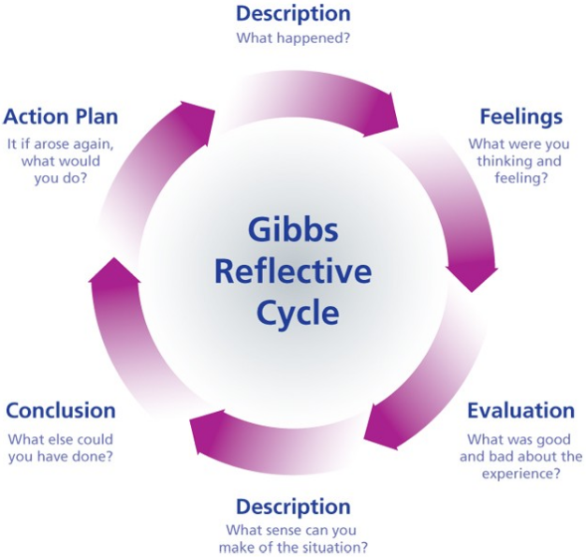
Figure 7: Gibbs model of Reflection.
(Source: Created by Learner)
The model of Gibbs's reflection is used similarly to enhance the work issues and their effects respectively. The six stages similarly consist of the reflective cycle to increase the work structure and potential development effectively respectively (Oscar, 2020). The particular model of reflection is taken into consideration for effective results and nominal investments in the respective planning structure as well. As per the Gibbs model, the six stages are descriptive nature, feeling type, evaluation techniques, again a description of values, and Action Plan related to lastly conclusion in a respective manner.

Personal Developed plan

Reflection

According to the vision of being a coach in the classroom exercise, I understood that being a coach is not only about solving the problem, but it means listening to your coach, empathizing with him, trying to find the problem with a few different questions, and finally, to you find a solution to the problem. In my coaching exercise, I had to help my coach Ionela, who was unsure about my proposal to be a manager. She had a little trouble with some of her classmates because she was younger than them, and they had the language barrier. After a few questions, I got her to tell them how she felt when they were rude to her, suggested she talk to them during breaks, and if they didn't cooperate move them to different groups. In the end I gave her another week to think about my proposal.

The model of Gibbs reflection is used in a similar manner to enhance with the work issues and its effects in a respective manner. There are six stages that consist of the reflective cycle in a similar manner to increase the work structure and potential development in an effective manner respectively (Oscar, 2020). Particular model of reflection is taken into consideration for effective results and nominal investments in the respective planning structure as well. As per the Gibbs model the six stages are descriptive nature, feeling type, evaluation techniques, again description of values and Action Plan related to lastly conclusion in a respective manner.

Personal Development Plan

What do I want/need to learn? | What will I do to achieve this? | What resources or support will I need? | What will my success criteria be? | Target dates for review and completion
Show more of my positive attributes and redirect negative reactions. | - Do not mentally disengage  - Ask, is this my best work.  - How I perceived in this moment?  - Remind myself that sometimes it is better to say nothing. | Professional supports from the university professors. | - Mental balance  - Best work practice  - Thinking and reflection on the impact.  - Analyze and then say anything. | 5 days
Work on effectively communicating my ideas and showing empathy. | - Light some fires use some context to set up the potential impacts | Team discussions and data | - Potential experiences aging the same field | 5 days
Create more frequent visibility and interaction with executives | - Regional leader, sales execs  - Bring big ideas to them.  - Declare my interest in taking the next step. | Executives meetings as a trial practices | - Sales experiences  - Big ideas innovation  - New step involvement. | 6 days
Strengthen my brand | - Creating opportunities for strategic initiative  - Leverage the team for transformational change. | Team support , professional supports | - Development of strategic ideas.  - Transformational change in similar ways. | 7 days
Conclusion
Here in this report, it is concluded that the coach it self trains the students for games and whereas meteor guides the student for their respective career growth as well. Thus, the effects of time management are seen in monitoring the particular student for the view or motive of making a vast and beautiful career for the respective students in a similar manner. The Gibbs reflection model is also used in the form of reflection theories to create a positive impact concerning bringing more cultural and respective changes in a major manner. The confrontation is taken into the matter for omissions as well as its resilience impacts on Coaching and also mentoring respectively. Hence, mentoring creates a positive impact on the students of universities in a measured way. Coaching has profound adverse effects on the minds in the form of techniques of teaching new structural methods in future advancement to make a better effective work environment.

References
ADOM, D., 2022. Personal Reflection on Practice as a Basic and Senior High School Teacher Using Gibbs Refective Model: Universal Design for Learning (UDL) in Focus. Reach, 35(1).
Bachkirova, T., Jackson, P. and Clutterbuck, D., 2021. Coaching and Mentoring Supervision: Theory and Practice, 2e. McGraw-Hill Education (UK).
Baker, E.L., Hengelbrok, H., Murphy, S.A. and Gilkey, R., 2021. Building a coaching culture—the roles of coaches, mentors, and sponsors. Journal of Public Health Management and Practice, 27(3), pp.325-328.
Browne, I., 2021. Exploring Reverse Mentoring;" Win-Win" Relationships in The Multi-Generational Workplace. International Journal of Evidence-Based Coaching & Mentoring, 15.
Burgess, A., van Diggele, C. and Mellis, C., 2018. Mentorship in the health professions: a review. The clinical teacher, 15(3), pp.197-202.
Chen, M., Zhang, S., Tenbhomer, M. and Tate, D., 2018, May. Evaluation of learning and teaching practice for design-oriented engineering modules. In 2018 4th International Conference on Humanities and Social Science Research (ICHSSR 2018) (pp. 763-768). Atlantis Press.
Cooper, J., Newman, J., Pallavi, G. and Yih, L., 2019. Elevate your medical writing team to success: Managing professional growth from internship to management. Medical Writing, 28(1).
Darmawan, D., Mardikaningsih, R., Sinambela, E.A., Arifin, S., Putra, A.R., Hariani, M., Irfan, M., Al Hakim, Y.R. and Issalillah, F., 2020. The Quality of Human Resources, Job Performance and Employee Loyalty. International Journal of Psychosocial Rehabilitation, 24(3), pp.2580-2592.
De Cuyper, P., Vandermeerschen, H. and Purkayastha, D., 2019. Migrant mentoring to work: defining an old-but-innovative instrument. International Journal of Evidence-Based Coaching and Mentoring, 17(2), pp.108-121.
Dyrbye, L.N., Shanafelt, T.D., Gill, P.R., Satele, D.V. and West, C.P., 2019. Effect of a professional coaching intervention on the well-being and distress of physicians: a pilot randomized clinical trial. JAMA internal medicine, 179(10), pp.1406-1414.
Geier, N., Eigbrecht, L. and Ehlers, U.D., 2022. REFLECTION OF EXPERIENTIAL LEARNING IN DUAL STUDY PROGRAMMES–A MODEL. Shaping the Digital Transformation of the Education Ecosystem in Europe, p.121.
Hamilton, D.A., Silasi, G., Magcalas, C.M., Pellis, S.M. and Kolb, B., 2020. Social and olfactory experiences modify mentorship neuronal morphology of the orbital frontal cortex. Behavioral Neuroscience, 134(1), p.59.
Hund, A.K., Churchill, A.C., Faist, A.M., Havrilla, C.A., Love Stowell, S.M., McCreery, H.F., Ng, J., Pinzone, C.A. and Scordato, E.S., 2018. Transforming mentorship in STEM by training scientists to be better leaders. Ecology and evolution, 8(20), pp.9962-9974.
Jackson, S., 2019. Coaching women towards authenticity: an appropriate workplace environment. International Journal of Evidence-Based Coaching and Mentoring, 17(2), pp.64-78.
Julia, I., Oscar, M., Analía, L., Zocolo Guilherme, J. and Virginia, L., 2020. Biofertilization with Macrocystis pyri-fera algae extracts combined coaching with PGPR-enhanced mentorship growth in Lactuca sativa seedlings. Journal of Applied Phycology, 32(6), pp.4361-4371.
Lofthouse, R., 2019. Coaching in education: A professional development process in formation. Professional development in education, 45(1), pp.33-45.
Leeder, T.M., Russell, K. and Beaumont, L.C., 2019. “Learning the hard way”: Understanding the workplace learning of sports coach mentors. International Sport Coaching Journal, 6(3), pp.263-273.
Milkievicz, T., Badia, V., Souza, V.B., Longhi, D.A., Galvao, A.C. and da Silva Robazza, W., 2020. Development of a general model to describe Salmonella spp. growth in chicken meat subjected to different temperature profiles. Food Control, 112, p.107151.
Oscar, T.P., 2020. A predictive model of coaching for growth of Salmonella Newport on Romaine lettuce. Journal of Food Safety Coaching, 40(3), p.e12786.
Ryder, M. and Downs, C., 2022. Rethinking reflective practice: John Boyd’s OODA loop as an alternative to Kolb. The International Journal of Management Education, 20(3), p.100703.
Segarra, V.A., Natalizio, B., Falkenberg, C.V., Pulford, S. and Holmes, R.M., 2018. STEAM: Using the arts to train well-rounded and creative scientists. Journal of microbiology & biology education, 19(1), pp.19-1.
Stokes, P., Fatien Diochon, P. and Otter, K., 2021. “Two sides of the same coin?” Coaching and mentoring and the agentic role of context. Annals of the New York Academy of Sciences, 1483(1), pp.142-152.
Sekerin, V.D., Gaisina, L.M., Shutov, N.V., Abdrakhmanov, N.K. and Valitova, N.E., 2018. Improving the quality of competence-oriented training of personnel at industrial enterprises. Calitatea, 19(165), pp.68-72.
Tolu, L.B., Feyissa, G.T., Ezeh, A. and Gudu, W., 2020. Managing resident mentoring workforce and residency training during COVID-19 pandemic: scoping review of adaptive approaches. Advances in Medical Education and Practice, 11, p.527.
Turner, E. and Hawkins, P., 2018. Mastering contracting. In Mastering Executive Coaching (pp. 10-25). Routledge.

