Programming I

  - Student Name: David James
  - Student ID: 1704050
  - Module: ACCA4004, Programming One
  - Lecturers: Mike Dacey, Dr Tim Bashford
Table of Contents
1. Part A – Understanding. 3
1.1. Variables. 3
1.1.1. Data Type: 3
1.1.2. Size: 3
1.1.3. Memory Address: 3
1.1.4. Name: 3
1.1.5. Value: 3
1.2. For-loop/Counting-loop. 4
1.3. Function Arguments. 5
1.4. Classes. 7
2. Part B – Interpretation. 9
3. Part C – Implementation. 13
3.1. Exercise 1. 13
3.2. Exercise 2. 13
3.3. Exercise 3. 14
3.4. Exercise 4. 15
3.5. Exercise 5. 16
3.6. Exercise 6. 17
3.7. Exercise 7. 20
4. Appendix. 23
4.1. Appendix A1. 23
4.2. Appendix A2. 24
4.3. Appendix A3. 25
4.4. Appendix A3. 27
4.5. Appendix A5. 28
4.6. Appendix A6. 32

Part A – Understanding.

Variables.

Working with computer memory when programming is an integral part of developing software. At a very high level a computer application is just a set of instructions that are executed where data is manipulated to achieve a working program.
This involves constant access to the computer’s memory as the software reads and writes data to various locations in memory. [1]
Computer memory is made up of addresses, each address is unique providing an individual location to store data.
A way to store data in to memory is by using a variable. When writing software variables are used to not only store but also characterise the data that build the foundations of any piece of software. [2]
Variables are an essential component to programming as they provide a way to distribute data to the computer’s memory.
Variables hold a few attributes which are outlined below.

Data Type:
The data type of a variable governs the kind of information that can be delegated to the variable.

Size:
The size of a variable is completely dependent on the data type and determines how much space the variable will occupy in the computer’s memory.

Memory Address:
The memory address describes the location at which the data is kept.

Name:
When declaring a variable, it’s best practice to provide a meaningful name that reflects on the purpose of the variable. The name of a variable is referred to when accessing its contents

Value:
The value is the contents of the variable and it is the value that is reserved in the computer’s memory.
A declaration of a variable can be seen in Fig. 1
Fig 1.

For-loop/Counting-loop.

When programming, a common task is to execute code multiple times. A typical way to do this is to use a construct known as the for-loop. A for-loop takes three pieces of information that are declared inside round brackets, as seen in Fig 2.
Fig 2.
To control the amount of iterations, the for-loop needs a value that acts as a limiter. Another value is also needed, this tells the for-loop on what iteration to start at and can be thought of as an index. The value of the index can’t be higher than the amount of iterations otherwise the for-loop will execute indefinitely.
The index is incremented every time the loop is executed increasing its value each time. This effectively acts as a counter which is why the for-loop can also be referred to as the counting-loop. [3]
An example of when to use a for-loop is when wanting to assign values to an array as seen in Fig 3.
Fig 3.
A for-loop can also be used to print out the contents of an array as seen in Fig 4.
Fig 4.

Function Arguments.

As programs expand it is good practice to break down code into modular chunks, this allows reuse of code in a more efficient and simplistic way.
Functions are a concept in programming that allows code to be executed inside a code block that is separate from the main branch of the program. A suitable function performs one task but may have multiple instructions inside it to achieve its purpose. [4, pp. 150-152]
The goal of a function is to wrap logical instructions into a single name that can then be called to execute each instruction.
At a glance the anatomy of a function can be split into two parts. The prototype as seen in Fig 5 and the body (Fig 6).
Fig 5.
Fig 6.
The body of a function can consist of multiple instructions. The instructions are confined to the scope of the function making any data within the body of the function exclusive and only accessible within the function.
Data can be returned from a function and assigned to a variable to then be used elsewhere in a program, but this is restricted to just a single piece of data. A function that returns data can be seen in Fig 7.
Fig 7.

Functions can be passed data to perform instructions with, each variable passed to a function is known as an argument. A function can have multiple arguments each with a different data type. A function that adds two numbers together by taking two arguments can be seen in Fig 8.
Fig 8.
The arguments of a function are placeholders which signify that the function can be passed data which is of the same type as the arguments. One use of arguments is that they make the function more flexible allowing it to be passed data as opposed to just returning it.
As shown in Fig 8 the functions name can clearly delineate its purpose. The function also takes two arguments which increases its use giving it a more generic context where it can be passed any two numbers and simply add them together and return the result.
The data within the main branch of code can be passed to the function by a simple function call. Once the function is called within the context of the main branch this allows any type of data within the main branch to be passed as arguments into an appropriate function, an example of this is displayed in Fig 9 and the output is shown in Fig 10.
Fig 9.
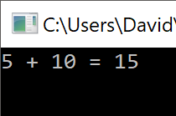
Fig 10.

Classes.

As discussed in the variables section of the report, computer applications manipulate huge amounts of data. A way to manage this data is to group it together where the grouped data takes the form of an object. The individual data that has been grouped is known as attributes. [5]
Attributes need to reflect the object they describe otherwise this can lead to an object losing its meaning.
The attributes can also be set to public or private which controls their accessibility, this allows for a technique known as data encapsulation.
A class can be created by declaring the keyword class, the private keyword can be declared to control the attributes accessibility, as seen in Fig 11.
Fig 11.
Functions can also be nested within classes, these are commonly known as methods.
Methods inherit all the same properties as a function, they also can modify and manipulate all the attributes within a class. Other functions known as properties grant the visibility and usage of an attribute outside of the class.
A class is split into two files, a header file which contains all the members of the class and a source file which contains the body of the properties and methods for the class.
An example of this can be seen in Fig 12 and 13.
Fig 12 (header file).
Fig 13 (source file).
The primary purpose of a class is to encapsulate data and allow the user to modify the data with the provided methods and properties of the class in the way intended by the class creator.
This can also be known as abstraction [4, p. 595]
Consider a car, like many real-world objects it has multiple attributes and behaviours that are concealed within it such as the pistons and chambers of an engine, or the wires and connections for the battery. The driver when pressing down on the accelerator or changing gears doesn’t need a full understanding of how these behaviours work but can still interact with the car as all the complex behaviours are hidden away only allowing the driver to use the car in the intended way. This is a simple concept of abstraction in terms of programming and is one of the useful cases of why classes play an important role in developing software with an object-oriented approach.

Part B – Interpretation.

The code provided is a simple application that has a menu system displaying options that are available to the user. The program allows the user to enter three numbers of their choice and then orders the numbers from smallest to largest.
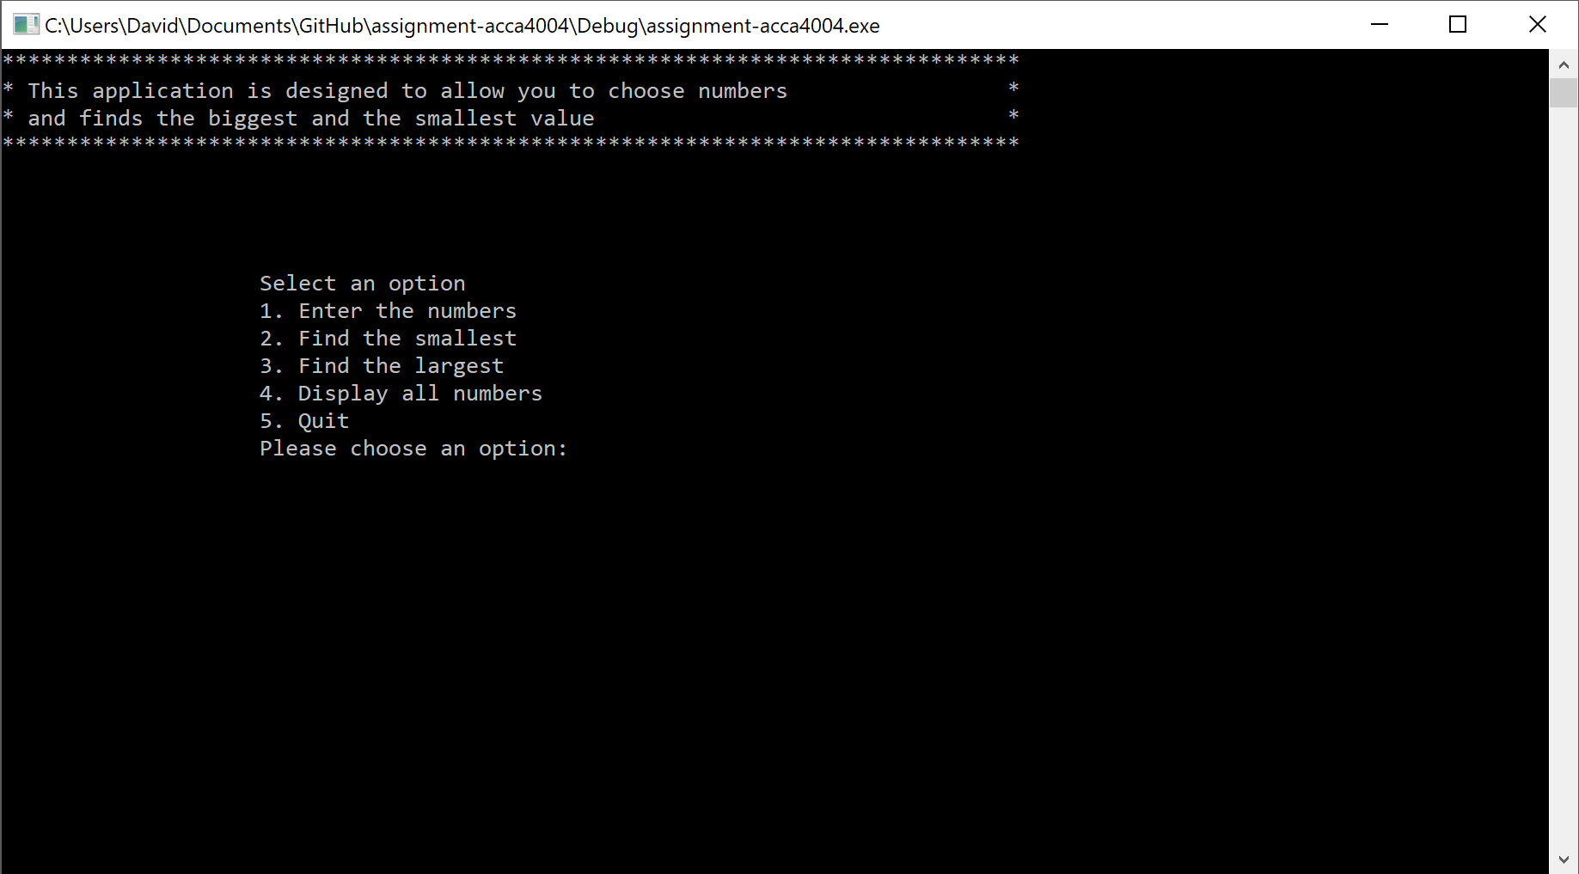
Fig 14
The main entry point of the program primarily consists of a while loop with function calls nested within it as seen in Fig 15.
Fig 15.
Within the main entry point of the program are three variables that are declared, the first variable is an array denoted by the square brackets that precede after the variable name theNumbers as seen in Fig 16.
Fig 16.
The value within the square brackets denotes the size of the array, on this occasion a variable called MAXNUMBERS is being used to signify the size. The variable MAXNUMBERS is a constant, unlike a variable where their values can be altered by the program a constant has a fixed value which doesn’t change.
The second variable that is declared is an integer and its value is set to zero as seen in Fig 17.
Fig 17.
The third variable is a Boolean type called quit which means that it can only have two states, true or false. This variable is used to control the programs state, whether it is running (false) or whether the user has quit (true). This variable can be seen in Fig 18.
Fig 18.
The first function that is within the main branch of the program initialises the array and sets all the elements to a value of 0. The function takes two arguments to perform its task. The function prototype can be seen in Fig 19.
Fig 19.
The function prototype shows the type of data that can be passed as arguments and gives the placeholder names of the variables that are passed to it. The placeholder variables are what is used inside the body of the function to portray the variables that are intended to be passed to the function, this can be seen in Fig 20.
Fig 20.
Fig 21.
The function will return to the main branch of the program and continue to the next instruction. This can be seen in Fig 22.
Fig 22.
The while loop checks on each cycle of the loop if quit is false. If quit remains false, the loop will continue and execute each instruction within it until the condition changes.
Fig 23.

Part C – Implementation.

All code for each exercise can be found within the appendices of the report.

Exercise 1.
Code provided in appendix A1.

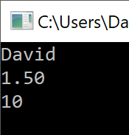
Fig 24.

Exercise 2.
Code provided in appendix A2.

Fig 25.
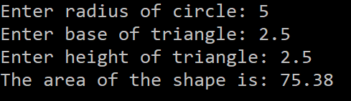
Fig 26.

Exercise 3.
Code provided in appendix A3.

Fig 27.
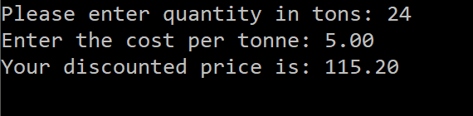
Fig 28.
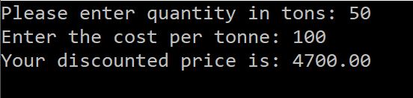
Fig 29.
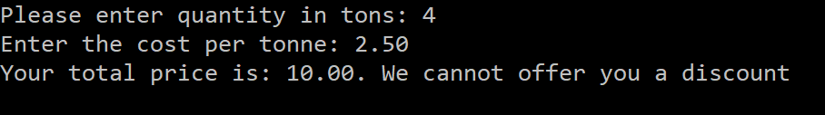
Fig 30.
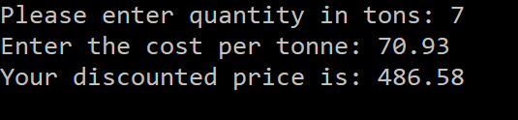
Fig 31.

Exercise 4.
Code provided in appendix A4.

Fig 32.
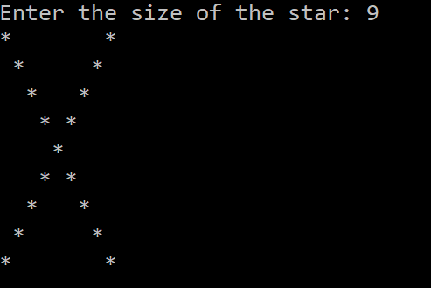
Fig 33.

Exercise 5.
Code provided in appendix A5.

Fig 34.
Fig 35.
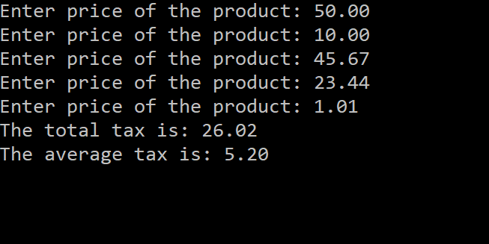
Fig 36.

Exercise 6.

When running the application and going through the menu system a bug was found with a selection within the menu.
By selecting option 4 from the menu the intended action was to provide the user with the opportunity to see the numbers the application currently stored, instead a prompt appeared asking the user if they wanted to quit.
By reviewing the code, it was found that within the switch statement the case four branch was calling a function that was expecting an option to quit the program.
Fig 37.

The following fix was implemented into the code.
Fig 38
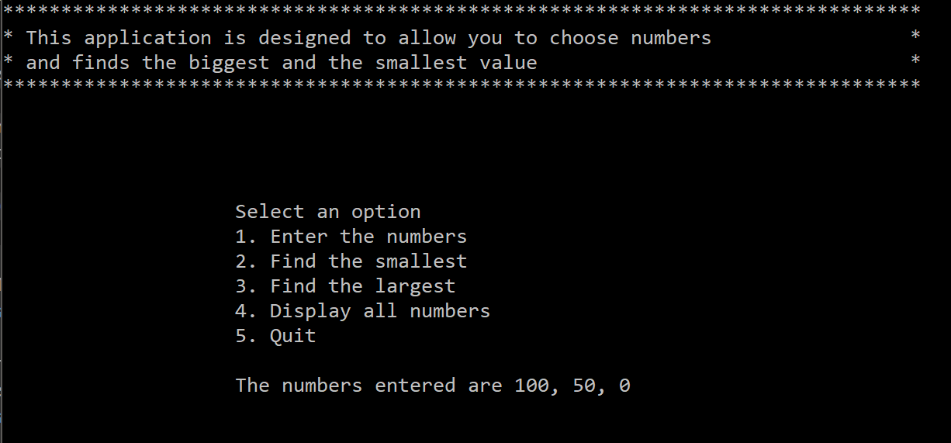
Fig 39.

Another bug was also found when inputting the numbers. A function which cleared the text from the screen wasn’t clearing the numbers entered, therefore leaving any numbers preceding the first digit.
Fig 40.
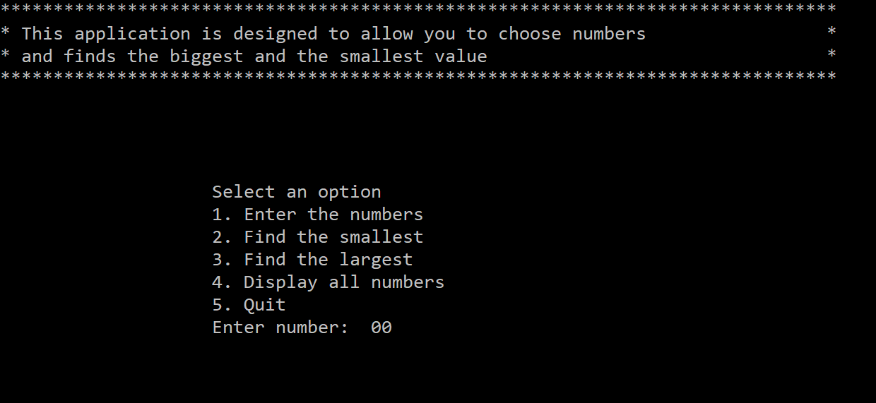
Fig 41.
To fix this an extra variable was added onto the argument.
Fig 42.

Exercise 7.
Code provided in appendix A6

Fig 43

Fig 44.

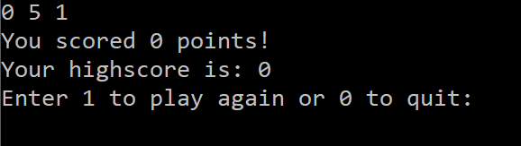
Fig 45
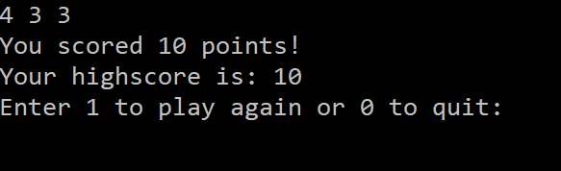
Fig 46.
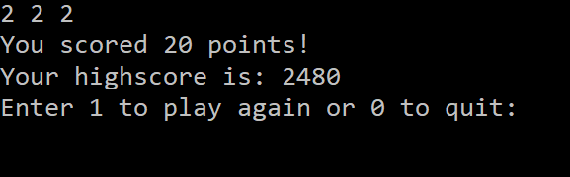
Fig 47.
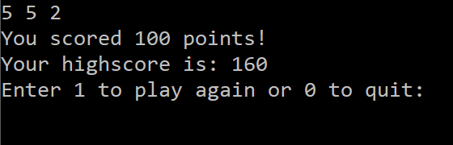
Fig 48.
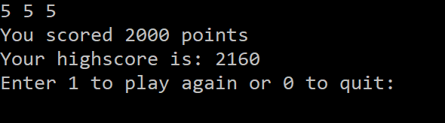
Fig 49.

References

[1] | M. Lee, “C++ Programming for the Absolute Beginner,” in Descending Deeper into Variables, 2nd ed., Course Technology, 2009, p. 27.
[2] | S. G. Kochan, “Working with Variables,” in Programming in C, Addison-Wesley, 2014, p. 29.
[3] | H. Schildt, “Statements,” in The Complete Reference C++, 4th ed., McGraw-Hill/Osborne, 2003, pp. 70-72.
[4] | P. J. D. Harvey M. Deitel, C: How to Program, 2nd ed., Prentice Hall International Editions, 1992.
[5] | R. Lafore, “The Big Picture,” in Object-Oriented Programming in C++, 4th ed., Sams Publishing, 2002, pp. 13-14.

Appendix.

Appendix A1.

Appendix A2.

Appendix A3.

Appendix A3.

Appendix A5.

Appendix A6.

