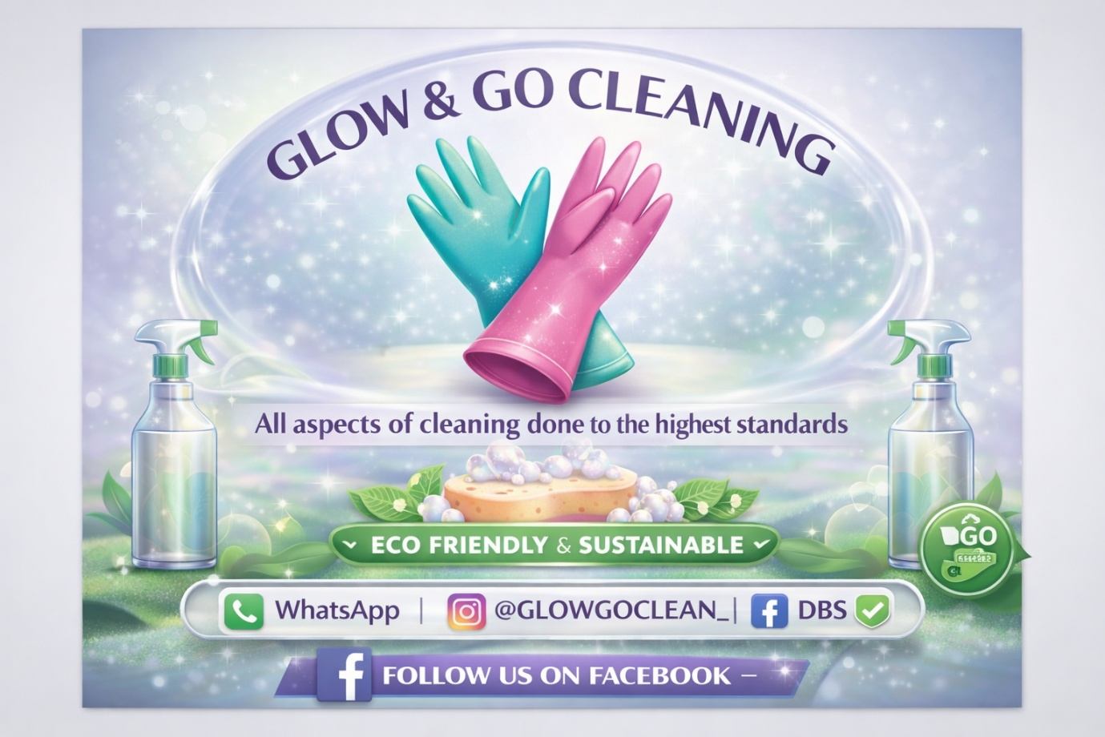

Carol Ann Rafferty
2517512
Nav-sustainable enterprise
09/03/2026
Introduction

In recent years, the demand for professional cleaning services has increased significantly as the same hygiene awareness has grown in recent years (Harris and Harris, 2025), leading to greater demand for convenience and healthier living environments. time, there is growing concern about the environmental impact of traditional cleaning products, many of which contain harsh chemicals that can contribute to indoor air pollution and environmental contamination.

The World Health Organization states that extended exposure to some chemical cleaning agents may have a negative impact on respiratory health and, if improperly disposed of, may also contribute to environmental pollution (World Health Organization, 2022). Environmentally friendly cleaning products are becoming more popular as a result.

Glow N Go Cleaning Services is a proposed sustainable cleaning enterprise that aims to meet this demand by providing reliable and eco-friendly cleaning services to residential and small business clients. The business will focus on using biodegradable, non-toxic cleaning products alongside efficient cleaning techniques that minimise waste and environmental impact. By prioritising sustainability and high-quality service, Glow N Go seeks to offer a healthier alternative to conventional cleaning services while maintaining competitive pricing and customer satisfaction.

This business plan outlines the development of Glow N Go Cleaning Services and explores how the enterprise will operate sustainably and profitably. The plan will discuss the company’s goals and objectives, required resources, and marketing strategy. In addition, a PESTLE and SWOT analysis will be conducted to evaluate the external and internal factors affecting the business. Finally, the report will present a financial cashflow forecast and contingency plan to demonstrate the viability and long-term potential of the enterprise.

Aims and objectives

The main aim of Glow N Go Cleaning Services is to provide reliable, high-quality, and environmentally friendly cleaning services to residential and small business clients while promoting healthier living and working environments.
The business seeks to build a strong reputation for professionalism, customer satisfaction, and sustainable cleaning practices by using eco-friendly products and efficient cleaning methods.
Glow N Go also aims to contribute to environmental sustainability by reducing the use of harmful chemical cleaning products. Organisations such as the Environmental Protection Agency highlight the importance of using safer cleaning products to reduce chemical exposure and environmental pollution (Environmental Protection Agency, 2021) By prioritising eco-friendly cleaning solutions, Glow N Go aims to support both customer health and environmental protection.

SWOT & PESTLE

A SWOT analysis helps evaluate the internal strengths and weaknesses of a business as well as the external opportunities and threats it may face. This analysis can help Glow N Go Cleaning Services identify areas where it can succeed and potential risks that need to be managed.

Strengths

By using environmentally friendly chemicals, Glow N Go Cleaning Services prides itself and draws clients who respect sustainability and good health. To meet various needs, it provides a range of services, such as deep, end-of-tenancy, and routine cleaning. Good customer service and reliable scheduling promote repeat business and build confidence. The company can expand gradually with little investment because to cheap initial costs.

Weaknesses
Customers often favour well-known cleaning businesses with solid reputations and ratings, which means Glow N Go may initially struggle with little brand recognition. Its limited workforce in the beginning could make it challenging to manage a high demand or replace staff absences, which is another risk. Furthermore, eco-friendly cleaning supplies are typically more costly than conventional ones, which raises operational expenses. Its ability to maintain competitive pricing may also be impacted by this.

Opportunities
Due to busy lives and increased awareness of hygiene, there is an increasing need for professional cleaning services (Mintel, 2023). As the need for expert and environmentally friendly cleaning services increases, Glow N Go may draw in more customers. By providing specific services and working with property managers and landlords for sustainable business, it can also grow.

Threats
Both big businesses and many local cleaners pose a serious threat to Glow N Go. Customers may spend less during economic downturns, especially on non-essential services like cleaning. If prices are unable to rise, rising eco-friendly product costs may also result in lower profitability. Glow N Go should concentrate on reasonable prices, excellent customer service, and successful marketing to remain competitive.

Pestle
Political factors
Laws that have an impact on how businesses operate are political considerations. When using cleaning supplies, Glow N Go must abide by health and safety regulations. Government grants or tax breaks for small businesses and eco-friendly practices could also aid in the company's growth.
Economic Factors
In growing economies, demand for cleaning services increases; yet, in recessions or periods of high inflation, demand could fall as consumers reduce non-essential spending. Expenses for Glow N Go may rise due to rising fuel and eco-friendly supply costs. However, because routine cleaning is necessary for hygiene, the industry is still steady.

Social Factors

The success of cleaning companies is greatly influenced by social trends. Awareness of sanitation and hygiene increased significantly following the COVID-19 pandemic (World Health Organization, 2022) Professional cleaning services are now highly valued by many clients. Customers are also looking for services that reflect their values and are growing more environmentally friendly. Glow N Go is well-positioned to address this increasing need because to its focus on sustainable procedures and eco-friendly cleaning supplies. Many people prefer to outsource domestic duties like cleaning because they lead busy lives and work longer hours.

Technological Factors

In the cleaning sector, technological advancements can boost productivity and client satisfaction. Digital solutions like mobile payment platforms, scheduling software, and online booking systems can help Glow N Go. Social media sites like Facebook, Instagram, and TikTok can also be used to advertise services, post customer reviews, and draw in new customers. Additionally, energy-efficient hoover systems and steam cleaners are examples of contemporary cleaning technology that can enhance cleaning efficiency while using less water and chemicals.

Legal Factors

For Glow N Go to be effective, business must comply to several legal standards. These include registering the company, getting the right insurance, and hiring employees in accordance with employment regulations. Because workers in the cleaning industry may handle chemicals or equipment that could be dangerous if handled improperly, health and safety requirements are especially crucial. Additionally, the company needs to make sure that the cleaning supplies it uses follow to environmental and safety regulations. Respecting the law helps safeguard clients and staff while protecting the business's standing in the industry.

Environmental Factors

Because Glow N Go wants to be a sustainable cleaning firm, environmental issues are very important. Conventional cleaning products may contain chemicals that contribute to indoor air pollution and environmental contamination (European Environment Agency, 2022). Glow N Go can lessen its influence on the environment and attract customers who care about the environment by choosing non-toxic and biodegradable cleaning supplies. Reusable cleaning supplies like microfibre cloths and refillable containers can help the company cut waste. Businesses that put sustainability first will probably have a competitive edge as environmental awareness rises.

In conclusion
All things considered, the PESTLE study identifies several outside variables that will affect Glow N Go Cleaning Services' success. Opportunities for the firm are created by social demand for eco-friendly services, political support for sustainability, and technical improvements. However, there may be difficulties due to shifting economic conditions, legal requirements, and growing prices for eco-friendly goods. Glow N Go can create plans that promote long-term expansion and sustainability in the cleaning sector by understanding all these factors and making suitable decisions.

Market research

Due to increased convenience demands and growing awareness of hygiene, especially in the wake of COVID-19, the UK cleaning services market has grown dramatically Despite fierce competition from (Consumer Trends Post-COVID-19: How Hygiene Habits Have Transformed Globally – Sanify Pro, 2024).independent cleaners and larger companies, cleaning is still in great demand since it is seen as an essential and ongoing service (Assertio, 2025) . Glow N Go Cleaning Service will target small companies, families, tenants, landlords, and busy professionals who are willing to pay for reliable, excellent cleaning services although often lack time to clean (Piolo, 2025). Additionally, customers are choosing more sustainable and non-toxic cleaning solutions because of a growing demand for eco-friendly lifestyles (Cleaning, 2026). This gives Glow N Go a chance to set itself apart by providing eco-friendly services along with affordable prices and expert standards.

Competitors analysis

The cleaning service market is highly competitive, with numerous local cleaners and well-known cleaning businesses providing comparable services. Glow n Go Cleaning can better understand the market and find ways to differentiate itself by conducting a competitor analysis.

Direct competitors
Independent home cleaners and local professional cleaning firms are direct rivals. Due to their lower operational costs, independent cleaners frequently provide lower charges; however, they might not have professional branding, reliability, or organised booking systems. Larger cleaning companies tend to have larger staff and more brand awareness, but many still use standard chemical cleaning chemicals instead of eco-friendly replacements.

Indirect competitors
include companies who offer self-use household cleaning supplies and homeowners who maintain their own houses. These choices might be less expensive, but they may not produce the same level of expert outcomes and demand more time and effort from clients.

Glow n Go Cleaning's focus on eco-friendly cleaning techniques, expert service, and flexible booking options give it a competitive edge. The company can attract eco-aware clients and set itself above typical cleaning services by using sustainable cleaning supplies and encouraging eco-friendly procedures.

Marketing
Product
For those who require help keeping a clean house, Glow N Go offers household cleaning services. Deep cleaning, end-of-tenancy cleaning, and regular house cleaning are among the services offered. Oven and fridge cleaning are examples of extra services that might be provided. These services are intended to help clients keep their homes hygienic and tidy while also saving them time. As more households search for practical answers to their hectic lifestyles, the need for cleaning services has grown (Harris & Harris, 2025).
Place
Glow N Go will operate locally and provide house cleaning services. Busy professionals, families, tenants, and landlords who might not have time to clean themselves make up the primary target market. Online tools like Google Business profiles and social media pages, which are often used by local service organisations to attract customers in their area, will allow customers to find the company (Kotler & Armstrong, 2019).
Promotion
Glow N Go will advertise its services locally via advertisements, social media, and referrals from others. Uploading before and after pictures of cleaning projects can help demonstrate the quality of the work and draw in new clients. Additionally, encouraging clients to write favourable internet reviews can enhance the company's brand and build confidence.
Price
Based on what other cleaning companies in the UK charge, Glow N Go are going to use competitive pricing. Deep cleaning services may cost more because they involve more time and effort, but regular cleaning services will cost between £15 and £25 per hour. Giving customers more alternatives and increasing revenue can be achieved by charging more for more services. To draw clients and maintain cash flow, competitive pricing is crucial (Buildela, n.d.).

Cashflow
This is a basic cash flow table for Glow N Go Cleaning that shows your startup costs and earnings.

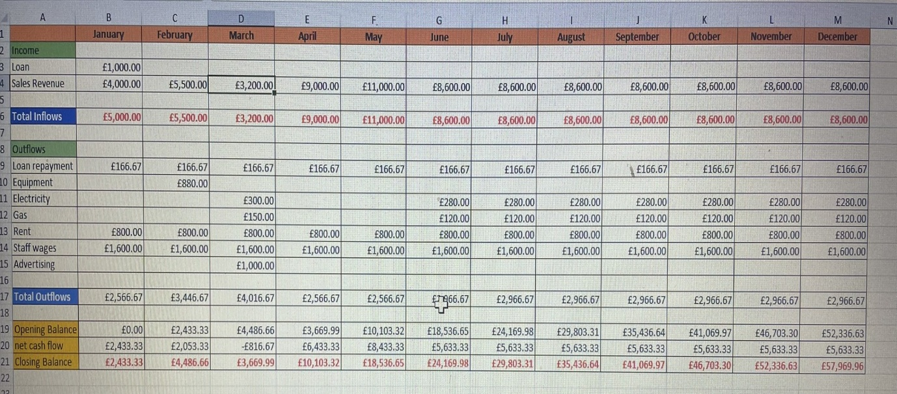

Financial overview

The financial plan for Glow n Go Cleaning focuses on maintaining low start-up costs while generating steady income through regular cleaning services. Initial funding will be used to purchase essential equipment, eco-friendly cleaning products, marketing materials, and insurance. The business is expected to generate income through residential and small commercial cleaning services, with regular clients providing consistent monthly revenue. By carefully managing expenses such as supplies, transport, and staff wages, Glow n Go Cleaning aims to achieve profitability within its first year of operation while maintaining sustainable business practices.

Estimated Start-Up Costs
Cleaning equipment: £800
Eco-friendly cleaning products: £400
Marketing and advertising: £300
Insurance and business registration: £500
Transportation costs: £600
Total estimated start-up cost: £2,600

Revenue Forecast
If Glow N Go secures 10 regular weekly clients paying approximately £50 per clean:
Weekly revenue: £500
Monthly revenue: £2,000
Annual projected revenue: £24,000
As the business grows and gains more clients, revenue could increase significantly through additional services such as deep cleaning or commercial contracts.

Contingency plan

Glow n Go Cleaning will have a backup plan in place to handle any hazards that might interfere with business operations. The company would step up its marketing efforts through social media promotions, referral discounts, and local advertising to draw in new customers if customer demand is less than expected. If there is a staffing problem, services will continue unchanged by using temporary personnel or flexible scheduling. The company will evaluate suppliers and think about buying in bulk to cut costs if operational expenses like transportation or cleaning supplies rise. Maintaining backup cleaning supplies will also help avoid service interruptions if equipment fails. These tactics will guarantee that the company can carry on successfully in the face of unexpected challenges.

Conclusion

All things considered, Glow N Go Cleaning Services has a great chance of being a long-term cleaning business. The company can fulfil the increasing demand for ecologically responsible services by combining eco-friendly cleaning techniques, effective advertising techniques, and effective budgeting. Glow N Go Cleaning Services is in a strong position to develop loyal clients and see long-term success in the cleaning sector due to rising consumer awareness of sustainability and hygiene

References

Assertio. (2025, December 8). UK cleaning statistics and industry trends 2026. https://assertioservices.com/uk-cleaning-statistics/

Buildela. (n.d.). What is Checkatrade’s pricing structure? https://www.buildela.com/checkatrade-pricing-structure-guide

European Environment Agency. (2026, February 20). Chemicals: In-depth topics. https://www.eea.europa.eu/themes/human/chemicals

Cleaning, J. H. (2026, March 1). Green cleaning in 2025: The future of eco-friendly cleaning solutions [Online forum post]. HelloNeighbor.info. https://www.helloneighbor.info/blog/green-cleaning-in-2025-the-future-of-eco-friendly-cleaning-solutions

Harris, S. (2025, January 22). UK cleaning industry statistics 2025. PolicyBee. https://www.policybee.co.uk/blog/uk-cleaning-industry-statistics

Kotler, P., & Armstrong, G. (2019). Principles of marketing. Pearson.

Mintel. (n.d.). Global market intelligence & research agency. https://www.mintel.com/

Piolo. (2025, March 27). The ideal demographics for a cleaning services company. AMPLIFY XL. https://amplifyxl.com/target-market-for-cleaning-services/

U.S. Environmental Protection Agency. (2026, February 10). Safer choice. https://www.epa.gov/saferchoice

Sanify Pro. (2024, December 31). Consumer trends post-COVID-19: How hygiene habits have transformed globally. https://sanifypro.com/2024/12/31/consumer-trends-post-covid-19-how-hygiene-habits-have-transformed-globally/

World Health Organization. (2025, December 16). Household air pollution. https://www.who.int/news-room/fact-sheets/detail/household-air-pollution-and-health

