INTRODUCTION TO HEALTH AND SOCIAL CARE
AMBULANCE SERVICES POSTER AND ESSAY

NAME: CHARLES ONIJE

STUDENT NUMBER: 2420902

LECTURER NAME: TSIWANI KHUMALO

Table of Contents
TASK 1: POSTER 3
TASK 2: ESSAY 4
INTRODUCTION 4
MAIN BODY 4
Origin and history of National Health Service 4
Key principles led to its development 4
Critical examining of current structure and functioning of NHS 5
CONCLUSION 5
REFERENCES 6

TASK 1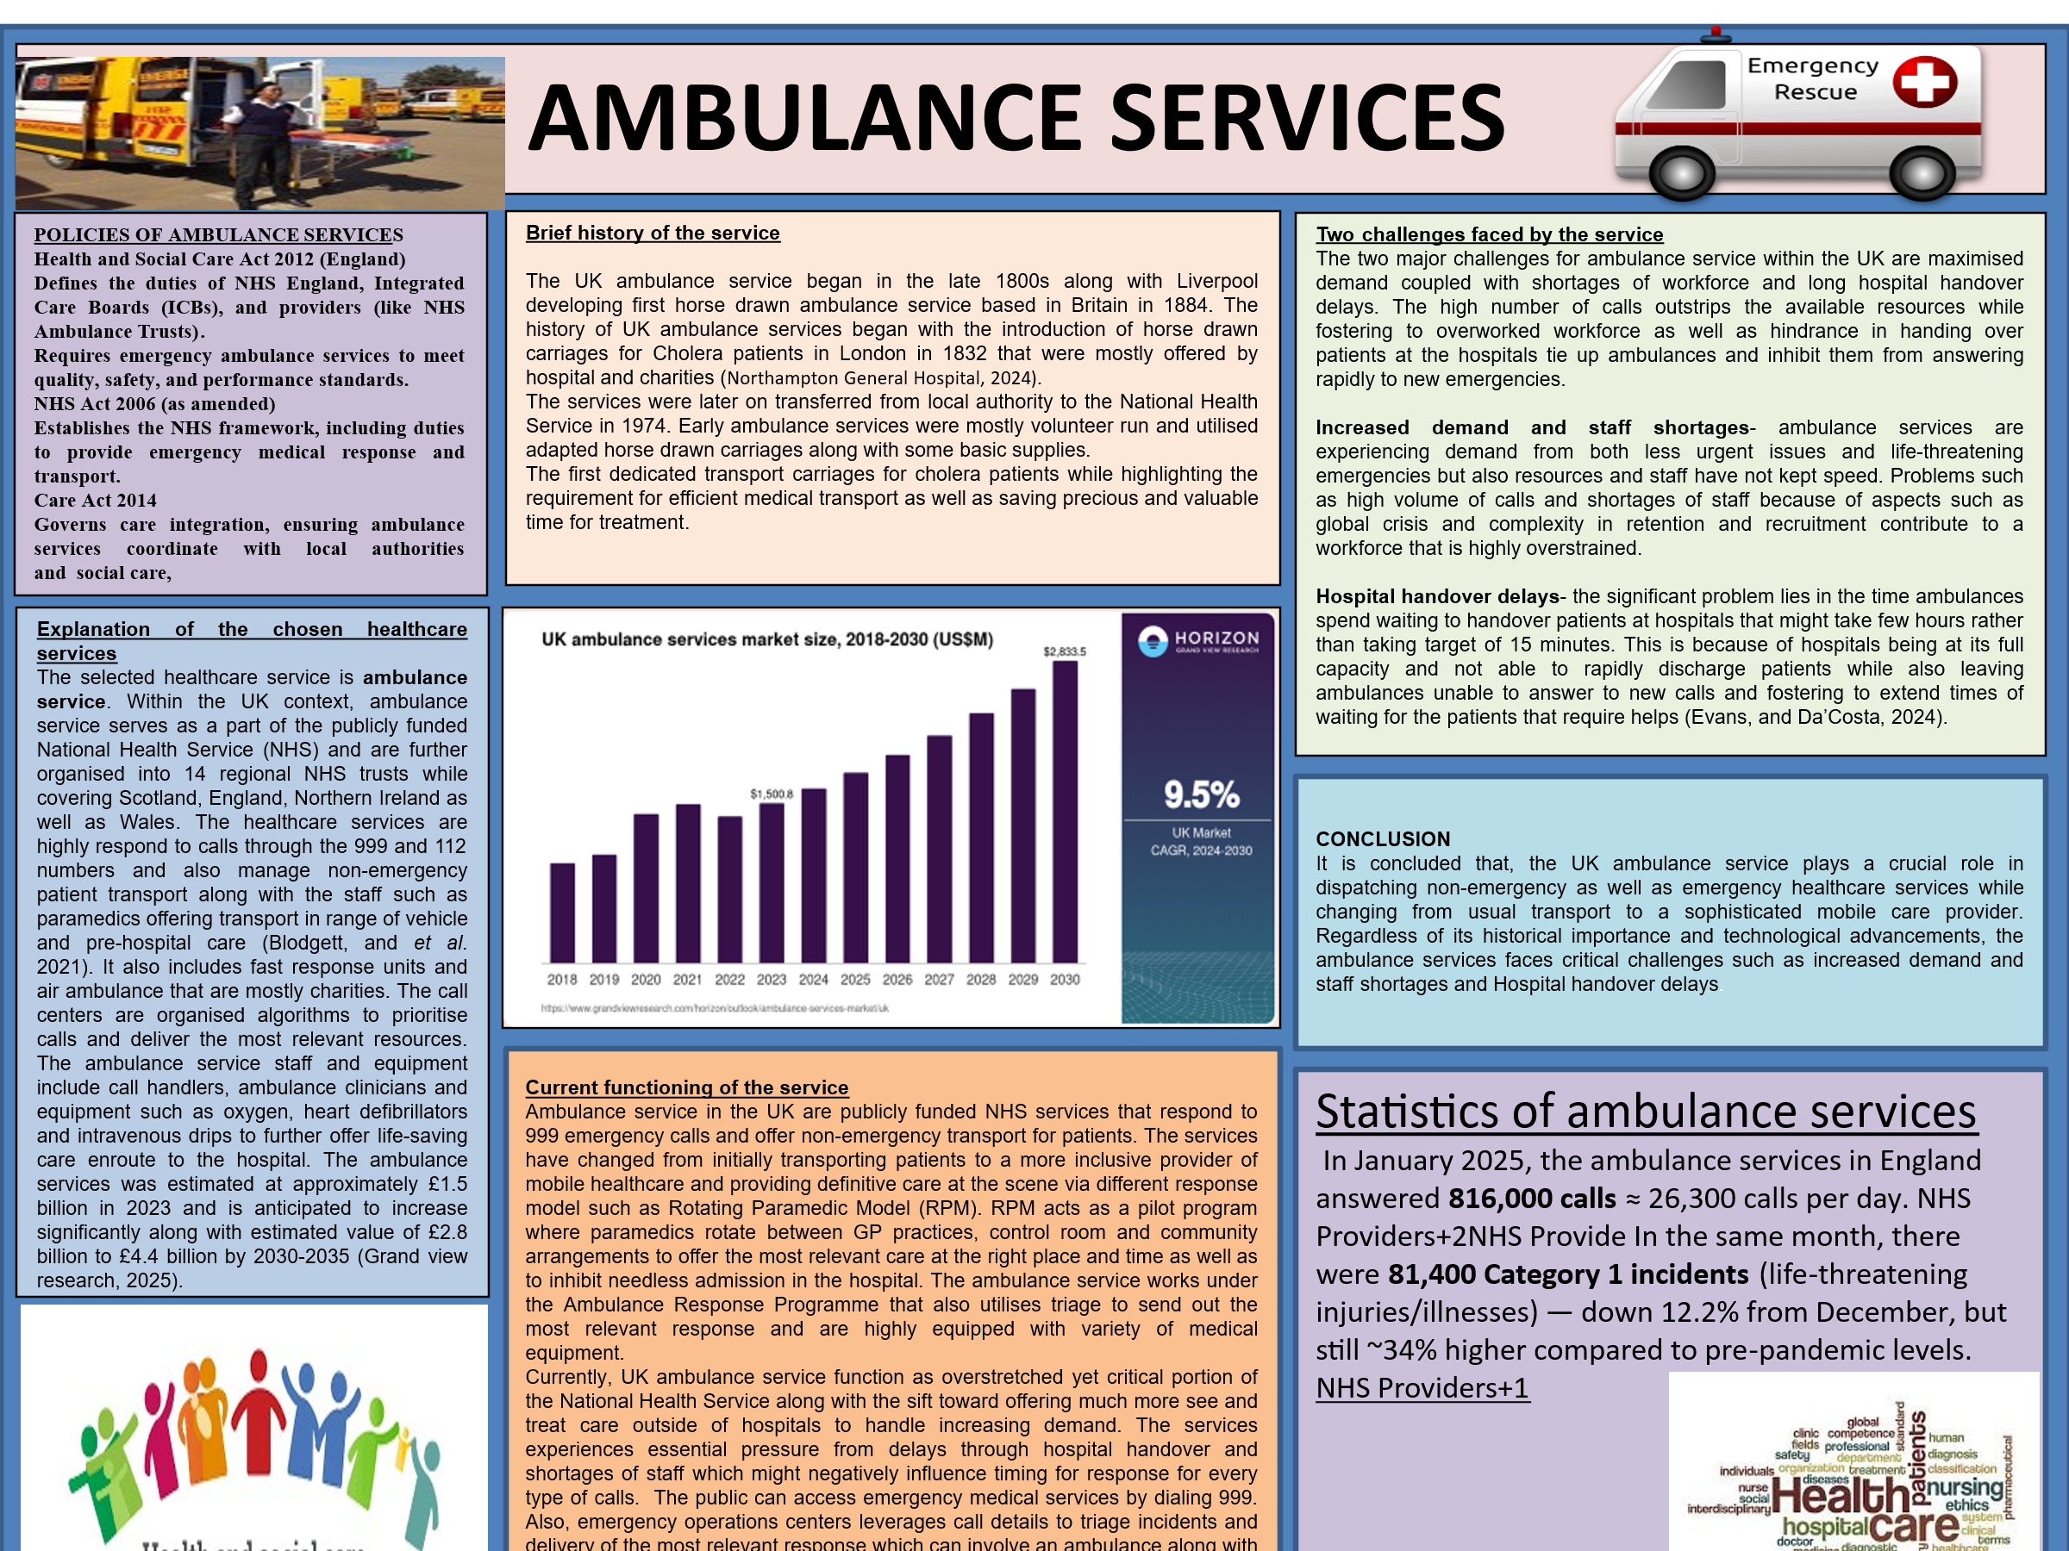

TASK 2:

INTRODUCTION
Healthcare services concentrate on diagnostic, medical and treatment meanwhile social care offers personal as well as practical support for daily living, maintaining independence and emotional challenges (Endeshaw, 2021).
The essay will discuss the origin of the National Health Service (NHS) while exploring historical context and main principles of its development. It will critically investigate the current structure of the NHS along with its functioning.

MAIN BODY

Origin and history of National Health Service
National Health Service UK was developed on July 5, 1948, succeeding the Second World War. Its origin lies in the 1942 Beveridge Report that proposed an inclusive system of social insurance. The base of NHS was positioned in the 1942 that proposed wide-ranging social insurance system for the entire population. Aneurin Bevan, the minister of health was the main figure in developing and launching the NHS, regardless of preliminary struggle from some dentist and doctors. Primarily, the NHS is funded by general taxes along with limited contribution from national insurance and fees paid by the patients for particular things such as optical care, prescription and dental care. Officially, National Health Service was propelled on 5 July, 1948 at the Park hospital in Manchester. NHS was established on principles of being universal, inclusive and free at the point of utilisation and also funded via general taxation (GOV. UK, 2025).

Key principles led to its development
The key principles that led to the development of National Health Service offering comprehensive and universal healthcare free at the point of use and delivery as well as based solely on clinical requirements (Garbi, 2021). These key principles are supported by Aneurin Bevan while aiming to replace the fragmented pre-war systems with one funded by central taxation. The NHS was originated on the ideal that healthcare must be available for every individuals, irrespective of wealth. Also, patient do not have to pat at the time of their treatment, appointment as well as hospital stay along with the serviced funded by general taxation. The treatment is offered according to medical requirement of the individual and not their ability to pay. The NHS offers inclusive and wide ranging services instead of one on the basis of insurance contribution or fragment and social settings (Klein, and Powell, 2025).

Critical examining of current structure and functioning of NHS
The National Health Service within the UK is complex and continuously changing system that offers universal, comprehensive and free healthcare services at the point of delivery. As per the views of Cosford, (2021), the persistent and founding principles of the NHS is that is offers inclusive range of services for every individuals on the basis of clinical requirements, instead of focusing on their ability to pay. The centralised nature of the National Health Services becomes helpful in enforcing and setting national standards for care and treatment of patients throughout the country, However, as critically opposed by Abela (2023), one of the most reflective and damaging criticism of the NHS structure, especially in England acts as a cycle of top to down and frequent reorganisation. Irrespective of public rhetoric regarding excess of administrators, the NHS is mostly defined by experts as undermanaged in crucial areas. The combination of an aging population alongside more chronic conditions, expensive medical advancements and inconsistent government funding has developed significant financial strains.

CONCLUSION
In conclusion, the National Health Service stands as a main stone of commitment to universal health within the UK while rooted in post-war vision of accessibility and quality. The essay addressed he key principles that led to the development of National Health Service like offering comprehensive and universal healthcare free at the point of use and delivery as well as based solely on clinical requirements.

REFERENCES
Books and journal
Abela, S., (2023). The Structure of the NHS. In Leadership and Management in Healthcare: A Guide for Medical and Dental Practitioners (pp. 3-18). Cham: Springer International Publishing.
Blodgett, J.M., and et.al, (2021). Alternatives to direct emergency department conveyance of ambulance patients: a scoping review of the evidence. Scandinavian Journal of Trauma, Resuscitation and Emergency Medicine, 29(1), p.4.
Cosford, P., (2021). The NHS: structure and functions. In Leadership and Management for Doctors in Training (pp. 53-63). CRC Press.
Eaton, G., and et.al, (2021). Understanding the role of the paramedic in primary care: a realist review. BMC medicine, 19(1), p.145.
Endeshaw, B., (2021). Healthcare service quality-measurement models: a review. Journal of Health Research. 35(2). pp.106-117.
Evans, C. and Da’Costa, A., (2024). A strategic solution to preventing the harm associated with ambulance handover delays. Emergency Nurse, 32(6).
Garbi, M., (2021). National Institute for Health and Care Excellence clinical guidelines development principles and processes. Heart, 107(12), pp.949-953.
Klein, R. and Powell, M., (2025). The new politics of the NHS: from creation to reinvention. CRC Press.
Yao, R., and et.al, (2022). Inequities in health care services caused by the adoption of digital health technologies: scoping review. Journal of medical Internet research, 24(3), p.e34144.
Online
GOV. UK, (2025). The National Health Service. Accessed through < https://assets.publishing.service.gov.uk/media/57a08d91e5274a31e000192c/The-history-and-development-of-the-UK-NHS.pdf> [Accessed on:17th October 2025].
Grand view research, (2025). Ambulance Service Market size. Accessed through <https://www.grandviewresearch.com/horizon/outlook/ambulance-services-market/uk> [Accessed on: 17th October 2025].
Northampton General Hospital, (2024). The history of ambulance service. Accessed through< https://www.northamptongeneral.nhs.uk/About/OurHistory/History-of-Ambulance.pdf> [Accessed on: 17th October 2025].

