Creating a Network of Virtual Machines using Oracle VirtualBox and Windows Networking
The purpose of this exercise is to implement a network of three segments, creating the virtual PCs and servers, installing the operating systems, and interconnecting them with IP addressing. This work requires the student to be able to act as systems manager, and demonstrates a small part of the work of a network manager/IT technician in establishing and maintaining a network.
VirtualBox is a type 2 hypervisor virtual machine manager, distributed currently by Oracle. It has a number of powerful features, including the ability to run alternative operating systems to the native PC operating system on virtual machines. It also has a (admittedly fairly limited) capability to simulate network connectivity, but it does not implement timing considerations or load calculations as an aspect of the network in the way that is usual with a dedicated network simulator (such as NetSim, or CISCO’s Packet Tracer).
Operating the virtual network as systems administrator (one of the first tasks included in the installation of the operating system is the creation of user accounts), you have a rich set of capabilities to draw on. These will be exercised in a very limited way, due to the time constraints on the practical work.

Task Summary
Using the worksheets provided as guidance:
1. Create four virtual PCs in VirtualBox, observing the naming convention given in the worksheets. Each is configured with a specific purpose, and the networking capabilities, disk size, RAM size and other parameters are chosen with this in mind. The approach is to create one server and one client, then clone each to give the four PCs (two servers, two clients) required for the task.
2. Install Windows Server 2008 R2 on both servers, install Windows 7 on both clients. This will be done by using a feature of VirtualBox allowing the user to point each virtual machine to an ISO image of the operating system on the hard drive (as a “virtual optical drive”). The operating system will load automatically on first power on of a virtual PC.
3. Configure static IP addresses manually for each PC in the network set up pages, and then verify the correctness of the configuration using the PC console command line and associated network commands (including ipconfig and ping).
4. Set up one of your servers as a primary domain controller and DNS, and then use one of the client PCs to join the domain.
5. Create a DHCP server on your DNS and reconfigure the client PC to acquire its IP address automatically from the server.
The students will work in pairs, and use the Windows Snipping Tool to record suitable screen shots to demonstrate the configurations and the network are working correctly.
PublicNet: 192.168.1.XXX

PublicNet:
192.168.1.100
Server 1
PrivateNet1:
192.168.100.1
PublicNet:
102.168.1.101
Server 2
PrivateNet2:
192.168.101.1
PrivateNet2: 192.168.101.XXX
PrivateNet1: 192.168.100.XXX
Client 1
PrivateNet1:
192.168.100.2
Client 2
PrivateNet2:
192.168.101.2

Figure 1: Trial Network Configuration

The network diagram of Figure 1 above shows the topology, address conventions, connections and names to be used throughout this exercise.

Preparation
- Find a partner to work with and choose a PC. You will need to use the same PC throughout this practical work (for the next five weeks of the module), and the configurations of the created virtual PCs are large (20GB virtual hard drive means basically 20GB per machine – and you will have four of these – so loading onto an USB stick is untenable if only due to time).
- Download the operating system ISO images from \\192.168.27.1\NOSSISOs onto your PC. Be careful to put them somewhere you can remember so you can find them easily from the file explorer screen during VirtualBox virtual machine set up. These are big files, and will take a while to download. You will need Windows Server 2008 R2 (64-bit) and Windows 7 (64-bit).
- Practice using the Snipping Tool to capture screen shots. Note that these can be included in Word documents using the copy and paste functions, and can be resized as other pictures in Word by dragging a corner of the image.
Open VirtualBox (click on it)

The Virtual Box landing screen opens:
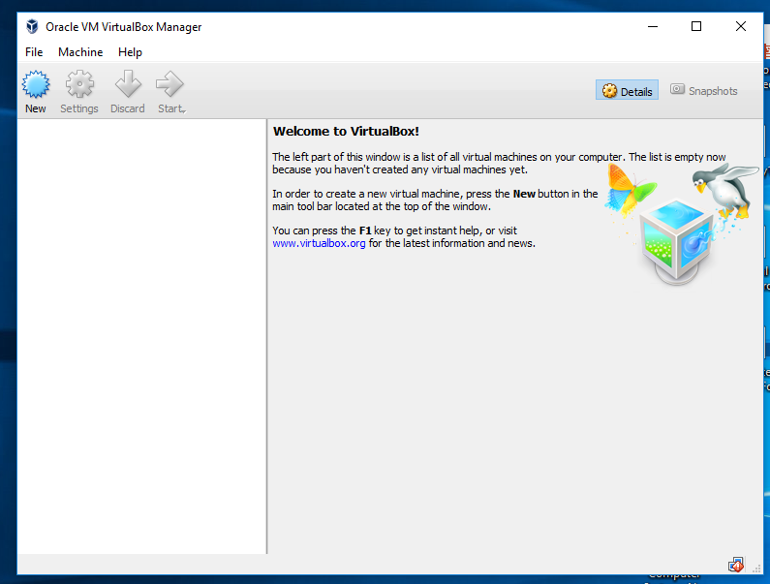
Click on New.
The “Create New Virtual Machine” window opens. Name your virtual machine, and choose Windows 2008 (64-bit) from the drop down menu:
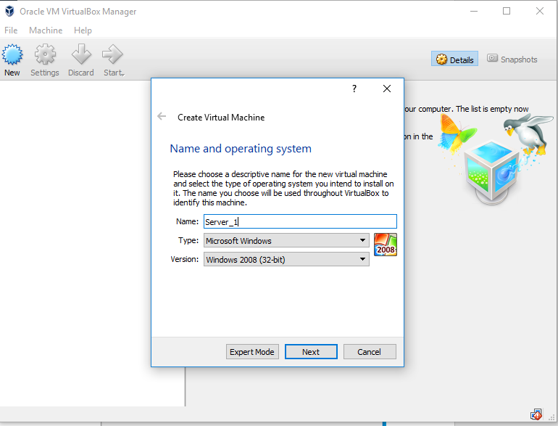

Click Next. This brings up the Memory Size window.
Enter 4096 Mbytes as the memory size for your virtual machine. Click “Next”

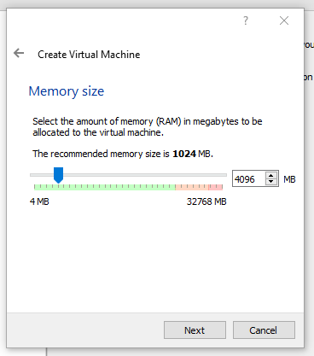
In the Hard disk window, click on “Create”

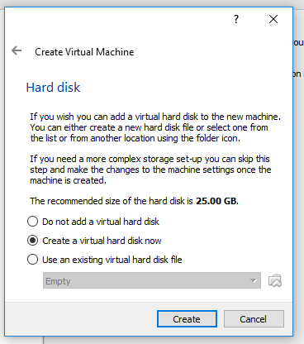

Leave the Hard Disk File Type as VDI, and click “Next”.
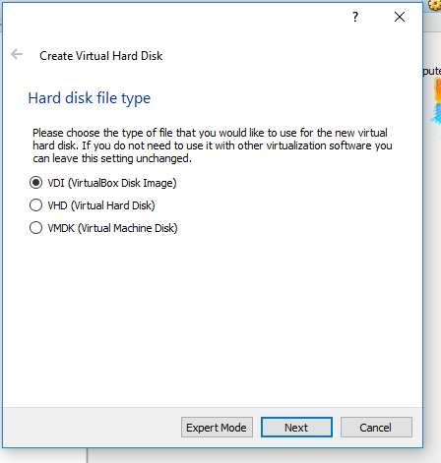

In the Storage on physical drive window which now comes up, select “Fixed size” and click “Next”:

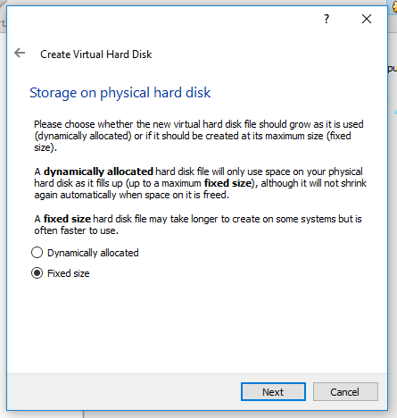

Make the size of your hard drive 20GB, then click “Create”. This may take a minute or two. The operating system you are going to load later in this lab takes up around 6 GB.

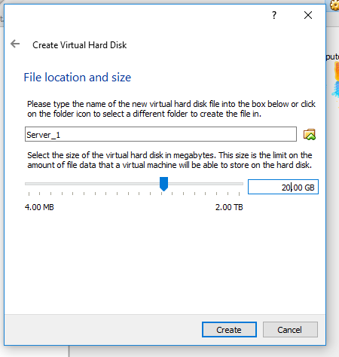
Congratulations! You have created (partially) your first virtual machine, Server_1:
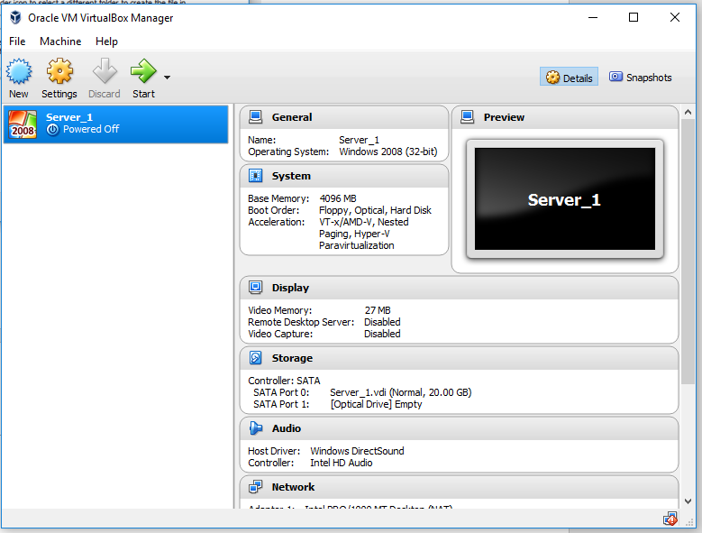
Click on Settings
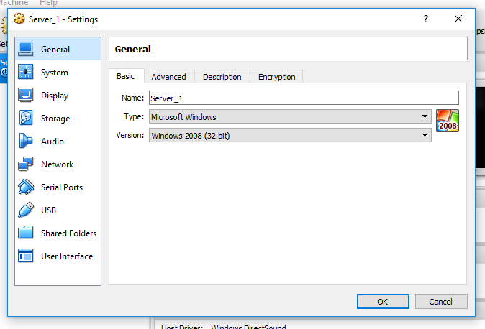
Click on Network.
Choose Internal Network from the “Attached to” drop down menu, and name your network PublicNet in the name box:
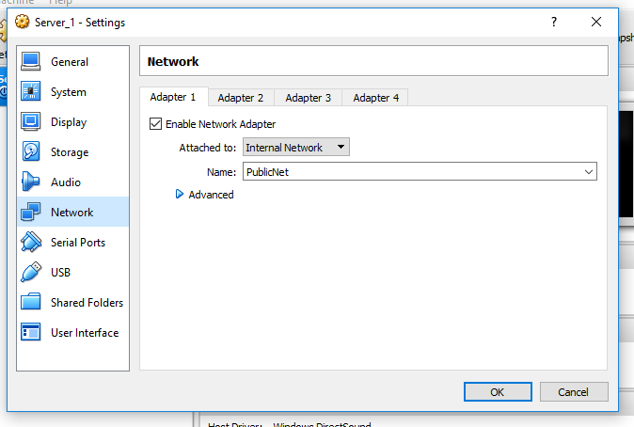
Click on the tab for Adapter 2. Check (click on) the Enable Network Adapter button check box. Select Internal Network from the drop down menu “Attached to”, and name your network PrivateNet1
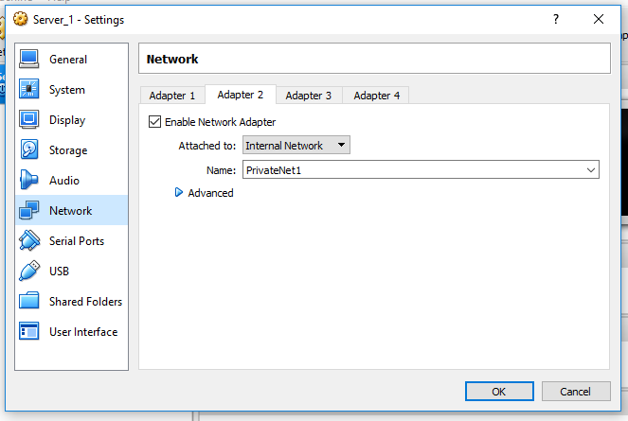

Click OK. This takes you back to the Virtual Machines menu.
Click on “Settings” again, then on “System”. We are enabling the right combination of processor features to work with the software we are going to install. Select (click) the Motherboard tab.
System – Motherboard (no changes)
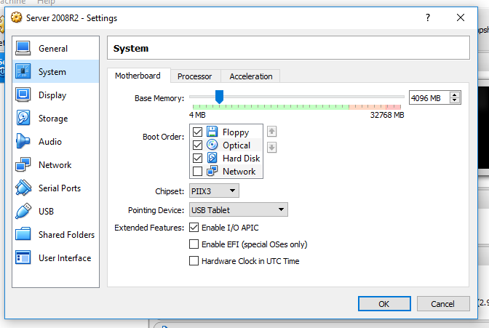
System – Processor: Select the Processor tab and turn on (check) Enable PAE/NX
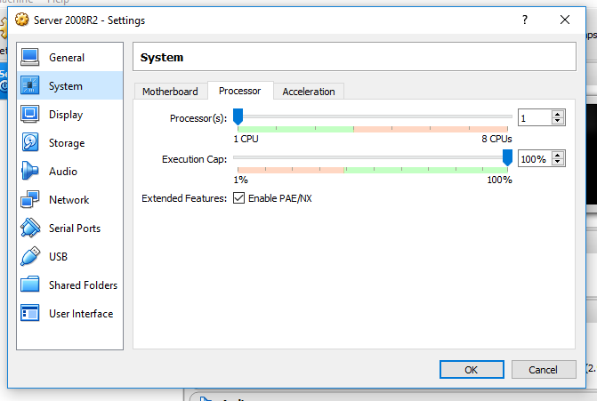
System – Acceleration: Choose the Acceleration tab, then turn off (uncheck) Enable Nested Paging
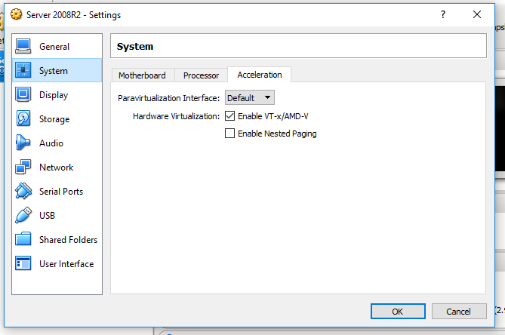
Click OK

Click on “Settings” again, then on “Storage”. Click on the “Empty” drive icon, ringed in red below:
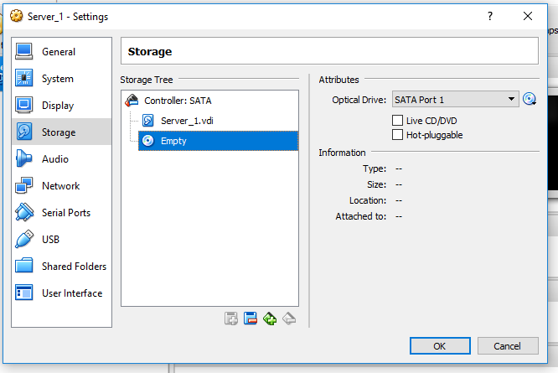
This brings up the Optical Drive: SATA Port 1 option in “Attributes”. Click on the optical disk icon next to the Optical Drive name box and select “Choose Virtual Optical Disk File”.

From the file menu, find and select the Windows 2008 server ISO image you have already downloaded. In this example, my copy of the Windows Server 2008 R2 ISO image was stored in the Desktop. Click OK.
Highlight the Windows Server 2008 R2 ISO and click “Open”
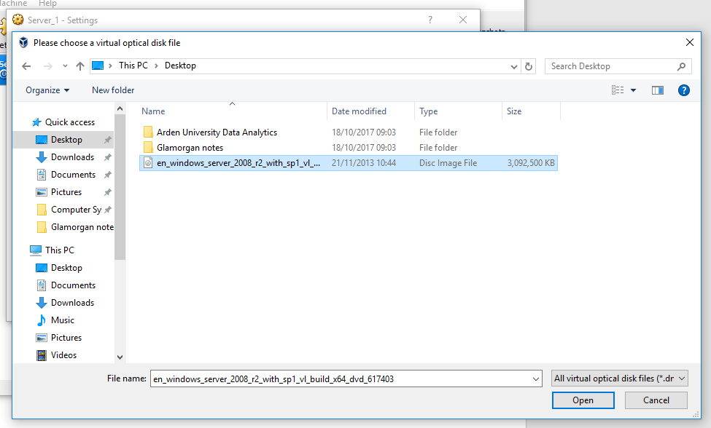

The file now appears as a virtual optical drive in the storage list:
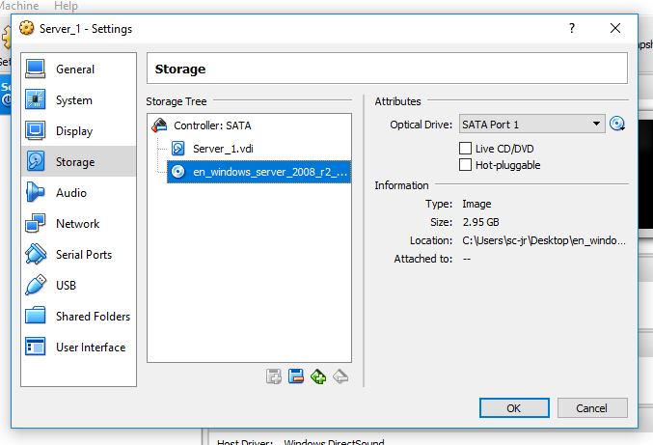

Click OK, which takes you to the main VM Virtualisation Manager window.
On the Virtual Machines main menu, double click on Server_1 to start your virtual machine.
Windows 2008 Server will start automatically and install itself (this takes some time). Be careful to write down your password as Administrator
Once installation is complete, configure the networking settings of your server as below.
Click Start – Control Panel, then double click Network and Sharing Center.
The click Manage Network connections
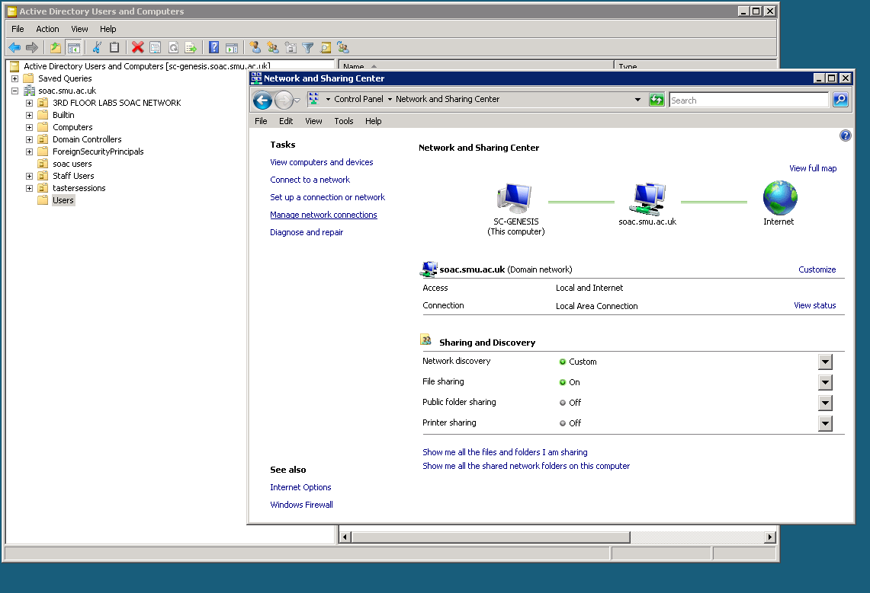
Right click on the Local Area Connection and choose Rename: call this connection Publicnetwork
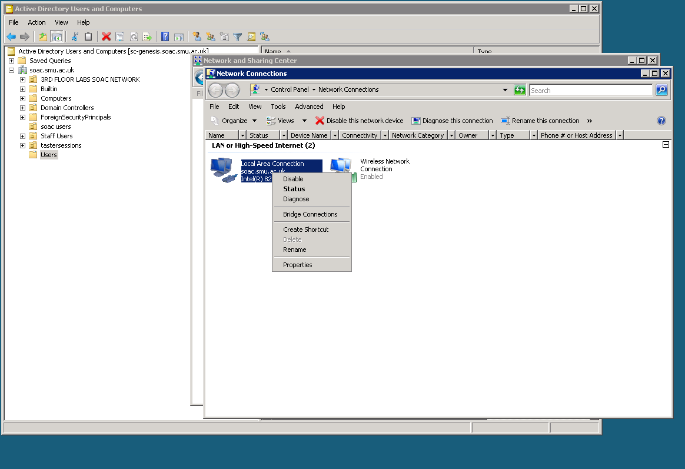
When renamed right click on the newly named adapter and choose Properties:
Now assign an IP address by clicking on TCP/IP version 4 and properties:
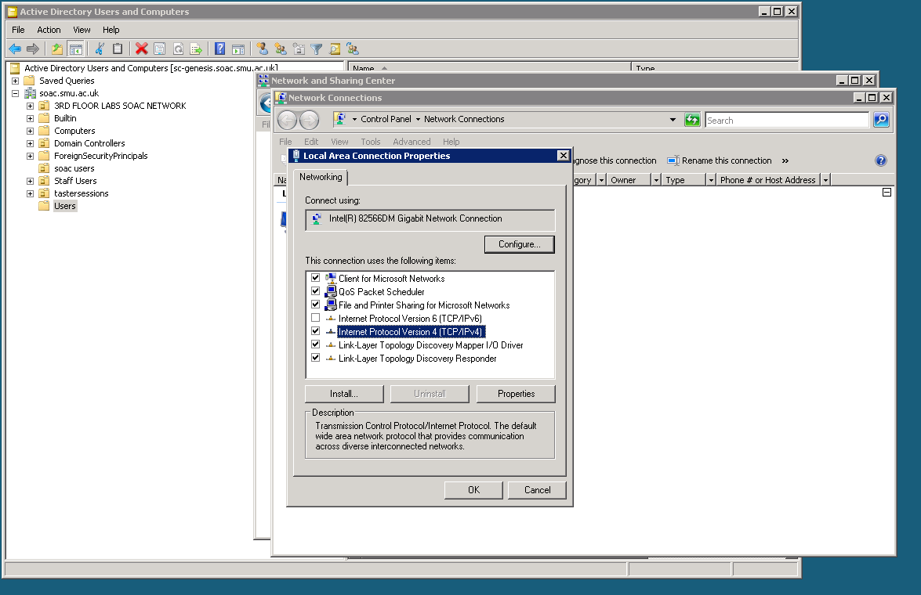

Allocate the following IP settings:
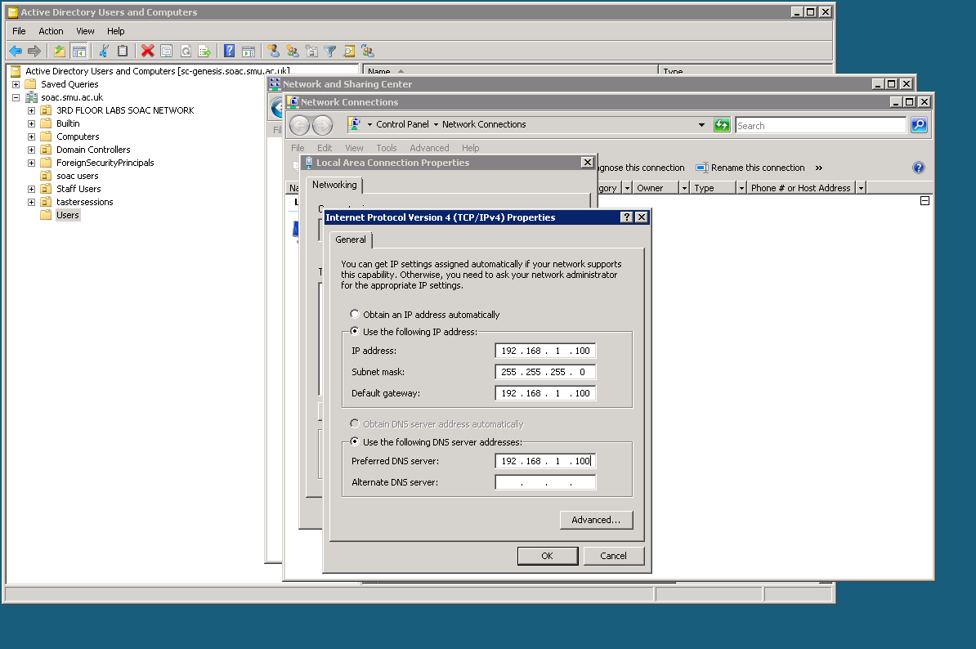
Now choose OK.
Go into Control Panel – Systems and Security – Windows Firewall and turn off the firewall. This is not usual, but is necessary for later applications of your network.
- In VirtualBox, go back to Settings and Network now click on the Adapter 2 tab check on enable Network Adapter and this time use the following virtual switch name (shown below):
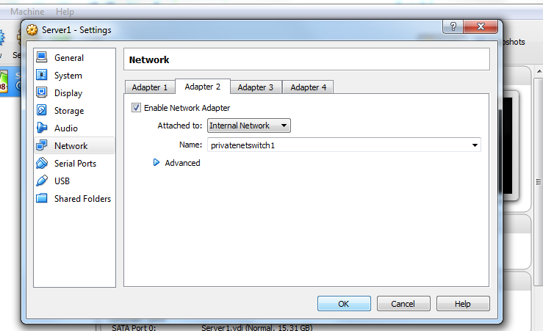
Start up the server in Windows 2008 and following the previous steps, renaming this new adapter to privatenet1. Assign the following IP settings to this adapter. Remember this adapter is the first of 2 hosts (Client1 will be the other) that are connected to the privatenet1.
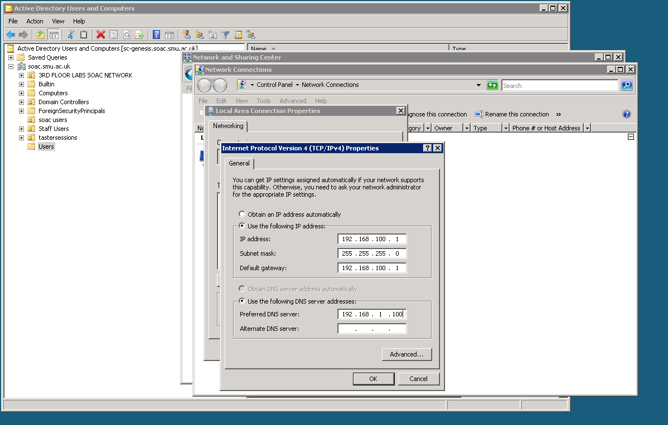
Task 2: Completing the Network
a). Repeat the above steps to configure Server2, use the following settings for the network adapters remembering that you should have 2 network adapters (we will need one to connect to the 192.168.1. class C network and one to connect to the 192.168.101 network).
b). Following this first network as your template, attempt to build the second private network on Server2 and Client2 (note that VMs can be cloned in VirtualBox, which saves time and effort – see the note at the end). There are some vital steps to bear in mind:
- Server2 has two adapters; Client2 has one
- One adapter in Server2 should be connected to Publicnetwork and therefore should receive a host address on the 192.168.1 network (e.g. 192.168.1.101).
- The other adapters should be connected to form a private network between Server2 and Client2 so the class C network should be common (e.g. both on 192.168.101) but the host part of the address should be unique (e.g. 192.168.101.1 for Server2 and 192.168.101.2 for Client2).
- Check all this very carefully – it can be frustrating to debug problems
Turn off the firewalls for all the virtual PCs (found in Control Panel – Settings – Firewalls) and restart the virtual computers. This is something we will only do in our virtual network, as it would be a security risk on a real network. It is necessary to permit the ping command (see below) to work.
Once built, try using the ping command to verify connectivity between hosts. Note which virtual machines are in contact.
To do this:
Click on the Start icon, then cmd (or put cmd in the search box). At the command prompt, enter
ping <ip address of the machine you want to verify is connected>
E.g. On 192.168.100.2 (Client 1) to see if Server 1 is connected
ping 192.168.100.1

Note:
If you are going to create Server2 and Client2 by cloning your first two virtual machines, don’t clone until you have installed the operating systems (these will also clone). Quite obviously, make sure the first pair are working properly before you clone them!
Key points:
- The cloning process will ask you whether to create new adapter MAC addresses. The answer to this is “yes”;
- Remember to change the IP4 addresses of the adapters for this second pair, otherwise you will have duplicate network addresses and nothing will work.
Also, it’s important to click “yes” when asked during cloning about changing the MAC addresses of the adapters. If you forgot to do this, you can change the MAC addresses under the “Advanced” section of Network Adapter settings.
Configuring virtual networking and using the dcpromo tool to upgrade a member server to a Domain Controller
Previously, we installed Windows Server onto a new partition with NTFS. Similarly we installed a client side operating system.

Here we first get our virtual networking configuration configured correctly to allow internal LAN connectivity between our Virtual systems.

Before we begin installing the Active Directory Service, we need to secure our login account since this account will be automatically elevated when we use it to configure a domain controller on this server.

We also need to add the Active Directory Domain Services role
- In the Server Manager window, open the Roles directory and in the Roles Summary section, click Add Roles
- On the Before You Begin page of the Add Roles Wizard, click Next
- On the Select Server roles page, select the Active Directory Domain Services check box, and the click Next on this page and the Confirmation page
- On the Installation Progress page click Install
- On the Results page after the role is successfully added, click Close

Creating an Active Directory Domain
We want to create our first domain, a Root Domain called uwtsd.com. When up and running the Active Directory and DNS will also be in place. For this exercise, we will not need to configure a child domain controller.

- Open the Internet Protocol Version 4 (TCP/IPv4) Properties window for the appropriate network adapter on your server
- Click Use the following DNS server addresses:
- Set the Preferred DNS server to the IP address of this network adapter

- Click the Start button, point at Programs, point at Administrative Tools, and then click Configure Your Server (alternatively you could click Start – Run – then type dcpromo).

- Click the Active Directory link on the left side of the window and then click Start the Active Directory wizard (you may have to scroll down a little to find the Start command). The Active Directory Wizard appears. Click Next to advance beyond the wizard's introductory screen.
- On the next screen, you are asked if you want to create a domain controller for a new domain or an additional domain in the existing forest. Choose the first option.

- Use an appropriate domain name (e.g. uwtsd.com).

- On the next screen you are asked to specify a folder on the computer that will hold the Active Directory database and the Active Directory log (the database holds all the information; the log holds the usage statistics). A default folder is specified for both the database and the log, so why mess with it? Go with the defaults by clicking Next.
- You are then asked to provide a folder for the Sysvol. This folder holds all the public files for the local Active Directory (which you want to make available to the Active Directory running on all other domain controllers in the tree). Again, a default folder is provided. Let's go with it. Click Next to continue.
- The next screen, shown below, wants to know if you want permissions set up so that they are backward compatible with any older version of windows. Choose Next to accept the defaults

- On the next screen, provide the password (and confirm it) that you want to use for the Administrator's account on this new domain controller. Use P@ssw0rd as the password associated with the administrator account, or the administrator password you have already set up for this server.

- After entering the info, click Next.
- The next screen provides a summary of the information that you provided on all the other wizard screens. Look it over (if you need to change anything, click the Back button) and then when you're ready, click Next.
- A screen pops up letting you know that the Active Directory Wizard is configuring the computer as a domain controller for your new domain. This may take a few minutes (but probably less time than it took to answer all the questions from the wizard!)
- When the wizard has completed its job, a screen appears letting you know that the Active Directory is good to go. Click Finish on the message screen and then click Restart on another box that pops up to complete the installation.
- After your server has rebooted, log on using the password you specified during that whole routine with the wizard and you're logged into the domain controller.
- NB: An important tip to remember; ONLY Domain admins level accounts can log onto a Domain controller server.

The Active Directory Users and Computers snap in should now be available as a program from Start – All programs - Administrative Tools (Active Directory Users and Computers). Launch this program to start creating the objects in your newly installed Network Directory Service.

Installing Client Computers and Basic Object creation in the Active Directory
To create domain objects we must first be in the right place within the directory. Click the domain icon (e.g. uwtsd.com) to expand it.

Click the Computers node to open it. Any servers or workstations that have already been added to the domain appear in the Details pane.

To add the new computer (the Windows 7 Domain client) to the domain, right-click the Computers container and point at New on the shortcut menu. Now select Computer from the cascading menu. The Create New Object - (Computer) dialog box appears, as shown in the diagram below.

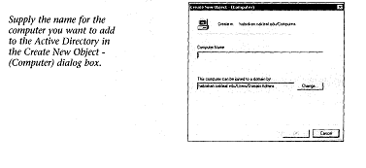

To specify the computer that you will add to the domain, type the name of the computer in the Computer Name box.

Give the computer an appropriate name (e.g. Domainclient1).

The default group of users (Domain Admins) that can add a computer to the network/domain is also specified in the dialog box (you don't need to change this; it should remain Domain Admins). Click OK to add the computer to the domain.

After you close the dialog box and return to the Active Directory, you will find that the computer you added to the domain is now listed in the Details pane of the Active Directory. After a Windows 7 Pro workstation has been added to the Active Directory, you can then connect the computer to the domain and allow your users to start using the computer for network access.

Installing/Connecting a Windows 7 client to the domain
- Install Windows 7 on the client Virtual machine in your domain
- You will need to open network and sharing center and then find the change adapter settings link. Right click on the adapter choose properties.
- Now choose the IP Version 4 settings and click properties. Here you will need to ensure an appropriate IP address from the 192.168.100. class c subnet is provided (e.g. 192.168.100.2. Furthermore you will need to enter the DNS address (this is the IP address of the Domain Name Server against which you wish to authenticate this client membership). So it is important to ensure Primary DNS is set to the right IP address.
BE CAREFUL – should this be 192.168.100.1 or 192.168.1.1?
Do not enter any parameters for Alternate DNS.
- To add the machine to the domain, right click on Computer (Note you will need to be logged in with an admin account).
- Choose Properties
- Then choose advanced system settings.
- Click on the Computer Name tab (top of the window)
- Click change
- In the domain text field type uwtsd.com (or whatever you called your domain).
- You will be asked to authenticate using an appropriate uwtsd domain account. This will be the administrator account you used to setup Active Directory earlier.

Comment
There is an oddity here, which arises because we are using VirtualBox’s approach to virtual networks. In most conventional networks with separate physical routers, the network gateway is the router’s IP address, and the server and its associated DNS are a separate IP location within the subnet. Here we have put the server and router together.

Observational Tasks 1
A). State the benefits of using Type 2 Hypervisor virtualisation software in your design. Comment on the strengths and weaknesses of the VirtualBox platform used in your network
B). Explain, with use of diagrams, the significance of the following terms: Active Directory Forests, Trees, Parent and Child Domains
C). Investigate and document the main roles and responsibilities of an Active Directory Domain Controller
D). What actions could we take in the event of a Domain Controller becoming unavailable?

Installing and configuring the DHCP Service

DHCP Part A: INSTALL / AUTHORISE THE DHCP SERVICE.

Please note your client needs to be connected to the domain before you begin. Also all your VirtualBox network settings should be correctly configured (e.g. Internal network mode on client and server)

[Complete DHCP Part A and Part B from the Server Machine]

- Start – Administrative Tools – Server Manager
- Click on Roles and then choose Add Role from the top menu
- Choose next and the default screen
- From the list of available services to install check on DHCP Server - .
- Choose Next at the next notification page.
- At the Select Network Connection Bindings screen choose the available network connection (it is shown along with the IP address).
- Accept the defaults and choose Next at the Specify IPV4 DNS Server Settings page.
- Choose WINS IS NOT REQUIRED FOR APPLICATIONS ON THIS NETWORK.
- Choose Next at the Add or Edit DHCP Scopes page.
- At the Configure DHCPV6 Stateless Mode screen choose – Disable DHCPV6 Stateless Mode for this Server – choose Next
- At the Authorise DHCP Server page choose Use current credentials.
- Choose Install - the Service will begin installing
- You should restart your server when the install is complete.
- To activate the scope, in the console tree, right click the Scope you’ve just created and click Activate.
- The scope should be active (next to the scope you have created you should see a small green tick/light. This informs the DHCP service the scope is active and is ready to lease IP addresses to clients.

DHCP Part B: CREATING A DHCP SCOPE FOR LEASING IP ADDRESSES TO DHCP CLIENTS ON THE PRIVATE NETWORK

DHCP Scopes:

When we have installed DHCP onto our Network, the next step is to create a scope.

A scope is a range/pool of IP addresses (held within an IP address database), that are valid to be leased/assigned to DHCP clients within a particular NETWORK. Here we will create a scope for our Private Network.

The scope must be configured before clients can use DHCP server for dynamic TCP/IP configuration.

Each subnet is allowed a single DHCP scope that has a single continuous range of addresses. Specific addresses for applications (e.g. Web Servers, Print Servers) should be made exempt/excluded from the range that DHCP scope specifies (e.g. Reserved IP Addresses).

Task:

- Start – Administrative Tools – DHCP Console
- In the Console tree – click the Server
- On the Action Menu – choose New Scope
- At the New Scope Wizard window – choose Next
- Scope Name: SalesClient
- Start IP Address: the IP address of the client, Go to the client machine and verify this address, whilst here you must set the client adapter to ‘Obtain IP address automatically and do the same with the Obtain DNS Server address automatically option.
- End IP Address: the same address as above
- Subnet Length: 24
- Lease duration: accept defaults
- Options: None (If asked say No to configuring options at this stage).

For demonstration purposes, we are only using one IP address in the Scope for the client in your network. At this time, we will not configure the Router: Default Gateway, Domain Name and DNS server and the WINS Server options.

DHCP Part C: TESTING DHCP LEASES

[Complete DHCP Part C from the Windows 7 client]

- Log in to the CLIENT with the following credentials:

User Name: Administrator
Password: P@ssw0rd
Domain: SALES or SMU this purely depends on which domain Server you have completed the previous tasks.

- Start – Run – cmd

- Type: ipconfig /release
- Type: ipconfig /renew (to obtain an IP address from DHCP Server)
- Type: ipconfig /all

NOTE: Verify that the DHCP server IP Address is the IP address of the Server we have installed DHCP and created Scopes on.

DHCP Part D: CONFIGURING DHCP OPTIONS

[Complete DHCP Part D from the Server]

- Start – Administrative Tools – DHCP Console
- In the console tree - Click Address Leases, verify that the Computer Name displayed is that of the client.

Configuring DHCP options with DHCP Server Service

Another vital stage in the process of setting up/configuring the pools of IP addresses that the DHCP server will hand out is managing DHCP options.

3 Common Management options:
- Server Options: Options that will apply to all the DHCP clients for the particular DHCP Server.
- Scope Options: Assigns values to just clients that get IP addresses from a particular scope
- Client Options: Assigns values to only those computers that have a client reservation.

DHCP options are parameters (values) that DHCP service assigns to DHCP clients when it assigns the IP address and Default Gateway:

The common DHCP options administrators can configure:

- Default Gateway – Address of the ‘next hop’ Router.
- Domain Name – Defines the name of the domain, to which the client belongs, e.g. smu.com
- DNS & WINS Servers – Addresses of DNS/WINS servers that clients can use for Network Communication.

Configuring DHCP Scope Options

- Open DHCP console
- In the console tree, under the server name click Scope Options
- In the Action menu – click Configure Options
- Option Level: Scope
- Option: 003 Router
- Option IP address: IP address of the Server (this would usually be the address of the Router device or the ‘default gateway to our network.

Testing the DHCP Options

[Complete this last part of DHCP Part E from the client PC]

- Start – Run – cmd
- Type: ipconfig /renew (to obtain a new IP address from DHCP server)
- Type: ipconfig/ all (verify that default gateway IP address for the connection is the IP address of the Server

