
Master of Business Administration
International Business pathway

Module name: International Marketing: Principles and Practices
Module code: LCMB7026
Lecturer name: Tushara Balendran
Student Name: Md Moinul Hasan Bappy
Student ID: 2503567
Word count:
Submission date: 24.4.2026

AI use acknowledgement
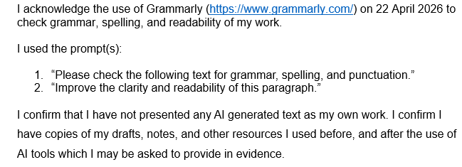

Table of Contents
Introduction 4
Section 1: Report 5
Background Information about Mercedes 5
a. The Macro Environment Analysis (PESTEL) of Mercedes-Benz in Germany and China 6
b. Comparative Analysis of STP (Segmentation, Targeting and Positioning) Strategies of Mercedes-Benz in Germany and China 13
1. Segmentation Strategy 13
2. Targeting Strategy 14
3. Positioning Strategy 15
4. Differences and similarities between German and Chinese Positioning Strategy 16
5. Similarities and Differences in STP Strategy 17
International Marketing Mix (7Ps) for Germany and China 18
1. Product Strategy 18
2. Price Strategy 19
3. Place (Distribution) Strategy 21
4. Promotion Strategy 21
5. People 22
6. Process 23
7. Physical Evidence 23
Germany vs. China Comparison of the 7Ps Marketing Mix. 26
c. Directional Development Strategy Using the Ansoff Matrix (China Market) 28
Definition of Directional Development Strategy 28
Application of the Ansoff Matrix to Mercedes-Benz in China 29
d. Ethical Issues Related to Mercedes-Benz Marketing Mix (China) 30
Ethical Marketing Practices 30
e. Recommendations for Future International Marketing Strategies 31
Section 2: Reflective Account Using Gibbs Reflective Cycle 32
1. Description 33
2. Feelings 33
3. Evaluation 33
4. Analysis 34
5. Conclusion 34
6. Action Plan 35
Conclusion 37
References 38

Introduction
International marketing is the way through which firms plan, market, and sell products or services in other nations and even adjust their strategies to suit varying economic, cultural and legal conditions (Baack, 2018). Global companies like Mercedes-Benz Group AG need to be aware of such differences in order to compete effectively in the international markets. This report evaluates the international marketing of Mercedes-Benz in Germany and China through the lens of understanding the macro environment, STP strategies, marketing mix decisions, growth strategies and ethical issues that affect the operations of the company in Germany and China. The report will also include a PESTLE analysis, cultural analysis presented by Hofstede, Ansoff growth strategies, and reflective analysis of international marketing practises.

Section 1: Report

Background Information about Mercedes
The Mercedes-Benz Group AG is one of the best automobile manufacturers in the world, with its headquarters in Stuttgart, Germany and the company was created in 1926 by Karl Benz and Gottlieb Daimler. Its mission is to provide innovative, luxury and sustainable solutions in mobility, and its vision is to be the future of premium mobility through advanced technology, electrification, and global automotive excellence. By 2024, Mercedes-Benz will be present in more than 150 countries and will have sold around 2.04 million automobiles worldwide in 2023, bringing in a turnover of around 153 billion euros. Germany is the largest market of the brand in Europe, with more than 267,000 vehicles sold in 2023, and China is the largest market of the brand in the world, with approximately 737,000 vehicles sold or more than 36 per cent of the total global sales (Ban, 2025).
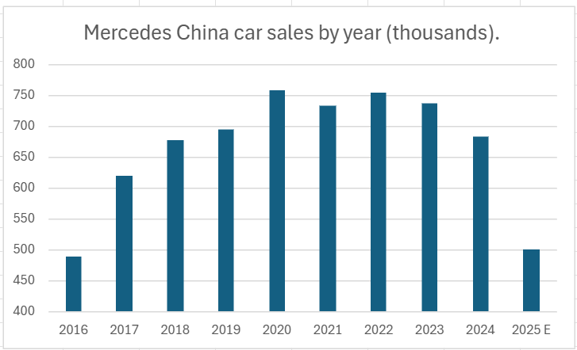
Figure 1: Mercedes China Car Sales by year
Source: (Ban, 2025)

a. The Macro Environment Analysis (PESTEL) of Mercedes-Benz in Germany and China
PESTLE analysis is a strategic model that is employed in analysing the influence of Political, Economic, Social, Technological, Legal, and Environmental forces in the external business environment of a company (Dalirazar and Sabzi, 2023). In this section, the analysis will involve the PESTLE factors influencing the operations of Mercedes-Benz Group AG in Germany and China.
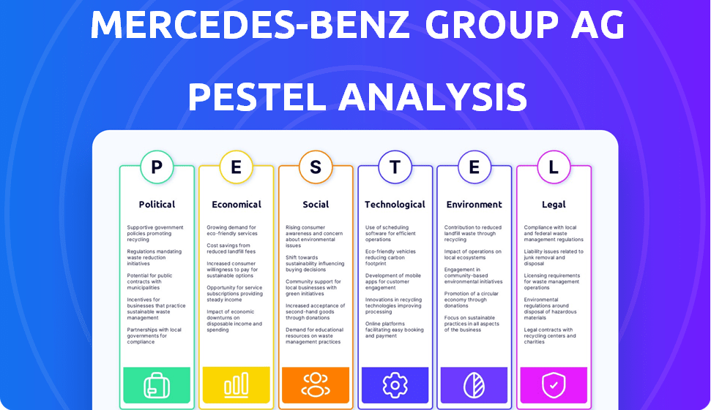
Figure 2: Pestle Analysis of Mercedes-Benz
Source: (The4, 2025)
Political Factors
Germany: Germany offers an extremely favourable political climate to Mercedes-Benz, given that it is the home country of the company and one of the most stable democracies in Europe. Germany has a score of above 1.5 in political stability, which translates to good institutions and regulatory transparency (Global Economy, 2024). The German automotive industry generates about 5 per cent of national GDP, and more than 830,000 individuals are employed in the industry, which shows that the government is highly supportive of automotive production.
Mercedes-Benz finds this political climate very favourable because stability, good institutions and government favour mean that the risk of doing business is low, and it can invest in the long term.
China: China also offers a slightly favourable political environment that is more regulated for Mercedes-Benz. The Chinese government is a great supporter of the automotive industry, which produced over 30 million vehicle shipments in 2023, the largest automotive market in the world (Automobility, 2024). China is also relatively stable politically, and the government has been very supportive of the automotive industry, which manufactured more than 30 million vehicle deliveries in 2023, the largest in the automotive industry in the world.
Generally, this political climate is fairly favourable, since the company is well supported by the government, but the regulations and government intervention pose some restrictions to overseas companies.

2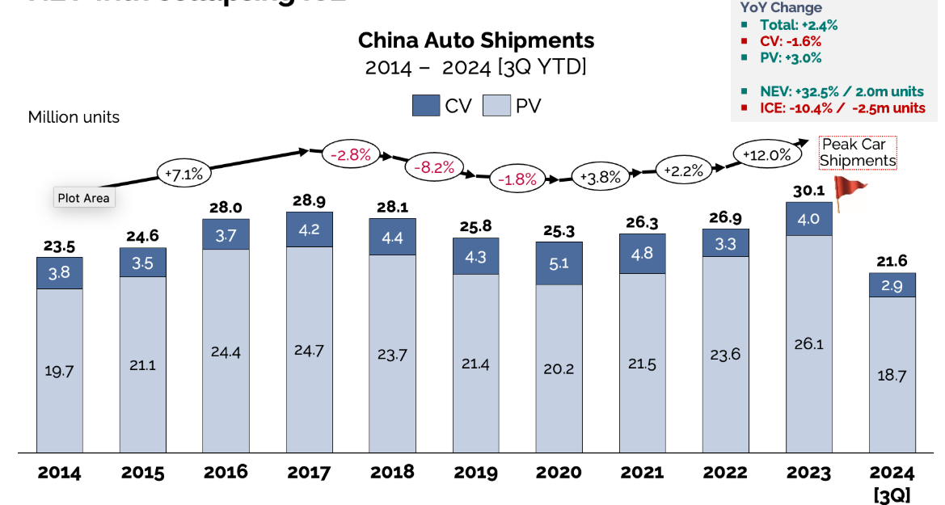
Figure 3: Total Shipments of Chinese Vehicles
Source: (Automobility, 2024)
Economic Factors
Germany: Germany is the largest economy in Europe, and its GDP stands at about 4.5 trillion in 2023, according to the International Monetary Fund. In 2023, approximately 2.84 million new passenger cars were registered in the German automotive market, with a considerable portion registered in luxury brands. It has an inflation rate of about 2.2% in 2025, and this is capable of lowering consumer expenditure on luxury cars (Statista, 2025). In 2023, the economy of Germany slightly shrank as price-adjusted GDP decreased by 0.3% because of high inflation, energy prices and low demand, and the GNP was high at USD 4.564 trillion.
The economic climate is moderately favourable, with high buying power and an established luxury market working in favour of Mercedes-Benz, yet inflation and a slowdown in the economy pose challenges to demand.
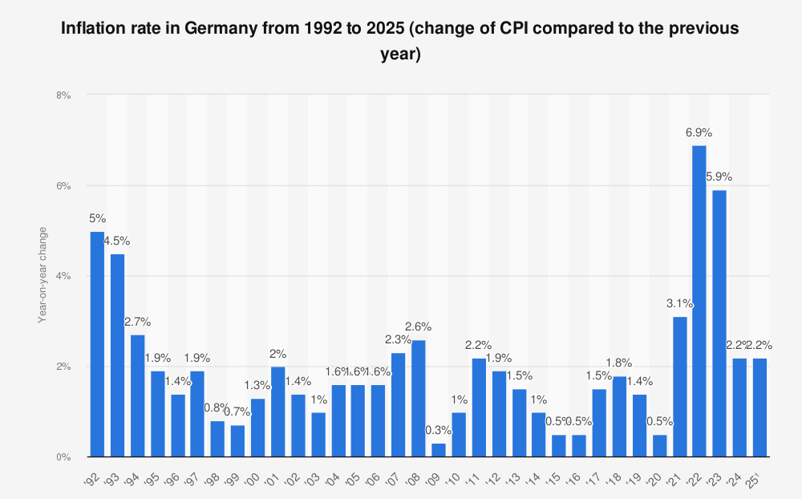
Figure 4: Inflation rate of Germany
Source: (Statista, 2025)
China: China is one of the most promising markets to be targeted by Mercedes-Benz because of the huge population and the increasing middle class. In 2023, the GDP of China amounted to around $17.7 trillion, which is the second-largest economy in the world (Ban, 2025). By 2023, the Chinese economy was stable, with a 5.2% rise in the GDP in line with government expectations, and GNP activity of about 125 trillion yuan. The inflation rate in China was only 0.2% per year, as compared to the government's target of approximately 3% per year.
The economic climate is very favourable, with high growth rates, income growth and a high number of consumers, which boosts the demand for luxury cars at a very high rate.
Social and Cultural Factors
Germany: German consumers are generally concerned with the quality of engineering, reliability, and environmental performance when they buy cars (Rastogi and Agarwal, 2023). Favourably, this pushes the demand for electric cars, fuel economy and high innovations in safety. Unfavourably, the high expectations make it more cost-sensitive and force manufacturers to invest in costly sustainable technologies constantly to stay on par.
In general, the social environment is good, yet challenging, with a focus on high-quality and high-end products and a growing focus on innovation and cost pressure.
China: Chinese consumers, on the contrary, include luxury cars as markers of social status and wealth. Social trends in China show that younger consumers have an increasing appeal to luxury and technologically advanced cars, and car ownership is becoming a symbol of social status, innovativeness, and prestige brand image (Ngai and Cho, 2025). The image of a brand is an important factor in the purchasing process.
This is a very favourable social environment with very high status consumption and brand consciousness, which creates a high demand for luxury brands such as Mercedes-Benz.
Cultural Differences Using Hofstede’s Cultural Dimensions
1. Power Distance
Germany has a low power distance culture with a score of 35, indicating that equality, decentralisation, and participative decision making are cherished (Bochner and Hesketh, 2022). Conversely, China has a score of 80, meaning that the society is hierarchical and authority and status are valued.
Comparison & Implication (Mercedes-Benz):
In the case of Mercedes-Benz, low power distance in Germany is good since consumers consider cars according to performance and quality, but not status. But in China, power distance is also positive, and luxury vehicles are a good indicator of status, which increases brand reputation and market demand (Kim and Zhang, 2014).
2. Collectivism vs Individualism.
The 67 score of Germany indicates a highly individualistic culture, in which personal preferences and making independent decisions are the dominant factors. A score of 20 in China represents a collectivist society in which opinions of the group, family matters, and social recognition influence purchasing behaviour (Nickerson, 2025).
Comparison & Implication (Mercedes-Benz):
Individualism is positive in Germany because consumers appreciate personalised features and engineering quality. Collectivism in China is favourable but complicated, because social approval is a factor in purchasing decisions; therefore, Mercedes-Benz can leverage its good brand image but focus on prestige and social status in its marketing (Narang, 2016).
3. Long-Term Orientation
China is ranked at 87, which means that the country has a high long-term orientation, aimed at perseverance, investment, and future rewards (Morck and Zhao, 2023). Germany also scores 83, which means that they are oriented on durability, quality, and long-term value.
Comparison & Implication (Mercedes-Benz):
This dimension is very favourable in the two countries. German consumers love engineering longevity, whereas Chinese consumers love long-term investment and brand image (Frey, 2004). Nevertheless, in China, the ongoing innovation can put additional pressure on the company.
Advantages of the Hofstede Model:
The Hofstede Cultural Dimensions model has some crucial benefits to Mercedes-Benz in the process of examining foreign markets like Germany and China. The model allows the firm to compare the cultural values across nations quantitatively through numerical indices (Vonk, 2024). For example, the individualism level of Germany is 67 against 20 in China; thus, Mercedes-Benz can clearly see why Germans feel so keen on product quality and engineering performance.
Disadvantages of the Hofstede Model:
Although the Hofstede model is useful, it has a series of weaknesses as it applies to the international marketing strategy of Mercedes-Benz. The key weakness is that the model relies on information that was initially gathered on IBM employees in the 1970s and that might not necessarily represent the current consumer behaviour as seen in fast-evolving markets like China, where more than 60 per cent of luxury car consumers are below 40 (Minkov and Kaasa, 2020).
Technological Factors
Germany: Technological innovation is one of the critical considerations that would determine the competitiveness of Mercedes-Benz (Mercedes-Benz Group, 2022). Germany is a car engineering and innovation leader in the world, with an investment of about 3.1% of its GDP in research and development in 2023. Mercedes-Benz takes advantage of this high-tech ecosystem with great research centres in Stuttgart and Sindelfingen.
This is a very favourable technological environment since powerful R&D infrastructure and innovation strength promote product development and competitive advantage.
China: China is also a very technologically developed market, especially in electric cars and internet connectivity. By 2023, the country had over 60 per cent of all the electric vehicle sales in the world, and sold over 8 million electric vehicles within the country itself. Chinese customers are highly fond of smart car features, such as AI-enabled infotainment systems, voice assistants, and advanced driver-assistance systems (Han, 2025).
This technological environment is more than favourable, with fast innovation and high levels of adoption of smart technologies providing great opportunities to Mercedes-Benz.
Environmental Factors
Germany: The automotive industry of the world is increasingly being influenced by environmental regulations and sustainability concerns. The environmental policy in Germany is considerably decisively affected by the Green Deal of the European Union, which seeks to alleviate greenhouse gas emissions by 55 per cent by 2030 in comparison with the 1990s (Thiel and Schmidt, 2025).
This environment is relatively favourable, because it promotes innovation of electric vehicles, but also compliance costs and regulatory pressure.

China: Rapid urbanisation and industrialisation are other significant challenges to China in terms of environmental issues. Beijing and Shanghai are some of the cities that have been hit by extreme air pollution, and the government has come up with stringent environmental policies that encourage green mobility.
This is a favourable environment, because stringent regulations are increasing the need for electric vehicles, which is advantageous to the sustainable product approach of Mercedes-Benz.
Legal Factors
Germany: The German legal environment offers a very transparent and well-regulated environment for automotive firms like Mercedes-Benz. The European Union General Data Protection Regulation (GDPR) 2016/679 is one of the most significant legal regulations that influences the company and rigidly regulates the gathering and utilisation of personal data.
This is a favourable legal environment, whereby transparency and high levels of legal protection provide a stable and predictable business environment, despite compliance requirements.
China: The foreign automotive companies find it harder to operate in a complex legal environment in China. Mercedes-Benz also has joint ventures in part due to the Foreign Investment Law of the People's Republic of China (2019), which governs foreign business operations. Also, the Cybersecurity Law of China (2017) and the Data Security Law (2021) have strict regulations on storing and transmitting vehicle and consumer data, especially connected vehicles (Wang and Chen, 2025).
This is a moderately poor legal climate, with stringent rules and data protection, and joint ventures that restrict the flexibility of operations by foreign businesses.
Similarities and Differences of PESTLE Between Two Countries:
Similarities: Germany and China are both politically stable regions, and both countries support the automotive industry. Both are large and influential economically, and they have a high demand for premium vehicles. Both nations have the lead in terms of technology, especially when it comes to electric cars and smart technologies. Also, harsh environmental rules in the two markets drive Mercedes-Benz to sustainability and low-emission mobility (Bharadwaj, 2018).
Differences: Germany puts more premiums on quality, engineering and regulatory transparency, whereas China puts more emphasis on market size, fast growth and state control. German consumers are more concerned with performance compared to Chinese consumers, who emphasise status and brand image. China is a more complicated country according to the law in terms of foreign investment and information laws (Corne, 2023).

b. Comparative Analysis of STP (Segmentation, Targeting and Positioning) Strategies of Mercedes-Benz in Germany and China

1. Segmentation Strategy
Market segmentation is the breakdown of a wide market into smaller and homogenous groups of consumers sharing similar needs, characteristics, or behaviours in order to target the customers effectively (Flashman, 2022). Mercedes-Benz uses a differentiated segmentation approach in Germany and China.
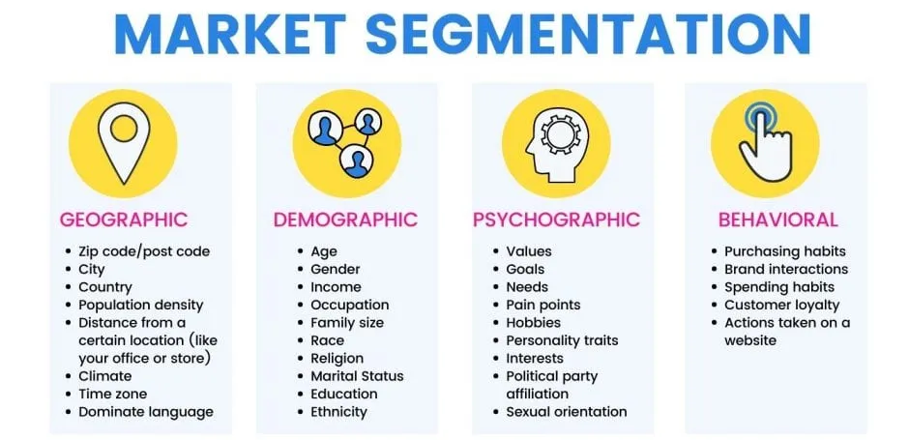
Figure 5: Market Segmentation
Source: (Flashman, 2022)
Demographic Segmentation:
This consists of age, sex, income, education, occupation and marital status. The brand in Germany is aimed at older (45+), high-income professionals and executives, and families with stable careers and higher education (Kalinowska and Kuhfeld, 2023). In China, it targets younger people (below 40), and entrepreneur and professional buyers in the fast-moving middle and upper classes, who have a strong purchasing power.
Geographic Segmentation:
Mercedes-Benz focuses on the urban and economically developed areas (Iosifidou and Achillas, 2024). Munich, Frankfurt, and Stuttgart are some of the major markets in Germany and Beijing and Shanghai are the cities that are the dominant markets in China because of their high disposable income.
Psychographic Segmentation (VALS):
German consumers fall into the category of the VALS framework as they are characterised by the thinkers and the achievers because they appreciate quality, sustainability, and reliability (Gutscher and Scholz, 2024). Chinese consumers are status, innovation and social recognition oriented, and they like technologically advanced luxury cars.
Benefit Segmentation:
The primary benefits in question are different:
- Germany: product lifecycle, fuel use, safety and the environment (Schreiber, 2017).
- China: status, brand, high-tech and social status (Schlegelmilch, 2022).
Behavioural Segmentation (Usage & Commitment):
The brand loyalty and repeat buying patterns of customers in Germany are high and particularly among corporate customers who prioritise long-term value (Bracke and Inoue, 2023). Consumers in China upgrade frequently and lack commitment to the long term as they want the newest features and prefer to adopt technologies fast (Wiedmann, Hennigs and Siebels, 2022).

2. Targeting Strategy
The differentiated approach that Mercedes-Benz employs targets different marketing mixes to different segments of customers in Germany and China instead of one undifferentiated approach. (Li and Wang, 2021).
Target Market in Germany: Mercedes-Benz in Germany is aimed at the middle-income professionals, corporate executives and mature customers (40 to 60 years). This segment is concerned with reliability, excellence in engineering and sustainability. The marketing mix that the company develops is targeted at high-quality, safety, and environment-friendly innovations (e.g., EQ electric models). Also, corporate fleet buyers are one of the target markets, which also demand individual pricing, leasing, and after-sales services (Propfe and Kreyenberg, 2024).
Target Market in China: On the other hand, Mercedes-Benz uses a different marketing mix among the younger wealthy customers (30-45), entrepreneurs, and urban elites. This is a more aspirational, digitally oriented group. In its focus, the company focuses on fashionable design, superior infotainment, and luxury experience, which translates to a high level of status-oriented consumption in China (Heinonen, 2024).

3. Positioning Strategy
Mercedes-Benz adopts a benefit positioning, but with the help of competitive differentiation, the company employs a support of user positioning (Li and Wang, 2021).
Germany (Benefit Positioning):
The brand is placed on the functional aspects of the brand like engineering quality, durability and sustainability. It emphasises German tradition and technological excellence, which attracts rational and quality-conscious buyers (Pylkkönen, 2023).
China (User Positioning):
In China, Mercedes-Benz focuses on user positioning, which depicts customers as high-status people who are successful. Marketing communications revolve around prestige, exclusivity and a luxury lifestyle, which coincides with cultural values of hierarchy and social recognition (Kim et al., 2019).
Perceptual Map (Conceptual):
A perceptual map can position Mercedes-Benz along two axes:
- X-axis: Price (Low → High)
- Y-axis: Luxury/Technology (Basic → Advanced)
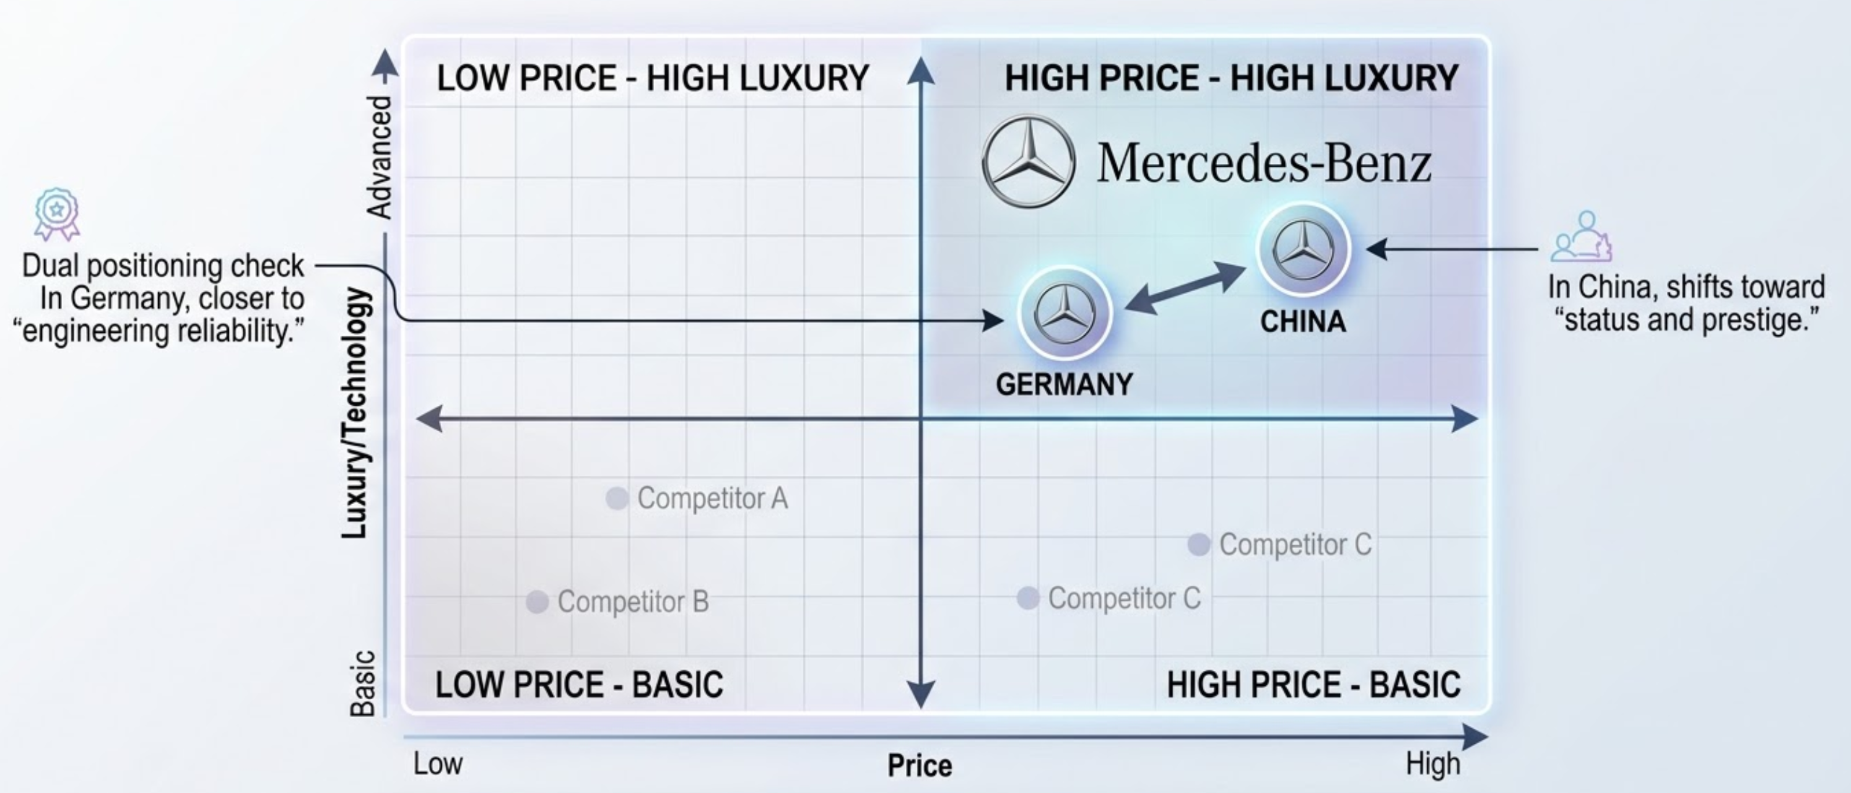
Figure 6: Perceptual Map
Source: (Self-Made)
In both markets, Mercedes-Benz occupies the high price–high luxury quadrant, but:
- In Germany, it is closer to “engineering reliability.”
- In China, it shifts toward “status and prestige.”
This dual positioning strengthens its competitive advantage across culturally distinct markets.

4. Differences and similarities between German and Chinese Positioning Strategy
Mercedes-Benz has a relatively steady global high-end positioning in both Germany and China, but the means of communicating this positioning and having it perceived vary greatly because of cultural, economic, and consumer behaviour variation (Li and Wang, 2021).
Similarities:
In Germany, as well as in China, Mercedes-Benz is a high-end luxury brand that is linked to high quality, innovative technologies, and high prices. The brand has always been in the high price, high luxury quadrant in the two markets, and this has helped it to strengthen the global image as a brand of excellence and innovation. This uniform positioning helps in maintaining uniformity in brand and enhances brand equity at the global level. Also, in both nations, Mercedes-Benz focuses on innovation, especially on electric mobility and high-technological automotive, which follows its global strategic vision (Iosifidou and Achillas, 2024).
Differences:
Although such a similarity in premium positioning, the essence of the value proposition is quite different in both countries. Positioning in Germany is functional and performance-based in nature and is centred around engineering excellence, reliability, safety and sustainability (Easa and Yan, 2019). The consumers are also more rational and quality-oriented, i.e. Mercedes-Benz competes with technical superiority and value over the long run.
Conversely, positioning in China is more symbolic and status-based, whereby Mercedes-Benz is a symbol of social prestige, success, and a luxury lifestyle. The brand targets emotional and aspirational needs, especially the younger generation that values owning a car as a symbol of social acceptance and personal success. Consequently, marketing communication in China is more focused on exclusiveness, design, digital capabilities, and brand image as compared to Germany (Polfuß and Sönmez, 2020).
The other important difference is in consumer motivation. Product attributes and performance benefits are important to German consumers, but Chinese consumers value the brand image and social signalling more (Kreppel and Holtbrügge, 2012). It leads to the repositioning of Mercedes-Benz in Germany to benefit positioning in China, to user and symbolic positioning.
Overall Evaluation:
This two-tiered positioning approach is a very successful one, since with this tactic, Mercedes-Benz is able to sustain a uniform worldwide luxury image, and in the same breath, it will also be able to adjust to the local market demands. Nevertheless, it must also be strategically balanced in such a way that it does not undermine global brand coherence by localisation.

5. Similarities and Differences in STP Strategy
Similarities: Both Germany and China are key markets to Mercedes-Benz, though the STP strategy of the company is indicative of significant variation in economic factors and cultural values. Mercedes-Benz in both nations is aimed at high-income consumers and is a premium luxury brand with a global brand identity (Pylkkönen, 2023).
Differences: Germany is a technologically and luxury-conscious mature market that emphasises engineering quality, sustainability and reliability. On the contrary, China is a fast-expanding and status-oriented luxury market, with younger consumers being more oriented to brand prestige and social statusb (Rovai, 2016). These variations indicate why Mercedes-Benz prioritises technical excellence and environmental innovation in Germany, and luxury status and intelligent technology in China.

International Marketing Mix (7Ps) for Germany and China
The marketing mix, also known as the 7Ps, encompasses product, price, place, promotion, people, process, and physical evidence, which is applied to create the appropriate marketing strategies in various markets (Armstrong et al., 2014). Mercedes-Benz uses the marketing mix to align with the economic, cultural and consumer behaviour in Germany and China.
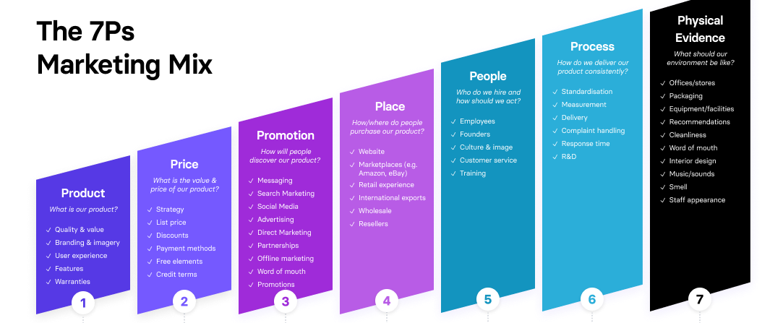
Figure 7: The 7Ps Marketing Mix
Source: (Brooks, 2020)

1. Product Strategy
The product component of the marketing mix is the aggregate product being offered to the consumers in terms of features, quality, design and branding. In the case of Mercedes-Benz Group AG, product strategy is formed based on innovation, luxury and performance, however, this is modified differently in Germany and China.
Product depth is there when one product line is varied. Mercedes-Benz has high product depth in the form of various variants of each model range, e.g. C-Class, E-Class and S-Class, all of which are available in different engine types, trims, and technological features (Mercedes-Benz, 2020). This will enable the company to satisfy the various customer preferences within the same segment in both Germany and China.
Product width is the diversity of the product lines. Mercedes-Benz has also gone wider with brand extensions like EQ electric cars (e.g. EQS, EQE), AMG performance models and Maybach ultra-luxury cars (Mercedes-Benz Group, 2022). The extensions allow the firm to reach environmentally conscious consumers in Germany and status-oriented luxury consumers in China.
Mercedes-Benz concentrates on high branding, innovation leadership and heritage positioning in terms of branding strategies (Iosifidou and Achillas, 2024). The brand has a stable global identity, but it makes changes, such as infotainment systems and digital connectivity in China.
Product change within markets is influenced by a number of factors such as the level of technology, environmental policies and also cultures (Cui et al., 2006). This is favourable to innovation, but expensive to production, as in Germany, more stringent environmental policies are driving the creation of electric and sustainable cars. In China, the environment is favourable to the technologically advanced and customised vehicles due to the high demand for digital features and luxury.
Although the basic product is similar in all countries, Mercedes-Benz focuses on selective adaptation whereby it provides functional value in Germany and symbolic and technological value in China.

2. Price Strategy
Pricing strategy is a term that is used to describe the way in which a particular company determines and modifies prices according to the market conditions. In Germany and China, Mercedes-Benz uses a premium pricing strategy as it is a luxury brand.
Pricing decisions are dependent on a number of factors. First, the markets vary in terms of demand. Germany is experiencing stable demand with mature consumers with a desire to be reliable, and China is experiencing high growth demand with young luxury buyers. Second, there is the element of competition, whereby there is intense competition against BMW and Audi in Germany, and intensive competition with the global and domestic luxury brands in China. Third, affordability is influenced by inflation and economic conditions. The moderate inflation in Germany can lower the disposable expenditure, and thus the environment will be slightly unfriendly, whereas the relatively constant inflation in China will favour the purchasing power and hence be favourable (Rosa, 2020). Lastly, the general economic stability in the two nations favours premium pricing, even though China needs a greater degree of flexibility due to competition in the market.
Germany: The GDP per capita of Germany is about $54,000 in 2023, and the country has a high buying capacity for luxury cars. Mercedes-Benz practises a premium price policy whereby luxury products are priced between 50, 000 and 120, 000 euros according to specifications (Intelligence Node, 2026). Nevertheless, economic pressures, e.g. 5.9% inflation in 2023, can decrease discretionary spending, demanding flexible financing and leasing programmes.
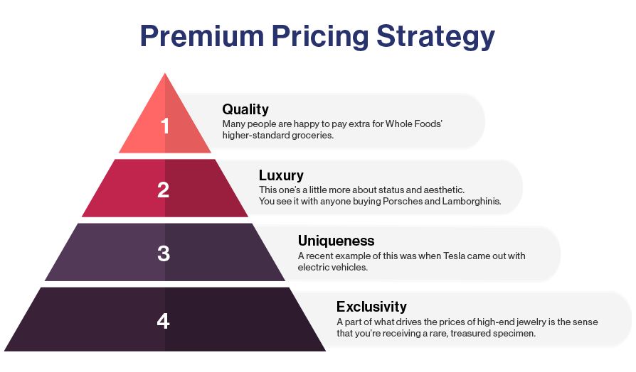
Figure 8: Premium Pricing Strategy of Mercedes
Source: (Intelligence Node, 2026)
China: The Chinese automotive market is much larger; in 2023, it sold more than 26 million passenger cars, which is almost nine times the German market. Mercedes-Benz also maintains premium pricing in China, though with wider price bands and finance plans to appeal to younger luxury consumers (Guevara, 2021).
Evaluation: The two markets are in premium brand positioning, but China needs a little bit more relaxed pricing and funding policies because its consumers are younger and the luxury market is more competitive.

3. Place (Distribution) Strategy
Place is the distribution of products and their availability to the customers. The combination of direct and indirect channels of distribution employed by Mercedes-Benz in both countries.
Germany has a relatively shorter and more stable channel structure in terms of channel structure, which is based on authorised dealerships and a direct sales platform (Yeung and Mok, 2012). The distribution level is selective and targets the high-end areas and brand exclusivity. Germany has a well-developed infrastructure, making physical distribution highly efficient, which makes this environment favourable.
The Chinese channel of distribution is more extensive and intricate, with alliances like joint ventures (e.g. with BAIC), authorised dealers, and growing online sales platforms. The geographic market is large, and the distribution length is longer to serve Tier-1 and Tier-2 cities. This brings in growth prospects but also complicates things.
In Germany, intermediary arrangements are more regulated, whereas in China, the intermediary arrangements include strategic local partnership deals so as to have access to the market and operational efficiency (Hänle, Weil and Cambré, 2022). Generally, Germany is more of a mature and efficient system of distribution as compared to China, which focuses on growth and availability.

4. Promotion Strategy
Promotion is known as integrated marketing communication (IMC), involving a combination of different tools of communication so as to provide a consistent brand message (Camilleri, 2018).
The combination of advertising, digital marketing, PR, and direct marketing is used by Mercedes-Benz in both markets. Promotional activities in Germany aim at excellence, safety and sustainability in engineering (Dauber et al., 2023). The company resorts to the traditional media, car shows, and environmentally oriented campaigns to attract the rational and quality-conscious customers.
Promotion in China is more digital and emotionally sensitive. Communicating luxury, status, and innovation, the company extensively employs social media, influencer marketing, and celebrity endorsements. Advertising appeals are aspirational, which emphasise prestige and lifestyle. Direct marketing is also more noticeable, particularly with personalised online experiences and online interaction.
Therefore, the promotion strategy adopted by Germany is more informational and credibility-based, whilst that of China is more emotional and status-oriented.In Germany, promotion is informational and product-oriented, but in China, it is emotional, aspirational and digitally intense (Igelbrink, 2020).

5. People
Employees and their contribution to service quality are mentioned by people. In both countries, Mercedes-Benz emphasizes highly on the ability of the workforce.
The company also enjoys a highly skilled workforce in Germany, which is aided by highly developed vocational training systems (Gessler, 2016). The training plans are based on technical skills, engineering perfection and customer care. This environment is favourable because motivation strategies are career development, good organisational culture and job stability.
Localisation and customer experience are prioritised in China. The employees are educated to learn digital tools, luxury service demands, and cultural inclinations. The strategies of motivation are performance incentives and customer satisfaction metrics. The rapidly expanding market brings both opportunities and demands for lifelong skill improvement (Liu et al., 2016).
Germany: Mercedes-Benz has more than 166,000 employees worldwide, including a large number based in Germany, especially in engineering and manufacturing plants (Mercedes-Benz Group, 2022). German workers are well-trained, as there is a great deal of vocational training and a culture of engineering in Germany. The car industry provides approximately 5% of the German GDP, which implies that customer care and technical skills are vital in car dealerships and service centres.
China: The workforce strategy of China is oriented towards localisation and customer experience. Mercedes-Benz cooperates with local partners, like BAIC, and allows efficient service operations and cultural adaptation (Pylkkönen, 2023). The luxury car market in China is projected to surpass 3.6 million units in 2023, and it needs highly skilled salespeople who are aware of the younger population's tendency towards digital technology and smart mobility.

6. Process
Process means the way things are done, especially the way services are offered to the customers and the system of handling complaints (Armstrong et al., 2014).
Germany has a structured, transparent and efficiency-oriented process. The customers usually do extensive research prior to the buying process, and Mercedes-Benz assists it by providing online configurators, consultation services, as well as transparent complaint resolution mechanisms (Martins, 2023). This brings a dependable and positive customer experience.
China is very digitalised in processes. The customers are dependent on mobile applications, online platforms, and AI-enabled services during the purchasing process. Handling of complaints is also incorporated in digital systems and enables quicker response and better interaction with the customer. This digital revolution is positive yet needs to be sustained by investment in technology. (Parise, Guinan and Kafka, 2016).
In this way, reliability and structure are the focus of Germany, whereas speed and digital convenience are the priorities of China.

7. Physical Evidence
Physical evidence is the physical and intangible aspects that back the brand experience.
Mercedes-Benz products are physical, high-value luxury cars, which are underpinned by intangible aspects, including brand reputation and customer experience.
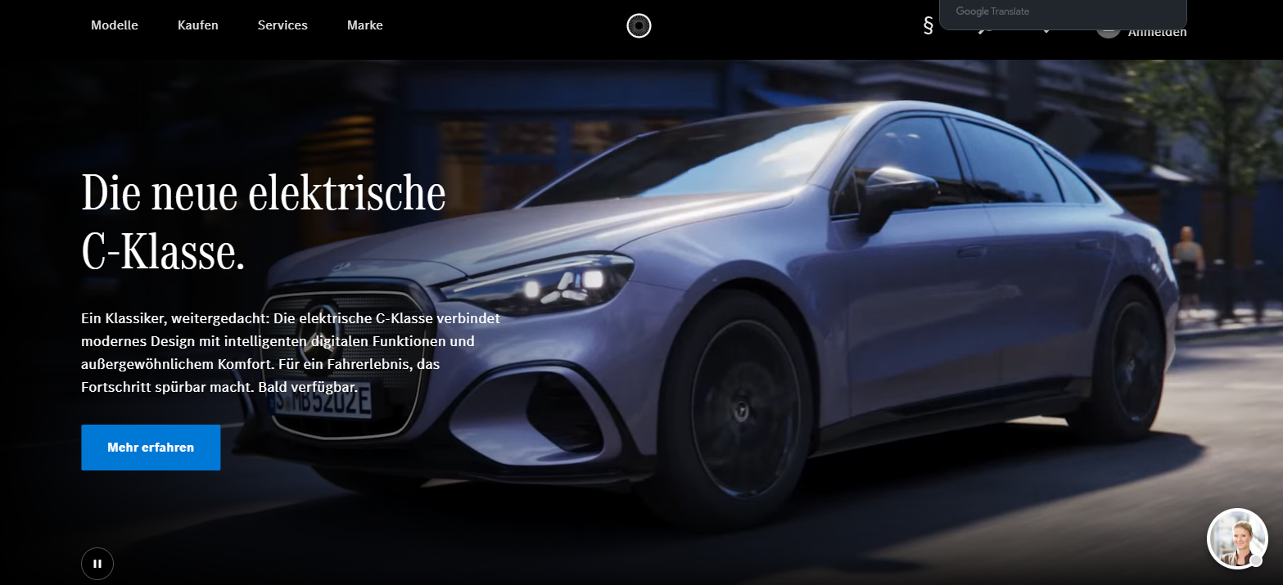
Figure 9: Mercedes-Benz German Website
Source: (Mercedes-Benz Group, 2025)
Physical evidence in Germany comprises high-quality showrooms, modern service centres and good brand heritage presentation.
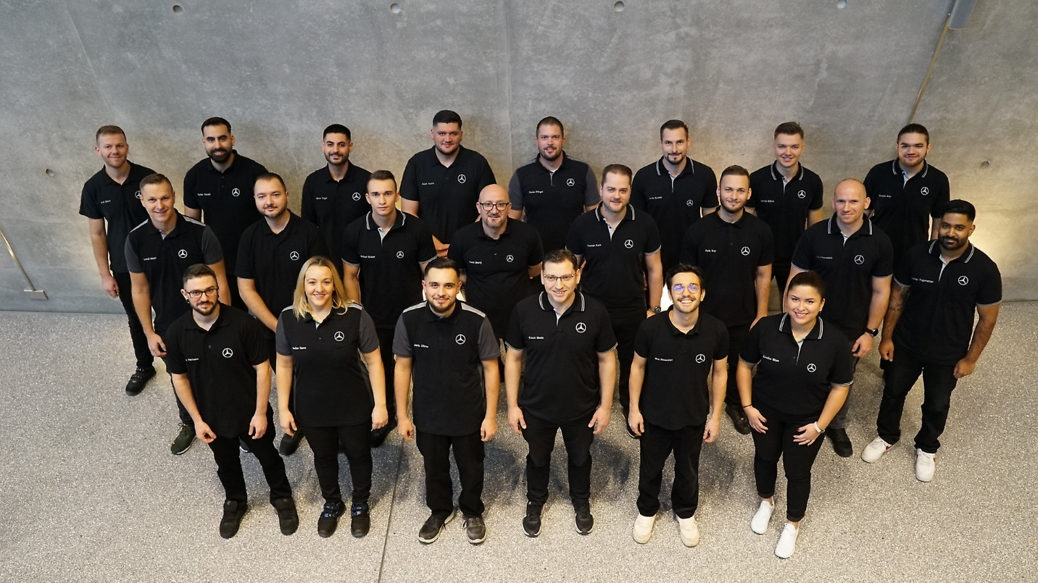
Figure 10Mercedes-Benz German Staff
Source: (Mercedes-Benz, 2023)
Professionalism and technical skills are demonstrated by staff uniforms and contribute to trust and quality.
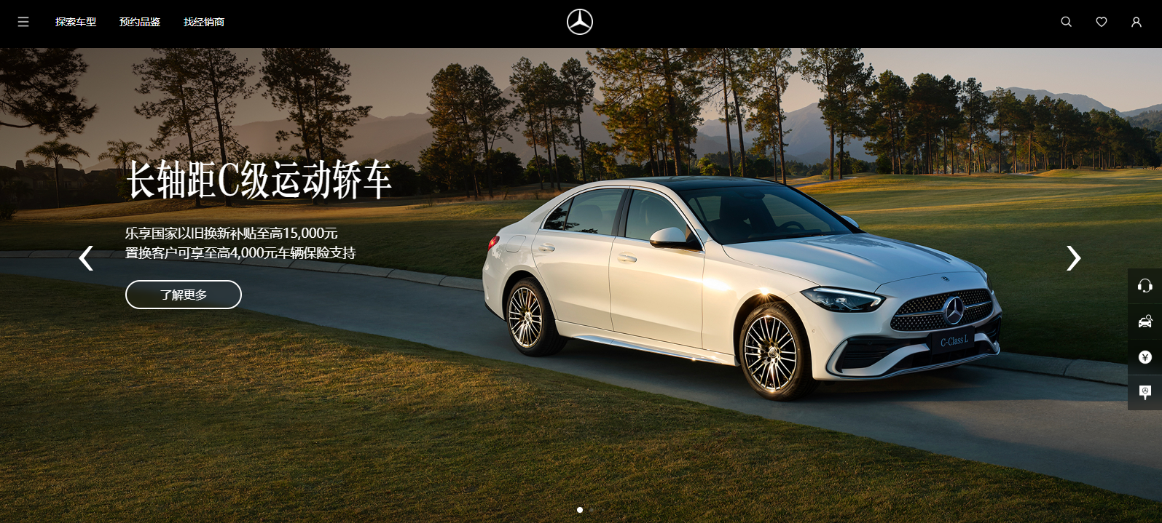
Figure 11: Mercedes-Benz Chinese Website
Source: (Mercedes-Benz, 2023)
Physical evidence in China is more experiential and spectacular. The dealerships are made as customer experience centres, which are luxurious, digitally displayed, have customer lounges and luxurious design.
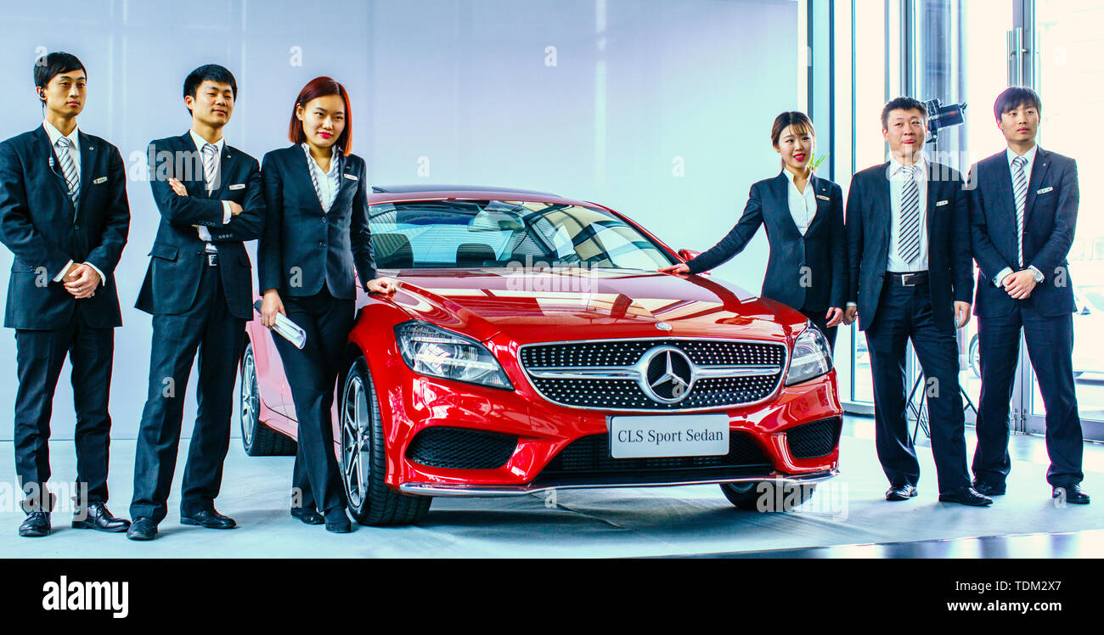
Figure 12: Mercedes-Benz Chinese Staff
Source : (Alamy Limited, 2026)
The presentation of the staff focuses on luxury service and interaction with customers.
Moreover, the official websites of the company in the two countries are also valuable digital physical evidence that demonstrates product offerings, innovation and brand identity that appeal to local populations.

Germany vs. China Comparison of the 7Ps Marketing Mix.
Mercedes-Benz embraces a mix of standardisation and adaptation in its marketing mix in Germany and China. Although the brand has a consistent global luxury perception, its application of the 7Ps is very different to depict discrepancies in the consumer behaviour, cultural values, and market conditions.
Similarities
In both Germany and China, Mercedes-Benz has a good premium position using all marketing mix elements. The product strategy is universally aligned in regards to basic design, quality and innovation, which guarantees brand standardisation. On the same note, the firm uses a premium pricing technique in the two markets to solidify its luxury automotive brand.
Place-wise, Mercedes-Benz relies on the networks of authorised dealerships and the robust after-sales service both in the countries, which, in effect, make it reliable and trusted by customers. Innovation, advanced technology, and brand heritage are also emphasised by the promotion strategy in both markets, and there has been a consistent global brand message.
Moreover, individuals, processes, and tangible items are always indicative of high service standards, professionalism, and a quality customer experience, which are crucial elements of luxury branding in both nations (Chevalier and Gutsatz, 2012).
Differences
Even with these similarities, there is considerable adjustment of the marketing mix between the two markets.
Product: In Germany, the products are geared towards engineering quality, efficiency, and sustainability, but in China, the products have been customised to accommodate luxury and digital technology as well as status-developing features like a longer wheelbase.
Price: In Germany, pricing is made on the basis of long-term value and product performance, whereas in China, it is flexible and is affected by financing opportunities and promotion techniques to appeal to younger consumers.
Place: Germany possesses a well-developed and consistent distribution channel, and China depends on joint ventures and fast urban market growth, as well as the development of digital sales zones.
Promotion: In Germany, promotion is logical and product-driven, and it revolves around engineering and sustainability. Conversely, China employs emotional and aspirational marketing, which is highly dependent on digital platforms, influencers, and the message about a luxury lifestyle.
People: Germany has efficient and technically oriented customer service, whereas China has relationship-driven and personalised customer service, which is more expectant of luxurious service.
Process: Germany focuses on standardised and efficient procedures, but China uses more flexible and more digitally integrated procedures to promote customer convenience.
Physical Evidence: German showrooms are functional and emphasise engineering accuracy, whereas Chinese showrooms are to provide a luxurious and immersive brand experience (Jyi et al., 2022).
Overall Evaluation
On the whole, Mercedes-Benz is evidence of a glocalisation strategy, where the main components of the marketing mix are standardised to ensure uniform global brand presence, with certain components being tailored to local market requirements. This balance helps the company to cater for the needs of German consumers who are concerned with performance and quality, and Chinese consumers who are preoccupied with status, technology and experience of luxury.
Nonetheless, over-adaptation can lead to the danger of brand dilution, and over-standardisation can lead to a decrease in local relevance. Thus, this strategic balance is also essential to ensure competitive advantage in both markets.

c. Directional Development Strategy Using the Ansoff Matrix (China Market)

Definition of Directional Development Strategy
Directional development strategy is the long-term strategic path taken by a company to grow its market share and realise growth in foreign markets (Moallemi and Nasiri, 2024). The Ansoff Matrix is one of the widely applied models to study such strategies, that is, it defines four available growth options: market penetration, product development, market development and diversification (Manny Martin-Morrissey, 2023). The application of this model is following:

Application of the Ansoff Matrix to Mercedes-Benz in China
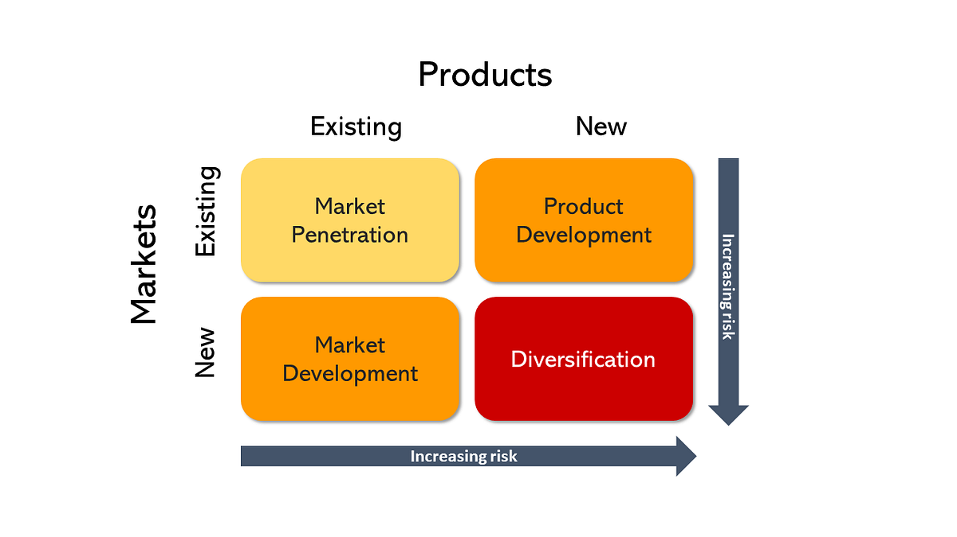
Figure 13: Application of the Ansoff Matrix
Source: (Manny Martin-Morrissey, 2023)
Market Penetration Strategy: Mercedes-Benz uses a deep penetration approach in China by selling more of its current luxury models to the same market. In the year 2023, China sold more than 26 million passenger vehicles, and it is the largest motor market in the world. It enhances its operations through collaborative production with BAIC Group, which allows local production and competitive prices.
Product Development Strategy: Another major growth strategy is product development. To enter the fast-growing EV market in China, Mercedes-Benz unveiled a new electric car brand called EQ. In 2023, China sold over 8 million electric vehicles, which is more than 60 per cent of all electric vehicles sold around the world (Elmnifi and Rajab, 2024). Mercedes-Benz changes its product range to suit the tastes of younger Chinese buyers, more than 60 per cent of whom are under 40 years old.
Market Development Strategy: Another strategy utilised by Mercedes-Benz is market development through extending distribution beyond the Tier-1 cities into Tier-2 cities like Chengdu, Hangzhou and Wuhan (Mercedes-Benz Group, 2022). China now has more than 400 million middle-class consumers, and there are tremendous growth prospects beyond big cities. By developing a network of dealerships and online stores, the company can reach the new and growing high-income consumers.
Diversification Strategy: Despite having a smaller dominance of diversification, Mercedes-Benz has invested in smart mobility and digital services that include connected vehicle technology and autonomous driving systems (Mercedes-Benz Group, 2022). The smart mobility industry in China is projected to reach over 200 billion by 2030, and the growth will be sustained in the long run.

d. Ethical Issues Related to Mercedes-Benz Marketing Mix (China)

Ethical Marketing Practices
1. Sustainable Electric Vehicle Promotion: In China, Mercedes-Benz is marketing EQ electric vehicles to enhance sustainable mobility in the environment (Achillas and Iosifidou, 2024). China has a goal of becoming carbon-neutral by 2060, and the government is very interested in the adoption of EVs. With an investment of more than 10 billion euros annually in research and development.
2. Responsible Data Protection in Connected Vehicles: The company has ensured high adherence to the China Data Security Law and the Cybersecurity Law of the People's Republic of China (Elmnifi and Rajab, 2024). The regulations are designed so that they prevent the irresponsible usage of data of users gathered by the connected cars and in-car information systems.
Unethical Marketing Issues
1. Luxury Status Advertising and Social Inequality: Some critics declare that Mercedes-Benz advertising in China places great emphasis on the luxury position and social status, which supports materialistic consumption behaviour. The Chinese power distance score is 80, which implies a high social hierarchy, and luxury advertising can exaggerate the perceptions of social inequality (Heinonen, 2024).
2. Environmental Concerns in High-Performance Models: Although Mercedes-Benz encourages the sale of electric cars, it still sells high-performance luxury SUVs and those powered by fossil fuel engines, which have greater emissions. International environmental reports show that the global automotive industry contributes about 24 per cent of transport-related CO2 emissions (Leimbach and Jaeger, 2024).

e. Recommendations for Future International Marketing Strategies
Recommendations for Germany
To become stronger in Germany, Mercedes-Benz must prioritise sustainability, innovation, and value creation in the long-term, all of which are in line with the tastes of the German consumers. To begin with, the company must speed up its process of switching to electric vehicles (EVs) by increasing its EQ product line and further investment in battery technology. It is crucial because of the stringent environmental policies and the growing need for environmentally friendly vehicles, which was recognised in the PESTEL analysis. Enhancement of EV infrastructure partnerships will enhance adoption as well.
Secondly, Mercedes-Benz ought to improve its value positioning approach by focusing on its engineering quality, safety and durability in its marketing messages. German consumers are very rational and quality sensitive; thus, enhancing functional advantages will reinforce brand loyalty. Thirdly, the company ought to increase its corporate and fleet sales approach, where it provides competitive leasing packages and service packages. This has the potential to give long-term stable flows of revenue since Germany is a mature market with a good business base.
Lastly, by preserving its image of reliability and efficiency, Mercedes-Benz needs to invest in the digital transformation of customer experience, including online configuration tools and personalised services. On the whole, these measures will enable Mercedes-Benz to stay competitive in a well-developed and highly regulated market and support its high-end and innovation-driven brand image.
Recommendations for China
In China, Mercedes-Benz needs to be more market-adaptive and growth-oriented, which should include digitalisation, luxury experience, and younger consumers. To begin with, the company needs to enhance its digital marketing and e-commerce, using platforms like social media and online car sales platforms. Chinese consumers are very online and sensitive to influencer marketing and online interactions, as the 7Ps analysis has revealed.
Secondly, Mercedes-Benz must go on to create technology-led and personalised vehicles, such as AI-connected cars, smart connectivity, and longer wheelbase cars. This is in line with the tendency of Chinese consumers to be highly innovative, status-conscious, and comfortable. Thirdly, the company must strengthen its branding as a status symbol and lifestyle through celebrity promotion, luxury partnerships and experiential marketing initiatives. This will enhance emotional appeal and brand desirability in younger affluent customers. Also, Mercedes-Benz ought to continue its strong alliance and joint ventures in the region, which will enable it to overcome regulatory hurdles and enhance efficiency in its operations in the Chinese market.
Lastly, the company must concentrate on a competitive pricing policy and flexible financing schemes whereby luxury cars are made more affordable to the emerging middle and upper-middle classes. Altogether, these measures will help Mercedes-Benz to take advantage of the rapid growth of the luxury market in China, as well as fit well in the local cultural and economic context.

Section 2: Reflective Account Using Gibbs Reflective Cycle
Gibbs Reflective Cycle is an organised model that assists individuals to reflect on experiences in order to enhance learning and future performance (Athal, 2025). The following section will reflect on how I went about doing Section 1 of this assignment, what I learned, what my challenges were and what I can do to improve in future.
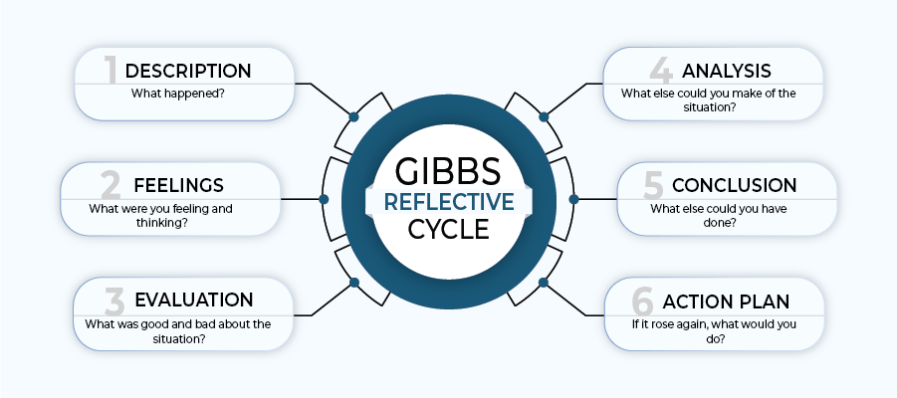
Figure 14: Gibbs Reflective Cycle
Source: (Athal, 2025)

1. Description
This assignment demanded that I write an international marketing analysis of the Mercedes-Benz Group AG and consider two countries, Germany and China. This was done by analysing the macro environment in terms of the PESTEL Analysis model and cultural differences in terms of the cultural dimensions theory developed by Geert Hofstede.
I also needed to analyse the STP strategy of the company and international marketing mix through the 7Ps framework. I have also used the Ansoff Matrix to evaluate directional development policies in China and addressed matters of ethics in relation to marketing efforts of the company.
To do this, I used different scholarly and business sources. I was meticulous in the arrangement of the information and divided it into various analytical elements. The general objective was to come up with a global comprehension of how a global firm relocates its marketing strategies to the various countries.

2. Feelings
I was excited and a little bit intimidated at the start of the assignment. The work involved the analysis of numerous strategic frameworks and the comparison of two giant markets, which did not seem to be so easy at first. Nonetheless, I had an interest in researching Mercedes-Benz since it ranks as one of the most recognisable automobile brands worldwide.
The more I advanced in my research, the more convinced I got. Reading the article on global marketing and cultural variations made me realise that international companies adjust to various consumer behaviours. The other satisfaction I enjoyed was the ability to relate theoretical frameworks like PESTEL and STP to actual market information in Germany and China.
Nevertheless, at times I was also challenged to arrange a vast body of information into a structured academic report. To make sure that the analysis was organised and logically sound, it meant planning and editing it carefully.

3. Evaluation
This was an interesting learning experience in completing this assignment. Among the good things was that it enabled me to acquire good research and analytical skills. Through various academic models, I could analyse the international marketing strategy of Mercedes-Benz in various directions.
The use of valid data sources was also another strength. The inclusion of statistics, including the GDP numbers, sales of vehicles, and demographic data, contributed to the credibility of my analysis. The comparison of Germany and China has also helped me comprehend the impact of the conditions of the economy, culture and technology on marketing strategies.
Although these were the strengths, some challenges were experienced. A constraint was the time that was necessary to gather the right and current information. There was a slight variance in some of the statistics provided by various sources, hence necessary careful verification. Moreover, the combination of different theoretical models within a single report had to be well organised to prevent repetition.

4. Analysis
Considering this experience, I understood that the application of theoretical frameworks was a significant factor in being able to guide my analysis. The PESTEL model aided me in taking a systematic look at the external macro environment in place of Mercedes-Benz in these two countries. It also emphasised the main disparities like government policies, economic conditions and environmental regulations.
On the same note, cultural dimensions outlined by Hofstede served to explain the difference in consumer behaviour in Germany and China. For example, the power distance and individualism of Germany have relatively low and high scores, respectively, which means that consumers attach importance to product quality and personal preferences. Conversely, China has a greater power distance and a collectivist society, meaning that status and social recognition can affect purchasing behaviour.
The STP model also helped to comprehend the way in which Mercedes-Benz divides its markets and focuses on a particular category of customers. I have noticed that the company is targeting older professionals in Germany and the younger, well-to-do customers in China. Also, the implementation of the Ansoff Matrix enabled me to learn how businesses determine growth strategies in the foreign market.

5. Conclusion
This reflective experience taught me some significant research on the topic of academic research and international marketing analysis. To begin with, successful research involves gathering data that is credible and that is from varied sources. Second, structured frameworks, including PESTEL, STP and Ansoff Matrix, can assist in organising complex information and enhancing analytical clarity.
I also came to know that when comparing two countries, economic and cultural differences have to be interpreted very carefully. These differences are critical in analysing the operation of multinational companies in global markets. Though I managed to complete the assignment successfully, I think my work might be enhanced with the use of more academic journal sources and more critical analysis of some strategic issues.

6. Action Plan
The action plan is the final stage where you transform your reflections into a concrete strategy for the future (Forester, 2024). The following action plan provides a set of actions that I will perform to improve my academic performance and get better results in other projects of this type.
Area for Improvement | Actions I Will Take | Expected Outcome | Timeline
Academic Research Skills | I will use more academic journals, books and databases such as Google Scholar and university library resources. | More credible and academically strong assignments. | Next assignments
Data Analysis | I will cross-check statistical data from multiple sources to ensure accuracy and reliability. | Improved accuracy and stronger analytical arguments. | Within 2–3 months
Critical Thinking | I will practice deeper analysis by comparing different theories and viewpoints in marketing literature. | Stronger critical evaluation and higher academic marks. | Ongoing
Time Management | I will create a research schedule and complete sections of assignments gradually instead of doing everything at the last moment. | Reduced stress and better quality work. | Immediate
Academic Writing | I will improve my academic writing style by reading high-quality journal articles and practising structured writing. | Clearer and more professional academic reports. | Continuous

Conclusion
In conclusion, the analysis indicates that Mercedes-Benz Group AG modifies its international marketing strategies based on the economic environment, cultural peculiarities and market boundaries in Germany and China. Germany is a mature market where the emphasis is placed on the quality and sustainability of engineering, and China is a fast-growing market with younger luxury consumers in addition to technological advancement. With the help of strategic adaptation using STP, marketing mix and growth strategies, the company ensures its high level of competitiveness in both markets.

References
Achillas, C. and Iosifidou, P. (2024). Shifting towards Electric Vehicles: A Case Study of Mercedes-Benz from the Perspective of Cross-Functional Teams and Workforce Transformation. World Electric Vehicle Journal, 15(7), p.325.
Alamy Limited (2026). Mercedes staff car hi-res stock photography and images - Alamy. [online] Alamy. Available at: https://www.alamy.com/stock-photo/mercedes-staff-car.html?sortBy=relevant [Accessed 21 Apr. 2026].
Andreeva, S. and Petikhin, D. (2022). Research on the marketing of technological innovations for car safety: case company: Mercedes-Benz. [online] www.theseus.fi. Available at: https://www.theseus.fi/handle/10024/787064 [Accessed 12 Mar. 2026].
Armstrong, G., Adam, S., Denize, S. and Kotler, P. (2014). Principles of Marketing. 6th ed. Sydney: Pearson Education Australia.
Athal, D.K. (2025). Gibbs Reflective Cycle Explained: A Framework for Structured Self-Reflection - Dr Krishna Athal. [online] Dr Krishna Athal - Life & Executive Coach. Available at: https://drkrishnaathal.com/blog/gibbs-reflective-cycle-explained-a-framework-for-structured-self-reflection/ [Accessed 12 Mar. 2026].
Automobility (2024). State of China’s Auto Market - October 2024 - Automobility. [online] Automobility. Available at: https://automobility.io/2024/10/state-of-chinas-auto-market-october-2024/ [Accessed 12 Mar. 2026].
Baack, D. G. (2018). International marketing., 2nd edition. London: SAGE Publications.
Ban, Z. (2025). Mercedes: China And E.U. Energy Risks Make It A Hold. [online] Seeking Alpha. Available at: https://seekingalpha.com/article/4832361-mercedes-china-and-eu-energy-risks-make-it-a-hold [Accessed 12 Mar. 2026].
Bharadwaj, A. (2018). Environmental regulations and innovation in advanced automobile technologies : perspectives from Germany, India, China and Brazil. Singapore: Springer.
Bochner, S. and Hesketh, B. (2022). Power Distance, Individualism/Collectivism, and Job-Related Attitudes in a Culturally Diverse Work Group. Journal of Cross-Cultural Psychology, [online] 25(2), pp.233–257. doi:https://doi.org/10.1177/0022022194252005.
Bracke, S. and Inoue, M. (2023). Reliability and safety engineering: The principles innovation and optimisation of German and Japanese product constructions. Safety and Reliability – Safe Societies in a Changing World, 7(3), pp.221–226. doi:https://doi.org/10.1201/9781351174664-28.
Brooks, A. (2020). The Marketing Mix: Building a Strategy With the 7Ps. [online] Venture Harbour. Available at: https://ventureharbour.com/marketing-mix/ [Accessed 12 Mar. 2026].
Camilleri, M.A. (2018). Integrated Marketing Communications. Tourism, Hospitality & Event Management, 1(1), pp.85–103. doi:https://doi.org/10.1007/978-3-319-49849-2_5.
Chevalier, M. and Gutsatz, M. (2012). Luxury Retail Management. John Wiley & Sons.
Constantinides, E. (2024). The Marketing Mix revisited: Towards the 21st Century Marketing. Journal of Marketing Management, 22(3-4), pp.407–438. doi:https://doi.org/10.1362/026725706776861190.
Corne, P. (2023). Foreign Investment in China. Martinus Nijhoff Publishers.
Cui, A.S., Griffith, D.A., Cavusgil, S.T. and Dabic, M. (2006). The influence of market and cultural environmental factors on technology transfer between foreign MNCs and local subsidiaries: A Croatian illustration. Journal of World Business, 41(2), pp.100–111. doi:https://doi.org/10.1016/j.jwb.2006.01.011.
Dalirazar, S. and Sabzi, Z. (2023). Strategic analysis of barriers and solutions to development of sustainable buildings using PESTLE technique. International Journal of Construction Management, 23(1), pp.1–30. doi:https://doi.org/10.1080/15623599.2020.1854931.
Dauber, C., Goerke-Mallet, P., Gräfingholt, B. and Warnecke, C. (2023). The Importance of Sustainability Criteria for the Professional Education of Geo-engineers and the Role of Academic Institutions. Yearbook of Sustainable Smart Mining and Energy - Technical, Economic and Legal Framework, pp.277–292. doi:https://doi.org/10.1007/978-3-031-41873-0_12.
Easa, S.M. and Yan, W.Y. (2019). Performance-Based Analysis in Civil Engineering: Overview of Applications. Infrastructures, 4(2), p.28. doi:https://doi.org/10.3390/infrastructures4020028.
Elmnifi, M. and Rajab, Z. (2024). Electric Vehicles in China, Europe, and the United States: Current Trend and Market Comparison. Int. J. Electr. Eng. and Sustain., [online] 2(1), pp.1–20. Available at: https://ijees.org/index.php/ijees/article/view/70 [Accessed 12 Mar. 2026].
Flashman, J. (2022). How To Set Up Market Segmentation And Make More Money. [online] www.referralcandy.com. Available at: https://www.referralcandy.com/blog/what-is-market-segmentation [Accessed 12 Mar. 2026].
Forester, J. (2024). Reflections on the future understanding of planning practice. International Planning Studies, 4(2), pp.175–193. doi:https://doi.org/10.1080/13563479908721734.
Frey, J. (2004). Building Consumer Good Brands in China. diplom.de.
Gessler, M. (2016). Educational Transfer as Transformation: A Case Study about the Emergence and Implementation of Dual Apprenticeship Structures in a German Automotive Transplant in the United States. Vocations and Learning, 10(1), pp.71–99. doi:https://doi.org/10.1007/s12186-016-9161-8.
Global Economy (2024). Germany Political stability - data, chart | TheGlobalEconomy.com. [online] TheGlobalEconomy.com. Available at: https://www.theglobaleconomy.com/Germany/wb_political_stability/ [Accessed 10 Mar. 2026].
Guevara, C., (2021). The Green Wave on the Luxury Automobile Industry (Master's thesis, Universidade NOVA de Lisboa (Portugal)).
Gutscher, H. and Scholz, R.W. (2024). Psychological determinants of fuel consumption of purchased new cars. Transportation Research Part F: Traffic Psychology and Behaviour, 14(3), pp.229–239. doi:https://doi.org/10.1016/j.trf.2011.01.003.
Han, Y. (2025). Artificial Intelligence and the Rise of the Chinese EV Industry. International Journal of Artificial Intelligence and Green Manufacturing, [online] 1(4). Available at: https://hopeembark.org/index.php/IJGMAI/article/view/72 [Accessed 14 Jan. 2026].
Hänle, F., Weil, S. and Cambré, B. (2022). China’s OFDI support mechanisms in Germany: how governments can work together to promote SME internationalization, reduce liability of foreignness and contribute positively to society. Journal of Entrepreneurship in Emerging Economies. doi:https://doi.org/10.1108/jeee-08-2021-0327.
Heinonen, T. (2024). Demand for luxury cars in China: development, trends and prospects. Theseus.fi, [online] 6(3). doi:urn:NBN:fi:amk-201404285203.
Igelbrink, J. (2020). Perceived brand localness : an empirical study of the German fashion market. Wiesbaden, Germany: Springer Gabler.
Intelligence Node (2026). Premium Pricing: The Ins & Outs Of A Successful Brand Strategy. [online] www.intelligencenode.com. Available at: https://www.intelligencenode.com/blog/premium-pricing-the-ins-outs-of-a-successful-brand-strategy/ [Accessed 12 Mar. 2026].
Iosifidou, P. and Achillas, C. (2024). Navigating the Shift to EVs: The Workforce Transformation Strategy Case at Mercedes-Benz. Communications in computer and information science, pp.251–260. doi:https://doi.org/10.1007/978-3-031-69351-9_22.
Jyi, M.W.H., Zaini, A.I., Koesmeri, D.R.A. and Bakar, R.A. (2022). Typology of Design Concepts for Luxury Car Showrooms. Advances in Civil Engineering Materials, 223, pp.55–61. doi:https://doi.org/10.1007/978-981-16-8667-2_7.
Kalinowska, D. and Kuhfeld, H. (2023). Motor Vehicle Use and Travel Behaviour in Germany: Determinants of Car Mileage. [online] www.econstor.eu. Available at: https://www.econstor.eu/handle/10419/18495 [Accessed 12 Mar. 2026].
Kim, J.-E., Lloyd, S., Adebeshin, K. and Kang, J.-Y.M. (2019). Decoding fashion advertising symbolism in masstige and luxury brands. Journal of Fashion Marketing and Management: An International Journal, 23(2), pp.277–295. doi:https://doi.org/10.1108/jfmm-04-2018-0047.
Kim, Y. and Zhang, Y. (2014). The Impact of Power-Distance Belief on Consumers’ Preference for Status Brands. Journal of Global Marketing, [online] 27(1), pp.13–29. doi:https://doi.org/10.1080/08911762.2013.844290.
Kreppel, H. and Holtbrügge, D. (2012). The Perceived Attractiveness of Chinese Products by German Consumers—A Sociopsychological Approach. Journal of Global Marketing, 25(2), pp.79–99. doi:https://doi.org/10.1080/08911762.2012.720535.
Leimbach, M. and Jaeger, C.C. (2024). International passenger transport and climate change: A sector analysis in car demand and associated emissions from 2000 to 2050. Energy Policy, 35(12), pp.6332–6345. doi:https://doi.org/10.1016/j.enpol.2007.07.025.
Li, Y. and Wang, Y. (2021). What Marketing Strategies Did Mercedes-Benz Use to Succeed in the US Market? [online] www.atlantis-press.com. doi:https://doi.org/10.2991/assehr.k.211209.106.
Liu, S., Perry, P., Moore, C. and Warnaby, G. (2016). The Standardization-Localization Dilemma of Brand Communications for Luxury Fashion retailers’ Internationalization into China. Journal of Business Research, [online] 69(1), pp.357–364. doi:https://doi.org/10.1016/j.jbusres.2015.08.008.
Löhr (2024). Passenger car market: significant drop in new registrations in December | VDIK - Verband der Internationalen Kraftfahrzeughersteller e.V. [online] VDIK - Verband der Internationalen Kraftfahrzeughersteller e.V. Available at: https://www.vdik.de/en/2024/passenger-car-market-significant-drop-in-new-registrations-in-december/ [Accessed 12 Mar. 2026].
Manny Martin-Morrissey (2023). The Ansoff Matrix: A simple framework to help you think about business growth. [online] Medium. Available at: https://medium.com/@manny.martinmorrissey/the-ansoff-matrix-3c82f407af9c [Accessed 12 Mar. 2026].
Martins, F.C., (2023). Customer Preferences for their Journey into the Future of the Automotive Industry (Master's thesis, Universidade NOVA de Lisboa (Portugal)).
Mercedes-Benz (2020). The new Mercedes-Benz S-Class. [online] MBCA Newsroom. Available at: https://media.mercedes-benz.ca/releases/the-new-mercedes-benz-s-class [Accessed 23 Apr. 2026].
Mercedes-Benz (2023). Mercedes-Benz Group. [online] Mercedes-Benz Group. Available at: https://group.mercedes-benz.com/sustainability/people/dshift.html.
Mercedes-Benz (2023). 梅赛德斯-奔驰. [online] www.mercedes-benz.com.cn. Available at: https://www.mercedes-benz.com.cn/.
Mercedes-Benz Group (2022). Mercedes-Benz Group. [online] Mercedes-Benz Group. Available at: https://group.mercedes-benz.com/technology/e-mobility/electric-drive/product-portfolio.html.
Mercedes-Benz Group (2022). Mercedes-Benz Group . [online] Mercedes-Benz Group. Available at: https://group.mercedes-benz.com/technology/innovation/vision/vision-eqxx.html [Accessed 12 Mar. 2026].
Mercedes-Benz Group (2025). Mercedes-Benz Personenwagen. [online] www.mercedes-benz.de. Available at: https://www.mercedes-benz.de/.
Minkov, M. and Kaasa, A. (2020). A Test of Hofstede’s Model of Culture following His Own Approach. Cross Cultural & Strategic Management, [online] 28(2), pp.384–406. Available at: https://www.emerald.com/insight/content/doi/10.1108/ccsm-05-2020-0120/full/html.
Moallemi, E.A. and Nasiri, M. (2024). Formulating directional industry strategies for renewable energies in developing countries: The case study of Iran’s wind turbine industry. Renewable Energy, 39(1), pp.299–306. doi:https://doi.org/10.1016/j.renene.2011.08.052.
Morck, R. and Zhao, M. (2023). Perspectives on China’s outward foreign direct investment. Journal of International Business Studies, [online] 39(3), pp.337–350. doi:https://doi.org/10.1057/palgrave.jibs.8400366.
Narang, R. (2016). Understanding purchase intention towards Chinese products: Role of ethnocentrism, animosity, status and self-esteem. Journal of Retailing and Consumer Services, 32, pp.253–261. doi:https://doi.org/10.1016/j.jretconser.2016.05.010.
Ngai, J. and Cho, E. (2025). The Young Luxury Consumers in China. Young Consumers, [online] 13(3), pp.255–266. doi:https://doi.org/10.1108/17473611211261656.
Nickerson, C. (2025). Hofstede’s Cultural Dimensions Theory & Examples. [online] Simply Psychology. Available at: https://www.simplypsychology.org/hofstedes-cultural-dimensions-theory.html [Accessed 12 Mar. 2026].
Parise, S., Guinan, P.J. and Kafka, R. (2016). Solving the crisis of immediacy: How digital technology can transform the customer experience. Business Horizons, 59(4), pp.411–420. doi:https://doi.org/10.1016/j.bushor.2016.03.004.
Polfuß, J. and Sönmez, D. (2020). Country-of-origin as a dynamic concept: an analysis of Chinese consumer electronics brands in Germany. Journal of Chinese Economic and Foreign Trade Studies, 13(3), pp.115–138. doi:https://doi.org/10.1108/jcefts-04-2020-0011.
Propfe, B. and Kreyenberg, D. (2024). Market penetration analysis of electric vehicles in the German passenger car market towards 2030. International Journal of Hydrogen Energy, 38(13), pp.5201–5208. doi:https://doi.org/10.1016/j.ijhydene.2013.02.049.
Pylkkönen, P. (2023). Customer Car Preference Options : A Case Of Mercedes-Benz. [online] www.theseus.fi. Available at: https://www.theseus.fi/handle/10024/815937 [Accessed 9 Mar. 2026].
Rastogi, S. and Agarwal, B. (2023). Factors Influencing Consumer Decision to Purchase a Car. Marketing and Management of Innovations, 14(1), pp.24–40. doi:https://doi.org/10.21272/mmi.2023.1-03.
Rosa, A.M. (2020). Analyzing the economic variables and their relationship to inflation in the US, China and Germany: Why empirical results demonstrate the inability to accurately assess economic policy through data. Open Science Journal, 5(4). doi:https://doi.org/10.23954/osj.v5i4.2633.
Rosen, M.A. (2021). Engineering Sustainability: A Technical Approach to Sustainability. Sustainability, 4(9), pp.2270–2292.
Rovai, S. (2016). The Chinese Luxury Client: Current Profile and New Attitudes. Luxury the Chinese Way, pp.98–110. doi:https://doi.org/10.1057/9781137537751_9.
Schlegelmilch, B.B. (2022). Segmenting Targeting and Positioning in Global Markets. Management for Professionals, [online] pp.129–159. Available at: https://link.springer.com/chapter/10.1007/978-3-030-90665-8_6.
Schreiber, F. (2017). Identification of customer groups in the German term life market: a benefit segmentation. Annals of Operations Research, 254(1-2), pp.365–399. doi:https://doi.org/10.1007/s10479-017-2446-y.
Statista (2025). Inflation rate in Germany 2025| Statista. [online] Statista. Available at: https://www.statista.com/statistics/262859/inflation-rate-in-germany-changes-of-the-cpi-compared-to-the-previous-year/?srsltid=AfmBOop60U6iypleHWI7U6F9Dvg0d7_t64--72jdNnb663T-Z4QgbRii [Accessed 12 Mar. 2026].
The4 (2025). MERCEDES-BENZ GROUP AG PESTEL ANALYSIS. [online] CANVAS, SWOT, PESTEL & BCG Matrix Editable Templates for Startups. Available at: https://canvasbusinessmodel.com/products/mercedes-benz-group-ag-pestle-analysis [Accessed 12 Mar. 2026].
Thiel, C. and Schmidt, J. (2025). Cost and well-to-wheel implications of the vehicle fleet CO2 emission regulation in the European Union. Transportation Research Part A: Policy and Practice, [online] 63(3), pp.25–42. doi:https://doi.org/10.1016/j.tra.2014.02.018.
Vonk, A. (2024). The Hofstede Model: Understanding a Multicultural Environment. Cultural Confluence in Organizational Change, 4(3), pp.47–76. doi:https://doi.org/10.1007/978-3-031-45403-5_4.
Wang, H. and Chen, Z. (2025). A Legal Study: How Do China’s Top 10 Intelligent Connected Vehicle Companies Protect Consumer Rights? World Electric Vehicle Journal, [online] 16(3), pp.140–140. doi:https://doi.org/10.3390/wevj16030140.
Wiedmann, K.-P. and Hennigs, N. (2024). The importance of brand heritage as a key performance driver in marketing management. Journal of Brand Management, 19(3), pp.182–194. doi:https://doi.org/10.1057/bm.2011.36.
Wiedmann, K.-P., Hennigs, N. and Siebels, A. (2022). Value-based Segmentation of Luxury Consumption Behavior. Psychology and Marketing, 26(7), pp.625–651. doi:https://doi.org/10.1002/mar.20292.
Yeung, G. and Mok, V. (2012). Manufacturing and Distribution Strategies, Distribution Channels, and Transaction Costs: The Case of Parallel Imported Automobiles. Managerial and Decision Economics, 34(1), pp.44–58. doi:https://doi.org/10.1002/mde.2573.

