
Understanding the importance of Stakeholder Engagement in successful commencement and completion of project

Student Number:2407747
Module Code: LCLM5001

Executive Summary
The report provides an elaborate stakeholder engagement plan for the successful introduction of a new wearable health device by the prominent UK-based healthcare technology firm Smith+Nephew. When the author is appointed as the project manager, he describes the six-month proposal to introduce a device to measure the heart rate, oxygen levels, and sleep patterns into the consumer market. The strategy will be based on comprehensive situational analysis, SWOT and PESTLE analysis, which will determine the internal strengths and weaknesses of the project, external opportunities and threats in the dynamic health-tech environment. The identification and mapping of key internal and external stakeholders, including the internal product development and internal marketing, as well as external regulatory organisations and the final users, are identified and mapped. The report applies the well-known models like the Power/Interest Matrix, a RACI matrix, and a thorough Communication and Engagement Plan to sort the stakeholders and select the engagement strategies. This is to keep the influential stakeholders at bay and all parties well informed and content. The most important aspect of this plan will be the active management of relations and possible disagreements with the help of the 4Cs model (Communication, Coordination, Cooperation, and Collaboration). The project will encourage risk reduction and a pool of knowledge among the stakeholders by creating an environment of open communication and common goals. The report considers the transformative effect that effective stakeholder engagement will have on the business performance, attributing it to better project deliverables, brand image and increased return on investment. It ends with practical recommendations on what Smith+Nephew should consider incorporating into its corporate strategy to incorporate into its future projects, which will guarantee its future success and innovativeness in the competitive healthcare market.

Table of Contents
Executive Summary 2
1.0 Introduction 4
2.0 Situational Analysis 4
2.1 SWOT Analysis 4
2.2 PESTLE Analysis 5
2.3 SMART Objectives 5
3.0 Key Stakeholder Identification 6
4.0 Stakeholder Roles, Responsibilities, and Impact 7
5.0 Stakeholder Engagement Frameworks 7
5.1 Stakeholder Power/Interest Matrix 7
5.2 RACI Matrix 8
5.3 Stakeholder Communication and Engagement Plan 8
6.0 Engagement Process and Conflict Management 9
6.1 The Engagement Process 9
6.2 Conflict Management: The 4C’s Model 9
7.0 Evaluation of Impact and Recommendations 10
7.1 Impact of Stakeholder Engagement on Business Performance 10
7.2 Recommendations 10
8.0 Conclusion 11
9.0 References 12

1.0 Introduction
The healthcare environment of the world is radically changing, as the development of technologies and the increase in consumer interest in personal health and wellness (Deloitte, 2024). Wearable health technology has become a central technology in this dynamic market, allowing people to manage themselves and their health. This report will deal with the strategic launch of a new wearable health device at Smith+Nephew, a well-known medical technology company based in the UK. Smith+Nephew, originally established in 1856, is a company that has an international presence in more than 100 countries and specialises in orthopaedics, sports medicine and wound management (Smith+Nephew, 2024). The current project entails the initiation of a new consumer-oriented device that will be used to monitor essential health parameters, such as heart rate, blood oxygen levels, and sleep patterns and is expected to be launched in half a year. Being a designated project manager, the main task of the author is to plan a perfect product launch by successfully connecting all other interested parties. This report contains an elaborate stakeholder engagement plan, which aims at embracing the advantages that stakeholders can offer, addressing their expectations, and reducing their possible conflicts. It will offer a situational analysis of the company, major stakeholders, and use the established theoretical frameworks to develop a solid engagement and communication strategy, and finally ensure that the project does not override Smith+Nephew's strategic business goals.

2.0 Situational Analysis
A thorough situational analysis is crucial for understanding the internal and external environments that will influence the project's success. By applying strategic tools like SWOT and PESTLE analyses, Smith+Nephew can better anticipate challenges and leverage opportunities (Kotler and Armstrong, 2021).

2.1 SWOT Analysis
A SWOT analysis is a critical analysis of the external business environment of the company and its internal competencies, which is essential in strategic planning (Sammut-Bonnici and Galea, 2015). Smith+Nephew is venturing into consumer wearables business venture which has several internal strengths. The organisation has an immaculate brand reputation within the medical sector that provides a solid source of trust and credibility which is one of the primary differentiators in the market environment where consumers are becoming highly sensitive to the accuracy and dependability of the health information. This is complemented by enormous research and development (R&D) potential that is accumulated over decades of medical devices development and has the potential to create technologically advanced and clinically proven products. In addition, the existing international distribution channel which the company has though is business to business offers scalable infrastructure which can be converted to consumer channels. Above all, its extensive knowledge in managing complex healthcare legislation is a huge chance which can assist a company to wade through the red tape and barriers to market entry which can easily bedevil new entrants.
However, such strengths are offset by major weaknesses. Another high learning curve in digital marketing, e-commerce logistics, and customer facing customer support field is that the company has limited experience in the direct-to-consumer (D2C) market. This is also augmented by the lower lifestyle and higher clinical brand image which demands a grandiose marketing strategy to rebrand the business to the wellness market with the primary medical identity that it is not producing. Agility could also be a problem with Smith+Nephew being a service-based company, with a large and long-established customer base; potentially slow decision-making processes can be seen as a weakness in the market where smaller and nimble tech start-ups can change direction with ease and identify new solutions to problems.
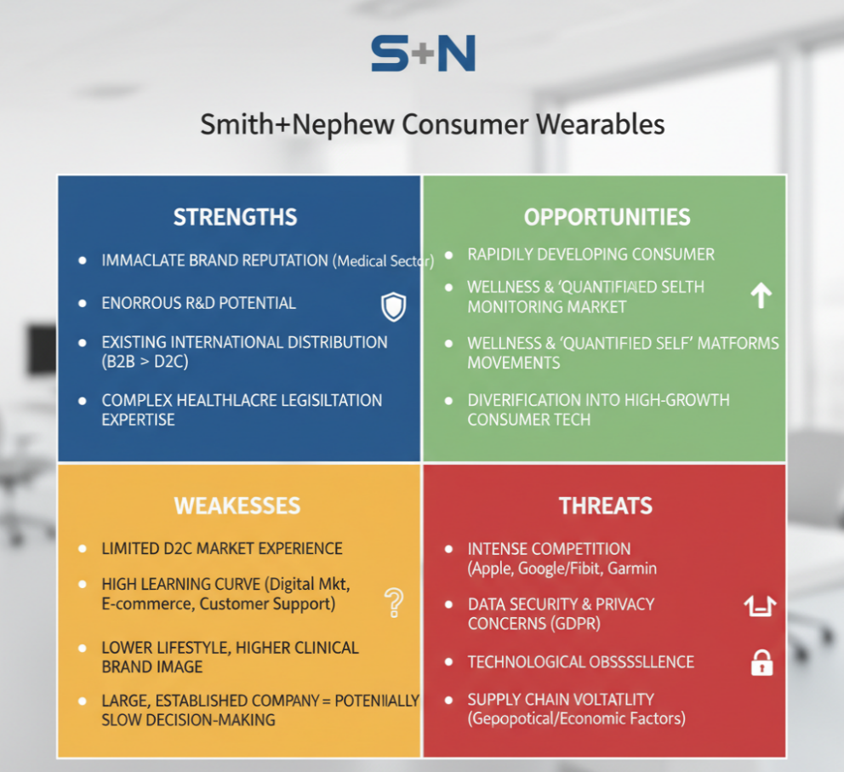

Figure 1: SWAT Analysis (Self Developed)
The externally offered project is provided with several appealing opportunities. The largest is consumer health monitoring market which is rapidly developing thanks to the wellness movement and quantified self-movement (Grand View Research, 2024). The rising consumer needs to know their health positions gives an ideal market on which a new medically viable device can flourish. A different strategic point of integration is to new telehealth platforms, which would make the device more than a one-product entity, and an access point to a more sizable digital health ecosystem that could produce recurrent revenues. This would also allow the company to diversify their reliance on the traditional medical device sales success in this venture by venturing into the high growth consumer technology sector.

Despite these opportunities, the project faces considerable threats. The primary threat is the intense competition from established technology giants like Apple, Google (Fitbit), and Garmin, who command vast resources, loyal user bases, and mature ecosystems. Data security and privacy concerns represent an existential risk; any breach could irrevocably damage consumer trust and cause significant reputational harm to the entire Smith+Nephew brand, with legal implications under GDPR (2018). The wearables market is also characterised by rapid technological obsolescence, meaning the product's features could become standard or outdated within a short period, demanding a continuous and agile innovation pipeline. Finally, the project is exposed to significant supply chain volatility, where geopolitical and economic factors could disrupt the availability of critical electronic components, jeopardising the launch timeline and inflating production costs (McKinsey & Company, 2023).

2.2 PESTLE Analysis
PESTEL analysis assists in determining the macro-environment elements that might affect the project and provides a wider context for strategic decision-making (Yuksel, 2012). Politically, the project has a chance of working with favourable policies on health in the government, like the NHS being offered opportunities to engage in digital health that promotes preventative care and remote monitoring. It is, however, also vulnerable to the risks that are a part of international trade policies and tariffs that may have a direct effect on the cost and availability of overseas-sourced components. On an economic note, the device performance is pegged on the current economic climate; during high economic times, there is an increased consumer discretionary expenditure in wellness gadgets, but when the economy is in recession or in high inflationary costs, the consumer will focus on the necessary expenditure, thus narrowing down the target market. Moreover, inflation directly raises the cost of production and operations and may be a squeezer of profit margins.
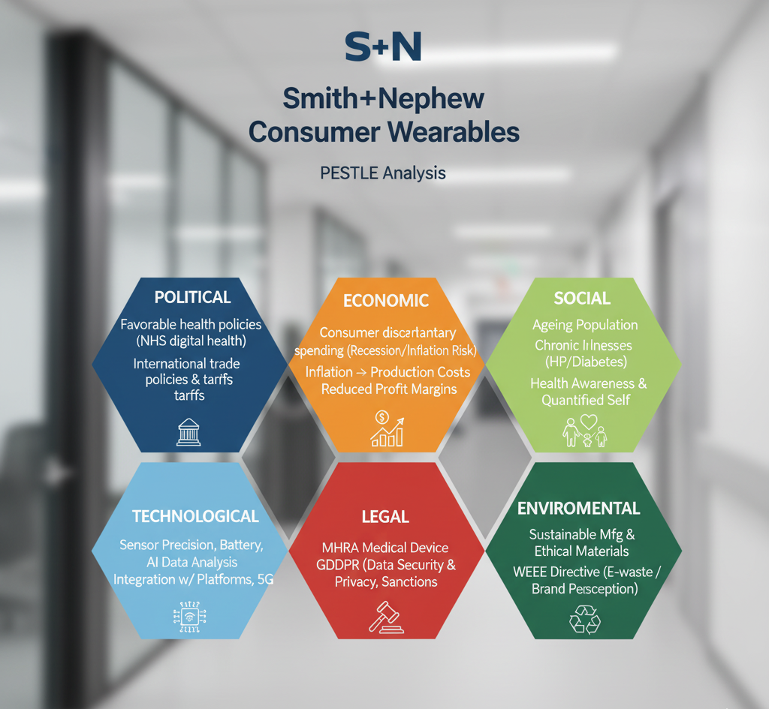

Figure 2: ESTLE Analysis (Self-Developed)

One of the favourable tail winds of the project is social trends. Ageing of the population, an increasing trend of chronic illnesses such as high blood pressure and diabetes and an increase in the cultural awareness of health are placing a long-term emphasis on monitoring personal health. The quantified self trend, in which people implement technology to monitor their daily lives, represents an advanced consumer group which is open to evidence-based health information. The swift rate of innovation is highly vital to the success of the project, especially in terms of technology. Increases in sensor precision, longer power supply, and use of AI-powered data analysis to give personalised information are not only features but key competitive demands. The growing ability to be integrated with other health platforms and the emergence of 5G connectivity also provide opportunities for improved functionality. The regulatory environment is challenging and tough in terms of law. The equipment should comply with strict medical device requirements by organisations such as the MHRA, which may be a time-consuming and expensive procedure. Also, the gathering and processing of sensitive health information should be strictly adhered to the GDPR, in which a breach can lead to harsh economic sanctions and reputational losses. Lastly, environmental issues are becoming more significant, and the demand to adopt sustainable manufacturing and ethically sourced materials is growing among consumers. It should also possess a clear policy regarding the handling of electronic waste according to such regulations as the WEEE Directive, since corporate environmental responsibility is one of the primary considerations in the contemporary brand perception.

2.3 SMART Objectives
To guide the project and ensure all stakeholders are aligned, a set of clear and measurable objectives is essential (Doran, 1981). The project's objectives have been framed using the SMART methodology to ensure clarity, focus, and accountability. The primary objective is Specific: to successfully design, manufacture, and launch the new wearable health device, featuring heart rate, oxygen level, and sleep pattern tracking, directly to the UK consumer market. This clarity ensures that all subsequent activities are focused on this precise outcome. Success will be Measurable through a clear set of key performance indicators (KPIs). These include achieving sales of 75,000 units and capturing a 5% share of the UK wearables market within the first twelve months post-launch, tracked via sales data and market analysis reports. Furthermore, product quality and user experience will be measured by securing an average customer satisfaction score of 4.5 out of 5 stars, gathered through post-purchase surveys and online reviews.
The objective is considered Achievable; while ambitious, it is grounded in the company’s existing strengths. It is achievable by leveraging Smith+Nephew's world-class R&D expertise to deliver a superior product and by forming strategic partnerships with established retailers and marketing agencies to overcome inexperience in the D2C sector. The project is also highly Relevant to the company's long-term strategy. It represents a crucial step to diversify Smith+Nephew's product portfolio beyond its traditional medical markets, create a significant new revenue stream, and strengthen its brand position in the rapidly growing digital health sector. Finally, all activities are Time-bound by an aggressive but clearly defined six-month timeline. This deadline encompasses all critical path activities, from final design freeze and regulatory submission to manufacturing ramp-up and the execution of the go-to-market plan, ensuring a focused and urgent approach to project delivery.

3.0 Key Stakeholder Identification
Stakeholders are any individuals, groups, or organisations that can affect or are affected by the project's activities (Freeman, 1984). Identifying them early is a foundational step in successful project management (Project Management Institute, 2021). The stakeholders for this project can be categorised as either internal or external to the organisation.
Internally, the key stakeholders include Senior Management and the Board of Directors, who provide strategic direction and funding and are accountable for the project's return on investment. The core Project Team, comprising engineers, designers, and developers, is responsible for the day-to-day execution. They are supported by several departments: the Marketing Department, which develops the go-to-market strategy; the Sales Department, which builds sales channels; the Legal and Compliance Department, which ensures adherence to regulations; the Finance Department, which manages the budget; Human Resources, which staffs the team; and the Manufacturing and Operations Team, which oversees production and the supply chain.
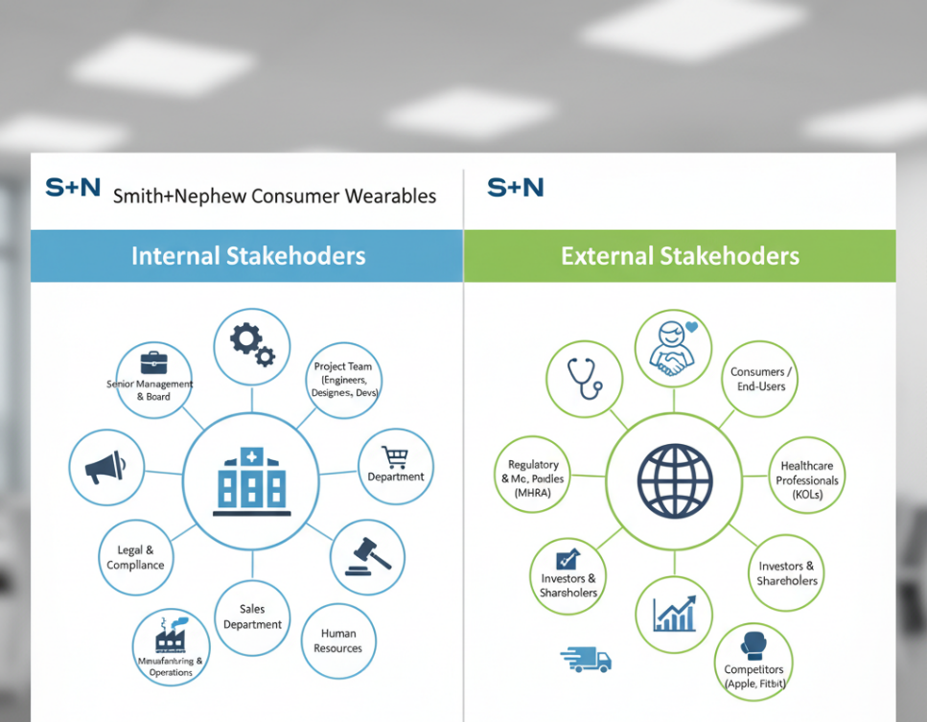

Figure 3: Key Stakeholders (Self-Developed)
Externally, the most crucial stakeholders are the Consumers or End-Users, whose adoption determines the product's success. Other vital external stakeholders include Suppliers and Manufacturing Partners, who provide the components and assembly services for the device. Regulatory Bodies, such as the MHRA in the UK, hold the authority to approve the device for sale, making them a critical gatekeeper. Healthcare Professionals may act as key opinion leaders, while Investors and Shareholders provide the necessary capital and expect a return. The competitive landscape is shaped by Competitors, whose actions must be monitored. Finally, Distributors and Retailers are essential partners for achieving market reach and making the product available to consumers.

4.0 Stakeholder Roles, Responsibilities, and Impact
It is necessary to grasp the roles, input, and possible issues with individual stakeholders that can arise in order to formulate a personalised engagement plan that would be capable of navigating the project complexities (Ashcroft, 2017). On the inside, the main duty of Senior Management is to be the champion of the project and obtain the relevant financial and human resources. The greatest advantage they introduce is their authority to eliminate the barriers in organisations and overcome the conflicts of the top level within the organisation, and keep the project from losing connection with the company's strategy. Nevertheless, the lack of experience in their daily working activities may pose a problem, including the establishment of unrealistic goals in terms of timing or budgets. Their emphasis on high-level returns on investment could also go against the requirement of the project team to invest in non-revenue-generating yet vital fields, such as user experience or quality of the product in the long run.
The Project Team is an engine that takes care of the technical execution of the plan, from designing and developing to testing and quality assurance. Their experience is the main advantage, because it is their innovation that will be the initiator of the new product, the one who has profound knowledge of the product and can bring the complex machine to life. Combating insurgency among themselves, such as the possibility of causing burnout due to the ill-thought-out six-month budget, possibly due to communication failure between hardware and software sub-teams, and the necessity to overcome internal conflicts of values based on technical priorities, are the primary issues. These activities are immediately bordered by the Marketing Department, whose task is to develop the market demand and perform as an internal spokesperson of the consumer. They critically do offer good information to the market and consumer behaviour that influences the features and positioning of the product. However, friction often appears when their offered strategy of how to go to market or their promotional campaigns are not similar to the true features of the product, its budget, as well as the ability of the engineering team can lead to a sort of mismatch in what is promised and what is done.

One such party of external stakeholders, whose importance should not be underestimated, is Regulatory Bodies, as they are essential conditions to guarantee the acceptance of the device because it is impossible to regulate the safety and efficacy of the device without regulation. They have to approve their products not just because it is the law, but also because it is a powerful selling point because it will give the product somewhat of credibility that will further separate it against these less exacting competitors. Their biggest issue is that the approval process is rather unpredictable in nature and may even be more time-consuming and it represents a significant risk to the project schedule. Request of additional information or explanation, which come late, can jeopardise the entire time of launching the project. Final decision makers regarding the success of a product are the consumers and End-Users due to the feedbacks they provide by adopting the product or not. They also provide priceless inputs in the form of early feedback in the beta testing which is essential in fine tuning user experience and elimination of bugs in the beta testing process before it is introduced in mass markets. Her requirements however are different and are likely to be conflicting and prioritising features is not an easy task. Besides, any reputational damage that may happen online can be extensive and fast during the digital age; therefore, the community management strategy must be proactive. Finally, but not the least are Suppliers who equally are major actors that guarantee quality components on time. A good close working relationship with the suppliers is a major strength, which will guarantee a sound production process and possibly access to new technology. They are also a significant cause of risk because any problem with quality control, unexpected price increment, or delay on the side of one critical supplier can bring the whole production line to a complete halt and cause a direct effect on the cost of the project and launch time.

5.0 Stakeholder Engagement Frameworks
To systematically manage stakeholders, a range of established frameworks can be applied (Bourne, 2015). These tools help in prioritising efforts and defining clear lines of communication and responsibility.

5.1 Stakeholder Power/Interest Matrix
The Power/Interest Matrix, developed by Mendelow (1991), categorises stakeholders to help prioritise engagement efforts. Stakeholders with high power and high interest, such as Senior Management and Regulatory Bodies, must be managed closely with constant engagement and involvement in key decisions. Those with high power but low interest, like the Finance and Legal departments, should be kept satisfied by ensuring their requirements for budgetary control and compliance are met without involving them in daily details. The third quadrant, containing stakeholders with low power but high interest, like the Project Team and End-Users, should be kept informed through regular and clear communication, such as progress reports and feedback channels. Finally, those with low power and low interest, such as Competitors, need only be monitored for potential market shifts.

5.2 RACI Matrix
The RACI matrix is a responsibility assignment chart that clarifies roles and prevents confusion (Jacka and Keller, 2009). It assigns stakeholders as either Responsible (doing the work), Accountable (ultimately answerable), Consulted (providing input), or Informed (kept up-to-date).
RACI Matrix:
Task | Project Manager | Project Team | Senior Management | Marketing Dept. | Legal Dept.
Finalise Device Design | A | R | C | C | I
Secure Regulatory Approval | A | C | I | I | R
Develop Marketing Campaign | A | I | C | R | C
Manage Project Budget | A | I | I | C | I

5.3 Stakeholder Communication and Engagement Plan
This plan operationalises the engagement strategy by defining the specific methods and frequency of communication for each stakeholder group (Newton, 2016).
Stakeholder Group | Key Interest | Communication Objective | Method | Frequency
Senior Management | ROI, Strategic Alignment | Ensure confidence, facilitate key decisions | Steering Committee Meeting, Dashboard Report | Bi-weekly
Project Team | Task clarity, progress | Foster collaboration, resolve issues | Daily Stand-up, Weekly Team Meeting | Daily/Weekly
Marketing Dept. | Product features, timeline | Align marketing and development efforts | Joint Workshops, Shared Project Plan | Weekly
Regulatory Bodies | Safety, Compliance | Achieve timely approval | Formal Submissions, Official Correspondence | As required
End-Users (Beta) | Functionality, Usability | Gather feedback for improvement | Surveys, Focus Groups, User Forums | Bi-weekly

6.0 Engagement Process and Conflict Management
As project manager, my role is to proactively lead the engagement process and establish a framework for managing conflicts constructively (Cleland and Ireland, 2006).

6.1 The Engagement Process
The engagement process is a continuous cycle, involving several key stages. It begins with identifying all potential stakeholders, after which they are analysed using frameworks like the Power/Interest Matrix to understand their needs and influence. Based on this analysis, a Communication and Engagement Plan is developed to define the strategy for each group. The core of the process is the engagement stage, where the plan is executed through active listening and two-way communication in meetings, reports, and workshops. Finally, the process requires constant monitoring and review to assess the effectiveness of the strategy and the satisfaction of stakeholders, allowing for adjustments to be made as the project evolves and stakeholder influence shifts.

6.2 Conflict Management: The 4C’s Model
Conflict is an inevitable and, at times, even healthy by-product of a complex project involving diverse stakeholders with differing priorities (Rahim, 2017). The key is not to avoid conflict but to manage it constructively. The 4C’s model provides a proactive framework for channelling disagreements into productive outcomes, transforming potential disputes into opportunities for clarification and improvement (Ellis, Gibbs and Rein, 1991). As project manager, my approach will be rooted in this model, beginning with its foundation: Communication. The strategy will be to establish a culture of open, honest, and regular communication to pre-empt misunderstandings. This involves more than just status updates; it means creating channels where team members feel safe to raise concerns without fear of blame. For instance, if a conflict arises between the Marketing team's desire for a new feature and the Engineering team's assessment of its technical feasibility within the timeline, I would facilitate a structured joint meeting. The goal would be to move beyond positional bargaining by having each team articulate their underlying interests and constraints, fostering mutual respect and a shared understanding of the trade-offs involved.
Building on this foundation is Coordination. This is the practical alignment of different stakeholder activities to prevent friction. While tools like the RACI matrix and shared project plans are instrumental, their true value lies in creating a single source of truth that reduces the ambiguity that often fuels conflict. By clearly defining responsibilities and dependencies, we can ensure that, for example, the Sales team’s launch preparations are perfectly synchronised with the final software validation from the quality assurance team, preventing last-minute crises. The next level, Cooperation, fosters a willingness among stakeholders to work towards shared project objectives, even when their departmental interests may not perfectly align. As project manager, my role is to consistently reinforce the project’s SMART objectives, framing discussions around what is best for the product's success. By celebrating collective milestones and transparently linking individual team efforts to the overall project victory, we can encourage a mindset where departments are willing to compromise on resource allocation or timelines for the greater good of the launch.

The deepest and most effective level of engagement is Collaboration, where stakeholders are empowered to actively co-create solutions. This transforms the dynamic from negotiation to innovation. For example, should beta testers report a significant usability issue with the device's user interface, this would be treated not as a failure but as a collaborative challenge. I would convene a workshop bringing together not only the software developers and UX designers but also the marketing lead and several of the beta testers themselves. This collaborative forum leverages the diverse perspectives of technical experts, market-facing teams, and end-users to diagnose the root cause and co-design a superior solution. This process transforms a potentially damaging conflict into a valuable opportunity for product improvement, ensuring the final device is more robust, user-friendly, and better aligned with market expectations.

7.0 Evaluation of Impact and Recommendations
Effective stakeholder engagement is not just a project management activity; it is a critical driver of business performance and long-term success (Laplume, Sonpar and Litz, 2008).

7.1 Impact of Stakeholder Engagement on Business Performance
The impact of a robust stakeholder engagement strategy on business performance is multifaceted. It leads to improved project outcomes by ensuring the final product meets market needs, thereby reducing the risk of costly rework and directly impacting profitability (Project Management Institute, 2021). Proactive communication and transparency build trust with customers and investors, enhancing the company's brand reputation. A well-aligned product, supported by engaged retail partners and endorsed by healthcare professionals, is more likely to achieve its sales targets and increase market share. Furthermore, engagement functions as an effective risk mitigation tool, as stakeholders are more likely to raise potential issues early, allowing the project manager to address them before they escalate. Finally, engaging a wide range of stakeholders brings diverse perspectives into the project, which can lead to significant product innovations and contribute to a culture of organisational learning that benefits future projects.

7.2 Recommendations
First, it is recommended that Smith+Nephew formalise its approach by developing a standardised stakeholder engagement framework. This would involve creating a company-wide toolkit containing templates for stakeholder mapping, communication plans, and risk assessments, transforming engagement from an individual project manager’s skill into a consistent and repeatable organisational capability. To support this, the company must invest in building the necessary expertise by providing project managers and team leaders with formal training in advanced communication, negotiation, and conflict resolution. A robust framework is only effective when people possess the sophisticated soft skills required to apply it in complex, high-pressure situations.

Second, the organisation should implement structural changes to foster greater collaboration and customer-centricity. For future direct-to-consumer launches, establishing a permanent cross-functional steering committee with representatives from marketing, R&D, sales, and operations is crucial. This structure would break down departmental silos from a project’s inception, ensuring strategic alignment and proactive coordination throughout the product lifecycle. This internal alignment must be complemented by an external focus, achieved by implementing a formal, continuous customer feedback loop. Creating a customer advisory board or utilising a sophisticated CRM system to systematically gather and analyse user feedback will ensure that the voice of the customer is a central driver of future innovation.
Finally, to ensure these practices are sustained, Smith+Nephew must drive accountability through its performance management system. The most critical step is to integrate stakeholder satisfaction as a key performance indicator (KPI) in the performance reviews of not only project managers but also senior business leaders. When successful engagement is directly linked to career progression and remuneration, it is elevated from a procedural task to a core business priority. This creates a powerful incentive for leaders to champion these practices, ensuring that the strategic importance of stakeholder relationships is embedded deeply within the organisational culture and becomes a lasting competitive advantage.

8.0 Conclusion
The launch of the new wearable health product represents a significant strategic opportunity for Smith + Nephew to diversify its resources in its newly-emerging consumer health-tech business. Of critical importance to the success of this six month project, however, is the need for a well-organised and rapid approach to stakeholder engagement. The strategic approach has been presented in this report through the analysis of the current context and identifying the stakeholders; and through the implementation of the powerful managerial models, including Power/Interest Matrix and RACI chart. The project manager can create a collaborative work environment where the combined forces of all interested parties can be brought together using the 4Cs model to manage conflicts in a structured way, and the ability to include everyone in the engagement process facilitates effective collaboration between them. The impact that this solution can bring on the project completion date is amazing, but the impact on business results is equally significant, and the company can gain a positive reputation from it, which reduces the risk and improves innovations and ultimately generates incomes. The proposed steps are a roadmap for Smith+Nephew to not only benefit from the success of this specific launch but also in developing a critical organisational capability in dealing with its stakeholders. In a dynamic marketplace in which competition is tough, the ability to fundamentally connect with everyone who has an interest in the success of the company will be an important determinant of the development of the company and its leadership over the long term.

9.0 References
Ashcroft, J. (2017) The relational lens: understanding, measuring, and managing stakeholder relationships. Cambridge: Cambridge University Press.
Bourne, L. (2015) Making projects work: the theory and practice of stakeholder engagement. Boca Raton, FL: CRC Press.
Cleland, D.I. and Ireland, L.R. (2006) Project management: strategic design and implementation. 5th edn. New York: McGraw-Hill.
Deloitte (2024) 2024 global health care outlook. Available at: https://www.google.com/search?q=https://www2.deloitte.com/global/en/pages/life-sciences-and-health-care/articles/global-health-care-sector-outlook.html (Accessed: 8 October 2025).
Doran, G.T. (1981) 'There's a S.M.A.R.T. way to write management's goals and objectives', Management Review, 70(11), pp. 35–36.
Ellis, C.A., Gibbs, S.J. and Rein, G.L. (1991) 'Groupware: some issues and experiences', Communications of the ACM, 34(1), pp. 38–58.
European Union (2018) General Data Protection Regulation (GDPR). Available at: https://gdpr-info.eu/ (Accessed: 8 October 2025).
Freeman, R.E. (1984) Strategic management: a stakeholder approach. Boston: Pitman.
Grand View Research (2024) Wearable Technology Market Size, Share & Trends Analysis Report. Available at: https://www.grandviewresearch.com/industry-analysis/wearable-technology-market (Accessed: 8 October 2025).
Jacka, J.M. and Keller, P. (2009) Business process mapping: improving customer satisfaction. 2nd edn. Hoboken, NJ: John Wiley & Sons.
Kotler, P. and Armstrong, G. (2021) Principles of marketing. 18th edn. Harlow: Pearson Education.
Laplume, A.O., Sonpar, K. and Litz, R.A. (2008) 'Stakeholder theory: reviewing a theory that moves us', Journal of Management, 34(6), pp. 1152–1189.
McKinsey & Company (2023) Navigating the semiconductor supply chain challenge. Available at: https://www.google.com/search?q=https://www.mckinsey.com/industries/semiconductors/our-insights/navigating-the-semiconductor-supply-chain-challenge (Accessed: 8 October 2025).
Mendelow, A.L. (1991) 'Stakeholder mapping', in Proceedings of the 2nd International Conference on Information Systems, Cambridge, MA.
Newton, P. (2016) Managing project communication: a practical guide. London: Project Management Institute.
Project Management Institute (2021) A guide to the project management body of knowledge (PMBOK® guide). 7th edn. Newtown Square, PA: Project Management Institute.
Rahim, M.A. (2017) Managing conflict in organizations. 6th edn. New York: Routledge.
Sammut-Bonnici, T. and Galea, D. (2015) 'SWOT Analysis', in Wiley Encyclopedia of Management. John Wiley & Sons, Ltd.
Smith+Nephew (2024) About Us. Available at: https://www.google.com/search?q=https://www.smith-nephew.com/about-us/ (Accessed: 8 October 2025).
Yüksel, I. (2012) 'Developing a PESTLE analysis framework for the evaluation of the external environment of a business', International Journal of Business and Management, 7(24), pp. 52-67.

