University of Wales Trinity Saint David
London Campus
Network Operating Systems and Services
ACCA5023
Configure and manage the Virtualised Enterprise network
Student name: Ilia Fedorovich
Student ID: 2410118
Group: 1
Lecturer name: Md. Sadeque Imam Shaikh
Contents
Routing 2
Domain Server 4
Encrypted Connection 7
Users 9
Domain Membership 11
DHCP Server 13
Test and Troubleshoot 15
Disk Drive 17
IIS Server 21
Remote Desktop Services 22

Routing
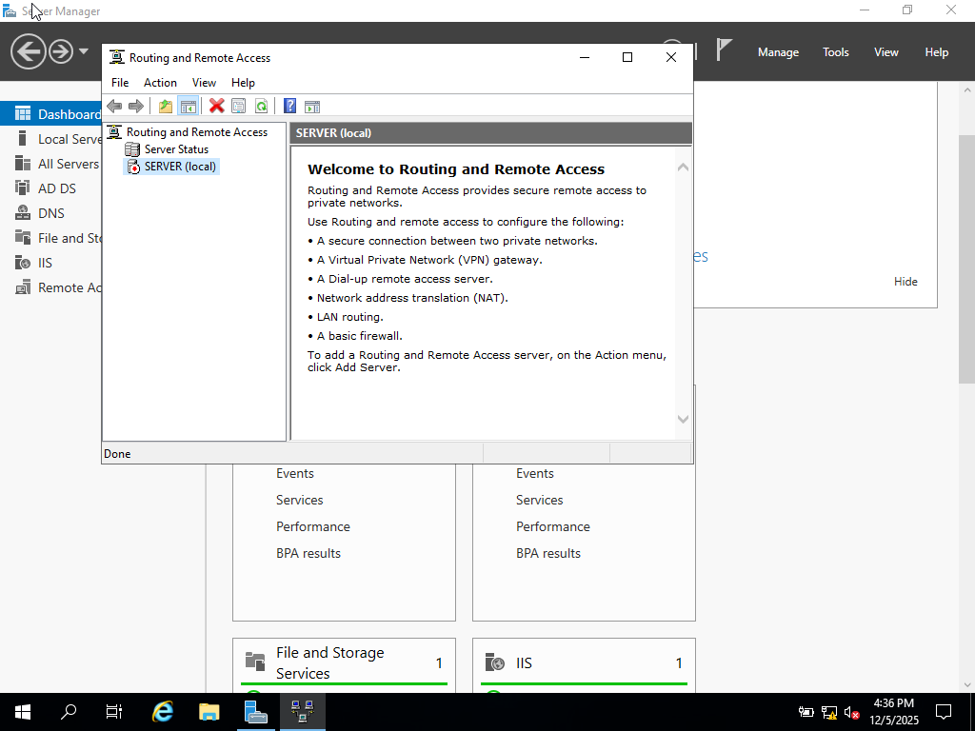
Figure 1. Displays the Routing and Remote Access console welcome screen
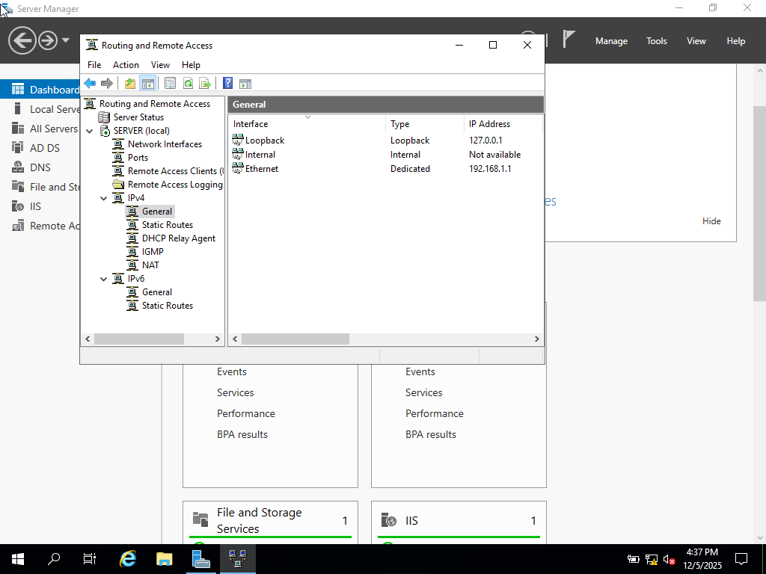
Figure 2. Demonstrates active IPv4 routing interfaces

Domain Server
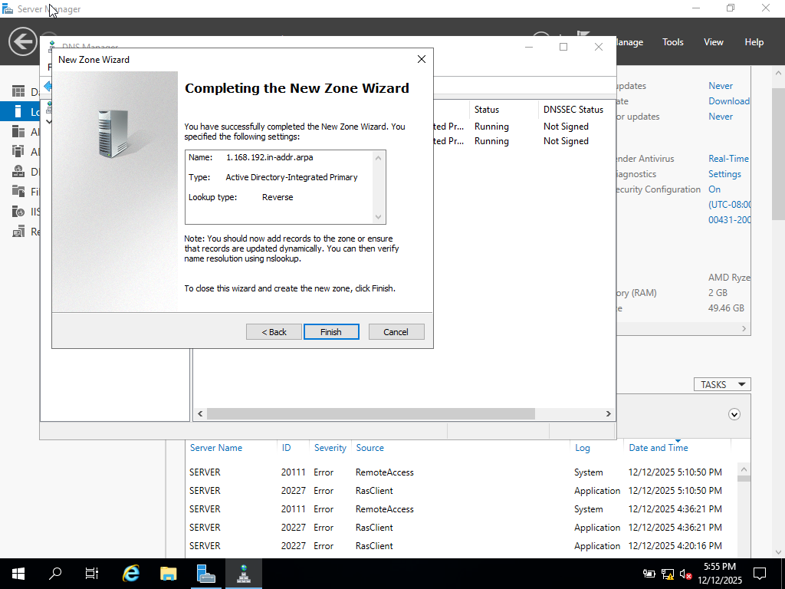
Figure 3. Demonstrates the creation of a new forest and domain
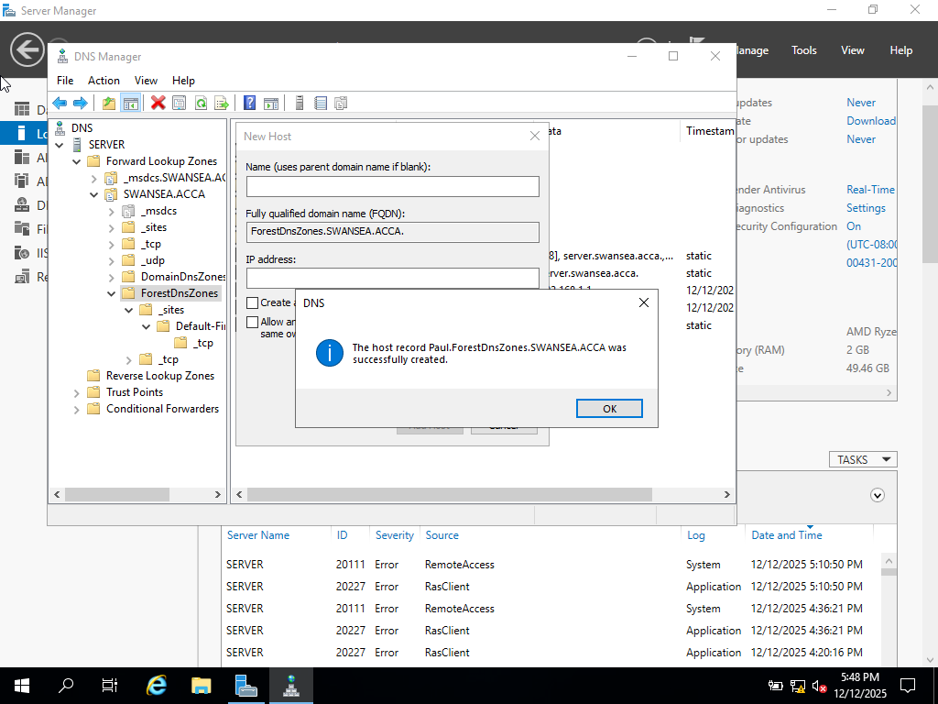
Figure 4. Demonstrates the confirmation message indicating that the record was successfully created
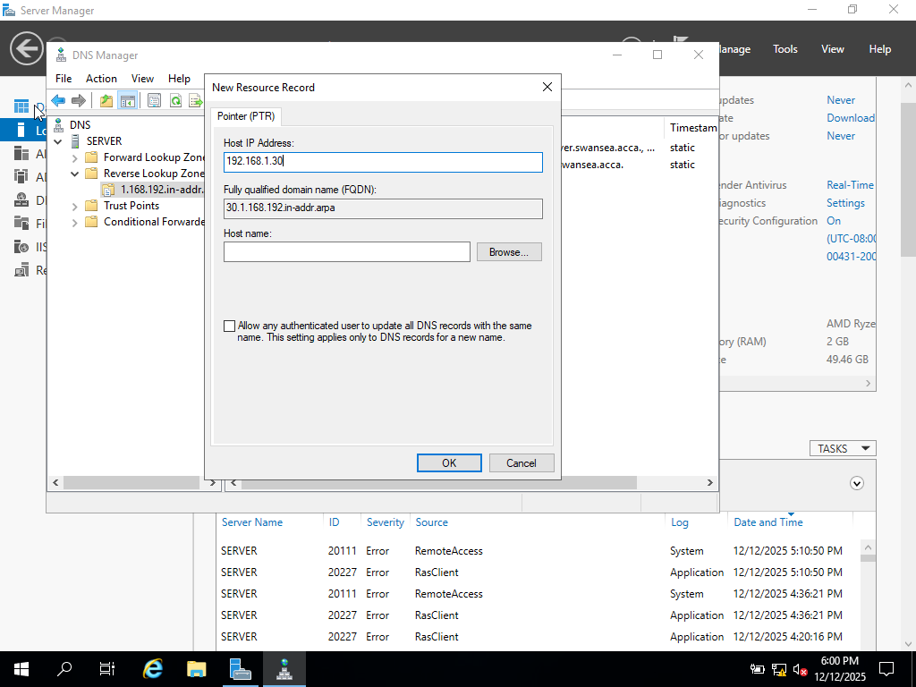
Figure 5. Demonstrates the creation of a PTR record for an IP address in the reverse lookup zone

Encrypted Connection
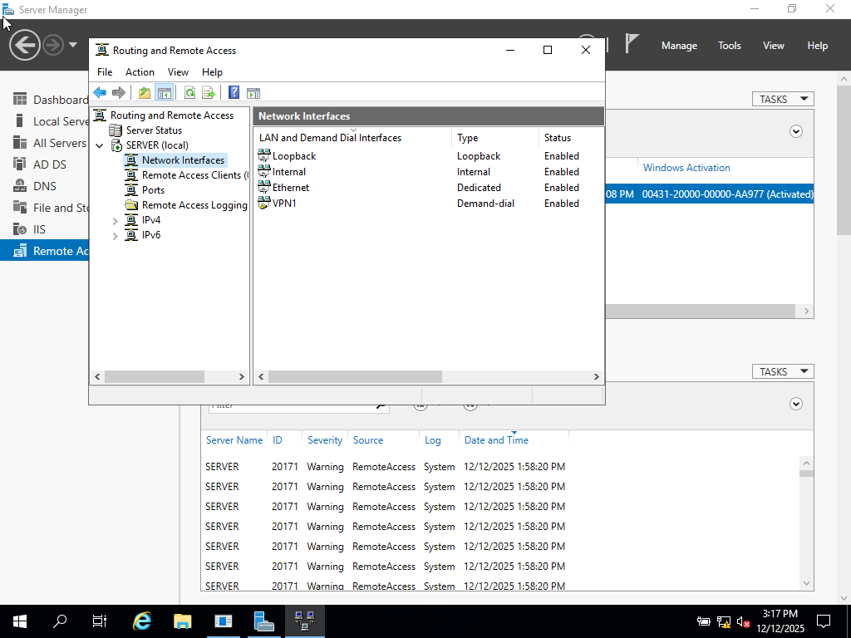
Figure 6. Demonstrates the creation of a Demand-Dial VPN interface
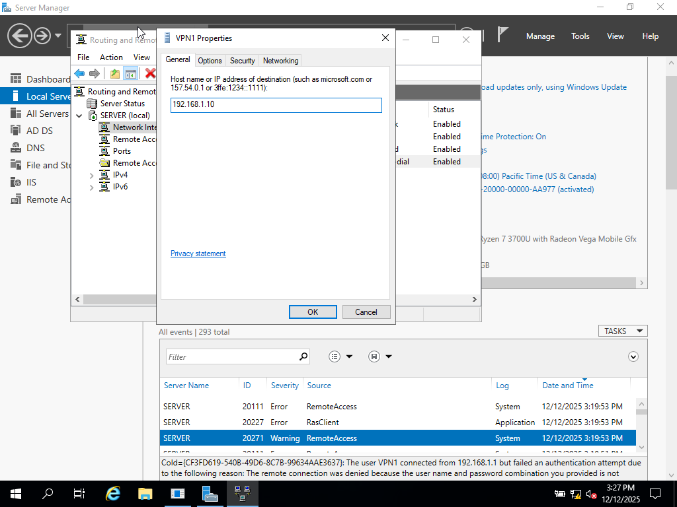
Figure 7. Shows the configuration of the remote destination IP address for the VPN connection

Users
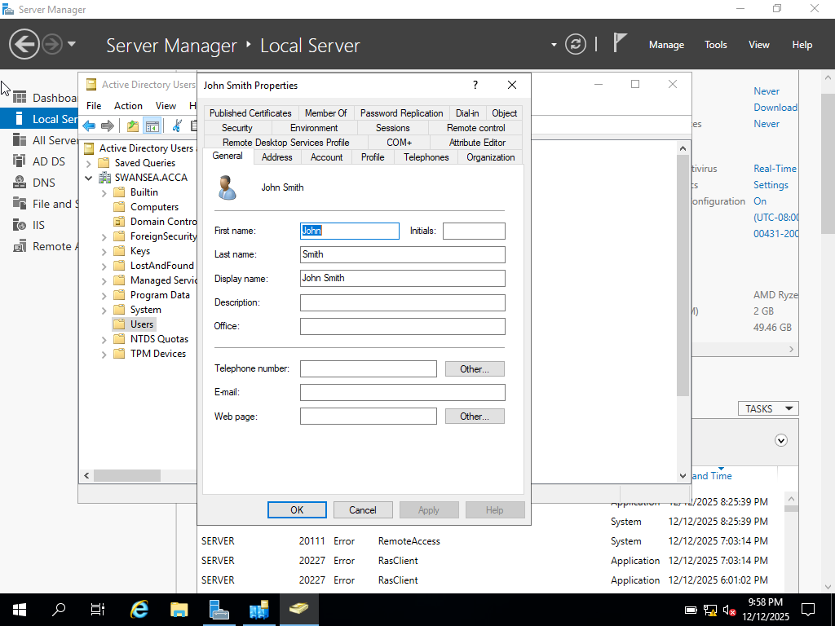
Figure 8. Demonstrates user account configuration
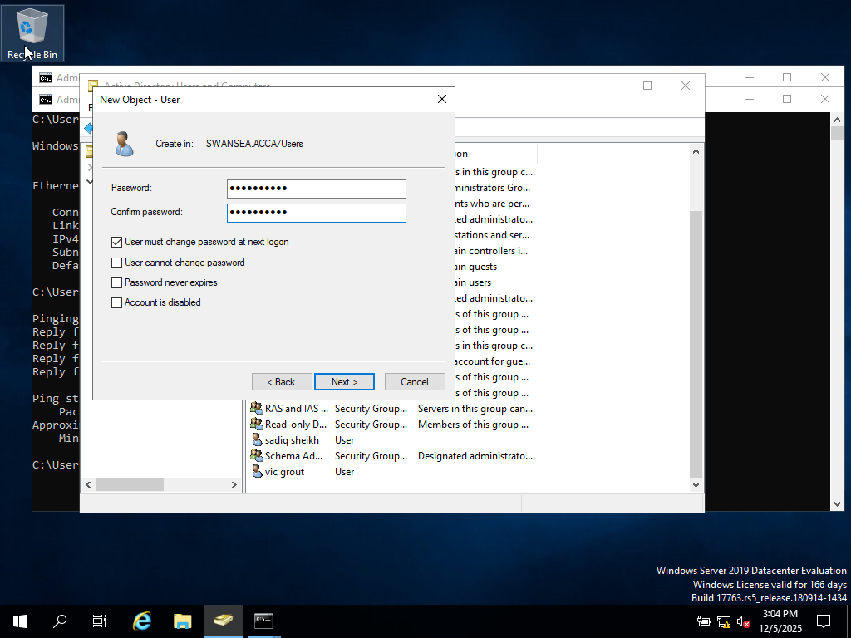
Figure 9. Shows the password configuration stage

Domain Membership
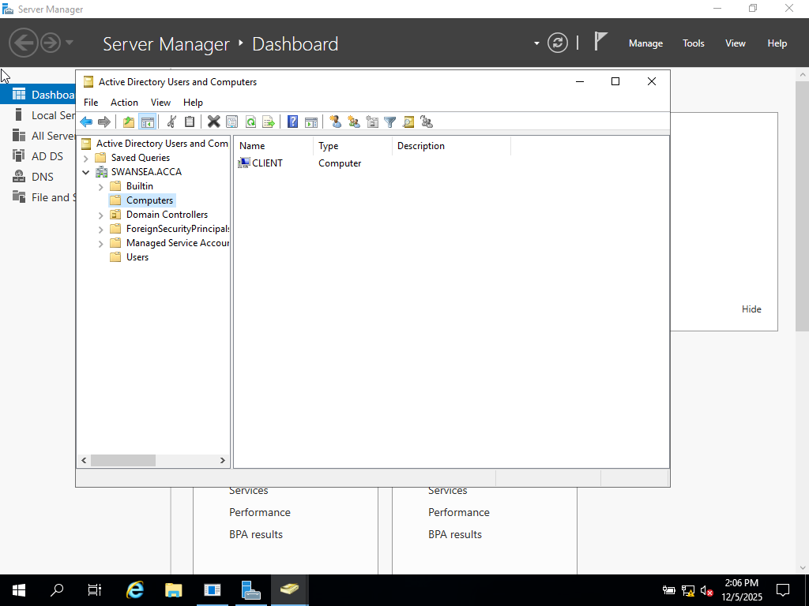
Figure 10. Demonstrates the Active Directory Computers container
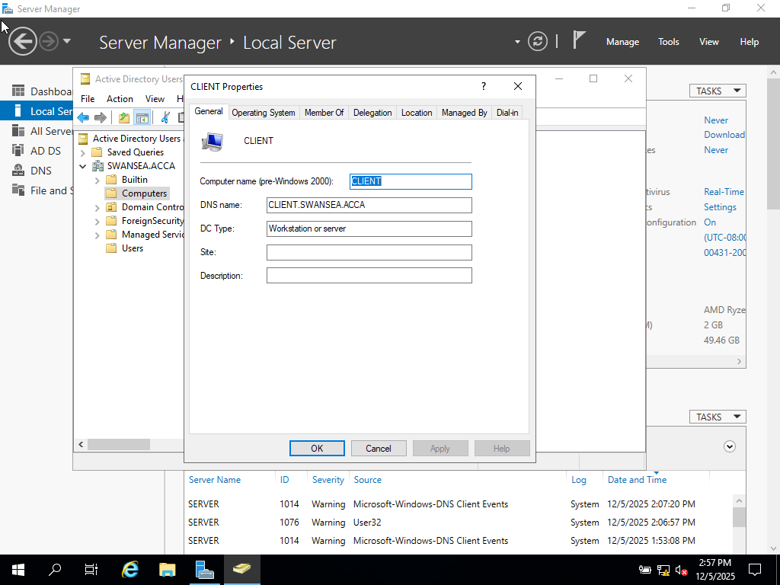
Figure 11. Shows the properties of a domain-joined client computer

DHCP Server
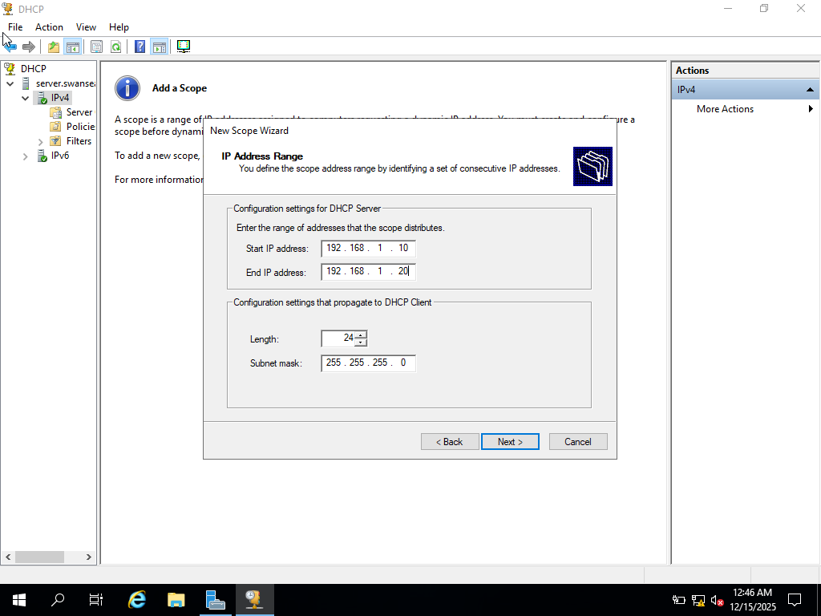
Figure 12. Shows the DHCP Manager with the configured scope
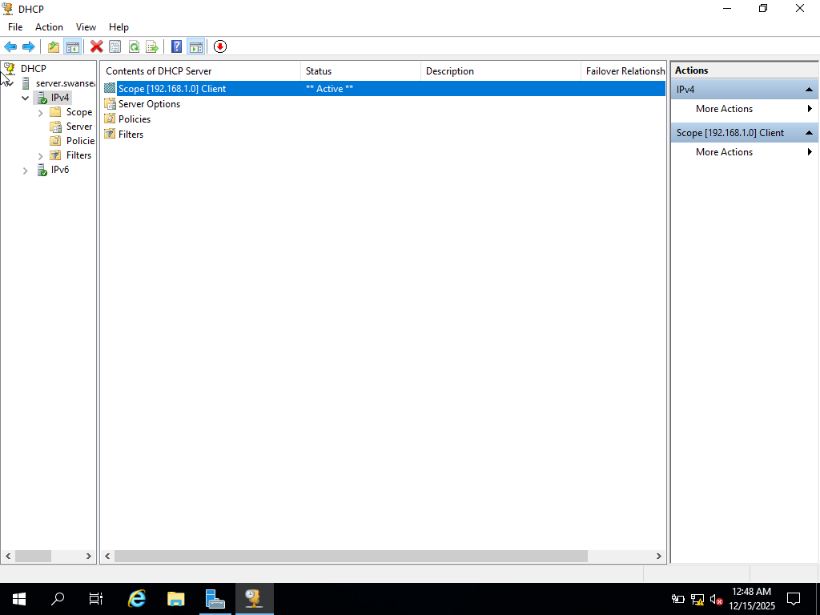
Figure 13. DHCP Manager with an active IPv4 scope

Test and Troubleshoot

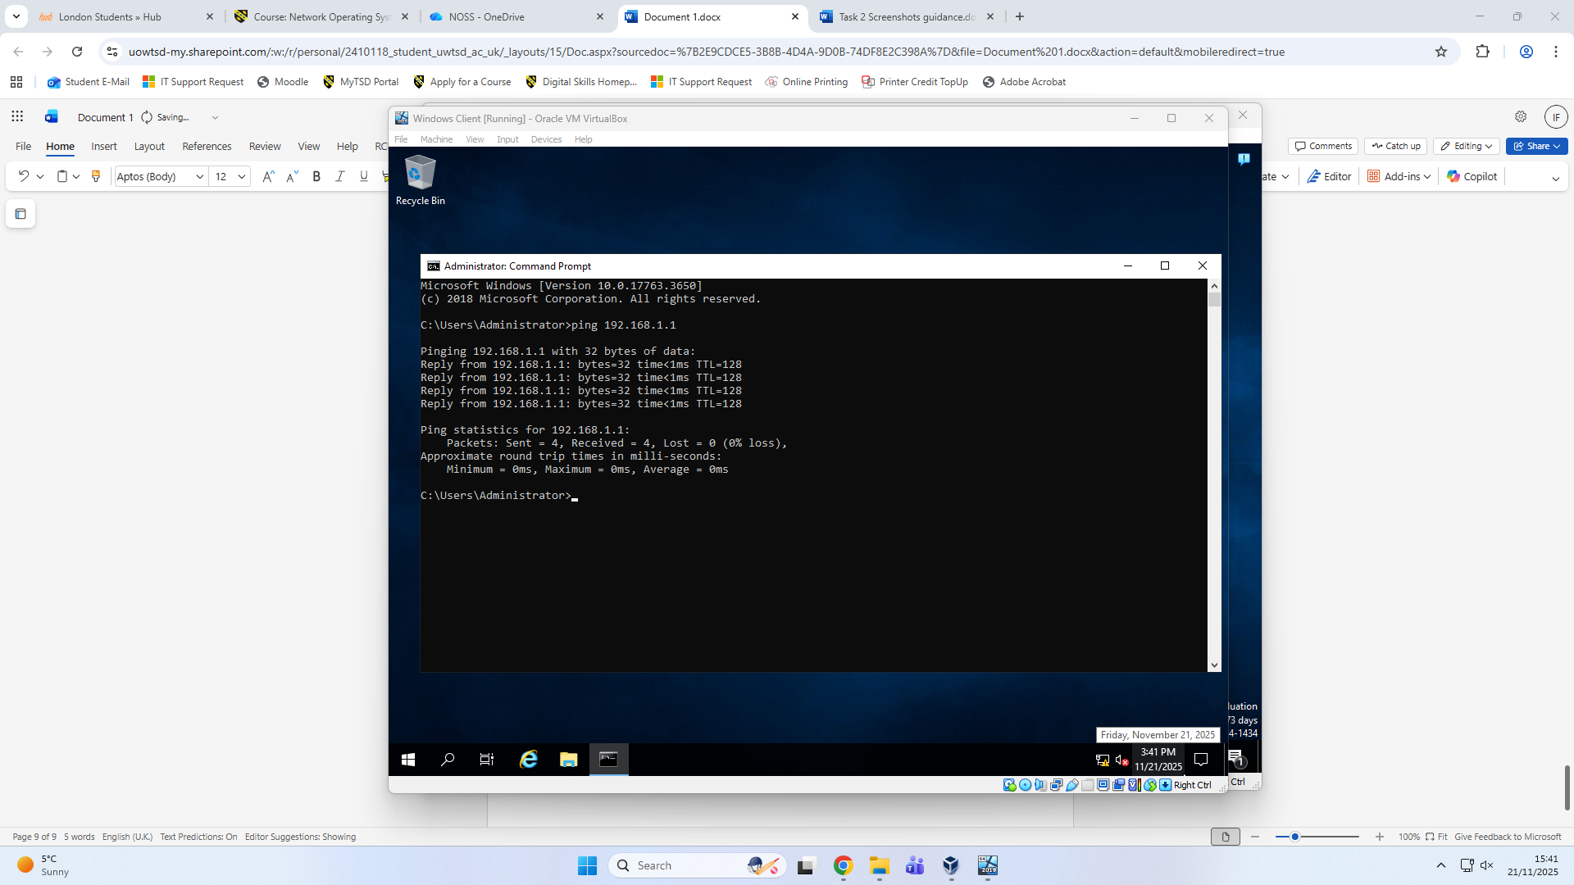
Figure 14. Demonstrates a success ping test
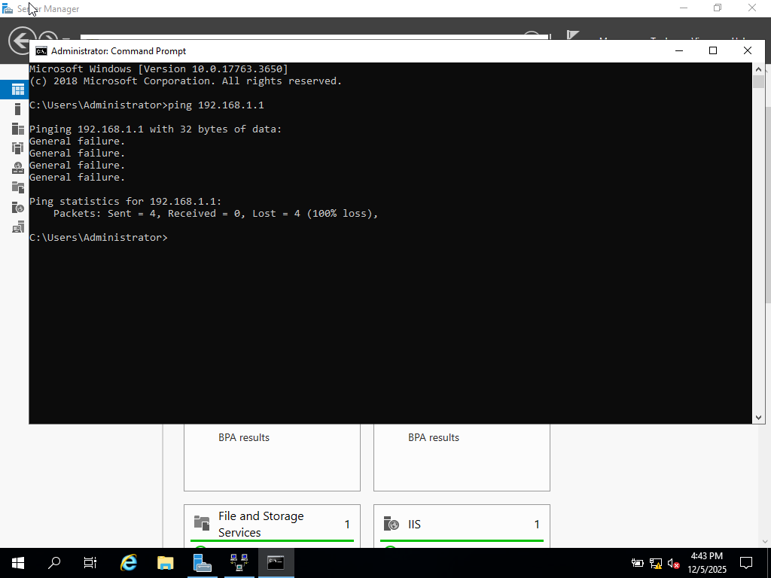
Figure 15. Demonstrates a ping test with failed responses

Disk Drive
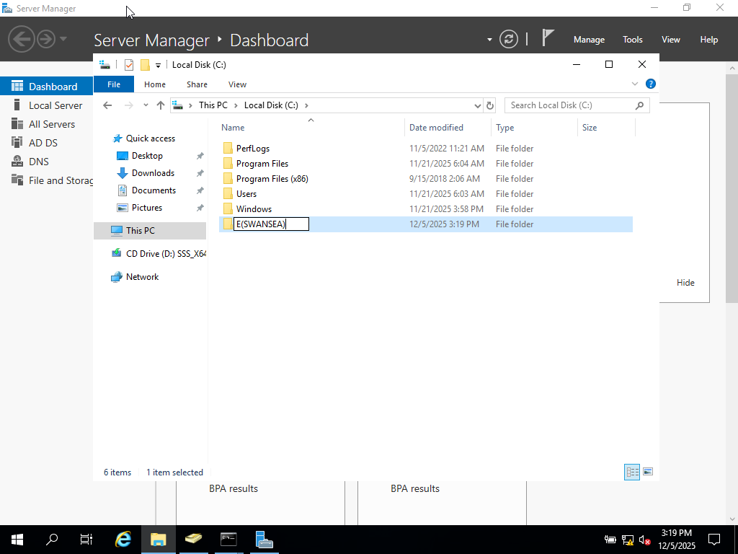
Figure 16. Shows the secondary disk and shared folder (E:\SWANSEA) created on the server
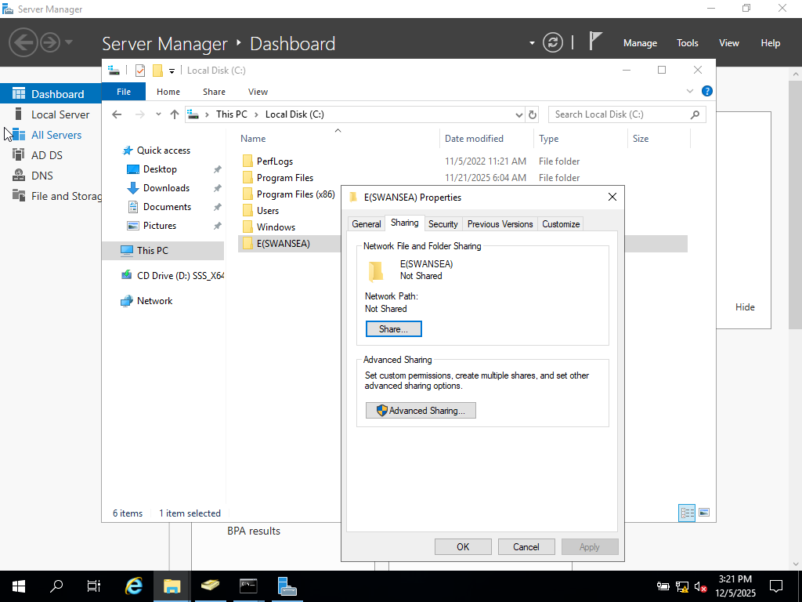
Figure 17. Demonstrates the sharing configuration of the folder
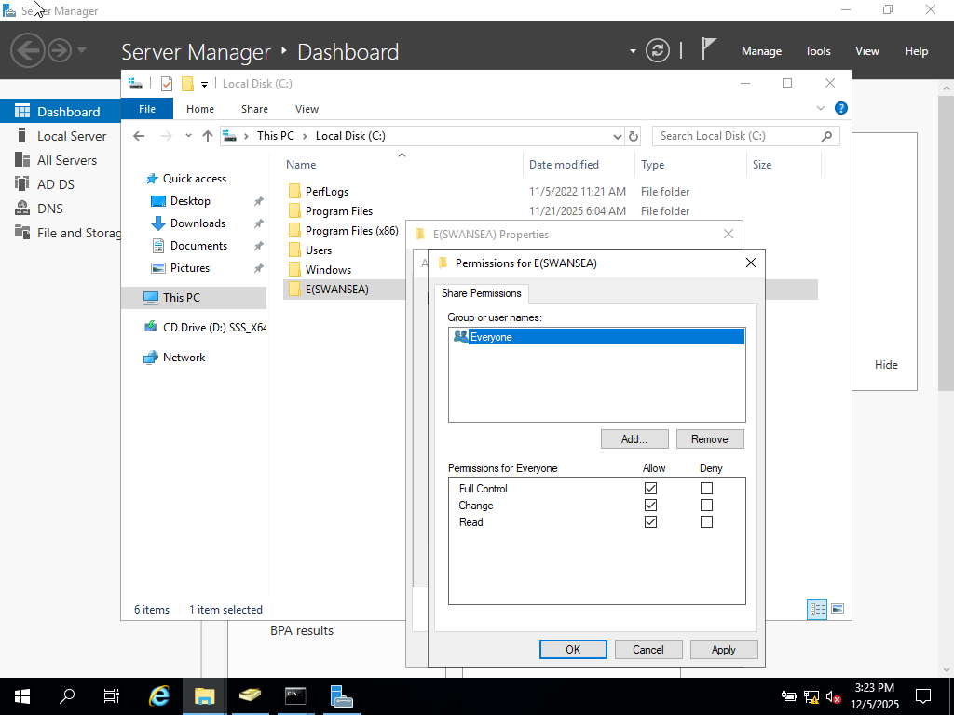
Figure 18. Shows the share permissions configuration
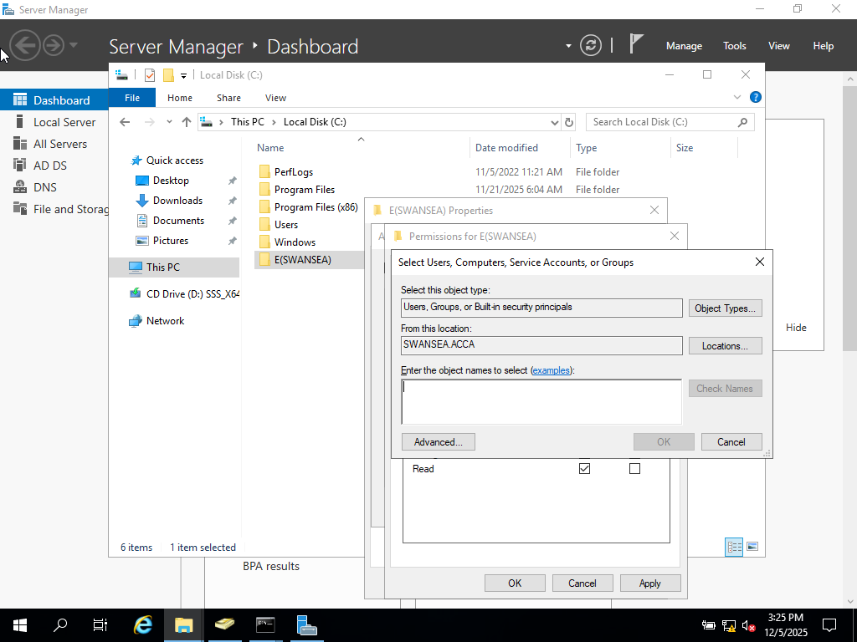
Figure 19. Demonstrates the assignment of domain users and groups to the shared folder permissions

IIS Server
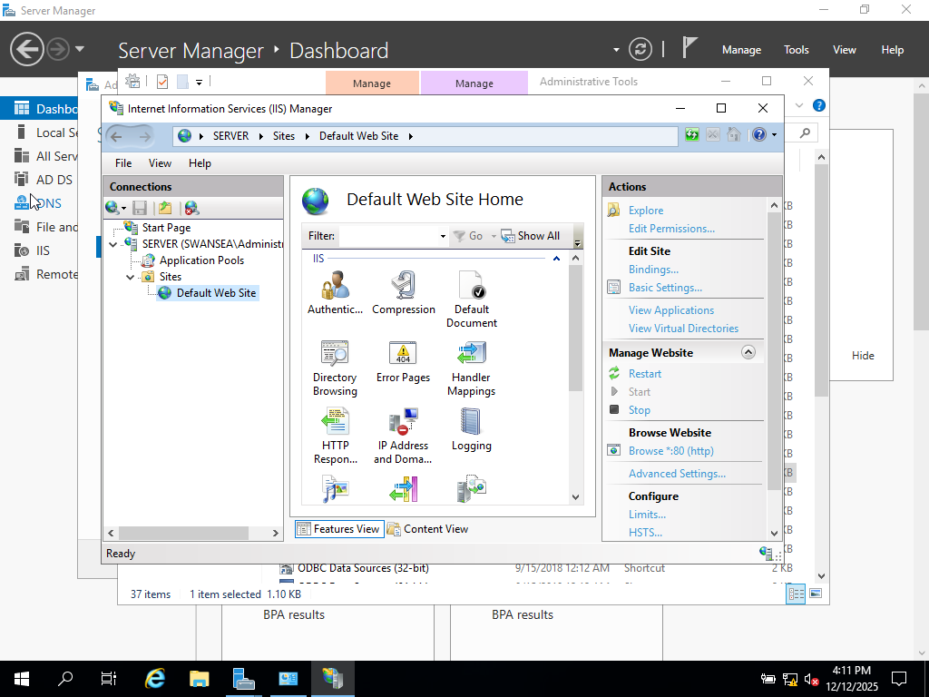
Figure 20. Shows the IIS Manager

Remote Desktop Services
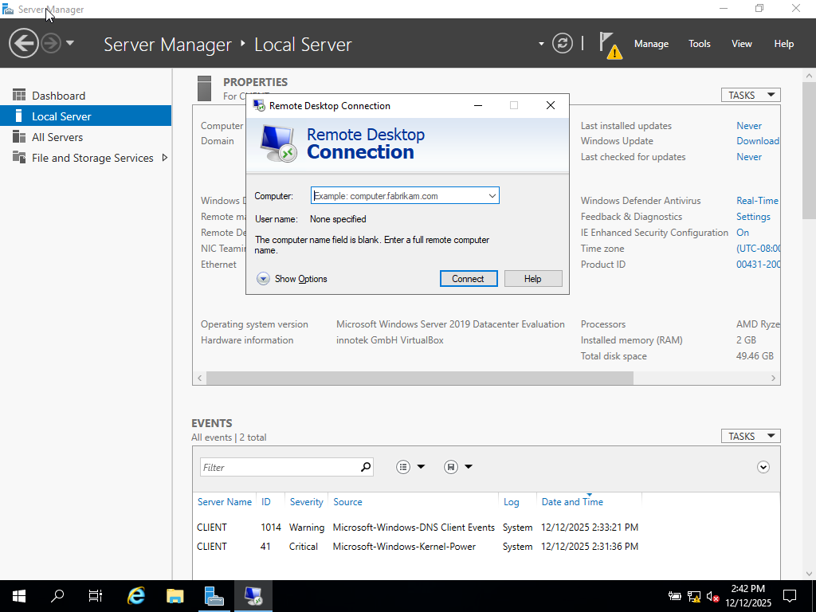
Figure 21. Shows the Remote Desktop Connection
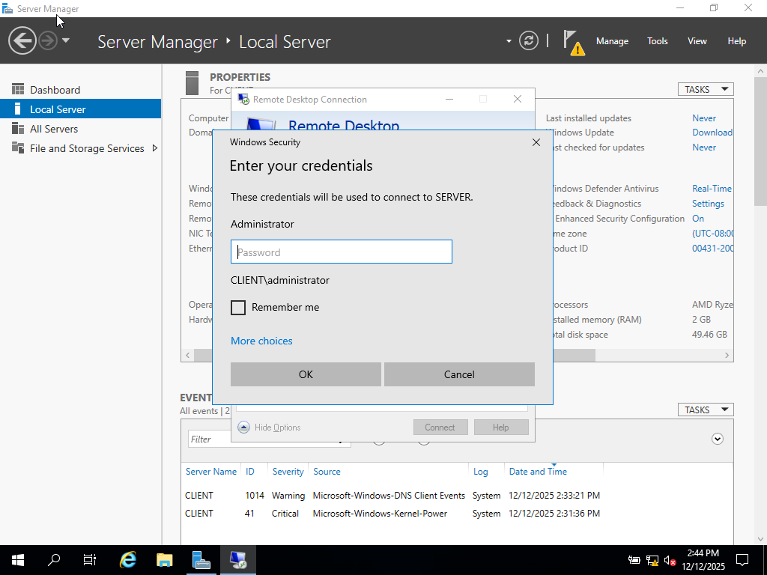
Figure 22. Demonstrates the credential prompt during the Remote Desktop connection
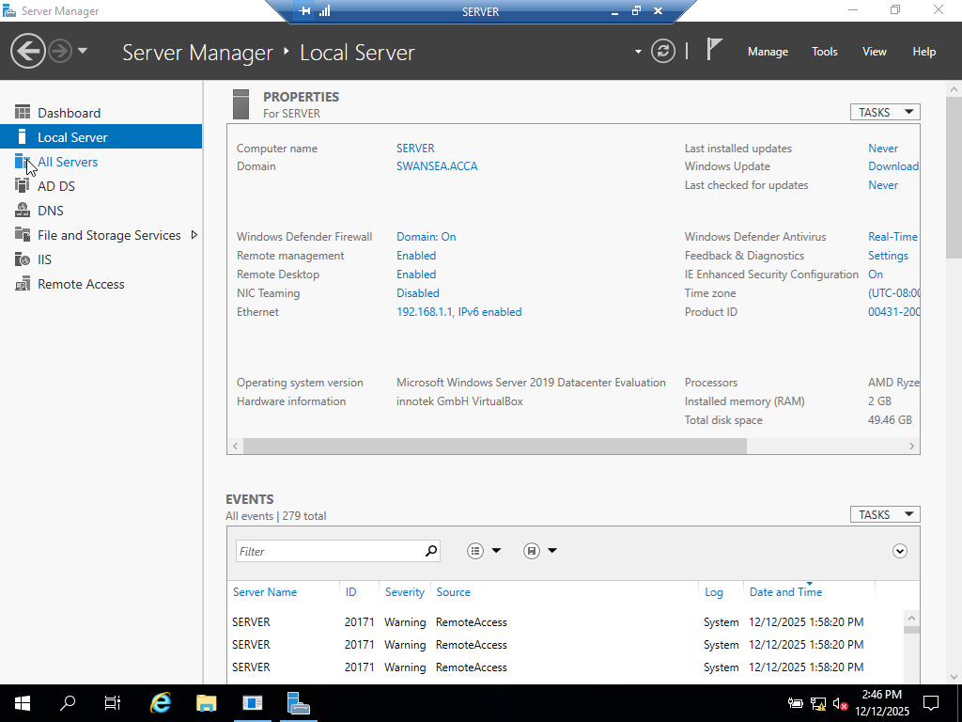
Figure 23. Shows the Local Server properties with Remote Desktop enabled

