HUMAN RESOURCE MANAGEMENT

STUDENT NAME: MANSI PRAJAPATI
SUBJECT: HUMAN RESOURCE MANEGMENT
STUDENT NUMBER: 2228670
Table of Contents
1.Introduction 3
a) Current state of the labour market in the UK 3
b) Emerging changes in the Human Resourcing Strategies 6
2.Conclusion 9
3. Reference list 11

List of Figures
- Regional unemployment Rate……………………………………………………………..4
- UK labour market 2011-2023 5
- UK Labour Market unemployment forecast 6
- Disability Employment Gap 7
- Critical factors of workforce strategies 9

Introduction
The labour market describes the production level of a country and performance of the companies. Based on the details of this market, a country significantly plans and develops the business categories even to expand internationally. The present report has significantly shows the current state of the UK labour market from where both the positive and negative aspects have come out. On the other hand, HR (Human Resource) strategy is the roadmap for an organisation to deal with the challenges that come from employee-centric situations. The policy creation, communication with employees, managing their skills, and development of their abilities, compensation management and the planning for corporate culture are done through the strategies in companies. This report has explained the emerging changes in HR strategies after the Covid-19 era and Brexit in the UK. Certain differences from the previous times have been explained in the report and the positive, as well as negative effects of it, have been explored.
Global labour market faced an overall slowdown from 2020 due to pandemic for which it started recovery in 2021 with a rise in productivity growth of 2.4%. Although it slowdown again in 2022 to 0.5% Also, global labour market is experiencing a downward trend which is a cause of concern. Between 2000-2014, average annual rate is of 1.8% whereas it is 1.4% between 2015-2022. Below diagram represents unemployment rate of different regions in world.
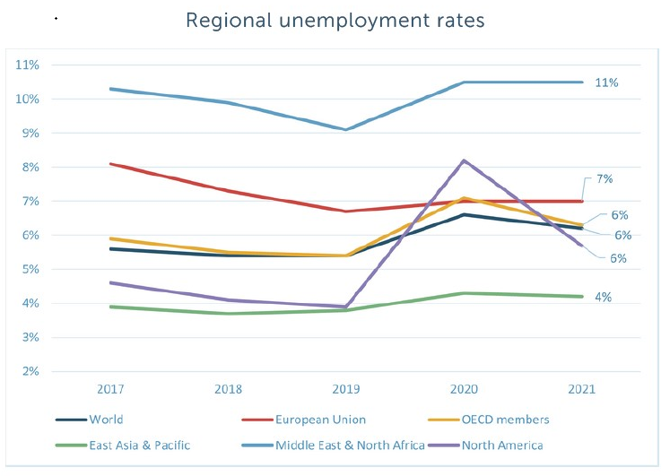
Fig. 01: Regional unemployment rates (ILO,2022)

1.a) Current state of the labour market in the UK
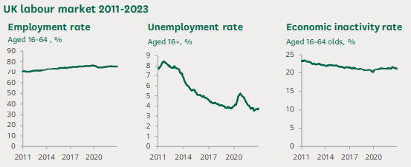
Figure 2: UK Labour Market 2011-2023
(Source: Francis-Devine and Powell, 2023)
The major discussed things for the current state of the labour market are employment, unemployment, economic inactivity, earning, people in the labour market. The above graph has made it clear that the employment rate has increased in the country whereas unemployment has decreased in a huge manner (Francis-Devine and Powell, 2023). Even, the employment inactivity rate has also been minimised in a proper manner. The report has also shown that the employment rate is 75.8% in the year 2022-2023 with 32.95 million people in the employment in the respective country. As per the information, it can be said that the labour market is strong in the country and it has developed gradually. Since 2011, the growth has become prominent and before the pandemic, in the year 2020, it reached a maximum rate of 76.6%. It is considered the highest record level in the country since 1971, though at the time of the pandemic, it has deteriorated and we witnessed fall at every stages due to pandemic.
Lockdown due to pandemic resulted in job losses of people, drop in the labour market rate which became 32.13 million (Francis-Devine and Powell, 2023). The low employment rate and high vacancy level has shown the tight labour market in the UK by which production growth is fostered. The Human Resources department constantly focuses on the recruitment process based on which the job facilities are developed in the country. Two types of employment are found in the country, which is Full-Time and Part-Time employment based on which segregation of employment has come out. Approximately 14.88 million men and 9.69 million women are engaged with full-time work from December 2022-February 2023 (Francis-Devine and Powell, 2023) and 24.57 million people are employed on a full-time basis whereas 8.38 million are considered part-time workers. Also there are both public and private sectors for employment, which also explains the conditions of the labour market. The private sector gives employment to 27.04 million people whereas, in the public sector, 5.80 million people are employed.
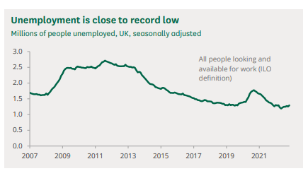
Figure 3: UK Labour Market Unemployment Forecast
(Source: Francis-Devine and Powell, 2023)
As the constant problems have been broadened in the UK labour market in the pandemic , a fall in employment is seen in a huge manner. Before the pandemic, the growth in private sector employees has been noticed and it has performed well since 2010. However, the pattern has been reversed hugely during and after the pandemic which impacted employment. The above graph mentions unemployment, though it is close to a record low after the changes in the labour market after the pandemic. According to Wang et al. (2021), the labour market is active in the country as regular paid employment has been enhanced there. The UK labour market is actually tight and strong, though, the lockdowns and restrictions made problems in the market (Costa Dias et al. 2020). However, after 2021, the numbers had been decreased, which describes the positive labour market growth in the UK.
It is also true that the inactive economy has been developed for a certain time in the UK and the prime reason behind it is the long-term sickness of people during the pandemic era (Li and Heath, 2020). It has become clarified that the annual growth in average pay in cash terms is found in 3 months to February 2023 where the real-time growth in earnings is observed (Francis-Devine and Powell, 2023). The report informs that average pay in the private sector has been increased by 6.1% and 6.9% including and excluding bonuses respectively. Despite the inactivity or the problems of the lockdowns and the pandemic, changes in the economy have been found. Most significantly, the growth has been developed in the context of employment, which showcases the labour market development. It is also found that the net employment balance has remained positive in the year 2023 because of the growth in employers’ plans and strong employment intentions (CIPD, 2023).
In the current labour market of the UK, parents of dependent children have the highest employment rate where 78% of mothers and 94% of fathers are significantly under this employment (Francis-Devine and Powell, 2023). However, lone parents who have dependent children have an employment rate, which is 66% and it is regarded the lower compared to other employment statuses. The current status of the labour market has also been proved through the growth in the employment status of almost all the people in the country based on which economic substantiality has come out (Consearo, 2021). However, unemployment has increased more in the minority groups such as Indian, Pakistani, Chinese and others. Though, the White people’s unemployment rate was lower than others and it is predicted 3.1% as per the report of October-December 2022.
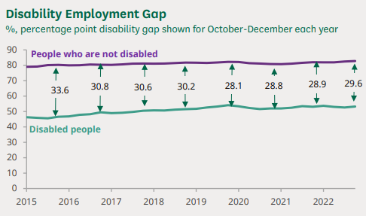
Figure 4: Disability Employment Gap
(Source: Francis-Devine and Powell, 2023)
According to Khayatzadeh-Mahani et al. (2020), the growth in the labour market has also been forecasted when disabled people of the country have gained almost similar opportunities. After the pandemic, the employment rate for those people is 53.2% and 82.8% for non-disabled people (Francis-Devine and Powell, 2023). It shows a 29.6% disability employment gap in the country, however, the gap was only 4.2% before the pandemic period. Therefore, it can be said that employment for those people has been lowered at the current time, though; it has contributed significantly to the labour market of the UK (Influenced by Frøyland et al. 2019). It is vivid that the pandemic has enhanced the problems in employment and the gradual restrictions have been increased. However, disabled people have strictly shown their interest towards employee development based on which the labour market has also progressed hugely.

1.b) Emerging changes in the Human Resourcing Strategies
- HR strategy changes in the post-pandemic
As certain changes are prominent in the UK during the pandemic period, changes in HR strategies are mandatory in the post-pandemic era. It is observed that the companies are facing major challenges to get back to the “new normal” after changing the HR strategies as a huge level of production has been affected by it. The HR managers are focusing on three main things for the employee recruitment and skill development processes, which are the integration of purposes, achievement of potential by individuals and perspective growth for the near future (HBR, 2020). This has strongly supported the managers to make changes in their HR strategies while selecting the workforce quickly. Applying this strategy, the managers have selected participants as per their skills after knowing their future plans, which shows their confidence in the post-pandemic era.
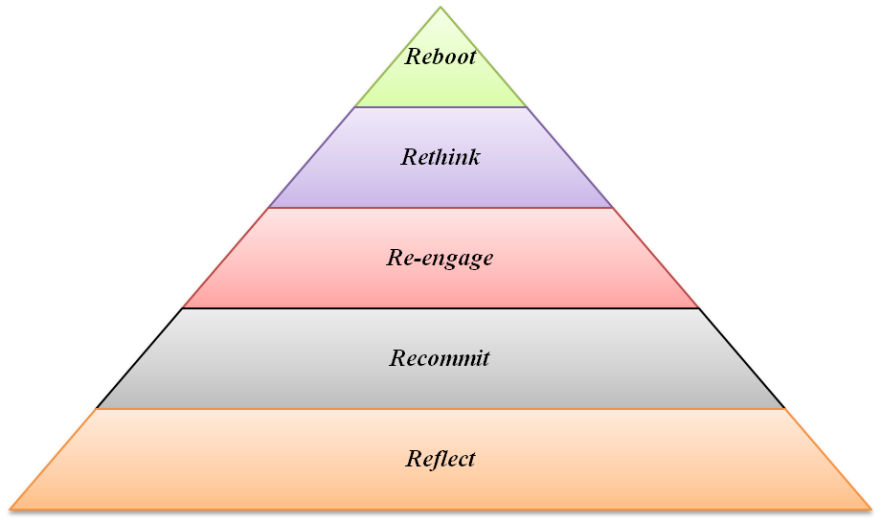
Figure 5: Critical factors of Workforce strategies
(Source: HBR, 2020)
Five more critical factors have been focused on by them, which are Reflect, Recommit, Re-engage, Rethink and Reboot (HBR, 2020). These have helped to make a bridge between employees and organisations based on which the crisis response can also be achieved. Through reflection, the HR managers bring the developed perspectives of employees, which are easier to select them than the earlier times. While the HR managers focus on recommitment, they basically focus on employee well-being and this has been improved after the pandemic. The employees search for a safe workplace after Covid-19 and the flexibilities are given by the HR managers in this regard (Influenced by Baporikar, 2021). Apart from this, HR strategies are not focusing on the critical business needs and clear directions for the employees’ skill growth. This has also served the best for team management and for workforce performance gradually. Therefore, this can also be mentioned as one of the major strategies in the present UK through which situations of the post-covid era are changing.
The HR managers have developed the critical goal of the workforce in order to rethink work properly. It is a pivotal part to make them a more resilient workforce in the respective country based on which the business opportunities can be broadened (Influenced by Dubey, 2020). HR leaders uniquely support the workforce by making the recovery of their positions after the pandemic period. The HR managers also give their focus towards compensation, performance management and promotion facilities more than the earlier times. The main reason behind it is the attraction creation for the employees based on which the weak workforce can be strengthened soon. From the viewpoints of Mamba et al. (2021), it is clear that HR strategies during the pandemic focused on production growth. However, in the post-pandemic era, the HR management team has focused hugely on the consumers’ choices before selecting the employees. They significantly assemble the requirements and make the training or development facility for the employees according to the requirements.
- HR strategy changes in the post-Brexit era
Brexit is mainly the leasing of the UK from the European Union and the name comes from the “exit” of “Britain. When it was under the EU, the rules, legislation and regulations for HR management were similar, however, with time, and Brexit, changes have been observed. Therefore, after the Brexit era, the HR strategy changes have taken its place in a huge manner through which the changes have also become prominent in the selection, recruitment or talent management process. As per the opinions of Riaz et al. (2020), the foremost thing, which has been done by HR managers, is the identification of financial crises. Depending on this strategy, the managers have known the facts and figures of companies based on which employees’ skills can be developed. Before Brexit, employers and HR managers do not negotiate hugely; however, it has increased hugely after the Brexit era. The HR team makes negotiations with the employees before giving them job facilities in order to reduce any type of confusion or conflicts in the country.
The HR strategies also build the employees’ mentality towards the work through different benefits of the workplace. From the analysis of Moradlou et al. (2022), it is vivid that the strategic decisions of the employers help to develop business benefits for employees so that it becomes one of their main choices. Therefore, when developing HR strategies, managers focus on the developed strategic decisions such as employee management, gradual increments and others. It assists the employees to select the companies significantly and the HR managers make changes in their forms of strategies to get skilled as well as efficient workers. This has significantly developed in the post-Brexit era because the HR managers get chances to select the employees on their own as Britain exits the European Union and their opinions have been significantly prioritised. As opined by Bailey et al. (2023), operational opportunities in firms are reviewed and monitored by the HR managers effectively in order to make the proper selection of employees. After the Brexit period, business operations have taken a downturn in the UK as it enhances their financial loss. Therefore, knowing the facts of operations properly, the HR managers have changed the strategy and developed their responsibilities to select employees rightly.
Another major thing, which has come out from the changes in HR strategy in the post-Brexit era is the continuous changes in the training of the staff (Patel and Hadman, 2021) Therefore, it is mentioned that after the period, the HR managers have strongly developed training facilities for the employees through which they can significantly enhance their efforts towards the companies. While giving the training, the HR team also informs the penalties and employment liabilities to the employees based on which they properly know the regulations in the UK and the legal dimensions of their working facilities. As severe changes have taken place due to Brexit, the HR managers have tried to make consistency in the working hours of employees for avoiding any type of legal problems again. In that case, they have suggested working for 8 hours per day based on which employees are getting motivation towards their work. According to the descriptions of Gorynia et al. (2021), Brexit has made changes in the future of HR strategies because the UK has made them free from the European Union for which the selection and recruitment categories are changed. Thus, the post-Brexit era has made certain changes in HR strategies and the HR managers have made it possible in a significant manner.
Analysis through PESTEL Analysis of Labour Market:
Below table has highlighted different factors which can affect the UK labour market existing condition.
Political | Highly susceptible to political stability and decisions such as Brexit and Lockdown imposed due to Covid-19 pandemic.  Dependency over policies and regulations formed by government.  Availability of Foreign workers are heavily dependent over immigration policies
Economical | Higher inflation and interest rates can affect the labour market.  Recession may deteriorate condition of labour market further.
Social | Increase in the ageing population can affect the worker availability  Diversity in workforce
Technological | Use of digitalization techniques such as Artificial intelligence, automation,
Environmental | Shift towards sustainability may create greener jobs.
Legal | Susceptible to change in employment trend, regulation, pension regulation, Right and protection of worker regulation.

Conclusion
The above discussion has shown the constant changes in the UK related to the labour market and HR strategies. In the first question, it is seen that the labour market of the UK has gained a strong position as continuous payment growth and employment facilities are found. From the information and dataset, it has become clear that the labour market statistics are high in the UK. The continued increase in employment is found in a huge manner based on which the production has been expanded in the country. Apparently, in the last 2-3 years, the unemployment rate has also developed due to the pandemic. However, the growth is seen hugely in the employment of disabled people or others based on which the country has significantly gained a high return in the economy. On the other hand, the HR strategies have been changed according to the post-pandemic and post-Brexit situations. The employers and HR managers have highly focused on employee-centric policies, training facilities, workforce performance management and others. These changes are done to satisfy and attract the employees in the period to increase the production of the country gradually. When the changes are made in these two situations, the HR managers have tried to give extraordinary facilities to the employees for the monetary growth in the UK.

Reference list
Bailey, D., Propris, L., Ruyter, A., Hearne, D. and Ortega-Argilés, R., (2023). “Brexit, trade and UK advanced manufacturing sectors: a Midlands’ perspective”. Contemporary Social Science, pp.1-16.
Baporikar, N.(2021). “Handbook of research on sustaining SMEs and entrepreneurial innovation in the post-COVID-19 era”. IGI Global.
CIPD, (2023). “Labour Market Outlook – Winter 2022/23”. Available at: https://www.cipd.co.uk/knowledge/work/trends/labour-market-outlook#gref [Accessed on 20/4/2023]
Consearo, L., (2021). “Economic substantiality: Skills in the UK labour market”. In The Sustainability Debate. Emerald Publishing Limited.
Costa Dias, M., Joyce, R., Postel‐Vinay, F. and Xu, X., (2020). “The challenges for labour market policy during the Covid‐19 pandemic”. Fiscal Studies, 41(2), pp.371-382.
Dubey, S.K., (2020). “Human Resources Role Post COVID 19”. International Journal of Management Research and Reviews, 10(10), pp.1-4.
Francis-Devine, B and Powell, A., (2023). “UK labour market statistics”. Available at: https://researchbriefings.files.parliament.uk/documents/CBP-9366/CBP-9366.pdf [Accessed on 19/4/2023]
Frøyland, K., Andreassen, T. and Innvær, S., (2019). “Contrasting supply-side, demand-side and combined approaches to labour market integration”. Journal of Social Policy, 48(2), pp.311-328.
Gorynia, M., Jankowska, B. and Mroczek-Dąbrowska, K. eds., (2021). “Brexit and the Future of the European Union: Firm-level Perspectives”. Routledge.
HBR, (2020). “Workforce Strategies for Post-COVID-19 Recovery”. Available at: https://hbr.org/sponsored/2020/05/workforce-strategies-for-post-covid-19-recovery [Accessed on 18/4/2023]
Khayatzadeh-Mahani, A., Wittevrongel, K., Nicholas, D.B. and Zwicker, J.D., (2020). “Prioritizing barriers and solutions to improve employment for persons with developmental disabilities”. Disability and rehabilitation, 42(19), pp.2696-2706.
Li, Y. and Heath, A., (2020). “Persisting disadvantages: a study of labour market dynamics of ethnic unemployment and earnings in the UK (2009–2015)”. Journal of Ethnic and Migration Studies, 46(5), pp.857-878.
Mamba, S., Beharry-Ramraj, A. and Mashau, P., (2021). “Human Resource Strategies During And Post-Covid-19 In South African Farms”. Academy of Strategic Management Journal, 20, pp.1-15.
Moradlou, H., Fratocchi, L., Skipworth, H. and Ghadge, A., (2022). “Post-Brexit back-shoring strategies: what UK manufacturing companies could learn from the past? ”. Production Planning & Control, 33(14), pp.1319-1336.
Patel, C. and Hadman, E., (2021). “How Brexit has affected the recruitment process”. Available at: https://www.peoplemanagement.co.uk/article/1743714/how-brexit-affected-recruitment-processes [Accessed on 18/4/2023]
Riaz, A., Ayyoub, M. and Yasmin, F., (2020). “Brexit: An Assessment, Implications, and Strategy for Pakistan”. Research Journal of Social Sciences and Economics Review, 1(3), pp.91-100.
Wang, S., Coutts, A., Burchell, B., Kamerāde, D. and Balderson, U., (2021). “Can active labour market programmes emulate the mental health benefits of regular paid employment? Longitudinal evidence from the United Kingdom”. Work, Employment and Society, 35(3), pp.545-565.

