Assignment Title: Critically evaluate a range of traits and motivations across a variety of different types of entrepreneurs
Student Name: Mohammad Abul Kalam Ali
Student ID number: 2234300
Module Title: BMIH5001 Entrepreneurship
Lecturers’ names: Charlotte Joyner

Introduction
Entrepreneurship requires skills that are essential in bringing about the management of complications in businesses. According to Barringer& Ireland (2018), a good entrepreneur needs to be able to think critically and creatively to ensure that, the strategies formulated help in meeting the practises of an organisation. Entrepreneurship requires the ability to understand the different modes of tactics through which internal as well as external practices can be regarded to play an essential role in survival. Therefore, for this reason, it is necessary to understand the success that entrepreneurs have received via the implementation of their skills.
The essay aims at identifying traits, motivations and characteristics that can be associated with being a successful entrepreneur. The essay tries to highlight significant models through which entrepreneurs can bring about change in their attitude and at the same time, ensure that the change develops positivity towards an individual. Throughout the essay, examples of several successful entrepreneurs are provided that have brought about a revolution in the market through creativity, patience as well as leadership skills. The essay is directed at helping entrepreneurs identify the successful ways through which specific commencement of business practises can be maintained and bring about ideal operations for growth.

Exploring entrepreneurial traits, motivation and characteristics
Entrepreneurship requires certain characteristics that can be identified to bring about positivity in an organisational setting. As stated by Williams (2021) both internal as well as external considerations must be maintained to bring about significant advantages in business. Some of the entrepreneurial traits that are significant in this case include being optimistic and openness in achieving success. In the words of Burns (2022), being optimistic brings about a positive environment through which an individual can help lead an organisation towards attaining growth. This optimisation comes from being confident of the skills and abilities possess.
A strong example of this can be the way Mark Zuckerberg brought about the development of Facebook. According to Ratten (2023), Zuckerberg faced many difficulties during the journey, which included a lack of support from his colleagues and doubt over the idea by his co-workers. However, the optimism that Zuckerberg had in bringing about success coupled with a characteristic that included a strong will and the ability to envision a change in the market had allowed in bringing about the evolution of the modern world. For this reason, being optimistic about the ability is necessary for being a good entrepreneur.
At this stage, the application of a motivational model can be comprehended to help bring about an assessment of entrepreneurship. In the words of Nelson (2013), motivation is needed to succeed and this motivation can come from the desire to influence power. As such, the application of McClelland’s Need for Achievement theory can be comprehended to align with the success of an individual. The need for power is a strong desire for any individual to succeed at the organisational level. According to Rickman& Roddick (2013), the intention to develop entrepreneurial practice can be the way forward for meeting this motivational scheme.
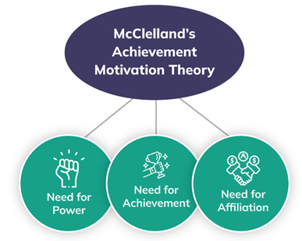
Figure 1: McClelland’s Need for Achievement Theory
(Source: Rickman& Roddick 2013)
Through this motivational theory, individuals believe that having control over others can help in bringing about changes. The example of Mark Zuckerberg can be considered in this case as the need to seek control over the idea had been the factor for success. The need for power, affiliation, as well as achievement, had driven Mark Zuckerberg to be involved in bringing about proper identification of the areas through which success can be comprehended. As understood by Audretsch& Fiedler (2023) the need for achievement theory is the best way to describe the suitability of practice for entrepreneurship.
Another trait that can be associated with entrepreneurship is that of being conscientiousness to succeed. In the words of Blackwell (2011), clarity of goals is an essential component that every individual needs to keep in mind so that being passionate to gain success needs to be simplified by the choices that are made. As understood by Hisrich, Peters & Shepherd (2008) being conscious of the needs and wants can be useful in securing the possibility for creativity and change. Hence, in this way, conscientiousness is a way to explore the task-oriented application and ensure that motivation is maintained for completing such tasks.
The alignment of such traits can be made with Steve Jobs, founder of Apple. The fact that Steve Jobs had been conscious of the changes to take place in the world was one of the areas that led to his excellence. According to Wekinget al. (2023), entrepreneurship can be characterised by the passion to succeed. In the case of Steve Jobs, this passion to succeed had been the identification of future trends and the ability to make changes according to the demand in the market.
The application of a motivation theory can be regarded in this case to help understand the reason for success. Alderfer’s ERG Theory can be applied so that the need for fulfilling strategies can be met. According to Mariotti&Glackin (2012), existence needs, relatedness needs as well as growth needs are to be directed to help understand the efforts made in achieving organisational compatibility. The fact that an entrepreneur needs to ensure that personal development, as well as interpersonal growth, is maintained is the defining factor for the motivation theory. In the words of Rae (2008), the aggravation of the growth needs seems to be associated with a method for performing well in the market.
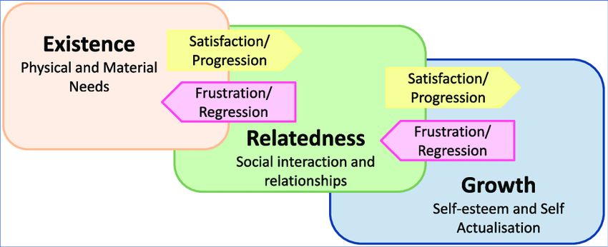Figure 2: Alderfer’s ERG Theory
(Source: Mariotti&Glackin2012)
The alignment can be made with the passion and conscientiousness trait of Steve Jobs to ensure that Apple becomes a success in the world. Each of the needs of customers is considered to be satisfied through the application of the ERG model. As pointed out by delOlmo-Garcíaet al. (2023) Steve Jobs believed in a democratic leadership style and hence the growth was directed towards the personal development of individuals. The self-confidence that Steve Jobs had and the way to achieve goals were the important criteria for success as an entrepreneur.
Another trait that can be considered in this case is extraversion. According to Timmons &Spinelli (2008), for an entrepreneur to be successful in an organisation, it is necessary that anticipation of the opportunities and threats can be gained to bring about operations that can be successful. In the words of, Zimmerer& Scarborough (2011), successful entrepreneurs need to be able to bring social interaction and remain communicative to form networks for bringing about success. This trait can be useful to ensure that knowledge of the market can be gained.
The example of Jeff Bezos can be regarded in this case as an inspirational leader with the ability to build a vast network like Amazon. As stated by Brutonet al. (2023) gaining knowledge of the needs and desires of the customers is an area through which success for Amazon is considered. Bezos has managed to bring about such networking and hence can be regarded as playing a significant role in setting up entrepreneurial advantage. Therefore, in this case, it can be stated that entrepreneurial characteristic like being proactive is an important area of focus.
According to Huang et al. (2023), being proactive can help an entrepreneur combine research activities and identify the threats that seem to be in existence in the business operations. Motivational theory like Vroom’s Theory of Expectancy can be applied in this case to ensure that entrepreneurship brings about positivity in the market. Gupta et al. (2023) understood that Vroom’s Theory of Expectancy provides an identification of the increase in performance as well as that of the value through which motivation for generating money can be made. The motivation for being involved with success via revenue allows entrepreneurs to remain proactive.
In the case of Jeff Bezos, the desire to remain one of the best in the world had driven the entrepreneur to achieve success with Amazon. The application of Vroom’s Expectancy Theory can help in maintaining the available resources to support the supervisor's needs. The proactive characteristic displayed by Jeff Bezos is to maintain a clear understanding of the relationship that exists between outcomes and results. Hence, as stated by Paul et al. (2023) justification for extraversion as an entrepreneurial trait can be aligned well with the Expectancy theory and the pro-activeness needed to succeed.
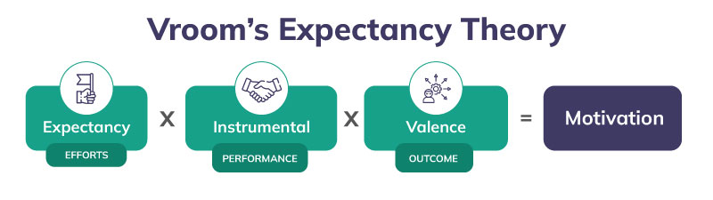Figure 3: Vroom’s Expectancy Theory
(Source: Gupta et al. 2023)
Another trait that can be regarded for entrepreneurial practice is agreeableness. According to Ben-Hafaïedhet al. (2024), the cooperation and compassion of individuals towards one another is regarded in this case to help bring about an identification of the personal gain and self-interest that seems to be in existence. In the words of Rickman & Roddick (2013), a competitive attitude towards interpersonal relationships is the ideal characteristic that separates good leaders from the best.
The example of Elon Musk can be regarded in this case to identify the agreeableness that seems to be in existence as a trait for entrepreneurship. Although del Olmo-García et al. (2023) are of the opinion that the leadership style Musk can be questionable due to the random firing of employees, their passion for business and generous understanding of personal gains marks him as one of the best. Hence, in this way, being a good leader is also another characteristic that can be associated with being a good entrepreneur. Elon Musk sets out the passion through which such creativity can be maintained.
The application of motivation theory like Hertzberg’s two-factor Theory can be introduced in this case to align the passion for entrepreneurship. As understood by Hisrich, Peters & Shepherd (2008) through this theory poor conditions that might hinder the work practises are identified and eliminated so that sufficient factors for the motivation of the employees can be prevalent. The organisational conditions present in an organisation help bring about achievement and recognition that are essential for personal growth. Such an association can help in decreasing job satisfaction.
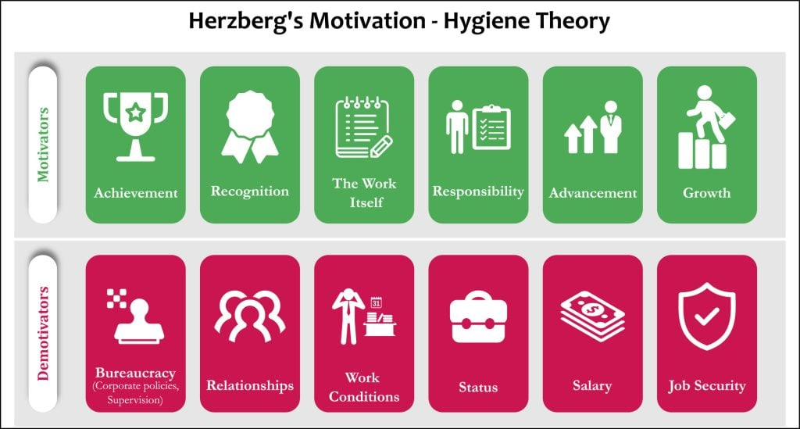Figure 4: Hertzberg’s two-factor Theory
(Source: Hisrich, Peters & Shepherd 2008)
The link with Elon Musk can be made as the entrepreneur tried to bring about a balance of work and quality through the firing of employees. Huang et al. (2023) stated that although exposure towards entrepreneurship cannot be considered encouraging, it has managed to bring about good results for companies like Tesla and X. Hence, from this example, one of the essential characteristics that can be highlighted is that leadership is important and as a leader, tough calls are necessary to be made so that organisational growth can be sustained. In the case of Elon Musk, such entrepreneurial activity can be marked with the alignment of Herzberg’s two-factor theory.

Conclusion
In conclusion, it can be stated that entrepreneurial practice is one of the important areas of growth and development through which creativity in problem-solving skills can be maintained. The essay has highlighted popular theories via which entrepreneurs can bring about an assessment of the characteristics and persuasion in the market. The ability of the entrepreneurs to remain affected by the proposed identification of innovation and growth seems to dictate the mindset of the entrepreneurs. Hence, for this reason, it can be highlighted that entrepreneurs need to possess abilities through which proper and quick change can be initiated in a market.
The traits, motivation and characteristics associated with employees seem to bring about an identification of the areas that are determined to help secure an entrepreneurial management system. Therefore, in this way, it is necessary that the approach undertaken be justified to help secure the prominent contents through which entrepreneurial management can be sorted to help secure growth. The essay has brought about an analysis of these areas through which entrepreneurship can be evaluated to understand its features. Hence, in this way, the essay can be justified to have provided a significant assessment of the requirement through which entrepreneurial practices can be a way to help settle organisations.

References
Audretsch, D. B., & Fiedler, A. (2023). Power and entrepreneurship. Small Business Economics, 60(4), pp.1573-1592.
Barringer, B. R. & Ireland, R.D. (2018) Entrepreneurship: Successfully Launching New Ventures, 4th Ed., Prentice Hall: New Jersey
Ben-Hafaïedh, C., Xheneti, M., Stenholm, P., Blackburn, R., Welter, F., &Urbano, D. (2024). The interplay of context and entrepreneurship: the new frontier for contextualisation research. Small Business Economics, 62(2), pp.571-582.
Blackwell, E. (2011), How to Prepare a Business Plan: Planning for Successful Start-up and Expansion, (5th Ed) Sunday Times Business Enterprise Series, Kogan Page
Bruton, G. D., Lewis, A., Cerecedo-Lopez, J. A., &Chapman, K. (2023).A racialized view of entrepreneurship: A review and proposal for future research. Academy of Management Annals, 17(2), pp.492-515.
Burns, P. (2022) Entrepreneurship and Small Business, 5th Ed., Palgrave Macmillan: Basingstoke
delOlmo-García, F., Domínguez-Fabián, I., Crecente-Romero, F. J., & del Val-Núñez, M. T. (2023). Determinant factors for the development of rural entrepreneurship. Technological Forecasting and Social Change, 191, p.122487.
Gupta, B. B., Gaurav, A., Panigrahi, P. K., &Arya, V. (2023).Analysis of artificial intelligence-based technologies and approaches on sustainable entrepreneurship. Technological Forecasting and Social Change, 186, p.122152.
Hisrich, R.D., Peters, M.P. & Shepherd, D.A. (2008) Entrepreneurship, 7th Ed.,McGraw Hill: NY
Huang, Y., Li, P., Chen, L., & Wang, J. (2023).Opportunity or necessity entrepreneurship? A study based on the national system of entrepreneurship. Journal of Innovation & Knowledge, 8(4), p.100448.
Mariotti, S. &Glackin, C. (2012) Entrepreneurship: Starting and Operating a Small Business (3rd Ed), London: Prentice-Hall.
Nelson, O. (2013) Enterprise development in SMEs and entrepreneurial firms dynamic processes. IGI Global.
Paul, J., Alhassan, I., Binsaif, N., & Singh, P. (2023).Digital entrepreneurship research: A systematic review. Journal of Business Research, 156, p.113507.
Rae, D. (2008) Entrepreneurship: from opportunity to action, 2nd Ed., Basingstoke: Palgrave Macmillan
Ratten, V. (2023).Entrepreneurship: Definitions, opportunities, challenges, and future directions. Global Business and Organizational Excellence, 42(5), pp.79-90.
Rickman, C., & Roddick, D. (2013) The Small Business Start-Up Workbook: A step-by-step guide to starting the business you’ve dreamed of. London, How To Books
Timmons, J. &Spinelli, S. (2008) New Venture Creation: Entrepreneurship for the 21st Century, McGraw Hill: Boston
Weking, J., Desouza, K. C., Fielt, E., &Kowalkiewicz, M. (2023).Metaverse-enabled entrepreneurship. Journal of Business Venturing Insights, 19, e00375.
Williams, S. (2021) FT Guide to Business Start Up: The most comprehensive guide for entrepreneurs, 32nd Ed., Financial Times Press: Harlow.
Zimmerer, T.W. & Scarborough, N.M. (2011) Essentials of Entrepreneurship, 6th Ed., Prentice Hall: New Jersey

