

Student name: Almira Kokayeva
Student ID: 2513892

Module name: Introduction to Health and Social Care
Module code: LCHS4003_LOD
Lecturer name: Oluwadamilola Tayo

Contents
- Introduction ............................................... Page 3
- Task 1: Residential Care Homes Poster .......... Page 4
2.1 What is a Residential Care Home ............. Page 4
2.2 History of Residential Care Homes ........... Page 4
2.3 How the Service Works Today ................. Page 4
2.4 Challenges .................................................. Page 4
2.5 Importance ................................................ Page 4
2.6 Conclusion ............................................... Page 4
- Task 2: Pharmacy Services Essay ............... Page 5
3.1 Introduction .............................................. Page 5
3.2 History of Pharmacy Services .................. Page 5
3.3 How the Service Works Today ................. Page 5
3.4 Importance ................................................ Page 6
3.5 Conclusion ............................................... Page 6
- References .................................................... Page 7
- Figures .......................................................... Page 7

Introduction
Health and social care services play an important role in supporting people in the United Kingdom. These services help individuals who need support due to age, illness, or disability. They aim to improve quality of life, promote independence, and ensure safety and wellbeing.
This assignment focuses on two important services: residential care homes and pharmacy services. Residential care homes provide long-term support for people who cannot live independently. Pharmacy services support the public by providing medicines, advice, and health services.
Both services are essential in the UK healthcare system. They collaborate with other professionals to meet the needs of individuals and communities.

Residential Care Homes in the UK

How the Service Works Today
• Provide 24-hour care and support
• Help with daily activities
• Manage and give medication
• Create personalised care plans
• Work with doctors and social workers
• Support residents’ wellbeing and independence

What is a Residential Care Home
History of Residential Care Homes
In the past, families were responsible for caring for older relatives at home. However, as society changed and people started living longer, it became more difficult for families to provide full-time care.
As a result, residential care homes were developed to meet the growing demand. Today, care homes are regulated and inspected to ensure safe and effective care, with clear standards and professional staff.

A residential care home is a place where people live when they cannot fully look after themselves at home. Most residents are older adults, but some may be younger people with disabilities or long-term health conditions.

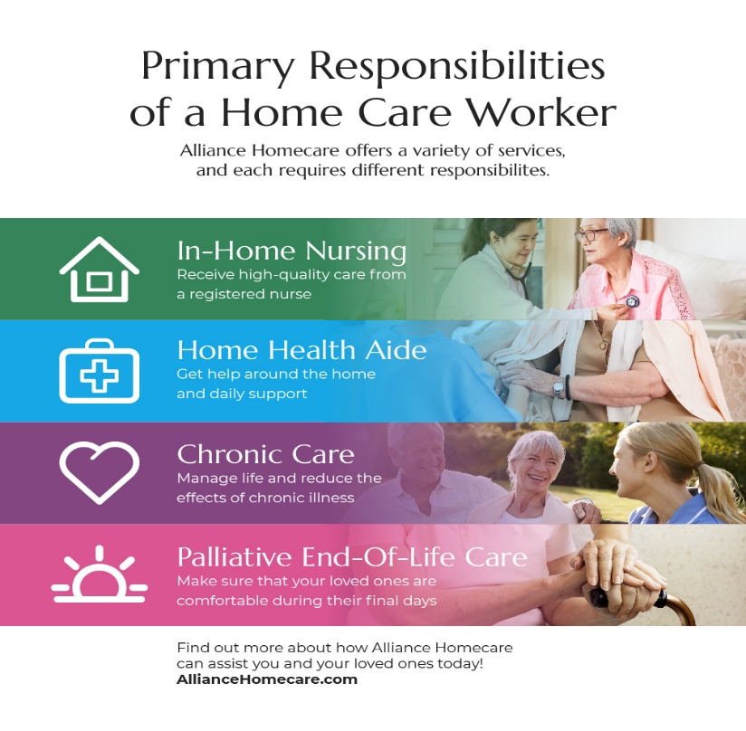
Residential care homes play an important role in the UK health and social care system. They provide essential support for people who cannot live independently. These services ensure safety, wellbeing, and a better quality of life for residents. Despite challenges such as staff shortages and high costs, residential care homes remain vital for supporting vulnerable people and reducing pressure on hospitals and families.

Conclusion

• Support people who cannot live independently
• Provide safety and emotional support
• Reduce pressure on hospitals and families
• Improve quality of life for residents
• Ensure professional and continuous care
• Staff shortages in care homes
• High cost of providing care
• Increasing demand due to ageing population
• Emotional pressure on staff and residents

Importance of Residential Care Homes
Challenges

Care homes provide support with daily activities such as washing, dressing, eating, and taking medication. Staff are trained to provide both physical and emotional support, helping residents feel safe, comfortable, and supported in their daily lives.

Pharmacy Services

What is a Pharmacy Service
A pharmacy service is an important part of the healthcare system that provides medicines and advice to patients. Pharmacies are often the first-place people go when they feel unwell or need help with minor health problems. Pharmacists are trained professionals who make sure that medicines are used safely and correctly.
Pharmacy services include dispensing prescription medicines given by doctors, as well as providing over-the-counter medicines that do not require a prescription. Pharmacists also give advice on how to take medicines, possible side effects, and how different medicines may interact with each other. In addition, they can support patients with minor illnesses such as colds, flu, headaches, and allergies.

History of Pharmacy Services
In the past, pharmacists were mainly responsible for preparing and selling medicines. They used to mix ingredients and create treatments for patients. Their role was more focused on the supply of medicines rather than patient care.
Over time, the role of pharmacists has developed significantly. As healthcare systems became more advanced, pharmacists started to take on more responsibilities. Today, they are not only involved in dispensing medicines but also play an important role in supporting patients and improving health outcomes.
Modern pharmacy services are now more patient-centred. Pharmacists collaborate closely with doctors, nurses, and other healthcare professionals to provide safe and effective care. They are also involved in public health services such as vaccinations and health promotion.

How the Service Works Today
Today, pharmacy services offer a wide range of support to patients and the community.
• Dispense prescription medicines safely and accurately
• Provide over-the-counter medicines for common conditions
• Give advice on minor illnesses and treatments
• Support patients with long-term conditions such as diabetes or asthma
• Provide health checks, for example blood pressure testing
• Offer vaccinations such as flu vaccines
• Work with doctors and other healthcare professionals
Pharmacies are easily accessible, and many are open long hours, which makes them convenient for patients. This helps reduce pressure on GP services and hospitals.

Challenges
Pharmacy services face several challenges in the modern healthcare system.
• High workload due to increasing patient demand
• Shortage of qualified staff in some areas
• Pressure to provide fast and accurate service
• Risk of medication errors if systems are not managed carefully
These challenges can affect the quality of care and increase stress for pharmacy staff. It is important that pharmacies have enough support and resources to continue providing safe services.

Importance of Pharmacy Services
Pharmacy services are very important for both individuals and the wider community.
• They help people use medicines safely and correctly
• Provide quick and easy access to healthcare advice
• Reduce pressure on GP services and emergency departments
• Support people with long-term health conditions
• Improve overall public health
Pharmacists also play a key role in educating patients about healthy lifestyles and preventing illness.

Conclusion
Pharmacy services are an essential part of the healthcare system. They provide safe access to medicines, professional advice, and support for patients. Although there are challenges such as high workload and staff shortages, pharmacy services remain vital. They help improve patient outcomes, support community health, and reduce pressure on other healthcare services.

References

NHS (2023) Pharmacy services. Available at: https://www.nhs.uk
General Pharmaceutical Council (2023) About pharmacy professionals. Available at: https://www.pharmacyregulation.org
World Health Organization (2023) Medicines and health services. Available at: https://www.who.int
Care Quality Commission (2024) The state of health care and adult social care in England. Available at: https://www.cqc.org.uk
Hamberley Care Homes (2025) Care Home in Keynsham. Available at: https://www.hamberleycarehomes.co.uk
Alliance Homecare (2025) What does a home care worker do? Available at: https://www.alliancehomecare.com

