RESEARCH PRACTICES (ADAD5001)
Samuel John

STUDENT NUMBER: 1702906
COURSE: BA Illustration
TUTOR: Scott Smith
WORDCOUNT: 2341

Character Design, Narrative and Portrayal
In this essay, an analysis of three separate key terms will make up the content of the writing. These three concepts will each be examined and explored with links to both textual interpretations and visual imagery. Using these concepts along with the texts, the essay will finally conclude with a question that will be the topic to be explored in a future dissertation. The terms chosen are ‘character design’, ‘portrayal, and ‘narrative’. A number of images will be used alongside the writing to give visual aid to these concepts, as the key words refer to the process of character design in the realm of visual communication. The essay will explore how this design process can be used to manipulate and mislead an audience into believing one thing about a character when in fact the opposite is revealed to be true, as well as how certain character archetypes have evolved over time.
The concept of character design is one used by almost any creator of books, film, television and any kind of media. It allows the creators to fabricate original characters using their imaginations and character archetypes, and make them in such a way that these archetypes are visible to the audience who perceives them. This is done through ways such as colour theory, figure, clothing, facial features and posture. Each of these aspects can give the viewer an impression about a certain character before we really know much about them. A good example of this is characters in animations such as Dreamworks’ Madagascar (2005), where the main characters of the movie are animals with very human characteristics.

For example, Gloria, a hippo with a big belly and short little legs, stretches twice her length, touches her toes, does karate kicks over her head, lies down on her back, and moves her belly without moving her hips. (Robertson, 2005)

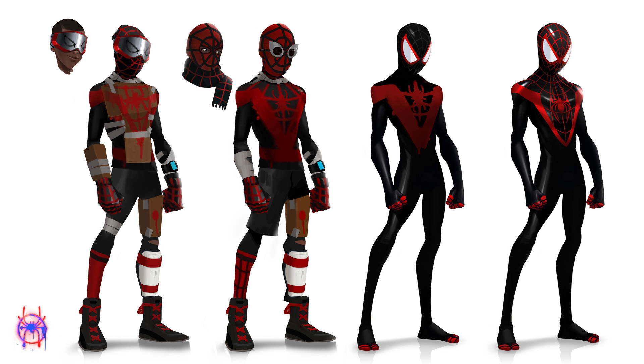
The way that most media companies and creators go about developing these characters and their unique postures, body types etc., is to make excessive amounts of character boards and concept art, illustrating them in poses and stances that suit them. Many designs might seem very out there in comparison to the final design. This technique is widely used by animators to develop the way their characters look and move. A great example of this is concept art from Spider-Man: Into the Spider-verse (2018) where a lot of the characters have exaggerated body types and vibrant colour schemes to accentuate their characters further.
Miles’ Costume Design (2018) Florent Auguy
This concept art of the protagonist Miles Morales depicts him in differing stages of his costumes design. Auguy has explored how his outfit might be more home-made, ramshackled looking with pieces of cardboard taped on as armour, to how his more accomplished, sleak and “professional” looking suit would look like. The red and black colour theme also gives a younger look to it, almost in a more edgy or darker way. This also shows his journey of learning how to be the Spider-Man of his own universe, which is Miles’ character development arch during the movie.
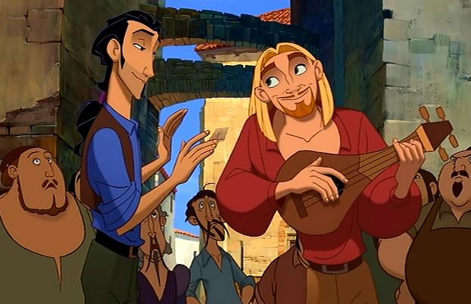
Another good example of character design is the appearances and personalities of the two main protagonists in Dreamworks’ The Road to El Dorado (2000), as seen below.

Tulio and Miguel (2000) The Road to El Dorado

Tulio and Miguel are a great example of a duo in context to character design. The two characters are so different in their appearance and personality but work well together as a whole. Tulio (left) is the more serious and smart of the two, as well as his sharp wit, which compliments nicely with his sharp facial expressions and dark colour scheme. Even the way he wears his hair says that he is a practical man. Miguel however is more light hearted and free spirited than his companion, which is suggested by his baggy clothes, bright and warm colour scheme and his cheeky facial expressions.
Character design tends to involve certain stereotypes, or archetypes of characters which are recognisable just by looking at the characters who fit them. The villain, the hero, the annoying side-kick, etc., these archetypes are made to make the audience assume what the character is like at a single glance.
To the extent that you made any judgment about these images, you made it based on stereotypes—schemas or prototypes in your memory that associate a pattern of cues with a typical set of qualities in a person. These cues can include dress, build, posture, grooming, age, gender, race, style of speaking and moving, as well as the company in which a person is seen. (Isbister, 2006)

Creating a good character means they need to be at least somewhat relatable, that could be through what they wear, what they do, or what they say. Making a relatable character and make them extremely valued to the audience, be it a hero or a villain. This can create emotive response to the audience when circumstances happen, or backstory is revealed about these valued characters.
When we identify with a character we imagine ourselves to be in his or her position. For example, Dixon and Bortolussi (2004), in reply to a critique by Diengott (2004), discuss research showing that identification is greater when readers make inferences about a character. Identification can result in the evocation of emotions. (Mar et al. 2011)

The always growing and evolving portrayal of certain character archetypes is a very interesting subject of discussion. As society as a whole has become more progressive and open minded, so has the portrayal of characters in media. People belonging to social minorities and oppressed or marginalised groups are being given more spotlight in popular media, as well as important social issues that the media would have, at one time, refused to address at all.

“I am Merida. And I’ll be shoodn’ for my own hand!” screamed Disney’s most recent (and arguably most defiant) princess, from the Disney-Pixar film, Brave. These words not only perfectly demonstrate the determined nature of young Merida, but also stand as a symbol for how far Disney has come in terms of creating the character of the princess. (Stephens, 2014)

The portrayal of certain archetypes in recent years has changed dramatically. A good archetype to look at that has evolved substantially in recent years is Disney princesses, as exemplified in the quote above. Having Disney princesses breaking the norms of their archetype, being more adventurous, tough, and having more of a personality is a big difference to earlier Disney movies such as snow white or sleeping beauty, where they have handsome princes save them from every little danger there is. Now they are adventurers, sailors, intellectuals, and powerful sorcerers that are given infinitely more depth as characters in recent years.
This can also be used for dramatic effect where the content creator can lead an audience member to believe or assume one thing about a character and then in actuality, have them think the opposite of them. An example of this could be the character of Varian from Disney’s Tangled: The series (2017).

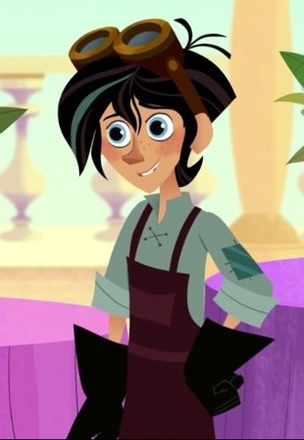
Varian is an interesting character because he starts off in the series as a recurring “good guy” character scattered across the first season of the series and is seen as your typical dorky, nerdy, awkward teenage boy. However, over the course of the first season, circumstances happen that turn him into the first season’s sinister and calculating main antagonist. The portrayal of Disney villains is changing in such a way that it's not the typical evil witch or sneaky royal advisor. They have become more human in recent years, being shown as people who have been wronged or have deeper interests than hunger for power.

Varian (2017) Tangled: The Series
Disabilities and deformities play a big part in the portrayal of typically evil characters, one famous example being The Phantom of the Opera (1910). As explained by Elaine Colleen:
We sometimes see archetypically evil characters redefined primarily by the telling of their backstories to provide rationale for their behavior and to evoke sympathy or pity from the audience. (Colleen, 2016)
This too has changed as more and more villain archetypes are portrayed by conventionally attractive people. This is somewhat scarier, making us believe the real monsters out there are average, even charming people – sometimes even people we know.
More and more positive representation of disabled people has been appearing in the mainstream media. A famous example of this, with multiple examples of disabilities and disfigurement are in the protagonists of A Game of Thrones (1996).

In this Fantasy novel saga, a handful of characters who are known to be fan favourites and are portrayed in a positive light suffer from a disability or deformity of some kind. They are still very capable characters all in their own ways with very deep personalities and backstories. An excellent example of this is Tyrion Lannister.
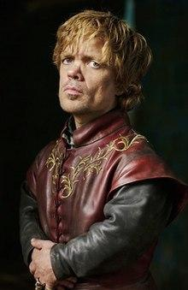

Peter Dinklage as Tyrion Lannister, Game of Thrones (2017)
Sometimes called ‘The Imp’ or ‘Half Man’, Tyrion is often shunned by the social order, even most of his own family, including his father and sister. As said by his father Tywin, “You are an ill-made, spiteful little creature full of envy, lust, and low cunning.” (Martin, 1996). He is portrayed as an incredibly intelligent man with a sharp wit and sarcastic sense of humor, spouting wise words of comfort to many of the other protagonists. As said by Tyrion to the bastard Jon Snow; “Let me give you some advice, bastard. Never forget what you are. The rest of the world will not. Wear it like armor, and it can never be used to hurt you.” (Martin, 1996)
Tyrion, amongst many others in the series are persecuted for their disabilities, but the author has made them excel in whatever they lack, making them into well rounded and likeable characters.
As well as portrayal, another key aspect of character design and creation is the narrative that said characters will live and take part in. Depending on the character, they may receive varying levels of development throughout the narrative structure that incorporate changes both large and small to a character’s appearance and personality. This can change dramatically, or just in subtle ways. An excellent example of this would be Elizabeth from Bioshock Infinite (2013)

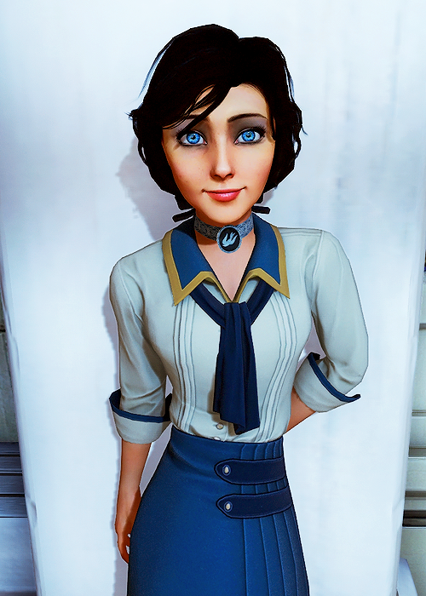

Elizabeth (2013) Bioshock Infinite

Elizabeth is an interesting character who takes a lot of different aspects of different character archetypes over the course of this very story driven game. She starts in the game as nothing more than a rumor or celebrity, never seen by the common folk and kept hidden away in a tower. Not too dissimilar to Rapunzel (Brothers Grimm, 1812) in her tower, kept away from the world.
As noted by the Game’s Protagonist Booker Dewitt "It didn't seem like a place to hold a young girl… what were these people so afraid of?" (Bioware, 2013). Her character for the beginning of the game is mysterious and only shown through a picture that the protagonist was given when the game starts. When you first meet her, she is excitable, intelligent and curious, wandering about the game environment, looking at different objects, making comments on things that interest her. While dancing with a band of musicians she makes the comment “Oh this is wonderful! Come dance with me Mister Dewitt!” (Bioware, 2013)

During the course of the game, conflicts arise and fights happen that cause Elizabeth to change. She has to adapt to survive this harsh environment she’s been dragged into full of lies, deceit and danger around every corner. The changes that Elizabeth goes through at first are quite subtle. Her shirt sleeves get ripped and her scarf comes undone and her hair becomes unkempt and messy.

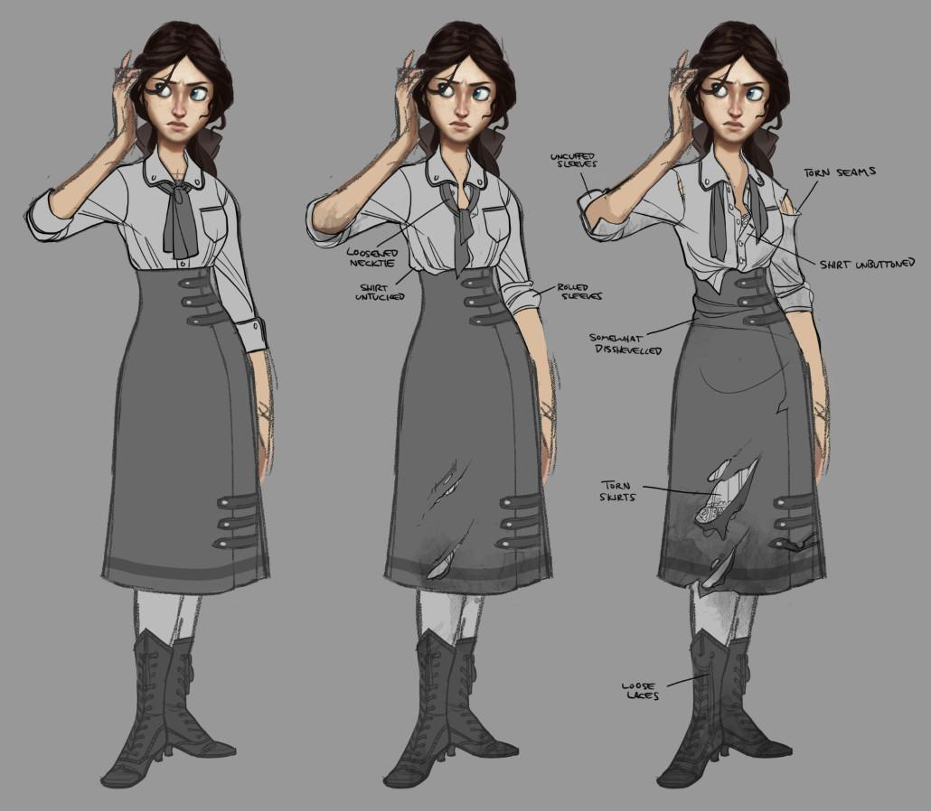

Damage Concepts (2013) Claire Hummel

Towards the end of the game, her outfit design changes completely after finding something out something shocking about the protagonist. She cuts her hair into a bob cut and wears a corset and blue jacket and a blue dress. She also becomes more sober, sticking to Booker Dewitt more closely, and makes more serious and sad comments on the environment around them, such as: “It wasn't the torture that broke me, it wasn't the indoctrination, it was time. Time rots everything Booker. Even Hope.” (Bioware, 2013)
Throughout the story of the game, Elizabeth had to grow up extremely quickly over the course of just a few days, and during this time she developed from the happy, excitable girl you meet near the start of the game, to a sober, more calculated woman who, by the end of the game, would not hesitate to kill a lot of people with her powers. “Really, Booker? What are you going to do to stop me?” (Bioware 2013). This really shows how far she comes as a character throughout her narrative, and the narrative of the game as a whole where she is put through things that would make any normal person of her age lose their mind.
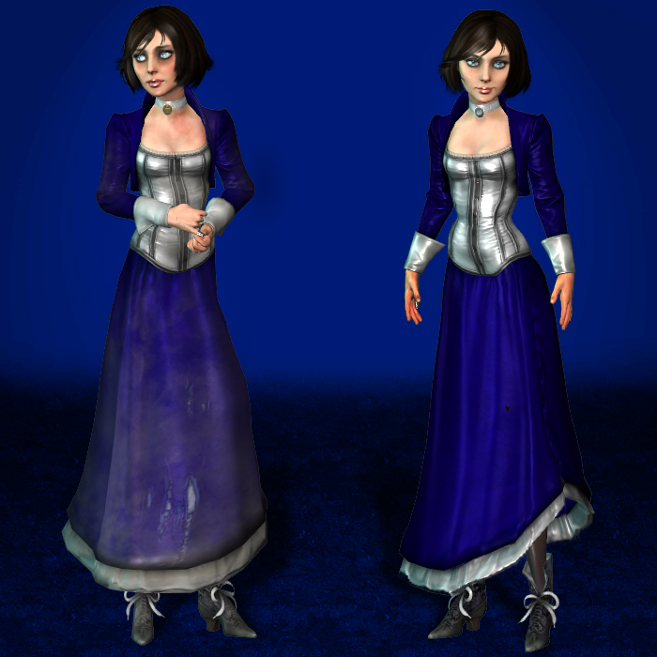

Elizabeth (2013) Bioshock Infinite

In conclusion to this essay, it has been noted that character design has several different aspects within its spectrum, each with different functions and uses to create well rounded, fleshed out characters for varying areas of media. The technical aspect of character design takes elements of colour theory, exaggeration of body types and creating many different approaches to what a character may look like in order to convey the character archetype. The progression of the archetypes have changed dramatically over the years from oppressed minorities becoming more prominent and in positive light, to Disney villains becoming more and more complex and deep with more human aspects to them. The use of narrative to develop said characters within their storylines and progression of personal story arcs shows how a single character can change so much over the course of their narrative.
Using the key words selected and the links examined within this essay, the question formulated could be: ‘How does the visual communication in Spider-Man: Into the Spider-Verse portray the specific archetypes of each alternate universe Spider-Man protagonist?’

Bibliography

Hummel, C. (2013) Damage Concepts [Digital Painting]. Available at: https://www.clairehummel.com/bioshock-infinite (Accessed: 8th May 2019).
Robertson, B. (2005) Born to be Wild. Glendale.
Auguy, F. (2018) Miles’ Costume Design [Digital painting]. Available at: https://www.artstation.com/artwork/W2BnDN (Accessed: 5 May 2019).
The Road to El Dorado (2000) Directed by Bibo Bergeron, Jeffry Katzenberg, Don Paul [DVD]. Dreamworks Animation.
Isbister, K. (2006) Better game characters by design. Boca Raton: CRC Press.
Mar, R., et al. (2011) Cognition and emotion. Taylor & Francis LTD.
Stephens, J. (2014) Disney's Darlings: An Analysis of The Princess and the Frog, Tangled, Brave and The Changing Characterization of the Princess Archetype. Interdisciplinary Humanities, vol. (31)3, pp. 95-107. Available at: http://search.ebscohost.com/login.aspx?direct=true&db=a9h&AN=101481692&site=ehost-live (Accessed: 5 May 2019)
Tangled: The Series (2017) Disney Studios.
Leroux, G. (1910) The Phantom of the Opera.
Donnelly, C. (2016). Re-visioning Negative Archetypes of Disability and Deformity in Fantasy: Wicked, Maleficent, and Game of Thrones. Disability Studies Quarterly, 36(4).
DOI: 10.18061/dsq.v36i4.5313. (Accessed: 5 May 2019)
Martin, G.R.R. (1996) A Game of Thrones. Bantam Spectra, Voyager Press.
Brothers Grimm. (1812) Rapunzel.
Bioware (2013). Bioshock Infinite. [Computer program]. Bioware.

