
Maéva RONCEY
2422915

Network Operating Systems and Services

Coursework 2

Table des matières
TASK 1 1
1. Introduction 2
2. Site-to-Site VPN 2
Network changes 2
Windows server’s configuration 3
Debian server’s configuration 4
Additional steps 6
Testing VPN connectivity 6
3. Active Directory Configuration 7
3.1. Swansea domain configuration 7
3.2. Cardiff child domain configuration 10
4. Importing Users 14
Adding Users to the Swansea Domain 14
Adding Users to the Cardiff Domain 15
5. Shared Folder Configuration 16
Adding and Mounting the New Disk 16
Creating the Shared Folder and Setting Permissions 17
Access Testing 18
6. IIS Web Server Setup 18
Preparing the Site and Certificate 18
Configuring the Website in IIS 19
The HTML page’s creation 19
Testing Access to the website from Clients 20
7. Remote Desktop Services (RDS) 21
RDS role’s installation 21
Publishing Applications 22
Accessing the RDS Portal 23
Testing from client to the Access 23
Conclusion 24

TASK 1

1. Introduction
This project builds upon the virtual infrastructure introduced in Coursework 1.The objective is to connect two geographically distinct networks - Swansea and Cardiff - through secure and persistent Site-to-Site VPN connections, while implementing robust domain, routing, and access control strategies. Core services such as DHCP, DNS, AD DS, certificate management, and file sharing were implemented to simulate a realistic enterprise IT infrastructure. This work also includes advanced configurations to ensure secure remote access and web-based authentication, demonstrating both technical proficiency and practical understanding of critical network services.

2. Site-to-Site VPN

Network changes
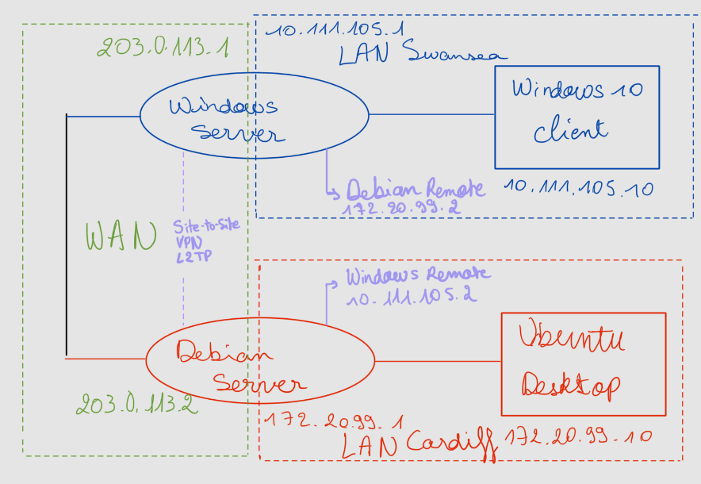
Figure 1 - Network's new topology

At the end of Coursework 1, both local networks were already operational, with DHCP and NAT enabled to provide internet access to each LAN. The new network set-up includes a VPN connection between the company's sites in Swansea and Cardiff. The diagram above shows the updated topology with the VPN tunnel between Swansea and Cardiff. This setup allows the two local area networks (LANs) to communicate securely and permanently via a protected tunnel. Each site has its own network infrastructure; Swansea uses a private subnet called 10.111.105.0/24 and the private subnet used by Cardiff is 172.20.99.0/24.
Swansea's Windows server acts as the VPN connection initiator, because it will host the shared folder, main Active Directory domain, web server, and RDS, using the L2TP/IPsec protocol with a pre-shared key (PSK) for authentication. The Cardiff Debian server accepts the incoming connection and manages the VPN traffic via xl2tpd and ppp services.

Windows server’s configuration
On the Windows Server in Swansea, the VPN was configured using the Routing and Remote Access (RRAS) console. The protocol selected for the site-to-site VPN was L2TP/IPsec, due to its strong security and widespread support. IPsec authentication was configured using a pre-shared key (PSK) instead of certificate-based credentials. The L2TP tunnel itself is authenticated using the Debian server’s credentials via the ppp package. Demand-Dial interface named Cardiff was created, enabling the Windows Server to initiate the VPN connection to the Debian server. The persistent connection option was enabled to ensure the tunnel remains always active and a static route was added to allow all traffic destined for the Cardiff LAN to pass through the VPN tunnel.
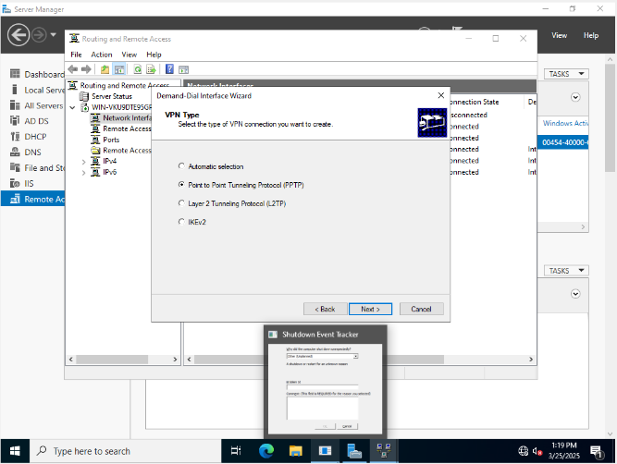
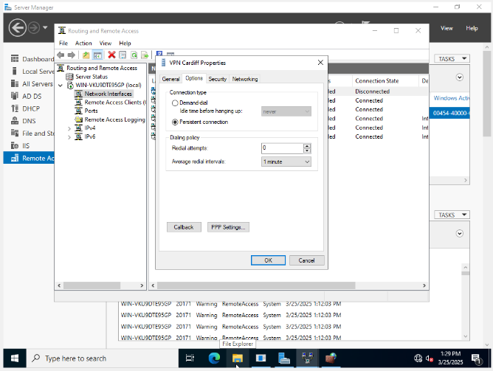
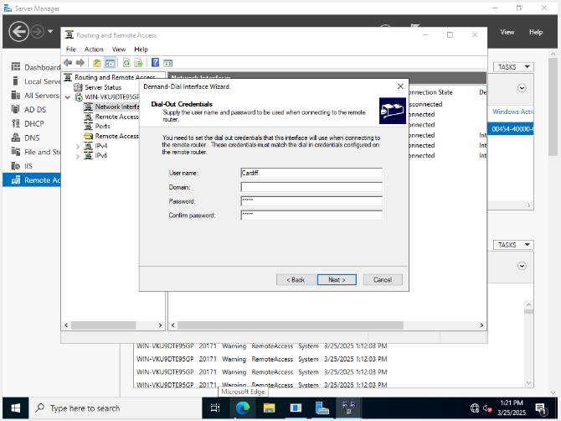
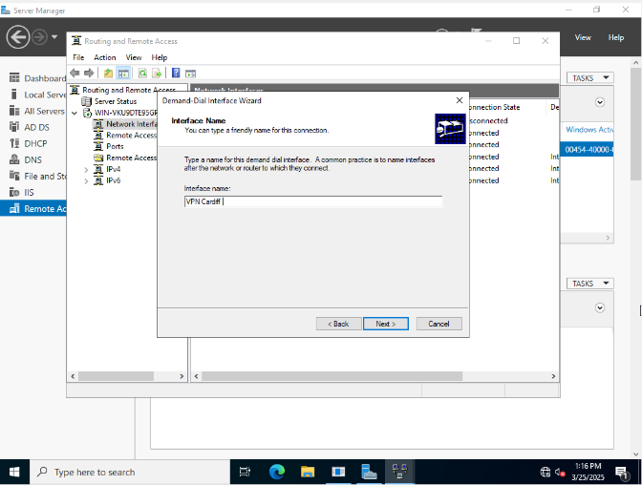
Figure 2 - The choice of type's VPN
Figure 5 - Persistent connection
Figure 4 - IPsec credentials for Debian
Figure 3 - Name of the demand-dial interface

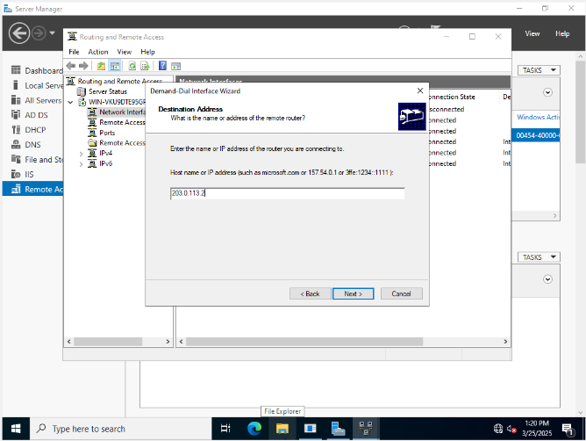
Figure 6 - Destination address

Debian server’s configuration
On the Debian server, the following packages were installed to configure the VPN server. The following packages were installed on the Debian server: StrongSwan for IPsec, xl2tpd for L2TP tunneling, and both ppp and pptpd for user authentication. We had to update the ipsec.conf file to accept incoming connections from Widows server’s WAN IP.
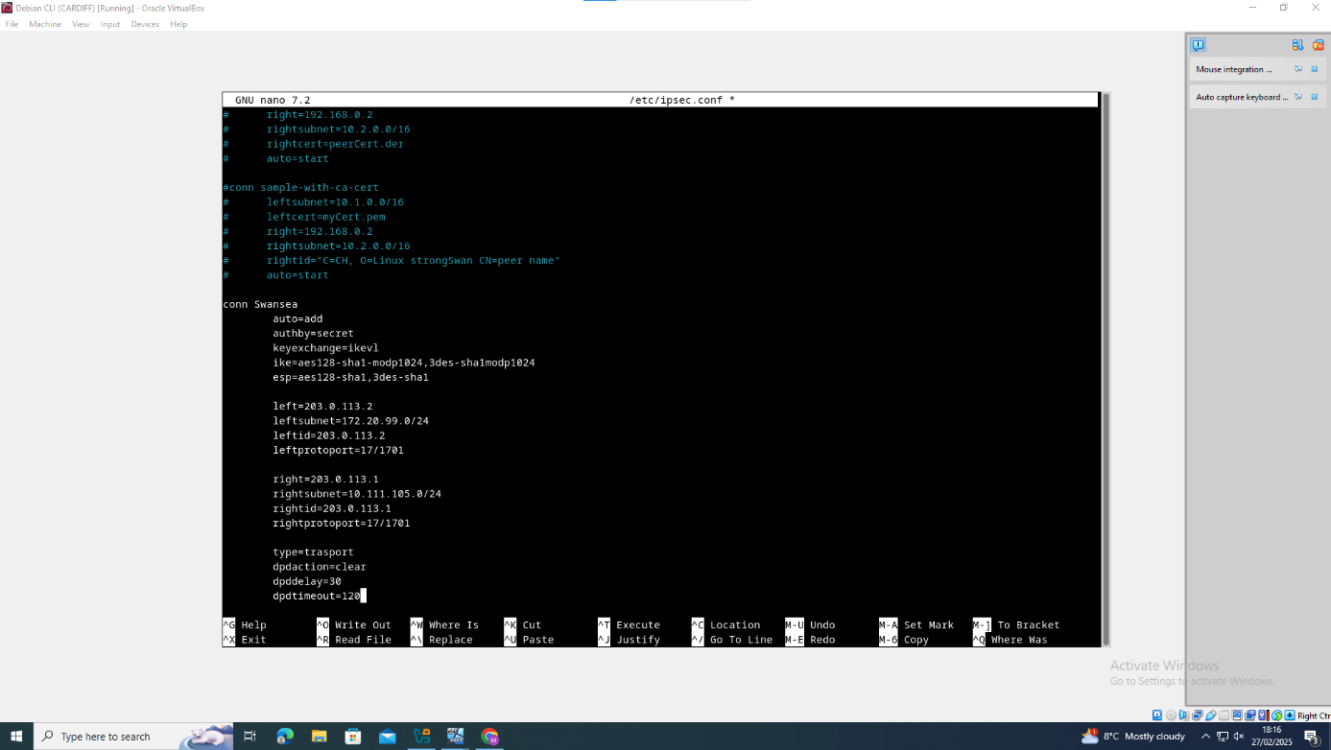

Figure 7 - ipsec.conf file updated

Then, we modified the xl2tpd.conf file to define local and remote IP ranges for the tunnel.
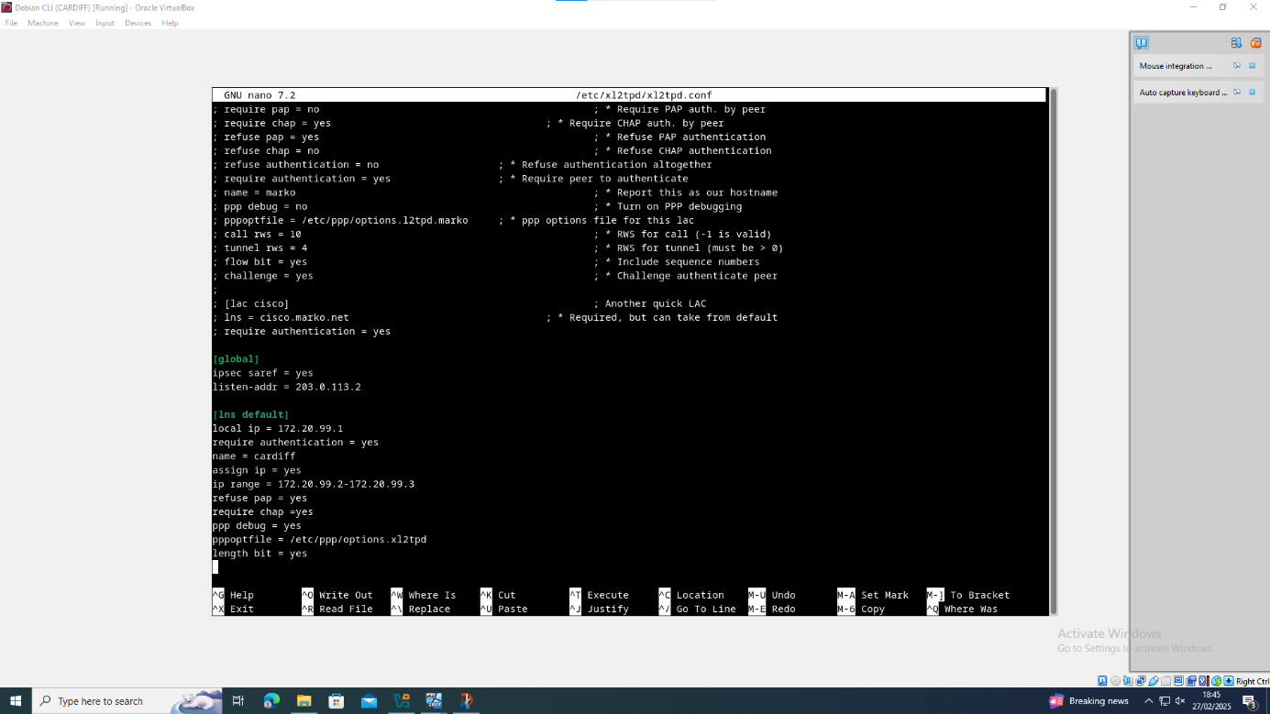
Figure 8 - xl2tpd.conf file modified

We set up the authentication in the chap-secrets file using the same credentials we chose in the previous section.

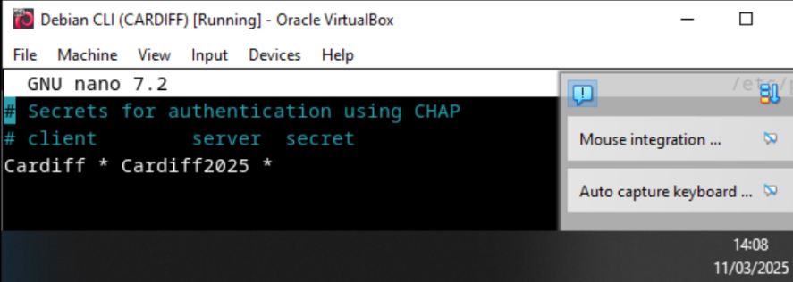
Figure 9 - Chap-secrets file

We also put a script in /etc/ppp/ip-up.d/ to automatically add the right static routes to the remote network whenever the VPN connection is made.
An issue occurred where the same IP address was assigned to both the LAN and the VPN interface, causing routing conflicts. This was resolved by enabling proxy ARP in the Debian sysctl.conf file.

Additional steps
Some more changes were needed to get everything working properly. On both servers, firewall rules had to be changed to allow VPN traffic and ICMPv4 requests between the two networks. Some new rules were added to the Windows system. These rules were to do with ICMP packets coming from the remote subnets (10.111.105.0/24 and 172.20.99.0/24).

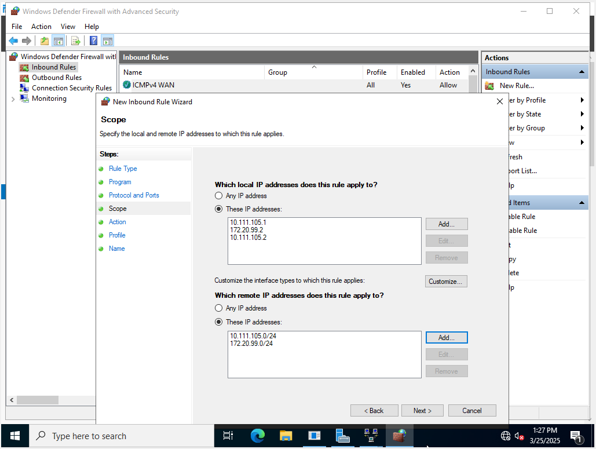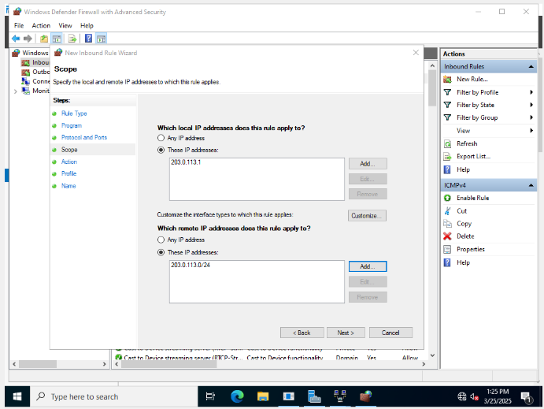
Figure 10 - Firewall rules allowing ICMP

Testing VPN connectivity
To check that the VPN tunnel was working properly. The Windows client in Swansea could communicate with the Debian server and Ubuntu client in Cardiff. The Ubuntu client could communicate with the Windows Server and its client without using restricted IP addresses (e.g. WAN interfaces). The VPN connection is now stable and persistent, allowing full communication between the two LANs while preserving internal routing rules.
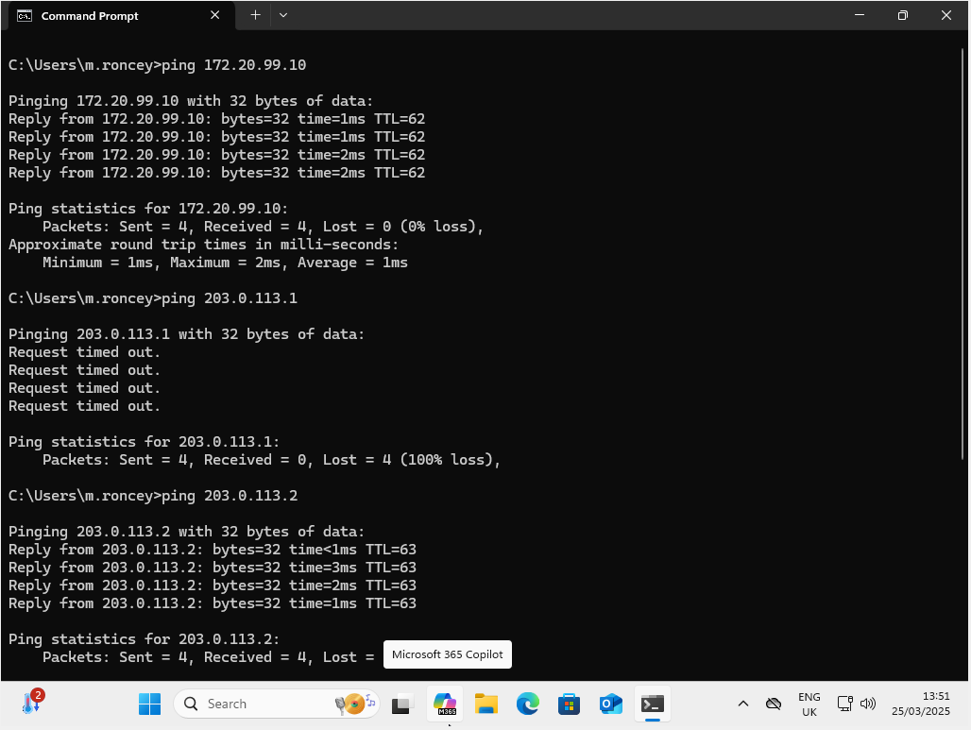

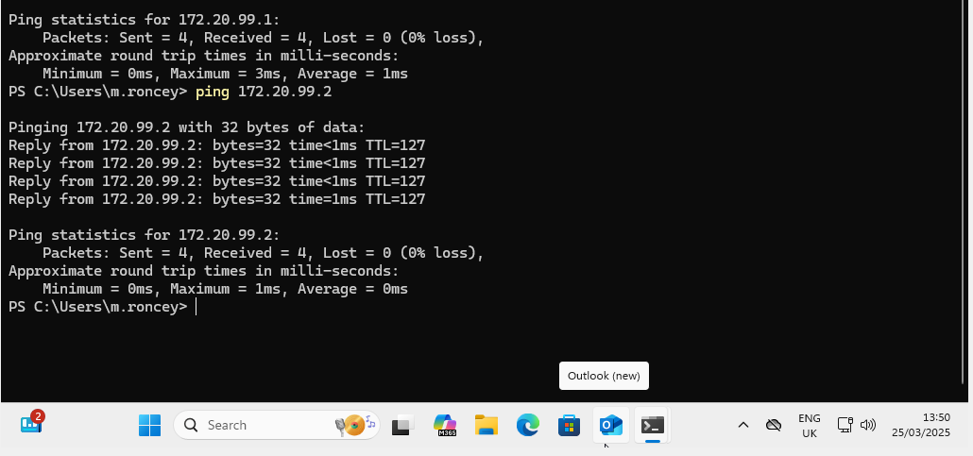
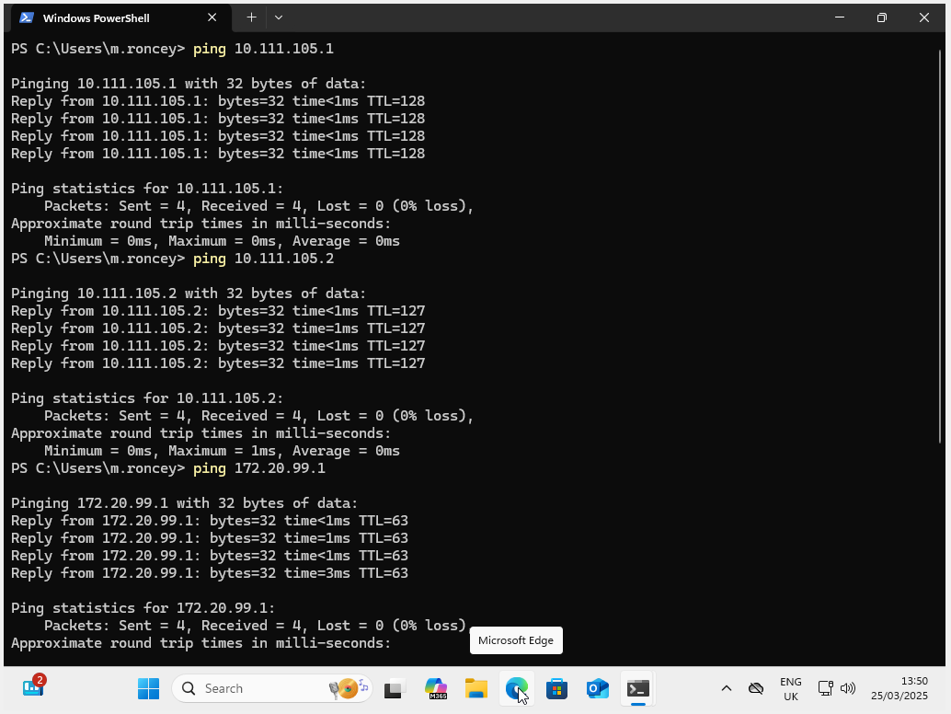
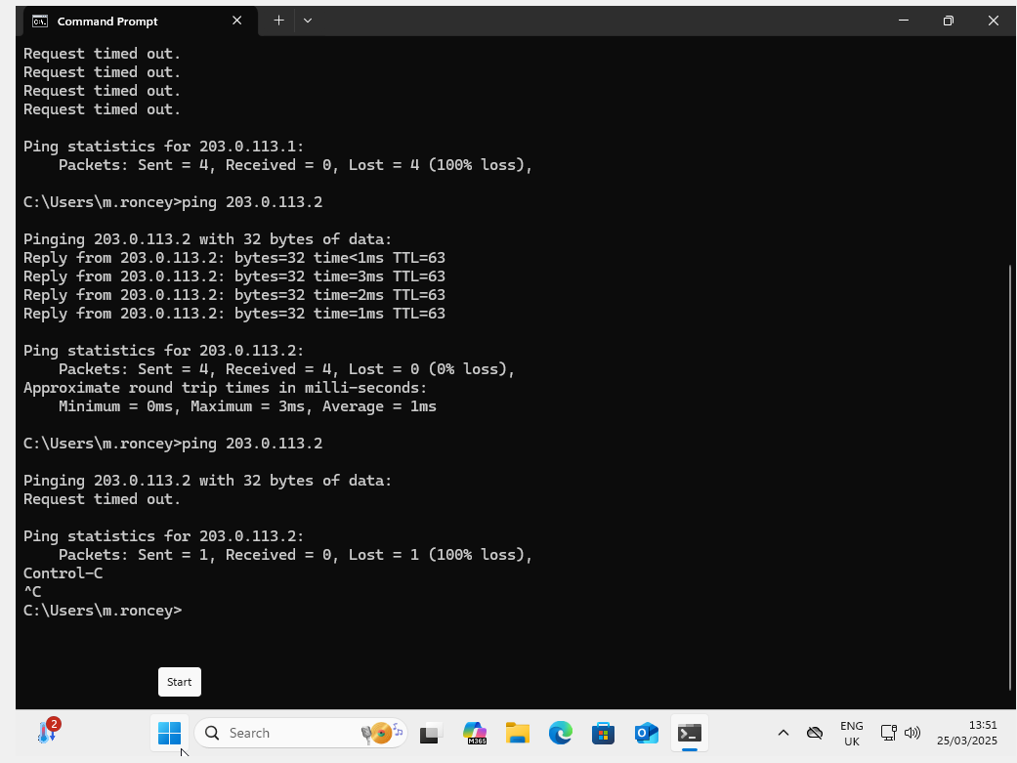
Figure 11 - Successful tests between Swansea and Cardiff
From these tests we can see that we successfully achieved our goals for the VPN.

3. Active Directory Configuration

3.1. Swansea domain configuration
The Windows Server in Swansea was first configured to host the main domain by installing the Active Directory Domain Services (AD DS) role using Server Manager.

A. Domain Controller Installation and Promotion
Once the role was installed, the server was promoted to a Domain Controller, and a new forest named maeva.acca was created.

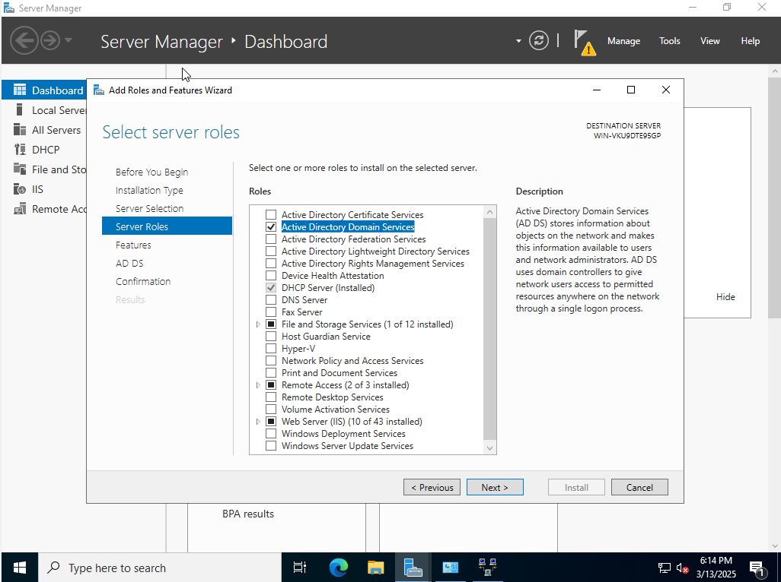
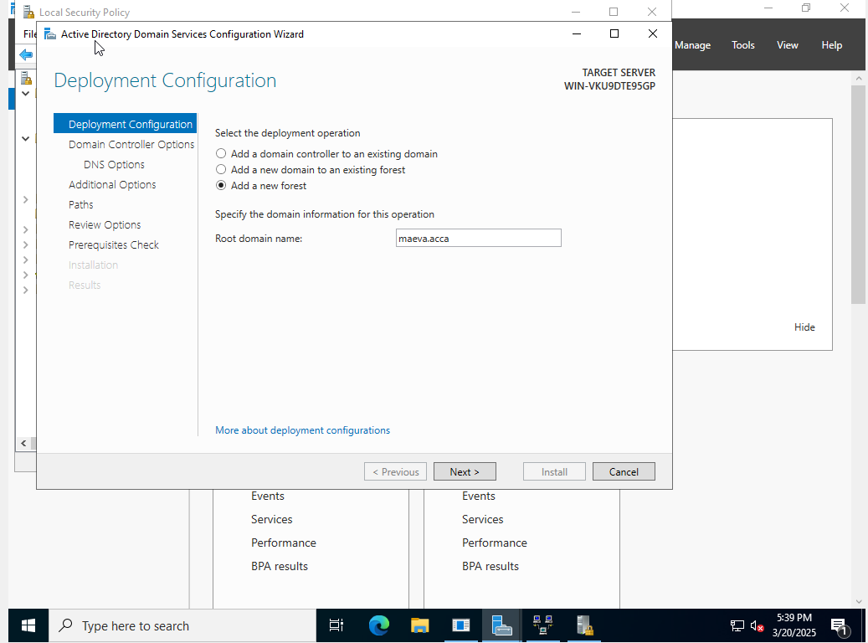
Figure 13 - Creation of the forest
Figure 12 - Installation of the AD

B. DNS configuration
After the domain was created, the DNS service was set up to respond only on the right interfaces, because a lot of unwanted IPs zones were created such as the Windows Server WAN’s IP. To solve this issue, the DNS Server was set to listen only on the LAN's interface and on the remote VPN interface in its settings, since the forest should not be accessible from the WAN interface. Additionally, public DNS forwarders were added to allow external name resolution for domain clients (i.e. 1.1.1.1 and 8.8.8.8).
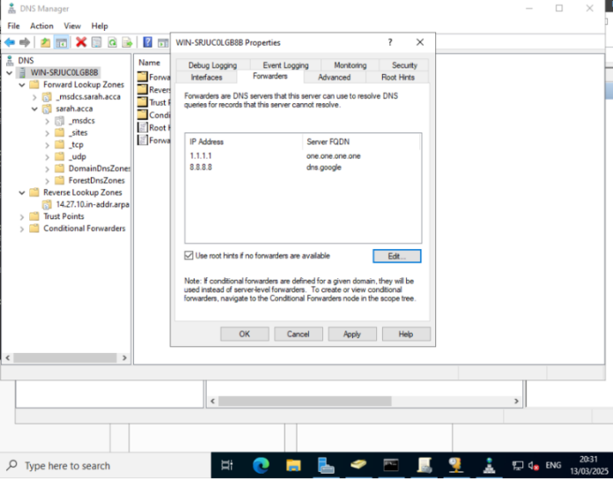
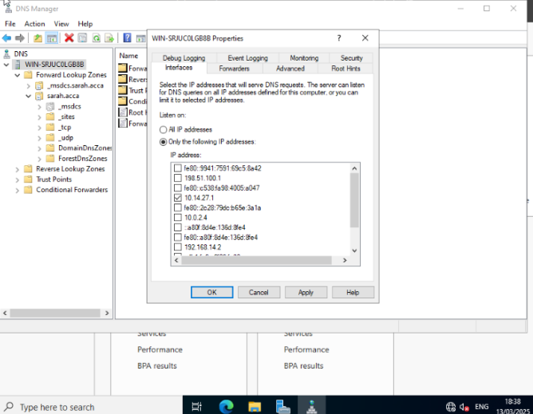
Figure 14 - DNS server's interfaces
Figure 15 - External DNS forwarder’s configuration

Once the external forwarders were set, the root DNS zone was cleaned by manually removing unnecessary records associated with unused or irrelevant interfaces (such as WAN and IPv6 addresses). To ensure these entries would not reappear, dynamic updates were disabled. A reverse lookup zone (PTR) was also created for both Swansea and Cardiff LAN subnets, allowing name resolution from IP to hostname in both directions.
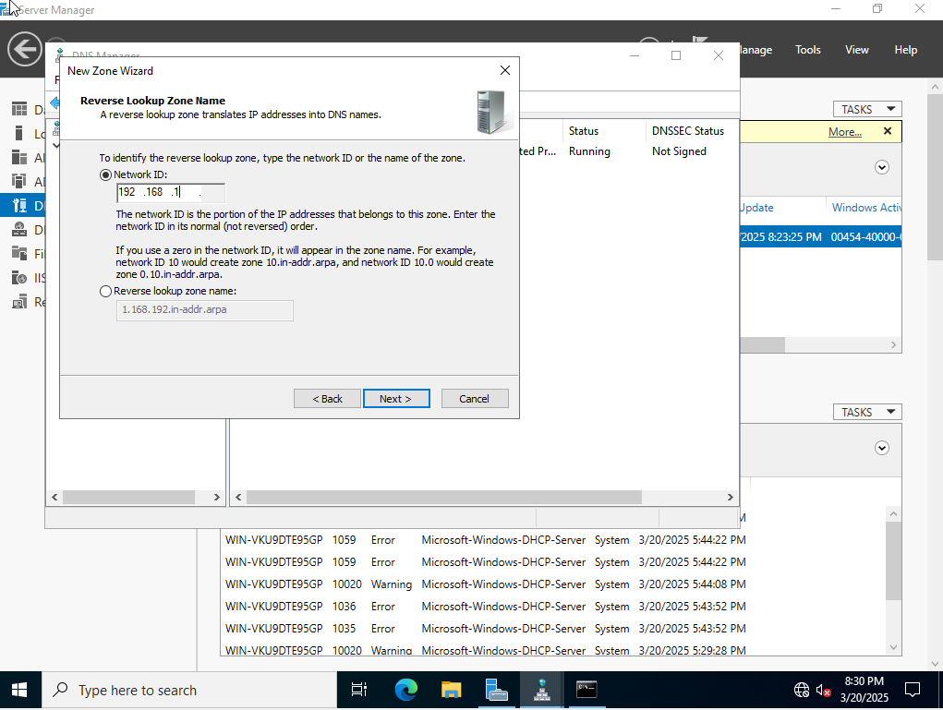
Figure 16 - Reverse lookup zone

C. DHCP scope options
The DHCP role was already installed and configured during Coursework 1 to provide automatic IP addressing to the clients. As part of the domain integration, its scope options were now updated to include the internal DNS server address (10.111.105.1). This change ensures that domain clients receive the correct DNS configuration automatically and can resolve internal domain names such as maeva.acca through the Windows Server.
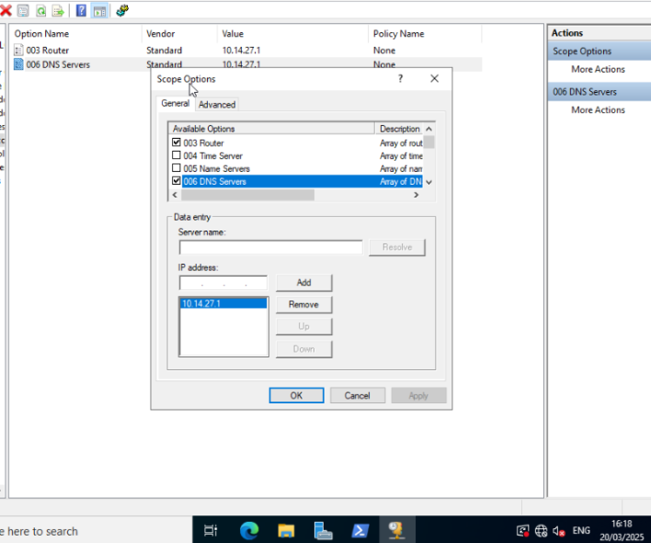

Figure 17 - Changing DNS server for DHCP clients

D. Creating and testing a user account
To check that the domain configuration is working properly, a test user account called m.roncey was created on the main domain, maeva.acca. The Windows 11 client, connected to the Swansea LAN and receiving its configuration via DHCP, was then used to join the domain.
The initial attempt to join the domain failed because the client was running Windows 11 Home, which does not support domain membership, which doesn't support domain joining. So, a new VM was created from the beginning with the Professional edition installed. The system was changed, including firewall rules to allow ICMPv4, and the domain join was successfully completed. We tested the login using the MAEVA\m.roncey credentials and it worked as expected.
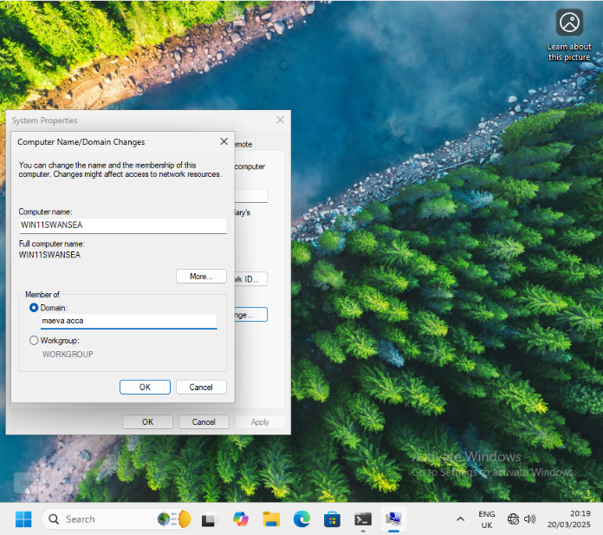
Figure 18 - joining client to domain

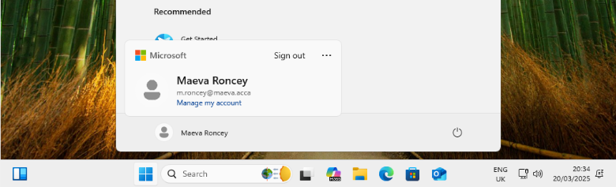
Figure 19 - Successfully connected

3.2. Cardiff child domain configuration
To connect the Cardiff site to the global Active Directory system, a child domain called car.maeva.acca (car for Cardiff) was created. The role of Domain Controller was assigned to a Debian server, using Samba for directory services and Kerberos for secure authentication. Once this was set up, the Cardiff domain was connected to the main maeva.acca forest through a trust that worked in both directions. This allowed users to be sure they were who they said they were, and gave them access to everything on both sites.

A. Provisioning and preparing the Debian server
The Debian server on the Cardiff LAN was prepared by installing the essential packages required for domain controller operation. These components enable domain provisioning, Windows compatibility, and Kerberos-based authentication. The child domain was created using the Samba-tool domain provision command. This was configured specifically as a child domain under the existing maeva.acca forest.
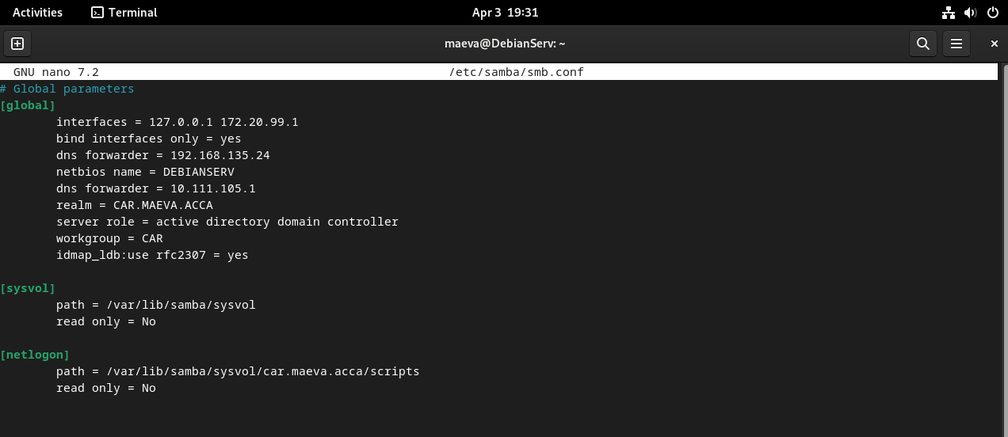
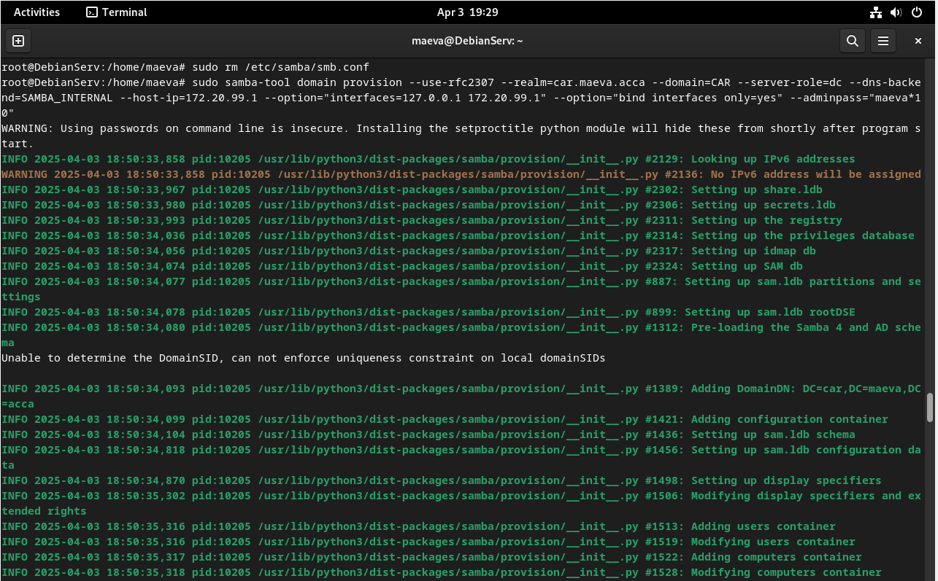
Configuration files such as smb.conf and krb5.conf were manually changed to show the new domain settings and to make sure they could communicate with the main domain controller in Swansea.
Figure 21 - Samba configuration
Figure 20 - Provisioning Samba domain

B. Provisioning and preparing the Debian server
To make sure that the names are correct between the two domains, the DNS records were updated on the Windows Server in Swansea. A new host (A) record was created for the Debian Domain Controller, pointing to its LAN IP address (172.20.99.1). A PTR record was added to the reverse lookup zone. This allowed machines in the Swansea LAN to find the hostname of the Cardiff domain controller and supported future trust establishment.
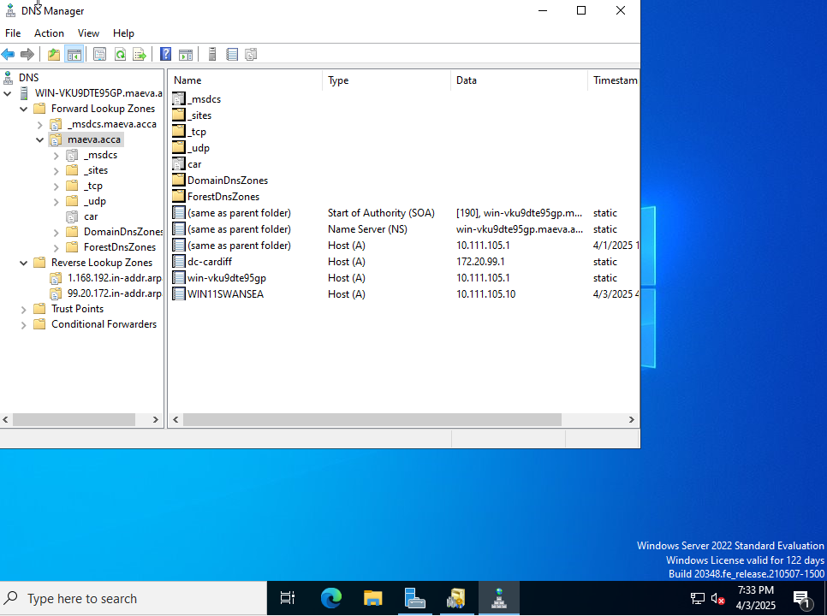

Figure 22 - DNS server's final configuration

C. Modifying Samba Policies and Creating a Test User
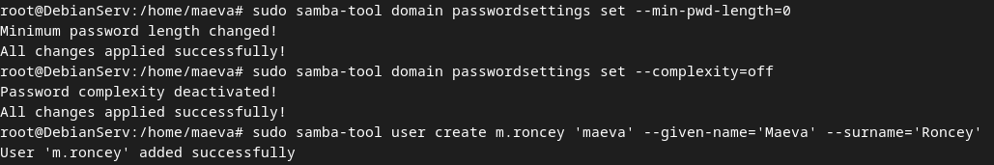
Samba has strict rules about how complex your password must be. These were changed to allow the creation of a basic test account for validation. A test user called m.roncey@car.maeva.acca was created using the Samba tool.
Figure 23 - Password policy changed, and user creation done with Samba-tool

D. Joining the Ubuntu Client to the Child Domain
The Ubuntu Desktop client, the realmd, sssd and PAM were then configured to join the newly created child domain. A new home directory was created, confirming that integration with the domain was complete.

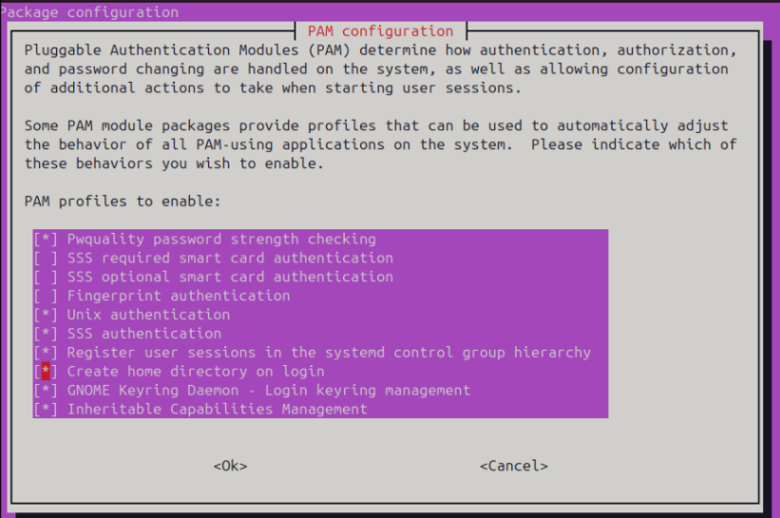
Figure 24 - PAM configuration

E. Creating and Validating the Trust Relationship
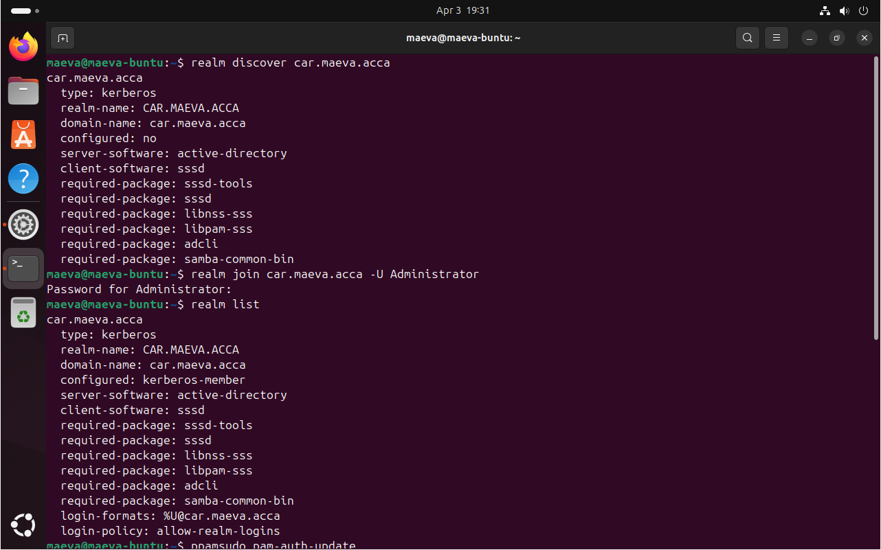
To allow authentication and access to resources across both domains, a trust was created that works in both directions. On the Windows Server, the trust was started using the Active Directory Domains and Trusts tool. The administrator's credentials from the Cardiff child domain were used to confirm the relationship. The Debian domain controller automatically recognised the trust and confirmed that it was valid.
Figure 25 - Successful join of Ubuntu

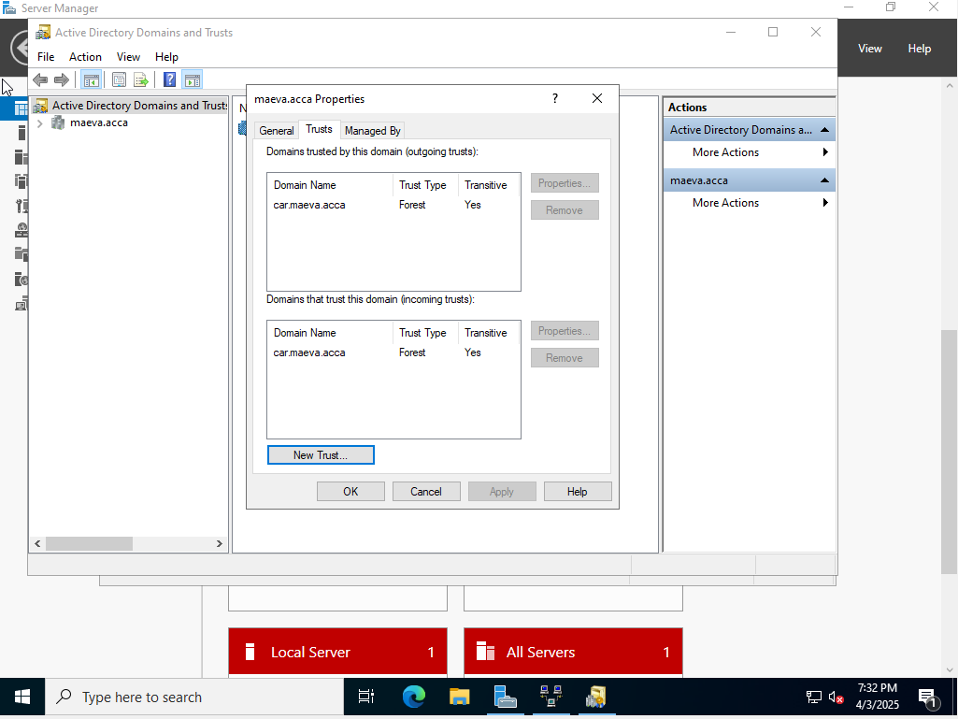
To allow users and services to communicate securely between the two domains, a bidirectional forest trust was established between maeva.acca and car.maeva.acca.
Figure 26 - Trust for child's creation

4. Importing Users
To test the system in a way that was similar to a real company, a list of users was imported into both domains using automation scripts. The user database was provided in a file named users_list_updated.csv, and users were divided between the parent and child domains based on their domain suffix.

Adding Users to the Swansea Domain
A PowerShell script was created on the Windows Server to automate the import of users from the CSV file. This script read the information in a CSV file and added users to the Active Directory automatically. The script used the Active Directory tool to set up a new user account. This account had the format: f.lastname (e.g., m.roncey). The script also set the job title, company and location as standard. It also set a password and made the account active right away. The script was tested with a small group of users before it was used with the whole list.

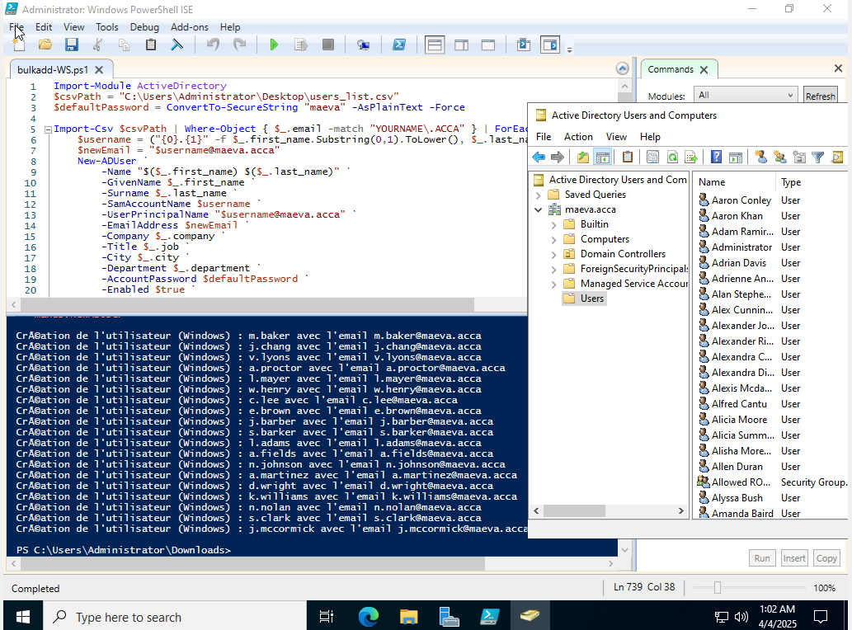

Figure 27 - PowerShell script

Adding Users to the Cardiff Domain
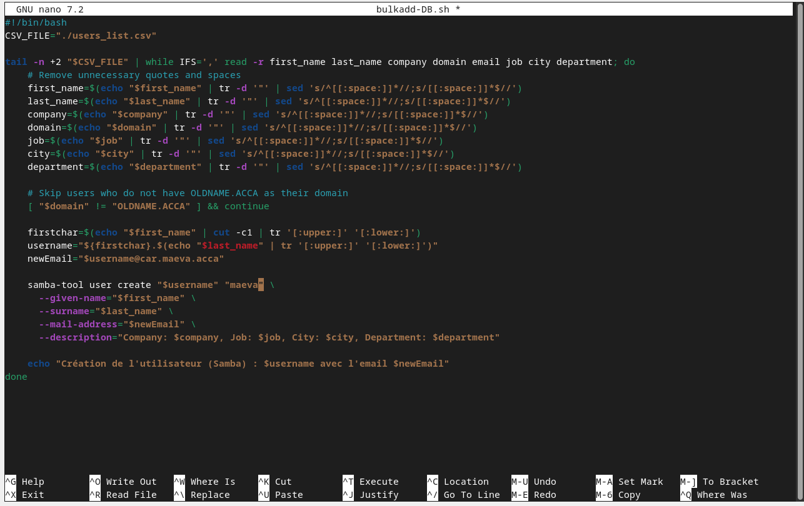
On the Debian server, users were created using a Bash script based on the same CSV file. The script made use of samba-tool to add accounts directly into the child domain. But since Samba does not support extended attributes like "company" or "job title", these values were inserted into the description field, and a common default password was applied to all accounts for testing purposes.
Figure28 - Add users’ Debian Bash script
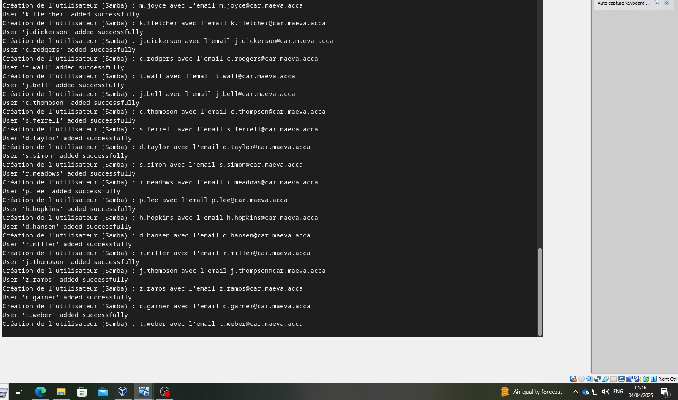
Figure 29 - Creation of users on Debian

5. Shared Folder Configuration
To allow file sharing between the two networks, a special virtual disk was added to the Windows Server in Swansea. This shared resource provides central storage that can be accessed from both the parent (maeva.acca) and child (car.maeva.acca) domains, with different access rights based on the user's domain.

Adding and Mounting the New Disk
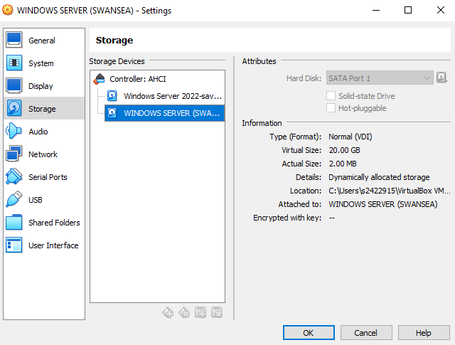
Using the virtual machine settings, a new virtual hard disk was attached to the Windows Server VM. Once the system booted, the disk was initialized and formatted via Disk Management with the NTFS file system. It was then mounted to the system and assigned the label: D:\SwanseaFiles

Figure 10 - Second virtual disk to Swansea server's addition
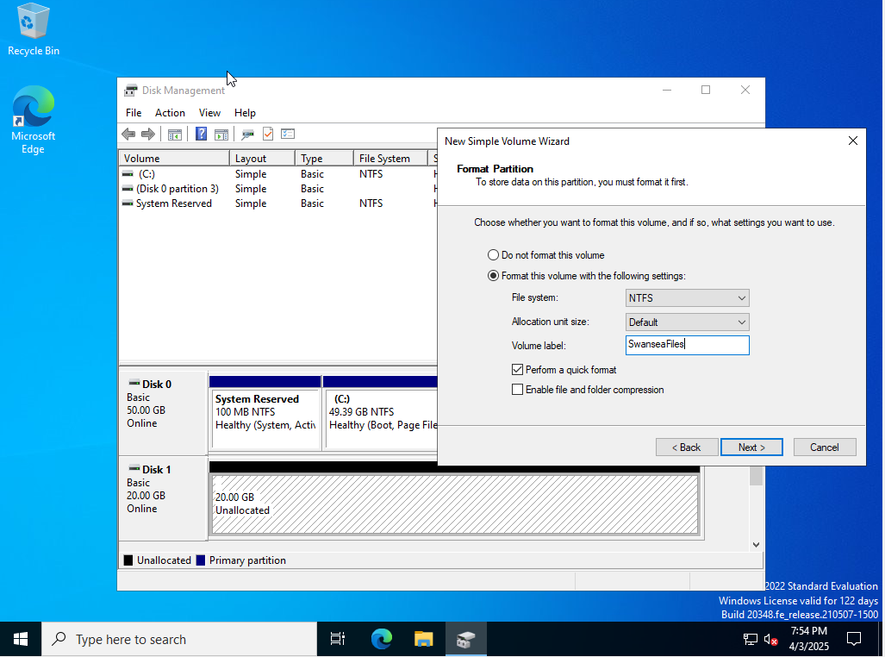

Figure 11 - Formatting and mounting the new Swansea's disk

Creating the Shared Folder and Setting Permissions
A folder called SwanseaFiles was created and shared over the network inside the new disk. Permissions were set so that users in the Swansea domain (maeva.acca) have full control, while users from the Cardiff domain (car.maeva.acca) have read-only access. (car.maeva.acca); and the groups Everyone and MAEVA\Users were also included to avoid potential access issues, particularly with inherited permissions and trust validation.
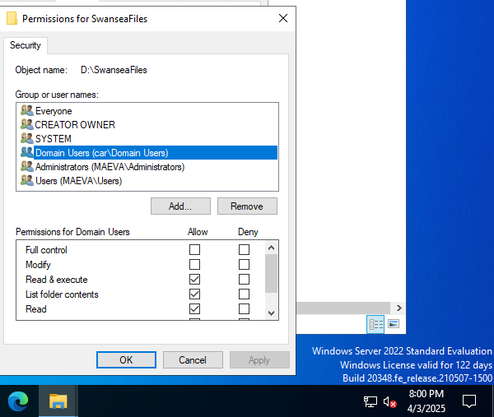

Figure 12 - Shared folder permissions for domains users from both Swansea and Cardiff's configuration

This configuration allowed Swansea users to create, modify, and delete files within the folder, while Cardiff users could only view and read files.

Access Testing
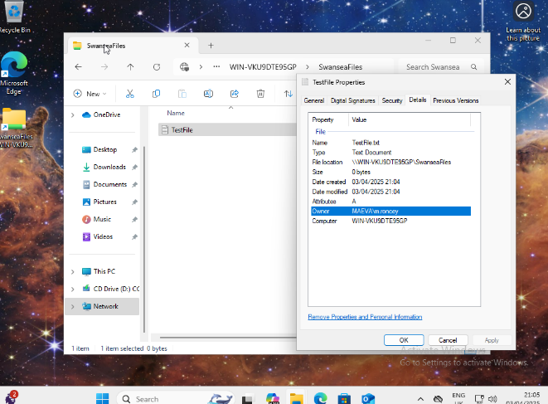
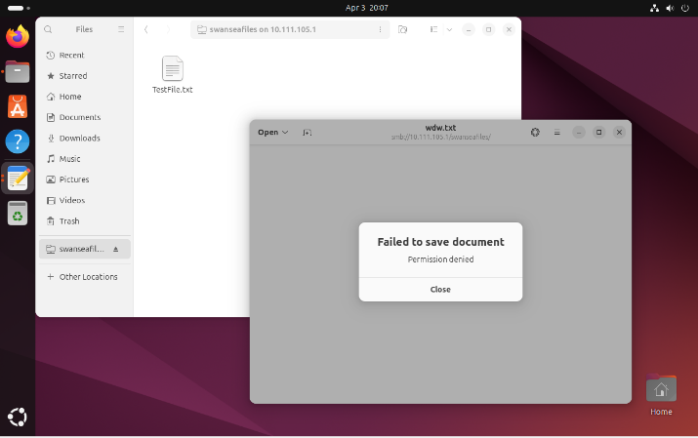
Tests were done using regular users from both places to check that access control worked as it should.
Figure 34 - When create a file on the share folder Swansea domain user are successful
Figure 33 - When trying to create a filed-on share Cardiff domain user is denied write access
This confirmed that the shared folder was working properly with domain-based access controls across the site-to-site VPN.

6. IIS Web Server Setup
To make internal services accessible via browser and to create a simulated real enterprise intranet, an internal website was created and deployed on the Windows Server in Swansea using Internet Information Services (IIS). The site is protected with Windows authentication and served via HTTPS using a self-signed SSL certificate.

Preparing the Site and Certificate
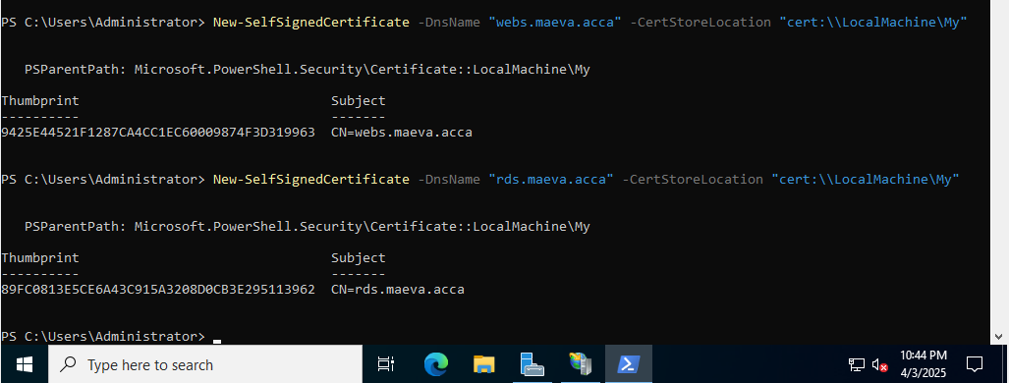
To secure the site, a self-signed SSL certificate was generated using PowerShell, this certificate was then applied to the HTTPS binding in IIS to webs.maeva.acca.
Figure 135 - Self-signed certificates with PowerShell for the website

Configuring the Website in IIS
A new website named 'webs' was created in the IIS Manager. The root folder is set to C:\webs.maeva.acca. The site was set up to accept connections from the IP address 10.111.105.1, port 443, using the HTTPS protocol. The hostname and SSL certificate were both called webs.maeva.acca.
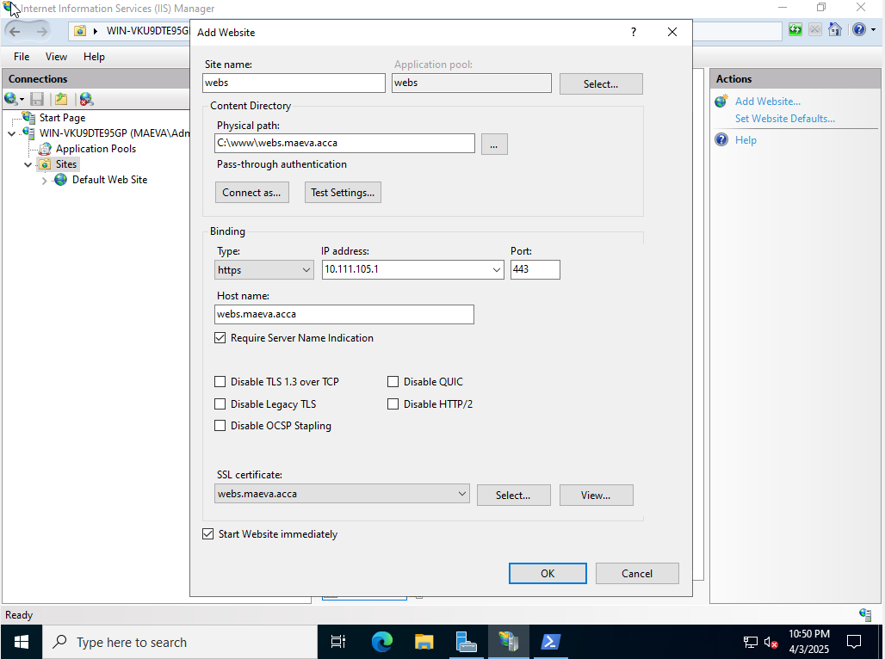
Figure 36 - New website's IIS configuration by using HTTPS protocol

The HTML page’s creation
A simple HTML page was manually created using Notepad and saved it as index.html.
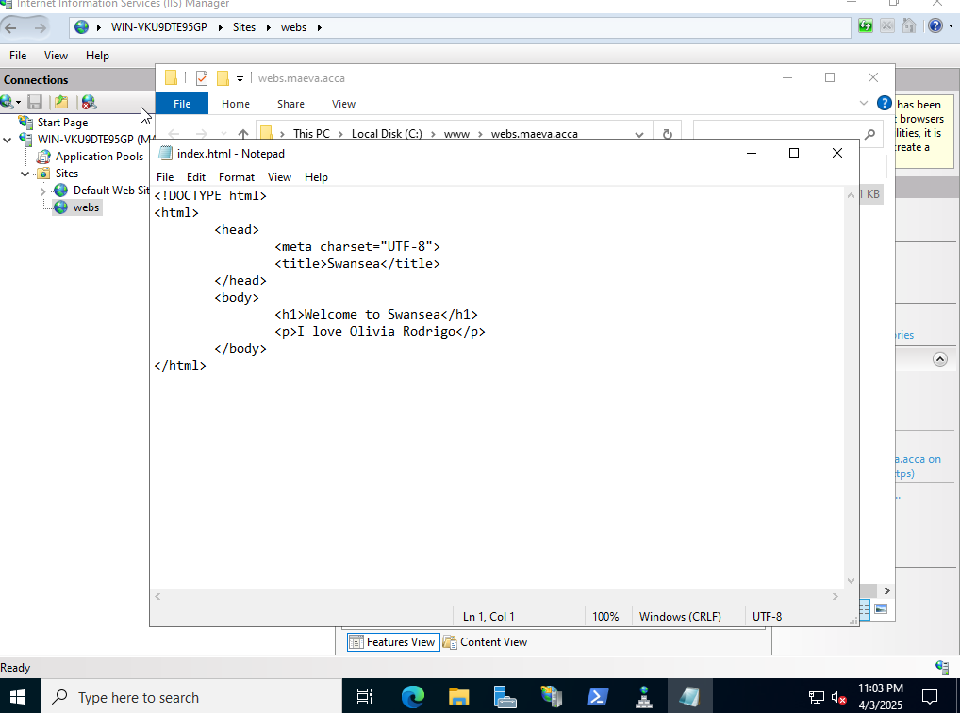
Figure 37 - HTML script for the test website

Testing Access to the website from Clients
We tested the website on the Windows 11 Client and on the Ubuntu to verify if its work. We saw everything we wanted on the page.
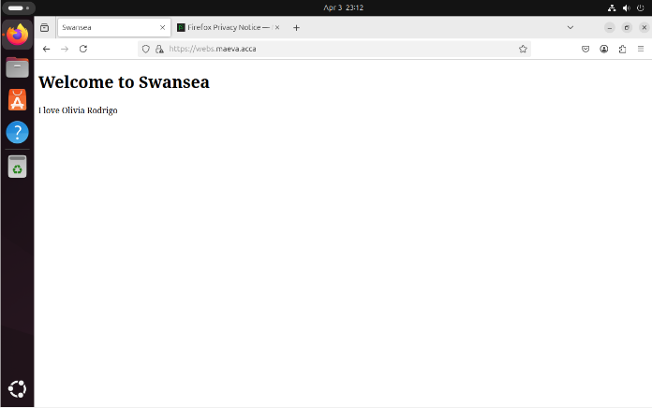
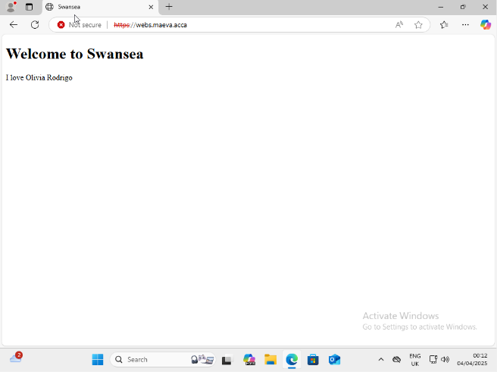
Figure 39 - Swansea website on Ubuntu
Figure 38 - Swansea website on Windows 11 Client
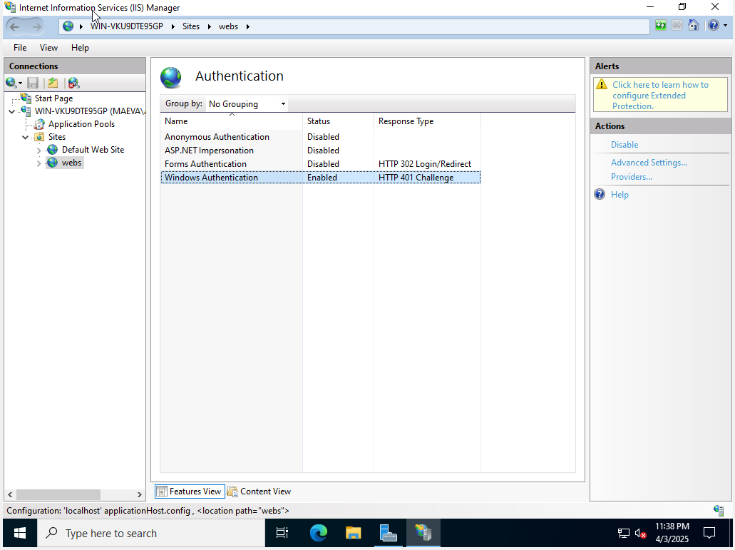
To ensure secure access, Windows Authentication was enabled for the site. All other authentication methods were disabled.
Figure 40 - Windows authentication’s enabling
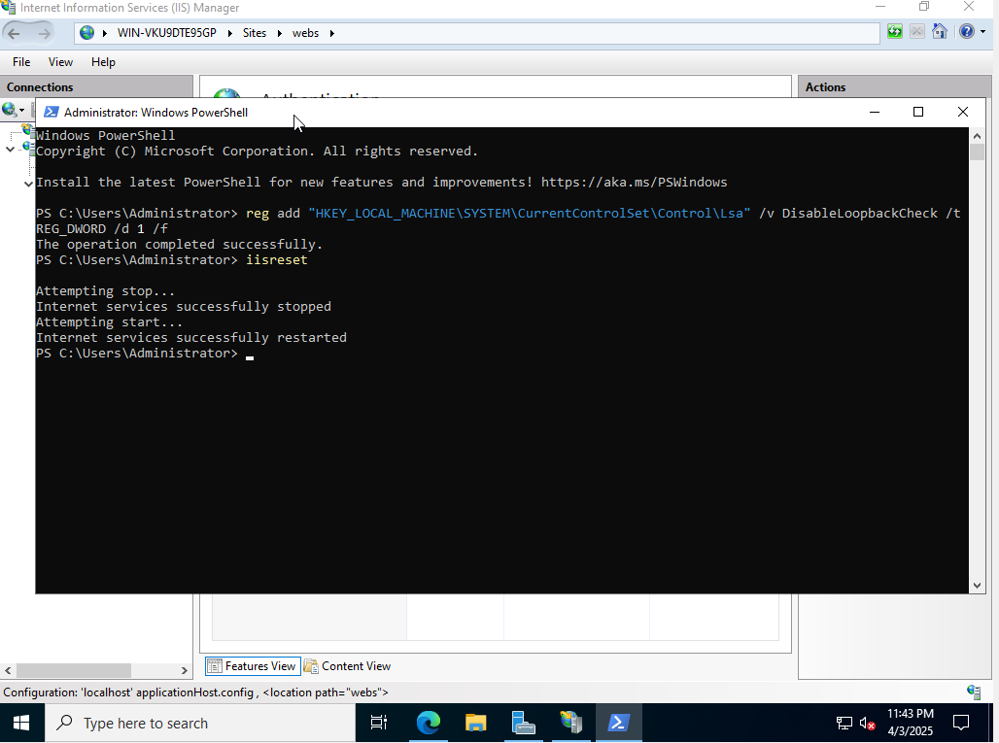
While accessing the site locally from the server, Windows Authentication failed due to the loopback check protection in Windows Server. To resolve this issue, a registry key was added via PowerShell. After this change, the site became accessible even from the host itself via its domain name.
Figure 41 - Loopback fix and IIS restart

7. Remote Desktop Services (RDS)
Remote Desktop Services (RDS) were installed on the Windows Server in Swansea to allow users from both the Swansea and Cardiff domains to remotely access Windows applications via the HTTPS web portal. The setup included role deployment, creation of a session collection, application publishing, and testing access through the RD Web interface.

RDS role’s installation
The first step was to add the Remote Desktop Services role using the Server Manager wizard. This included RD Session Host, RD Web Access, and a basic session collection.

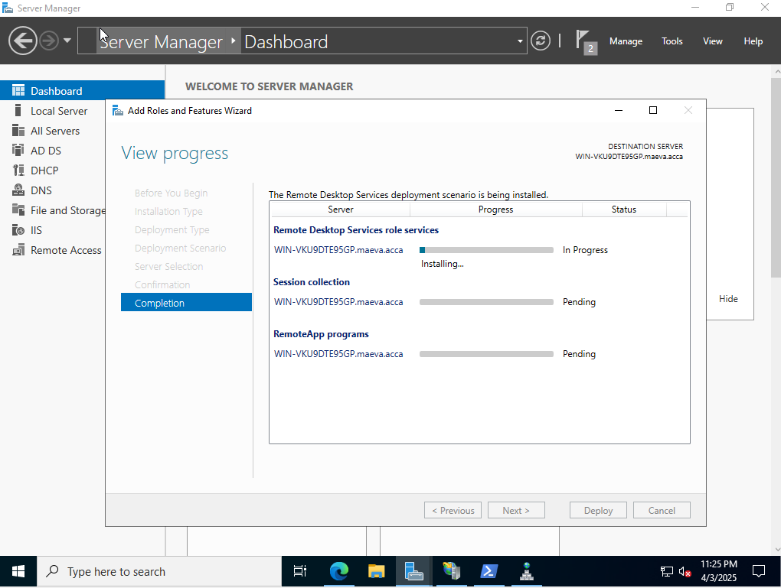
Figure 142 - Installation of the RDS on DC-SWANSEA

A session collection was automatically created and named QuickSessionCollection. Two types of users, MAEVA Domain Users and CAR Domain Users, were given access to the user groups. This allowed users from the two domains to connect, managing published apps.

Publishing Applications
Several tools and applications were selected and published to the collection using the Publish RemoteApp Programs wizard; including administrative tools (Active Directory, Group Policy), server utilities (Server Manager, DNS, IIS) and standard apps (Paint, Calculator, WordPad, etc.)
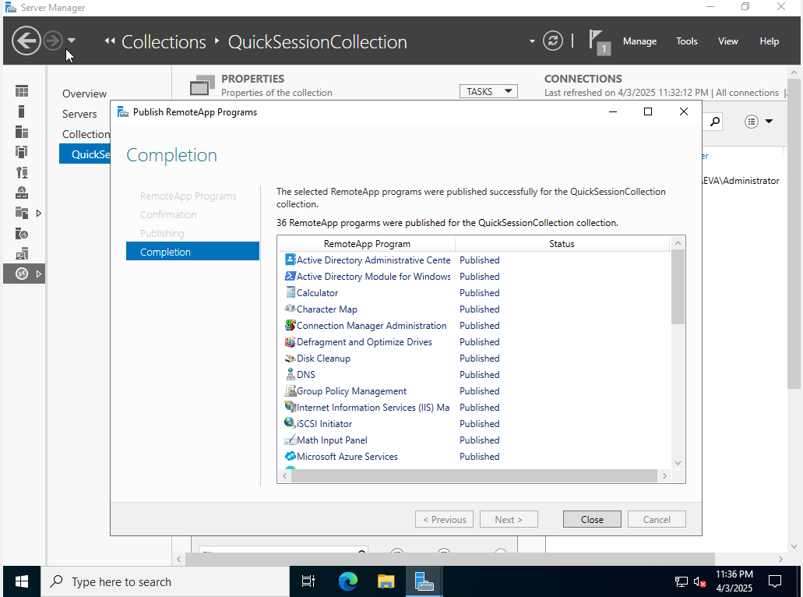

Figure 43 - RemoteApp published on the collection

Accessing the RDS Portal
Once the setup was complete, the RDS Web Access portal became available at:
https://rds.maeva.acca/RDWeb The hostname had already been configured and secured via an SSL certificate in the previous step (as previously configured during the IIS setup in section 6). Users from either domain could log in using their domain credentials and see the list of published applications.
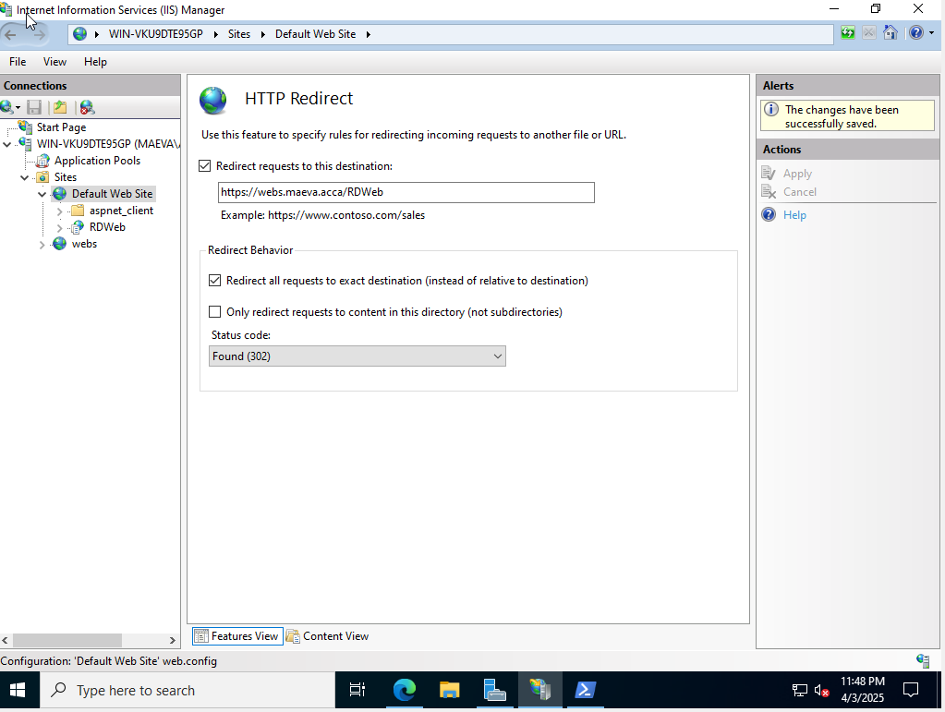
Figure 44 - RDS redirect

Testing from client to the Access
We tested the Rd Web from the Windows 11 Client browser, and after login, we had access to all the published applications on display, they all were able to be launched.
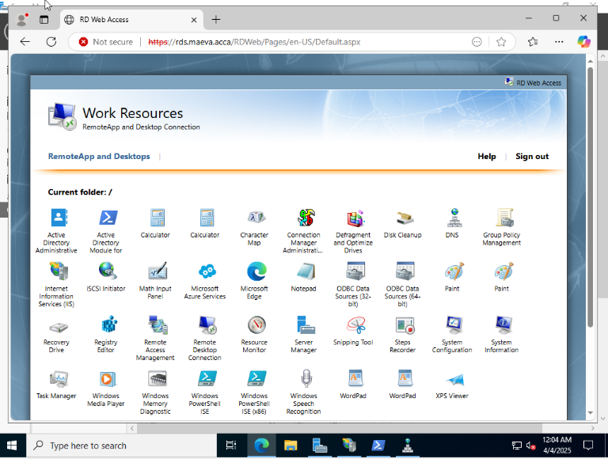

Figure 45 - Connection to Rd Web from a client browser successful

Conclusion
This project was both a technical challenge and a valuable opportunity to explore how network services work together in a virtual environment. The network started off as a basic setup. Over time, it was slowly built up to a full infrastructure that covered two sites. This included things like secure communication, domain trust, user management, file sharing and remote access.
The most important thing was the process itself: understanding how the system worked, solving unexpected problems, and learning to solve problems and adapt. Even though they used limited resources in a virtual lab, the results were the same as a real-world company network, showing that complex infrastructures can be realistically tested and used.

