Francesca Lewis (P152124)
P152124 UWTSD
portfolio
SKILLS FOR LIFE & EMPLOYABILITY
Component One
Personal Statement.
I have always had a fascination with the way the brain works and the many different functions that it has. Most importantly what happens when it doesn’t function how we expect it too. For many years, since I left school, I have helped and worked alongside people on a professional and personal level, with different needs and issues. These ranged from mental health issues, mobility needs, personal care, drug abuse and alcoholism. It is the desire to understand what these people are going through that drives me to become a Mental Health Nurse.
I am utterly passionate about changing people’s perspective about mental health and putting to the rest some of the many myths surrounding it. One of the myths surrounding mental health, is that people who suffer with mental health issues are a danger to society, when in fact they are more of a danger to themselves. I am motivated to study mental health nursing as, I am now 36 years old, with an extremely supportive family behind me. I have brought up 6 children whilst always being in employment, and now truly feel ready to utilize my work experience and my life skills, and dedicate both of these to enable me to help the people who live daily with a mental health illness.
Over the years I have dealt with a variation of ages, situations, physical and emotional issues. Specifically I had the opportunity to work in a small private home for adults with learning disabilities. It was here that I discovered that I had the skills to understand and reassure people when they have an illness or condition, that makes them anxious or confused. The service users had a wide and complex range of conditions and needs, such as autism, cerebral palsy, downs syndrome and mental health conditions. Over the seven years I was employed there, I learnt to balance their needs and meet them, assisting them with their emotional and physical needs. This involved working within a team, also liaising with other healthcare professionals, such as doctors, consultants and the service user’s families. In addition to this, I have worked within a nursing home setting and after time, was given the responsibility of administering medication and ensuring that records were correctly filled out. Mental health nursing requires patience and empathy, whilst being emotionally strong and extremely committed. Throughout my adult life I have acquired good listening skills and having somebody just listen to you can help immensely. It shows compassion and patience. Just by listening, it may help them with their problem. Having worked out in the community as a career, I learnt to manage my time extremely well and work to deadlines, providing a face to face service to a wide range of different age groups with varying needs. I have learnt to work to my own initiative, and am confident completing any task given to me, and to be organised. I feel that I have developed as a person and this is now my time to put in place my career. When I qualify, my career plan is to work in the community, as I feel that it is extremely beneficial for people to remain in their own homes, and receive a high level of care without residing in a clinical setting.

Having completed the pre access to health course, I had expectations as to what would be required of me on the Access course. I am thoroughly enjoying the Access course and will possess the relevant skills required for university. I have a keen interest in imaginative writing, and excelled at comprehensive school in my English subjects. One of the first pieces of coursework I specifically found extremely interesting and emotive, was the medical ethics surrounding euthanasia. This is such a highly emotive subject and I found the balance to see both ends of the spectrum involving euthanasia. In addition to this, I have developed a good understanding of the Welfare State and the NHS.I also learnt about the concept of utilitarianism, and the principle behind it.

Being in my late thirties, I am mature and have had life experience, as well as work experience. I have faced many challenges. I relocated to Essex in 1997, this was incredibly difficult as I left behind my family and friends, but this made me emotionally strong and taught me to be independent and stand on my own feet. I know exactly what I want to achieve and the path to go down to reach my destination. Time management and organisation, is something that comes natural to me in my everyday life. Having implemented care plans and policies in previous employment, has given me the skills to follow instructions and carry out tasks within guidelines.

I have a keen interest in finding out how things functions, and why they go wrong. Obviously I realise that not everything can be fixed, and the human body never ceases to amaze me. The human brain fascinates me, and I am keen to learn and absorb all I can regarding it. I love documentaries about natural discoveries, you could say I am just curious! Becoming a Mental Health Nurse would be a huge achievement for me, and my work experience would, after twenty years be utilized. I am passionate about coming a Mental Health Nurse, it really does consume me and at my stage in life, I can think of nothing else I would rather do. I am more than ready to make the transition from college to university and my background in care and mental health, along with my abundance of life experience, put together, would make a competent, caring and successful Mental Health Nurse.

Component Two

Name: _Francesca Lewis__________________________ Student Number: ___p152124______________________
Using the stages of the STAR technique draft a response to the following question.
Could you give us an example of how you have contributed to a team or group activity?
Situation
I attended my final session for the life skills and employability module. Towards the end of the session, we were assigned with a group task. The module had focused upon employability, and skills for life, with this session, providing an in-depth view into conflict resolution and conflict management strategies within the workplace. Groupwork was not something that had been explored, throughout the degree programme and this task, gave individuals the opportunity as a group, and individually to build upon key employability and life skills.

Task
The task was to produce a 10-minute power point, to critically analyse Belbin’s roles and how these roles can affect the workplace. The power point then had to be presented to the lecturer, and the other students.

Activity
As a group, we decided that we first needed to know who Belbin was, and what the roles were. We each researched Belbin and the Belbin roles. Once we had some background on the Belbin roles, we were able to research some evidence-based research papers. Each person from the group, was given the opportunity to give an overview of any research papers, they thought would be relevant to the task. We then decided on key points that we felt, would have an effect on the workplace. These points were succinctly put onto slides on the power point.

Result
The result was a well-produced power point, given the time scale, with 6 slides. Slide one gave a background on Belbin. Slide two described Belbin’s roles. Slide three continued with Belbin’s roles. Slide four, five and six critically analysed how these roles could affect the workplace, with research-based evidence.

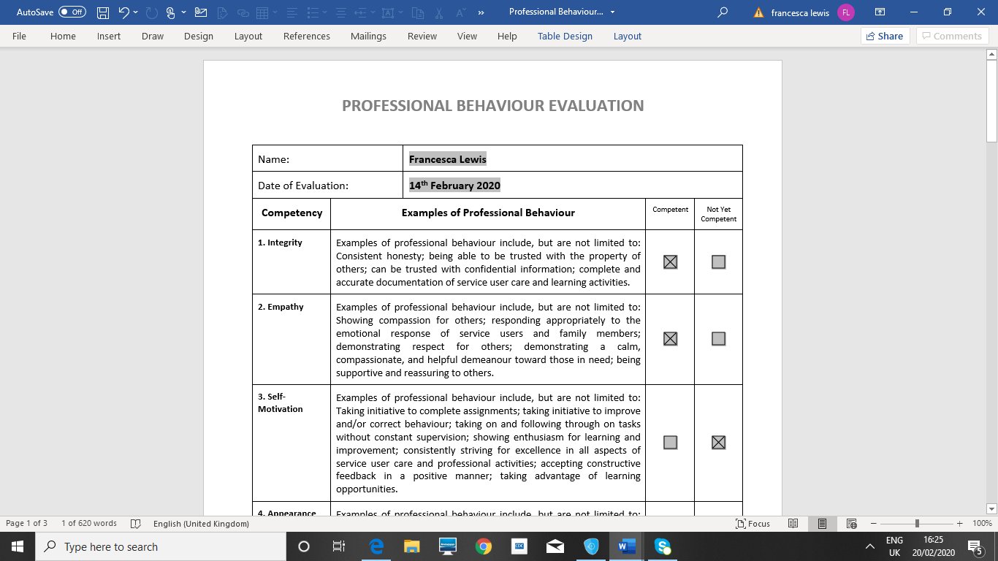

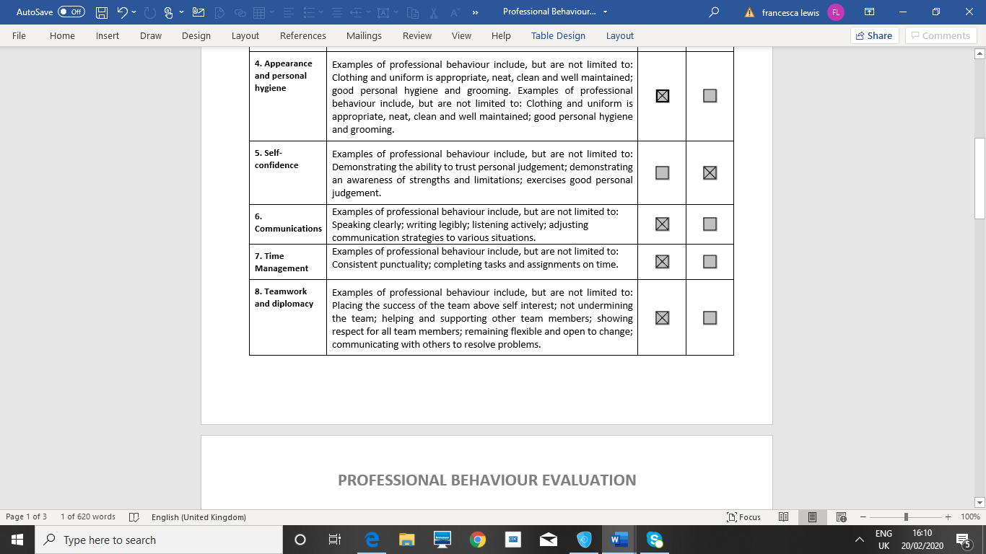

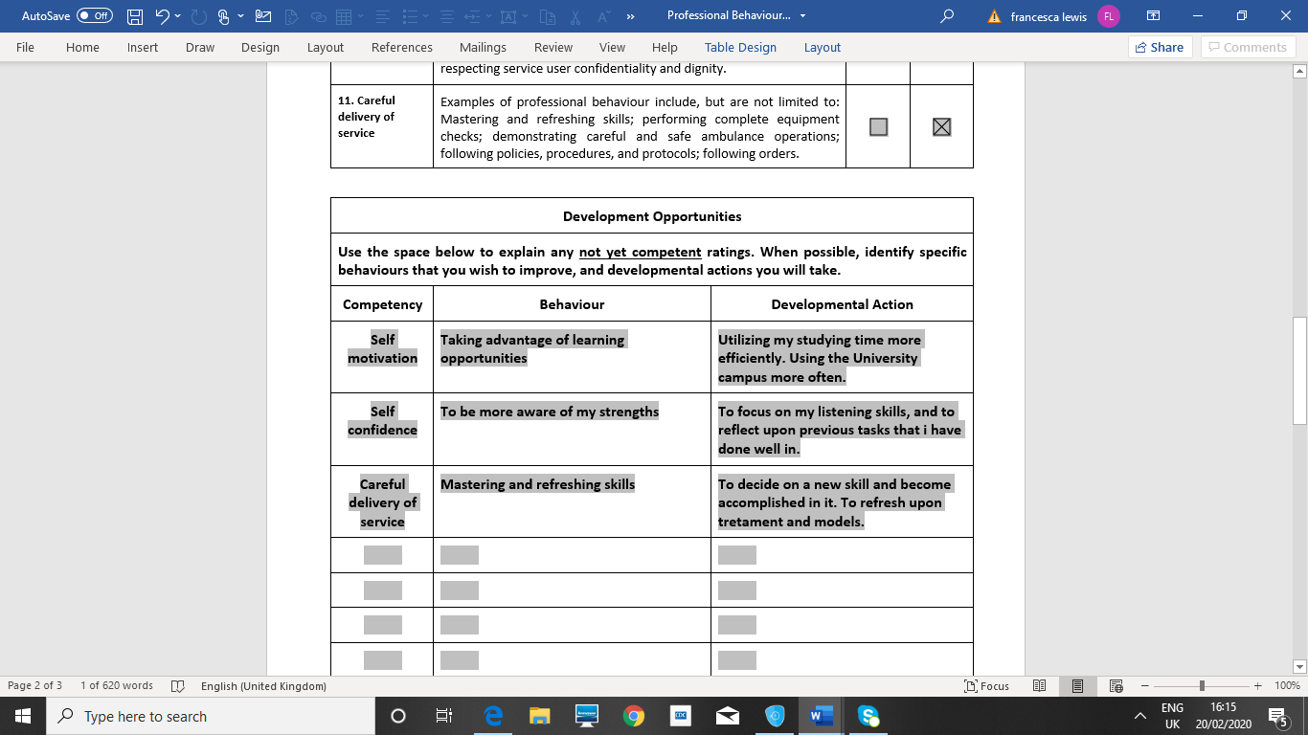
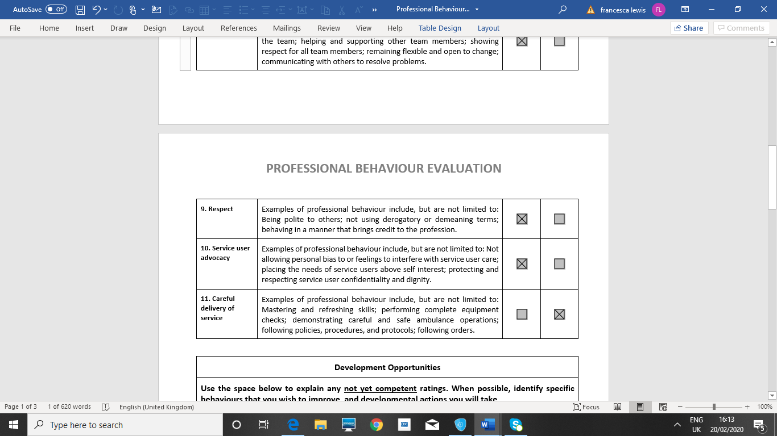

Reflective Piece

This reflective piece of writing, will critically reflect upon my own personal development, through the Skills for Life and Employability module. A critical reflection will be given on my employability, advanced competencies and transferable skills. According to Davies (2012) reflective practice is an important part of continuing personal development, and allows individuals to identify strengths and weaknesses, and specific learning goals, in order to maintain professional competencies, and to aid lifelong learning.
The Life skills and Employability module aimed to develop enterprising thinking, develop behaviours, attitudes, and advanced competencies, foster an employability mindset and critically reflect upon one’s development needs. The module was split into three sessions, and consisted of mindfulness and work, employment and entrepreneurship skills, individual differences and leadership, and conflict resolution and conflict management strategies. Critical reflection will be made using the Gibbs reflective cycle. The University of Edinburgh (2020) state that Gibbs Reflective Cycle was developed by Graham Gibbs in 1998. It examines experiences and allows for future learning and planning, by covering six stages of description of the experience, feelings of the experience, an evaluation of the experience, an analysis to make sense of the situation, a conclusion to state what has been learned, and finally an action plan, to deal with how things could be done differently next time, or in similar situation.
My initial thoughts of the module, were that of confusion, and I did not know what to expect, as it was new type of module for us. Whilst I engage in all new modules, I did feel apprehensive about this module, as the word entrepreneurship is a new concept to me, but after learning about the different types of entrepreneurship, I have come to realise that I will use this skill in future employment. Greene and Saridakis (2008) examined career progression of graduates that had entrepreneurial settings, and found that higher education is important in supporting graduates in employment. After engaging in the module, I realised that entrepreneurship is relevant to my employability, and it is a competency that employers look for in a potential employee. Looking to my future employability, when there is a skill that I do not think is relevant to my skill set, I plan to be far more open minded, and to engage more from the beginning.
During the first session of the module, a guest speaker, who practised and taught mindfulness, came to speak to the class about what mindfulness was, where it originated from, and how to practice a mindful minute. A quasi - experimental study evaluating effectiveness of mindfulness in education, by Schonert – Reichl and Lawlor (2010) found that mindfulness aided development of social and emotional competence, optimism, and positive self – concept.
Whilst I feel fairly confident about my present employability, there are certain skills that this module has highlighted to me, that need to be developed. In addition to this, my enterprise skills need focus. Tran (2016) suggests that promoting university enterprise skills, enhances graduate’s employability, and benefits society. After I had learnt about enterprise skills, I realised that in my everyday studies, working independently and strategic thinking, defined enterprise skills. This made me think about enterprise more positively, and I did not see the subject as such a daunting task.
I decided to use my personal statement from several years ago, as my first component. I felt that this showcased, how my skills have developed through the degree programme, and it helped to reflect on my employability then, and now. The key skills that I felt I had developed were, communication and interpersonal skills, compassion and empathy. The skill I felt that I need to develop is self-confidence. Potgeiter (2012) studied the relationship between self-esteem and confidence, and employability, and found that there is a significant relationship, between self confidence and employability. After reading over my personal statement, it made me realise how far I had come, and that I had learnt an incredible amount over five years of study. To continue my development regarding my employability skills, I will continue to expand on my communication and interpersonal skills and develop my enterprise and self-confidence skills.
The second component that I engaged with was the STAR technique. We were given a group task, to critically analyse Belbin’s roles, and how these affect the workplace. Dr Meredith Belbin suggested, that within a team there are 9 different roles, and for a team to be effective, each team member needs a role. The roles were shaper, implementor, completer finisher, coordinator, team worker, resource investigator, plant, monitor evaluator and specialist (University of Cambridge, 2016). According to Belbin’s roles, my role during this task was the coordinator. There was a 90-minute time deadline, and there were 8 in the group. The task was to produce a power point, and present it to the lecturer, and the class. I felt very apprehensive, as I had not participated in a group task before, and felt slightly nervous, as I was new to the group, and they had been in the class together since the first year of the degree. Crebert, Bates, Bell, Patrick and Cragnolini (2004) suggest that groupwork is of great importance, and aids collaboration and responsibility skills. The task turned out far better than I anticipated, and this was a relief to myself, and other members of the group. I was tasked with production of the power point, which gave me opportunity to show my creative thinking skills, and time management capability. Esroy (2014) suggests that creative thinking produces more adaptability, and multidimensional viewpoints. I feel that I would benefit, from participating in groupwork at another given opportunity.
The Professional Behaviour Evaluation was the third component, that I chose to engage with. This involved a list of competencies that I had to decide, whether I was competent or not competent in. This evaluation was comprehensive and gave details of behaviours for each competency. I found this evaluation an extremely valuable tool, to assess my current employability, as it allowed me to action plan any competencies that I felt I did not possess or need to develop. I viewed the whole component as an entirely positive task, which enabled me to list rather specifically, skill that needed development. From the evaluation, I identified three key competencies that I need to focus and develop on. These are self-motivation, self-confidence, and careful delivery of service.
Whilst I do not struggle to undertake my assignments, and submit to deadlines, I do occasionally struggle to take advantage of learning opportunities, such as additional tasks on Moodle, that have been set to aid my study, and extra reading, which may not be essential, but would aid my learning. My self-motivation needs focus, and regular review, and I need to be aware of my weaknesses as well as my strengths. Evidence from an in-depth qualitative study, undertaken by Barnes, Green and De Hoyes (2015) suggest that self-motivation can aid in enhancing employability, and open new learning pathways.
Whilst evaluating the questionnaire, another weakness emerged, this being self-confidence. This is a competency that I rarely feel positively about, as I feel having to examine one’s self so closely, draws about more insecurities than praise. The evaluation made me realise that I do possess some strong competencies, but confidence in myself is low. If I was to do the Professional Behaviour Evaluation again, I would action plan more specific behaviours. Sinclair (2017) suggests that confidence can be raised, and employability skills improved, by adaptability and application of knowledge.
During the behaviour evaluation, another competency that I felt needs developing, is careful delivery of service. This competency highlights my need to refresh on a new skill, or to learn a new skill. Rosenburg, Heimler and Morote (2012) state that the adaptability to new skills, and additional training, are basic employability skills. I feel that I would benefit from, refreshing upon some previous modules. The stress coping and resilience module was extremely informative, in particular, coping methods for stress. Secondly, treatment models and approaches in mental health, additionally I am keen to keep up to date with emerging treatment models for mental health, including alternative therapies such as mindfulness. In a report of randomized trials, for mindfulness-based therapy, Coronado-Montoya, Levis, Kwakkenbos, Steele, Turner and Thomba (2016) report that mindfulness-based therapy, had statistically significant results.
During one of the early sessions of this module, we were privileged to have a guest speaker who was a qualified mindfulness practitioner. At first, I did not know what mindfulness even was, where it came from, or how it was practised, or of the benefits. After listening to the guest speaker, I could appreciate mindfulness, and I felt curious to see if it could work for me. I was given the opportunity to take part in a mindful minute. However, I did feel slightly uncomfortable participating in front of my fellow classmates. I do feel that if I had been on my own, and in a different place, I would have engaged more with the activity. The guest speaker had a slight hearing issue o n the day, which made the activity slightly difficult. This highlighted the need for effective communication, and most certainly good listening skills, for everybody involved to get the most out of the activity. I would like to try the mindful minute again and will be doing some research into it.
This module has helped me move forward into future employment, by allowing me to engage and reflect on my employability, and my skills for life. There have been times when I have felt frustrated, for example the group task, as it was a new concept to me, and it a venture into the unknown. It has also highlighted my weaknesses, such as my lack of self-confidence, my need to develop my self-motivation, and the need to plan a more careful delivery of my skills and learning, for future employability. I found that looking back at my personal statement, was extremely helpful in how my skills have developed, and how much I have learnt, since starting the degree programme. The STAR evaluation discovered skills that need developing for my future employability, but also highlighted to me that I a good creative thinker and can work under time constraints.
The Professional Behaviour Evaluation was very productive, and pointed out to me that, whilst there are competencies that need developing, I do have a skill set. The evaluation, allowed for an action plan to be put in place, which enabled me to assess behaviours linked to these competencies, and plan accordingly. If I could do anything differently, I may have used to entrepreneurship activity, as a component in my portfolio, as I feel this is a skill that is going to become a key factor in employability. Concluding this reflective piece, I feel that to reflect back through a module, that is a new concept to me has helped me greatly, even though at the start I was not sure what this module would involve, and the word entrepreneurship meant little to me. I now have the confidence to move forward, into future employment in the mental health profession, possessing strong, sought after skills, and build upon the competencies that need development, for my future employability and life skills.

References
Barnes, S. A., Green, A., & De-Hoyes, M. (2015). Crowdsourcing and work: individual factors and circumstances influencing employability. New technology, Work and Employment, 30 (1), 16 – 31.
Barth, I., & Wagner, A. (2017). Physical appearance as invisible discrimination. Management and diversity, 4.
Basadur, M. (1997). Organizational development interventions for enhancing creativity in the workplace. The Journal of Creative Behaviour, 31 (1), 59 – 72.
Claussens, B.J., Van Eerde, W., Rutte, C. G., & Roe, R. A. (2007). A review of the time management literature. Personal Review, 36 (2), 255- 276.
Corondo – Montoya, S., Levis, A. W., Kwakkenbos, L., Steele, R., Turner, E. H., & Thombs, B. D. (2016). Reporting of Positive Results in Randomized Controlled Trials of Mindfulness – Based Mental Health Interventions. Plosone, 11 (4).
Crebert, G., Bates, M., Bell, B., Patrick, C. J., & Cragnolini, V. C. (2004). Developing generic skills at university during work placement and in employment: graduates’ perceptions. Higher Education Research & Development, 23 (2), 147 – 165.
Davies, S. (2015). Embracing Reflective Practice. Journal of Education and Primary Care, 23 (1), 9 – 12.
Esroy, E. (2014). The effects of problem-based learning method in Higher Education on creative thinking. Procedia – Social and Behavioural Sciences, 116, 3494 – 3498.
Gerdes, K.E., & Segal, E. (2011). Importance of empathy for Social Work Practice: Integrating New Science. Social Work, 56 (2), 141 – 148.
Greene, F. J., & Saridakis, G. (2008). The role of Higher Education skills and support in graduate self-employment. Studies in Higher Education, 33 (6), 653 – 672.
Hattrup, K., O’Connell, & Labrador, J. R. (2005). Incremental validity of locus of control after controlling for cognitive ability and conscientiousness. Journal of Business and Psychology, 19 (40, 461 – 481.
King, N., Bravington, A., Brooks, J., Melvin, J., & Wilde, D. (2017). “Go make your face known”: Collaborative Working through the lens of personal relationships. International Journal of Integrated Care, 17 (4).
Mills, D. (2008). The Practice of Integrity for Mental Health Professionals. The Journal of Aggression, Maltreatment & Trauma, 11 91), 51 – 62.
Miners, C. T.H., & Hideg, I. (2015). International Encyclopaedia of the social & Behavioural Sciences. Orlando: Elsevier Ltd.
NIMH. (2020). Substance use and Mental Health. NIMH. Online. Available from: https://www.nihm.nih.gov/health/topics/substance-use-and-mental-health-index.shtml [Accessed 14th February 2020].
Nowell, L.S., NorrisJ. M., White, D. E., & Moules, N. J. (2017). Thematic Analysis: Striving to meet Trustworthiness criteria. International Journal of Qualitative Methods, 2.
Nursing & Midwifery Council (NMC). (2010). Standards for competence for registered nurses. NMC: London.
Papageorgiou, A., Loke, Y. K., & Fromage, M. (2017). Communication skills training for mental health professionals working with people with severe mental illness. Cochrane Database of Systematic Reviews, 6.
Potgeiter, I. (2012). The relationship between the self esteem and employability attributes of postgraduate business management students. SA Journal of Human Resource Management, 10 (2).
Raque – Bogdan, T. L., Ericson, S. K., Jackson, J., Martin, H. M., & Bryan, N. (20110. Attachment and mental and physical health: Self – compassion and mattering as mediators. Journal of Counselling Psychology, 58 (2), 272.
Rosenburg, S., Heimler, R., & Morale, E. S. (2012). Basis employability skills. A triangular design approach. Education & Training, 54 (1), 7- 20.
Santamaria – Garcia, H., Baez, S., Garcia, A. M., Flichtentrei, D., Prats, M., Mastandueno, R., Sigma, M., Matallan, D., Cetkovich, M., & Ibanez, A. (2017). Empathy for others suffering, and its mediators in mental health professionals. Scientific Reports, 7 (6391).
Schonert – Reich, A., & Lawlor, M. S. (2010). The Effects of a Mindfulness Based Education Program on a Pre and early Adolescents. Wellbeing and social and emotional competence. Mindfulness, 1, 137 – 151.
Sinclair, A. J. (2017). Enhancing student’s confidence in Employability skills through the Practice of Recall, Adapt and Apply. Higher Education studies, 7 (3).
Singh, J., & Chopra, V. G. (2018). Workplace, Spirituality, Grit and Work Engagement. Asia – Pacific Journal of Management Research and Innovation, 14, (1), 50 – 59.
The University of Edinburgh. (2000). Reflection Toolkit. The University of Edinburgh. Online. Available from: www.ed.ac.uk [Accessed 15th February 2020].
Tran, T. T. (2016). Enhancing graduate employability and the need for university enterprise collaboration. Journal of Teaching and Learning for Graduate Employability, 7 (1).
University of Bath. (2020). Writing a personal statement for an undergraduate course. University of Bath. Online. Available from: https://www.bath.ac.uk.guides/writing-a-personal-statement-for-an-undergraduate-course/ [Accessed 14th February 2020].
University of Cambridge. (2016). Belbin’s team roles. Online. Available from: www.cam.ac.uk [Accessed 17th February 2020].
University of Essex. (2020). The Importance of Critical Thinking. The University of Essex. Online. Available from; www.edu.ac.uk [Accessed 17th February 2020].
WHO. (2012). Risk to Mental Health: An overview of vulnerabilities and Risk factors. WHO. Online. Available from: https://www.who.int/mental_health/mhgap/risks_to_mental_health_EN_27_08_12.PDF [Accessed 16th February 2020].

