Project Management Plan

Student: Mihaita Robert Nedelea
Student Number: 2129063
Module name: Managing Projects in the Workplace
Module Code: BMSW5104
Lecturer Name: Aderemi Ojebode

Table of Content
Introduction…………………………………………………………………………………………………………………….….….3
Description of the project……………………………………………………………………………………………………….4
Scope…………………………………………………………………………………………………………………………….……….6
Work breakdown structure…………………………………………………………………………………………………….7.
Quad Chart……………………………………………………………………………………………………………………….…….9
Gantt Chart…………………………………………………………………………………………………………………………...11
Stakeholders' involvement……………………………………………………………………………………………….……11
Allocation of resources……………………………………………………………………………………………………….…12
Risk Analysis……………………………………………………………………………………………………………………….…13.
Conclusion…………………………………………………………………………………………………………………………….15
References…………………………………………………………………………………………………………………………….16
Appendix……………………………………………………………………………………………………………………………….18

Introduction
This project management plan explores Balkan Bakery Bliss's exciting endeavour to launch a new line of cookies specifically designed for diabetic people. To meet the huge demand for healthy snacks, we are pleased to introduce a range of cookies that have undergone extensive development to fully comply with the dietary needs of individuals with diabetes. Through this initiative, our aim is to enhance the lives of our customers while expanding our market reach.
Our diabetic-friendly cookies result from extensive collaboration with nutritionists and diabetes experts, ensuring they not only meet taste and texture expectations but also comply with stringent dietary requirements. We are committed to providing guilt-free indulgence to those seeking delicious treats without compromising on health, achieved using natural ingredients and innovative recipes (Khasanov, 2016).
Throughout this Project Management Plan, we will delve into comprehensive strategies and methodologies employed to execute this project seamlessly. Everything from defining the project's scope and developing a WBS to identifying risks and assigning resources will be carefully planned and carried out. Recognising the critical role that stakeholder involvement plays, active efforts will be made to ensure transparency and alignment with project goals (Roberts, 2011).
This project management plan serves as a roadmap guiding us toward the successful launch of our diabetic-friendly cookies. We have a fantastic chance to make a big difference in the healthy snack market because of our unwavering dedication to quality, innovation, and client satisfaction.

Description of the project
Objective
Balkan Bakery Bliss is excited to unveil the introduction of a fresh range of all-natural, diabetic-friendly cookies. Our aim is to address the needs of people with diabetes while also expanding our market reach. Crafted exclusively with natural ingredients, our new cookie line is meticulously designed to adhere to the dietary needs of diabetics, all while preserving the delicious flavour and satisfying texture. Our guilt-free, diabetic-friendly cookies are ideal for anyone seeking delightful treats without compromising their well-being (Heinemann, 2021).
In close collaboration with dietitians and diabetes experts, we have ensured that our diabetic-friendly cookies meet rigorous dietary standards. Their endorsement further underscores our dedication to delivering reliable products tailored to the needs of diabetic individuals. Thanks to expert manufacturing, our cookies strike the perfect balance between nutrition and taste.
Balkan Bakery Bliss is proud to introduce a selection of cookies tailored for individuals with diabetes:
Almond butter cookies: our latest offerings feature almond butter as the main ingredient, imparting a rich and nutty flavour. These cookies are low in glycaemic index due to their stevia sweetening, and they are free of grains and gluten to suit a variety of dietary needs.
Carrot coconut cookies: these cookies are a delightful combination of the tropical essence of coconut and the sweetness of carrot. They are made with almond flour, coconut flakes, coconut oil, and a hint of cinnamon for warmth. They are free of gluten and sweetened with stevia. The texture of the eggs is soft and chewy, and the crunch of the coconut flakes is satisfying.
Almond walnut seed cookies: these treats, which are made with almond flour and loaded with protein, healthy fats, and Omega-3 fatty acids, provide a nutritious take on classic cookies. With chia seeds, stevia, and pumpkin seeds, they offer a guilt-free treat. Coconut oil unites the ingredients and adds a taste of the tropics.
Balkan Bakery Bliss proudly presents these diabetic-friendly cookies, showcasing not only a diversification of our product line but also an extension of our inclusivity to a broader audience. Committed to our sustainability values, we continue to prioritize eco-friendly packaging for our products.
Start date of the project: February 1, 2024
End date of the project: March 31, 2024
Team members: Valentina Dinca, Violeta Nedelea and Mihaita Nedelea
Budget: £10,000

Balkan Bakery Bliss is set to debut a fresh assortment of cookies tailored for individuals with diabetes. With a total project budget of £10,000, our team will oversee various aspects including recipe creation, ingredient procurement, packaging conceptualization, marketing tactics, and quality control. The project is scheduled to commence on February 1, 2024, and conclude on March 31, 2024. Throughout this period, our dedicated team will diligently work to introduce the new line of diabetic-friendly cookies, ensuring adherence to strict deadlines and maintaining high-quality standards (Khasanov, 2016).

Source of funding
The bakery was established through a personal investment of £42,000. Additionally, £10,000 from the bakery's existing sales will contribute to funding this project.

Responsibility Matrixes
Task Activity | Valentina | Violeta | Mihaita
Market Analysis | S | O
Product Creation | S | O
Create Packaging | R | S
Purchasing Materials |  | S | O
Production |  | S | O
Quality Assurance | R |  | S
Financial Management |  | S | O
Marketing Campaigns | O | S
Working with Experts | S |  | O
Key: O - Owner; R – Responsible; S – Support. Table 1 – Responsibility Matrixes

The scope
The scope of the project includes all necessary expenses to launch the diabetic-friendly biscuit line within the allocated £10,000 budget. This covers costs for developing recipes, locating ingredients, packaging, advertising, and quality assurance. Furthermore, a 10% contingency fund called MISELINOS will be set up to deal with any unanticipated costs or problems that may come up while the project is underway. This contingency fund ensures that we can manage unexpected costs while still adhering to our budget and ensuring a timely and high-quality product launch.

Work breakdown structure.
A work breakdown structure (WBS) breaks down the project scope into manageable tasks using a hierarchical format. The successful launch of the newest diabetic-friendly cookies from Balkan Bakery Bliss depends on a well-planned project management approach. The key actions and tasks needed to introduce this ground-breaking product are outlined in this work breakdown structure. Every component in the WBS is essential to ensuring the success of the launch of the diabetic-friendly cookie (Han, 2021).
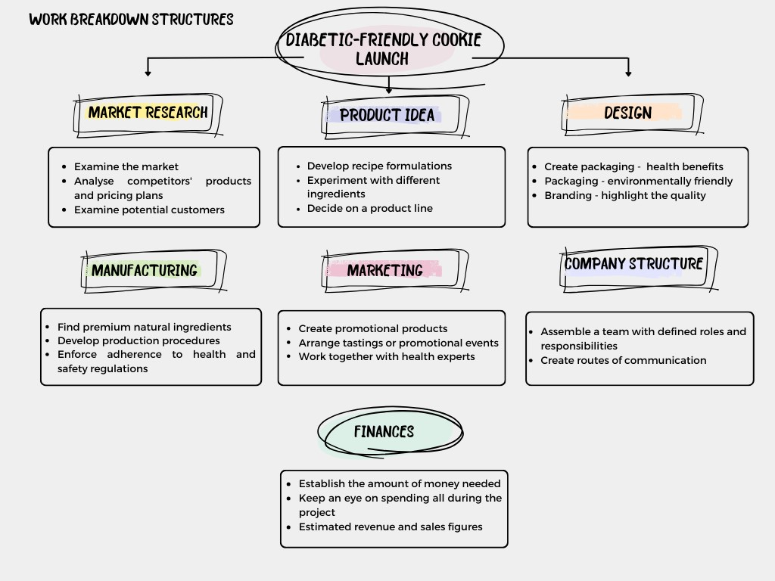Figure 1 - Work breakdown structure

Market Research
- Analyse the market to determine the demand for diabetic cookies.
- Examine the pricing and products tactics of rivals.
- Analyse prospective clients to learn about their tastes and buying patterns.
Product Concept
- Create diabetic cookie recipes by modelling them.
- Try varying the ingredients and flavours to improve the taste and quality of the cookies.
- Make a product line decision based on market research and feedback from taste tests.
Design
- Create packaging that clearly conveys the natural ingredients and health benefits of the cookies.
- Make packaging that is compliant and friendly to the environment.
- Provide identifying elements for the diabetic-friendly cookie line that emphasise its superior quality and unique features.
Manufacturing
- Source superior natural ingredients for cookie production.
- Establish production procedures to maintain freshness and consistency.
- Implement quality control measures to ensure compliance with health and safety regulations.
Marketing
- Produce promotional materials such as flyers, brochures, and social media content for platforms like Facebook, Instagram, Google Ads.
- Arrange for promotional events or public tastings to unveil the new product line.
- Collaborate with influencers or health experts to emphasise the health advantages of the product.

Organizational structure
- Establish communication channels to enable smooth departmental coordination.
- Create a team with clearly defined roles and responsibilities for the launch of the new product line.
Financial Management
- Determine the budget required for recipe creation, manufacturing, packaging, and promotion.
- Monitor project expenses to ensure cost-effectiveness.
- Project revenue and sales estimates based on pricing strategies and market research.

Quad Chart

PURPOSE  (AIMS/OBJECTIVES) | CUSTOMERS  (STAKEHOLDERS)
This project endeavours to offer an upscale range of cookies tailored for individuals with diabetes, addressing the rising need for healthier snack options among this demographic.  The primary goals include elevating the brand reputation of Balkan Bakery Bliss, broadening its product portfolio, and fostering better health outcomes for its customers.  Ultimately, this initiative is anticipated to bolster market presence and generate increased revenue from a growing segment of health-conscious consumers. | Internal stakeholders: Bakery owners  External stakeholders:  Diabetic patients  Providers  Competitors  Residents  Nutritionists  Health &Safety agency  Investors
DESIRED END RESULT  (CRITICAL SUCCESS FACTORS) | MEASURES OF SUCCESS  (STANDARDS / CRITERIA)
A variety of cookies with natural flavour low-glycaemic index that are appropriate for people with diabetes are now available.  Creating a happy chain of Balkan bakeries as a reliable source for wholesome snacks.  Enhance consumer loyalty and brand awareness. | Get a 4.5 out of 5 customer satisfaction rating after launch.  In the first three months after launch, raise sales by 15%.  Within six months, raise brand awareness by 25%.  Boost social media and marketing initiatives by 15%.  Keep the customer retention rate at 35% or above, after the first year of use  Obtain minimum 90% of the favourable reviews from the participated media and influencers.  Make sure that all health and safety regulations, as well as dietary recommendations, are followed to the letter.
Table 2 – Quad Chart

Gantt Chart
This Gantt chart shows our project schedule visually, with tasks and their start and finish dates indicated. It helps with scheduling, resource distribution, and deadline monitoring and provides a thorough overview of the project's progress.
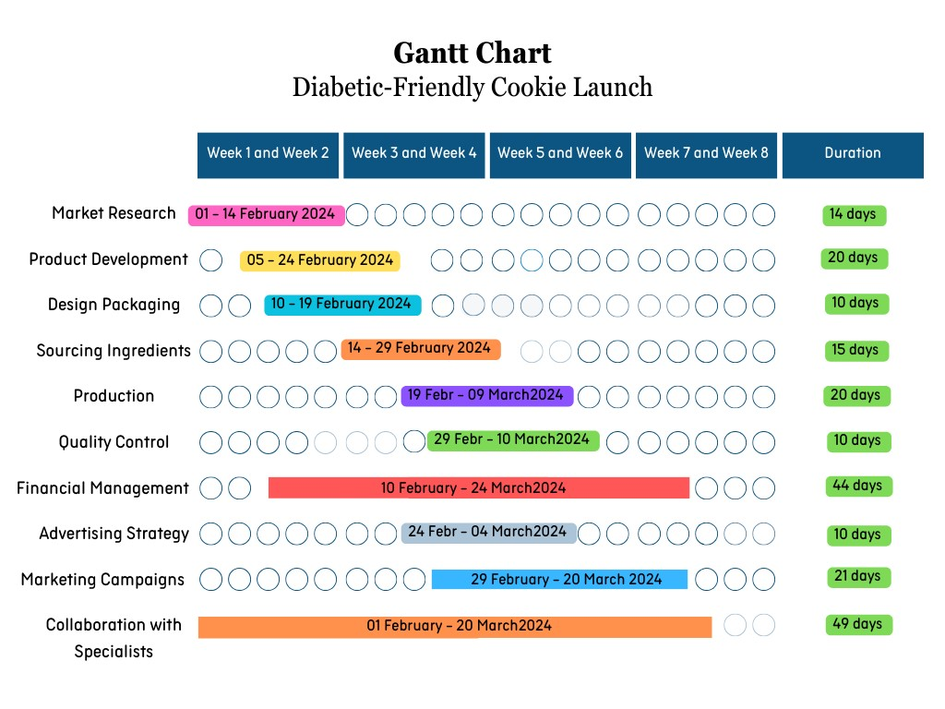
Figure 2 – Gantt Chart

Stakeholders' involvement
Internal Stakeholders: A key factor in the success of the introduction of diabetic-friendly cookies is the ownership of bakeries. From recipe development to distribution, they supervise every step, guaranteeing quality control and effective departmental coordination.
External Stakeholders:
Diabetic Patients are central to our target audience for the diabetic-friendly cookies, offering essential feedback on taste and satisfaction.
Providers, including healthcare professionals like doctors and dietitians, are crucial in endorsing dietary solutions for diabetic patients. Collaborating with them will help raise awareness and provide valuable nutritional information.
Competitors' strategies and offerings influence market dynamics, guiding our monitoring and adjustment of pricing and marketing tactics.
Residents represent potential customers, offering feedback on product availability and satisfaction.
Nutritionists offer expert advice on dietary requirements, particularly for diabetics, aiding in validating the nutritional value of our cookies.
Health and safety agencies regulate food safety standards, our collaboration with them ensures compliance and consumer safety.
Investors provide crucial financial backing, supporting the development, manufacturing, and marketing of our diabetic-friendly cookies.

Allocation of resources
The diabetic-friendly cookie project needs to be launched successfully, which means that resources must be carefully distributed among many tasks. With a £10,000 budget, it's crucial to allocate money carefully so that every part of the project has enough funding. The estimated costs for each activity are displayed in this budget plan table. The purpose of the contingency fund is to pay for unforeseen costs.

Table of budget plan
Activity | Estimated Cost (£)
Market Analysis | £500
Development of Recipes | £1,000
Ingredients Purchasing | £1,200
Product Testing | £800
Packaging Design | £700
Marketing and Branding | £1,500
Production Configuration | £2,000
Quality Control | £600
Launch Event | £1,200
Post-Launch Evaluation | £400
Contingency (MISELINOS) | £1,000
Total | £10,000
Table 3 – Table of Budget plan

Risk Analysis
Any business endeavour needs risk management, but it's especially critical for the introduction of a new product like our line of diabetic-friendly cookies. Numerous external risks have the potential to impact the project's budget, schedule, and overall success. To lessen their effects and guarantee the successful execution of the project, it is critical to recognise these risks and take preventative action (Steen, 2015).

Risk management steps:

Inflation is a form of economic risk that is manageable.
The project to create diabetic-friendly cookies faces financial risk due to inflation, which could raise the price of ingredients, manufacturing, and delivery. Changes in inflation rates could have an impact on consumers' purchasing power, which would then influence the demand for and pricing of the cookies that are suitable for diabetics. The impact of inflation on project expenses can be lessened and profitability can be maintained by putting proactive pricing strategies into place and closely observing market trends (Steen, 2015).
Market fluctuations - Risk type: market/economic risk, which we are willing to accept.
The market's trends, consumer preferences, and economic conditions can all impact how much demand there is for diabetes-friendly products. embracing the possibility that minor changes in consumer preferences won't have a significant impact.
We handle supply chain disruptions as an operational risk.
Transportation issues, delays from suppliers, and ingredient shortages can all hinder production.
Treat supply chain risks by talking proactively with suppliers, diversifying your supplier base, and developing backup plans (Steen, 2015).
We handle the risk because it is a legal and regulatory concern.
Ensuring adherence to food safety laws and labelling specifications can lead to legal problems and harm to our reputation. We must make sure that all products adhere to all applicable laws and regulations to prevent this. To guarantee compliance, quality assurance procedures must be put in place at every stage of the production process (Sarfraz, 2021).
Competition - Commercial risk - the presence of rival bakeries offering similar diabetics friendly cookies could have an influence on our market share.
By treating risk and differentiating our product through distinctive branding, premium ingredients, and an exceptional customer experience, we stay ahead of the competition. Maintain a competitive edge by monitoring rivals and making necessary adjustments to your strategy (Holst, 2019).
Technical problems: We transfer the technical risk.
If there are any problems with the software or equipment, we assign responsibility to another party. Technical problems, such as malfunctioning software or equipment, can lead to production delays. Purchasing dependable tools and technology can help us lower the likelihood of technical problems (Sarfraz, 2021).

Conclusion

With the introduction of our diabetic cookies line, we have opportunity to expand our clientele, add new products to our lineup, and provide healthier options. Our strategy has been meticulously planned and executed, with a strong emphasis on quality, innovation, and customer satisfaction at every turn, from recipe development to production and marketing.
Not only do our diabetic-friendly cookies fulfil the dietary requirements of our diabetic customers, but they also satisfy the cravings of our regular customers.
We achieve this by using only organic and natural ingredients and putting strict quality control measures in place. In the bakery industry, we stand out from the competition because of our steadfast dedication to sustainability, legal compliance, and ongoing development.
We will never waver in our resolve to provide outstanding customer service and products that go above and beyond. For our valued clients as well as our company, we are still committed to fostering growth and profitability.

References

A. R. Khasanov (2016) “THE EVOLUTION OF NEW PRODUCT LAUNCHING THEORIES,” Strategii biznesa [Preprint], (1).

Barrow, C., Barrow, P. and Brown, R. (2021) The business plan workbook: a step-by-step guide to creating and developing a successful business. Tenth edition. London; Kogan Page.

Billingham, Vicky. (2008) Project management: how to plan and deliver a successful project. Abergele: Studymates.

Chow, T.C. et al. (2021) “Impact of sustainable project management on project plan and project success of the manufacturing firm: Structural model assessment,” PloS one, 16(11), pp. e0259819–e0259819.

Ferreira, M., Aleksandra Figurek, Goncharuk, A.G. and Sirbu, A. (2023). Baking Business Sustainability Through Life Cycle Management. Springer Nature.

Finch, B. (2022) How to write a business plan: win backing and support for your ideas and ventures. Seventh edition. London; Kogan Page.

Guiné, R.P.F., Florença, S.G., Barroca, M.J. and Anjos, O. (2020). The Link between the Consumer and the Innovations in Food Product Development. Foods, [online] 9(9), p.1317.

Han, X. (2021) “WBS-free scheduling method based on database relational model,” International journal of system assurance engineering and management, 12(3), pp. 509–519.

Heinemann, L. and Klonoff, D.C. (2021). Input of Patients for New Diabetes Technology Products. Journal of Diabetes Science and Technology, 15(5), pp.983–985.

Holst, K. (2019) Product Management: Launching Your Product. Carpenteria, CA: linkedin.com.

Kunreuther, H. et al. (2019) The Future of Risk Management. Edited by H. Kunreuther, R.J. Meyer, and E.O. Michel-Kerjan. Philadelphia: University of Pennsylvania

Lock, D. (2013) Project management. 10th edition. Burlington, Vt: Gower.

Nicoleta Ciucescu (2016) “BUSINESS PLAN - MANAGEMENT TOOL OF THE ENTREPRENEUR,” Studies and Scientific Research. Economics Edition (University of Bacau) [Preprint].

Refugia, J. and Pittman, G.O. (2014) Business Continuity Management Plan.

Roberts, P. (2011) Effective project management. London; Kogan Page.

Rocha, J., Oliveira, S. and Capinha, C. (eds) (2020) Risk Management and Assessment. London: IntechOpen.

Sahin, A.W., Zannini, E., Coffey, A. and Arendt, E.K. (2019). Sugar reduction in bakery products: Current strategies and sourdough technology as a potential novel approach. Food Research International, [online] 126, p.108583.

Sarfraz, M. and Ivascu, L. (eds) (2021) Risk Management. London: Intech Open.

Steen, R. (2015) “A risk assessment approach to support the launching of new products, services or processes.”

Appendix


