University of Wales Trinity Saint David

Wales Institute of Science & Art

Rubber Band Propelled Car Project
Engineering Projects
ACHA4034

Group: B

(DD/MM/YYYY)
Contents
1 Introduction 4
2 Research 5
3 Development 6
4 Reflection 7
5 Results 8
6 References 9

-------------------------EXTRA/IMPORTANT INFO DELETE LATER----------------------------
Brief - (Engineering Projects intro 2025-26.pptx)
Lollipop sticks (max 20 per group) ____CDs (max 4 per group) ____ Rubber bands (plenty available) ____ Wooden dowels (5 per group) ____ Straws (plenty available) ____ Washers (10 per group) ____ Paper clips (plenty) ____ Cellotape ____ Modelling clay ____ Wooden wheels (4 per group) ____ Glue guns
Tests – How quick it can travel 2m
How far it can travel
Plan: Intro
Research in design and why choices were made
Hand – drawn design iterations
Can use data from testing as analysis and draw conclusions from this
Evaluation of how the project went, what you could have improved upon
Adequate referencing used throughout

Poworpoint to support presentation (10 mins)

Dates
Constuction weeks – November 17th and 1st
Hand in (Written 23rd Jan 2026)
Presentations 26th January
------------------------------------END OF PLAN-------------------------------------------

Introduction (200 words)
This project is a team project which is to show our progress researching, developing and testing how we can construct the most effective propelled rubber band car possible. We have a list of restraints we must adhere to such as limited materials.
- 20 Lollipop sticks
- 4 CDs
- Rubber Bands (Plenty)
- 5 Wooden Dowels
- Straws (Plenty)
- 10 Washers
- Paper Clips (Plenty)
- Cello tape
- Modelling Clay
- 4 Wooden Wheels
- Glue Gun
As well as limited materials we are working within a group, so we must organise when and how we are going to work on this project and this is going to be especially challenging with deadlines that are near.
The target of this project is to build a rubber band propelled car which must be designed in a way to excel in two tests we will be given. The first is to see how fast it can travel 2 Meters and the second is to see how far it can travel overall, so when designing we must consider how the car will perform on each test and adjust provide a car than can shine on both.

Research (300 Words)
We investigated different manufacture design chassis; we compared heavy duty chassis built off two main beams that were heavily reinforced, however we settled on a triangular based chassis to prioritise speed. Like the lotus chassis and when looking at the triangular based design we had the option to assemble the triangle at the rear or the front. Following this we then compared the outcomes of deciding whether we wanted front, rear or all-wheel drive.
With our setup we decided to go with rear wheel drive because when looking into drag racing we found out that the vast majority of the cars that participate are rear wheel drive. We found that this is because when the cars launch all the weight shifts to the rear axle meaning there is a lack of grip to the front tyres. When looking at all wheel drive although it has the benefits of faster acceleration, we found that increasing the moving parts could result in more weight and less reliability.
When looking at materials we saw we split each section into three parts. First, we focus on the chassis, opting for lollipop sticks as they are structurally strong, and easy to configure with glue due to their flat faces. We did look at using dowels for the chassis however this design would have exceeded the threshold for the maximum number of dowels per group.
For the axle we decided to run the dowels through the straw in the hopes the dowels would freely move allowing the wheels to rotate then allowing us to glue the straw to the chassis. To then rotate the wheel, we have decided to add a small wood chip, leaving enough clearance so it does catch on the frame yet allowing the rubber band to secure and to spin freely.
(Guide for research – talking points
-Existing products, systems or solutions you researched
-Key engineering principles, formulas, or theory relevant to the project
- material selection reasoning or standardsd you referred to
- any testing or data used to guide design choices
References that will be useful looking at
(https://www.smallpeicetrust.org.uk/wp-content/uploads/2025/08/EaS-01-The-Rubber-Band-Car-Challenge.pdf)
(https://www.sciencebuddies.org/science-fair-projects/project-ideas/Phys_p125/physics/rubber-band-powered-car-challenge)
(https://engineering.jhu.edu/sabes/wp-content/uploads/2015/07/Rubberband-Cars.pdf)

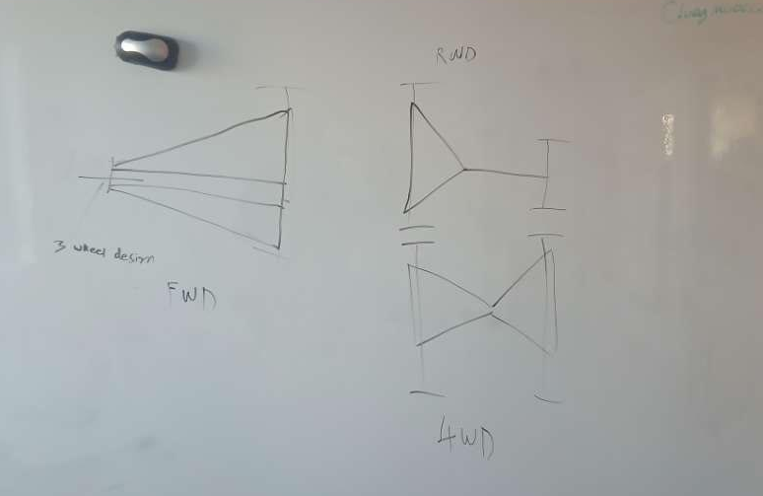
Development (450 words)
During the development process we changed and refined different aspects of the rubber band car by conducting multiple rounds of testing and evaluation. Each iteration allowed us to identify weaknesses in the design and make improvements based on performance and reliability. We experimented with several different drivetrain models including rear wheel drive, front wheel drive and all wheel drive to determine which configuration would be the most effective given our materials and construction limitations. Testing multiple drivetrains helped us better understand how energy from the rubber band was transferred through the vehicle and how this affected stability, acceleration and distance travelled.
After testing the front wheel drive configuration we found that the model flipped over during operation. This was caused by an excessive energy released from the rubber band being transferred directly to the front wheels which lifted the rear of the vehicle off the ground. As a result the model was unstable and unreliable making it unsuitable for consistent testing. When implementing an all wheel drive system we observed that the car accelerated extremely quickly. However this rapid acceleration caused the rubber band to release its stored energy extremely fast meaning the vehicle failed to travel as far as expected. Although the all wheel drive system provided good traction it did not allow for efficient energy use over a longer distance.
Ultimately we chose rear wheel drive because it provided a simpler mechanism that was easier to control, adjust and build upon. The rear wheel drive configuration allowed for smoother power delivery and improved stability throughout the run. Additionally, rear wheel drive made it easier to identify performance limits by using the wheels as an independent variable during testing. This allowed us to make more precise adjustments to wheel size, grip, and axle setup without drastically affecting other components of the car.
When choosing wheels, we debated between using wooden wheels or CDs. The wooden wheels provided more grip due to their rougher surface but this came with the cavoite of a smaller diameter which could limit distance. In contrast, the CDs offered a much larger diameter which could potentially increase distance travelled per rotation, but they suffered from poor traction on the floor. Through further testing we discovered that the wooden wheels could be significantly improved by adding plasticine around the edges to act as tyres. This modification greatly increased grip between the wheels and the floor reducing wheel slip and leading to more consistent and improved performance across multiple tests.
When attaching the wheels to the vehicle we initially struggled to find a method that was both sturdy and efficient. Our first idea was to create a supporting structure out of skewers however we quickly realized that this design would be too flimsy and prone to bending under load. Eventually we decided to use paper clips as axle supports. This proved to be an effective solution, as they created a near frictionless surface for the axle to rotate smoothly improving the overall efficiency and reliability of our model.
From the selection of materials we opted for the main chassis to be made from lollipop sticks as opposed to wooden dowel. The wooden dowel was scarce with only five pieces available so we chose to conserve these for use as axles where strength and rigidity were most important. Using lollipop sticks for the chassis allowed for greater structural flexibility while still providing sufficient strength resulting in a lightweight yet durable frame for the rubber band car.

Design Choices
- What concepts you considered and which one you selected
- Why that design was chosen (engineering justification, constraints, practicality)

Design Process / Hand-Drawn
- Explain your design iterations
- Include drawings and sketches
- Mention feedback or test results that shaped design changes

Testing, Data & Calculations
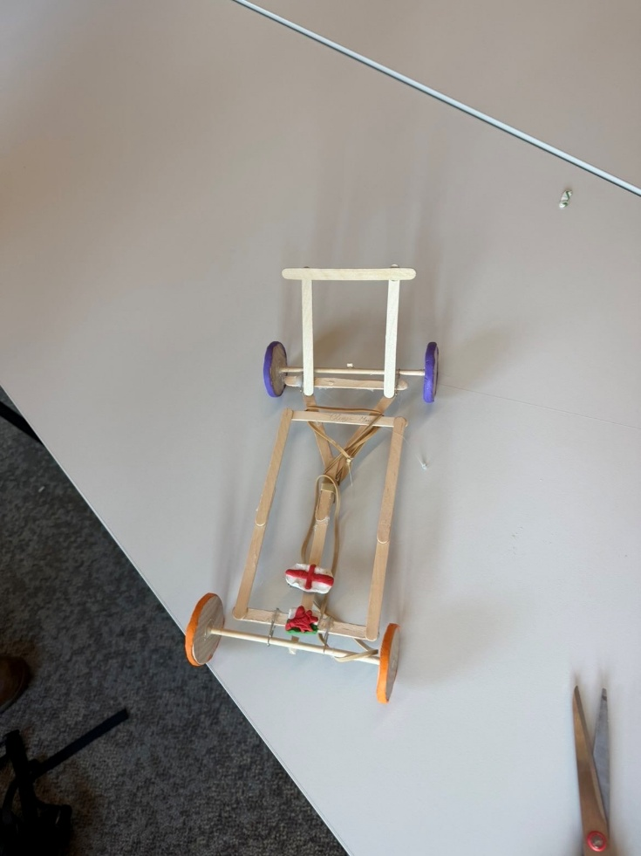
It made a metre
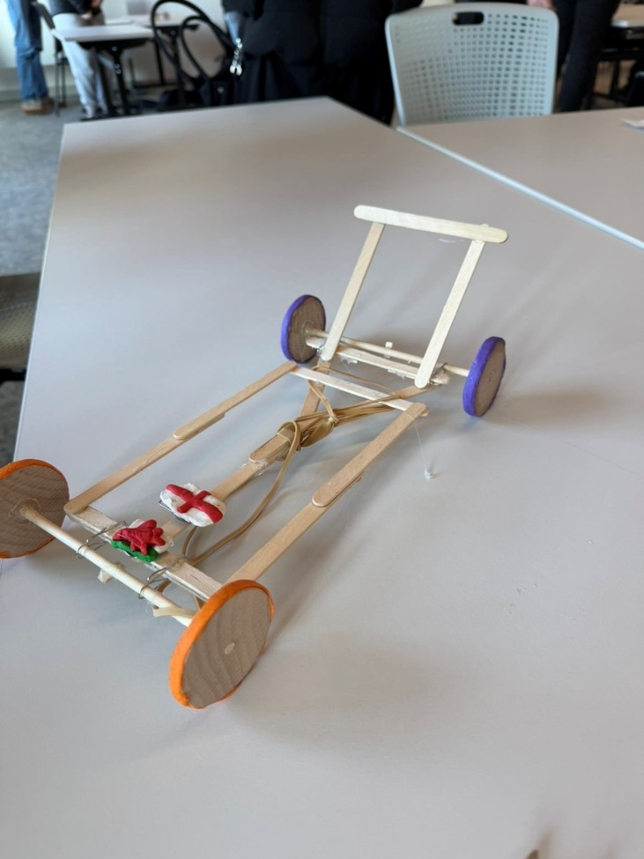

Evaluation (450 Words)
The rubber band car project was mostly successful because the car moved properly and met most of the goals set at the beginning. The car used a rear wheel drive setup and medium-sized wooden wheels, which helped it travel in a straight line and stay balanced during testing. While the design worked well overall, a few issues limited how far and fast the car could go.
What Went Well
One of the best parts of the design was the rear-wheel-drive system. Having the power go to the back wheels made the car move forward smoothly and with good control. When the wheels had enough grip, the car accelerated nicely without wobbling or turning off course. The choice of medium sized wooden wheels also worked well they were small enough for quick movement but large enough to keep the car steady. This balance helped the car travel a good distance without losing control.
The car’s build quality was another strong point. The wooden base was strong and didn’t crack or bend during testing, even after several runs. The axles stayed straight, so the wheels spun evenly and consistently. Because of this, the car’s performance stayed similar in each test, showing reliability. Over time, small improvements made the final version faster, smoother, and more stable than the earlier ones.
Planning and testing also went well. The team finished building the car on schedule, leaving time for trial runs. After testing, a few small adjustments were made tightening the frame and adjusting the rubber band tension which helped boost the car’s performance. This careful testing made a noticeable difference in how well the car worked.
What Could Have Been Improved
The biggest issue was traction. The wooden rear wheels sometimes slipped, especially at the start when the rubber band released the most energy. The smooth surface of the wheels didn’t grip the floor very well, so some energy was wasted. In the future, adding rubber bands, tape, or textured material to the wheel surface could help stop this problem and improve acceleration.
Friction also slowed the car down. The axles rubbed against the wooden frame, increasing drag. Using smoother materials or adding lubrication would help reduce friction. Another improvement could be to make the car lighter, since the wooden frame added extra weight. Using cardboard, plastic, or thinner wood could help it go faster and farther.
Finally, testing could have been more consistent. The car was tested on different surfaces, which changed how much grip the wheels had. Testing every version on the same surface would give more accurate results.
Conclusion
In conclusion, the rubber band car performed well and met most of its design goals. The rear-wheel-drive system and wooden wheels helped it move forward reliably and steadily. However a few improvements like improving grip, reducing friction, and using lighter materials could make the design even better. Overall, the project was a success and showed how small adjustments in design can make a big difference in performance.

- finish with 2-3 sentences summarizing the overall outcome of the project

Results
Table 1 - Example Table

Table 1 - Example Table 7

References

