Jamie Dick (2103999)
Level 5 Public services
Has the evolution of equality law helped Britain to become a more fair, just, and tolerant society?
Equality, Diversity and Communities (BMPS 5015)

Contents
An Introduction to UK Equality Laws 2
About the Equality Act 2010 2
Fairness and Tolerance in the UK 2
Easier access for the disabled. 2
LGBTQ+ rights 3
Race Equality 3
Conclusion 5
References 5

Introduce each paragraph, what point are you trying to make?
Then make the point and then conclude whilst linking to the next paragraph
Try to present an argument about whether UK has become more fair and tolerant due to the legislation, e.g. Turin was arrested – now gay sex and marriage is legal

An Introduction to UK Equality Laws
This report will discuss the different laws that have helped equality within the United Kingdom. Furthermore, the report will involve laws and Acts, such as: the Equality Act 2010, the Race Relations Act 1976, the Disability Discrimination Act 1995. Also, this report will examine three of the protected characteristics as outlined in the Equality Act 2010, and how over time these communities have been treated in the UK. The three characteristics being debated is this report are Disability, LGBTQ rights and Race, and the objective is to determine whether the UK has become a more fair and tolerant society as a result of the legislation in these three areas.

About the Equality Act 2010
Before explaining the different ways that UK Equality Laws have helped Britain over time, the Equality Act 2010 needs to be introduced as it is an act, which has replaced previous anti-discrimination laws and made them into one Act of Parliament. According to the Government Equalities Office and the Equality and Human rights commission (2013), this makes the law easier to understand and strengths protection. The purpose of the Equality Act 2010 is to “protect people from discrimination within the workplace or in society” (Government Equalities Office and Equality and Human rights commission, 2013). The Equality Act 2010, chapter 1, sets out characteristics that need protection from discrimination. These characteristics are age, disability, gender reassignment, marriage and civil partnership, race, religion or belief, sex, sexual orientation and pregnancy and maternity.
The Equality Act 2010 outlines that a person cannot be discriminated against if they have a disability, furthermore, there should be no discrimination by perception (an individual who thinks that person has as disability) or discrimination by association (an individual is related to a person who has a disability) (Equality and Human Rights Commission, 2022)

Is there Fairness and Tolerance in the UK?

Easier access for the disabled.
According to the Equality and Human Rights Commission (2022) disability discrimination is when an individual is “treated less well” because of their disability. The treatment does not have to be intentional to be unlawful, for example it could be a barrier or rule which makes access to a service or place difficult.
Historical context
The Equality Act 2010, sections 20 to 22 have a set of adjustments and regulations for a disabled person. Section 20 explains the “Duty to make adjustments”; this section is to make sure that the person who is disabled has an environment where they are not at a disadvantage, whether it is a physical feature, for example doors are not wide enough for wheelchair access. There are three requirements when dealing with the adjustments. If there is a physical feature that is causing a problem, then s20 subsection 9 states, the physical object should be removed, altering it or providing a reasonable means to avoiding it. Other two requirements
The first requirement is a requirement, where a provision, criterion or practice of A's puts a disabled person at a substantial disadvantage in relation to a relevant matter in comparison with persons who are not disabled, to take such steps as it is reasonable to have to take to avoid the disadvantage.
(4)The second requirement is a requirement, where a physical feature puts a disabled person at a substantial disadvantage in relation to a relevant matter in comparison with persons who are not disabled, to take such steps as it is reasonable to have to take to avoid the disadvantage.
(5)The third requirement is a requirement, where a disabled person would, but for the provision of an auxiliary aid, be put at a substantial disadvantage in relation to a relevant matter in comparison with persons who are not disabled, to take such steps as it is reasonable to have to take to provide the auxiliary aid
The environments that section 20 refers to are workplaces, education, services and public functions, premises and associations. Section 21 outlines that failure to comply with the three requirements means that the person responsible is guilty of discrimination against a disabled person. Lastly, Section 22, explains the regulations that need to be kept
According to Lewis (2020), the Disability Discrimination Act 1995 was the first UK legislation that helped protect disabled people from discrimination within the workplace or in society. The Act was designed to help make ‘reasonable adjustments’ so disabled people have easier access to places like the workplace, shops, offices or any other place that puts disable people at a disadvantage (UK Government, 2010). In 2010 the Equality Act 2010 replaced the Disability Discrimination Act 1995.
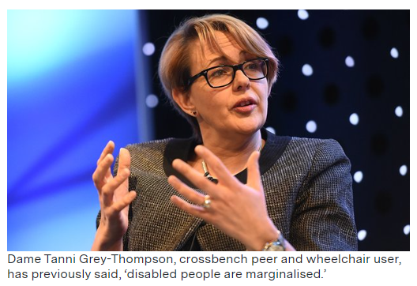
However, according to a report titled “Independent, Confident, Connected” which interviewed 2000 working age disabled people in Britain (Smith and Dixon, 2018) 49% of disabled people feel excluded from society. The results found that 41% do not feel they are respected or valued meanwhile, 42% feel that Britain is a friendly place for the disabled to live. According to Verma (2018) the Equality Act 2010 is to protect disabled people from discrimination and make them feel treated equally and protected from discrimination, however, he suggests that these “formal laws” are one thing but “practical application” is something else. Verma debates whether having these laws are actually enabling disabled people to “enjoy these rights” in their everyday lives. Additionally, according to Verma (2018) prominent paralympic athlete and member of the House of Lords Dame Tanni Grey-Thompson has stated that “disabled people are marginalised”.

LGBTQ+ rights
In the 1950’s, UK police enforced laws preventing sexual behaviour between men. It was recorded by the end of 1954 in England and Wales, that there were 1069 gay men arrested and sent to prison, with an average age of 37 years old. During this period there was also the arrest of Alan Turing, who was a scientist, mathematician, and war time code breaker. He was convicted in 1952 of “gross indecency” after admitting to an intimate relationship with another man (NHS Foundation Trust, 2021). In 1952, the Diagnostic and Statistical Manual of Mental Disorder classified Homosexuality as a mental illness (CITE). It was not until 1992 when the World Health Organisation declassified homosexuality as a mental illness, which was good news for the LGBTQ+ community as homosexuals had previously been asked to get treatment to “cure” their sexuality. In 1988, the Local Government Act 1988 was passed which included in it ‘Section 28’ which prevented schoolteachers from talking about or promoting gay relationships. It was not until 2003 that this law was overturned due to the public arguing that this prevented teachers from discussing homosexual relationships.
https://www.legislation.gov.uk/ukpga/1988/9/section/28/enacted
The UK Parliament in 2013, allowed same sex marriage to be legal in England and Wales due to the passing of the Marriage Act 2013. After the legislation was passed, some religious organisations chose to help with the marrying same sex couples. However, religious organisations can also decline helping same sex couples to get married (UK Parliament, 2022). The Scottish Parliament have also legislated to accept same sex marriage, meanwhile, the Northern Ireland assembly have not legislated the idea of same sex marriage, however they do allow civil partnership which gives couples the same rights as married couples but is non-religious (CITATION).
Add negatives

Race Equality
Acts such as the Race Relations Act 1976 and the Equality Act 2010 protect people from discrimination due to race (Equality Human Rights Commission, 2022). According to the Equality Act 2010 s.9 (1), race could mean, “colour, nationality and ethnic or national origin”. Colour includes “white, black or brown” and nationality, for example, is being a “British, Chinese or Indian citizen”.
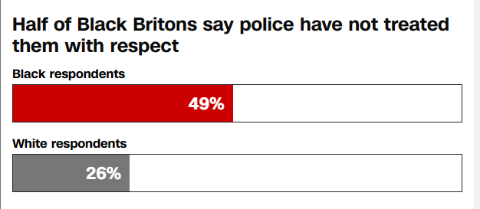
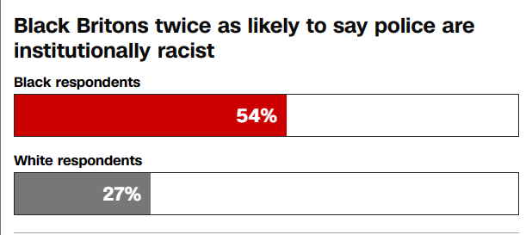
An article from Greene (2020), researched attitudes of the White and Black Asian and Minority Ethnic (BAME) people on a range of issues. When asking Black Britons if they feel respected by UK police, just under half said they did not feel respected and asking the same question to White Britons, around a quarter of them said they did not feel respected.

Another survey in response to the Black Lives Matter protests in the UK, showed........


Lastly, Greene’s (2020) survey also showed that two thirds of black Britons believe that black people are under-represented on TV and in films and the BAME community excluding black people shows 37% of the community agree that there is little representation of black people in films and TV.
The Race Relations Act 1976 covered areas to do with Employment agencies,
Greene (2020)

Areas that the Race Relations Act 1976 covers discrimination against

Give more historical context for Race equality

Conclusion

References
Equality and Human Rights Commission (2022) Disability Discrimination. Available at: https://www.equalityhumanrights.com/en/advice-and-guidance/disability-discrimination (Accessed: 26 February 2023)
Greene. R.A, (2020) Britain’s big race divide. https://edition.cnn.com/interactive/2020/06/europe/britain-racism-cnn-poll-gbr-intl/ (Accessed: 28 February 2023)
Government Equalities Office and Equality and Human Rights Commission (2013) Equality Act 2010: guidance. Available at: https://www.gov.uk/guidance/equality-act-2010-guidance (Accessed: 20 February 2023)
Legislation.gov.uk (2010) Disability Discrimination Act 1995 s.6. Available at: https://www.legislation.gov.uk/ukpga/1995/50/part/II/crossheading/partnerships (Accessed: 19 February 2023)
Lewis. P (2020) Disability Discrimination Act: 1995 and now. Available at: https://lordslibrary.parliament.uk/disability-discrimination-act-1995-and-now/#:~:text=The%20Disability%20Discrimination%20Act%201995,including%20incidents%20of%20civil%20disobedience. (Accessed: 21 February 2023)
NHS Foundation Trust (2021) History of LGBTQ+ rights in the UK. Available at: https://www.candi.nhs.uk/news/history-lgbtq-rights-uk . (Accessed: 26 February 2023)
UK Parliament (2022) The law of marriage. Available at: https://www.parliament.uk/about/living-heritage/transformingsociety/private-lives/relationships/overview/lawofmarriage-/#:~:text=Marriage%20(Same%20Sex%20Couples)%20Act,couples%20in%20England%20and%20Wales. (Accessed: 21 February 2023)
Verma. R (2018) 49% of Disabled People Feel Excluded From Society. Available at: https://eachother.org.uk/49-of-disabled-people-feel-excluded-from-society/#:~:text=It%20found%20that%2041%25%20don,because%20of%20other%20people's%20attitudes. (Accessed: 5 March 2023)
Wadham, Robinson, A., Ruebain, D., & Uppal, S. (2012). Blackstone’s guide to the Equality Act 2010 (2nd ed.). Oxford University Press.

