Jac Beynon
WORK BASED PROJECT LECTURER – DEBORAH HUGHES
WORK BASED PROJECT

Table of Contents
- Proposed Research Title – PAGE 2
- Abstract – PAGE 2
- Research Context – PAGE 2
- Research Questions – PAGE 2-3
- Research Methods – PAGE 3
- Significance of Research – PAGE 3
- Literature Review – PAGE 3 - 5
- Methodology – PAGE 6
- Primary Research Results – PAGE 7 - 11
- Conclusion – PAGE 12
- Personal Reflection – PAGE 12
- Reference Page / Bibliography – PAGE 13

- Proposed Research Title
How has covid-19 had an effect on the construction industry in the UK
- Abstract
This research will seek to better my and the readers understanding on the affects Covid-19 has had on the construction industry in the UK but concentrating mainly on the affects in Wales, I intend on doing this by completing research online and through doing interviews or meetings with professionals in the industry that I have got to connect with through my time in construction, I will also use my own knowledge of the impact covid-19 has had in Wales as having worked through it in the industry I have experienced hands on the effects it has had on businesses and people
- Research Context
I have chosen this topic if research as throughout coronavirus I was involved in the construction industry and had a relatively good idea of the affects it had on people, companies and projects, therefore I would like to know more about the issue which was at hand and research into other affects it might have had on material prices, labour costs and many more.
The research findings will be very beneficial to me as a young professional in the construction industry and will help me gain even more knowledge in the industry and give me the chance to speak only about the issues and how covid-19 still has an effect on us today in the construction industry in Wales and the UK.
I decided to choose a geographical location of Wales as that is the area that I work in for my construction Company Jones Brothers (Henllan) Ltd, and also PBeynon groundworks and Fencing who was my previous employer. I also chose this location as I have seen the affect it has had on local contractors in this area that have had to go into administration due to costs getting increased on everything, which then had a domino effect on projects and sub-contractors that are working with these contractors.
Although I would like to go into detail about the issues that have occurred in the whole industry I am mainly wanting to put my attention into the affect it has had on employees in the industry..
- Research Questions
My main aim of this research proposal is to find out the affect the coronavirus has had on construction industry in the UK, in mostly a negative way but also to see if there has been any positive effects of the pandemic. I have stated that I will research in the ‘UK’ but I will be aiming to concentrate on Wales as that is where I have spent my time during Covid-19, and it is also the only place I have worked in the construction industry therefore I think that I will have the most knowledge in the subject. I Will find this out by completing secondary research on my objectives which will help my identify the affect covid-19 has had on the construction industry in various different areas.
I aim to concentrate on specific areas such as the rise in material prices, employment in principle contractors, I will also be researching into company’s status after the effects of covid-19 have had on them such as going into liquidation / having administrators’ setup as we have seen lately with some big contractors in the south – west Wales area.
My main attention will be on the affect covid-19 has had on employees in Wales and how it has affected their ability to work in Wales to have a good wage and life, I think this is a good topic to look at as I see a lot of people living in Wales but working in England in places such as Bristol, Bath and other south-west cities in England for bigger contractors for a better salary and better career development chances.

- Research Methods
To conduct my research, I will use methods such as interviews with professionals in the industry, online articles and library-based. As this is a fairly modern topic as it is an issue that has come about over the last 3-4 years then interviews and researching online might get me more of the data and information I am looking for.
I also intend on using a questionnaire to gather information and data on the topic, this is a great way of gathering information as it can get to a broad audience of people in the construction industry from management staff to on-site teams, this would make sure there for a range of different opinions and data to review and argue to agree with.
- Significance of Research
Completing research such as 1 on 1 interviews with industry professionals will help me better understand the impacts that covid-19 has had on construction in Wales and how it has declined since covid started in 2019. Topics such as staff shortages is something I would like to look at in more detail, as in why people who live in Wales have chosen to go into England to work over the last few years since covid-19 started, is it better pay? More career development opportunities? This is something I will be looking into by talking to people in the industry who have done the change.
- Literature review
COVID-19 has brought immediate change to many construction companies and their place of work all over the world, but the reason for this literature review is to understand the affects the pandemic had on the UK but most importantly Wales which is where I would like to concentrate my research to where possible.
From the start of COVID-19 to now there has been massive changes in the construction industry in Wales, such as the rise in Material costs, many companies struggling with cash flow problems, also projects being put on hold and delayed due to these issues.
According to (roofing today, 2022) the year-on-year change to May 2022 saw the material prices for new housing in the UK rise by up to 23% for general materials such as timber, masonry and aggregate. There was also an increase in the repair and maintenance sector with material prices there rising by up to 25.5% for the same material. There is very worrying to see as for big main contractors who have tendered for projects pre COVID-19 they would have had to take the increase of material prices on the chin as they might not have had anything in the contract to state if prices increase, they could then forward that cost on to the client.
In an article from (Narwan, A. 2022) it states that as material costs are rising house prices are not increasing in line with the cost of material, this is worrying as it shows that the profit in the house building sector is decreasing as everything is increasing in cost but the prices of houses are not, therefore reducing the return on investment for the contractor.
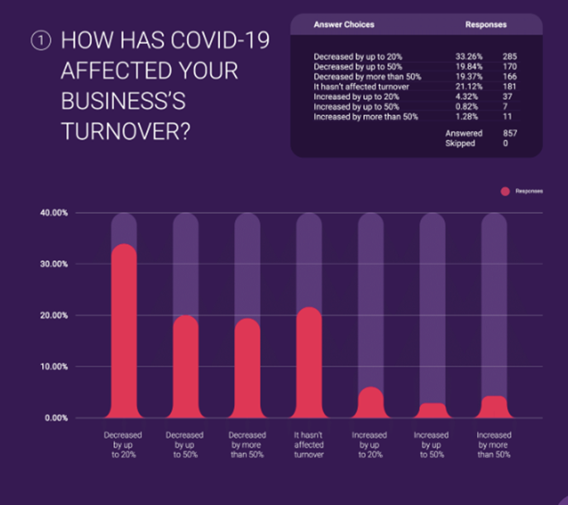
Although in May 2022 we are at the backend of COVID-19 and were no longer having to work from home, social distance or take tests, the affects were still being felt by contractors who have been starting to get back to projects which might have been on stop due to covid-19. An article on the CHAS website by Alex Minett (Minett, A. 2020) states that of the 857 business owners in the construction industry they surveyed 80% said that they had to cancel or postpone projects due to Covid-19, he goes on to say that this is because their supply chain could not operate as many of the suppliers and contractors they used either down scaled during covid-19 to save on running costs or just completely shut down due to their not being enough work or as employees were going on furlough as they were not required by law to come in.

In the same article (Minett, A. 2020) it states that 40% of the 857 had to cease operations at some point during covid-19, this meaning they completely stopped trading for a certain period during COVID-19, this could be down to supply chain issues as previously stated, staff not wanting to work during covid-19 as they did not want to gather the infection, it could also be down to the projects they were working on during COVID-19 as has been stated earlier in the article.
The graph which I obtained from the CHAS website shows the analyse of a question given to the same 857 business people who are in the construction industry.

From analysing the data, you can see that about 75% (643 people) out of the total have seen their turnover decrease 20% - 50%+ from the effects of covid-19.
This is catastrophic for the construction industry as a considerately lot more than 50% of companies asked have seen their turnovers decrease by a major amount.
This can lead to major problems such as making employees redundant as they cannot afford to keep them, losing projects due to not having the money to complete them, all coming from cash-flow problems that have come from covid-19 where companies still had to pay their employees when no work was getting done or limited work was getting done as people were having to social distance, meaning people could not work together encase of infection.
An article I found on Sky News (Narwan, G. 2022) sums up the problems facing construction companies due to decreased turnover and cash flow problems as she states that construction companies are going bust at their fastest rate in a decade, with the highest number of company insolvencies since the financial crisis, this really shows the issues COVID-19 has had on construction companies over the last 2-3 years, these being rising material costs, staff shortages and consumer demand which has decreased heavily over the last couple years as clients don’t have the money to spent on multi-million pound projects.
Figures show that company insolvencies in the second quarter of 2022 were at their highest in Wales, for example JEHU Group, who were a family run construction company based in Swansea who were trading for the best part of 80 years went into administration due to not having the cash reserve in hand to pay back all debtors in order to keep running as a company, in my place of work we have recently had a number of ex-JEHU staff coming to work for us therefore something I would like to do is plan an interview with one or two of them to see their view on how COVID-19 effected the company to end up going insolvent at the backend of 2022 (Narwan, G. 2022)
In the same article (Narwan, G. 2022) it states the cause for most of these insolvencies is the increase in costs but most importantly material costs, as Steel rose by 17% in the year leading to October 2022, concrete blocks which are used on most new construction jobs these days rose by up t0 18% in the same period and timber which is the most used material in the industry rose by up to 19% in Wales, as I said earlier these costs are hard to pass on the clients as they are not wanting to pay the extra fee for the materials, this is one of the main reasons that companies have gone insolvent as they are carrying on to do these projects for little to no profit as it is going towards increased costs, which ends up with them making no profit but still doing the projects as no new works is coming to tender as no one has the funding to do them.
From all companies that are exposed to this issue of going insolvent due to issues facing construction companies due to COVID-19 local small builders are most at risk as they for one do not have economies of scale at their advantage (Narwan, G. 2022).
Moving on from material increases and their affects, there are also many more effects that COVID=19 had on the construction industry, my first point is that new construction work in the UK fell to £100,199 million in 2020, which is down 15.90% from the year before the pandemic first hit us in Wales and the UK (Office for national statistics, 2022), however this quickly rose after our first national lockdown as new orders of construction orders rose 30.50% in 2021, which is the highest level in over 45 years.
Although construction was on the decline during COVID-19 with many projects being put on hold as there was no funding for them to carry on, but for a couple contractors work carried on with more demand than ever as £166 million was spent in Wales on 19 new hospitals to help cope with the demand of people getting infected with covid-19 (GOV.WALES, 2020).
These hospitals brought double the number of beds than they had pre COVID-19 to wales in just under 8 weeks, with stadiums, commercial sheds and new buildings being used to accompany the demand of extra beds, this meaning that some contractors even benefitted from COVID=19 by building these hospitals for the government.
Another big area of construction that was affected during the pandemic was employment. During one of the peaks of the virus in 2020 total employment in the construction industry fell for the first time in 10 years (GILPIN, J. 2020).

- Research Methodology
After completing my literature review there are still a few areas I would more of an insight into which I think would help tell a story of how badly COVID-19 really did affect the construction industry, therefore I will be creating a questionnaire which I will be handing out to different professionals in the industry from groundworks to managing directors of companies so that I can get different views and opinions on the certain topic and hopefully tell me something that I don’t know so I have more data which I can analyse and compare with what I found by using the website and articles in the literature review.
I will create a questionnaire on Survey Monkey and send the link around my place of work and to people I know in the industry that I think will be able to give their opinion on the topic. I will mainly make my questionnaire around the increase in costs that have occurred from covid-19, whilst also getting their opinion on employment during and post covid-19, I can therefore get an overall view of the effects COVID-19 has had.
As far as interviews go I would be interested to interview a couple different people, at the moment I am thinking a Buyer in a main contracting business, this would give me the insight I need to see the price increase materials has had since COVID-19 struck us in Wales, I would also be interested in speaking to my Managing director, or any director in the business that I work for to get their opinion how covid-19 has affected the company not only financially but in terms of how its run and if they have changed their views on the company moving forward and if they had the chance to do something different during covid-19 which would have aided the company positively than what would that be.
If I get the time, I would also like to talk with people in contractors which have had a positive effect from covid-19 coming to Wales, this could include contractors that help build the nightingale hospitals all over Wales to help keep up with the demand for beds during the pandemic, this would help argue against my point as I believe that COVID-19 has had a negative effect on the industry.
By completing questionnaires, I will be doing both quantitative and qualitative research, but this is dependent on the type of questions I ask, as yes/no questions are quantitative, whereas leaving a box for people to write would be classed as qualitative research. By completing interviews, I will be researching in only a qualitative method, this isn’t bad as it would give me a lot of data to analyse, but would make it harder to compare as there is so much to go through, so having a range of both quantitative and qualitative would be the best option for me in my opinion, and would best suit this project. There for I will be completing mixed method research to gather my primary data which I hope to analyse and create an argument with my secondary data that I have already gathered.
If any are available, I will like to look into case studies, but as this is a fairly new topic, I don’t think there would be many out there that would be of use to me for this project but I will give it a look to see what is out there.

- My Research Results
For the first part of my primary research, I decided to create a questionnaire, the questionnaire will hopefully get me the information and data that I could not find whilst doing secondary research on my chosen topic. The questionnaire was capped at 10 responses, this was due to the website I used only allowed me to see 10 responses, if I were to do this again, I would have found a better website to use which would allow me to see more of the responses which would give me a variation in the answers.
The questionnaire was uploaded to my LinkedIn profile where professionals in the construction industry would be able to answer my questions and give me the data that I needed. To ensure that I only got construction professionals to answer my questionnaire the first question on the survey was, what is your job role? I thought this would be the best question to start with as it would allow me to know if their answers would be of any use to me, as if they were not working in the industry then their opinions would be of less important in this instance.
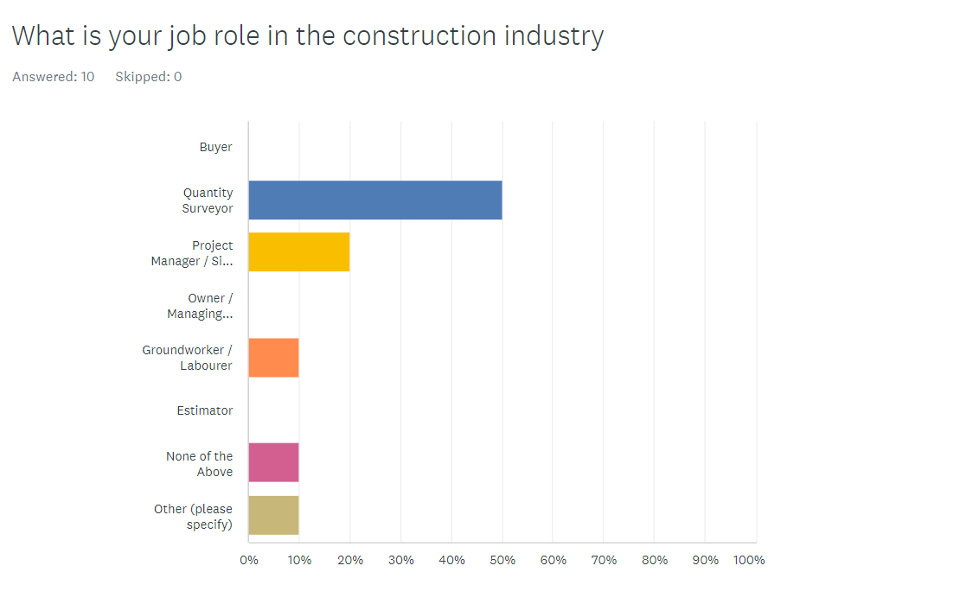
Question 1

Above are the answers to the first question of my questionnaire, I gave the above opinions as possible job roles in the construction is because they work and see construction in many different ways as for example a Quantity Surveyor would work for a main contractor but employees sub-contractors to their projects so they would see how both would have been affected in the industry during COVID-19.
From the results you can see that 50% were quantity surveyors, this was expected for me as my main connections are quantity surveyors as that is my role in the industry. The second highest was project and site managers at 20%, again I would have predicted this before creating the questionnaire as there are many of these in the industry and they would have also seen a big difference during covid-19. We then have groundworker at 10% which I did not expect anyone to answer would I think it would be good to see their opinions on some of the asked questions.
The last 20% came from ‘none of the above’ in which I received no response from but I did receive an answer on the last 10% which was a sales manager, this shows why it was important for me to put this option in here as on the website I used which was survey monkey I would be able to see their answers to the questions which would allow me to leave them out or compare to the answers from construction professionals.
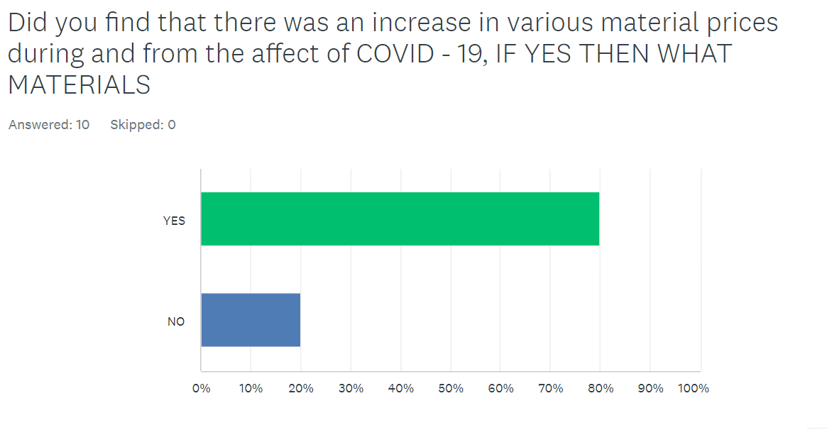
Question 2

Above is my second question of my questionnaire, this was one that I knew I had to ask as I could not find enough on the topic whilst researching online. This is also the answer I was expecting to see as I personally saw that there was a material cost increase from the affects of COVID-19, therefore this did not surprise me that 80% said yes to this question, if I were to be surprised at something it is that the percentage is not higher, I would have expected 90%-100% as I believe it was inevitable that material prices went up.
Question 3
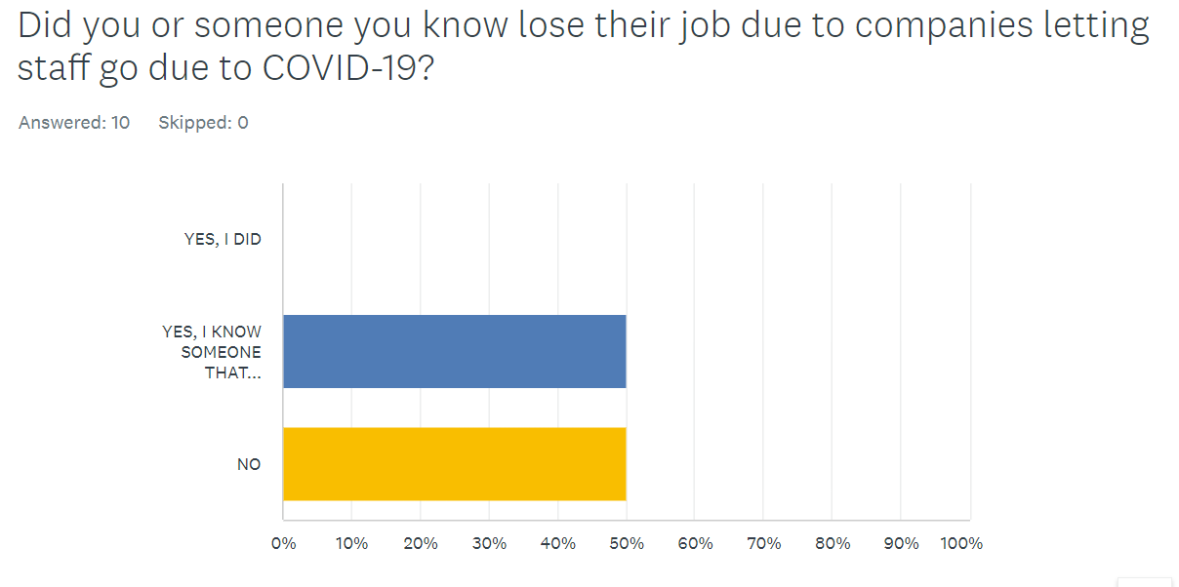

My third question of the survey was the above, this is also a question I knew I had to ask as I could not find enough detail and information on this while doing my research, although I did find that people did lose their jobs and I have stated that, this data helps me prove my point that people indeed did lose their jobs due to the effects of COVID-19.
The data does not surprise me as I would not have said more than 50% of the people that took the survey would have known someone who lost their job due to COVID-19, but it is good data for me to help prove my point that COVID-19 did indeed have an effect on people’s employability during it’s time.
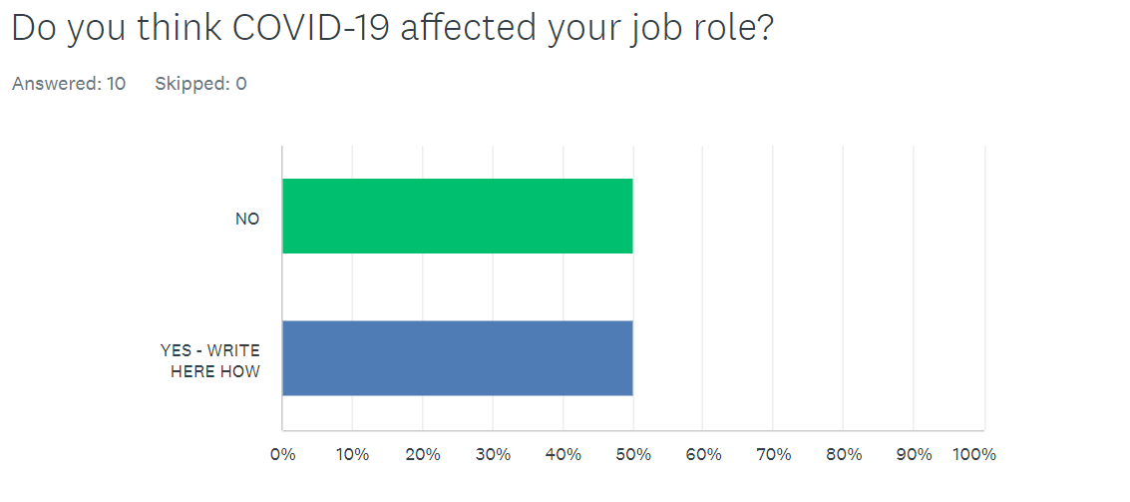
Question 4

The next question was ‘do you think COVID-19 affected your job role?’ as you can see by the responses 50% said that they got affected, this is exactly what I was expecting here. The reason I asked this question was because I would get a variety of different answers which would help me with answering my main aim of this project.

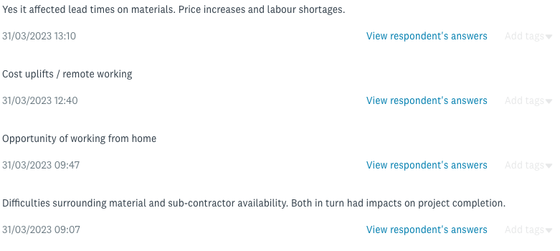
The below image shows the responses I had to question 4 of my questionnaire. The first responses backs up my earlier stated points about material lead time and cost, this was a big issue during and after COVID-19 first started as material could not be shipped or transported worldwide which resulted in contractors having to use locally sourced material, this intern would mean paying more for materials, but it was helping local builders merchants as that’s all that was open and all people could find during such a difficult time in the industry.
The second response reiterates the first point in many ways as they go on about ‘cost uplifts’ which in many ways was the main affect of COVID-19, but the second part of his response along with the third response goes into something that I have not spoken about much, but was also a big effect of COVID-19, remote working / working from home. This can be spoken about either way as some might say it was an advantage of COVID-19 as they would not have to travel to the office instead, they would work from their home, this can also be a disadvantage as many construction companies aid from all their staff being in the office as they would be working as a team, this would be hard to do on teams or zoom.
The last response I got was as you can see regarding difficulty in the procurement of materials and sub-contractors during COVID-19, this point is obviously aimed from a main contractors point of view who in my opinion were some of the worse affected due to having so much money out in projects which clients were not willing to pay due to them being on stop, this saw a number of big contractors go into administration as they could not carry on trading, this is something we are still seeing now due to the long term affects COVID-19 had on contractors, as I have stated earlier the likes of JEHU a welsh national contractor lately went into administration due to cash flow problems which occurred from the affects COVID-19 had on them.
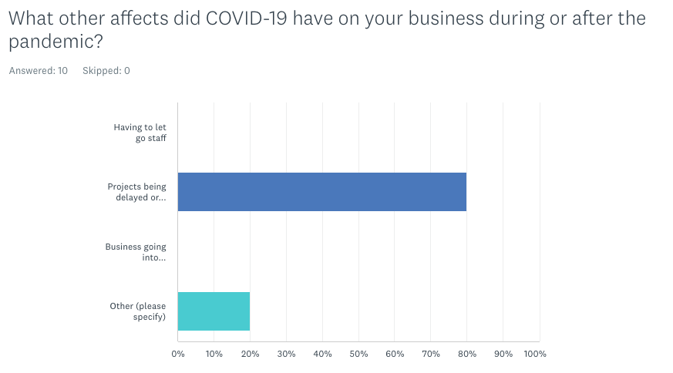
Question 5

To conclude on my questionnaire above is the last question I asked in my questionnaire, this question asked the participants ‘what other affects did COVID-19 have on your business during or after the pandemic?’ I chose 3 options and also a comment box for this as I thought that the 3 options were what I though occurred the most during the pandemic, therefore I was shocked to see that no one had to let staff go as I though this was something that happened a lot during the pandemic as cuts were being made and money was short, but as construction didn’t really stop, I understand how this was something that was not picked on this question.
80% of the people that took my survey said that they witnessed project delays and cancellations due to COVID-19 this is something that I agree with as during COVID-19 a lot of sites were shut down as people could not work as teams instead, they had to work on their own which doesn’t really work on most sites and the ones that did couldn’t have been very profitable as one man doing a task of 2-3 people would take much longer therefore taking the money out of the exercise.
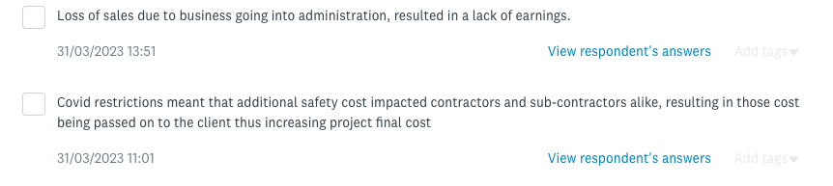
The other option that I thought would have had some response was people seeing companies going into administration, I guess this is right as they did not go into administration during the pandemic, instead companies that did go into administration happened from the effects on COVID-19 which would be months maybe years after.

The fourth and final option for this question was a open response, and above you can see the responses I had from the survey on this question, the first responses was from the sales manager that answered my survey which I did not want to include for this research as most of their responses would not be of any relevance to me, but this I thought I would include as it highlights points which I have stated in this work such as businesses going into administration which leads to a lack of earnings which he has stated in his response. This helps back my points about COVID-19 having a negative effect on the construction industry during as an effect of the pandemic.
To conclude this question the last response has opened a new talking point for me as I have yet to discuss the costs that health and safety has brought to contractors and projects as I did not think this was a big talking point but as it was brought up it surely has had a big effect on the industry.
I do understand the point as during COVID-19 and following the pandemic sites and offices had to get hand sanitiser, office dividing screens, masks and other special PPE that only had to be used as a pandemic had started. This has obviously brought cost implications to contractors and then being passed on to the client as this would not have been accounted for when tendering for the project as a pandemic was far from everyone’s mind 6-12 months before March 2020 when the pandemic began.7

- Conclusion
To conclude upon this research there are many things I have learned within this topic that I did not know before picking this topic, some being the extent that COVID-19 affected business in the construction industry, this is evident in my literature review and then further on in my primary research which helps backs up data and statements which I found whilst doing my research.

- Personal Reflection
As a personal reflection I can see myself doing many things differently if I were to do this again such as use different types of research such as interviews and maybe concentrate my time in different areas of the research. Apart from this I do not believe that I would have done much different in all honesty.

- Reference list
• Gilpin, J. (2022). Brexit & COVID-19 Impact on Construction Workers - Supply2Gov Tenders. [online] www.supply2govtenders.co.uk. Available at: https://www.supply2govtenders.co.uk/brexit-covid-impact-on-construction/.
• GOV.WALES. (2020). How Wales created 19 new field hospitals in less than 8 weeks…. [online] Available at: https://www.gov.wales/how-wales-created-19-new-field-hospitals-less-8-weeks [Accessed 6 Mar. 2023].
• Minett, A. (2020). The Impact of COVID-19 on Construction Businesses. [online] CHAS. Available at: https://www.chas.co.uk/blog/covid-impact-on-construction-industry/#:~:text=80%25%20of%20Businesses%20Cancelled%20or%20Postponed%20Projects&text=Construction%20work%20has%20already%20resumed.
• Narwan, G. (2022). Building firms going bust at fastest rate since financial crisis. [online] Sky News. Available at: https://news.sky.com/story/building-firms-going-bust-at-fastest-rate-since-financial-crisis-12770697 [Accessed 6 Mar. 2023].
• Office for National Statistics (2022). Construction statistics, Great Britain - Office for National Statistics. [online] www.ons.gov.uk. Available at: https://www.ons.gov.uk/businessindustryandtrade/constructionindustry/articles/constructionstatistics/2021.
• roofing today (2022). Construction Material Prices Risen by 27% in Past Year. [online] Roofing Today. Available at: https://roofingtoday.co.uk/construction-material-prices-risen-by-27-in-past-year/#:~:text=Breaking%20the%20increase%20down%2C%20the [Accessed 6 Mar. 2023].

