




























Tesco
Marketing
Plan

Wenxuan Dang (2300603)
Strategic Marketing (BMBM6016)
Lecturer: Gwyneth Jones
Contents
Executive Summary 2
1.0 Introduction 3
2.0 Marketing plan 4
2.1 Situation Analysis 4
2.1.1 Strengths & Opportunities 4
2.1.2 Strengths & Threats 4
2.1.3 Weaknesses & Opportunities 5
2.1.4 Weaknesses & Threats 5
2.2 Objectives 5
2.2.1 SMART 5
2.2.2 Benefits of strategic marketing objectives for Tesco 6
2.3 Strategy 9
2.3.1 Market Penetration 9
2.3.2 Market Development 10
2.3.3 Product Development 11
2.3.4 Diversification 11
2.4 Tactics 12
2.4.1 Product 12
2.4.2 Place 12
2.4.3 Price 13
2.4.4 Promotion 13
2.4.5 People 14
2.4.6 Process 14
2.4.7 Physical Evidence 14
2.5 Actions 15
2.6 Control 15
3.0 Recommendations 17
4.0 Conclusion 18
References 19

Executive Summary
This report uses SMART to detail one of the selected strategic marketing objectives and a detailed marketing plan is constructed using SOSTAC. The strategic part of the plan uses the Ansoff Growth Matrix, the tactical part uses marketing mix decisions, the action part uses a Gantt chart arrangement and finally monitoring and evaluation is carried out in the control part. It is suggested that Tesco has the option of measuring and evaluating the global chocolate market share by using different key indicators.

1.0 Introduction
SOSTAC is a planning model originally developed by PR Smith in the 1990s to help with marketing planning. SOSTAC has six steps - Situation, Objectives, Strategy, Tactics, Actions and Control. Of these, situation means where are we now? Objectives means what do we want to achieve? Strategy means how do we get there? Tactics means how exactly are we going to get there? Actions means what is our plan? Control means did we reach our goal? (Chaffey, 2023). SMART goals are used to help guide goal setting; SMART is an acronym for Specific, Measurable, Achievable, Realistic, and Timely. As such, SMART goals incorporate all of these criteria to help organisations focus their efforts and increase the chances of achieving their goals (CFI, 2023).

2.0 Marketing plan

2.1 Situation Analysis

2.1.1 Strengths & Opportunities
Strength 1: High customer perception of local foods
Opportunity 1: Win more potential customers by adapting product offerings to cater for changing preferences and needs
Adapt product offerings to win more potential customers by capitalising on high customer perceptions.

Advantage 2: Patents that generate additional revenue
Opportunity 2: Finding new expansion opportunities in international markets
Utilise patents to generate additional revenue in international markets.

2.1.2 Strengths & Threats
Advantage 2: Patents that generate additional revenue
Threat 2: Government changes in tax rates, VAT, duties and surcharges can force up product prices
Additional revenue is generated by licensing patents to other manufacturers to stabilise product prices.

Advantage 3: As well as its staff and distribution network is very hard to come by
Threat 5: The threat of new entrants in the retail sector is very high
Tesco's staff and distribution network are very well established and will not be easily threatened by new entrants.

2.1.3 Weaknesses & Opportunities
Disadvantage 1: Tesco's cost structure affects the company's overall profitability
Opportunity 3: Operating in multiple formats
Adjusting the cost structure by using multiple forms of operation to improve overall profitability.

Disadvantage 2: Its patent organisation is not utilising the full potential of these patents
Opportunity 2: Seek new expansion opportunities in international markets
Sell patents to other countries to earn additional revenue for expansion.

2.1.4 Weaknesses & Threats
Weakness 1: Tesco's cost structure affects the overall profitability of the company
Threat 6: Customers also have strong bargaining power
Focus on customer data and adjust cost structure.

2.2 Objectives

2.2.1 SMART
Specific needs to have a clear desired outcome, as SMART objectives are set to achieve specific goals rather than broad objectives. The goal should be clear so that everyone can agree on it, identifying what is to be achieved and the actions that need to be taken to achieve it.Measurable numbers need to be relevant to the goal, and there needs to be a quantifiable goal so that progress can be tracked and performance can be assessed against the goal. The goal should be measured in some objective way, and there is a need to determine what data will be used to measure the goal and to develop a methodology for collecting the data (Leonard & Watts, 2022). A goal should not be completely out of the realm of possibility; it must be realistic in order to maintain enthusiasm for working towards it. Setting great goals is a good option, but they may need to be broken down into many small steps to ensure a steady and error-free achievement step by step. If the goal is not achievable, then it may be necessary to increase resources to give yourself the opportunity to create success. the "A" and "R" in SMART are closely related. In addition to setting achievable goals, you need to set realistic goals. For example, a goal is achievable in the future, but it will take each team member several weeks of overtime to reach it. While this is an achievable goal, it is not realistic, and by having a clear resource management plan in place ensures that the goal is both (Boogaard, 2023). SMART goals should have a deadline. Not having a time limit can lead to project delays, unclear indicators of success, and suffering from scope creep. Deadline setting means that the success of the effort can be evaluated and the next new goal can begin to be set. And deadlines provide a sense of urgency, so short-term tasks don't drag down long-term goals for no reason (Martins, 2024).

2.2.2 Benefits of strategic marketing objectives for Tesco
As an employee in the strategic marketing department, one of the strategic marketing objectives I have chosen is that the international marketing team will increase our share of the global chocolate market from 27.4 per cent to 28.6 per cent in the next 12 months. If this objective is successfully achieved it will bring significant benefits to Tesco. Firstly, the international marketing arm allows Tesco to expand its customer base, resulting in greater profit margins. Also expanding into other countries will help the company to remain solvent in the event of an economic downturn in a country and the company will have the opportunity to sell products or services that are no longer selling well in its home market. An international marketing department can also provide the opportunity to rebrand or enhance a company's brand and reduce competition for its products or services. In addition, international marketing can also bring new sources of finance to the company, making it more profitable (Coursera, 2024). An increase in a company's market share allows the company to operate on a larger scale and increase profitability. It also helps the company to develop its cost advantage over its peer competitors. An increase in market share also helps in increasing the total sales of the company. When consumers focus on the brand loyalty of most of their peers, they compare and find the best brand and buy it, while the rest of the consumers are also driven by the mainstream to buy the product. Increased market share also helps a company expand its customer base. When the majority of the consumer base is loyal to a brand or product, the rest are likely to follow suit. An increase in market share also helps to improve the company's reputation, and a good reputation helps to boost sales and expand the customer base. As market share increases, this company will begin to dominate an industry. With increased dominance of the industry, the company can exercise certain powers, such as having greater bargaining power. The firm begins to gain the upper hand and can negotiate with suppliers and members of the distribution channel to its advantage (CFI, 2023).

Similarly, market growth enables organisations to increase revenue and expand their customer base, leading to greater profitability and long-term success. Growing markets offer higher sales and profit potential giving companies more opportunities to make more money. On the other hand, high growth can also attract new entrants to the market. Market growth also has an impact on competition. Growing markets represent more opportunities to increase revenues and profitability without diverting customers away from competitors, and as the market grows the company can compete for more money (Mehta, 2024). Market growth helps to determine the current and potential status of a product or service in terms of demand. If a product has been in existence for some time but the market growth rate is low, then this means that the product or service is currently at a saturation point or in decline (Nasrudin, 2022). It also helps in identifying the company, its competitors and its position in the market. Companies can use this information to formulate strategies that will help them stay ahead of the competition. The market growth rate helps the company to plan future marketing efforts and make decisions on pricing policies, product development and distribution channels. It can also be used to measure a company's performance in comparison to its competitors. It helps companies understand their position in the industry and make necessary changes to stay competitive (Bhasin, 2023).

Before bringing a new product to market, its effectiveness needs to be established during the product development process, which enables the company to save time and money by adapting the idea to market needs or withdrawing it altogether. The process of new product development is a driver and enabler of new ideas for the business, so developing and nurturing a culture of innovation in the organisation and amongst employees is essential for business growth. As with facing new business, a company needs to properly define its product concept at the start of the new product development lifecycle. It must do this by considering the intended consumer, so the company must describe this product in meaningful consumer terms (SafetyCulture, 2024). Once the final idea is finalised it is necessary to test it and target it according to market conditions. This is done by testing the target consumers through market research practices, which will show the product to the consumers through pictures or written descriptions, but better results can be observed from real physical models (Patil, 2024). After presenting the concept to consumers, the company can ask for responses and engage in product discussions with them, and these suggestions will eventually be used as assets to improve the product and the consumer experience. The new product development process can help a company develop a marketing strategy for its product. Once a company's concept has been designed and tested, it can use the intelligence gathered during the development phase to translate it into a marketing strategy, and then streamline and accelerate the process (Makadia, 2021).

2.3 Strategy
The Ansoff Growth Matrix was developed by H. Igor Ansoff and first published in the Harvard Business Review in 1957 in an article titled "Diversification Strategies." It has provided generations of marketers and business leaders with a quick and easy way to think about growth risks. The matrix shows four strategies that companies can use to grow their business. It also helps you analyse the risks associated with each strategy, which increase each time you move into a new quadrant (horizontal or vertical) (Ansoff, 1957).

2.3.1 Market Penetration
The market penetration strategy is the first quadrant of the Ansoff matrix and has the least risk of the four growth options. It is aimed at companies aiming to find new customers in the same market or sell more products to the existing market and increase market share. It helps them to expand their existing customer base and sell the same products and services to more customers. The main aim of this strategy is to increase the current market share and also market penetration strategy can be implemented when the market is still growing. If the market reaches saturation the company should opt for a different strategy. The market penetration strategy can be implemented by changing the current marketing mix, this can be done by adjusting the pricing strategy, updating promotional efforts, etc (Joshi, 2023). The strategy of increasing market penetration is ideally suited to organisations operating in a large and growing market where their products have a competitive advantage over their competitors. Although the risk and investment are low, this strategy is not sufficient to support ambitious growth plans. Just beyond a point the market can't expand any further because there is a limit to what a company can sell to the same customers without changing its products (Wright, 2022).

2.3.2 Market Development
When an organisation uses its current product and tries to grow into other markets. This could include expanding into other cities, other regions, nationally or even internationally. Whenever an organisation expands from their current market to another market that they don't yet exist in, it is a market development growth strategy regardless of what that new market is. Companies can also target new types of customers in their current market through different market segmentation strategies (Hanlon, 2021). Before implementing a marketing strategy, it is important to make sure that you understand the new customer base. There are a number of ways in which this strategy can be achieved, for example, a company can improve product packaging, restructure distribution channels or expand into new countries or cities. Although the risks are somewhat greater than a market penetration growth strategy, this strategy has a higher chance of success if the company is able to increase production without negatively affecting finances or distribution, and if its products are unique enough to stand out in the new marketplace (Rogers, 2023).

2.3.3 Product Development
Product development strategy centres on creating new and improved products for existing markets. It requires companies to have a deep understanding of current market conditions and customer needs. Based on these factors, a company can add new products to its portfolio. Companies usually expand their product range by investing in research and development. For example, the automotive industry is welcoming self-driving cars as customer needs continue to evolve. With the increase in environmental pollution issues, industry leaders are now focusing on developing self-driving and electric vehicles (Jurevicius, 2024).

2.3.4 Diversification
Diversification is the most risky of the four strategies for firms because it involves untested products in markets where there is no experience. On the one hand, the challenge of creating a new product is all the potential problems that can occur in the process, and on the other hand, developing a new market with little experience, whose characteristics may be very different from the currently known market. Despite the risks, diversification remains attractive and is used by many companies because the rewards of successfully executing the strategy far outweigh the risks. When used well, companies can achieve higher growth and higher returns than the other three conservative options. In the long run, diversified companies can build resilience. For example, changes in geographic location or regulatory norms in a particular market or shifts in customer preferences may affect a market segment or product line, but have a limited impact on the overall revenues of a diversified company (Peterdy, 2023). There are two types of diversification in total, which are related diversification and unrelated diversification. Related diversification is when a company's new product complements what they already produce, or at least exists in the same field. Whereas unrelated diversification is when a company's new product is beyond their known capabilities (Indeed, 2023).

2.4 Tactics

2.4.1 Product
In the early stages of product development, it is extremely important to conduct extensive research on the life cycle of the product being created. All products have their own life cycle that includes a growth phase, a maturity phase and a sales decline phase. Once a product enters the sales decline phase, marketers need to find new ways to increase sales again. When developing the right product, there are a number of issues that need to be considered to ensure that one's product is better than the competition's, i.e. what the customer wants from the product or how, where and why the customer uses the product (Allen, 2023).

2.4.2 Place
In the context of the marketing mix, location refers to the position and distribution of products sold in places accessible to the target audience, which can be high street shops, online shops or by post. In order to ensure that products are positioned in the best locations, it is vital to understand the customer and their shopping habits. Therefore to develop a distribution strategy, a company needs to let its customers know where its products are located, the ways and means by which they can buy them, the benefits of selling online for the company (Hanlon, 2023).

2.4.3 Price
Pricing is an extremely important component of the marketing mix as it determines profits and product costs. Changing the price of a product affects the entire marketing strategy, as well as the sales and demand for the product. As a newcomer to the market, it can be tempting to set the price high, especially if the company knows that its product is good value for money. However, it's not as recognisable or trustworthy because the brand is just starting out may result in target customers being less willing to pay the price to try it out. These situations will slowly improve over time though. Pricing also helps consumers to determine their perception of a product. For example, lower priced products are perceived as less inferior in terms of quality and capability compared to higher priced products (Mailchimp, 2023).

2.4.4 Promotion
Within the marketing mix, promotion is an element that can be used to increase sales and brand awareness through advertising, sales promotion, sales organisation and public relations. When promoting a product, a company can decide on all of the promotional elements mentioned above or simply choose techniques that target the audience more effectively. However, in order to develop a successful product promotion strategy, one needs to know the best time to promote the product, the competitors' strategies, the benefits of using social media to promote the product, the way to send marketing messages to the target audience and the marketing channels that are suitable for promoting the product to the audience. The promotional strategy used by a company also depends on its budget, communication and how it wishes to convey its message and the target market (Focus7, 2018).

2.4.5 People
Another important factor in the marketing mix is people. This includes whether the target audience is large enough and whether there is a large enough demand for the product. Consumers are not the only important people to consider in a marketing strategy, but the people who will be providing the marketing and selling of the product must also be considered. In order to ensure that quality service and marketing is provided, there needs to be people who are fully trained, such as customer service assistants, writers, designers or sales representatives (Brooks, 2023).

2.4.6 Process
As for the processes in the marketing mix, organisational processes can affect the performance of the services offered, including the delivery of products to consumers. As a business, it is vital to ensure that it is easy to do business, which means efficient, helpful and timely. By ensuring that your organisation has good processes in place, not only will you save time and money but you will also increase efficiency and the standard of service provided to your customers will be consistent, which is great for developing brand reputation and customer loyalty (McCabe, 2024).

2.4.7 Physical Evidence
The last in the marketing mix is physical evidence, which refers to everything that customers see or hear when they interact with a company's business. This is not just about the product, but also the brand, the product packaging, the physical space such as the shop, and even the way employees and sales representatives behave and dress. The way the brand is actually portrayed has a big impact on consumers and can lead to either increased or decreased sales (Ridge, 2023).

2.5 Actions
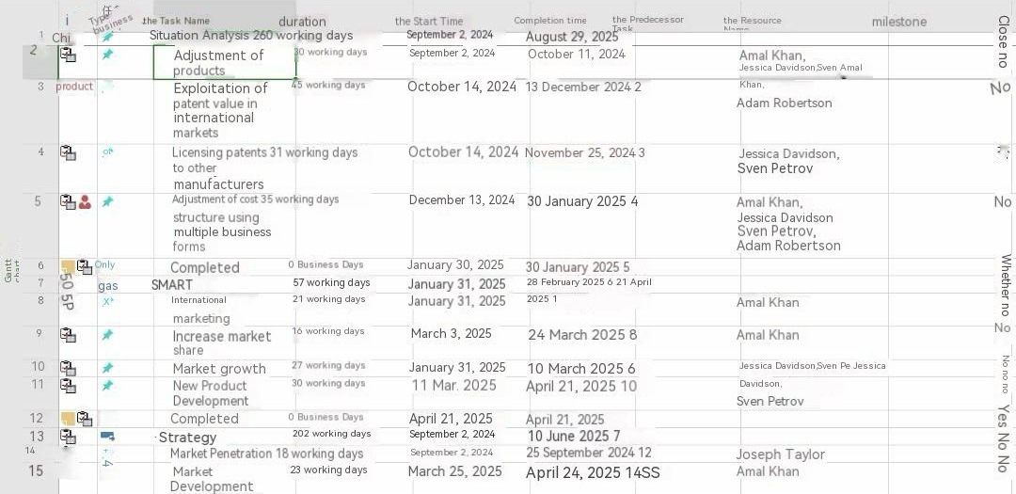
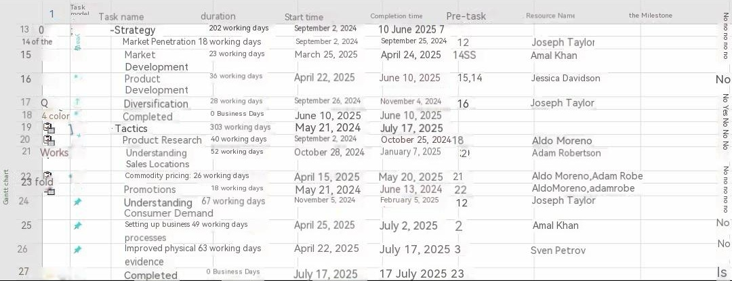

2.6 Control
Key Performance Indicators (KPIs) are quantifiable metrics used to measure the overall long-term performance of a company.KPIs are useful in determining a company's strategic, financial, and operational achievements (Twin, 2024). Once the organisation has identified its KPIs this information should be communicated to employees so that everyone understands the metrics used to measure the performance of the business. KPI performance is continually monitored and evaluated against our chosen strategic marketing objectives, using performance data to measure trends in the global chocolate market share on a monthly basis to determine its development. Any performance gaps are addressed by evaluating and analysing the data collected to identify areas for improvement, corrective action or process improvement (Undru, 2024). By using ThoughtSpot's monitoring feature, we can be notified when a KPI meets a specific threshold condition, or we can set up KPI notifications on an hourly, daily, weekly, or monthly basis.

3.0 Recommendations
Tesco can choose to measure and evaluate the global chocolate market share by using different key metrics such as ROI, market share, customer lifetime value, cost per acquisition, cost per lead, click-through rate and so on. Once all these data are available, the ones that best fit this strategic marketing objective are selected for in-depth monitoring and evaluation to get the final results.

4.0 Conclusion
Using SOSTAC and SMART a detailed plan was developed to achieve the strategic marketing objective chosen by the staff. This objective was analysed in SMART to obtain results that Tesco could benefit from, including profits generated by the international marketing department, increased market share, emergence of new consumers, market growth and new product development. The Ansoff Growth Matrix analyses the risks associated with each of the four strategies, the marketing mix illustrates the methodology for achieving the objective, and then a Gantt chart is used to organise the responsibilities of the employees within the timeframe. Finally, KPIs are used to monitor and evaluate the results. It is suggested that Tesco may choose to measure and evaluate the global chocolate market share by using different KPIs.

References
- Chaffey, D. (2023) Sostac Marketing Planning Model Guide. [online] Smart Insights. Available at: https://www.smartinsights.com/digital-marketing-strategy/sostac-model/ (Accessed: 09 May 2024)
- CFI (2023) Smart goals. [online] Corporate Finance Institute. Available at: https://corporatefinanceinstitute.com/resources/management/smart-goal/ (Accessed: 09 May 2024)
- Leonard, K. and Watts, R. (2022) The Ultimate Guide to S.M.A.R.T. goals. [online] Forbes. Available at: https://www.forbes.com/advisor/business/smart-goals/ (Accessed: 04 May 2024)
- Boogaard, K. (2023) How to write smart goals (with examples). [online] Work Life by Atlassian. Available at: https://www.atlassian.com/blog/productivity/how-to-write-smart-goals (Accessed: 04 May 2024)
- Martins, J. (2024) Set-and achieve-smart-er goals [2024]. [online] Asana. Available at: https://asana.com/resources/smart-goals (Accessed: 04 May 2024)
- Coursera (2024) International Marketing: Career Guide (2024). [online] Coursera. Available at: https://www.coursera.org/articles/international-marketing (Accessed: 04 May 2024)
- CFI (2023) Market share. [online] Corporate Finance Institute. Available at: https://corporatefinanceinstitute.com/resources/economics/market-share/#:~:text=Impact%20of%20Market%20Share%201%201.%20Economies%20of,industry%20...%206%206.%20Increased%20bargaining%20power%20 (Accessed: 04 May 2024)
- Mehta, K. (2024) Market growth - what is it, formula, examples, how to calculate? [online] WallStreetMojo. Available at: https://www.wallstreetmojo.com/market-growth/ (Accessed: 05 May 2024)
- Nasrudin, A. (2022) Market growth: Meaning, importance, influencing factors. [online] Penpoin. Available at: https://penpoin.com/market-growth/ (Accessed: 05 May 2024)
- Bhasin, H. (2023) Market growth: Definition, types, calculation & examples. [online] Marketing91. Available at: https://www.marketing91.com/market-growth/ (Accessed: 05 May 2024)
- SafetyCulture (2024) New product development: An in-depth guide. [online] SafetyCulture. Available at: https://safetyculture.com/topics/product-development/new-product-development/ (Accessed: 05 May 2024)
- Patil, G. (2024) What is new product development? know all the benefits. [online] Ideausher. Available at: https://ideausher.com/blog/new-product-development/ (Accessed: 05 May 2024)
- Makadia, M. (2021) Mitul Makadia. [online] CustomerThink. Available at: https://customerthink.com/top-5-benefits-of-new-product-development-process-for-businesses/#:~:text=Top%205%20Benefits%20of%20New%20Product%20Development%20Process,Concept%20Testing%20...%205%205.%20Marketing%20Strategy%20 (Accessed: 05 May 2024)
- Ansoff, H. (1957) 'Strategies for Diversification,' Harvard Business Review, Volume 35, Issue 5, October 1957. (Accessed: 06 May 2024)
- Joshi, S. (2023) Ansoff Matrix: Growth Strategies, Challenges & Benefits. [online] G2. Available at: https://www.g2.com/articles/ansoff-matrix (Accessed: 06 May 2024)
- Wright, T. (2022) The Ansoff Matrix: 4 growth strategies explained (with examples). [online] Strategy Software for Planning & Execution. Available at: https://www.cascade.app/blog/the-ansoff-matrix-helps-organizations-grow (Accessed: 06 May 2024)
- Hanlon, A. (2021) The Ansoff model [marketing strategy matrix]. [online] Smart Insights. Available at: https://www.smartinsights.com/marketing-planning/create-a-marketing-plan/ansoff-model/ (Accessed: 06 May 2024)
- Rogers, P. (2023) The Ansoff Matrix: Comprehensive Overview with examples. [online] LogRocket Blog. Available at: https://blog.logrocket.com/product-management/the-ansoff-matrix-comprehensive-overview-examples/ (Accessed: 06 May 2024)
- Jurevicius, O. (2024) Ansoff matrix explained - SM insight. [online] Strategic Management Insight. Available at: https://strategicmanagementinsight.com/tools/ansoff-matrix/ (Accessed: 06 May 2024)
- Peterdy, K. (2023) Ansoff matrix. [online] Corporate Finance Institute. Available at: https://corporatefinanceinstitute.com/resources/management/ansoff-matrix/ (Accessed: 06 May 2024)
- Indeed (2023) Ansoff matrix: Definition, strategies and how to use | indeed.com. [online] Indeed. Available at: https://www.indeed.com/career-advice/career-development/ansoff-matrix (Accessed: 06 May 2024)
- Allen, A. (2023) Understanding the 7PS of the marketing mix. [online] Oxford College of Marketing Blog. Available at: https://blog.oxfordcollegeofmarketing.com/2020/10/08/understanding-the-7ps-of-the-marketing-mix/ (Accessed: 07 May 2024)
- Hanlon, A. (2023) How to use the 7PS marketing mix strategy model? [online] Smart Insights. Available at: https://www.smartinsights.com/marketing-planning/marketing-models/how-to-use-the-7ps-marketing-mix/ (Accessed: 07 May 2024)
- Mailchimp (2023) Marketing mix and the 7 PS of Marketing. [online] Mailchimp. Available at: https://mailchimp.com/marketing-glossary/marketing-mix-7ps/ (Accessed: 07 May 2024)
- Focus7 (2018) Marketing mix process - understanding the 7PS of a marketing mix. [online] Focus7. Available at: https://focus7international.com/2018/05/29/understanding-the-7ps-of-a-marketing-mix/ (Accessed: 07 May 2024)
- Brooks, A. (2023) The marketing mix: Building a strategy with the 7ps. [online] Venture Harbour. Available at: https://www.ventureharbour.com/marketing-mix/ (Accessed: 07 May 2024)
- McCabe, A. (2024) The 7PS of the marketing mix: Streamline your strategy. [online] Hurree’s Marketing Blog. Available at: https://blog.hurree.co/marketing-mix-7ps (Accessed: 07 May 2024)
- Ridge, B.V. (2023) Understanding the 7P marketing mix: A comprehensive guide to enhancing your marketing strategy. [online] MEDIUM Multimedia Agencia de Marketing Digital. Available at: https://www.mediummultimedia.com/en/marketing-usa/what-is-the-7p-marketing-mix/ (Accessed: 07 May 2024)
- Twin, A. (2024) Kpis: What are key performance indicators? types and examples. [online] Investopedia. Available at: https://www.investopedia.com/terms/k/kpi.asp (Accessed: 08 May 2024)
- Undru, A. (2024) What is a key performance indicator (KPI)? A detailed guide. [online] ThoughtSpot. Available at: https://www.thoughtspot.com/data-trends/kpi/what-is-a-kpi (Accessed: 08 May 2024)

