

Student name:Mabinty Kamara
Student ID: 2327089
Module name: Changemakers: Building your Personal Brand for Sustainable Employment
Module code: BMHP5015
Lecturer Brian Mashumba

Table of Contents
INTRODUCTION 3
JOB DESCRIPTION 3
ANALYSIS OF THE SKILLS NEEDED FOR THE JOB 5
DEVELOPMENT OF PERSONAL SKILLS AND RESOURCES 5
ACTION PLAN AND TIMELINE 6
Five-Year Action Plan Timeline 7
COMMUNICATION OF SKILLS TO POTENTIAL EMPLOYERS 8
CONCLUSION 8
REFERENCES 9

INTRODUCTION
Establishing a solid professional identity and fostering the employability skills needed in a particular position are critical steps to gaining meaningful employment in the UK health and social care sector. This report addresses the case of a Children Social Worker specifically in the services provided to children with disabilities. The profession is crucial in preserving vulnerable children, as well as supporting their wellbeing, and collaborating with families, schools, and other multi-agency partners to make sure that every child has access to safe, person-centred, and inclusive support. Being a career pathway that supports my personal values of empathy, resilience, cultural sensitivity and service to others, the role is a logical continuation of my academic knowledge and future goals.
This report has threefold purposes. First, it will examine the personal employability skills I need to have to be a good practice Children Social Worker in UK. This involves research on job description, person specification and behavioural competencies that are highlighted in existing vacancies in local authorities. Secondly, the report will analyze my skills, strengths, areas of improvement, and the tools that I have applied to analyze my abilities, including reflective models and feedback. Such self-reflection will allow detecting the gaps between my current knowledge and experience and those expected of a professional. Third, the report will include a structured plan of action and a plan of action detailing the steps that I will undertake to acquire the skills, qualifications, and professional networks needed to secure this position.
The report will also show how I can create a powerful personal brand, foster my professional identity, and create a supportive professional network that can increase my employability. These factors, in combination, will demonstrate an understandable, realistic, and strategic course of becoming a competent and confident Children Social Worker, able to make positive contributions to the lives of children living with disabilities and their families.

JOB DESCRIPTION
The job that I have chosen is Children Social worker in the Children and Families services of a local authority in the UK. The job was gotten from an advert by the Gloucestershire County Council that called out the position of Children and Families Senior Social Worker / Social Worker (Children social care) who is expected to work full-time and on a permanent basis with caseload of children in need, children looked after and children at risk. (Gloucestershire.gov.uk, 2025)
The work as a Children Social Worker on the advert is diverse with the responsibility of managing a mixed case-load and carrying out statutory assessments (where needed, child protection, looked-after children), drafting and executing care and support plans, and collaborating with multi-agency partners such as schools, health services, and family carers to protect children and enhance welfare. It is also necessary to have effective case-recording, report preparation, legal documentation and even represent the agency in court proceedings where necessary. (Gloucestershire.gov.uk, 2025)
Along with a technical role, the person specification also focuses on a recognized social work qualification, registration under the controlling body Social Work England, an improved DBS clearance, in many cases driving license and travel, and individual attributes (empathy, resilience, cultural competence, emotional maturity, excellent communication skills, both verbal and written). There is also the need to work under pressure, manage caseloads, protect commitment and act in multi-agency partnerships. (Gloucestershire.gov.uk, 2025)
This role fits very well with my personal ambitions, values, and maturing professional identity. The role was well suited to my interests in working with children, particularly those with disabilities, my focus on empathy, communication, cultural sensitivity, and reflective practice, among other factors. Additionally, the focus on the role, which is on safeguarding, multi-agency work, and ongoing professional growth appeals to my long-term vision of developing a meaningful, ethical career in health and social care. (Gloucestershire.gov.uk, 2025)
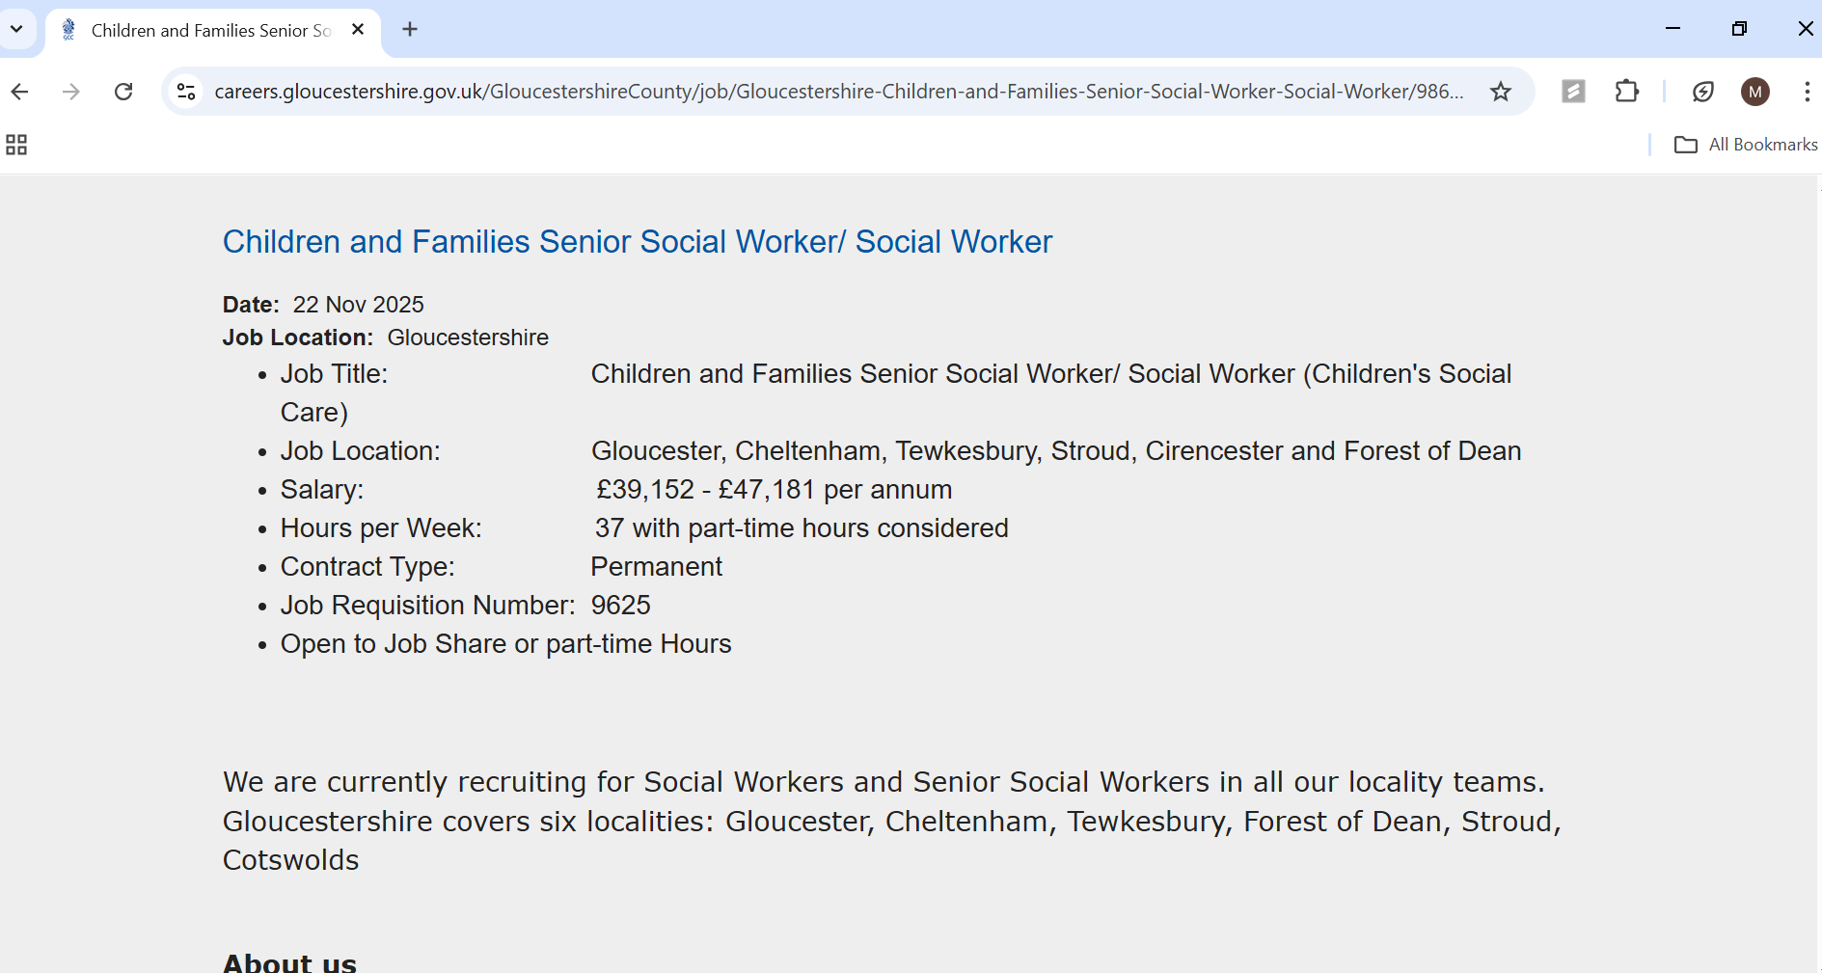
(Gloucestershire.gov.uk, 2025)

ANALYSIS OF THE SKILLS NEEDED FOR THE JOB
The role of Children Social Worker demands professional, interpersonal and organisational skills. There are key competencies listed in the job description created by the Gloucestershire County Council, such as strong communication, empathy, resilience, knowledge safeguarding, case management, report writing, digital literacy, and working under pressure (Gloucestershire County Council, 2025). Cultural competence, reflective practice, teamwork, and devotion to the ongoing development of professionalism were also noted in the person specification.
Considering my personal abilities, I have a number of strengths that can match these requirements. My university education and Changemakers module have enabled me to achieve a good level of self-awareness, communication, and empathy. The Johari Window exercise made me realize that communication and empathy are my main strengths, and the ability to solve strategic problems under pressure is one of the areas that I need to work on. I also enhanced my skill to make thoughtful decisions and handle emotions when learnt about cognitive biases and emotional intelligence, which are essential in safeguarding and risk assessment. Additionally, the discussions of cultural competence in the Changemakers module has made me more mindful of diversity, inclusion, and person-centred care as the key aspects when providing services to children with disabilities and families with varied backgrounds.
With regards to experience, I have undertaken academic modules associated with health and social care, took part in online-based forums where real cases scenario analysis including mental health in schools and domestic-violence interventions have been conducted, and performed reflective practice exercises based on some models, such as Gibbs Reflective Cycle. The experiences have enhanced my critical thinking, cultural awareness and communication. Even though I am not a qualified social worker yet, my high values, emerging professional orientation, and dedication towards learning make me well-placed to develop. In order to further evaluate and sharpen my competence, I can keep on getting feedbacks provided by tutors, supervisors, and the seniors social workers. University career services, mentors and voluntary organisations may also help me in acquiring the practical skills, training and exposure to help me move towards being a competent Children Social Worker.

DEVELOPMENT OF PERSONAL SKILLS AND RESOURCES
My personal brand as a future Children Social Worker would be to establish myself as a compassionate, thoughtful, and culturally sensitive practitioner who can commit to protecting and empowering children with disabilities. A powerful personal brand involves ensuring that I am well aware of my values and strengths and the professional image I wish to convey. Skills for Care (2022) notes that social care professionals should be emphatic, reliable, and effective communicators, which I have already recognized as my personal strengths using such reflective instruments as the Johari Window and the Gibbs Reflective Cycle . To support my brand, I would create a professional online presence in LinkedIn, ensure that I have a polished CV and a digital portfolio of my reflections, training and learning experiences.
My unusual selling point is that I am passionately interested and personally connected to supporting children with disabilities and advocating their wellbeing, inclusion, and equal opportunities. My passion is to make sure that no child, irrespective of his or her ability, feels undermined, unheard, or unsupported. The given passion inspires me to approach children with patience, empathy, and creativity so that I could develop trusting relationships and adjust my communication style to meet the individual needs of the child. My reflective and cultural sensitivity also enable me to approach other families with respect and work well with them despite their differences so that care plans can be person-centred and empowering. The ability to dedicate myself deeply to patient care and the building of my professional skills will make me a caring, trustworthy, and child-centered future practitioner who will do anything to leave a lasting impact on the life of a child with disabilities.
To achieve the entire spectrum of skills necessary to perform this role, I will have to make investment in additional education, experience and specific training. This involves the completion of a recognized degree in Social Work, the accomplishment of training on safeguarding and child protection and the practical learning approach through volunteering work with children organizations and agencies like Barnardo or local disability support agencies. Participating in CPD workshops, and becoming members of professional bodies, and having a mentor who would be successful social workers, will also contribute to my professional identity and employability. These will facilitate my growth as a Children Social Worker through attainment of confidence, competence, and credibility.

ACTION PLAN AND TIMELINE
An action plan serves as a step-by-step guideline of what a person expects to accomplish within a certain goal, giving a sense of direction and clarity (Hari S, 2025). In order to gain all the skills and competencies necessary to become a Children social workers, I have prepared a five-year action plan that will help me to realize the important steps I should follow. This involves acquiring recognised qualifications, gaining work experience as an employee in the field of working with children with disabilities, work on my own personal branding, and work on the core employability attributes like communication, safeguarding, and reflexive practice. Professional development is a key concept in social care as it is the only way to keep practitioners competent and abreast of policy changes, legislation, and changes in the best practice standards (Health and Care Professions Council, 2021). As well, early engagement in voluntary work contributes to the development of confidence in real-life and enhances professional identity in health and social care environments (Skills for Care, 2022). The table below outlines my action plan for becoming a Children’s Social Worker

Five-Year Action Plan Timeline
Tineframe | Action steps | Expected Outcome
Year 1 | - Enroll in a recognised degree in Social Work (BA/MA).  - Start volunteering in a children disability organisation.  - Get total basic safeguarding and child protection training.  - Improve my LinkedIn profile and CV.  - Find a mentor who is a very skilled social worker.  - Start developing an online professional profile. | Develop preliminary credentials and develop personal brand.
Year 2 | - Begin working with children and families either part-time or full-time.  - Acquire skill in report writing and case recording  - Undergo autism awareness training, Attention Deficit Hyperactivity Disorder training and behaviour support training. | Gain experience in the field and enhance expert knowledge.
Year 3 | - Accept greater responsibility in placement positions.  - Go through advanced safeguarding courses to the full. | Gain confidence and case management skills.
Year 4 | - Join Social Work England upon finishing my degree.  - Apply as Children Social Worker.  - Engage in frequent supervision and reflection. | Professional practice transition.
Year 5 | Continuing Professional Development in disability social work or trauma-informed practice.  - Strengthen relationships by organizing events and training.. | Enhance the professionalism and strengthen the expertise

COMMUNICATION OF SKILLS TO POTENTIAL EMPLOYERS
Communication is one of the essential skills that must be acquired to get a job. (Blue, 2023) To successfully get a job as a Children Social Worker, I will present my competencies in a number of career platforms, such as a written resume, a properly organized LinkedIn page, and a portfolio on the Internet. In my CV, it will be obvious that I have qualifications, I engaged in social care training, and I intend to continue my professional growth since employers in the social care field appreciate clarity, relevance, and signs of reflective practice (Skills for Care, 2022). I will also highlight my interest in working with children with disabilities, my communication skills, my ability to empathise and be resilient.
I will use my LinkedIn account as a virtual expansion of my personal brand. I will also have a professional summary, information on my education, experience in placements, Continuing Professional Development activities, and mentor or supervisor recommendations. It is well known that LinkedIn is a valuable means of networking and presenting professional identity, particularly in professions that involve a practice of collaboration and multidisciplinarity (LinkedIn, 2023). Sharing reflections, achievements, and interactions with social care topics will contribute to proving my dedication to evidence-based practice and inclusive service delivery. I will also develop a basic digital portfolio where I could post reflections. This site will enable potential employers to observe viable evidence of my development, studying, and readiness of the position.
All these communication tools will assist me in projecting a powerful, believable and professional image that will be in tandem with what employers require of me in the health and social care industry.

CONCLUSION
Overall, this report has examined my desire to be a Children Social Worker and the actions that must be undertaken to reach my desired destination. I evaluated my own strengths, weaknesses, and related experiences and analysed the major employability skills that are described in the job description. I also considered the way in which I will establish a robust personal brand, express my professional identity, and show my interest in helping children with disabilities. Additionally, I have come up with a detailed five-year action plan that defines the qualifications, training, and practical work I should obtain. With this plan, continuous development, and effectively conveying my skills to employers, I believe that I will be able to advance to this fulfilling and valuable job.

REFERENCES
Blue, J. (2023). Employability Skills: Communication | Cambridge. [online] World of Better Learning | Cambridge University Press. Available at: https://www.cambridge.org/elt/blog/2023/02/22/strongemployability-skills-communication-strong/.
‌Gloucestershire.gov.uk. (2025). Children and Families Senior Social Worker/ Social Worker. [online] Available at: https://careers.gloucestershire.gov.uk/GloucestershireCounty/job/Gloucestershire-Children-and-Families-Senior-Social-Worker-Social-Worker/986412855/ [Accessed 29 Oct. 2025].
Hari S (2025). Employee action plan example: Explanation, components, and best practices. [online] CultureMonkey. Available at: https://www.culturemonkey.io/employee-engagement/employee-action-plan-example/.
‌Health and Care Professions Council (HCPC) (2021) Continuing professional development and your registration. Available at: https://www.hcpc-uk.org/
(Accessed: 1 November 2025).
LinkedIn (2023) Professional networking and career development. Available at: https://www.linkedin.com
(Accessed: 2 September 2025).
Skills for Care (2022) Core skills and knowledge for social care workers. Available at: https://www.skillsforcare.org.uk/
(Accessed: 12 November 2025).
Skills for Care (2023). Skills for Care - Home. [online] Skillsforcare.org.uk. Available at: https://www.skillsforcare.org.uk/Home.aspx.
‌
‌

