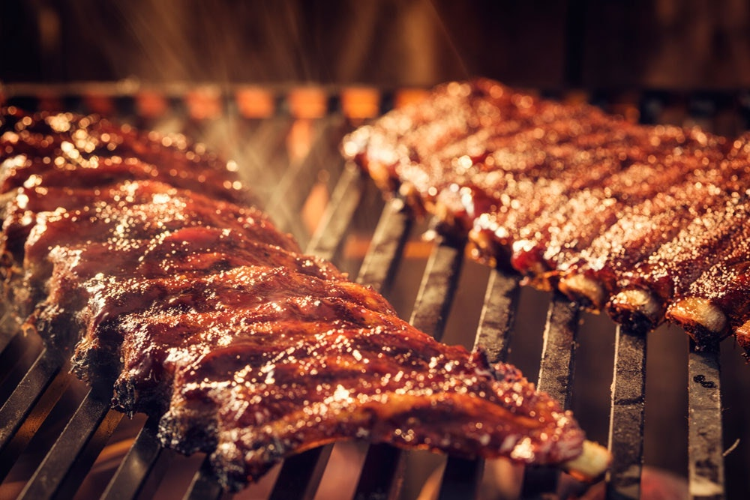  Steak by the table  Physical resources | Student:  Camelia-Florina Ungureanu (1816236)

Table of Contents
Introduction 2
1.Physical resources 3
2.Steak by the table 4
2.1 Management information systems 5
2.2 Key skills : IT 6
3. Swot analysis 7
Appendix: 8
References: 10

Introduction

Steak by the table wants to be a restaurant that through the services it will offer to change the image about restaurants in Wales, by the appearance of one more "different" than the other restaurants. The main purpose of the business is to succeed in attracting a loyal clientele, and especially special ones, even if it requires time and high investments. This restaurant should be a select restaurant by itself, select by what it offers, by its atmosphere, by its customers.
The activity aimed at establishing the company is in the tertiary sector respectively services, materialized in the opening of a restaurant with specific British and not only. The dishes offered, as mentioned, will generally have specific British without being exclusive. Other selections of selected cuisine, especially by quality, aroma and flavor will be considered. The quality, the presentation of the dishes, the service and the kindness of the staff and not least the location will be the strengths of this restaurant.
At the local level, there are no possibilities for expansion, and neither will this be followed. In Swansea the company will have only one restaurant to ensure the exclusivity and uniqueness of the service. Another reason for this option is the relatively small size of the market segment to which the offer is addressed. They will only try to improve as much as possible the services, the menus, equipping with new equipment, equipment (new annexes for the bar) if all these investments lead to the increase of the labor productivity, reduce energy consumption, leading to increased profit.

1.Physical resources

Physical resources may be more or less crucial depending on the nature of the industry. Physical resources typically require a significant outlay of capital.
The resources of the company are materialized in the material, financial, human and informational potential that it has at a given moment and are represented by:
Physical resources: Represents the physical components of the capital of an enterprise, which include buildings, machinery and production equipment, raw materials and energy resources. Every business need resources, whether it's people, money, suppliers, or time. The physical resources include tangible items that are necessary and available for a business to function.
In addition to physical resources or assets, a business also has intangible resources, human resources and financial resources. Intangible resources include a company's goodwill, reputation, brands and intellectual property. Human resources include the knowledge and skills of a company's workforce, and financial resources include cash assets and credit lines.
Physical resources are tangible items that are used in the operation of the business. Some of the resources are used to operate the business or provide products and services. Some of the most common physical resources include raw materials, buildings and facilities, machinery, energy, and supplies. Physical resources can be sold if a business is facing a cash flow issue.
Physical resources may encompass a wide variety of specific items and objects depending on the nature of the business.
- Land, buildings, water and water rights
- Machinery and manufacturing equipment
- Vehicles and distribution networks
- IT equipment and hardware
- Point-of-sale systems

These are items that take space, have a value, and are used in the operation of the company. Physical resources are necessary for all types of business. Product-based businesses use physical resources for providing the goods for sale and for the operation of the business. Service-based businesses use physical resources to facilitate the delivery of the service, such as having a space to work, tools that are needed for the service, and resources used to support the service.

2.Steak by the table
Physical resources

,,Steak by the table’’ is a company whose main activity is in the tertiary sector respectively a restaurant. This restaurant will open in Swansea and will offer services of a high quality that those of competing restaurants.
The location of the restaurant will be Gower Road, Swansea West Glamorgan SA27AA and is provided with a large kitchen, two dining’s rooms, toilet and storage room. Outside the building is provided with a children playground and private parking with 15 parking spaces. for the safety of the clients and the material goods, the building is provided with surveillance cameras both in front of the building, inside and also in the back.
The children's playground is located on the right side of the building and it contains: a plastic slide, two swings for babies, a swing for children over 3 years and a rocker. The building was already provided with this playground, so no additional expenses were required.
For the playground, a person was hired to create activities for the clients' children so that they could eat quietly. The employer will ensure, as far as is reasonably practicable, the health and safety children at playground. The employer has a health and safety policy and arrangements to implement it.
In the storage room will be deposited products like: carbonated and natural drinks, alcoholic drinks, toilet paper soaps, cleaning sprays, bleach, washing solution, paper rolls, towels, forks, knives, spoons, bags, kitchen sponges, dishwasher clothes detergents.
This location will be rented for a sum of 1500 ponds/month with a deposit of 3000 ponds. The rent money is shared between the four investors.
The advantages of renting the location is that in case of any problem, the investors have the owner’s guarantee that he will repair everything that belongs to the building at no additional cost such as: flooding the restaurant, toilets damages , dampening the walls, breaking the roof, breaking the floor or ceiling.
The disadvantages of this property are that it comes without furniture in dinning rooms and without cooking equipment in the kitchen which means that additional costs will be required
The kitchen must be provided with two grills, 2 hoods, an electric hob, an oven, a sin, two fryers, two refrigerators, and a dishwasher. For the first dining room it is necessary to have 3 tables for 10 people, 4 tables for 4-6 people, and 6 tables for 2 people. In In the second dining room it is necessary to have 6 tables with grill and hood incorporated. All these will be purchased through Forest Contracts,, Buy now pay later’’ program, and will be paid within 6 months of their purchase. All these equipment’s will meet the health and safety standards and food hygiene regulations, and they are modern enough to produce the testiest preparations in a very short time.
This location it was chosen because it is located in a popular area, has view at the sea, the rent is small compared with another locations and because is provided with private parking.
Because the main method of serving will be at the table, the restaurant doesn’t offer take a way services, which means that no extra expenses will be needed.
At the restaurant atmosphere, one of the attraction points will be the interior design distinguished by the special furniture and the decoration mode. Another characteristic of the business will be the service staff which is evidenced by their behavior outfit and ,, etiquette’’. The proposed menu will be varied, including all the dishes offered by the directly competing restaurants.
The prices charged will be similar to those of the competitors. What will distinguish the menu will be, house specialties ‘’. They will contain natural ingredients and the best quality.
The restaurant is divided into two dining rooms:
In the first dining room the order is made from the table , based on the menu and send it through the iPod straight in the kitchen or, at the customer's request, the order is taken by the restaurant staff and the estimated waiting time for an order is 20-25 minutes.
In the second dining room according to the client's requirements he can cook his own stick directly to the table or, in front of him a chef can cook the steak according to his preferences. This method of serving the steak is the only one in Wales and is expected to have a great impact on customers.
Because all the food is fresh and will be cooked at the customers request at the table, the estimated waiting time for an order is 30 minutes. But for the house specialties like, Trio of lamb ‘’ the estimated time is the 40 minutes. The customer will be notified about this waiting time when they place the order, to avoid subsequent complains.
All this will lead to the formation of a positive image of restaurant resulting in the gain of a loyal if not frequent clients, willing to spend to receive a differentiated service.

2.1 Management information systems

The main suppliers of the restaurant are in the immediate vicinity. The supplies will be made with their own means of transport to obtain time savings and financial resources.
The management of the restaurant will be provided by a manager who will manage the company and will present a regular activity report.
The management of the stocks and their control will be carried out by one of the owners in collaboration with the restaurant manager. It will ensure as far as possible an optimum supply with raw materials and diminution of the stocks to a level hat used the process: ,,Just in time ‘’ the arrival of the stocks is made at the right time and in the quantities strictly necessary. Another reason for applying the JUST IN TIME method is given by the nature of the stocks formed mainly by perishable products that have a guarantee term limited to 3-7 days and maximum 24 hours for vegetables and fruits. For some products (spices) the stocks may be higher. In the case of expensive alcoholic drinks, higher stocks can be made, this to avoid the common phenomenon of increasing the prices of these products around the legal and religious holidays.
All these will be checked every evening, and labels will be placed with the date of product opening and shelf life.

2.2 Key skills : IT

For the restaurant to work well, people with the following IT skills were hired:
Clear verbal communication-They need to communicate with the shop supplies and customers. Having effective written and verbal communication skills will help them to build good working relationships. Every communication should reflect the image they are trying to project.
Leadership – The managers can employ people, so the leadership is a key skill for them. They have to be able to motivate their staff in order to get the best out of them and improve the sales.
Problem solving – They need to be able to make good decision, sometimes under pressure because no matter how much they plan, they will encounter problems at work.
Customer service experience – Represent an advantage.

In order to run a restaurant, in addition to the key skills needed by the employees, the owners must have the following skills:
Project management and planning: They will have to manage a range of projects, such as setting up a website, arranging the fit-out of your premises and developing a range of policies and procedures. Knowing how to effectively manage their resources, including time, money and staff will help them to achieve their goals.
Networking:
Building good relationships through networking will help them to grow their business and give them the support they’ll need
Delegation and time management:
Managing their time effectively may mean delegating responsibility to someone else in the restaurant. Identifying who you can delegate tasks to, allows them to concentrate on those tasks that generate revenue.
Negotiation: They will have to negotiate with the suppliers or potential investors.

3. Swot analysis

Strengths:
- Excellent customer services
- Communication skills
- Problem solving skills
- Organizational skills
- Teamwork skills
- Modern equipment
- Qualified staff
- Private parking
- Good prices
Weaknesses:
- Taking too many risks.
- Equipment taken in installments

.

Appendix:
Business plan questionnaire
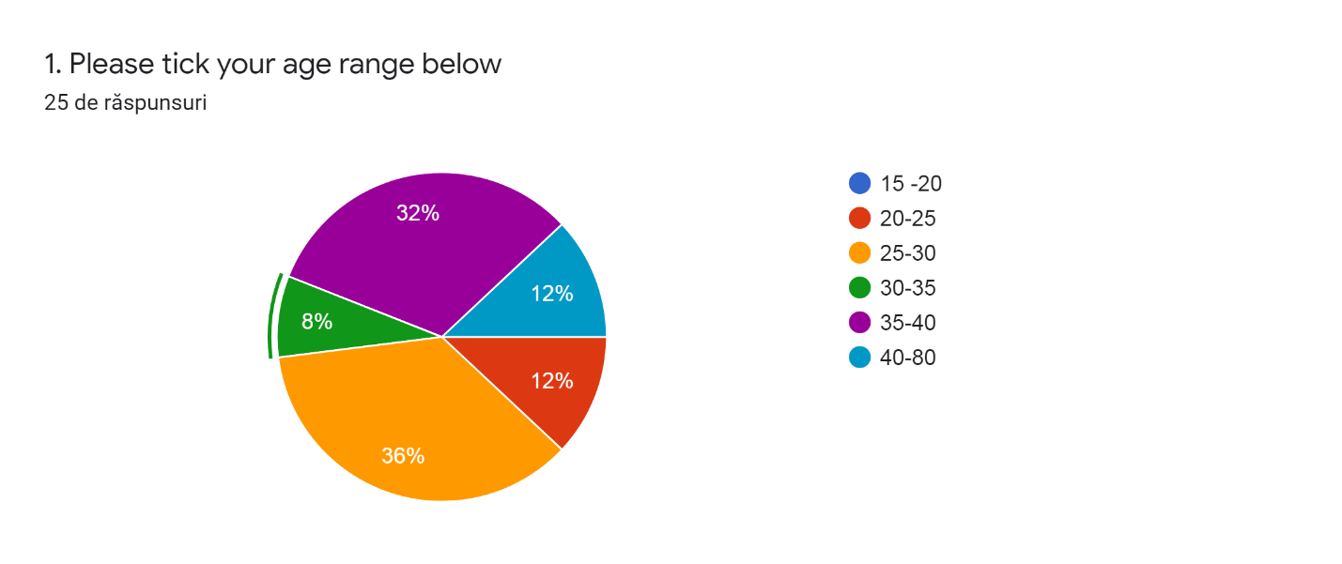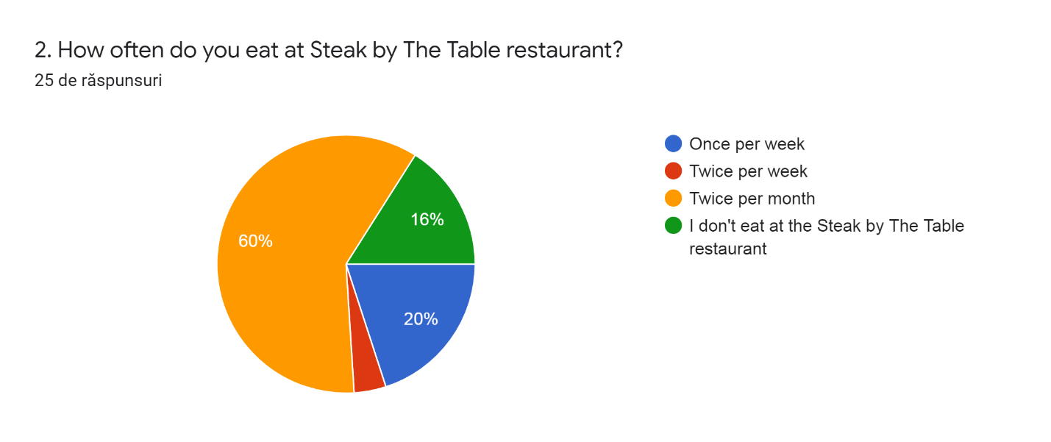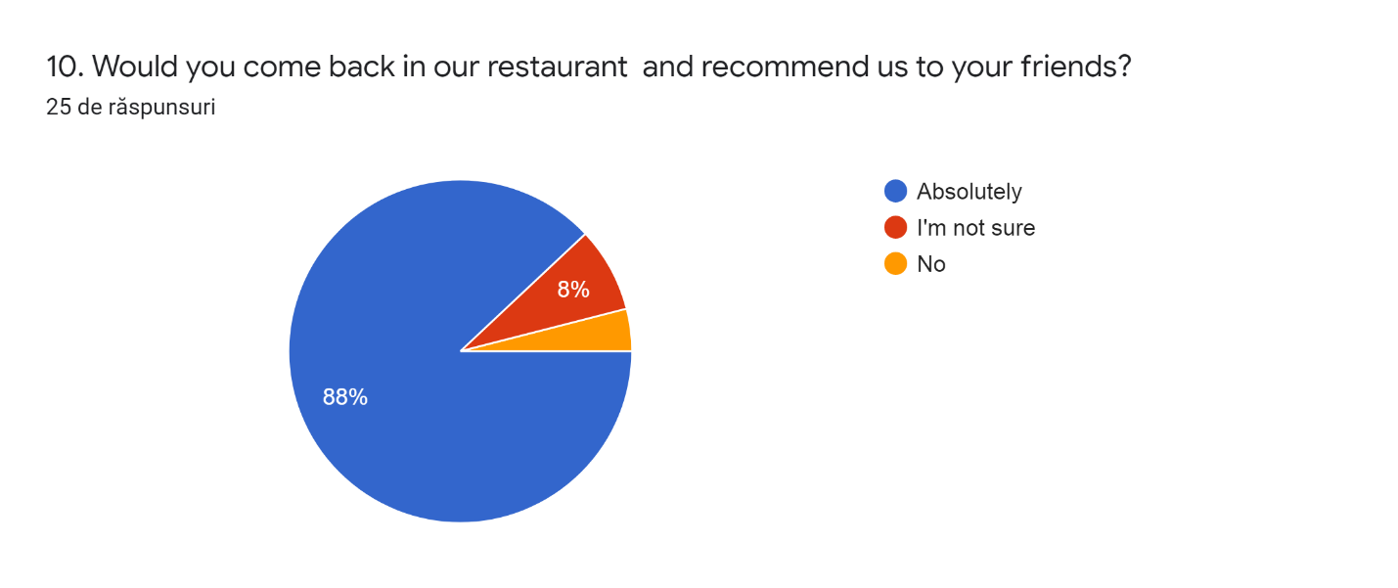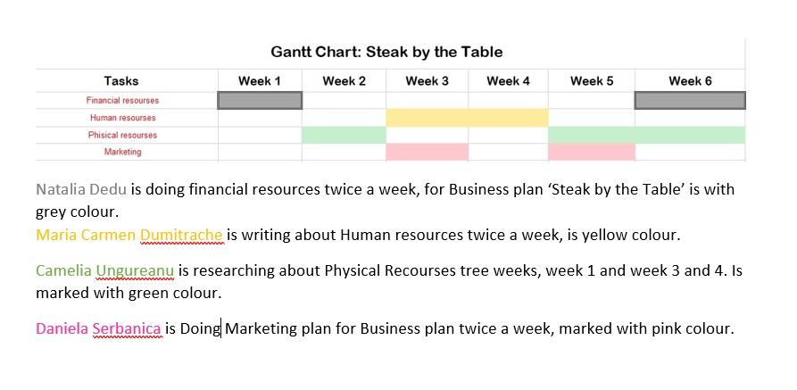

References:

Essays, UK. (November 2018). Management Of Physical Resources Business Essay. Retrieved from https://www.ukessays.com/essays/business/management-of-physical-resources-business-essay.php?vref=1
Fine, Gary Alan. “Justifying Work: Occupational Rhetorics as Resources in Restaurant Kitchens.” Administrative Science Quarterly, vol. 41, no. 1, 1996, pp. 90–115. JSTOR, www.jstor.org/stable/2393987. Accessed 14 Mar. 2020
Forest Contract. 2020. Commercial Furniture - UK Manufacturer - Forest Contract. [online] Available at: <https://www.forestcontract.com/> [Accessed 14 March 2020].
Han, S., Bonn, M. and Cho, M., 2016. The relationship between customer incivility, restaurant frontline service employee burnout and turnover intention. International Journal of Hospitality Management, 52, pp.97-106.
Holbeche, L. (2009). Aligning Human Resources and Business Strategy. London: Routledge, https://doi.org/10.4324/9780080941424.
Images.template.net. 2020. [online] Available at: <https://images.template.net/wp-content/uploads/2016/02/22043358/TechnologyRoadmappingProject.pdf> [Accessed 12 March 2020].
Journal of Rural Studies, 2006. Multiple business ownership in the Norwegian farm sector: Resource transfer and performance consequences. [online] 22(3), pp.313-322. Available at: <https://www.sciencedirect.com/science/article/abs/pii/S0743016705000859> [Accessed 14 March 2020].
Miller & Carter. 2020. Swansea - Steakhouse Restaurant. [online] Available at: <https://www.millerandcarter.co.uk/restaurants/wales/millerandcarterkillay?utm_source=google&utm_medium=organic&utm_campaign=gmb> [Accessed 14 March 2020].
Study.com. 2020. What Are Physical Resources In Business? - Video & Lesson Transcript | Study.Com. [online] Available at: <https://study.com/academy/lesson/what-are-physical-resources-in-business.html> [Accessed 14 March 2020].
UKEssays.com. 2020. Management Of Physical Resources Business Essay. [online] Available at: <https://www.ukessays.com/essays/business/management-of-physical-resources-business-essay.php> [Accessed 9 March 2020].

