Marissa Collins
1708540
Program of Study: Music Technology
Module: M4X01560

Tasks in the order I received them:
Task One: Observational Writing: Identify an image and write a semiotic analysis - Ryan Moule = 515 words (including in text citation)

Task Two: Manifesto Writing: “What do I believe in?” – Julia Lockheart = 487 words (including in text citation)

Task Three: Reflective Writing: Do you know what you think? – Jon Pugh = 481 words (including in text citation) (excluding the statement below title)

Task One: Semiotic Analysis (Ryan’s task)

Nowadays the contemporary condition of society is presented by a sense of false consciousness due to the residual self- image of the 21st century media. The difference between a message without a code and a message with a code for instance the difference between the literal and the symbolic, for example a red traffic light, representing a signal to stop but in other ways could demonstrate as excitement or prosperity. As said by Guy Debord written in “The Society of the spectacle” (1967, p. 6) “the present age, which prefers the sign to the thing signified, the copy to the original”, which emphasizes a sense of fake news and enhancing the habitual thought rather than perceiving and thinking in an open minded space. In some ways this could be perceived as how words, things we can see, different senses used by people can be used as signs rather than things.

People have been raised with a certain concept of habitual ways of thinking down many, many generations over past centuries and have taken them more literal rather than just a way of perceiving, not even thinking if it’s the best way to perceive situations or not. Nowadays some may think of these concepts of thinking as “old fashioned” and are now attempting to change these in the use of digital social media during the developments of technology. Authenticity seems to have lost its purpose through the years until now, where people of the upcoming generations are recollecting their thoughts.

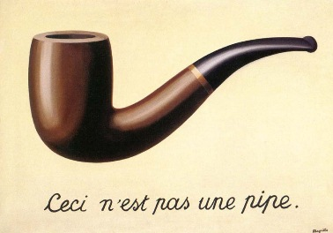
(En.wikipedia.org, 2019)

Rene Magritte – creator of my chosen piece “c’est n’est pas une pipe”, presents the fact that the piece of art, is a painting of a pipe, not an actual pipe, therefore demonstrating the semiotic terms of a message without a code such as what the image shows comparing to what a message with a code would be for instance what is implied by the image.

In historical context, the piece was painted at the end of world war one, where there was a very high level of uncertainty between people due to the instability it left behind (Fernandez, 2015). Some of his methods used in this piece, for instance, his use of persistence in tension between reality and surreality (Renemagritte.org, n.d.). Magritte emphasizing his style of art using the definition of surrealism which involves being completely honest in art (Public Delivery, 2019). Focusing on the reality of when the painting was released, it was a new era of new developments which was a part of the uncertainty due to new developments in other areas of society such as, Sigmund Freud and Quantum physics.
In comparison of the surreality of when the painting would be released which would be the far end of the future which would bring us to around now, which would be a new era of new development in technology such as, artificial intelligence and stem- cell therapy (Fernandez, 2015).

The extreme development of a world of things not making sense, presented by a somewhat simple image or painting of a pipe which continues to puzzle people these days (Public Delivery, 2019).

Bibliography

Debord, G. (1967). Society of the spectacle. p.6.

Fernandez, M. (2015). Why this is not a pipe | FUSION. [online] Fusionmagazine.org. Available at: https://www.fusionmagazine.org/why-this-is-not-a-pipe/ [Accessed 3 Dec. 2019].

En.wikipedia.org. (2019). The Treachery of Images. [online] Available at: https://en.wikipedia.org/wiki/The_Treachery_of_Images [Accessed 12 Nov. 2019].

Renemagritte.org. (n.d.). The Treachery of Images, 1929 by Rene Magritte. [online] Available at: https://www.renemagritte.org/the-treachery-of-images.jsp [Accessed 12 Nov. 2019].

Public Delivery. (2019). This is not a pipe - Magritte's most famous painting. [online] Available at: https://publicdelivery.org/magritte-not-a-pipe/ [Accessed 3 Dec. 2019].

Task Two: Manifesto Writing (Julia’s Task)

- Having the ability to create artwork (album covers) that have multiple meanings that won’t create confusion for the listeners.

- Future Intensions – Give radio stations freedom to play songs without having to take out or bleep certain words because of the nature of those particular words, excluding words that cuss.
- Always make effort to create music that is relatable for all ages.
- Be present in a world of living whilst creating music– not living life through a virtual world.
- Don’t use social media as a way to release music – go through people to gain popularity.
- Developments are made every day for the music industry – bare in mind developments are made to change over time.
- To connect with the audience emotionally – to not need prior knowledge to know a certain feeling.
- Be an influencer for the next generation of musicians.

Keywords and Images

IDEOLOGY

- Having the ability to create artwork (album covers) that have multiple meanings that won’t create confusion for the listeners.

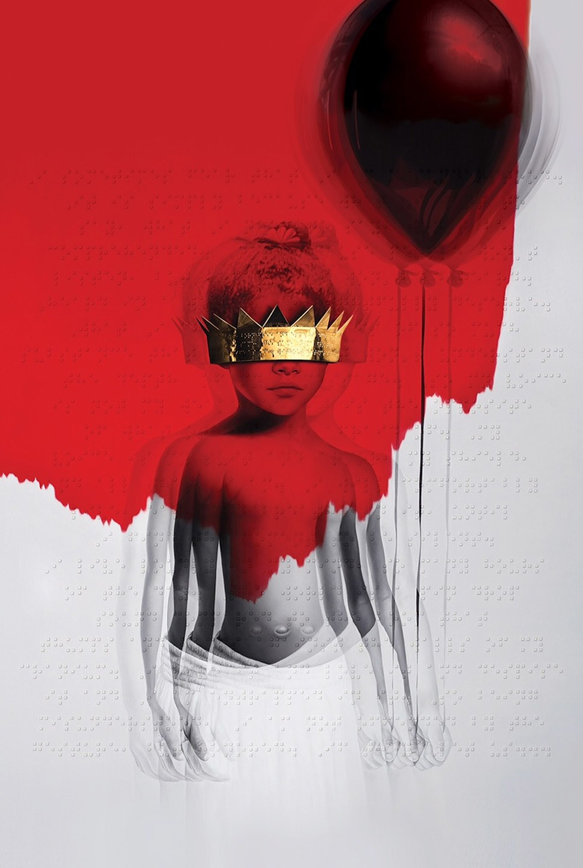

(Taylor, 2015)

Rihanna being an influencer of mine, using the artwork from the album ANTI was a no brainer. The image of Rihanna as a child represents a snapshot of childhood and the crown covering her eyes demonstrates the music of which is being created in this album. The braille message that is also included on the album cover from a poem written by Chloe Mitchell which says "I sometimes fear that I am misunderstood. / It is simply because what I want to say, / what I need to say, won't be heard." (Grunge.com, n.d.) Creating a concept of contrast presenting multiple meanings below the surface but yet a simple and minimal piece of art for which the listeners of Rihanna’s music are understanding the concept.

TECHNOLOGY
4. Be present in a world of living whilst creating music – not living life through a virtual world. (145)

Creating music has changed over many years, from using real in life instruments to using digitized ones that can be altered in seconds, the argument of no authenticity due to electrical and internet development from the late 19th century to the modern day 21st century, creates a stand - off between the pros and cons of developments in technology. Are we getting lazy as creators?
“While in some ways digital technology seems to be merely increasing the efficiency of music storage and distribution, it is important to remember that all previous modes of the distribution of music were physical: the noted or recorded object had to be moved from place to place” (Taylor, 2010)

Not how the development of social media has come into play with the use of distribution of music digitally. Using platforms such as Facebook, Instagram, YouTube and many more are increasing the way artists are promoting their work and yet having this anxiety on top of them. In comparison to how legendary bands such as Queen and many more didn’t have the internet for the help of building popularity, they played gigs and went to different areas to promote themselves.
DEVELOPMENT
- Developments are made every day for the music industry – bare in mind developments are made to change over time. (Craft)

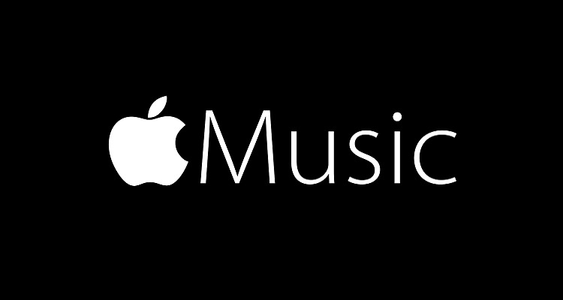
Apple Music logo
(Cohen, 2019)

(Developer.spotify.com, n.d.)

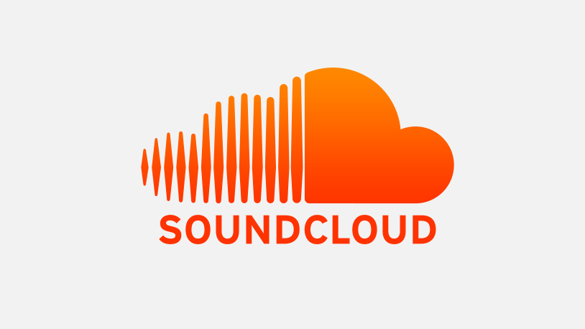
(Aswad and Aswad, 2017)

The gramophone in the late 19th century was a creation to develop music distribution and storage, the technology to invent this creation had been steeped up in order to do so therefore “production, storage and portability were once again greatly altered” (Taylor, 2010). The use of the platforms shown above have become extremely popular with distribution, storage, production and consumption of music of the 21st century. Creating different opportunities for artists to promote their art and creativity and reaching out to different audiences and developing thoroughly through every chance the artists get and keeping up with the times. Development is an on - going process, especially development in technology, that will continue until human nature has run out of ideas but that’s nearly impossible considering the creativity it takes to use the technology is always on - going from the users of the older generation to the upcoming generations that have been born into a world of technology, potentially you could call it a “technology frenzy”.

Bibliography

Taylor, E. (2015). The Artist Behind Rihanna’s Anti Cover Explains What It Means. [online] Vanity Fair. Available at: https://www.vanityfair.com/culture/2015/10/rihanna-anti-cover-what-it-means-roy-nachum [Accessed 17 Dec. 2019].

Grunge.com. (n.d.). The hidden meaning behind these album covers. [online] Available at: https://www.grunge.com/93758/hidden-meaning-album-covers/ [Accessed 17 Dec. 2019].

Taylor, T. (2010). Strange sounds. New York: Routledge, p.4.

Cohen, C. (2019). California Court Dismisses Apple Music Data Privacy Lawsuit. [online] Digital Music News. Available at: https://www.digitalmusicnews.com/2019/11/26/court-dismisses-apple-music-data-privacy-lawsuit/ [Accessed 17 Dec. 2019].

Developer.spotify.com. (n.d.). Branding Guidelines | Spotify for Developers. [online] Available at: https://developer.spotify.com/branding-guidelines/ [Accessed 17 Dec. 2019].

Aswad, J. and Aswad, J. (2017). SoundCloud Responds to ‘Extensive Inaccuracies’ in Article Claiming It’s Almost Out of Money. [online] Variety. Available at: https://variety.com/2017/music/news/soundcloud-responds-to-techcrunch-article-claiming-it-is-almost-out-of-money-1202494837/ [Accessed 17 Dec. 2019].

Taylor, T. (2010). Strange sounds. New York: Routledge, p.4.

Task Three. Reflexive Writing (Jon’s Task)

A reflection of the song Scars to your Beautiful written by Alessia Cara and how the meaning is relevant to this day.
A representation of a truly meaningful and personal song would be the chosen one above, demonstrating how the imperfections of perfection are beautiful in every way no matter how they are portrayed by different people: different is better. Alessia Cara said the whole reason the song is what it is because it was written for “self - acceptance” (YouTube, 2017) and to make a statement that everyone is beautiful in their own ways and rights and there is no need to go through harmful things to change how someone should look or act depending on the way society tells them to be. The words “The spectacle is a permanent opium war” (Debord, 1967)
presenting the notion that the world has become a social drug we are all addicted to, due to the anxiety machines we know as social media. The present day has become a whirlwind of living life through social media and presenting the best side of ourselves even though that might not be the case in life itself, posting the best “happy go lucky” images where - as that might not be what’s happening on the other side of the screen. Cara’s attempt for the song is to reveal that beauty should reflect from the inside and shines out not something that creates scars to please other people in the world to “fit in”.

The lyrics: “She has dreams to be an envy, so she's starving
You know, "Cover-girls eat nothing"
She says, "Beauty is pain and there's beauty in everything"
"What's a little bit of hunger?"
"I can go a little while longer," she fades away” (azlyrics, 2016)

Cara emphasizes in the lyrics shown above the lengths in which people, especially girls and women of all ages go through to fit the perfect body image, looking up to role models and super models and not appreciating their personal beauty in all shapes and sizes. The song portrays the natural scars such as stretch marks are the beautiful ones where girls and women should be proud of how their body looks to them and only them and completely remove the stigma of how women are treated for how they look, but this stigma applies to all beings for men and women.
“There's a hope that's waiting for you in the dark
You should know you're beautiful just the way you are
You don't have to change a thing, the world could change its heart
No scars to your beautiful
We're stars and we're beautiful” (azlyrics, 2016)

Cara presents that there is a sense of hope after all even in this world of self - doubt and pain that many of us go through in our lives, that there is a light at the end of the tunnel, we just have to believe in ourselves that we are worthy of being beautiful in our very own special and personal ways.

Bibliography
YouTube. (2017). Alessia Cara Talks Meaning Behind 'Scars To Your Beautiful', Self Acceptance, More | The V. [online] Available at: https://www.youtube.com/watch?v=U1uRH4vaZCU.

Debord, G. (1967). Society of the spectacle. p.22.

azlyrics. (2016). Scars to your Beautiful Lyrics. [online] Available at: https://www.azlyrics.com/lyrics/loveandtheoutcome/scarstoyourbeautiful.html.

Cara, A. (2016). Alessia Cara - Scars To Your Beautiful. [online] YouTube. Available at: https://www.youtube.com/watch?v=MWASeaYuHZo.

