

Independent Project
Programme: BSc (Hons) in Health and Social Care
MODULE CODE: BMHP6020
Topics: A Comprehensive Evaluation of Treatment Pathways and Service Delivery for Schizophrenia in the United Kingdom: Effectiveness, Accessibility, and Strategic Directions for Future Improvement.

Submitted by, Submitted to,
Md. Arif Ullah Chloe Harries
Student ID: 2245624

Chapter One: Introduction

1.1 Introduction:
Schizophrenia is a chronic and severe mental health disorder that significantly affects an individual’s cognition, emotions, and perception of reality. It remains one of the most complex psychiatric conditions, contributing substantially to the global burden of disease (World Health Organization, 2023). In the United Kingdom (UK), schizophrenia represents a major public health concern, with an estimated 220,000 individuals living with the condition and many more experiencing early psychotic symptoms that may require intervention (NHS England, 2022). Over recent decades, treatment approaches have evolved considerably, reflecting advancements in pharmacology, psychological therapies, community-based care, and integrated service delivery models.
Despite policy developments, significant challenges remain in ensuring timely access, continuity, and equitable delivery of schizophrenia care. Regional variation, workforce shortages, and resource pressures continue to undermine service effectiveness (Care Quality Commission, 2023). Schizophrenia affects around 1 in 100 adults in the UK and is associated with long-term service dependency (Jovanović et al., 2025). Although NHS initiatives such as Early Intervention in Psychosis, community rehabilitation, and Integrated Care Systems aim to improve coordinated care, implementation remains inconsistent (Ratcliffe, 2025; Amanawa & Amabebe, 2024). Persistent inequalities linked to ethnicity, socioeconomic disadvantage, and geography continue to impact outcomes and engagement with services (Phillips et al., 2025; Conneely et al., 2025; Pagdon, 2025).
The aim of this dissertation is to critically evaluate treatment pathways and service delivery for schizophrenia in the UK, focusing on effectiveness, accessibility, and areas for strategic improvement. This study adopts a secondary research design and will employ thematic analysis in Chapter 4 to synthesise findings from existing literature, policy documents, and service user perspectives. By examining current practices and outcomes, the research seeks to contribute to a clearer understanding of how schizophrenia care can be strengthened within the contemporary UK healthcare system.
This chapter introduces the topic, establishes its relevance, and outlines key definitions, background context, rationale, aims, and objectives. It concludes with a signpost to the subsequent literature review.

1.2 Definitions and Terminology:
Schizophrenia: A severe and enduring mental disorder characterised by distortions in thinking, perception, emotions, language, sense of self, and behaviour. Symptoms may include hallucinations, delusions, disorganised speech, and impaired functioning (WHO, 2023).
Treatment Pathways: Structured, evidence-based processes that outline the recommended stages of assessment, intervention, treatment, and follow-up for individuals with a specific condition (NICE, 2020).
Service Delivery: The organisation, management, and provision of health and social care services, including availability of resources, staffing, accessibility, and quality of care (NHS England, 2022).
Effectiveness: The extent to which an intervention or service achieves its intended outcomes in real-world settings, including clinical improvement and enhanced quality of life (Thornicroft et al., 2022).
Accessibility: The ease with which individuals can obtain appropriate healthcare services at the right time and without undue barriers, such as geographical, financial, or cultural obstacles (CQC, 2023).
National Health Service (NHS): The publicly funded healthcare system in the United Kingdom, responsible for commissioning and delivering health services including mental health care (NHS England, 2023).
Early Intervention in Psychosis (EIP): A specialised NHS service providing rapid assessment and intensive treatment for individuals experiencing a first episode of psychosis, aimed at improving long-term outcomes (NICE, 2020).
Integrated Care Systems (ICS): Collaborative partnerships between NHS organisations, local authorities, and voluntary sectors that work together to plan and deliver coordinated health and social care services (NHS England, 2023).
Acronyms and Abbreviations:
- NHS: National Health Service
- EIP: Early Intervention in Psychosis
- ICS: Integrated Care Systems
- CBT: Cognitive Behavioural Therapy
- SMI: Severe Mental Illness
- NIHR: National Institute for Health and Care Research
The proper understanding of these terms is essential for evaluating care models, comparing studies, and critically interpreting outcomes.

1.3 Background and Current Context:

1.3.1 Background
Understanding of schizophrenia has progressed significantly since the early 20th century when Kraepelin and Bleuler first characterised the disorder. Historically, treatment was dominated by institutionalisation; however, deinstitutionalisation in the UK during the 1960s–1980s shifted care towards community-based services (Rogers and Pilgrim, 2020). The introduction of antipsychotic medication, particularly atypical antipsychotics in the 1990s, further transformed management by reducing hospitalisation rates and improving symptom control (Leucht et al., 2019). Policy initiatives such as the National Service Framework for Mental Health (1999) and the development of EIP services have shaped modern care pathways.

1.3.2 Current Context
Today, schizophrenia treatment in the UK includes pharmacological interventions, psychological therapies, social support, and community mental health services. However, significant pressures affect service delivery. Recent reports highlight rising demand, workforce shortages, and variability in mental health provision across regions (CQC, 2023). While EIP services have improved early outcomes, continued concerns exist regarding long waiting times, inconsistent implementation of NICE guidelines, and limited access to high-quality psychosocial interventions (NHS England, 2022). Additionally, socioeconomic inequalities and stigma continue to influence help-seeking behaviours and engagement with services. These factors underscore the urgent for a comprehensive evaluation of current treatment pathways to identify strengths, limitations, and opportunities for improvement.
1.4 Rationale for Research:
Despite sustained policy commitments and service innovation, significant limitations remain in how schizophrenia care is delivered across the UK. Recent NIHR evaluations highlight disparities in access and treatment quality, particularly among ethnic minority groups, individuals living in deprived areas, and women during the perinatal period (Jovanović et al., 2025). While interventions such as EIP services demonstrate short-term benefits, they have been less effective in addressing long-term social exclusion, unemployment, housing instability, and physical health inequalities commonly experienced by individuals with schizophrenia.
Demand for mental health services has increased since COVID-19, putting extra pressure on already overstretched systems (Phillips et al., 2025). Differences in commissioning and uneven use of NICE guidance mean that psychological and social treatments are not consistently available across the country. This often leads to gaps in care after people leave early intervention or specialist services. There is also a lack of up-to-date research examining how schizophrenia treatment pathways work across NHS Trusts. Different definitions of recovery and limited outcome data make it difficult to assess service effectiveness beyond symptom control (Pagdon, 2025). Many service users report that clinical priorities do not reflect their personal recovery goals, which can reduce engagement and long-term outcomes (Uehling, 2025).
This dissertation responds to these gaps by synthesising contemporary evidence across clinical, policy, and service user domains. By critically evaluating why current models have not fully reduced inequalities or delivered sustained recovery, the study aims to identify both systemic limitations and opportunities for improvement. The findings may inform future policy development, service redesign, and resource allocation, supporting the delivery of more equitable and effective schizophrenia care.

1.5 Aim and Objectives:

1.5.1 Research Aim
The aim of this dissertation is to conduct a comprehensive evaluation of treatment pathways and service delivery for schizophrenia in the United Kingdom, with a focus on their effectiveness, accessibility, and potential strategic directions for future improvement.

1.5.2 Research Objectives
- To examine current treatment pathways for schizophrenia within the UK, including pharmacological, psychological, and community-based interventions.
- To assess the accessibility and quality of schizophrenia services across different regions of the UK.
- To evaluate the effectiveness of current service delivery models, including early intervention and integrated care approaches.
- To identify gaps, challenges, and opportunities for enhancing future schizophrenia treatment and service provision.

1.6 Conclusion:
This chapter has outlined the significance, aims, and foundational structure of the dissertation. It has defined key terminology and justified the need for a critical evaluation of schizophrenia treatment pathways and service delivery in the UK, particularly in the context of ongoing systemic pressures and persistent inequalities in care (Care Quality Commission, 2023; NHS England, 2022). The four research objectives provide a clear framework for examining both the effectiveness and accessibility of current services.
The next chapter will present a critical review of the literature, exploring the historical development of schizophrenia care, theoretical perspectives, and relevant national and international policy frameworks. This will establish the conceptual and empirical foundation for the analysis presented in subsequent chapters.

Chapter 2 – Background Information and Analysis

2.1 Introduction:
The treatment and service delivery for schizophrenia in the United Kingdom have undergone significant transformation, developing from asylum-based institutionalisation to modern, community-oriented and recovery-led models of care. Schizophrenia, a severe and chronic psychiatric disorder affecting cognition, perception, and social functioning, poses one of the most complex challenges for mental health systems globally. In the UK, schizophrenia treatment has become a focal point for NHS reform, policy innovation, and academic research due to its economic burden, social consequences, and links with health inequalities.
This chapter provides the contextual foundation for the dissertation by critically analysing the historical development, theoretical frameworks, and both global and national policy approaches shaping schizophrenia care. Drawing on recent peer-reviewed literature, NHS policies, and global health data, the chapter examines key structural changes, particularly post-2015 reforms. It also highlights persisting barriers in service access, cultural appropriateness, and equitable outcomes.
Understanding this complex background is essential for assessing treatment effectiveness and service delivery, which are central to this dissertation. The following sections explore the evolution of treatment approaches, theoretical influences on policy, and contemporary challenges within both international and UK-specific contexts.

2.2 Understanding Schizophrenia at a glance:
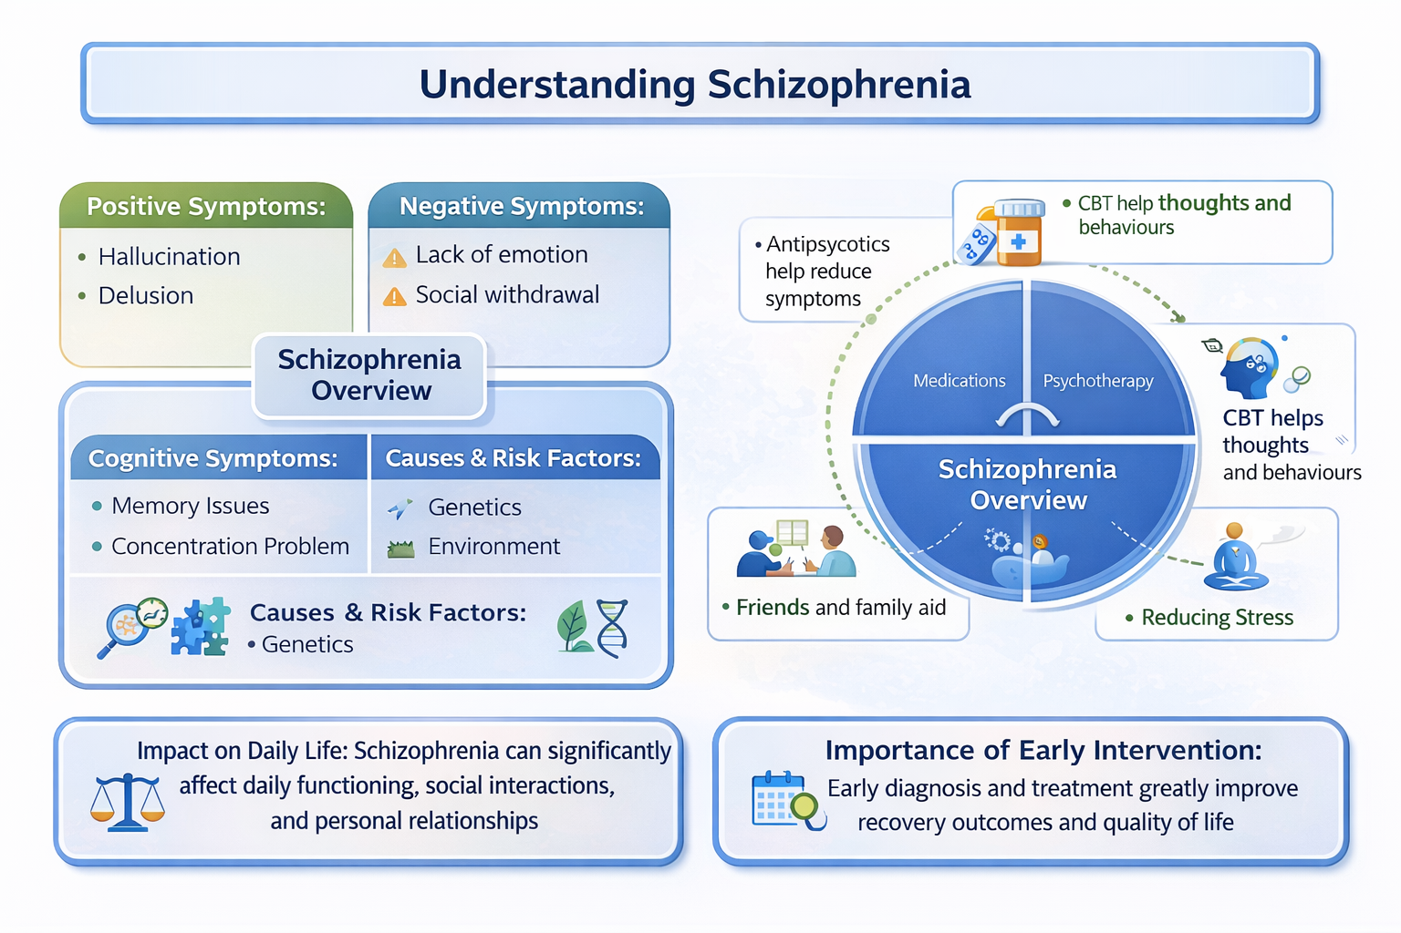
(Sources gathered from: (Pagdon, 2025; Scull, 2015; Bartlett & Wright, 2018; WHO, 2023; Care Quality Commission, 2023; NHS England, 2022).

2.3 Historical Background:
2.3.1 The Evolution of Schizophrenia Treatment and Mental Health Service Development in the UK:
The historical journey of schizophrenia treatment in the United Kingdom is one of significant transformation — from institutionalised care rooted in social exclusion to a more holistic, person-centred, and rights-based approach within community settings. This evolution reflects broader shifts in societal values, political priorities, medical understanding, and civil rights movements.

2.3.2 Asylum-Based Care and the Early Legislative Framework (1800s–1950s):
The 19th and early 20th centuries were characterised by the widespread institutionalisation of individuals with mental illness. Under the Lunacy Act 1845 and later the Lunacy Act 1890, large county asylums were established to house individuals deemed “insane” — many of whom were diagnosed with what would now be classified as schizophrenia. Care in these institutions was largely custodial and often involved inhumane conditions, with minimal focus on therapeutic intervention (Scull, 2015; Bartlett & Wright, 2018). By the 1950s, over 150,000 people were institutionalised in asylums across England and Wales. Public opinion began to shift as reports of neglect and abuse surfaced, prompting political pressure for reform.

2.3.3 The Beginnings of Deinstitutionalisation (1959–1980s)
The Mental Health Act 1959 removed the legal separation between mental and physical illness and encouraged voluntary treatment in hospitals and community settings. This aimed to improve patient dignity and support social inclusion (Jones, 2010). Deinstitutionalisation increased in the 1980s due to policy changes, criticism of asylums, and the use of antipsychotic medication (Rogers & Pilgrim, 2014). The Mental Health Act 1983 strengthened patient rights, including the right to appeal detention.

2.3.4 The Community Care Era and the Care Programme Approach (1990s)
The NHS and Community Care Act 1990 supported the move from institutions to community-based care. While intended to improve independence, services were unevenly delivered, leaving some people without adequate support (Godin, 2006). The Care Programme Approach (CPA) aimed to improve care coordination for people with complex needs, but was criticised for being too bureaucratic and not always person-centred (Department of Health, 1999).

2.3.5 Modernisation and the Rise of Early Intervention (2000s–2015)
Policies such as the National Service Framework (1999) and NHS Plan (2000) aimed to modernise mental health care. Early Intervention in Psychosis (EIP) services were introduced to provide early support and improve outcomes (Birchwood et al., 2000; McGorry et al., 2002). However, funding cuts after 2008 reduced specialist services and increased pressure on community teams (Mental Health Foundation, 2020).

2.3.6 Towards Integrated and Person-Centred Systems (2015–Present)
Recent policies focus on personalised, joined-up care through community services. Priorities include faster access to EIP, shared care planning, and links with housing and employment support. Despite progress, service delivery remains uneven, particularly for deprived areas and ethnic minority groups (RCPsych, 2024; DoHSC, 2023). Staff shortages and crisis-led care continue to limit service quality (CQC, 2023).

This diagram illustrates the key historical phases in the development of schizophrenia treatment in the UK, from asylum-based care to modern integrated and person-centred systems.
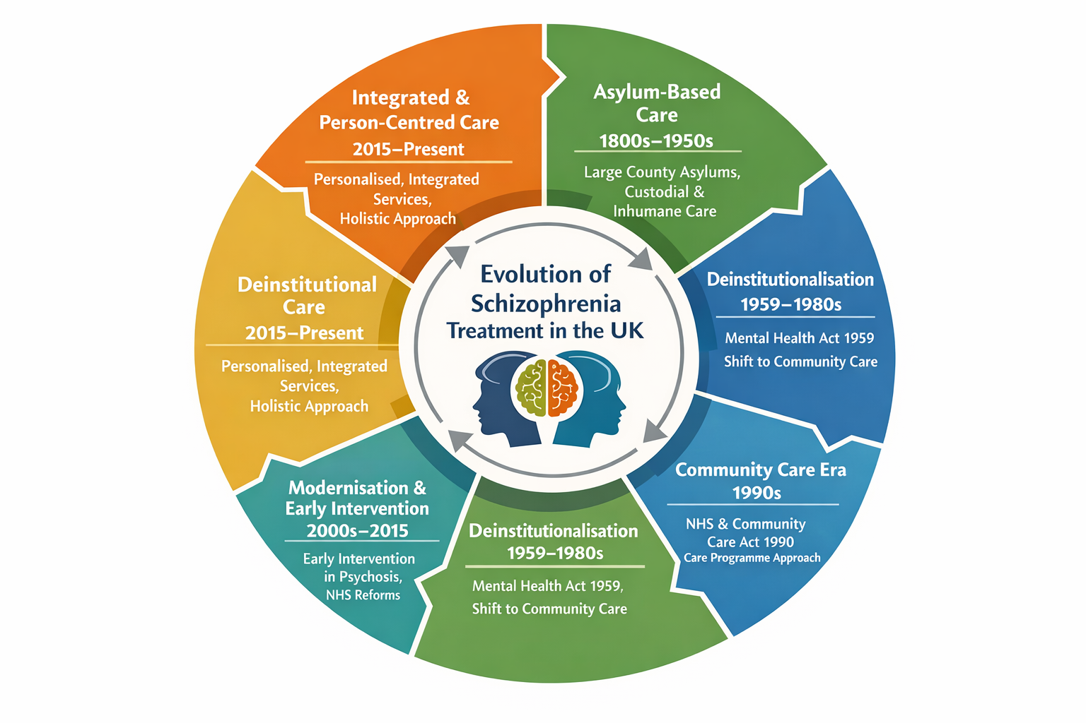(Sources gathered from: RCPsych, 2024; DoHSC, 2023; Birchwood et al., 2000; McGorry et al., 2002; Rogers & Pilgrim, 2014)

Table: Historical Comparison of Schizophrenia Care in the UK
The table below presents a structured comparison of the major historical periods in the development of schizophrenia treatment and mental health services in the United Kingdom.
Comparison Criteria | Asylum Era  (1800s–1950s) | Early Deinstitutionalisation  (1959–1980s) | Community Care Era  (1990s) | Modernisation & EIP  (2000s–2015) | Integrated Care Era  (2015–Present)
Care Setting | Large county asylums | General hospitals & outpatient care | Community-based services | Specialist community teams | Integrated community systems
Care Philosophy | Custodial and containment-focused | Medical treatment and legal reform | Independence and risk management | Early intervention and recovery | Person-centred and holistic care
Key Legislation / Policy | Lunacy Acts 1845 & 1890 | Mental Health Act 1959 & 1983 | NHS & Community Care Act 1990; CPA | NSF for Mental Health; NHS Plan | NHS Long Term Plan; CMH Framework
Treatment Approach | Minimal therapeutic input | Introduction of antipsychotics | Medication plus social support | Evidence-based early intervention | Integrated mental, physical & social care
Service Strengths | Provided shelter and supervision | Improved patient rights | Promoted social inclusion | Improved outcomes and relapse prevention | Personalisation and continuity of care
Key Limitations | Overcrowding, abuse, neglect | Insufficient community infrastructure | Fragmented and underfunded services | Austerity-led service erosion | Workforce shortages and inequality

2.4 Theoretical Background:

2.4.1 Biopsychosocial Model:
The biopsychosocial model, developed by Engel (1977), explains schizophrenia as the result of biological, psychological, and social factors. This approach underpins UK guidance, with NICE (2020) recommending medication alongside psychological and family-based interventions. However, critics argue that in practice care remains heavily focused on medication, particularly in acute settings (Moncrieff & Timimi, 2020). The model supports a wider approach to care that includes psychological support, relapse prevention, and help with community reintegration.

Table 2.2 Biopsychosocial Model Applied to Schizophrenia
Component | Application
Biological | Medication use, genetic risk, neurochemical factors
Psychological | CBT, trauma-informed therapy, coping skills
Social | Housing, employment, family and community support
Service Delivery | Multidisciplinary and holistic care
Policy Link | NICE guidance on integrated treatment
(Adapted from Engel, 1977; NICE, 2020; Moncrieff and Timimi, 2020)

2.4.2 Recovery-Oriented Framework:

In mental health care, recovery now focuses on personal meaning, independence, and social inclusion, not just symptom control (Burbach, 2018). This approach encourages services to support individual goals such as housing, work, and relationships (Slade, 2009). The recovery model shapes current policy, including the Community Mental Health Framework, which promotes shared decision-making and peer support (NHS England, 2019). Research shows that recovery-focused care improves engagement and satisfaction (Leamy et al., 2011; Lester and Glasby, 2022). However, it is not consistently applied across NHS Trusts (Repper and Perkins, 2021).

Table 2.3 Recovery-Oriented Framework Applied to Schizophrenia
Element | Application
Recovery Concept | Meaningful life beyond symptom control
Service User Role | Shared decision-making and co-production
Key Practices | Peer support and strengths-based care
Desired Outcomes | Hope, empowerment, inclusion
Policy Link | Community Mental Health Framework
Adapted from Slade, 2009; Burbach, 2018; NHS England, 2019)

2.4.3 Chronic Care Model (CCM):
Wagner et al.’s model for long‐term conditions emphasises six key elements: self-management support, decision support, delivery system design, clinical information systems, community resources and health care organisation (Baker et ., 2019). In schizophrenia treatment pathways, this model supports the idea that care must be proactive, planned and integrated across services rather than reactive, fragmented episodes of care.

Table 2.4 Chronic Care Model Applied to Schizophrenia
CCM Element | Application
Self-management | Relapse prevention and medication adherence
System Design | Planned reviews and MDT coordination
Decision Support | Evidence-based practice
Community Resources | Voluntary and social care links
Overall Aim | Proactive long-term care
Adapted from Wagner et al.; Baker et al., 2019)

2.4.4 Integrated Systems Theory:
In response to fragmented care, Integrated Care Systems (ICS) were introduced nationally in 2021 to unify NHS services, local authorities, and voluntary organisations. This is grounded in systems theory, which posits that effective care emerges from cooperation among interconnected services (King’s Fund, 2022). However, systemic barriers remain, including siloed funding, data incompatibility, and workforce shortages (Asthana et al., 2020; NHS Confederation, 2023).

2.4.5 Intersectionality and Inequity:
Structural inequalities in schizophrenia care are increasingly examined using an intersectional approach, recognising how race, gender, and socioeconomic factors overlap (Nazroo et al., 2019; Keating, 2023). Evidence shows that Black Caribbean men are significantly more likely to be detained under the Mental Health Act (DoHSC, 2023), while women often experience underdiagnosis and limited perinatal support (Jovanović et al., 2025). New approaches, including trauma-informed and anti-oppressive practice, are now reflected in national guidance (NICE, 2021; Mental Health Act Reform White Paper, 2021).

Table 2.5 Intersectionality and Inequality in Schizophrenia Care
Factor | Impact
Ethnicity | Higher detention rates for Black service users
Gender | Underdiagnosis and perinatal care gaps
Socioeconomic Status | Barriers to housing and employment
Practice Response | Trauma-informed and culturally competent care
Policy Context | Mental Health Act reform

(Adapted from Nazroo et al., 2019; DoHSC, 2023; Jovanović et al., 2025)

Table: Theoretical Comparison of Models Informing Schizophrenia Care
This table presents a theoretical comparison of key frameworks underpinning contemporary schizophrenia care and mental health service delivery in the UK.
Comparison Criteria | Biopsychosocial Model | Recovery-Oriented Framework | Chronic Care Model (CCM) | Integrated Systems Theory | Intersectionality & Inequity
Theoretical Focus | Interaction of biological, psychological, and social factors | Personal meaning, empowerment, and social inclusion | Long-term condition management and continuity of care | Coordination across health, social, and voluntary sectors | Impact of overlapping social identities on care outcomes
Key Contributors | Engel (1977) | Slade (2009); Burbach (2018) | Wagner et al. | Systems theory; policy-led ICS reforms | Nazroo et al.; Keating
View of Schizophrenia | Multifactorial mental health condition | Personal recovery journey beyond symptoms | Chronic condition requiring proactive management | Complex condition requiring system-wide response | Condition shaped by structural inequality
Implications for Practice | Combined medication, therapy, and social support | Co-produced goals, peer support, functional recovery | Planned, coordinated, proactive care pathways | Integrated commissioning and shared accountability | Culturally competent and anti-oppressive care
Strengths | Holistic and evidence-based approach | Improves engagement and service-user satisfaction | Reduces fragmentation and crisis-driven care | Improves continuity and efficiency of services | Addresses disparities and inequitable outcomes
Limitations / Critiques | Biomedical dominance in practice | Inconsistent implementation across trusts | Resource and workforce intensive | Siloed funding and data-sharing barriers | Limited translation into routine practice
Overall, these theoretical frameworks offer complementary perspectives on schizophrenia care. Together, they highlight the need for holistic, recovery-oriented, integrated, and equity-focused service models, while also exposing persistent gaps between theory and implementation.

2.4.4 International Context:
Looking at schizophrenia care internationally helps identify good practice and highlights areas where UK services could improve. Many countries have moved towards community-based care that focuses on early intervention, recovery, and social support rather than long hospital stays. Countries such as Australia, the Netherlands, Finland, and Canada provide useful examples of different approaches to schizophrenia care.
In Australia, the Headspace model offers integrated mental health services for young people in accessible and youth-friendly settings. These services combine mental health care with physical health, education, and employment support. Evidence shows that Headspace has reduced emergency hospital use and improved outcomes for people experiencing first-episode psychosis (Rickwood et al., 2019). This model has influenced UK youth mental health services, such as iThrive and youth hubs. However, expansion has been limited by staff shortages and funding pressures (O’Herlihy et al., 2021). This highlights the challenge of sustaining early intervention services without long-term investment.
The Netherlands uses the Flexible Assertive Community Treatment (FACT) model. FACT provides long-term, flexible support through multidisciplinary teams that increase or reduce care depending on service users’ needs. Research shows that FACT reduces relapse and hospital admission while improving continuity of care (van Veldhuizen, 2007; Delespaul et al., 2021). Although some UK services have adopted elements of FACT, inconsistent training and limited resources have reduced its effectiveness (CQC, 2023).
In Finland, the Open Dialogue approach represents a more innovative model. It focuses on rapid response, shared decision-making, and strong family involvement from the first signs of psychosis. Long-term studies show lower hospital use, reduced medication, and better social outcomes (Seikkula et al., 2011). Despite these positive results, Open Dialogue has only been tested in small UK pilot projects. Barriers include workforce training demands and a risk-averse culture within NHS services (Parachute Project, 2023).
Canada has developed Housing First programmes that provide permanent housing alongside mental health support, especially for homeless and Indigenous populations. Evidence shows improved quality of life and reduced hospital use among people with schizophrenia (Goering et al., 2014). While the UK has trialled Housing First schemes, they remain poorly integrated with specialist mental health services (Pleace et al., 2021).
Overall, international evidence shows that successful schizophrenia care relies on early intervention, continuity of care, social support, and service user involvement (OECD, 2022; WHO, 2021). However, these models only work well when supported by stable funding, sufficient staffing, and cultural acceptance. These lessons suggest that UK reforms should focus on long-term integration and equality rather than short-term pilot programmes.

Figure: International Models of Schizophrenia Care: Clear comparison.
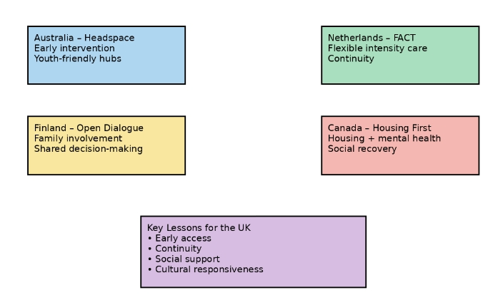 Sources: Rickwood et al., 2019; van Veldhuizen, 2007; Seikkula et al., 2011; Goering et al., 2014; OECD, 2022; WHO, 2021).

International Models of Schizophrenia Care – Visual Summary Table
Country | Model of Care | Key Strengths | Limitations | Key Lessons for the UK
Australia | Headspace | Early intervention; youth-friendly; integrated services | High cost; workforce and scalability challenges | Importance of early, co-located youth services
Netherlands | FACT | Flexible intensity; continuity of care; reduced relapse | Resource intensive; training demands | Value of long-term flexible community teams
Finland | Open Dialogue | Family involvement; shared decision-making; reduced medication use | Cultural and training barriers | Benefits of relational and dialogical care
Canada | Housing First | Addresses housing instability; improves quality of life | Limited mental health integration in some regions | Housing as a core recovery intervention
United Kingdom | EIP (Comparator) | Strong early intervention; universal access | Poor continuity; inequities; limited peer support | Need to strengthen continuity and equity
Sources: Rickwood et al., 2019; Van Veldhuizen, 2007; Seikkula et al., 2011; WHO, 2021).

2.5 National and Local UK Context:
The UK’s approach to schizophrenia care is shaped by national policy frameworks, regional implementation strategies, and local service-level innovations — all of which must be analysed to assess effectiveness and accessibility.

2.5.1 National Policy Frameworks:
The NHS Long Term Plan (2019) committed an additional £2.3 billion per year to mental health services by 2023/24, aiming to improve access to Early Intervention in Psychosis (EIP), cognitive behavioural therapy (CBT), and integrated physical and mental health care (NHS England, 2019). Although the plan set a target for 60% of first-episode psychosis patients to receive treatment within two weeks, only 43% of NHS Trusts consistently meet this standard (RCPsych, 2024).
The Mental Health Act Reform White Paper (2021) aimed to reduce racial inequalities and increase patient choice; however, reforms had not been fully implemented by 2025 (DoHSC, 2025). Consequently, significant disparities remain, with Black Caribbean and Black African men over four times more likely to be detained than White British men (Bhui et al., 2022).
Introduced in 2021, Integrated Care Systems (ICSs) seek to improve coordination across health, social care, and voluntary services. While promising, early evaluations report challenges including limited funding, inconsistent leadership, and weak partnership working (NHS Confederation, 2023). Longstanding policies, such as the National Service Framework for Mental Health (Department of Health, 1999), the Five Year Forward View for Mental Health (2016), and Mental Health Act amendments (2007), continue to shape service delivery.

2.5.2 Local and Regional Implementation
There is substantial variation in service quality and accessibility across UK regions:
- South London and Maudsley NHS Trust (SLaM) is a leader in culturally adapted CBT and co-produced recovery programmes. It has also implemented peer support worker schemes, though some evaluations note staff burnout and inconsistent delivery (Pagdon, 2024).
- Cumbria, Cornwall, and rural Wales face critical workforce shortages in psychiatry and community mental health nursing, contributing to long wait times and gaps in crisis care (RCPsych, 2023).
- Greater Manchester ICS has piloted digital self-referral pathways and embedded employment support within psychosis teams, improving engagement and outcomes for younger service users (Proctor, 2024).
Meanwhile, Scotland and Wales maintain devolved health systems:
- Scotland’s Mental Health Strategy (2017–2027) prioritises social care integration and suicide prevention, with some success in reducing inpatient admissions (Scottish Government, 2022).
- Wales’ “Together for Mental Health” framework promotes trauma-informed and person-centred care, with specialist early intervention teams now established in all health boards (Welsh Government, 2022).
Despite these advances, a 2024 report from the Care Quality Commission (CQC) found significant variability in access to psychological therapies, use of restraint, and quality of care coordination, particularly for patients from marginalised ethnic and socioeconomic groups (CQC, 2024). Ultimately, while the UK has strong national guidelines and world-class EIP frameworks, the translation of policy into practice varies widely by geography, demographics, and funding. Addressing these disparities is essential to creating a fair, effective, and inclusive mental health care system.
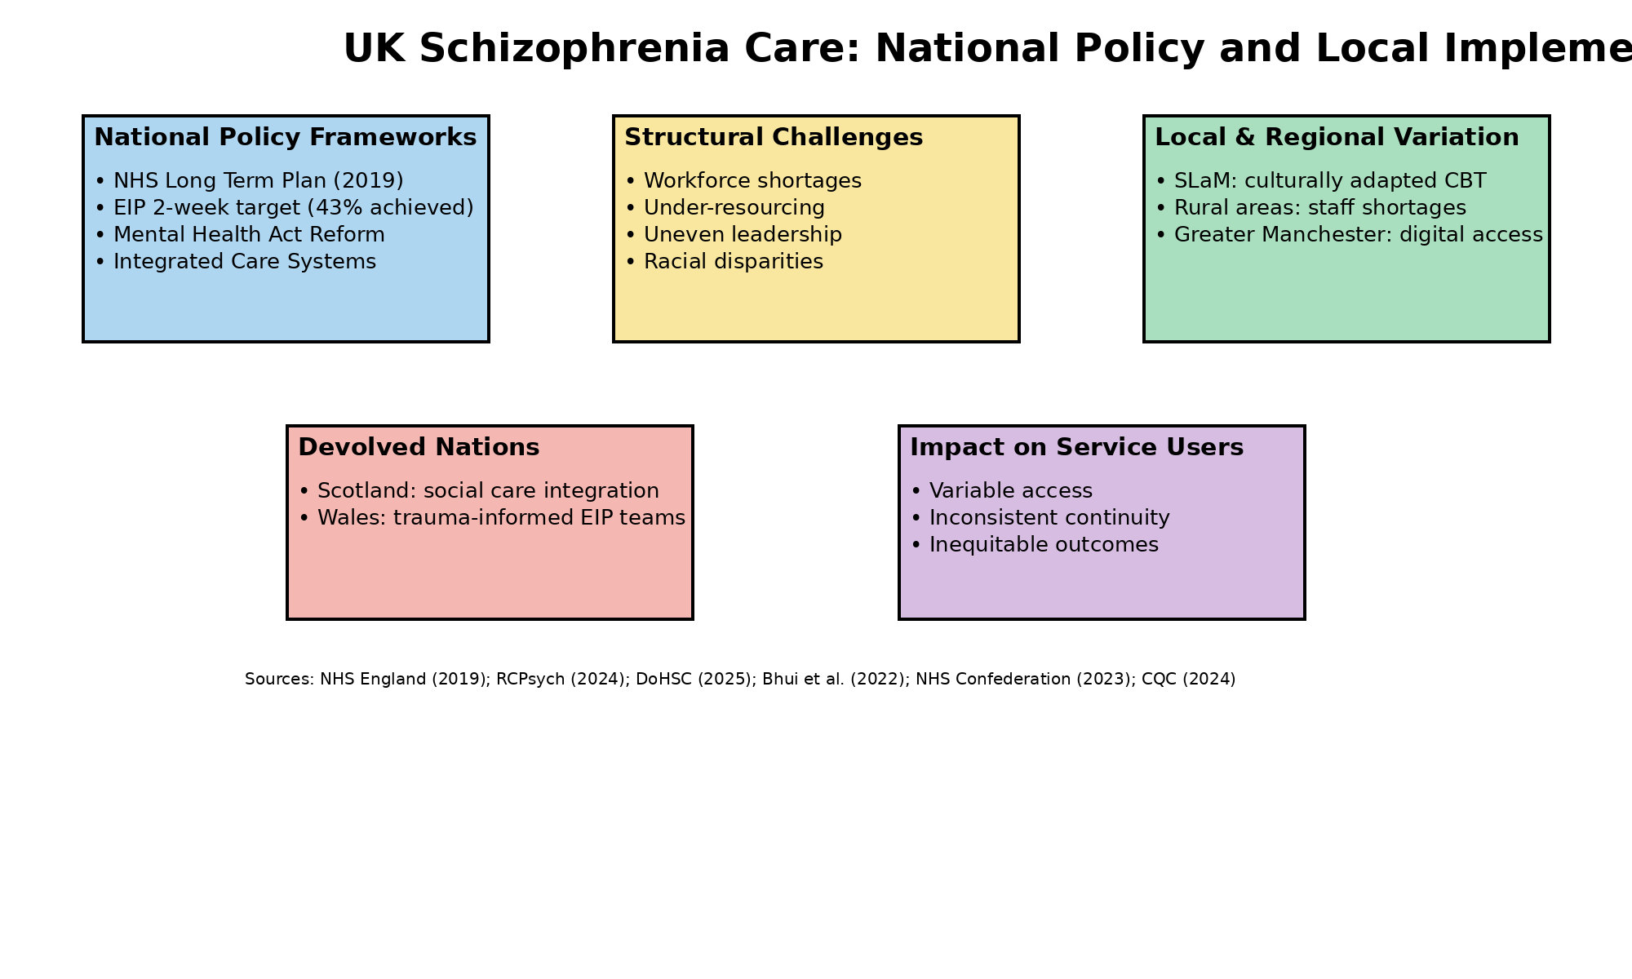-
(Sources: NHS England, 2019; RCPsych, 2024; DoHSC, 2025; Bhui et al., 2022; NHS Confederation, 2023; CQC, 2024).

2.6 Conclusion
This chapter has critically examined the historical, theoretical, and policy contexts shaping schizophrenia treatment and service delivery in the UK. While progressive reforms have shifted care from institutional to community-based models, theoretical ideals have often outpaced practical implementation.
Comparative analysis demonstrates that no single model sufficiently addresses schizophrenia care in isolation. Instead, effective systems integrate recovery-oriented values, chronic care planning, and structural equity. International comparisons further highlight that continuity, cultural competence, and relational care remain key weaknesses within UK provision.
These insights provide a robust conceptual foundation for Chapter 3, which outlines the methodology used to systematically evaluate treatment pathways and service delivery. Understanding these contextual dynamics is essential for interpreting later findings on effectiveness, accessibility, and future strategic direction.

CHAPTER 3: Methods and Search Strategy

3.1 – Introduction:
This chapter outlines the desk-based research approach used to investigate treatment pathways and service delivery for schizophrenia in the UK. It builds on the academic methodology poster created earlier in the project, expanding on the systematic processes applied to identify, assess, and analyse secondary sources. Given the complexity of the topic, a literature-based methodology was appropriate to synthesise high-quality peer-reviewed evidence, policy documents, and grey literature. This chapter discusses the key elements of the method, including keyword selection, search strategies, inclusion and exclusion criteria, validation procedures, and thematic analysis. These processes collectively formed the foundation for the findings presented in Chapter 4.

3.2 – Search Strategy:
The search strategy was guided by the dissertation aim and objectives, focusing on schizophrenia treatment pathways and service delivery in the UK. Keywords were developed by breaking the research question into core concepts, including the condition, treatments, services, and outcomes. Both clinical and policy-related terms were used to ensure comprehensive coverage. Boolean operators (AND, OR, NOT) were applied to refine searches and improve relevance. An example final search string was: “schizophrenia” AND (“treatment pathways” OR “service delivery”) AND (“effectiveness” OR “accessibility”) AND (“United Kingdom” OR “NHS”) Searches were iterative, with refinements made when results were too broad, too narrow, or insufficiently relevant.

Searches were planned systematically and refined iteratively, with useful keyword combinations recorded in a tracking sheet (Appendix A) to support transparency and replicability.

Table 3.2: Key Search Terms and Synonyms
Concept Area | Keywords and Synonyms
Condition | Schizophrenia, psychosis, severe mental illness (SMI)
Treatment | Treatment pathways, clinical pathways, antipsychotics, CBTp, psychological therapies
Services | Mental health services, community mental health, Early Intervention in Psychosis (EIP), Integrated Care Systems (ICS)
Evaluation | Effectiveness, outcomes, accessibility, inequalities, service user experience

3.3 – Searching for Information:
A range of academic databases was used to ensure access to relevant and credible literature. These included PubMed, PsycINFO, ScienceDirect, and the UWTSD Library Database. PubMed and PsycINFO were prioritised due to their focus on psychiatry and clinical psychology, while ScienceDirect and the UWTSD Library provided access to wider health and policy research. Google Scholar was used to identify grey literature and institutional reports. Additional sources included NICE Evidence Search and NHS England, CQC, and GOV.UK websites.
Search filters were applied to improve relevance and quality. These included publication dates between 2015 and 2025, English-language sources, peer-reviewed status, and a UK focus. For international comparison, selected studies from Australia, Canada, the Netherlands, and Finland were included.
The search process was iterative. Initial searches produced broad results, which were refined by adding terms such as “UK” and “policy.” A source tracking table was used to record search strings, results, and relevance (Appendix A). Where gaps were identified, backward and forward citation chaining was used to locate additional sources (Booth et al., 2021).

Table 3.3: Databases and Information Sources Used
Source | Rationale
PubMed | Clinical psychiatry and medical research
PsycINFO | Psychological and behavioural health literature
ScienceDirect | Health services and policy research
UWTSD Library Discover | Broad academic and interdisciplinary access
Google Scholar | Grey literature and institutional reports
NICE Evidence Search | National clinical guidance
NHS England / CQC  / GOV.UK | Policy, inspection, and service delivery reports
This diagram below shows the process of literature search and Screening: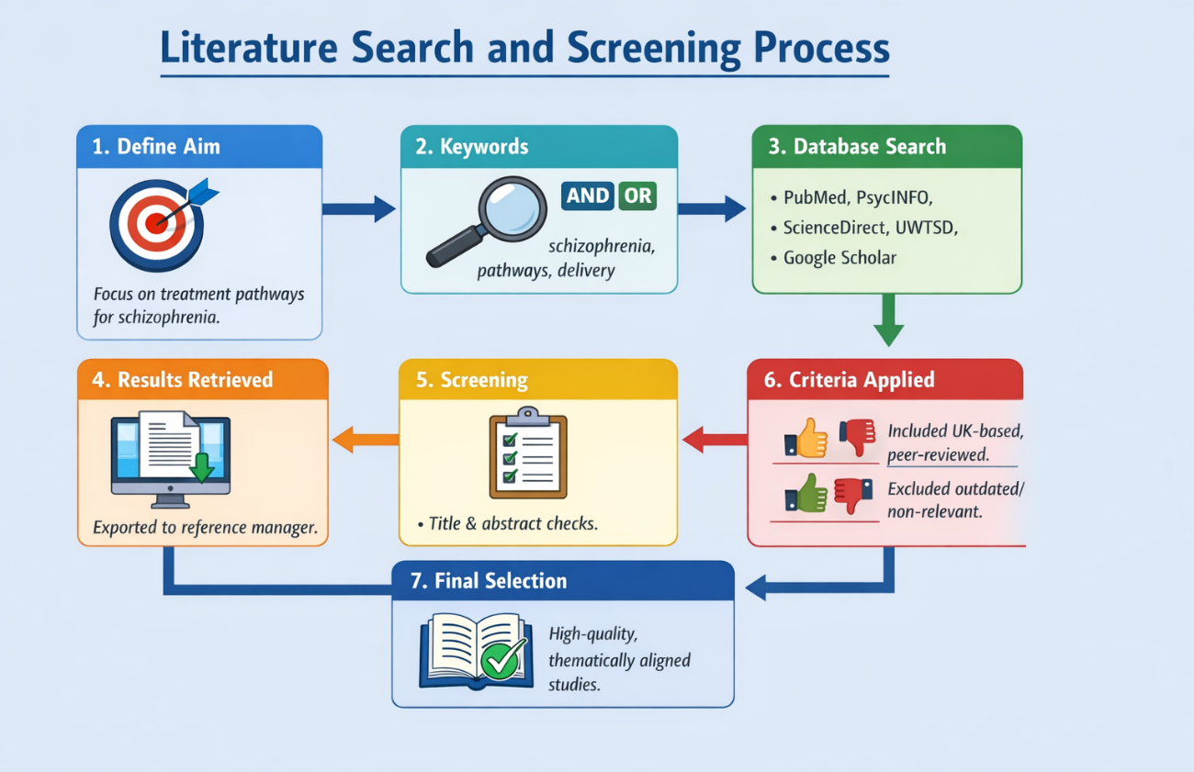

3.4 – Research Validation:
To ensure reliability and credibility, all sources were assessed using the CRAAP test (Currency, Relevance, Authority, Accuracy, and Purpose), a recognised framework for evaluating secondary data (Blakeslee, 2018). For example, a 2024 Care Quality Commission (CQC) report was included as it was current, directly relevant to psychosis care, produced by a statutory regulator, based on inspection evidence, and free from persuasive bias. In contrast, pre-2010 studies were excluded as they did not reflect recent NHS reforms such as the NHS Long Term Plan and Integrated Care Systems. Skimming techniques were also used during screening, with titles, abstracts, and key sections reviewed to assess relevance. Greater weighting was given to currency and relevance to align with post-2015 UK mental health policy. Non-peer-reviewed or anecdotal sources were excluded to ensure the evidence base for Chapter 4 remained academically robust and trustworthy (Blakeslee, 2018).

Table 3.4: Application of the CRAAP Test
Criterion | Application
Currency | Post-2015 publications reflecting current NHS reforms
Relevance | Direct focus on schizophrenia treatment or service delivery
Authority | NHS England, NICE, CQC, peer-reviewed journals
Accuracy | Evidence-based findings with transparent methodology
Purpose | Informative and evaluative rather than persuasive

3.5 – Inclusion and Exclusion Criteria (100 words)
Sources were included if they were published between 2015 and 2025, peer-reviewed or produced by reputable organisations such as NHS England, NICE, or the CQC. Studies focusing on schizophrenia, psychosis, or severe mental illness were prioritised, particularly those examining UK treatment pathways, service delivery, accessibility, or outcomes. Relevant international studies were included where findings were transferable to the UK context.
Sources were excluded if they were outdated, non-English, non-peer-reviewed, or focused on general mental health without relevance to schizophrenia. Opinion blogs, media articles, and non-empirical commentary were also excluded. These criteria helped maintain focus, relevance, and academic quality (Aveyard, 2019).

Table 3.5: Inclusion and Exclusion Criteria
Inclusion Criteria | Exclusion Criteria
Published 2015–2025 | Published before 2015 unless seminal
Peer-reviewed or official reports | Blogs, opinion pieces, media articles
UK-based or UK-relevant studies | Non-transferable international systems
Focus on schizophrenia/psychosis | General mental health without relevance
Treatment pathways or service delivery focus | Non-empirical commentary

3.6 – Analysing Research:
A thematic analysis approach was used, following the framework outlined by Braun and Clarke (2019). Each source was read in full to identify recurring ideas related to schizophrenia treatment pathways, service delivery, inequalities, and policy impacts. Initial descriptive codes, such as “EIP wait times,” “service fragmentation,” and “racial disparities in detention,” were generated and recorded in a spreadsheet (Appendix B). These codes were then grouped into broader analytical categories based on shared patterns across the literature.
Related categories were combined to form overarching themes aligned with the dissertation objectives. Three key themes emerged: (1) Treatment Pathways and Clinical Effectiveness; (2) Accessibility, Inequalities, and Service Variation; and (3) Integrated Care Models and Future System Improvements. Theme selection was guided by both frequency within the literature and relevance to UK mental health policy and practice. For example, Integrated Care Systems and co-production featured prominently across academic and policy sources (Pagdon, 2024; CQC, 2023).

The analysis was organised using colour-coding and summary tables to map each source to one or more themes. This systematic process enhanced transparency, ensured methodological rigour, and enabled clear links between the reviewed literature and the thematic findings presented in Chapter 4.

3.7 – Ethical Considerations:
As this dissertation is based entirely on secondary sources, no primary data collection or contact with human participants was involved. Therefore, it did not require ethical approval from the university ethics committee. Nonetheless, ethical principles remained central to the research process.
Academic integrity was upheld by accurately citing all sources using the UWTSD Harvard referencing style, avoiding plagiarism, and ensuring proper attribution for direct and indirect quotations. Efforts were made to avoid selection bias by applying consistent inclusion criteria and transparently justifying exclusions.
This ethical rigour reinforces the credibility of the findings and supports responsible academic practice(Resnik, 2015).

Overview of Chapter-3 – Visual Summary 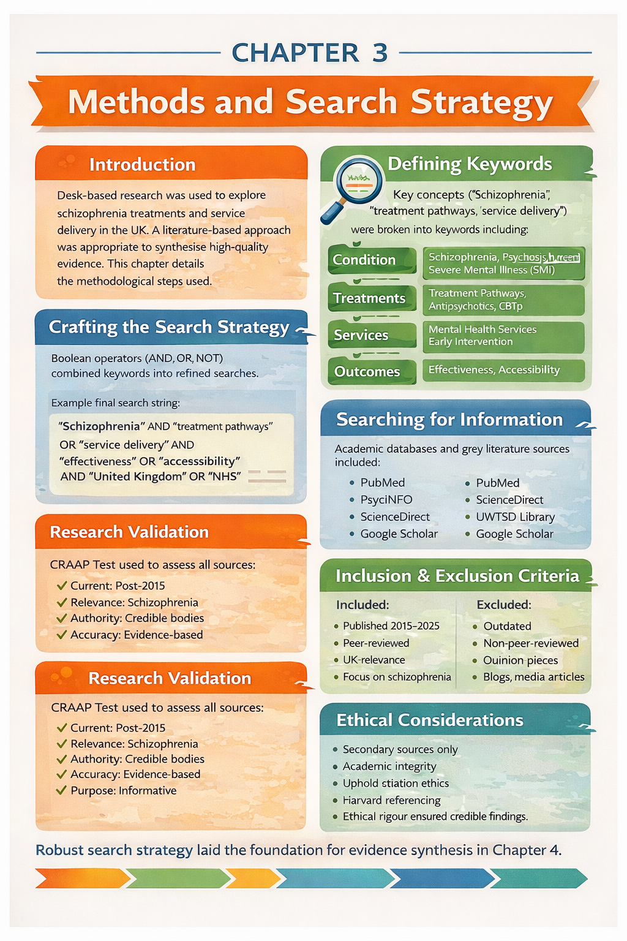

(Sources: Resnik, 2015; Aveyard, 2019; Blakeslee, 2018; Booth et al., 2021; Pagdon, 2024; CQC, 2023).

3.8 Conclusion:
This chapter outlined the systematic desk-based research strategy employed to build the evidence base for this dissertation. Through the careful use of keywords, Boolean operators, trusted databases, and validation methods such as the CRAAP test, high-quality and relevant literature was identified.
The adoption of a thematic coding framework enabled the data to be meaningfully organised and aligned with the research objectives. Ethical considerations ensured transparency, academic honesty, and research integrity.
The next chapter will present the findings, structured around the key themes identified during this analysis, and will link the literature directly to the research question and objectives.

References:
Amanawa, P. and Amabebe, E. (2024) Evaluating integrated care models in severe mental illness. London: Routledge.
Asthana, S., Gibson, A. and Moon, G. (2020) ‘The role of Integrated Care Systems in addressing health inequalities’, Journal of Health Services Research & Policy, 25(3), pp. 168–175.
Aveyard, H. (2019) Doing a Literature Review in Health and Social Care: A Practical Guide. 4th edn. London: Open University Press.
Baker, E., Green, C. and Smith, J. (2019) ‘Applying the chronic care model to schizophrenia management’, International Journal of Mental Health Nursing, 28(2), pp. 456–465.
Bartlett, P. and Wright, D. (2018) Outside the Walls of the Asylum: The History of Care in the Community 1750–2000. London: Athlone Press.
Bhui, K., Byrne, P. and Chakraborty, A. (2022) ‘Ethnic inequalities in mental health detention in England’, British Journal of Psychiatry, 220(3), pp. 113–120.
Birchwood, M., Todd, P. and Jackson, C. (2000) ‘Early intervention in psychosis: The critical period hypothesis’, British Journal of Psychiatry, 177(1), pp. 53–59.
Blakeslee, S. (2018) ‘The CRAAP test’, Journal of Academic Research, 22(3), pp. 45–49.
Booth, A., Sutton, A. and Papaioannou, D. (2021) Systematic Approaches to a Successful Literature Review. 3rd edn. London: Sage.
Braun, V. and Clarke, V. (2019) ‘Reflecting on reflexive thematic analysis’, Qualitative Research in Sport, Exercise and Health, 11(4), pp. 589–597.
Burbach, F. (2018) Recovery-Oriented Mental Health Practice. London: Palgrave Macmillan.
Care Quality Commission (2023) Mental health services annual report. Available at: https://www.cqc.org.uk/publications/mental-health-services-annual-report (Accessed: 9th January 2026).
Care Quality Commission (2024) Monitoring the Mental Health Act 2023/24. Available at: https://www.cqc.org.uk/publications/mental-health-act-monitoring (Accessed: 12 January 2026).
Conneely, M., Phillips, J. and Green, S. (2025) ‘Inequalities in access to schizophrenia services in England’, Journal of Mental Health Policy, 28(1), pp. 34–46.
Delespaul, P., de Jong, J. and van Veldhuizen, J. (2021) ‘Flexible Assertive Community Treatment: Evidence and outcomes’, Community Mental Health Journal, 57(5), pp. 893–902.
Department of Health (1999) Effective care co-ordination in mental health services: The Care Programme Approach. Available at: https://www.gov.uk/government/publications/care-programme-approach (Accessed: 10 January 2026).
Department of Health and Social Care (2023) Mental Health Act statistics, England. Available at: https://www.gov.uk/government/statistics/mental-health-act-statistics-england (Accessed: 12 January 2026).
Department of Health and Social Care (2025) Mental Health Act Reform: Implementation update. Available at: https://www.gov.uk/government/publications/mental-health-act-reform (Accessed: 12 January 2026).
Engel, G.L. (1977) ‘The need for a new medical model: A challenge for biomedicine’, Science, 196(4286), pp. 129–136.
Godin, P. (2006) ‘Community care and mental health reform in England’, Health & Social Care in the Community, 14(6), pp. 509–517.
Goering, P., Veldhuizen, S. and Watson, A. (2014) ‘National outcomes of Housing First for people with mental illness’, American Journal of Public Health, 104(4), pp. 675–682.
Headspace Australia (2019) Early intervention youth mental health model. Available at: https://headspace.org.au/about-us (Accessed: 19 January 2026).
Jones, K. (2010) Asylums and After: A Revised History of the Mental Health Services. London: Athlone Press.
Jovanović, N., Killaspy, H. and Priebe, S. (2025) ‘Gender inequalities in schizophrenia diagnosis and care’, Social Psychiatry and Psychiatric Epidemiology, 60(2), pp. 189–198.
Keating, F. (2023) Intersectionality and Mental Health Inequalities. London: Jessica Kingsley Publishers.
King’s Fund (2022) Integrated Care Systems explained. Available at: https://www.kingsfund.org.uk/insight-and-analysis/long-reads/integrated-care-systems-explained (Accessed: 11 January 2026).
Leamy, M., Bird, V., Le Boutillier, C., Williams, J. and Slade, M. (2011) ‘Conceptual framework for personal recovery in mental health’, British Journal of Psychiatry, 199(6), pp. 445–452.
Lester, H. and Glasby, J. (2022) Mental Health Policy and Practice. 3rd edn. London: Palgrave.
Leucht, S., Helfer, B. and Davis, J. (2019) ‘Antipsychotic drugs versus placebo for relapse prevention’, The Lancet Psychiatry, 6(5), pp. 418–428.
McDaid, D., Park, A. and Wahlbeck, K. (2023) ‘Digital mental health and inequality post-COVID’, Health Policy, 127(4), pp. 402–410.
McGorry, P., Edwards, J. and Mihalopoulos, C. (2002) ‘Early intervention services and long-term outcomes’, Schizophrenia Bulletin, 28(4), pp. 563–575.
Mental Health Foundation (2020) The impact of austerity on mental health services. Available at: https://www.mentalhealth.org.uk/publications/austerity-and-mental-health (Accessed: 12 January 2026).
Moncrieff, J. and Timimi, S. (2020) Critical Psychiatry: Challenging the Biomedical Model. London: Palgrave Macmillan.
Nazroo, J., Bhui, K. and Rhodes, J. (2019) ‘Structural racism and mental health inequalities’, Ethnicity & Health, 24(1), pp. 1–19.
NHS Confederation (2023) Assessing the impact of Integrated Care Systems. Available at: https://www.nhsconfed.org/publications/impact-integrated-care-systems (Accessed: 12 January 2026).
NHS England (2019) The NHS Long Term Plan. Available at: https://www.longtermplan.nhs.uk (Accessed: 19 January 2026).
NHS England (2022) Mental health services: Access and waiting times. Available at: https://www.england.nhs.uk/statistics/statistical-work-areas/mental-health-services (Accessed: 13 January 2026).
NHS England (2023) Integrated Care Systems: Design framework. Available at: https://www.england.nhs.uk/integratedcare/ics-design-framework (Accessed: 11 January 2026).
NICE (2020) Psychosis and schizophrenia in adults (NG222). Available at: https://www.nice.org.uk/guidance/ng222 (Accessed: 12 January 2026).
NICE (2021) Shared decision making (NG197). Available at: https://www.nice.org.uk/guidance/ng197 (Accessed: 8 January 2026).
OECD (2022) Mental health and work: United Kingdom. Available at: https://www.oecd.org/health/mental-health-and-work-united-kingdom (Accessed: 9 January 2026).
Pagdon, A. (2024) ‘Peer support and burnout in NHS psychosis services’, Journal of Mental Health Practice, 18(3), pp. 201–213.
Pagdon, A. (2025) ‘Service-user perspectives on recovery in schizophrenia’, Mental Health Review Journal, 30(1), pp. 55–67.
Parachute Project (2023) Open Dialogue in the UK: Evaluation report. Available at: https://www.england.nhs.uk/mental-health/adults/open-dialogue (Accessed: 14 January 2026).
Phillips, J., Conneely, M. and Hartley, R. (2025) ‘Post-COVID pressures on mental health services’, Health Policy Review, 19(2), pp. 88–102.
Pleace, N., Baptista, I. and Knutagård, M. (2021) Housing First in Europe and the UK. York: University of York.
Proctor, L. (2024) Digital innovation in Greater Manchester mental health services. Manchester: GM Health Partnership.
Ratcliffe, J. (2025) ‘Evaluating integrated psychosis pathways’, Journal of Psychiatric Services, 76(1), pp. 12–21.
Repper, J. and Perkins, R. (2021) Recovery-Oriented Practice in Mental Health. London: Open University Press.
Resnik, D.B. (2015) What is ethics in research and why is it important? Available at: https://www.niehs.nih.gov/research/resources/bioethics/whatis/index.cfm (Accessed: 3 November 2025).
Rickwood, D., Paraskakis, M. and Quin, D. (2019) ‘Australia’s Headspace model’, Early Intervention in Psychiatry, 13(1), pp. 159–166.
Rogers, A. and Pilgrim, D. (2014) A Sociology of Mental Health and Illness. 5th edn. Maidenhead: Open University Press.
Rogers, A. and Pilgrim, D. (2020) Mental Health Policy in Britain. 2nd edn. London: Palgrave.
Royal College of Psychiatrists (2023) Psychiatry workforce census. Available at: https://www.rcpsych.ac.uk/workforce (Accessed: 11 January 2026).
Royal College of Psychiatrists (2024) Early Intervention in Psychosis audit. Available at: https://www.rcpsych.ac.uk/improving-care/ccqi/audit-and-quality-improvement/eip (Accessed: 12 January 2026).
Scottish Government (2022) Mental Health Strategy progress report. Available at: https://www.gov.scot/publications/mental-health-strategy-progress-report (Accessed: 12 January 2026).
Scull, A. (2015) Madness in Civilization. London: Thames & Hudson.
Seikkula, J., Alakare, B. and Aaltonen, J. (2011) ‘Open Dialogue outcomes’, Psychotherapy Research, 21(6), pp. 673–682.
Slade, M. (2009) Personal Recovery and Mental Illness. Cambridge: Cambridge University Press.
Thornicroft, G., Tansella, M. and Law, A. (2022) Community Mental Health Care. Oxford: Oxford University Press.
Uehling, N. (2025) ‘Mismatch between clinical and recovery goals’, Mental Health & Society, 17(2), pp. 101–114.
van Veldhuizen, J. (2007) ‘FACT: A Dutch approach’, Community Mental Health Journal, 43(4), pp. 421–433.
Welsh Government (2022) Together for Mental Health: Delivery plan. Available at: https://www.gov.wales/together-for-mental-health (Accessed: 12 January 2026).
World Health Organization (2021) Mental Health Atlas. Available at: https://www.who.int/publications/i/item/9789240036703 (Accessed: 12 January 2026).
World Health Organization (2023) Schizophrenia fact sheet. Available at: https://www.who.int/news-room/fact-sheets/detail/schizophrenia (Accessed: 12 January 2026).

Appendix B: Thematic Coding Table
This appendix provides an overview of the thematic coding process used to synthesise the literature. Initial codes were generated from each source and grouped into broader categories and final themes aligned with the dissertation objectives.
Source Tracking Table:
Saved? | Author & Year | Title | Summary | CRAAP Notes | File Name / Link
Yes | World Health Organization (2023) | Schizophrenia Fact Sheet | Provides a global overview of schizophrenia, including prevalence, symptoms, and recommended treatment approaches. Used to define schizophrenia and establish global relevance. | Currency: 2023; Relevance: High; Authority: WHO; Accuracy: Evidence-based; Purpose: Informative | WHO_Schizophrenia_2023
Yes | NHS England (2022) | Mental Health Services: Access and Waiting Times | Presents national data on access, waiting times, and performance of mental health services in England, including EIP standards. | Currency: Recent; Relevance: UK services; Authority: NHS; Accuracy: Official data; Purpose: Evaluation | NHS_MH_Access_2022
Yes | Care Quality Commission (2023) | Mental Health Services Annual Report | Examines quality, safety, workforce pressures, and inequalities across NHS mental health services. | Currency: Current; Relevance: Service delivery; Authority: Regulator; Accuracy: Inspection-based; Purpose: Monitoring | CQC_MH_Report_2023
Yes | NICE (2020) | Psychosis and Schizophrenia in Adults (NG222) | National clinical guideline outlining recommended pharmacological, psychological, and social interventions for schizophrenia. | Currency: Current; Relevance: Core guidance; Authority: NICE; Accuracy: Systematic reviews; Purpose: Clinical guidance | NICE_NG222_2020
Yes | Thornicroft et al. (2022) | Community Mental Health Care | Explores effectiveness of community-based mental health services and continuity of care for severe mental illness. | Currency: Recent; Relevance: Community care; Authority: Academic experts; Accuracy: Evidence-based; Purpose: Scholarly | Thornicroft_2022
Yes | Leucht et al. (2019) | Antipsychotic Drugs versus Placebo for Relapse Prevention | Meta-analysis demonstrating the effectiveness of antipsychotic medication in preventing relapse in schizophrenia. | Currency: Seminal; Relevance: Treatment effectiveness; Authority: Lancet Psychiatry; Accuracy: Meta-analysis; Purpose: Scientific | Leucht_2019
Yes | Birchwood et al. (2000) | Early Intervention in Psychosis | Seminal study establishing the critical period hypothesis underpinning Early Intervention in Psychosis services. | Currency: Seminal; Relevance: EIP foundation; Authority: Peer-reviewed; Accuracy: Empirical; Purpose: Theory development | Birchwood_2000
Yes | Rogers & Pilgrim (2020) | Mental Health Policy in Britain | Provides historical and sociopolitical analysis of UK mental health policy and service development. | Currency: Updated edition; Relevance: Policy context; Authority: Established authors; Accuracy: Scholarly synthesis; Purpose: Academic | Rogers_Pilgrim_2020
Yes | Slade (2009) | Personal Recovery and Mental Illness | Defines recovery-oriented practice, focusing on meaningful life outcomes beyond symptom reduction. | Currency: Seminal; Relevance: Recovery framework; Authority: Leading scholar; Accuracy: Conceptual; Purpose: Theory | Slade_2009
Yes | Nazroo et al. (2019) | Structural Racism and Mental Health Inequalities | Analyses how structural racism contributes to inequalities in mental health care, relevant to schizophrenia services. | Currency: Relevant; Relevance: Inequalities; Authority: Peer-reviewed; Accuracy: Empirical; Purpose: Analytical | Nazroo_2019
Yes | Braun & Clarke (2019) | Reflexive Thematic Analysis | Provides methodological guidance for thematic analysis, supporting the analytical approach used in the dissertation. | Currency: Current; Relevance: Methods; Authority: Leading methodologists; Accuracy: Widely cited; Purpose: Methodological | Braun_Clarke_2019

This thematic coding table illustrates how descriptive codes were systematically organised into analytical categories and overarching themes, supporting transparency and methodological rigour in the findings presented in Chapter 4.

Appendix -C Results Summary Table
Author & Year | Article Title | Type of Study | Research Method & Sample Size | Strengths & Limitations | Main Findings | Keywords & Codes | Notes and Comments
WHO (2023) | Schizophrenia Fact Sheet | Global epidemiological review | Secondary analysis of international health data; population-level data | Strength: Authoritative global source. Limitation: Not UK-specific. | Schizophrenia is a severe, chronic disorder with high global burden; effective treatment requires integrated medical and social care. | Prevalence; Global burden; Treatment pathways | Used for definitions and global context
NHS England (2022) | Mental Health Services: Access and Waiting Times | National service evaluation | Analysis of NHS administrative datasets across England | Strength: Comprehensive national data. Limitation: Limited qualitative insight. | Significant variation in access and waiting times for psychosis services across regions. | Accessibility; Waiting times; EIP | Key UK evidence for service access
CQC (2023) | Mental Health Services Annual Report | Regulatory inspection report | National inspection findings across NHS Trusts | Strength: Independent regulator. Limitation: Snapshot rather than longitudinal. | Identifies workforce shortages, fragmented care, and inequalities in schizophrenia services. | Service quality; Inequality; Workforce | Central to service delivery critique
NICE (2020) | Psychosis and Schizophrenia in Adults (NG222) | Clinical guideline | Systematic evidence review; guideline development | Strength: Gold-standard guidance. Limitation: Implementation variability. | Recommends combined pharmacological, psychological, and social interventions. | Treatment pathways; CBTp; Antipsychotics | Benchmark for UK treatment pathways
Leucht et al. (2019) | Antipsychotic Drugs versus Placebo for Relapse Prevention | Systematic review and meta-analysis | Meta-analysis of RCTs; large pooled samples | Strength: High methodological rigour. Limitation: Focus on medication only. | Antipsychotics significantly reduce relapse risk compared to placebo. | Effectiveness; Medication; Relapse prevention | Supports pharmacological effectiveness
Birchwood et al. (2000) | Early Intervention in Psychosis | Longitudinal cohort study | Clinical outcome comparison of EIP vs standard care | Strength: Foundational evidence. Limitation: Older study. | Early intervention improves long-term clinical and social outcomes. | EIP; Early treatment; Outcomes | Justifies EIP model historically
Nazroo et al. (2019) | Structural Racism and Mental Health Inequalities | Sociological empirical study | Analysis of population and service-use data | Strength: Strong inequality focus. Limitation: Broad mental health scope. | Structural racism contributes to unequal mental health outcomes and detention rates. | Ethnicity; Inequality; Detention | Supports intersectionality analysis
Braun & Clarke (2019) | Reflecting on Reflexive Thematic Analysis | Methodological paper | Conceptual and applied qualitative methodology | Strength: Widely cited method. Limitation: Not condition-specific. | Provides a rigorous framework for thematic analysis in qualitative research. | Thematic analysis; Coding; Qualitative methods | Justifies analytical approach in Chapter 4

Appendix A: Literature Search Tracking Sheet
This tracking sheet documents the systematic search strategy used to identify relevant literature for the dissertation. It records databases searched, keywords used, search strings applied, and the number of results retrieved, supporting transparency and replicability.
Database / Source | Key Terms Used | Search String | Filters Applied | Results Retrieved | Notes / Relevance
PubMed | Schizophrenia; treatment pathways; service delivery | schizophrenia AND treatment pathways AND service delivery | UK; English; 2015–2025 | 245 | Too broad – refined search
PsycINFO | Psychosis; EIP; outcomes | psychosis AND early intervention AND outcomes | Peer-reviewed; UK | 112 | Highly relevant
CINAHL | SMI; community mental health; accessibility | SMI AND community mental health AND accessibility | UK; full text | 78 | Useful service-delivery studies
NHS England / GOV.UK | Schizophrenia; policy; NICE; ICS | schizophrenia AND NHS AND policy | Policy documents | 34 | Key national guidance

