Qualification: CIPD Diploma in Applied Human Resources

Module Name: 5CIHR

Using a Research Approach in HR

Word Count: 815

Student Name: Katy Barron
Student Number: 1811083
CIPD Membership Number: 5339341X
By signing below, I confirm that the work/evidence presented is my own, unaided work. I understand the regulations pertaining to candidate malpractice and the action that may be taken as a result.

Signed: K.L.Barron
Date: 04/11/2018

Using a Research Approach in HR
Research is a study or investigation into a specific issue, problem or concern to increase knowledge by using materials and resources in a systematic way (Anderson 2013). The size of a study varies due to organisations’ own policies and procedures.
Research topics could include sickness absence. Perhaps there is a department with high or reoccurring absences. With research, the reason for this could be poor equipment used or lack of support regarding stress/mental health. Another example could be improving staff wellbeing. Through research, recommendations of ways to improve could come alight, such as lunch time yoga sessions. Once the topic has been identified there must be consideration of the process.
Horn (2009) states professionals must recognise similar existing studies and knowledge surrounding the topic also highlighting four possible methods of researching a topic. Depending on the subject, the relevancy of the methods will vary. First is the burning desire strategy formed from a personal interest into a specific area. If the topic chosen is something of high interest to the professional, they may choose this strategy. Next is the replication strategy; reapplying previous research into a new context. Replicating an earlier research project on the same topic and amending to fit within the organisation. Then there’s the practical problem strategy. Perhaps following a staff briefing, a problem has arisen which the HR professional has decided to study, resolving through a focused project. Finally, the convenient strategy is where a professional will choose a research topic because they have access to it. (Horn, 2009) This could be a learning and development co-ordinator looking into training for staff through surveys.
Anderson (2013), created a research roadmap guide listing the different stages required to successfully complete a research project. Initially a professional will need to decide the research topic and design. They will be reading/evaluating what’s already known; drafting a literature review. It’s essential to collect good quality data and again write a draft of the data collected. Following this, they’ll need to illustrate the information by writing drafts of the introduction, analysis and conclusions/recommendations. Finally, they will need to present the result through a final draft. Appendix 1 demonstrates this.
The two types of data used in research; primary/secondary and qualitative/quantitative (Anderson, 2013).
Primary data is collected during the study and secondary data is information that exists. (Anderson, 2013). Qualitative data is consistently based around words and meanings, whereas quantitative data contains numbers and statistics. (Bryman and Bell, 2015).
Bryman and Bell (2015) states three basic criteria must be met during the final research design; reliable, replicable and valid.
To ensure that a conclusion is valid it must ensure consistency with the data collected. According to Lesser (2010) organisations can’t see the performance of their workforce without consistent data.
Anderson (2013) stipulates four research strategies HR professionals follow, all relating to different situations. Firstly, a cross sectional strategy involves the accumulation of data through a survey. A beneficial strategy proving very cost effective. Secondly is a case study. In contrast, this requires detailed research. (Anderson, 2013). Data collection could be through observation or interviews (Free Management Library, 2015). Benefits of this result in large volume of qualitative data. However, can prove difficult to analyse.
Action research is the base of problem-solving and aims to understand/encourage change. An advantageous approach to solve a specific problem by involving others in the research, meaning change to thinking patterns and experiment with new ideas and situations. (V Anderson 2013). The last strategy is comparative. This compares various situations and groups. Similarly, to cross sectional, comparative designs often use surveys and interviews to gather data in multiple settings thus allowing professionals to compare data. A popular data collection method is sampling. Sampling is a cost effective and practical way to speed up data collection. (Creswell, 2007 and Horn, 2012). However, when using the sampling method, it’s important to consider that there’s a reflection on wider groups with no bias in the data. (Bee and Bee, 2005 and Creswell, 2007).
As stated by Anderson (2013) and Bryman and Bell (2015), research projects are usually made up of one or more method of data collection. One approach is surveys where a document is produced with specific and relevant questions (Bryman and Bell, 2015).
Secondly are interviews, requiring more preparation which reflects on the detail and information collected (Horn, 2012).
Another approach is focus groups, used to assess how groups of individuals understand specific concepts and ideas (Walker 1985).
Lastly, is participant observation where the researcher steps into a social setting to gather real information. Providing the reality of the workplace hasn’t been modified for the purpose of the observer. (Anderson, 2013)
Finally, professionals analyse and conclude, studying the data for themes. Once established, the researcher will draw a conclusion and present. Anderson (2013) advises charts and tables to present data, whereas Bryman and Bell (2015) prefer bullet points.

Appendix
Appendix 1.1 Roadmap
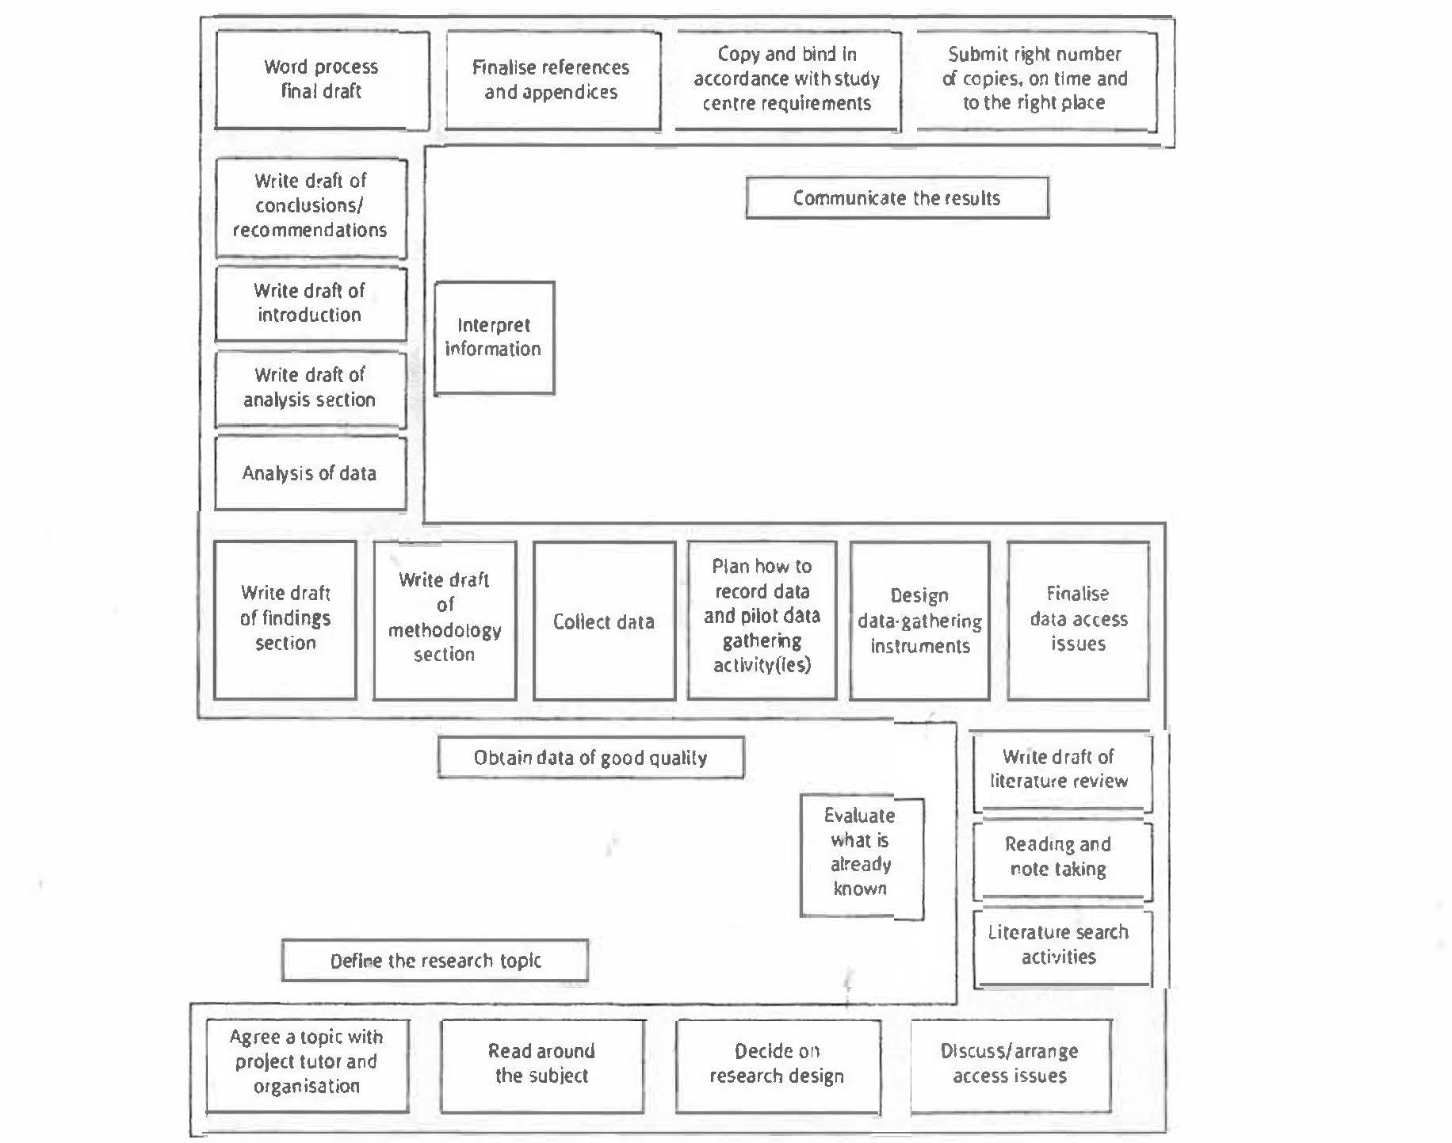

Bibliography
Anderson, V. (2013) Research methods in human resource management. 3rd ed. London: Chartered Institute of Personnel and Development.
Bee, F. and Bee, R. (2005) Managing information and statistics. 2nd ed. London: Chartered Institute of Personnel and Development.
Bryman, A. and Bell, E. (2015) Business research methods. 4th ed. Oxford: Oxford University Press.
Creswell, J. W. (2007) Qualitative inquiry and research design. 2nd ed. London: Sage.
Free Management Library (2015) Basic business research methods [online]. Available at: http://managementheko.org/businessresearch/index.htm. [Accessed 29 October 2018].
Horn, R. (2012) Researching and writing dissertations: a complete guide for business and management students. 2nd ed. London: Chartered Institute of Personnel and Development.
Lesser, E. (2010) HR analytics: go figure. People Management. 20 May 2010. [online]. Available at: https://www.peoplemanagement.co.uk/long-reads/articles/hr-analytics-go-figure. [Accessed 2 November 2018].
Walker, R. (1985) Applied qualitative research. Aldershot: Gower.

