

A comparison of the marketing methods of two multinational Hotel chains
Student Name: Koshis Bhattarai
Student ID: 2239001
Module Name: Marketing Essentials
Module Number: BMIH4005

Contents
Figures 2
Introduction 3
Main body 3
SWOT 3
Strengths 3
Weaknesses 4
Opportunities 4
Threats 4
PESTLE 4
Political 4
Economic 4
Social 5
Technological 5
Legal 5
Environmental 5
Marketing mix 5
Product 5
Pricing 6
Place 6
Promotion 7
Process 7
People 7
Physical presence 7
Targeting and positioning 8
Conclusion 8
Reference list 9

Figures
Figure 1: Holiday Inn 6
Figure 2: Six Senses 7

Introduction
This work examines promotional strategies for understanding two well- known hotel chains regarding how it functions to achieve the goals in understanding of marketing techniques. Holiday Inn, a well-known hotel chain in the United States, and Six Senses, a well-known hotel chain in Thailand. This essay will compare the results of a SWOT Analysis and a PESTLE Analysis of the two hotels. In this essay, the marketing mix methods, and the advantages they provide to their respective businesses will be discussed. In addition, this essay will show how both the company and its intended audience can benefit from using web-based technologies.

Main body

SWOT

Strengths
Holiday Inn has a solid foundation financially and job experience functions which provide exceptional and reliable services (Rafahat, 2022). Its own name recognition is a strong advantage. Six Senses stands out for its dedication to environmental preservation in Thailand for its environmental and sustainable practises. Both hotels have strong reputations among their target audiences.

Weaknesses
The Holiday Inn requires a large investment to keep its services running smoothly. The firm is currently fighting an uphill battle to expand its global footprint (Rafahat, 2022). However, Six Senses lack recognition globally. It is also expensive comparing to other lodging options because of their upscale offerings. Both Hotels need to compete for higher profits to sustain.

Opportunities
Six Senses can increase its consumer base and brand recognition by expanding into new locations and Markets. Holiday Inn brand has better chances in US because of the familiarity of the brand leading to more people utilizing amenities.

Threats
- Holiday Inn- Increasing Supply Cost
- Six Senses – Financial crises may impact high-end demand.

- Both hotels – Big Competition, need to invest money to meet guests' preferences.

PESTLE

Political
The United States of America has been given a perfect political stability score. Due to the country's relative political calm, Holiday Inn may find success there (TheGlobalEconomy, 2023).
A low political score of -0.53 indicates posing risk for Six Senses in Thailand. The Global Economy (2023) warns that it may be risky for Six Senses to maintain normal operations within the country.

Economic
According to recent reports, the United States' GDP growth rate is 1.1%. (Historical-Calender, 2023). The decline in national income may have some negative effects on the Holiday Inn hotel group.
Thailand's GDP growth rate, on the other hand, is 1.9%, which is higher than the US's 1.6%. (Historical - Calendar, 2023). When compared to Holiday Inn, the Six Senses has several advantages, including the potential to earn more money in the country. There is room for development and expansion at the hotel in Thailand.

Social
The United States actively fosters a society that values individualism. Holiday Inn can benefit from this because it will bring attention to the hotel chain as an individual entity. Thailand encourages a collectivist society, which emphasises teamwork and mutual benefit (Zablocki et al., 2019). If the national hotel chain fosters a culture of cooperation, it will be able to take advantage of additional business prospects.

Technological
Virtually every person living in the United States currently makes use of at least one social networking site. The hotel can utilize the information to improve its marketing nationwide. Additionally, hotels can use social media to promote their offerings, attracting a wider audience. In Thailand, roughly 81.2% of the population is active on social media. Users contributes to fulfilling the social media goals in both countries. wishes.

Legal
The United States of America has a comprehensive law against workplace discrimination. Holiday Inn employees benefit from a safe workplace environment. Employees in Thailand have the right to take up to two sick days per year under the country's labour code. The Six Senses hotel chain stands to gain from this legislation, as a more engaged workforce is essential to the success of the company.

Environmental
Holiday Inn must implement strict rules to ensure environmental sustainability. There are a few responsibilities that must be met to keep the country's air quality at a healthy level. Multiple emissions of carbonated gases contribute to poor air quality in the United States. The air in Thailand is much better than in the United States. The Thai hotel company, however, must pay attention to its responsibilities if it is to ensure that the air is not affected while doing business.

Marketing mix

Product
To accommodate its guests' varying requirements, Holiday Inn provides a variety of spacious, modern accommodation types. They have restaurants and other conveniences like free Wi-Fi and exercise centres. However, Six Senses places a premium on giving each of its visitors something new and innovative. The company is committed to environmental responsibility, so they use renewable energy sources and organic materials in their designs.
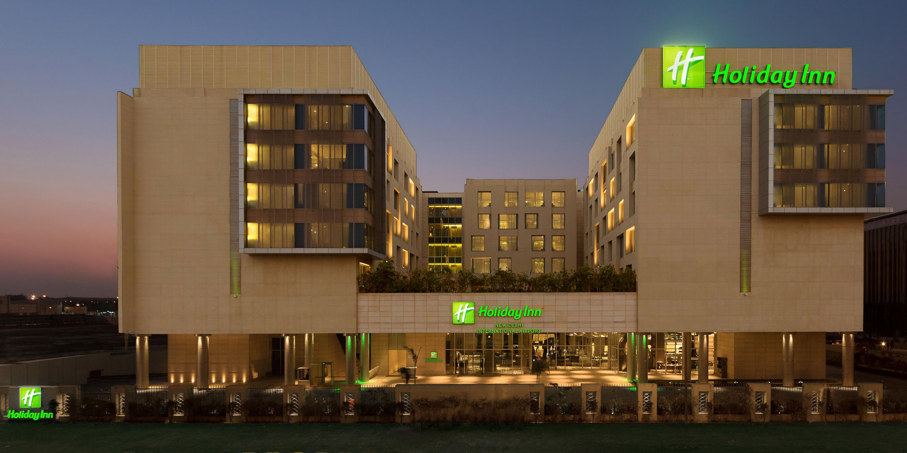
Figure 1: Holiday Inn
(Source: IHG, 2023)

Pricing
Holiday Inn offers the service directly using websites reservation with the prices reflecting the service costs. (Kwok et al., 2020). Six Senses markets itself as a high-end with limited availability and high-quality services with higher costs. Both hotel chains have adopted very similar pricing strategies.

Place
Hotels in the Holiday Inn chain are typically placed in busy tourist and business districts. In addition, it costs in specific areas by keeping an eye on sales prospects (Paul and Mas, 2020.). On the other hand, Six Senses attracts potential guests using a combination of direct bookings through its website and a partnership with online a, which is managed by means of online travel agencies.
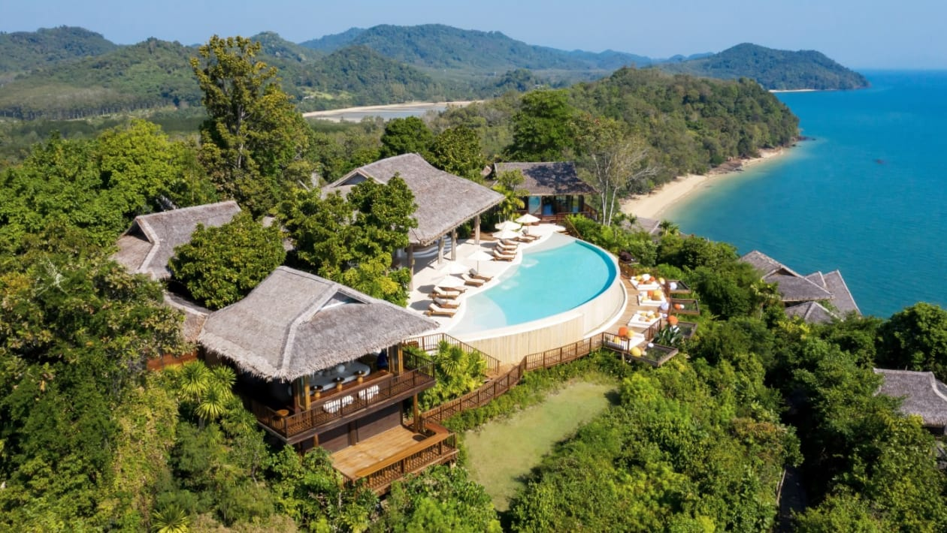
Figure 2: Six Senses
(Source: Leigh, 2022)

Promotion
Holiday runs commercials on several different television shows and social media platforms to bring in Customers. Six Senses creates good content for online platforms to attract customers. Successful advertisement attracts guests.

Process
Holiday Inn uses effective and user-friendly reservation platforms. Six Senses focuses in about eliminating unnecessary friction at every turn. The event planners ensure quality in-room service for guests.

People
Holiday Inn is focused on every guest satisfaction via professional development and friendliness (Paul and Mas, 2020.). Thai hospitality industry training emphasises providing exceptional service to guests. In addition, licenced massage therapists and other experts can be found at the hotel chain's spas.

Physical presence
Holiday Inn highlights cleanliness in public areas and eateries. Strategic utilisation of room, lobby, and other property amenities, pleases the guests (Paul and Mas, 2020.). Six Senses applies design which offers yoga studios and gyms, the brand also features organic restaurants, spas, and other luxury amenities.
Both hotels’ chains use very similar marketing mix techniques, with the main distinction being in their respective prices.

Targeting and positioning
The Holiday Inn hotel chain is renowned for its excellent customer service targeting primary the customer of 30-50 using digital marketing and online service agencies to draw in their ideal clientele with their tactics. The promotions are made using the online service agencies. In addition, PPC advertising is used to promote the company's offerings. The adverts aid the hotel in accommodating more potential guests. In the United States, people visit a wide variety of websites to learn more about different hotel companies. Holiday Inn's tactics have helped the chain steadily expand throughout the years. However, Six Senses is well-known in Thailand's. The hotel's website employs a wide range of data analytics, search engine optimization, email marketing, and other methods to help it reach its target audience (Huang and Rust, 2021). The hotel primarily caters to the country's youthful professionals and those under the age of 50. The hotel's internet profiles continue to positively reinforce the hotel's positioning approach. Effective promotion and customer acquisition are achieved via block postings and descriptive materials. Successful positioning with digital marketing for good advertisement and streamlines online bookings. Both hotel groups' official websites allow customers to view amenity availability. However, holiday encourages a solitary approach to work. Six Senses, on the other hand, fosters teamwork among its employees. The service of Six Senses is superior to Holiday Inn because it aimed at the general populace, traditional marketing has a larger potential audience (Li et al., 2021). With the use of client data like age and gender, businesses can better tailor their digital marketing campaigns to their ideal audience. Using digital marketing tactics, businesses may reach a global audience and expand their consumer base. Digital marketing is cost effective comparing to conventional advertisement.

Conclusion
Reading this piece, one comes away with the impression that there are several openings for Holiday Inn franchises across the country. Six Senses has some growth potential in Thailand, but to compete with established rivals, it will need to invest significantly more capital. During business, they encounter several obstacles, both internal and external. The internal and external environmental factors that have influenced both hotels have been discussed in detail in the article. Similarities between the hotels' marketing mix methods have been outlined and illustrated in this essay. Additionally, the essay has covered a comparison of the two hotels' approaches to marketing to its target demographic.

Reference list
Historical - Calendar (2023) Thailand GDP growth RATE2023 data - 2024 forecast - 1993-2022 historical - calendar, Thailand GDP Growth Rate - 2023 Data - 2024 Forecast - 1993-2022 Historical - Calendar. Available at: https://tradingeconomics.com/thailand/gdp-growth (Accessed: 19 May 2023).
Historical-Calender (2023) United States GDP growth RATE2023 data - 2024 forecast - 1947-2022 historical, United States GDP Growth Rate - 2023 Data - 2024 Forecast - 1947-2022 Historical. Available at: https://tradingeconomics.com/united-states/gdp-growth (Accessed: 19 May 2023).
Huang, M.H. and Rust, R.T., 2021. A strategic framework for artificial intelligence in marketing. Journal of the Academy of Marketing Science, 49, pp.30-50.
IHG (2023) Hotel in New Delhi: Holiday inn new delhi int’l airport hotel, IHG. Available at: https://www.ihg.com/holidayinn/hotels/us/en/new-delhi/delap/hoteldetail (Accessed: 19 May 2023).
Kwok, L., Tang, Y. and Yu, B., 2020. The 7 Ps marketing mix of home-sharing services: Mining travelers’ online reviews on Airbnb. International Journal of Hospitality Management, 90, p.102616.
Leigh, W. (2022) Six senses yao noi: A sensational island retreat, The Week UK. Available at: https://www.theweek.co.uk/arts-life/travel/957335/six-senses-yao-noi-hotel-review-thailand (Accessed: 19 May 2023).
Li, F., Larimo, J. and Leonidou, L.C., 2021. Social media marketing strategy: definition, conceptualization, taxonomy, validation, and future agenda. Journal of the Academy of Marketing Science, 49, pp.51-70.
Paul, J. and Mas, E., 2020. Toward a 7-P framework for international marketing. Journal of Strategic Marketing, 28(8), pp.681-701.
Rafahat, M., 2022. Service Strategy of Hotel Holiday Inn (Doctoral dissertation, Sonargaon University (SU)).
TheGlobalEconomy (2023) Political stability by country, around the world, TheGlobalEconomy.com. Available at: https://www.theglobaleconomy.com/rankings/wb_political_stability/ (Accessed: 19 May 2023).
TheGlobalEconomy (2023) Thailand political stability - data, Chart, TheGlobalEconomy.com. Available at: https://www.theglobaleconomy.com/Thailand/wb_political_stability/ (Accessed: 19 May 2023).
Zablocki, A., Makri, K. and Houston, M.J., 2019. Emotions within online reviews and their influence on product attitudes in Austria, USA and Thailand. Journal of interactive marketing, 46(1), pp.20-39.

