Digital skills

How to create a chart in a word format?

Table of Contents
Introduction 3
Process of creating a chart in a word format 4
Conclusion 6
Reference 7

Introduction
Creating a chart format in word document helps in upgrading data presentation and making its visually accessible. The report is based on learning about the process of creating charts in word format.

Process of creating a chart in a word format
Open Microsoft Word
Open Microsoft Word to begin a new document to achieve an empty space where the poster layout creation will take place efficiently.
Set Up Your Poster Layout
Under the Layout tab, you can change the page size to be equal to the desired size of a poster, such as A3 or A2, and set your margins to ensure the appropriate placing of content on a poster (Coşkunserçe and Aydoğdu, 2022).
Insert a Chart
Go to the Insert tab and click on the button Chart, there are various types of charts. Select the one you think best describes your data for graphic representation and click OK.
Choose a Chart Type
The choices include Column, Line, or even Pie charts. All have their special uses addressing various datasets, choose one that best suits your intended message.
Enter Your Data
Write your data into the excel sheet that is displayed right beside the chart (Coşkunserçe and Aydoğdu, 2022). It will be represented on the chart and you shall immediately see the changes by just editing it on the computer.
Customize Your Chart
To customize the chart, go to the Chart Design and Format tab. Do not get confused with colors, styles, and layouts as you work on the poster.
Resize and Position the Chart
Move the chart around by clicking on it, and changing the chart size to different angles using the edges of the chart. Place it as part of the general design in your poster template so you can easily reach other items.
Final Adjustments
All the necessary changes to the format of the chart have probably been made, but you need to double-check for neatness and easy to read fonts. If needed, change the size and color of the text.
Save Your Document
After final adjustment, save the document as it is likely to be lost. Provide a descriptive file name so that the creator knows where the file is later, And it is wise to save the file in a few different formats at a time.

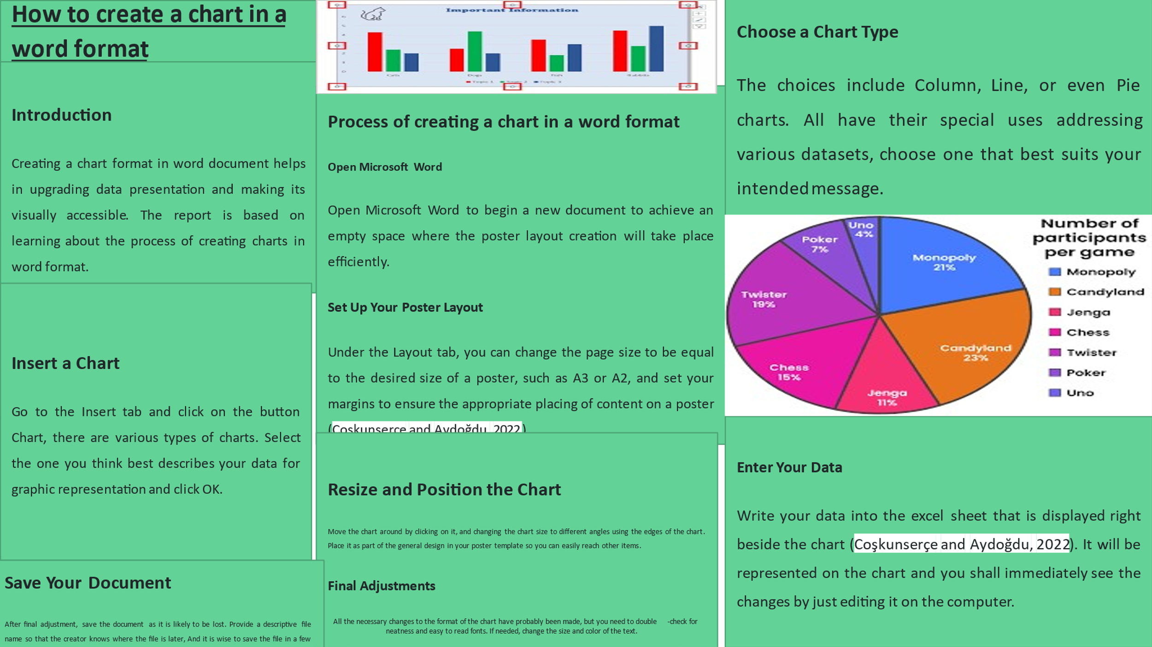

Conclusion
Leveraging charts into a word document helps in elevating the overall communication of data. The reports help in learning about the overall process of creating a word document for upgrading customer engagement and understanding.

Reference
Coşkunserçe, O. and Aydoğdu, Ş., (2022). Investigating the digital skills of undergraduate students in terms of various variables. Journal of Educational Technology and Online Learning, 5(4), pp.1219-1237.

