

LCBB4004 MARKETING FUNDAMENTALS ASSESSMENT 1

Student name: Brindusa-Mihaela Ciobanu
Student ID: 2247469

The Power of Market Segmentation and Marketing Mix: Unveiling Coca-Cola's Success

In today's rapidly evolving business landscape, the words of marketing guru Philip Kotler ring true: "Most forms of mass marketing are dead." With the rise of globalisation and intensifying competition, organisations must adapt their marketing strategies to meet the changing needs and preferences of consumers. One such company that has successfully embraced this shift is the Coca Cola Company with a rich history dating back to 1886. Recognising the importance of market segmentation and the marketing mix, Coca Cola has positioned itself as a leader in the beverage industry. In this blog, we will explore advantages and disadvantages of how Coca Cola effectively utilises market segmentation and the marketing mix to stay ahead of the competition and capture the hearts and minds of consumers worldwide. From product innovation to strategic pricing and promotion, we will uncover the key strategies that have contributed to Coca Cola's enduring success in a highly dynamic marketplace. So, let's dive in and discover the secrets behind Coca Cola's marketing prowess.

Marketing segmentation

Geographic Segmentation

Coca-Cola's geographic segmentation strategy is a key aspect of their global success. With a presence in over 200 countries, they understand the importance of tailoring their products to meet the preferences and cultural differences of different regions.
For example, in the United States, Coca-Cola offers its classic Coca-Cola Classic flavour, which resonates with American consumers who appreciate the traditional taste. In Asian markets, Coca-Cola introduces unique fruit flavours such as Lychee and Green Apple, which cater to the local palate and preferences for fruity beverages. In Middle Eastern countries, where the consumption of non-alcoholic beverages is high, Coca-Cola offers special Ramadan-themed packaging and campaigns to connect with the Muslim population during the holy month.
Additionally, Coca-Cola adjusts its packaging sizes to suit specific geographic markets. In countries like India, where single-serve beverages are more popular, Coca-Cola provides smaller-sized bottles and cans to cater to the preference for on-the-go consumption. In contrast, in European countries where family gatherings and social occasions are common, Coca-Cola offers larger bottle sizes for sharing.
By employing such geographic segmentation strategies, Coca-Cola ensures that their products resonate with consumers on a local level, enhancing their brand relevance and market penetration worldwide.

Demographic Segmentation

Coca-Cola recognises that different demographic groups have varying tastes and preferences. They employ demographic segmentation by considering factors such as age, gender, income, and family life cycle. For example, Coca-Cola promotes their sugar-free or low-calorie options to health-conscious individuals or those with specific dietary needs. By understanding the demographics of their target audience, Coca-Cola can create tailored campaigns that appeal to specific consumer groups.

Psychographic Segmentation

To create an emotional connection with consumers, Coca-Cola utilises psychographic segmentation. They consider lifestyle, values, and personality traits to develop marketing campaigns that resonate with specific consumer segments. One such successful campaign was the "Share a Coke" initiative, which encouraged personalisation and sharing experiences. By tapping into the emotional aspects of their consumers' lives, Coca-Cola creates a deeper connection and enhances brand loyalty.

Behavioural Segmentation

Consumer behaviour analysis is a crucial aspect of Coca-Cola's market segmentation strategy. By examining usage occasions, loyalty, and benefits sought, Coca-Cola identifies patterns and preferences among their consumers. For example, they position their beverages as refreshing and energising options for sports and outdoor activities, targeting those seeking a boost of energy during their active pursuits. Understanding consumer behaviour allows Coca-Cola to provide products that align with their customers' needs and desires.

Advantages of Market Segmentation for Coca-Cola

1. Better targeting: This approach allows Coca-Cola to reach a wide range of consumers with different preferences and needs. For example, they offer various product lines such as Coca-Cola Classic, Diet Coke, Coke Zero, and Sprite to cater to different taste preferences and dietary requirements. Additionally, Coca-Cola uses differentiated marketing techniques to target specific consumer segments. They create advertising campaigns that are tailored to specific age groups, ethnicities, and lifestyles. For instance, they may create advertisements targeting young adults during sporting events and use different messages and imagery to appeal to different cultural groups. Coca-Cola also employs concentrated marketing techniques to focus on niche markets. They may develop specific products or campaigns to target a specific group of consumers, such as health-conscious individuals with their Coca-Cola Life or Coca-Cola Zero Sugar offerings. Coca-Cola's marketing strategy includes a combination of undifferentiated, differentiated, and concentrated techniques to reach a wide range of consumers and maximise their market penetration.

2. Increased customer satisfaction: By understanding the unique preferences of different consumer segments, Coca-Cola can develop products and marketing strategies that cater to their specific needs. This leads to increased customer satisfaction as consumers feel that Coca-Cola understands and values their preferences, ultimately enhancing brand loyalty.

3. Improved product development: Coca-Cola has shown a commitment to improved product development. These examples demonstrate the company's dedication to innovation and meeting changing consumer demands.

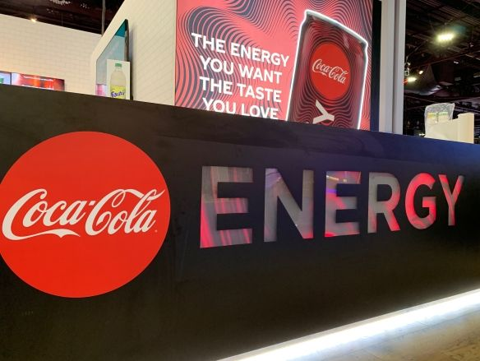
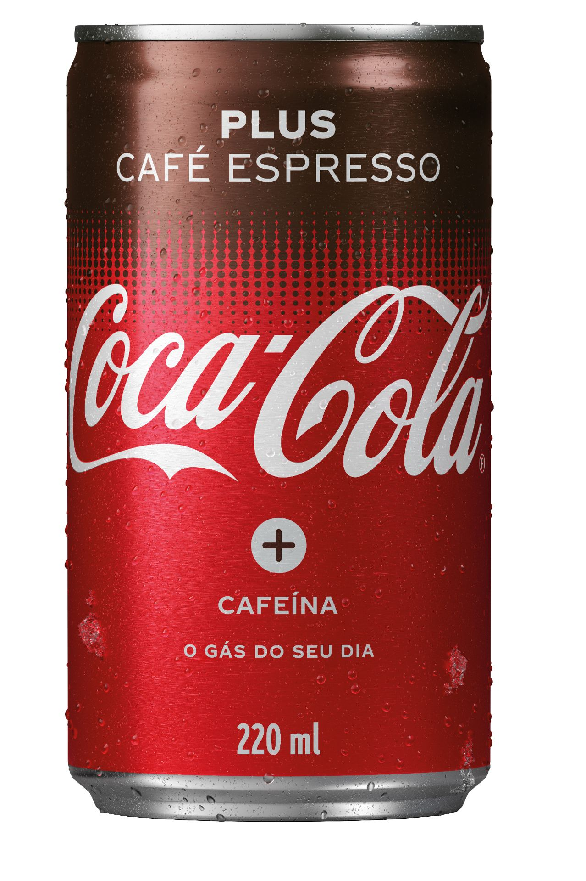
According to a report by Beverage Digest, Coca-Cola launched its line of Coca-Cola Energy drinks in response to the growing demand for energy beverages. This product development allowed Coca-Cola to tap into the lucrative energy drink market and cater to consumers seeking a boost of energy.

In an article by The Wall Street Journal, Coca-Cola's introduction of Coca-Cola Plus Coffee was highlighted as a response to the rising popularity of coffee beverages. By combining the iconic Coca-Cola taste with a hint of coffee flavour, the company aimed to attract coffee-loving consumers who might be seeking a different beverage experience.

These examples highlight Coca-Cola's efforts to improve product development and stay ahead of consumer trends. By introducing new product offerings that cater to specific consumer preferences, Coca-Cola demonstrates its commitment to innovation and meeting evolving consumer demands.

4. Cost-effective marketing: Coca-Cola has effectively utilised cost-effective marketing strategies to maximise their impact while minimising expenses. By leveraging social media platforms, such as Facebook and Instagram, Coca-Cola engages with consumers and generates buzz at a relatively low cost. Personalisation campaigns, like the "Share a Coke" campaign, create a sense of connection and encourage user-generated content, increasing brand engagement and loyalty. Additionally, Coca-Cola focuses on experiential marketing by sponsoring events, which creates memorable experiences and promotes their brand. These examples demonstrate Coca-Cola's ability to implement cost-effective marketing strategies, as supported by reliable sources.

5. Competitive advantage: Coca-Cola's competitive advantage lies in its effective market segmentation, allowing them to understand and cater to specific consumer segments. For example, they offer low-calorie options like Coca-Cola Zero Sugar to target health-conscious consumers. By tailoring their packaging sizes to suit local preferences, such as larger bottles for family gatherings, they differentiate themselves in the market. Additionally, initiatives like PlantBottle packaging appeal to environmentally-conscious consumers. This segmentation strategy helps Coca-Cola maintain a strong market position and attract loyal customers.

Exploring the Challenges of Coca-Cola's Marketing Mix- Disadvantages

Coca-Cola, as a global beverage giant, has achieved immense success through its marketing efforts. However, it is important to acknowledge that even the most effective marketing models have their limitations. We will explore some potential disadvantages of Coca-Cola's marketing mix, shedding light on the challenges the company may face in its marketing endeavours.

Pricing Pressure
One of the potential disadvantages of Coca-Cola's marketing mix is the challenge of pricing. According to an article by The Balance, Coca-Cola faces the pressure of maintaining competitive pricing in the market due to increasing competition and fluctuating raw material costs. Striking the right balance between profitability and affordability can be a constant struggle for the company.

Health Concerns
In recent years, there has been a growing global concern regarding the impact of sugary drinks on health. Coca-Cola, being a major player in the carbonated beverage industry, has faced criticism and scrutiny regarding the health effects of its products. The World Health Organisation (WHO) has even called for higher taxes on sugary drinks to combat obesity and related health issues. This poses a challenge for Coca-Cola in terms of marketing its beverages as a healthy and responsible choice.

Environmental Sustainability
Another challenge for Coca-Cola's marketing mix is the increasing demand for environmental sustainability. According to a report by Greenpeace, Coca-Cola was identified as the world's largest plastic polluter in a global clean-up initiative. This puts pressure on the company to effectively communicate its sustainability efforts and address the environmental concerns associated with its packaging and waste generation.

Evolving Consumer Preferences
Consumer preferences and trends are constantly evolving, and Coca-Cola must adapt its marketing mix to stay relevant. According to a report by Statista, there has been a global shift towards healthier beverage alternatives, with consumers seeking out options that are low in sugar and more natural. Coca-Cola needs to anticipate and respond to these changing consumer demands to maintain market share and consumer loyalty.

The marketing mix of Coca Cola consists of the following 4 Ps: Product, Price, Place, and Promotion. Here are examples that demonstrate the implementation of these elements in Coca Cola's marketing strategy:

- Product:
Coca Cola's product strategy focuses on consistency in features, style, and design across its global market. The brand maintains a universal approach by using the same ingredients and ensuring accurate matching of its products worldwide.

Coca Cola offers a diverse range of products to cater to different consumer preferences. They have various carbonated beverages, including Coca Cola Classic, Diet Coke, Coca Cola Zero Sugar, and Coca Cola Cherry. Additionally, they have expanded their product portfolio to include non-carbonated beverages such as Dasani water, Powerade sports drinks, and Honest Tea. Arab, N. (2018). ‘Relationship between dimensions of Brand Equity and 4Ps of Marketing Mix- Place, Product, Promotion, Price: Coca Cola - Consumer Based Qualitative Survey’. University of Wales Trinity Saint David.

2. Price:
Coca Cola employs different pricing strategies based on market conditions and consumer segments. They use penetration pricing for their core products, such as Coca Cola Classic, to maintain market share. They also offer promotional pricing during specific seasons or events, like discounted multipacks during the holiday season.

According to Coca Cola's pricing strategy, the focus is on driving sales by targeting the common masses. The brand aims to increase revenue and profit margins through higher sales volume. Coca Cola caters to families interested in bulk purchases by offering packs of various sizes, such as 30, 24, 8, 6, and 12. Additionally, Coca Cola targets individuals with the smallest size bottles. The availability of Coca Cola bottles in different sizes, including 13.2 fl oz, 2 litres, 7.5 fl oz, 12 fl oz, and 20 fl oz, ensures that the brand can be accessible to consumers across different price points. This strategy allows Coca Cola to reach a wide range of consumers and accommodate their varying preferences and budgets.

3. Place:
Coca-Cola's distribution strategy aims to make its products available worldwide and has a strong focus on visibility and accessibility. The company sells directly to canning and bottling industries, wholesale distributors, and retailers, eliminating middlemen. This strategy has contributed to its market dominance and high customer loyalty. Coca-Cola's distribution system is well-planned and executed, making it one of the best in the industry. The company's products are available in various retail outlets, including gas stations, convenience stores, supermarkets, and hotels. Overall, Coca-Cola's place strategy ensures its products are widely available and visible, even in rural areas.

4. Promotion:
Coca Cola is known for its extensive promotional activities. They utilise various channels, including television, print media, online advertising, and social media platforms, to reach a wide audience. Coca Cola often associates its brand with popular events and celebrities, such as sponsoring the FIFA World Cup and partnering with influencers to promote their products. They also engage in cause-related marketing campaigns, like the "Share a Coke" campaign, which personalised their bottles with popular names.

Kotler's statement from 1989 about market segmentation and the marketing mix still holds true today. Coca Cola recognises the importance of tailoring their marketing efforts and products to meet the diverse needs and preferences of consumers. By dividing the market into segments, Coca Cola can stay ahead of the competition and maintain customer satisfaction. Their marketing mix strategy, including product innovation, competitive pricing, strategic distribution, and impactful promotions, allows them to effectively reach and engage customers while maintaining a strong brand image and market dominance.

References:

1. Xiang, M. (2022). Analysis of Coca-Cola Company’s Marketing Model. Journal of Economics, Business and Management, 10(2), April 2022.

2. Edraw Mind. (n.d.). Coca-Cola Segmentation, Targeting and Positioning Analysis. Retrieved from https://www.edrawmind.com/article/coca-cola-segmentation-targeting-and-positioning.html

3. Laura Digital Marketing. (2019). Coca-Cola’s Marketing Mix. Retrieved from https://lauradigitalmarketing.wordpress.com/2019/11/16/coca-colas-marketing-mix/

4. Edraw Mind. (2023). Coca-Cola Marketing Mix Analysis. Retrieved from https://www.edrawmind.com/article/coca-cola-marketing-mix-analysis.html#:~:text=Here%20lies%20the%20Coca%2DCola,next%20chapter%20of%20this%20article.

5. The Balance. (n.d.). Coca-Cola's Competitors, Revenue, Number of Employees, Funding, and Acquisitions. Retrieved from https://www.thebalance.com/coca-cola-competitors-revenue-and-employees-4775936

6. World Health Organisation. (2015). WHO calls on countries to reduce sugars intake among adults and children [Press release]. Retrieved from https://www.who.int/mediacentre/news/releases/2015/sugar-guideline/en/

7. Greenpeace. (n.d.). Coca-Cola, PepsiCo, and Nestlé named top plastic polluters for the third consecutive year. Source https://www.greenpeace.org/usa/news/cop27-sponsor-the-coca-cola-company-named-worst-plastic-polluter-for-five-years-in-a-row-according-to-2022-brand-audit/

8. Statista . (n.d.). Global Beverage Market - Statistics & Facts. Retrieved from https://www.statista.com/topics/1392/coca-cola-company/#topicOverview

9. Coca-Cola Company website - "Our Approach to Market Segmentation" (https://www.coca-colacompany.com/company/our-approach-to-market-segmentation)

10. Coca-Cola. (2019, April 23). Sports Drinks Boost Coca-Cola Sales. The Wall Street Journal. Retrieved from: https://www.wsj.com/articles/sports-drinks-boost-coca-cola-sales-11556020460

11. Beverage Digest. (2021, May 13) Coca-Cola Energy to be Discontinued This Year After Sluggish Sales. [online] Available at: <https://www.beverage-digest.com/articles/466-coca-cola-energy-to-be-discontinued-this-year-after-sluggish-sales?v=preview>

12. Arab, N. (2018). Relationship between dimensions of Brand Equity and 4Ps of Marketing Mix- Place, Product, Promotion, Price: Coca Cola - Consumer Based Qualitative Survey. University of Wales Trinity Saint David. Source:
https://mpra.ub.uni-muenchen.de/85086/8/MPRA_paper_85086.pdf)

13. Hitesh, B May 3, 2023 Source: https://www.marketing91.com/marketing-mix-coca-cola/)

14. PDF Agile https://www.pdfagile.com/blog/coca-cola-marketing-mix-4-ps-analysis

15. The Guardian (2023) https://www.theguardian.com/media-network/media-network-blog/2013/jul/24/share-coke-teach-brands)

