CASE STUDY ANALYSIS REPORT
LCHS7002 - Health Care System Organisation and Leadership
Case Study 4: The Lewis Blackman Patient-Safety Case
A systems, governance and leadership analysis of failure to rescue

Student Name: Freeda Zeb
Student ID: 2126497

Executive Summary
This report examines the death of 15-year-old Lewis Blackman after elective surgery at a South Carolina teaching hospital. It argues that the event was a failure to rescue caused by interacting weaknesses in clinical recognition, communication, resident supervision, monitoring, hierarchy and patient-family access to senior decision-makers. Using systems thinking, Soft Systems Methodology and CATWOE, the incident is reframed as a socio-technical governance failure. The analysis identifies an authority-responsibility inversion: critical information remained at the bedside with staff and family members, while senior authority was remote and escalation was unreliable. The report considers the advantages and disadvantages of centralisation and decentralisation, behavioural, contingency, Path-Goal and transformational leadership theories, current evidence on safety culture in the United States, and Martha's Rule in England. It proposes selective centralisation of non-negotiable safety controls alongside distributed authority to speak up, escalate and learn. A five-year Reliable Rescue and Patient Voice programme is proposed, supported by SEIPS 2.0, PDSA testing, measurable standards, a risk register and board accountability.

Contents
Executive Summary 2
1. Introduction 4
2. Identifying the Problem and Setting the System Context 4
2.1 Defining the Core Problem 4
2.2 Global, United States and Comparative Significance 5
2.3 Systems Thinking, SSM and CATWOE 6
2.4 Feedback Loops and Governance Level 8
3. Centralisation and Decentralisation 9
3.1 Centralised Authority 9
3.2 Decentralised Delivery and Distributed Intelligence 10
3.3 Selective Centralisation and Distributed Vigilance 10
4. Leadership Theories and Application 11
4.1 Behavioural Leadership and the Tannenbaum-Schmidt Continuum 11
4.2 Fiedler's Contingency Theory 12
4.3 Path-Goal Theory 12
4.4 Transformational, Ethical and Emotionally Intelligent Leadership 13
4.5 Leadership Synthesis 13
5. Improvement and Lessons Learned 14
5.1 What the Reform Achieved 14
5.2 What the Reform Did Not Fully Address 15
5.3 Evidence-Based Improvement Strategy 15
5.4 Implementation Risks and Mitigation 17
5.5 Lessons for Other Health Systems 17
6. Recommendations 18
7. Conclusion 19
8. Reference List 21

1. Introduction
Lewis Blackman was a healthy 15-year-old admitted to a large South Carolina teaching hospital in November 2000 for elective surgery to correct pectus excavatum. The surgery was described as technically uncomplicated, but his condition worsened over several days. He received epidural opioids and additional intravenous ketorolac, while his oxygen-saturation alarm threshold was lowered and the monitor was turned off. Severe abdominal pain, tachycardia, pallor, abdominal distension and decreased urine output were attributed to constipation, while an unrecordable blood pressure was treated as equipment malfunction. Lewis's mother repeatedly requested a senior medical review, but none of the physicians who saw him before his cardiac arrest and death carried one out. The autopsy showed a perforated duodenal ulcer, peritonitis and significant internal bleeding (Patient Safety Movement Foundation, n.d.; Acquaviva, Haskell and Johnson, 2013).
The case is significant because it demonstrates that harm was caused by apparently routine decisions that were made, not just one outstanding error. The leadership in health and social care is about how leaders influence individuals, relationships and systems to meet shared objectives, including safe, equitable and responsive care. It's about the actions of formally established leaders and the structure of authority, information, accountability and voice. Centralisation involves moving decision rights and standards up the hierarchy; decentralisation involves moving decision rights and standards down the hierarchy. Centralisation is not necessarily a bad thing, as it gives a degree of uniformity, but it can also have the effect of inhibiting local intelligence, whilst decentralisation can enable a quick response but can also have the effect of reducing accountability.
This report does not seek to find one cause but rather sees the Lewis Blackman case as a transformation challenge. It first looks at the problem from a systems perspective, a Soft Systems Methodology (SSM) perspective, a CATWOE perspective and a Rich Picture perspective, and then looks at the centralised professional authority and decentralised delivery in the hospital. These theories are critically applied: Fiedler's contingency theory, House's Path-Goal theory, Tannenbaum-Schmidt continuum, transformational leadership and emotional intelligence. The report then assesses the effectiveness of the Lewis Blackman Hospital Patient Safety Act and recommends governance, monitoring, escalation, workforce and learning changes.

2. Identifying the Problem and Setting the System Context

2.1 Defining the Core Problem
The clinical sequence involved a postoperative complication that was not recognised or rescued. 'Failure to rescue' is more useful than 'diagnostic error' because it addresses the organisation's ability to recognise, communicate and respond to deterioration. Burke, Downey and Almoudaris (2022) distinguish three components: failure of recognition, failure of relay and failure of reaction. Recognition failed when abnormal signs and family observations were normalised; relay failed when the pattern was not brought together across professions; and reaction failed because no reliable escalation route turned concern into senior assessment and treatment.
Lewis was reported to have severe abdominal pain, pallor, hypothermia, tachycardia, no urine output, oxygen desaturation and repeated unrecordable blood pressure. Twelve attempts using seven devices were largely treated as equipment failure. The oxygen alarm threshold was reduced, and the alarm was then turned off. These behaviours show a drift away from the purpose of monitoring and a cognitive focus on constipation despite contradictory evidence (Patient Safety Movement Foundation, n.d.; Acquaviva, Haskell and Johnson, 2013).
It was not only a lack of knowledge in the junior clinician but also that no reliable backup was provided for the inexperienced clinician when he or she was placed in a high-stakes situation. The family were not aware of who was responsible for managing the team, nor how they could move beyond the immediate team, and no attending was called, although they had requested it.

2.2 Global, United States and Comparative Significance
The case is part of an ongoing global patient-safety problem. According to the World Health Organisation (WHO, 2023), approximately one in ten people receiving healthcare experience harm, and unsafe care contributes to more than 3 million deaths each year, with over half of this harm considered preventable. The WHO Global Patient Safety Action Plan therefore treats patient safety as a health-system responsibility that must be led, staffed, supported and learned from through reliable clinical processes (WHO, 2021).
United States evidence shows that patient harm remains a persistent national problem. In October 2018, 25% of Medicare patients experienced an adverse event or temporary harm during a hospital stay, and 43% of these events were preventable (HHS OIG, 2022). In the 2024 AHRQ SOPS database, 284,036 staff from 445 hospitals responded; 55% reported positively on staffing and work pace, 64% on response to error, and 47% reported at least one safety event in the previous year (Tyler et al., 2024). The database is not nationally representative and is voluntary but highlights ongoing issues with staffing, learning, and reporting.
The situation was highlighted at the state level of the conflict between autonomy and enforceable rights of patients. Staff and trainee identification, information to attend with a person and trainee participation, assistance in contacting the attending, and an always-available route for immediate help must be included in the 2005 Lewis Blackman Hospital Patient Safety Act (South Carolina Legislature, 2005). Publicly available organisation-specific performance data from the hospital at the time of the incident are limited; therefore, national safety-culture evidence is used to contextualise the case rather than directly explain it.
Martha's Rule in England is used as a contemporary comparator rather than as United States evidence. Between September 2024 and April 2026, 14,654 calls were made; 4,632 concerned acute deterioration and 2,720 resulted in a treatment change, including 616 transfers to higher or specialist care (NHS England, 2026a). The comparison suggests that family concern can strengthen surveillance, but escalation rights only work when routes are accessible, independent clinical capacity is available, and responses are timely.
Table 1. Selected evidence establishing the global, United States and state/comparative context.
Level/source | Key evidence | Implication for the case
Global - WHO | About 1 in 10 patients harmed; over half preventable | Failure to rescue is a system-design and leadership issue.
United States - HHS OIG | 25% of Medicare inpatients experienced harm; 43% judged preventable | National burden supports stronger recognition, escalation and rescue controls.
United States - AHRQ SOPS | 55% positive for staffing/work pace; 64% for response to error | Workload and learning culture can weaken surveillance and speaking up.
South Carolina / comparator | Statutory escalation rights; Martha's Rule treatment changes | Escalation rights require operational capacity, accessibility and a timely response.

2.3 Systems Thinking, SSM and CATWOE
The emphasis of systems thinking is on relations, feedback and unintended consequences, not the parts of the system (Checkland, 1999; Carayon et al., 2006). A linear account – ketorolac induces an ulcer, the staff doesn't notice the bleeding, Lewis dies – is no explanation for the control structure that ties these things together. Within the context of Reason's (2000) systems approach, active failures are embedded in broader latent conditions. In this instance, porous defences were established through medication risk, alarm management, weekend staffing and lack of staff supervision, hierarchy, inadequate documentation, and failure to leverage family knowledge.
The Rich Picture in Figure 1 represents Lewis and his family within interacting clinical, technological, educational and governance systems. The solid arrows represent information or authority; the dashed red arrows represent blocked or absent escalation routes.
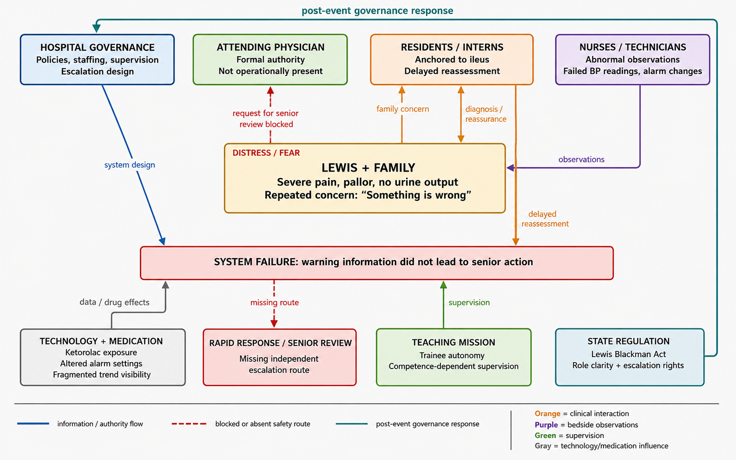
Figure 1. Rich Picture of the Lewis Blackman system. Source: synthesis from Acquaviva, Haskell and Johnson (2013), Patient Safety Movement Foundation (n.d.) and South Carolina Legislature (2005).

Table 2. CATWOE analysis of the required transformation.
CATWOE element | Application to the case
C – Customers | Lewis, his family and future postoperative patients.
A – Actors | Nurses, trainees, attending physicians, technicians, pharmacists, managers, rapid-response clinicians and regulators.
T – Transformation | Fragmented, reactive care → supervised detection, integrated evidence and guaranteed senior response.
W – Worldview | Family concern and frontline unease are legitimate safety data.
O – Owners | Hospital governing body, medical leadership and state regulator.
E – Environment | Teaching-hospital model, staffing, training needs, alarm fatigue, regulation and diagnostic uncertainty.

CATWOE explains the transformation required (Table 2). Patients and families are the customers; nurses, trainees, attendings, technicians, managers and regulators are the actors; and the governing body, medical leadership and state regulator are the owners. The system must move from trainee-dependent, fragmented care to supervised detection with guaranteed senior response. Its worldview treats family concern and frontline unease as safety data, while constraints include staffing, training, alarm fatigue and diagnostic uncertainty. The SSM root definition is a hospital-governed multidisciplinary system that brings together physiological and experiential evidence and ensures timely senior review.

2.4 Feedback Loops and Governance Level
Figure 2 identifies two reinforcing loops and one balancing loop. In the hierarchy-silence loop, status distance decreases the likelihood of speaking up and reduces senior awareness; as the situation deteriorates, pressure rises, but deference may also increase. In the anchoring loop, the initial diagnosis directs attention towards confirming evidence, reduces the influence of contradictory trends and delays reassessment. The intended balancing loop begins when physiological abnormality or family concern triggers independent review, treatment and risk reduction. There was no such loop in Lewis' care.
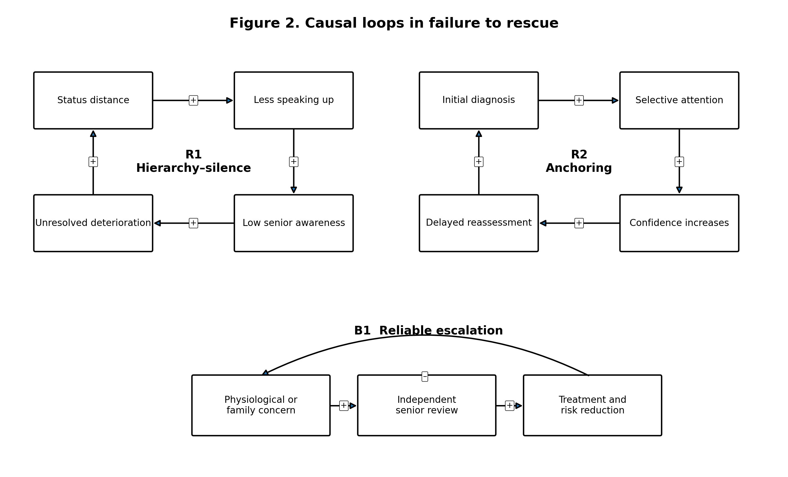
Figure 2. The pattern of causal loops in failure to rescue. R = reinforcing loop, B = balancing loop.
There were three layers of governance – micro, meso and macro. Alarms, observations and escalation were made at the bedside and therefore immediately posed a risk; the policy had an impact on supervision, staffing, and rapid response access within the hospital; and state law, licensing, and training standards established minimum expectations.

3. Centralisation and Decentralisation
The United States health system is pluralistic and decentralised, as funding, regulation and delivery occur at the federal and state levels through private organisations, professional bodies and local providers. Central standards remain in place at hospitals, including federal Conditions of Participation, state licensing and accreditation (CMS, 2024). Academic hospitals take one step further: They have governing bodies and their medical staff are credentialed and have formal accountability, whereas residents, interns, nurses and technicians deliver much of the care on a daily basis. The case therefore contains both centralised and decentralised elements, which sometimes conflict.

3.1 Centralised Authority
In the hospital, the final decision was with the attending physician; senior doctors had responsibility for diagnosis and escalation, and nurses and trainees had a hierarchy. This can offer standards and accountability but can fall apart if there is no decision making authority. Tyler et al., 2024 indicate that 64% felt positively about response to error in the 2024 SOPS database and 55% felt positively about staffing and work pace in the 2024 SOPS database.
Centralisation failed because formal authority existed but was not operationally available. Lower-level staff appeared unable or unwilling to cross organisational boundaries, and the family's request for an attending was not received by a senior clinical decision maker. This 'hollow centralisation' restricted frontline autonomy without reliably bringing senior expertise into the situation. It can develop a learned dependency: Frontline employees may assume the risk is being managed by senior clinicians, and senior clinicians may not be aware. There must also be a chain of command that is a chain of communication and response.
The latter Act tightened up the central control by clarifying the concept of attending responsibility, mandating identification of the role and introducing enforceable escalation rights. While these requirements provide a basic safety framework and promote fairness, regulation can be performative – that is, badges and telephone numbers do not mean that concerns are accepted and that there is capacity to respond. This means that local staffing, capability and evaluation (Raymond et al., 2009; Albutt et al., 2017) are required.

3.2 Decentralised Delivery and Distributed Intelligence
Care delivery was operationally decentralised to nurses, technicians and trainees who continuously observed Lewis. Bedside staff are closest to changes in a patient's condition and can respond faster than remote leaders. However, 53% of respondents in the 2024 AHRQ database reported no safety event in the previous year, despite the high national burden of hospital harm (Tyler et al., 2024; HHS OIG, 2022). Distributed observation is only useful when staff can interpret, communicate and escalate concern without fear or delay.
There is no public data on the staffing level on Lewis’s ward at the time of admission, and it would be unfair to attribute the incident to a particular nurse-to-patient ratio. According to the 2000 National Sample Survey of Registered Nurses (NSSRN), however, South Carolina had 728 employed registered nurses per 100,000 population, while the national rate was 782 per 100,000 (Spratley et al., 2001). The state-level figures indicate a relatively low supply of nurses, but not that Lewis’s ward was understaffed. Nevertheless, they support the governance argument that acuity-based staffing, good senior clinical cover, and effective night and weekend escalation processes are needed.
The problem in Lewis's care was decentralised responsibility without enough authority, competence or support. Junior clinicians were expected to make high-stakes assessments, but supervision was limited, and escalation routes were unclear. Alarm thresholds could be changed and monitoring turned off without a second protective check. Fragmentation also meant that nobody brought together the trends in pain, pulse, temperature, urine output, oxygen saturation and blood pressure. Decentralisation therefore became variation and diffusion of accountability rather than empowered expertise.
Modern training governance attempts to correct this imbalance. ACGME requirements describe resident practice as progressive responsibility carried out with guidance and supervision from qualified faculty (ACGME, 2026). This is decentralised learning with centralised accountability. In Lewis's care, autonomy should have reduced as uncertainty, physiological instability and family concern increased.

3.3 Selective Centralisation and Distributed Vigilance
Selective centralisation is the most defensible model. Non-negotiable controls should include high-risk medication, alarm configuration, vital-sign trends, escalation thresholds, attending-response times, role identification and incident learning. These standards address predictable, high-consequence risks where variation is unsafe. At the same time, the authority to recognise and raise concern should be shared with nurses, trainees, patients and families, who should be able to trigger review without fear of retaliation or first having to persuade the person whose judgement is being challenged.
This hybrid design avoids the false choice between command and participation. It brings accountability together at the centre while distributing voice. It also distinguishes clinical hierarchy from epistemic hierarchy: the attending may have the final say, but the most useful information at a particular time may come from a parent, nurse or technician. High-reliability organisations show 'deference to expertise', meaning that decisions move towards the person with the most relevant knowledge rather than simply the highest rank (Weick and Sutcliffe, 2015).
Technical efficiency can be improved through standardised electronic trending and risk-based monitoring, which reduce duplicated observation and focus monitoring on high-risk patients. Allocative efficiency requires senior and rapid-response capacity to follow risk, especially at nights and weekends. Continuous pulse oximetry can improve detection of desaturation, but outcome evidence remains limited, so it should be introduced in a targeted way with evaluation rather than as a technology-only solution (Khanna et al., 2024). Controls and accountability should be centralised, while local action and learning remain decentralised.

4. Leadership Theories and Application
Leadership theory helps explain why a well-informed organisation may still fail to act. The models are lenses rather than labels. Staffing and non-punitive response to error are common weaknesses in international safety-culture research (Alabdullah and Karwowski, 2024) and in United States SOPS data (Tyler et al., 2024).

4.1 Behavioural Leadership and the Tannenbaum-Schmidt Continuum
Behavioural approaches distinguish task-oriented behaviour, such as defining roles, monitoring performance and directing action, from people-oriented behaviour, such as listening, supporting and developing relationships. Leadership behaviours surrounding Lewis's care were inconsistent. Task orientation was disorganised: staff repeatedly took blood-pressure readings and administered medication but did not organise their work around the purpose of identifying shock. People orientation was also weak because Lewis's suffering and his mother's concerns were not treated as decision-relevant evidence. This shows that there was considerable activity but no effective leadership.
The Tannenbaum and Schmidt (1973) continuum moves from leader-centred 'tell' behaviour to team-centred delegation. In this case, the culture was leader-centred, but the senior leader was absent. Junior clinicians repeated hierarchical closure but lacked the experience and authority to manage the crisis. Once an experienced responder arrived, temporary directive action - stop the drug, investigate, resuscitate and escalate - would have been appropriate. Before that point, consultative behaviour was needed to bring together nursing observations and family information. Good leadership would therefore have adapted as the situation changed.
The continuum is useful because it considers leader, follower and situational factors, but it assumes that one leader controls the amount of freedom. In hospitals, authority crosses professional boundaries.

4.2 Fiedler's Contingency Theory
Fiedler's (1967) hypotheses are based on the premise that leader effectiveness is related to the congruence of the leader's orientation and the situational favourableness determined by leader-member relations and task structure/positional power. As Lewis grew sicker and sicker, confidence waned, the diagnostic question grew murky, and the trainees' authority was limited. It was necessary to have a relationship-oriented leader in place who would rebuild trust and question the constipation explanation at the early stage of instability, and a task-oriented senior leader to bring some structure and resource mobilisation at a later stage.
This is a very useful reminder from Fiedler that the assignment of leaders is important: untrained trainees should not be the effective leaders of complex deterioration. The theory is based on a relatively constant style, though, which is not very appropriate for rapidly changing care and can easily be forced to fit in a poor way of behaviour as a 'mismatch'. The implication of the practical is to ensure that the necessary expertise and authority are engaged at the right time and in the right way during escalation.

4.3 Path-Goal Theory
House's (1971) Path-Goal theory is the most operational because it refers to leadership as the process of eliminating barriers for others so they are able to achieve their desired goals. It suggests directive, supportive, participative and achievement oriented behaviours. The safety objective in Lewis's case was straightforward: identify and respond to deterioration, but the unclear roles and lack of supervision, cognitive focus, and fear of challenging hierarchy posed barriers.
If the parameters were not recorded, pulse increased rapidly, oliguria was present, or oxygen saturation was altered, or if there was persistent family concern, then this should have raised a red flag for senior review and activation of the rapid response. Junior staff had to be supported by the leadership to seek assistance without any embarrassment. Participative leadership was needed to integrate the mother's observations and nursing judgement. The achievement-oriented leadership may establish an expectation of a reliable rescue, instead of just task completion.
Path-Goal is still based on the leader and does not pay enough attention to staffing, technology and regulation. The supportive behaviour cannot replace appropriate coverage, and escalation will not be effective if staff are afraid of damage to their reputation.

4.4 Transformational, Ethical and Emotionally Intelligent Leadership
Transformational leadership unites people on a common purpose; challenges assumptions; and builds followers (Bass and Riggio, 2006). It has an impact in this context because status and professional expertise discouraged challenge. By paying attention to and rewarding what leaders notice, leaders set the culture, and by making uncertainty safe by thanking and supporting those who raise concerns, and acknowledging that revised diagnoses are learning, leaders can make uncertainty safer (Schein and Schein, 2017). Supportive, transformational and ethical leadership are correlated with improved safety culture, but there were some variations between studies, and so making a definite causal conclusion hard to draw (Singh, Yeravdekar and Jadhav, 2024; Althobaiti, 2026).
But transformational leadership alone is not sufficient. Silent alarms will not be prevented by a safety vision. Hard governance is needed, along with soft culture – the requirement of escalation standards that can be enforced, and leaders who demonstrate curiosity, humility and openness. Ethical leadership also implies that trainees should not be given excessive responsibility without support and families should not be deemed ‘difficult' for challenging care.
Emotional intelligence can be used to understand defensive responses to challenges to professional judgement. Automatic reassurance can be replaced by self-awareness, self-regulation and empathy (Goleman, 1998). But this is not simply a personality solution; workload stress and/or fear of reputation may restrict otherwise empathising clinicians' behaviour. Therefore, psychological safety is an organisational outcome that needs to be created in a way that is credible to empower people to speak up (Edmondson, 1999; Kim et al., 2020; Wawersik et al., 2023).

4.5 Leadership Synthesis
The most suitable model is adaptive and layered. Transformational and ethical leadership is about creating culture; Path-Goal behaviours are about removing operational barriers; the Tannenbaum-Schmidt continuum helps leaders move between participation and command, and Fiedler emphasises the right leader in the right place in high-risk situations.
Table 3. Critical comparison of leadership theories applied to the case.
Theory | Case application | Analytical value | Main limitation
Tannenbaum–Schmidt | Move between consult/join and temporary tell | Explains required shifts in participation and command | Understates multi-professional power
Fiedler | Match leader orientation to situational favourableness | Highlights inappropriate reliance on trainees | Fixed-style assumption limits adaptability
Path–Goal | Remove barriers using directive, supportive and participative behaviours | Strongest operational lens for escalation | Leader-centric without system redesign
Transformational/ethical | Create a safety purpose, challenge hierarchy and develop staff | Supports long-term cultural change | Vision requires transactional controls

5. Improvement and Lessons Learned
After Lewis's death, the transformation included advocacy, organisational change and the 2005 Lewis Blackman Hospital Patient Safety Act. The Act requires staff and trainee identification, written information about the roles of trainees and the attending physician, assistance for patients who want to contact the attending, and an always-available mechanism for immediate help with medical-care concerns (South Carolina Legislature, 2005). These provisions directly address three failures in the case: unclear roles, inaccessible senior authority and the lack of an independent escalation route.

5.1 What the Reform Achieved
Later family-activated escalation programmes, including paediatric family-activated rapid-response interventions reviewed by Cresham Fox et al. (2023), support the logic of the Act. Figure 3 presents Martha's Rule outcomes as nested figures: 14,654 calls were made, 4,632 concerned acute deterioration, and 2,720 required a treatment change, including 616 transfers and 2,104 other treatment changes (NHS England, 2026a). These management data do not prove causation or direct transferability to South Carolina, but they show that independent escalation can identify concerns that lead to important changes in care. Patient voice should complement, not replace, surveillance and professional responsibility.
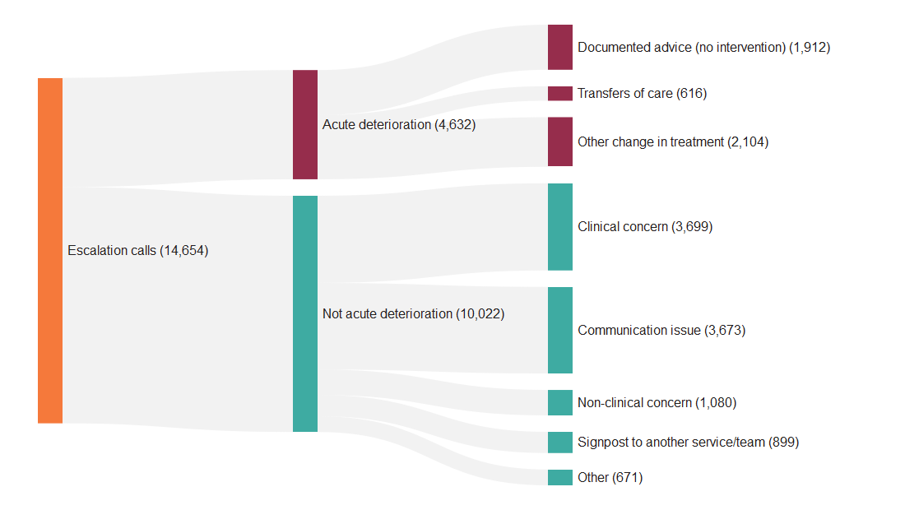
Figure 3. Nested outcomes from Martha's Rule calls, September 2024-April 2026. The 616 transfers are included within the 2,720 treatment changes. Source: NHS England (2026a).

5.2 What the Reform Did Not Fully Address
The Act is necessary but not sufficient. It does not define medication safeguards, continuous monitoring, alarm management, required responses to unrecordable observations or minimum senior staffing; nor can legislation create psychological safety on its own. Language, disability, health literacy and fear of authority may also create unequal access, so escalation routes need to be co-produced, multilingual and accessible (Sutton et al., 2025). Reliable learning also requires systems-based investigation rather than blame. The NHS Patient Safety Incident Response Framework offers a comparator for compassionate involvement and system learning (NHS England, 2022). SEIPS considers interactions between people, tasks, tools, environment and organisation (Carayon et al., 2006; Holden et al., 2013), which here include medication protocols, ward placement, staffing, supervision, alarms, documentation and family participation.

5.3 Evidence-Based Improvement Strategy
Five connected interventions are needed to create a comprehensive strategy, organised through SEIPS 2.0. First, a deterioration bundle should include risk-stratified monitoring, visible trends, required actions when observations cannot be recorded, and controls on alarm changes. Considering people, tasks, tools, environment and organisation helps avoid a narrow technology solution (Carayon et al., 2006; Holden et al., 2013). Continuous oximetry and capnography can improve detection of opioid-related respiratory compromise, but they require adequate response capacity and careful risk selection to reduce alarm burden (Khanna et al., 2024).
The second intervention is a two-channel escalation system: one route for staff concerns and early-warning triggers leading to rapid response, and a second route allowing patients and families independent access to senior or critical-care review. Both routes should operate 24 hours a day, with time-defined and documented responses and automatic higher review for repeated concern, in line with guidance on reliable patient-, family- and staff-led escalation (Welch et al., 2025).
The third intervention is supervision by design. Rosters should identify a named attending with clear response requirements, and resident autonomy should be based on competence and risk (ACGME, 2026). Education also needs reinforcement because blame can persist; simulation should rehearse deterioration, challenge, family escalation and uncertainty (Agbar et al., 2023).
Fourth, leaders should practise 'listen, acknowledge, verify and escalate', use structured speaking-up processes such as CUS and the two-challenge rule, and debrief without humiliating the person who raised concern. A just culture distinguishes human error, at-risk behaviour and reckless behaviour while balancing learning and accountability. Measures should include communication openness, response to error, handovers, staffing and management support (Tyler et al., 2024). Transformational claims must be tested at the frontline: if staff cannot obtain senior help at 03:00, the culture is not reliable.
The fifth intervention is a learning and measurement system. Failure to rescue, delayed escalation, alarm overrides and family calls should be reviewed together as a board-level portfolio. Run charts should monitor time from trigger to review, compliance, repeated escalation, unplanned transfer, cardiac arrest outside critical care and family experience. Near misses should be reviewed qualitatively, and PDSA cycles should involve patients, residents and nurses.
Months 0-3: Map current work; establish baselines and co-design accessible escalation routes. Threshold testing, multilingual materials and night coverage should be attempted on two surgical wards in months 4-6. The bundle should be further developed in months 7-12 with run charts, by case review and with feedback from staff and families, before being shared with a wider spread. This maintains consistency of non-negotiable standards whilst enabling local adaptations to be trialled and modified.
The proposed strategy is also consistent with Soft Systems Thinking because failure to rescue is seen as a contested socio-technical problem that is interpreted differently by different stakeholders (Checkland, 2000). Co-designed escalation processes and SEIPS 2.0 work-system analysis involve patients, families, and healthcare professionals as active members of a connected and responsive healthcare system (Holden et al., 2013). Iterative PDSA cycles would allow these stakeholders to assess whether changes are systemically desirable and culturally feasible, while generating ongoing evidence about the unforeseen effects of the change rather than assuming that a single technical change will solve the entire issue (Taylor et al., 2014).

5.4 Implementation Risks and Mitigation
The programme should be planned to avoid further damage. Table 4 identifies controls for alarm fatigue, excessive or inequitable escalation, blame, technological reassurance and inadequate senior capacity. Risk-tiered alerts, independent triage, accessible communication, just–culture protection, clinical verification and backup escalation are all forms of mitigation. Risks should be reviewed monthly when implementing and quarterly thereafter, and should give permission to pause components that increase workload, inequality or unnecessary transfers.
Table 4. Risk register for Reliable Rescue and Patient Voice programme.
Implementation risk | Potential consequence | Mitigation/balancing control | Owner/measure
Alarm fatigue | Overrides or delayed response | Risk-tiered alerts; weekly alarm audit; require rationale for threshold changes | Clinical engineering; override rate
Excess escalation | Workload and avoidable transfer | Independent clinical triage; response standards; review low-value calls | Rapid-response lead; calls and transfers
Inequitable access | Underuse by minority, disabled or low-literacy groups | Multilingual, disability-accessible routes; interpreter and advocacy support | Patient experience; use by demographic group
Fear of blame | Continued silence and under-reporting | Just-culture policy; protected escalation; feedback to reporters | Chief nurse; openness and reporting scores
Technology reassurance | Deterioration missed despite monitors | Require clinical and family concern to override score-based reassurance | CMIO; missed-trigger reviews
Senior capacity gap | Calls unanswered at nights/weekends | Roster redesign; response time standard; backup escalation level. | CMO; median and 90th-centile response time.

5.5 Lessons for Other Health Systems
Case transferability is due to the fact that hierarchy, diagnostic anchoring, fragmented responsibility and unheard family concern are common system problems that are transferable across financing models. Martha's Rule shows that family escalation remains valuable, but families should provide an additional safety net rather than replace professional surveillance and responsibility.

6. Recommendations
The hospital should introduce a five-year programme called 'Reliable Rescue and Patient Voice', beginning with a 12-month implementation phase and supported by board-level accountability.
1. Establish accountable governance: The governing body should appoint executive and clinical owners for deterioration. Every inpatient should have a named attending or designee who is visible to staff and families and has clear response expectations. Failure to rescue, ward cardiac arrest, delayed review, family escalation and workforce indicators should be included in a quarterly board dashboard. Reviews should use a systems approach while still holding individuals accountable for reckless disregard of safety controls.
2. Establish a dual escalation pathway: Patients, families and staff should have access to a well-publicised number for independent review 24 hours a day. Calls should reach rapid-response or critical-care clinicians outside the immediate treating team, and information should be multilingual and accessible. Calls should be acknowledged within five minutes. Where urgent deterioration is suspected, an independent clinician should assess the patient at the bedside within 15 minutes, with automatic escalation if this standard is not met. Measures should include response time, treatment change, transfer and caller experience.
3. Improve monitoring and medication controls: A risk-based postoperative protocol should be used for patients receiving opioids or medicines associated with bleeding or respiratory risk. Alarm changes and monitor discontinuation should require a documented reason, with independent authorisation for high-risk patients. Trends and alert combinations, such as tachycardia, oliguria and falling blood pressure, should be visible in electronic records. High-risk protocols should be reviewed annually by pharmacy, surgical and nursing leaders, with continuous monitoring focused on selected risk groups.
4. Redesign resident supervision and staffing: High-risk time periods, especially nights and weekends, should be identified and matched to attending and rapid response capacity. The supervision level should be related to the level of patient acuity and trainee competence through a supervision matrix.
Escalation, diagnostic challenge and family communication and help seeking should be covered in simulation and assessment. Allocative efficiency requires senior expertise to be concentrated in the wards, patient groups and time periods with the greatest failure-to-rescue risk.
5. Encourage and sustain a safe environment for learning and growth: Safety Huddles, Safety Speaking Up Tools and Multidisciplinary Debriefs should be utilised in the hospital. It should also periodically survey residents, nurses, other patients and families on a pulse basis with relevant items from the AHRQ Hospital Survey on Patient Safety Culture, along with an annual survey. Patient representatives should co-chair the programme and help review materials and performance data. One surgical pathway should be tested before wider implementation; false alarms, workload, unnecessary transfer and unequal access are monitored as balancing mechanisms in PDSA cycles.
At 12 months, success should include at least 90% compliance with named-attending and monitoring standards, an urgent-review time below 15 minutes, improved communication-openness scores and documented treatment changes following escalation.
Evaluation should combine outcome, process, balancing and equity measures. Outcomes include failure to rescue, ward cardiac arrest and unplanned ICU transfer; process measures include review time, named-attending compliance and documentation of alarm changes. Balancing measures include workload, false-positive calls and avoidable transfers. Results should be analysed by age, disability, language, race or ethnicity and time of day, and quarterly PDSA reviews should combine numerical trends with stakeholder experiences.
Table 5. Implementation priorities for the Reliable Rescue and Patient Voice programme.
Priority | Core action | Accountable owner | Timescale
Governance | Name executive and clinical owners; integrate rescue metrics | Board / CMO | 0–3 months
Escalation | Launch 24/7 independent staff and family route | Critical-care outreach | 3–6 months
Monitoring | Risk-stratified protocol; controlled alarm changes | Surgery/anaesthesia/nursing | 3–9 months
Supervision | Acuity-based attending coverage and competency matrix | Medical education lead | 0–9 months
Learning | PDSA cycles, culture surveys and patient co-chairing | Quality and safety team | Ongoing

7. Conclusion
Lewis Blackman's death cannot be adequately explained by a single medication, clinician or missed diagnosis. It was a system failure to rescue in which clinical deterioration, technology, trainee supervision, hierarchy, communication and governance all played a part. The worst structural issue was that information was not linked to authority; Lewis, his mother, nurses and junior doctors were near the new hazard, but senior clinical accountability was far away. What resulted was lots of activity but no unified response.
Systems thinking and CATWOE demonstrate that prevention is about changing relationships and control mechanisms and not just about people being more careful. The hospital combined centralised professional control with decentralised responsibility, creating an accountability gap. A safer hybrid concentrates on the non-negotiable requirements for supervision, oversight and response, and redistributes the power to speak up and initiate help. Leadership must also be combined - transformational and ethical leadership for culture development; Path-Goal behaviours for barriers removal; participative leadership for patient and frontline knowledge; and decisive task leadership for critical situations.
The Act clarified roles and escalation rights, but legal access does not guarantee rescue. Monitoring, staffing, supervision, psychological safety, accessibility and learning should be a single system. Families have some very valuable safety information but shouldn't be responsible for fixing the unsafe care. That information becomes action, shared learning and scrutiny of unequal access and unintended effects with good leadership. The proposed programme will be implemented in these ways to enhance safer care: Selective centralisation, distributed vigilance, SEIPS, and PDSA.

8. Reference List
Accreditation Council for Graduate Medical Education (ACGME) (2026) ACGME Common Program Requirements (Residency). Effective 1 July 2026. Chicago, IL: ACGME. Available at: https://www.acgme.org/programs-and-institutions/programs/common-program-requirements/ (Accessed: 24 July 2026).
Acquaviva, K.D., Haskell, H. and Johnson, J. (2013) ‘Human cognition and the dynamics of failure to rescue: the Lewis Blackman case’, Journal of Professional Nursing, 29(2), pp. 95–101. doi: 10.1016/j.profnurs.2012.12.009.
Agbar, F., Zhang, S., Wu, Y. and Mustafa, M. (2023) ‘Effect of patient safety education interventions on patient safety culture of health care professionals: systematic review and meta-analysis’, Nurse Education in Practice, 67, 103565. doi: 10.1016/j.nepr.2023.103565.
Alabdullah, H. and Karwowski, W. (2024) ‘Patient safety culture in hospital settings across continents: a systematic review’, Applied Sciences, 14(18), 8496. doi: 10.3390/app14188496.
Albutt, A.K., O’Hara, J.K., Conner, M.T., Fletcher, S.J. and Lawton, R.J. (2017) ‘Is there a role for patients and their relatives in escalating clinical deterioration in hospital? A systematic review’, Health Expectations, 20(5), pp. 818–825. doi: 10.1111/hex.12496.
Althobaiti, F.M. (2026) ‘The effects of leadership on patient safety culture in health care: a systematic review’, BMC Nursing, 25, 125. doi: 10.1186/s12912-025-04263-7.
Bass, B.M. and Riggio, R.E. (2006) Transformational Leadership. 2nd edn. Mahwah, NJ: Lawrence Erlbaum Associates.
Burke, J.R., Downey, C. and Almoudaris, A.M. (2022) ‘Failure to rescue deteriorating patients: a systematic review of root causes and improvement strategies’, Journal of Patient Safety, 18(1), pp. e140–e155. doi: 10.1097/PTS.0000000000000720.
Carayon, P. et al. (2006) ‘Work system design for patient safety: the SEIPS model’, Quality and Safety in Health Care, 15(Suppl 1), pp. i50–i58. doi: 10.1136/qshc.2005.015842.
Centres for Medicare & Medicaid Services (CMS) (2024) State Operations Manual: Appendix A—Survey Protocol, Regulations and Interpretive Guidelines for Hospitals. Publication 100-07, Transmittal R220SOMA. Baltimore, MD: CMS. Available at: https://www.cms.gov/medicare/regulations-guidance/transmittals/2024-transmittals/r220soma (Accessed: 24 July 2026).
Checkland, P. (1999) Systems Thinking, Systems Practice. Chichester: Wiley.
Checkland, P. (2000) ‘Soft systems methodology: a thirty-year retrospective’, Systems Research and Behavioural Science, 17(S1), pp. S11–S58. doi: 10.1002/1099-1743(200011)17:1+<::AID-SRES374>3.0.CO;2-O.
Cresham Fox, S., Taylor, N., Marufu, T.C., Hendron, E. and Manning, J.C. (2023) ‘Paediatric family activated rapid response interventions; qualitative systematic review’, Intensive and Critical Care Nursing, 75, 103363. doi: 10.1016/j.iccn.2022.103363.
Edmondson, A. (1999) ‘Psychological safety and learning behaviour in work teams’, Administrative Science Quarterly, 44(2), pp. 350–383. doi: 10.2307/2666999.
Fiedler, F.E. (1967) A Theory of Leadership Effectiveness. New York: McGraw-Hill.
Goleman, D. (1998) Working with Emotional Intelligence. New York: Bantam Books.
Holden, R.J., Carayon, P., Gurses, A.P., Hoonakker, P., Schoofs Hundt, A., Ozok, A.A. and Rivera-Rodriguez, A.J. (2013) ‘SEIPS 2.0: a human factors framework for studying and improving the work of healthcare professionals and patients’, Ergonomics, 56(11), pp. 1669–1686. doi: 10.1080/00140139.2013.838643.
House, R.J. (1971) ‘A path-goal theory of leader effectiveness’, Administrative Science Quarterly, 16(3), pp. 321–338. doi: 10.2307/2391905.
Khanna, A.K. et al. (2024) ‘Role of continuous pulse oximetry and capnography monitoring in the prevention of postoperative respiratory failure, postoperative opioid-induced respiratory depression and adverse outcomes on hospital wards: a systematic review and meta-analysis’, Journal of Clinical Anaesthesia, 94, 111374. doi: 10.1016/j.jclinane.2024.111374.
Kim, S. et al. (2020) ‘Patient safety over power hierarchy: a scoping review of healthcare professionals’ speaking-up skills training’, Journal for Healthcare Quality, 42(5), pp. 249–263. doi: 10.1097/JHQ.0000000000000257.
NHS England (2022) Patient Safety Incident Response Framework. London: NHS England. Available at: https://www.england.nhs.uk/patient-safety/incident-response-framework/ (Accessed: 24 July 2026).
NHS England (2026a) Martha’s Rule Programme April 2026. London: NHS England. Available at: https://www.england.nhs.uk/statistics/statistical-work-areas/marthas-rule/statistical-work-areas-marthas-rule-marthas-rule-2026-27/marthas-rule-programme-april2026/ (Accessed: 24 July 2026).
NHS England (2026b) Martha’s Rule: Core Standards. 2 March. London: NHS England. Available at: https://www.england.nhs.uk/publication/marthas-rule-core-standards/ (Accessed: 24 July 2026).
Patient Safety Movement Foundation (n.d.) Lewis Blackman: Continuous Monitoring in Hospitals—A Patient’s Story. Available at: https://psmf.org/story/lewis-blackman/ (Accessed: 24 July 2026).
Raymond, J., Kyzer, B., Copper, T., Stephens, K., Oldendick, R., Coker, D., Stinson, M. and Barker, J. (2009) ‘South Carolina patient safety legislation: the impact of the Lewis Blackman Hospital Patient Safety Act on a large teaching hospital’, Journal of the South Carolina Medical Association, 105(1), pp. 12–15.
Reason, J. (2000) ‘Human error: models and management’, BMJ, 320(7237), pp. 768–770. doi: 10.1136/bmj.320.7237.768.
Schein, E.H. and Schein, P.A. (2017) Organisational Culture and Leadership. 5th edn. Hoboken, NJ: Wiley.
Singh, A., Yeravdekar, R. and Jadhav, S. (2024) ‘Investigating the influence of selected leadership styles on patient safety and quality of care: a systematic review and meta-analysis’, BMJ Leader, 8(3), pp. 208–214. doi: 10.1136/leader-2023-000846.
South Carolina Legislature (2005) Lewis Blackman Hospital Patient Safety Act, Act No. 146, South Carolina Code, Title 44, Chapter 7, Article 27. Available at: https://www.scstatehouse.gov/code/t44c007.php (Accessed: 24 July 2026).
Spratley, E., Johnson, A., Sochalski, J., Fritz, M. and Spencer, W. (2001) The Registered Nurse Population, March 2000: Findings from the National Sample Survey of Registered Nurses. Rockville, MD: U.S. Department of Health and Human Services, Health Resources and Services Administration, Bureau of Health Professions, Division of Nursing. Available at: https://data.hrsa.gov/DataDownload/NSSRN/GeneralPUF00/rnsurvey2000.pdf (Accessed: 27 July 2026).
Sutton, E., Ibrahim, M., Plath, W., Booth, L., Sujan, M., McCulloch, P. and Mackintosh, N. (2025) ‘Understanding the enablers and barriers to implementing a patient-led escalation system: a qualitative study’, BMJ Quality & Safety, 34(1), pp. 18–27. doi: 10.1136/bmjqs-2024-017132.
Tannenbaum, R. and Schmidt, W.H. (1973) ‘How to choose a leadership pattern’, Harvard Business Review, 51(3), pp. 162–180.
Taylor, M.J., McNicholas, C., Nicolay, C., Darzi, A., Bell, D. and Reed, J.E. (2014) ‘Systematic review of the application of the plan–do–study–act method to improve quality in healthcare’, BMJ Quality & Safety, 23(4), pp. 290–298. doi: 10.1136/bmjqs-2013-001862.
Tyler, E.R., Yalden, O., Fan, L., Ji, S., Kirchner, J., Yount, N.D. and Sorra, J. (2024) Surveys on Patient Safety Culture (SOPS) Hospital Survey 2.0: 2024 User Database Report. Rockville, MD: Agency for Healthcare Research and Quality. AHRQ Publication No. 25-0006. Available at: https://www.ahrq.gov/sops/databases/hospital/index.html (Accessed: 24 July 2026).
U.S. Department of Health and Human Services, Office of Inspector General (HHS OIG) (2022) Adverse Events in Hospitals: A Quarter of Medicare Patients Experienced Harm in October 2018. OEI-06-18-00400. Washington, DC: HHS OIG. Available at: https://oig.hhs.gov/reports/featured/adverse-events/ (Accessed: 24 July 2026).
Wawersik, D.M., Boutin, E.R., Gore, T. and Palaganas, J.C. (2023) ‘Individual characteristics that promote or prevent psychological safety and error reporting in healthcare: a systematic review’, Journal of Healthcare Leadership, 15, pp. 59–70. doi: 10.2147/JHL.S369242.
Weick, K.E. and Sutcliffe, K.M. (2015) Managing the Unexpected: Sustained Performance in a Complex World. 3rd edn. Hoboken, NJ: Wiley.
Welch, J., Murkin, J., Edwards, E., Inada-Kim, M. and Subbe, C. (2025) ‘Giving patients, families and staff a reliable voice in acute care: expert guidance for implementation of Martha’s Rule in UK hospitals’, Future Healthcare Journal, 12(1), 100223. doi: 10.1016/j.fhj.2025.100223.
World Health Organisation (2021) Global Patient Safety Action Plan 2021–2030: Towards Eliminating Avoidable Harm in Health Care. Geneva: World Health Organisation. Available at: https://www.who.int/publications/i/item/9789240032705 (Accessed: 24 July 2026).
World Health Organisation (2023) Patient Safety. Geneva: World Health Organisation. Available at: https://www.who.int/news-room/fact-sheets/detail/patient-safety (Accessed: 24 July 2026).

