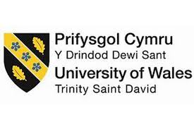

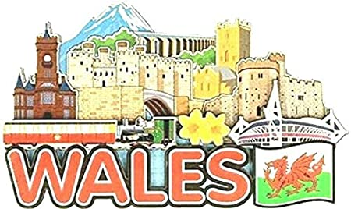
SJIE5004 Celebrating Language and Culture – Belonging to Wales

Contents
Rationale Page 3 - 4
Overview of activities Page 5 - 7
Evaluation/ Conclusion Page 8
Appendices Page 9 - 16
Reference List Page 17 – 18.

The following portfolio will consist of an activity that has been created and delivered by myself in ones setting, this activity will include promoting the Welsh language, including cultural, historical and geographical features, whilst critically analysing the significance of the concepts of identity and belonging to Wales.
Bilingualism or multilinguism should be seen as an advantage rather than a disadvantage. Baker (2001) identifies bilingualism as being advantageous in many ways, allowing children to experience two sets of traditions, literature and ways of thinking leading to more flexible and creative learning. He also recognises that bilingualism can break down barriers and create tolerance. It is important that children learning their welsh cultural language as an additional language are not viewed from a deficit standpoint, but that their home language is nurtured alongside the development of English (Palaiologou, 2013). In 2010, 24.8 per cent of the welsh population were reported being able to speak welsh, although in the 2001 census 16 per cent of the population declared an ability to understand, speak, read and write welsh. The development of Wales as a bilingual nation is a central Welsh Government policy focus, and the study of welsh is compulsory until the age of 16 years of age in all mainstream educational settings (WAG, 2012b). The curriculum for Wales framework is being developed with the aim to help each school develop its own curriculum, enabling their learners to develop towards the four purposes of the curriculum and to ensure that all schools cover the same core learning and to secure a consistency of approach for learners across Wales. As stated in Donaldson successful futures report (2015), “All children and young people will be given the support to become ambitious capable learners, enterprising creative contributors, healthy confident individuals and ethical informed citizens” (Gov.Wales,2015). The report suggests greater focus on children and young people’s ability to speak welsh confidently in everyday settings, this will then go to strengthen and sustain the welsh language within the education system, giving learners the opportunity to learn welsh, to communicate in conversation and understanding, which can then lead on to being used in the workplace, allowing more opportunities to young people in Wales. Curriculum Cymreig is being used in Schools to work along Donaldson’s views in that, “It helps pupils to understand and celebrate the distinctive quality of living and learning in Wales, to identify their own sense of Welshness and to feel a heightened sense of belonging to their local community and country” (Gov.Wales, 2003, p2). This works alongside the UNICEF UN convention rights of the child as it states in Article 30, “That every child has the right to learn and use the language, customs and religion of their family, whether or not these are shared by the majority of the people in the country where they live.” This giving the individual child the right to speak and learn their heritage language. This is shown to be effective and encouraged in one’s school setting, as stated in School A’s Policy for Welsh, “Although the school is situated in a mainly English speaking area of South Pembrokeshire, we take every opportunity to promote welsh as a second language. It reflects the essential part that Welsh plays in the education of our pupils, and is important that a positive attitude towards Welsh is encouraged amongst all pupils In order to develop a sense of heritage and pride about our country. The aim to give Welsh a prominent visual and actual role throughout the school, every child has an entitlement to learn the language, whatever his or her academic ability and with all staff having the aim to create an ethos that is conductive and supportive of the teaching of the Welsh language”. (School A, 2020). This is shown to be seen and put to good practice in the outcomes of the schools Estyn report which states, “Generally, pupils make a good start to learning the Welsh language. In the Foundation Phase, many respond appropriately to instructions and questions in Welsh. Most ask and answer questions about the weather and a few use the past tense correctly to describe yesterday’s weather. Provision for developing Welsh skills is adequate. There is good attention to developing pupils’ spoken Welsh in the Foundation Phase, (Estyn, 2015). To ensure continuity and progression in welsh as a second language, the Siarter Iaith framework is being implemented positively in the setting, to also coincide and meet the criteria outlined in Donaldson’s successful futures, with one of the main aims being, ‘To embed positive language use practices supported by formal and informal opportunities to use Welsh socially.’, (Gov.Wales,2019, p3). In addition embedding and extending this formal use of Welsh will become a key part of the areas of learning experience, as Professor Donaldson emphasises, “this importance as an integral part of the curriculum to broaden the learner’s horizons, to ignite their imagination and to promote enjoyment in learning”, (Gov.Wales, 2019, p 4). This can benefit the welsh culture in the long term in that it will help to see that the language is not something solely connected to school /education, but that it instils positive attitudes towards the language which translates into active use and provides a rich, social and cultural world associated with it. Thus giving learners in Wales the opportunity to develop their welsh language skills for social and work use in the future and ensuring that they can continue to use the Welsh language after leaving education, (Gov.Wales, 2019).
In the foundation phase we aim to introduce Welsh as a second language through a variety of skills and techniques that will encourage the children to communicate naturally and effectively by using a scheme of work that is broad, balanced and sensitive to the needs of both the children and the non – welsh speaking teacher. The emphasis being on speaking and listening, children will be given the opportunity and encouraged to respond and communicate as individuals, pairs and groups or as a class through lessons that are well structured, varied and lively. By taking all this into account, as mentioned above in the introduction, activities were taken place in order to promote the Welsh language. The following activities were delivered to foundation phase, pre-school and nursery age children and were planned using the foundation phase framework, in the Welsh Language Development area of learning, (see appendix 1). The first activity had the learning objective of working on children’s oracy skills, and the participation as individuals and in pairs, by using a range of stimuli such as games, whilst also encouraging turn taking and sharing. The welsh game was based around a topic that the children had previously been learning about in class. “The Colour Monster book”. This book focussed on feelings, so the welsh activity had the outcome that children would be able to express their feelings in welsh and ask each other how the monster would be feeling, in relation to the game. (See appendix 2). The children were encouraged to take turns rolling the dice, then moving their coloured counter to the correct monster, the child’s partner would then ask the child, “sut wyt ti?” and the child would answer in welsh, in relation to the monster picture that they had landed on. This encouraged talking about feelings and achieving welsh oracy through play. This relates to the theorist Vygotsky who stated that, “Play promotes cognitive, social and emotional development in children. Cognitive development stems from social interactions from guided learning within the zone of proximal development, as children and their peers co-construct knowledge” (Pound, 2005, p40). This was giving the children the chance to be independent in speaking welsh, but also having the enjoyment that the feelings were imaginary, that of the monster and not of themselves. A follow up to this was an independent activity for children to pick a monster relating to how they were feeling that day, and to thread it with string, again focusing on the outcomes of oracy, asking and answering in welsh but also an independent activity that focussed on fine motor skills, (See appendix 3). This repetition of the oracy and feelings can be linked to that of theorist Jean Piaget who’s theory of ‘cognitive development’ is that children can learn to develop new understandings and concepts through repeated patterns of exercise, (Allan & Gordon, 2011). It also relates to that of Bruner who believed in the concept that, “The more one has practice, the more likely it is that one will generalise what they have learnt into problem solving and enquiry, that will serve for any kind of task” (Bates, 2016,p54). The importance of repetition to Bruner’s concept of learning was particularly clear in his description of the spiral curriculum, where he stated that , “As it develops (revisits) basic ideas, repeatedly building on them, until the student has grasped the full outcome desired” (Macleod – Brudenell, 2008,p98). This implying that the more children revisit a task and the more it is repeated the more likely they are to learn it and learn from it, whilst retaining the information. The idea of repeating this task to the children was to focus on the oracy and the fact that they could then relate the feelings of the monster to their own feelings, when asked on a daily basis during circle time how they are feeling. After practicing this repeatedly they would then have the opportunity to answer it in a full sentence in welsh as well as English.
The children in foundation phase in ones setting celebrated ‘Shwmae Day’ which is a day marked each year in Wales to celebrate and promote the welsh language. In accordance with this day, the other activities that took place involved working towards shwmae day. The learning objectives for these activities and the focus was on welsh foods and welsh culture. Children were introduced the meaning of the word ‘shwmae’ and were giving the opportunity to practice writing it in the playground and then design it with an object of their choice (See appendix 4). The children decided to do this with leaves and use the outside learning area, this activity was able to cross-curricular into other areas of the seven areas of learning as it used creative development, language, literacy and communication skills, mathematical development as the children counted the leaves and physical development and knowledge and understanding, as the children were able to explore the outside area of the school field to accumulate the leaves. This relates to John Dewey theory in that he believed we learn through a ‘hands – on approach’ and that in order for children to learn they must interact with the environment around them in order to adapt and learn, (Mooney, 2000). To introduce children to welsh foods and the culture of Wales activities were planned to encourage as much independent learning from the children as possible. Children learn through first-hand experiential activities with the focus of “play” being the main focus in the foundation phase. Through play children can practice and consolidate their learning, play with ideas, experiment, take risks and make decisions individually or in groups. First hand experiences allow children to develop an understanding of themselves and the world around them, (Gov.Wales, 2015). Taking this into consideration the following activities, (see appendix 5) were designed to give children a playful way of learning about welsh culture. Children were given the task of creating a Welsh dish, leek and potato soup. Children were given first hand experiences of seeing and exploring these vegetables and able to use them in an interactive, playful, hands - on way, in that they were used in paint to print, with the outcome to make a leek and potato soup. They were given the knowledge of the leek being a welsh emblem and its significance to wales again this was able to cross- curricular into other areas of learning and not just focus on the Welsh language development area of learning. Once children had printed their traditional welsh food they were giving the opportunity to use the outside learning area to make this in the mud kitchen using a recipe that had been made for them, (see appendix 6). Again this gave the children an interactive, hands on experience to learn and use welsh oracy in play by naming the vegetables in welsh and counting the ingredients using their knowledge of welsh numbers. This could be seen In relation to Noam Chomsky theory that children can develop language from a very early age he states that, “Since young children are primed for natural language acquisition, learning a second language may be more effective in early childhood”, (Bates, 2016, p98). To further the children’s knowledge and understanding of the welsh language and to develop this further at home to share with their parents, a sheet was given with some activities that parents could encourage their children to do together, to extend the welsh learning beyond the classroom and introduce it into the home, to further the learning experience, thus benefiting the child significantly. (See appendix 7). As stated in School A policy, (2020), parents are informed of the language topic being taught by the class teacher during each term and parents who wish to learn welsh are informed of welsh language courses throughout the year.
To conclude in all the activities that were planned, these were able to cross-reference into other areas of learning giving outcomes that can be used just not in welsh language development but in the other areas of learning. I feel that the majority of the outcomes were met as stated in the foundation phase profile for development of the welsh language, (see appendix 8). Although these activities could be extended in that the children could have used some Information Technology (IT skills) in the activities and took some more ownership, in that they could have been given some preference and choices in what they would have liked to have learnt. All children that took part in the activities were using more welsh daily and enjoyed sharing their activities with their peers on ‘Shwmae day’. Welsh greetings and feelings are used on a daily basis and with putting activities that relate to these, give children a better understanding and a more visual way of learning and retaining the information. The use of play and the outside area to help the teaching of the welsh language, showed more participation and enthusiasm from the children and promoted discovery and independence as a resource for children’s learning. With a more positive and enthusiastic outlook on the teaching of the welsh language, and with children learning it from a very early age we are able to give children a better opportunity to enhance the culture and identity and feel a sense of belonging. Although this does need to transpire through the transition of primary to secondary school, where sometimes the language children have learnt from a young age, consistently through primary school can get forgotten. Education policy makers in wales have recognised the importance of this transition and that the issue of continuity between the primary and secondary phases of education is a necessity, in order to give good practice and ensure the continuity of academic achievement in the welsh language, (Powell & Smith, 2006).

Appendices
Appendix 1
Ducklings Weekly Planning

Date & times  Week beginning  12th October 2020  Monday- Tuesday | Activities planned & resources needed.  - Introduce children to ‘Shwmae’ week, why we celebrate it? What it means? The benefits to using welsh in the classroom. Encourage children to use as much welsh language in their daily activities in the classroom as possible, and how rewards will be given to the children using the most welsh throughout the school day . (Welsh stickers/certificate).  - Start day by welsh song, “Bore da, Sut wyt ti?’ Days week in welsh, ask how children are feeling in welsh at beginning of each day and get them to ask each other “Sut wyt ti? Sut mae’r tywydd heddiw?
Wednesday 14th October  Thursday 15th October  Shwmae Day | - fine motor skills – relate to the ‘The colour monster’ book that children have been reading, threading monsters with wool, feelings ask each other how the monster feels in welsh, question and answer in welsh.  - Colour monster game, encourage turn taking, and counting in welsh, numbers 1-10, un-deg.  - Big “Shwmae” in welsh on playground using leaves, get children to go on a leaf hunt to find as many leaves as possible to enter for shwmae competition.  - Celebrate “Shwmae Day” children to wear colours of the welsh flag, red, white, green.  - Competitions, throughout the day to use the most welsh.  - Discuss welsh emblems, the history why there significant to Wales. Creative/ independent activities – give children choice to make sheep, leek, daffodil, St David, welsh flag, and welsh lady using sheets and materials provided.  - Discuss welsh foods – particularly leek & Potato soup, children create soup using the vegetables to print in paint, then go outside and creature it in the mud kitchen using the recipe provided, kitchen utensils and things they can find on the field, e.g. Leaves, sticks, water, conkers. List all these in welsh so children are familiar with the welsh words.  - Resources needed  Paint, leek & Potato, kitchen utensils, wool, crayons, apron, photocopied sheets, creative materials form creative area eg, tissue paper, card, scissors, glue etc. dice, counters.

Appendix 2
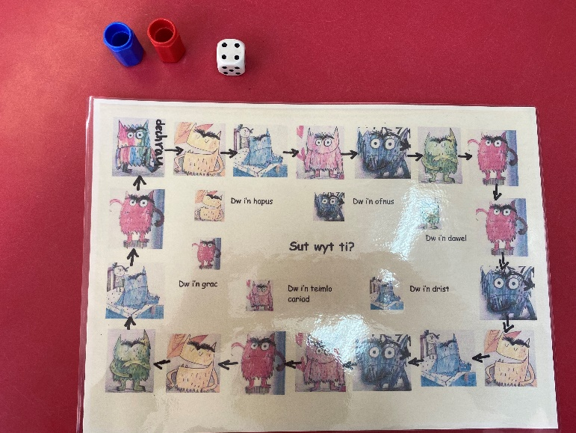
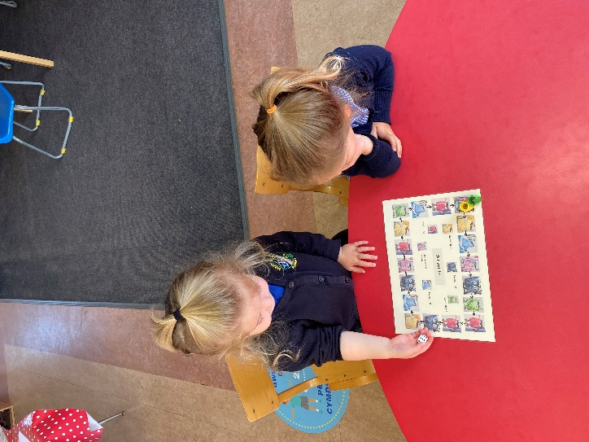

(Spencer, 2020)
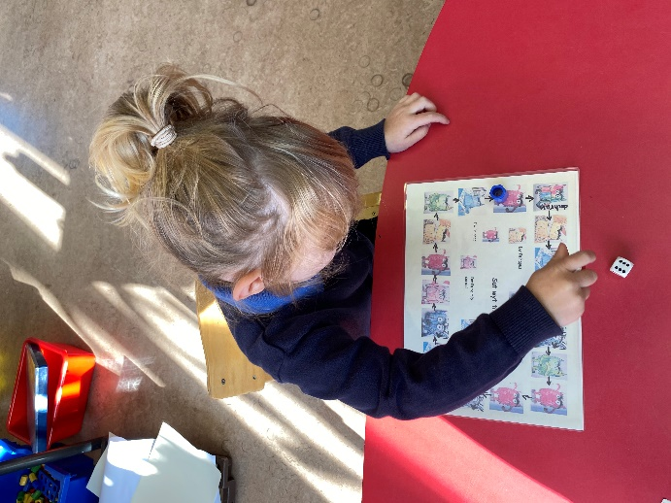(Spencer, 2020)

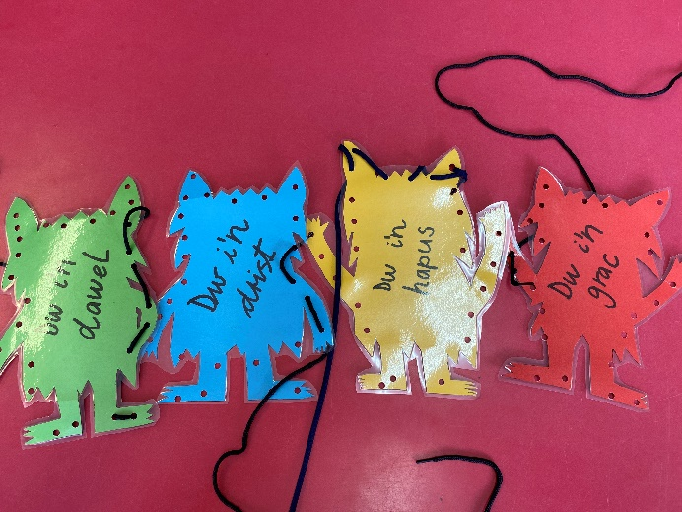
Appendix 3

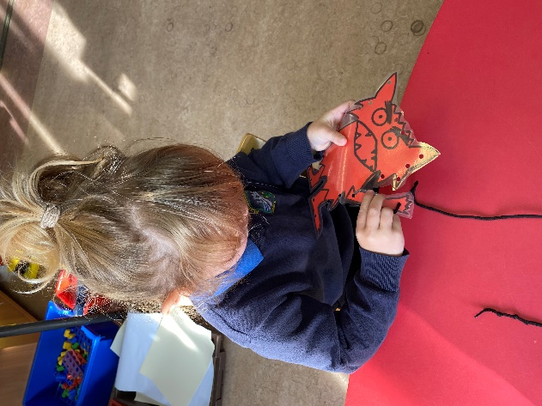

(Spencer, 2020)

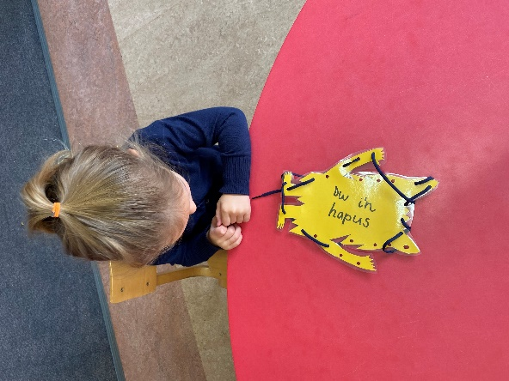

Appendix 4

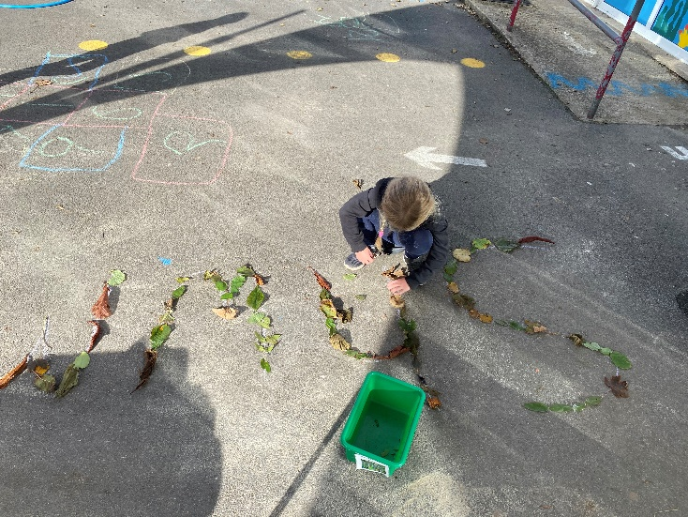
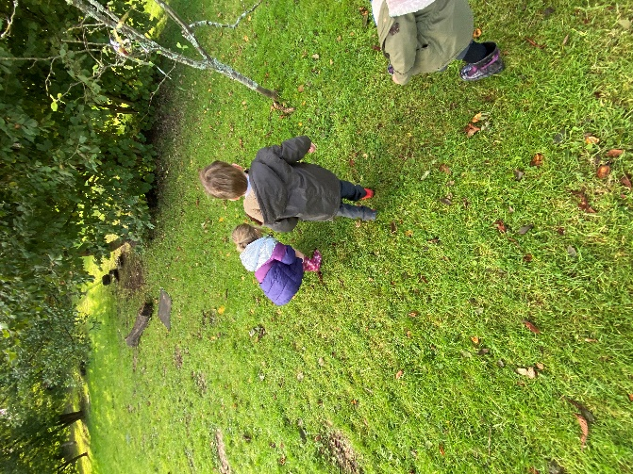 (Spencer, 2020)
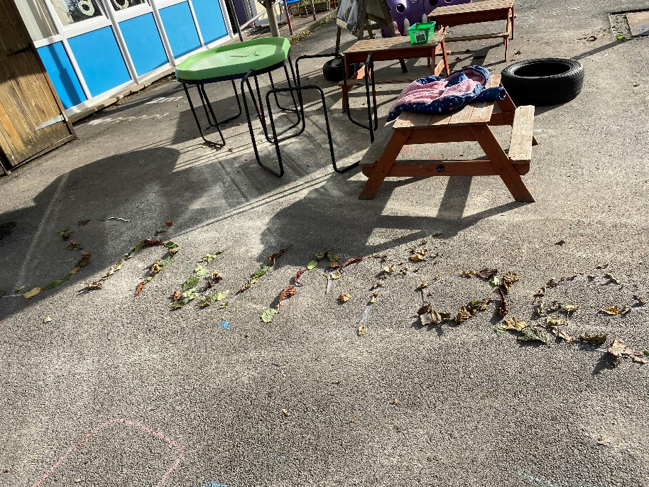

Appendix 5
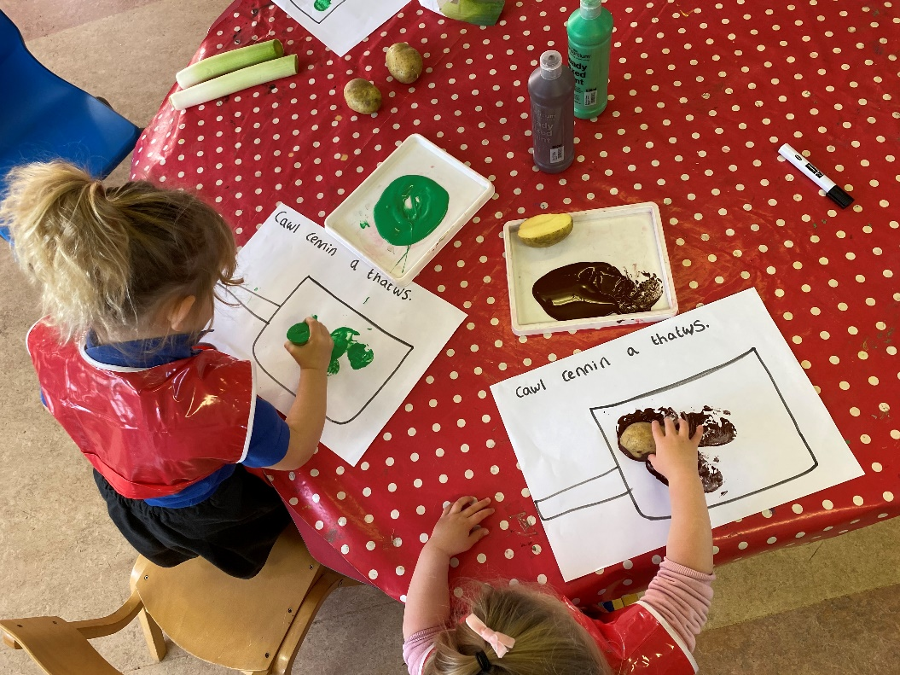

(Spencer, 2020)

Appendix 6

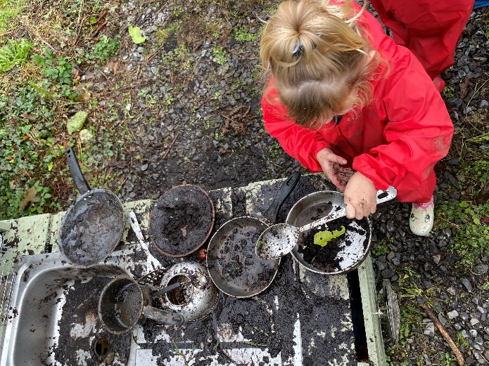
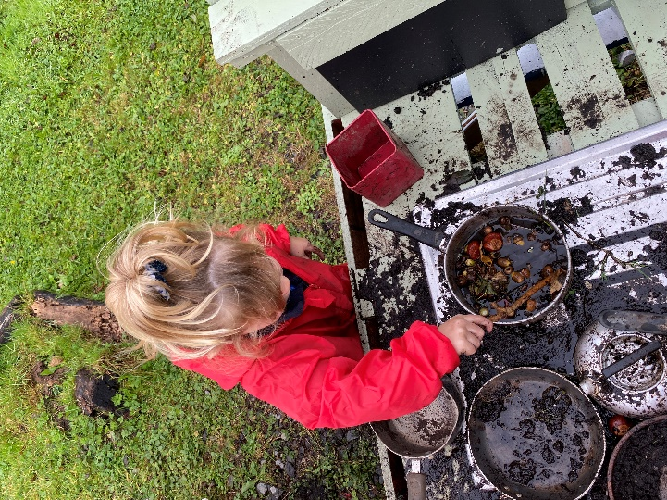

(Spencer, 2020)

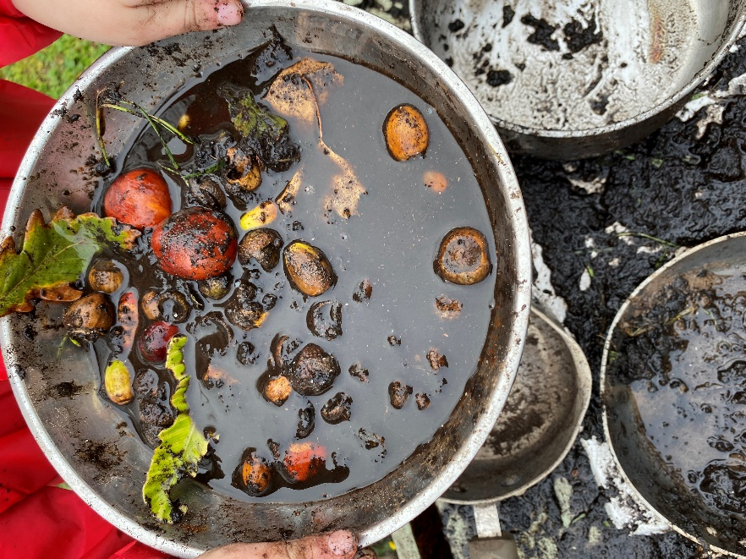
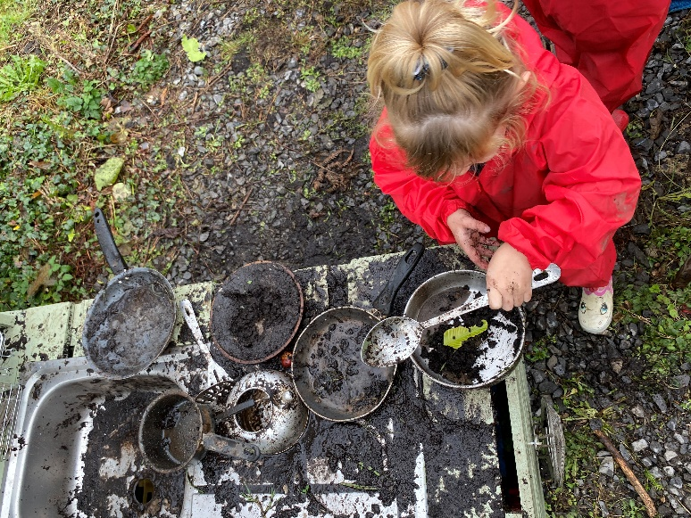

Spencer, 2020)
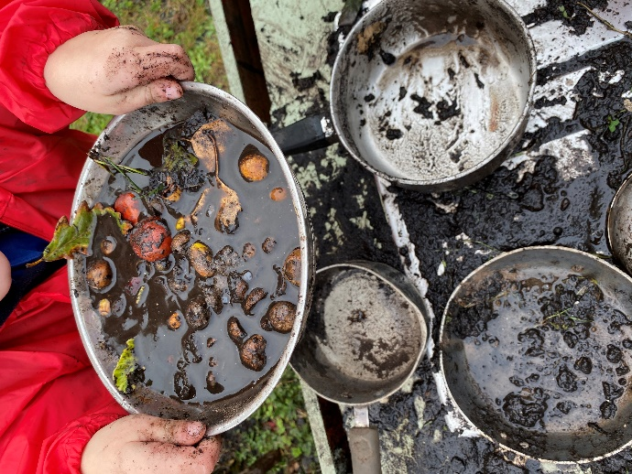

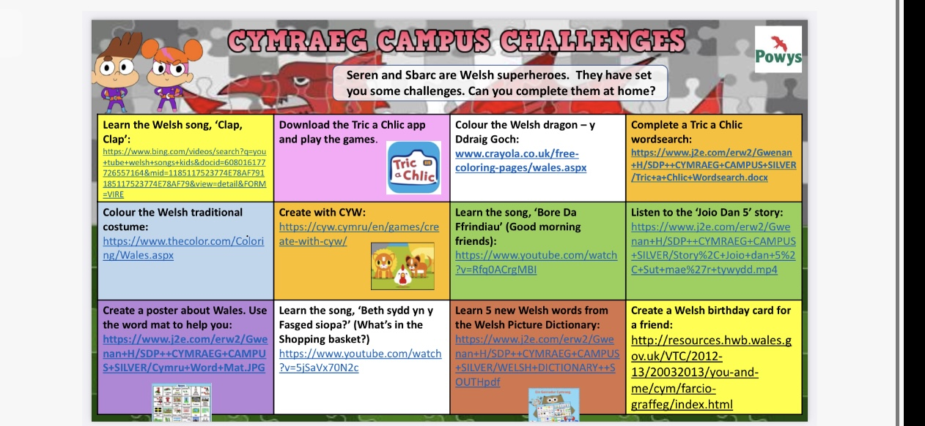
Appendix 7

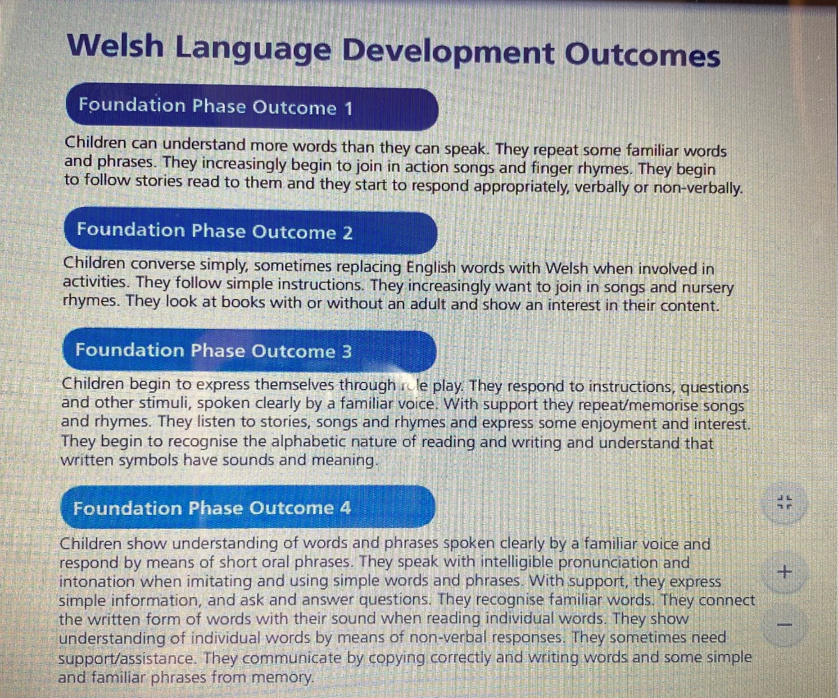
Appendix 8
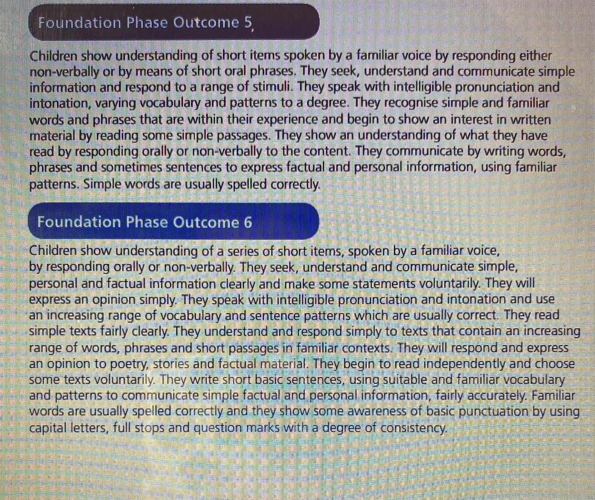 (Gov.Wales, 2015)

Reference List:
Allen, S, Gordon, P, (2011), How Children Learn 4 Thinking on Special Educational Needs and Inclusion. 1st Ed, Practical Pre-School books.
Baker, C. (2001) Foundations of Bilingual Education and Bilingualism, 3rd ED, New York: Multilingual Matters.
Bates, B, (2016), Learning theories Simplified and how to apply them in teaching. 1st Ed, London: SAGE publications Ltd.
Davies, J. (2014) The Welsh Language a History, University of Wales press.
Donaldson, G, (2015), Successful futures looking at the curriculum and assessments arrangements in Wales, Available at: https://gov.wales/sites/default/files/publications/2018-03/succesful-futures-a-summary-of-professor-graham-donaldsons-report.pdf Accessed on: (15/10/2020).
Estyn, (2015), Available at: https://www.estyn.gov.wales, Accessed on: (3/11/2020).
Macleod – Brudenell, I, Kay, J, (2008), Advanced Early Years for Foundation Degrees, Levels 4/5, 2nd ed. Essex, Pearson Education Limited.
Mooney, C, (2000), Theories of childhood: An introduction to Dewey, Montessori, Erikson, Piaget & Vygotsky. MN: Red leaf press.
Morgan, G. (2008) A Brief History of Wales, 1St Ed, Ceredigion, Y Lolfa Cyf.
Palaiologou, I, (2013), The Early Years Foundation Stage Theory and Practice, 2nd Ed, London, SAGE publications Ltd.
Pound, L, (2005), How Children Learn, Lemington Spa, Step Forward Publishing.
Powel, R, Smith, R, (2006) Transition from Primary to Secondary School: Current Arrangements & Good Practice in Wales, Available at: https://www.nfer.ac.uk/media/2243/wtn01.pdf Accessed on (11/11/2020).
School A policy for Welsh, (2020).
Spencer, N, (2020), Author own pictures.
UNICEF, (1992) United Kingdom UN Convention on Childs Rights, Available at: https://www.unicef.org.uk, Accessed on (7/11/2020).
The United Nations Convention on the Rights of the Child, (2011), Available at: http://www.childrensrights.wales/index.php/right/file Accessed on: (21/10/2020).
Vygotsky, L. (1978). Mind in Society. Cambridge, MA: Harvard University Press.
Welsh Government, (2015) Foundation Phase Framework, Available at: https://gov.wales/sites/default/files/publications/2018-02/foundation-phase-framework-revised-2015 Accessed on (13/11/2020).
Welsh Government, (2003) Developing the Curriculum Cymreig, Available at: https://hwb.gov.wales/curriculum-for-wales-2008/subject-guidance/developing-the-curriculum-cymreig, Accessed on: (5/11/2020).
Welsh Government, (2019) Siarter Iaith Framework: Initial Guidance for Schools, Available at: https://hwb.gov.wales/api/storage/3b73bf7c-640d-4c34-855d-9586b0b30c80/siarter-iaith-framework.pdf Accessed on: (8/11/2020).
Walton, A and Goddard, G. (2012) Supporting Every Child, 2nd Ed, London: SAGE Publications.
Welsh Assembly Government (WAG), (2012) Available at: https://www.g2ov.uk, Accessed on: (3/11/2020).

