ACMA5010 Stress Analysis and Dynamics
Analysis and simulation of a centrifugal clutch Project Report
Emyr Hunnam (2216571)
Renishaw PLC



Table of Contents

Table of Contents 1
Task A 2
Introduction 2
What is a Centrifugal Clutch? 2
Development of the Centrifugal Friction Clutch 3
Materials Used in a Centrifugal Clutch 3
Applications and Operating Conditions for a Centrifugal Clutch 4
Advantages of a Centrifugal Clutch 4
Current Applications of Electromagnetic Clutches in Modern Automation of Manufacturing Processes 5
Conclusion 5
Task B 7
Question 1 7
Question 2 7
Question 3 8
Question 4 9
Question 5 10
Question 6 11
Question 7 12
Reference List 14
Appendix 15

Task A

Introduction
Centrifugal clutches were a fundamental cornerstone of power transmission in various small motor equipment. They have undergone significant evolution over the past century. Although their prominence in contemporary mechanical systems has diminished with the advancement of fluid mechanical clutches, understanding the development, applications, materials, operating conditions, and advantages of centrifugal clutches remains when comprehending their significance and potential relevance today. Additionally, in the ever-changing field of automation and manufacturing, electromagnetic clutches have become innovative solutions with distinct advantages for improving efficiency and precision. In this assignment, we will delve into the world of centrifugal clutches, exploring their history and relevance in specific applications. At the same time, we'll examine the modern automation landscape, where electromagnetic clutches are reshaping how power is managed and controlled.

What is a Centrifugal Clutch?
A centrifugal clutch is a mechanical device designed to facilitate automatic engagement and disengagement of power transmission between a driving source, typically an engine, and a driven component like a wheel or a shaft. According to Patton (1980), centrifugal clutches are often used with engines as they cannot be started under load. This process is predicated on the principle of centrifugal force. As the engine's rotational speed increases, centrifugal force triggers the clutch mechanism to engage, enabling power transmission. Conversely, a decrease in engine speed results in disengagement, allowing the engine to operate without directly driving the load. According to the BLM Team (2019) this ingenious design is commonly used in various applications, such as go-karts, chainsaws, and lawnmowers, where it ensures seamless power transfer with minimal manual intervention. Below is a diagram by Kholil et al. (2021) that shows the most important parts of the centrifugal clutch.

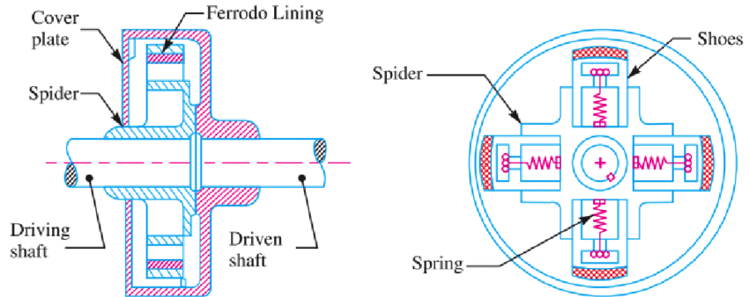

Figure 1 – Diagram of centrifugal Clutch by Kholil et al. (2021)

Development of the Centrifugal Friction Clutch
The evolution of the centrifugal clutch over the years has been a testament to the pursuit of improved efficiency and user-friendliness in various applications. According to MechStudies (2021) the centrifugal clutch was firstly used in motor vehicles by British company Armstong Siddeley in 1936. The source also states that along with Armstrong Siddely, Thomas Fogarty is also credited for inventing the centrifugal clutch. During this period, centrifugal clutches gained popularity in applications such as lawnmowers, small tractors, and stationary engines. These clutches were characterized by their straightforward design, using weighted arms or shoes that would swing outward as the engine's speed increased, engaging the clutch to transmit power. Over time, advancements in materials, manufacturing techniques, and design have enhanced the clutch's performance, durability, and adaptability. Materials like advanced alloys and friction linings, precision machining, and design innovations have all contributed to the reliability of centrifugal clutches in diverse applications. These clutches have found their way into small vehicles, industrial machinery, and even automotive transmissions, marking a testament to their versatility and enduring relevance.

Materials Used in a Centrifugal Clutch
Materials used in centrifugal clutches play a crucial role in determining their performance, durability, and reliability. The choice of materials for different components within a centrifugal clutch is based on factors such as friction, wear resistance, heat dissipation, and overall mechanical strength. Here are some of the key materials commonly used in centrifugal clutches:

- Clutch Shoes or Weights:
- Steel: Steel is a commonly used material for the shoes or weights in centrifugal clutches. It offers good mechanical strength and durability.

- Friction Materials:
- Some clutch shoes or weights are equipped with friction materials, such as composite materials or ceramics, to improve engagement and disengagement efficiency. These materials offer excellent friction properties and wear resistance. According to Li, Huang and Lin (2016) the materials used in the clutch can have a significant impact on the ‘judder’ when the clutch is engaging and disengaging.

- Clutch Drum or Bell:
- Cast Iron: The clutch drum or bell is often made from cast iron due to its excellent heat dissipation properties. It can handle the heat generated during clutch engagement without deforming.
- Aluminium: In some applications, aluminium is used to reduce weight and enhance heat dissipation. However, it may not be as durable as cast iron.

- Bearings and Bushings:
- Bronze: Bearings and bushings in centrifugal clutches may use bronze due to its self-lubricating properties, which reduce friction and wear. Bronze is also corrosion resistant.
- Steel: Steel bearings are used in some centrifugal clutches for their strength and load-bearing capacity.

- Springs:
- Spring Steel: Springs in centrifugal clutches are typically made of spring steel due to its ability to withstand repeated compression and expansion cycles without deformation.

- Housings and Frames:
- Cast Aluminium: In some centrifugal clutches, the housing or frame components are made from cast aluminium to reduce overall weight. Aluminium is also corrosion-resistant and offers good thermal conductivity.

- Fasteners:
- Steel or Stainless Steel: Fasteners, such as bolts and nuts, are often made from steel or stainless steel for their strength and corrosion resistance.

The selection of materials for each component depends on the specific application and operating conditions of the centrifugal clutch. In high-performance or heavy-duty applications, materials with superior wear resistance and heat dissipation properties may be preferred. In contrast, lightweight materials like aluminium can be suitable for applications where weight reduction is critical. Suitable material selection is crucial to ensure the longevity and efficient operation of centrifugal clutches in various machinery and equipment.

Applications and Operating Conditions for a Centrifugal Clutch
Centrifugal clutches have applications across a wide spectrum of equipment and machinery, particularly in situations where automatic power transmission control based on engine speed is essential. According to Parrish (2016) they offer the convenience of automatic engagement and disengagement, making them ideal for small engine-powered devices like go-karts, chainsaws, and lawnmowers. In industrial contexts, they are integrated into power take-off (PTO) systems such as stationary engines, where they can handle heavy loads and high torque requirements.

The operating conditions for centrifugal clutches vary but typically involve a range of engine speeds, with the clutch engaging and disengaging as needed. This allows the clutch to optimize performance and safety. These clutches serve as safety features in devices such as chainsaws by allowing the chain to stay stationary whilst the engine is still running. This allows the operator to leave the saw running whilst they perform other tasks and return to use without starting the chainsaw again. This can improve fuel efficiency and contribute to reduced equipment wear and tear on items such as starter motors.

Advantages of a Centrifugal Clutch
Centrifugal clutches offer several significant advantages. Their automatic engagement and disengagement of power transmission simplify operation, particularly in applications like go-karts and chainsaws. They also enhance safety by preventing sudden jolts or stalls in the engine, reducing the risk of accidents. This spring force and shoe weights can be designed to allow the driven element to engage when the optimised RPM and torque are achieved. By allowing the engine to operate at an optimal speed, centrifugal clutches improve fuel efficiency in vehicles. Additionally, they reduce wear and tear on equipment by preventing excessive loading. The low maintenance requirements, reliability, and versatility of centrifugal clutches in various applications make them invaluable components in many machines and vehicles.

Current Applications of Electromagnetic Clutches in Modern Automation of Manufacturing Processes
In modern manufacturing, electromagnetic clutches have emerged as critical components for automation and control. These clutches operate on the principle of electromagnetic attraction and can engage and disengaging power transmission with exceptional precision. This allows them to be controlled remotely via instruments such as solenoid valve and PLC’s. They find application in a wide range of automated processes, enhancing efficiency and control.

Automotive Industry: In the automotive sector, electromagnetic clutches are used in automatic transmissions to regulate torque converter lock-up and engagement. By optimizing the connection between the engine and the transmission, they contribute to improved fuel efficiency and smoother gear shifts. According to Carandbiketeam (2021) this makes them especially suitable for paddle shift system where the paddles send electrical signals to the clutch and gearbox to change up or down a gear.

Industrial Robotics: According to SEPAC, Inc (n.d.) Electromagnetic clutches are integral to industrial robots, where precise control of rotational movements is essential. These clutches enable robots to perform intricate tasks with high precision and responsiveness.

Vehicle water pumps: Electromagnetic clutches in vehicle engine cooling systems reduce fuel consumption by allowing variable and temperature-responsive control of cooling fans and water pumps. According to Shin, Kim and Kim (2013), they minimize parasitic losses by disengaging when not needed, ensuring the engine operates at its most efficient state. This not only conserves fuel during city driving or low-load conditions but also facilitates quicker engine warm-up, resulting in improved overall fuel economy and reduced emissions.

Printers and Copiers: According to Piao et al. (2010), electromagnetic clutches are even used in office equipment like printers and copiers, electromagnetic clutches control paper feeding and various paper handling mechanisms. Their ability to provide accurate and synchronized motion is crucial for consistent and high-quality output.

Conclusion
In the world of mechanical power transmission, centrifugal clutches have played a pivotal role in many different fields. Their ability to automatically engage and disengage driven components has improved the efficiency, ease of use and safety for many devices. The development of centrifugal clutches has been a testament to the pursuit of reliability and performance. Material optimisation has allowed to same fundamental design to me more efficient in their individual applications.

Meanwhile, electromagnetic clutches have made a significant impact on modern manufacturing automation. Their precision, responsiveness, and reliability have found applications in critical industries, from automotive engineering to manufacturing robotics and office automation. As technology continues to advance, these clutches are poised to play an increasingly vital role in shaping the future of manufacturing processes, further enhancing efficiency and control.

Task B

Question 1
$$Radius from shaft centre to shoe centre of mass=95mm$$
$$Distance from shoe outer to drum inner=9mm$$
$$Drum thickness=4mm$$

$$Total radius=95+9+4=108mm$$
$$∴ Diameter=0.216m (216mm)$$

Question 2
$$Centrifugal Force=Mass ×{Angular Velocity}^{2}×Radius$$
$$Friction Force=Coeffiecient of Friction ×Normal Force$$
$$Normal Force=Total Mass ×Gravity$$

$$Total Mass=4 \left(shoes\right)×0.275kg$$
$$Total Mass=1.1kg$$

$$Spring Force=7.5KN/m$$
$$Spring Force=7.5N/mm$$
$$Distance for shoe to travel=9mm$$
$$Spring Force=7.5x9$$
$$Spring Force=67.5N$$
$$Total Spring Force=67.5×4$$
$$Total Spring Force=270N$$

$$Centrifugal Force=Mass ×{Angular Velocity}^{2}×Radius$$
$${Angular Velocity}^{2}=\frac{Centrifugal Force}{Mass×Radius}$$
$$Angular Velocity=\sqrt{\frac{Centrifugal Force}{Mass×Radius}}$$
$$Angular Velocity=\sqrt{\frac{270}{1.1×0.104}}$$
$$Angular Velocity=48.58 rad/s$$
$$Angular Velocity=48.58 ×(60÷2π)$$
$$Angular Velocity=463.9RPM$$

$$Rounded to the nearest whole number the clutch engages at 464RPM$$

Question 3
$$Radial Force=Mass×{Angular Velocity}^{2}×Radius$$
$$Radial Force=1.1×{Angular Velocity}^{2}×0.104$$

$$RPM to Radians$$
$$=(2π×RPM)÷60$$
$$=(2π×550)÷60$$
$$=57.6 rad/s$$

$$Radial Force=Mass ×{Angular Velocity}^{2}×Radius$$
$$Radial Force=1.1 ×{57.596}^{2}×0.104$$
$$Radial Force=379.5N$$
$$At 550RPM the radial force on the clutch face is 379.5N$$

Question 4
$$Torque=Force ×Distance$$
$$Torque=379.5 ×0.104$$
$$Torque=39.5N/m$$
$$Torque=39.5×μ$$
$$μ=0.35$$
$$Torque=39.5×0.35$$
$$Torque=13.8Nm$$

$$At 550RPM the torque on the clutch face is 13.8Nm$$

Question 5

Figure 2 – Scatter chart illustrating output torque from 400-700 RPM when there is a 0.35 coefficient of friction

Question 6

Figure 3 – Scatter chart illustrating the different output torques from 400-700 RPM when there is varying coefficient of friction

The chart above proves that the highest torque values are achieved when there is greater friction present. If there were no friction present, then the torque value would be low meaning any load applied to the driven shaft would likely overcome the friction force and cause the clutch to slip.

Question 7
- For the maximum possible transmitted torque determined from either point 5 or 6 above, and given that the mass of the drum is 750 grams and can be considered as a solid disc, what is the angular acceleration of the drum to achieve the maximum possible torque?

$$Maximum output torque from Q5 \& Q6=25.6NM @ 700RPM with Friction 0.4$$
$$F=\frac{T}{R}$$

$$F=\frac{25.6}{0.104}$$

$$F=246N$$

$$Drum mass=0.75kg$$
$$Drum radius=0.108m$$
$$RPM to Radians$$
$$=(2π×RPM)÷60$$
$$=(2π×700)÷60$$
$$=73.3 rad/s$$
$$Radial Force=Mass ×{Angular Velocity}^{2}×Radius$$
$$Radial Force of drum=0.75 ×{73.3}^{2}×0.108$$
$$F=435.2N$$

$$Total Force=681.2N$$

$$I=\frac{1}{2}MR^{2}$$
$$I=\frac{1}{2}×0.75×{0.108}^{2}$$

$$I=4.374×{10}^{-3}$$

$$τ=I∝$$

$$∝=\frac{τ}{I}$$

$$∝=\frac{FR}{\frac{1}{2}MR^{2}}$$

$$∝=\frac{F}{\frac{1}{2}MR}$$

$$∝=\frac{2F}{MR}$$

$$∝=\frac{2×681.2}{1.85×0.104}$$

$$∝=7081 rad/s^{2}$$

Reference List
BLM Team (2019). Advantages and Disadvantages of Centrifugal Clutches. [online] BLM Automatic Clutch. Available at: https://www.blm-cm.com/blog/advantages-disadvantages-centrifugal-clutches/ [Accessed 30 Oct. 2023].

Carandbiketeam (2021). The 5 Types of Clutches and How They Function. [online] carandbike. Available at: https://www.carandbike.com/news/the-5-types-of-clutches-and-how-do-they-function-2679430 [Accessed 2 Nov. 2023].

Kholil, A., Dwiyati, S.T., Riyadi and Randika, H.P. (2021). Performance Testing of Motorcycle Centrifugal Clutch Lining Made from Composite Wood Powder, Coconut Fibre, and Green Mussel Shell. Journal of Physics: Conference Series, 2019(1), p.012065. doi:https://doi.org/10.1088/1742-6596/2019/1/012065.

Li, T.-C., Huang, Y.-W. and Lin, J.-F. (2016). Studies on centrifugal clutch judder behavior and the design of frictional lining materials. Mechanical Systems and Signal Processing, 66-67, pp.811–828. doi:https://doi.org/10.1016/j.ymssp.2015.06.010.

MechStudies (2021). Centrifugal Clutches - Definition, Parts, Types, Working, Application - www.mechstudies.com. [online] www.mechstudies.com. Available at: https://www.mechstudies.com/centrifugal-clutches-parts-types-working/?expand_article=1 [Accessed 31 Oct. 2023].

Parrish, R. ed., (2016). Centrifugal Clutches for Small Engines. [online] LSU AgCenter. Available at: https://www.lsuagcenter.com/topics/lawn_garden/commercial_horticulture/equipment/small%20engines/centrifugal-clutches-for-small-engines.

Patton, W.J. (1980). Mechanical Power transmission. Englewood Cliffs, Nj Prentice-Hall.

Piao, C.H., Huang, Z.Y., Wang, J. and Cho, C.D. (2010). Torque Analysis and Shape Optimization of Electromagnetic Clutch. Key Engineering Materials, 426-427, pp.122–126. doi:https://doi.org/10.4028/www.scientific.net/kem.426-427.122.

SEPAC, Inc. (n.d.). ROBOTICS. [online] Available at: https://sepac.com/industries/robotics/ [Accessed 2 Nov. 2023].

Shin, Y.H., Kim, S.C. and Kim, M.S. (2013). Use of electromagnetic clutch water pumps in vehicle engine cooling systems to reduce fuel consumption. Energy, 57(57), pp.624–631. doi:https://doi.org/10.1016/j.energy.2013.04.073.

Appendix

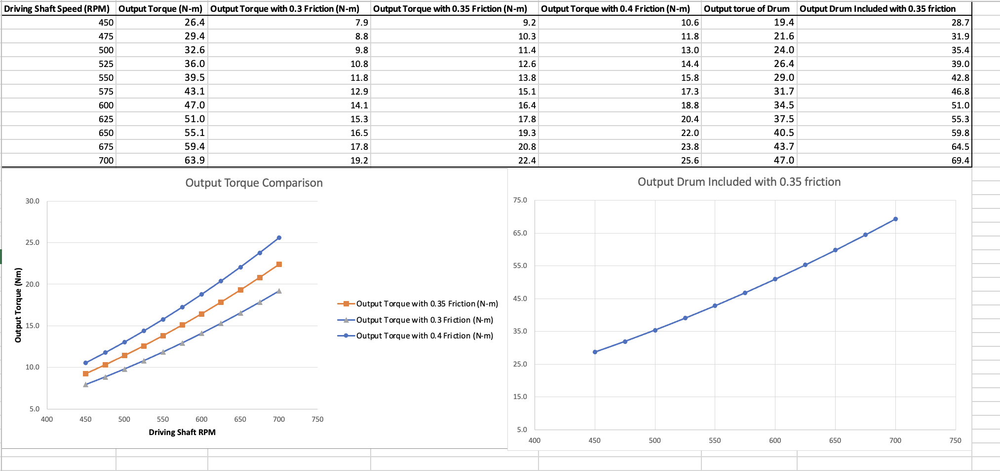

Figure 4 – Chart data for task B Question 5 & 6

