Title Page
Lab Report for Flame Test
Author Stephen Deane
Date 27th June 2024
Student number:2307720

Contents
Contents 2
1 Introduction 3
2 Results 4
3 Discussion 4
4 Conclusion 6
5 References 7
6 Appendices 7

Figure 1- Electron ground to excited cycle 3
Figure 2 - Electromagnetic spectrum 4

Table 1 - Experiment Result Table 4
Table 2 - Metal ions and Corresponding flame colour 8

Equation 1 - Speed of light equal to frequency X wavelength 3
Equation 2 - Delta E equal Planck constant X light frequency 3
Equation 3 - Frequency equals wavelength / speed of light 5
Equation 4 - frequency for Strontium 5
Equation 5- Frequency for Lithium Chloride 5
Equation 6 - changing energy levels of strontium 5
Equation 7 - changing energy levels of Lithium Chloride 5

Introduction
The flame test is the quick experiment that chemists can do to try and work out the presence of different metal ions depending on what colour the flame changes to. The learners aim for this experiment was to conduct a flame test with mystery jars of metal salt solutions and see if they can work out the different metals from using an electromagnetic spectrum and a table that was provided. The purpose behind the experiment is wanting to have visible representation of the electrons transition from grounded state to excited state and then back to ground state. An electron always wants to be in a grounded state naturally but when it is stimulated by heat or electricity it will move to a excited state but cannot stay here. The electron will rapidly fall back down to the ground state and when this happens it will release the gained energy as a photon which is seen as a wavelength of light specific to the material which is what changes the colour of the flame. This is shown in the image below.
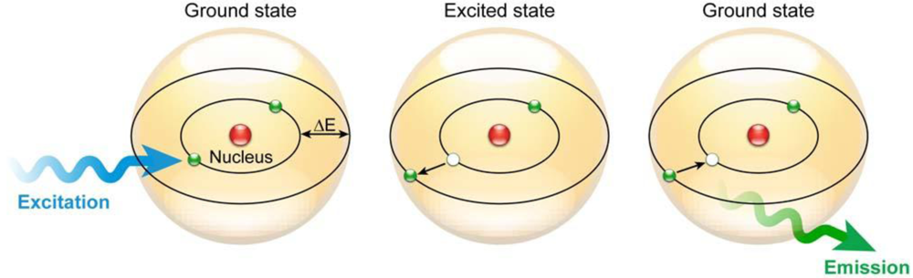
Figure 1- Electron ground to excited cycle

Some key factors for this experiment are the different variables involved such as the independent being the unknown solutions that will be burnt up in the fire. The dependent variable is the colour of the flame which will change depending on the different metal solutions used. The controlled variable is the flame itself the learner making sure to use the same type of flame when testing all the solutions.
The learner was provided with two different equations for this lab assessment that being.
𝑐=𝑓𝜆
Equation 1 - Speed of light equal to frequency X wavelength
The breakdown: c – speed of light (3.0x10e8 ms-1) = f – Frequency of light (Hz) * λ – wavelength (m)
∆𝐸=ℎ𝑓
Equation 2 - Delta E equal Planck constant X light frequency
The breakdown: ΔE – Different energy levels = h – Planck constant (6.63 x10-34 Js) * f – Frequency of light (Hz)

Results
For the results the students (this was a group task. The learner worked with A Clarke and S Shepherdson) used an image of the electromagnetic spectrum like the one below in Figure 2 and table that was provided to them see table 2 for reference, to determent what they believed to be the right colour/metal match throughout the experiment. The following graph is the students results.

Unknown Metal Salt | Colour of the flame | Identity of metal | Wavelength
Dl water | Orange
HCL | Green/Blue
A | Orange | Sodium | 625
B | Lavender | Potassium | 400
C | Red/ Orange | Calcium | 650
D | Red | Strontium | 750
E | Blue/Green | Copper chloride | 500
F | Red/Pink | Lithium chloride | 675
G | Yellow/Green | Barium | 575
H | Yellow/Orange | Sodium chloride + Potassium | 610
Table 1 - Experiment Result Table

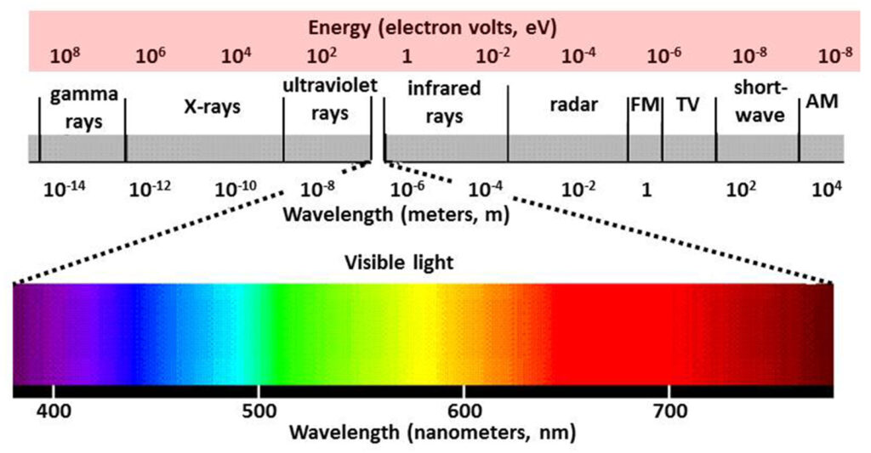
Looking at the results more than half of the metals when tested showed to have a wavelength higher than 550nm. Using the electromagnetic spectrum above (Figure two) that shows us that 6 of the metals had very similar or overlapping colours. The remaining 2 were fairly spread out away from the rest on the spectrum. Between all the metals the whole colour spectrum was seen, giving the learner a good chance to see how different elements can have different energy levels which in turn give different reactions i.e., the photon colours.
Figure 2 - Electromagnetic spectrum

Discussion
Taking two of the solutions used in the flame test being D and F which were believed to be strontium and Lithium chloride, the leaner chose these metals as he was interested in looking at the equation break down for two materials that had a very similar wavelength on the infrared side of the spectrum.
Rearranging equation 1 we can use this to find the frequency so this will help us for equation 2. See Equation 3 for the rearrangement.
f=λ/c
Equation 3 - Frequency equals wavelength / speed of light
The learner can then add in the values for both metals see equations 4 and 5.

$$2.5*{10}^{-15}Hz=\frac{750*{10}^{-9}}{3.0* {10}^{8}}$$
Equation 4 - frequency for Strontium

$$2.25* {10}^{-15}Hz =\frac{675* {10}^{-9} }{3.0* {10}^{8}}$$
Equation 5- Frequency for Lithium Chloride
Now the learner has found the frequency for both metals he can substitute the values into equation
2.
$$1.6575* {10}^{-48}=\left(6.63* {10}^{-34}\right)*(2.5* {10}^{-15})$$
Equation 6 - changing energy levels of strontium
$$1.49175* {10}^{-48}=\left(6.63* {10}^{-34}\right)*(2.25* {10}^{-15})$$
Equation 7 - changing energy levels of Lithium Chloride
Using equations 4 to 7 the learner can infer that there is very little difference between the wavelengths for the chosen metals both being on the higher end of the spectrum. From the workings and the results from the flame test it supports the learner’s belief that these metals had very little difference between them when it comes to the wavelength, frequency and energy levels especially if the comparison was done with a metal like Potassium.

This colourful flame affect has many different uses the most common being fireworks, most of the other uses are more tailored for safety features this being.
- Standard red flare used as a distress signal.
- Orange smoke distress flares used during the day only.
- Illuminating flare this is a white flare used at night signal position.
- Infrared Countermeasures decoy flares used against heat seeking missiles.
- Indoor pyrotechnics used for film sets.
To further assess the flame test conducted in this study, my observations of the advantages and disadvantages regarding the process can be outlined as follows.
- The experiment can be done in a quick turnaround time.
- This form of the test is low cost as not much equipment or material needed.
- It is a simple process that anyone could follow.

How ever there are just as many disadvantages to this test, that being:
- Contamination was a issue as residue would stick to the wire and effect the flame colour.
- Assessing colour/ shades is a subjective thing so error can occur depending on the learner.
- Eyesite conditions like colour-blindness can make the resulting date completely invalid.

Conclusion
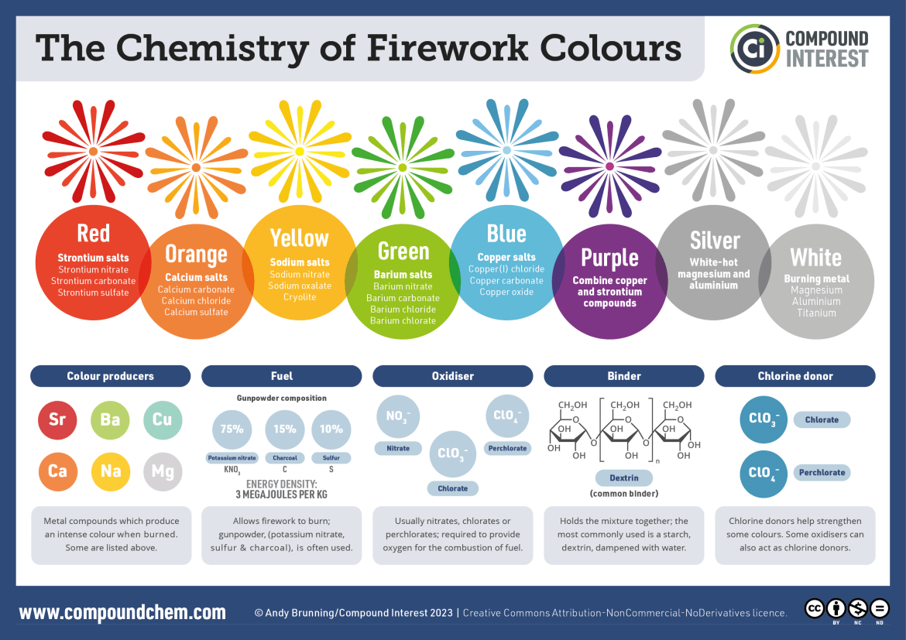
When looking at the experiment it is an okay test that will provide anyone preforming the experiment with useable data that does support the hypothesis proving the light release from the energized electron. While being able to complete it in a good time frame/budget. It could do with a lot of improvement with better equipment or resource, this does take away from the advantages, but this is only if you were able to cover the cost for more precious data. One point that took the learners interest from his research was the use of this photon emission in different product such as fireworks which led them to finding a book “The Chemistry of Fireworks” and things such as figure 3 that give that gives information such as chemical make ups for what colours they want to use and how the fire work is put together.

References

[1] “What is electromagnetic radiation,” Ozonedepletiontheory, https://ozonedepletiontheory.info/what-is-radiation/ (accessed Jun. 26, 2024).
[2] “What is electromagnetic radiation,” Ozonedepletiontheory, https://ozonedepletiontheory.info/what-is-radiation/ (accessed Jun. 26, 2024).
[3] A. Brunning, “The chemistry of the colours of fireworks,” Compound Interest, 30-Dec-2013. [Online]. Available: https://www.compoundchem.com/2013/12/30/the-chemistry-of-fireworks/. [Accessed: 28-Jun-2024].

Appendices
Materials used in experiments.

- Bunsen burner
- Matches
- Heat-resistant mat
- Metal rod
- 1M solutions of unknown metal salts labelled A-H
- Beaker of 1M Hydrochloric Acid (HCL)
- Beaker of deionised water (DI water)
- Blue cobalt glass.
Step by step
1 – set up Bunsen burner on heat resistant mat. Light the burner and move the air vent to change the flame to a double blue cone. Change flame back to safety yellow flame when not in use.
2 – clean the wire by dipping it in to the HCL then heat it in the hottest part of the flame. This will need to be repeated several times until there is no other colour showing. If the flame changes colour this is due to impurities on the wire, repeat the cleaning steps again till the wire is clean.
3 – Dip wire into DL water then place in the flame again to remove and HCL residue. Repeat cleaning steps (2 and 3) before/ after every test.
4 – Cool the wire down then dip into a one of the unknown metal salt solutions. heat in the hottest part of the flame again this time observing and recording the flame colour. The cobalt glass can be used to identify the sodium and potassium.
5 – Repeat steps 2-4 for all the other samples.
6 – Record the colour of the flame for both DL water and HCL.

Metal ion | Flame colour | Metal ion | Flame colour
Barium | Yellow-green | Potassium | Lavender
Calcium | Red-orange | Sodium | Yellow-orange
Lithium | Red-pink | Copper | Blue-green
Strontium | Red
Table 2 - Metal ions and Corresponding flame colour

